Team 6 Group Report
Team Organisation:

Team Collaboration Mechanisms and Facilities:
Student ID | Name | Subsystem developed
19342075 | Mohammad | Student Union Management System
19311012 | Josh (Will be the one to upload due to extension) | USU student app
19334080 | Hamza (Team Leader) | USU operations app
19297059 | Luke | Society leader manager

REPOSITORY URL:
https://github.com/Hamza-4080/COMP5047_CW_GROUP6.git

Folders and explanations:

Folders | Contents
Meeting notes folder | Contains all meeting notes from 1-9
Task 2 folder | Contains each of our task 2
Task 3 folder | Contains each of our task 3 and 3b
Task 4 folder | Contains 4a and 4b
Task 5 folder | Contains 5a and 5b

Team Operation Summary:

Meetings | date | Venue | Start time | Finish time | topics | Meeting chairperson | Attendance | Agenda/minutes URL
1 | 23/09/25 | Library 3rd floor | 14:00 | 14:30 | Read spec/case study | Hamza | All | https://github.com/Hamza-4080/COMP5047_CW_  GROUP6/blob/main/MeetingNotes/MeetingNotes1
2 | 5/10/2025 | Library 3rd floor | 15:00 | 16:00 | Make folder | Hamza | All but Luke | https://github.com/Hamza-4080/COMP5047_CW_GROUP6/blob/main/MeetingNotes/MeetingNotes2
3 | 12/10/2025 | Online WhatsApp | 20:00 | 21:00 | Task 3 discussion | Mohammad | All | https://github.com/Hamza-4080/COMP5047_CW_GROUP6/blob/main/MeetingNotes/Meeting%20notes%203
4 | 16/10/2025 | Online WhatsApp | 16:00 | 16:25 | Task 3a and b discussion | Hamza | All | https://github.com/Hamza-4080/COMP5047_CW_GROUP6/blob/main/MeetingNotes/MeetingNotes4.txt
5 | 24/10/2025 | Online WhatsApp | 15:10 | 15:38 | Feedback on 3 and viewing 4 | Hamza | All | https://github.com/Hamza-4080/COMP5047_CW_GROUP6/blob/main/MeetingNotes/MeetingNotes5#L2
6 | 09/11/2025 | Online WhatsApp | 19:30 | 20:00 | View changes to 3b and start 4a | Mohammad | All | https://github.com/Hamza-4080/COMP5047_CW_GROUP6/blob/main/MeetingNotes/meeting%20notes%206
7 | 16/11/2025 | Online WhatsApp | 21:30 | 10:00 | Review 4a | Mohammad | All | https://github.com/Hamza-4080/COMP5047_CW_GROUP6/blob/main/MeetingNotes/meeting%20note%207
8 | 09/12/2025 | Forum | 13:00 | 13:30 | Start 4b together | Mohammad | All | https://github.com/Hamza-4080/COMP5047_CW_GROUP6/blob/main/MeetingNotes/meeting%20notes%208
9 | 11/12/2025 | WhatsApp online |  |  | 5a and b review | Mohammad | All

Statement on Team Collaboration:

What We Did Well — Team Strengths
In this project out team showcased a high level of collaboration, organisation, and communication consistently and effectively. From the first week, we worked together in an effective manner by meeting in person, we read the specification and case study to allocate subsystems and completion of task 1 as a group. This gave us a very strong start and set an expectation for the teamwork for the future.
One of our biggest strengths was regular and reliable communication. We used WhatsApp regularly and in person meetings to stay updated, share progress and resolve issues. All our meetings were documented from week 1-9, this showed we maintained a structured approach throughout the coursework. Even when someone could not attend (e.g. Luke in meeting 2), they communicated early and still submitted their work showing a very responsible teamwork.
We were very organised as a team, the GitHub was organised and structured with dedicated folder for each task, and we consistently uploaded all our drafts, diagrams and final versions upon feedback. We managed our folders efficiently creating them on time and assigning the duties appropriately, so we all had something to do and were always involved. This showed a shared leadership and supporting one another.
Our team has showed great strong peer support and constructive feedback. Nearly every meeting involved reviewing each other’s work, identifying improvements, correcting misunderstanding and helping with tools like papyrus.
For example, in meeting 2: we clarified task 2 misunderstandings and helped each other focus on one functional requirement.
For meeting 4 and 5: we gave detailed improvements and feedback on task 3 diagrams.
Meeting 6 and 7 we supported each other with papyrus issues and refined task 3b and 4a
Form meeting 8 and 9: We had done 4b wrong with Josh helping a lot in fixing the issue and the rest of the team collaborating in fixing it together for their respective sections.
Reviewing work:
We all reviewed each other’s work rather than one person reviewing to make sure we don’t miss anything. Giving appropriate feedback when something wrong either in the team meeting or on WhatsApp. Mohammad reviewed Josh, Lukes and Hamza’s task 2 straight after it finished and gave appropriate feedback, Luke viewed the other 3 member’ work and gave feedback, Hamza reviewed the other 3 members and then Josh also reviewed the rest. We made sure we all gave opinions on the drafts and made improvements.
For the final week, for task 5a and b:
-Mohammad reviewed all of Hamza’s work on 5a and 5b and then proofread all his tasks and gave feedback
-Hamza read all of Mohammad’s work on 5a and 5b and then proofread all his tasks and gave feedback
-Luke read all of Josh’s work on 5a and 5b and then proofread all his tasks and gave feedback
-Josh read all of Luke’s work on 5a and 5b and then proofread all his tasks and gave feedback making sure we have all met the requirements.

We shared the role of meeting chairman efficiently and shared the workload rather than dumping workload on one person between Hamza and Mohammad.
We decided to work on task 4b together all in one place but as this meant that we only had one person at the computer at one time (adding their subsystem part on the full system architecture), we decided it would be more time efficient to also work on the team report part at the same time. Mohammad made the template/structure of this report and wrote the majority of it with input from everyone else (while we were making our 4b diagram one-by-one with input from respective members’ about how their subsystems connected).
The reason why we decided to work on task 4b (which was a team activity to make a diagram which required everyone’s subsystem) together in-person instead of setting the project up on GitHub and working on it one-by-one was because half of our members were having major problems with papyrus (which are documented in the meeting notes). The group tried to get the problem fixed themselves and by contacting university staff but were unable to get it working with stability. However, even though it was hard work and required everyone to show up together for a long time (over 7 hours) we managed to make a relevant and systematically correct architecture diagram (to the best of our abilities) for our whole system in one sitting. This was probably the most challenging part of this coursework for us due to the nature of the task (connecting individual work, tracking changes that need to be made to our individual work, making sure common components actually do the functionality our individual subsystems require, etc), but with patience and the common goal to complete this coursework to the best of our ability, everyone collaborated with all their effort to focus on the task at hand in a cooperative environment.
Another key strength we had was time management and consistency. Meetings happened almost every week from September to December with some time off due to having a week extension where we all focused on refining our work. We all maintained progress even when our schedules had changed with communication through WhatsApp.
Finally, we demonstrated collaborative problem solving. When issues arose such as papyrus not working or diagrams needing reconstructing – all members helped each other and adjusted plans quickly. This created a positive working environment which ensured we all contributed to the final output.
Something we could’ve done better was that we could’ve set meetings at fixed times as we often rescheduled due to someone being busy. While being flexible with our meetings had it’s own advantages, having fixed meeting times no matter what not only gives the whole team solid deadlines for delegated work but also makes sure that we stay organised moving forward and not having to spend time and energy adjusting plans instead of actually doing the work.
Overall, our main strengths included strong communication, strong organisation on GitHub, consistent attendance and participation, effective peer feedback, and a positive collaborative atmosphere. These factors contributed greatly to our team completing all tasks to the best standard we could’ve and meeting all coursework requirements on time. Through this coursework, our group learned the importance of organisation, time management, communication and adherence to plans for real-world projects that we will keep in mind going forward.

Architectural Design of the System:
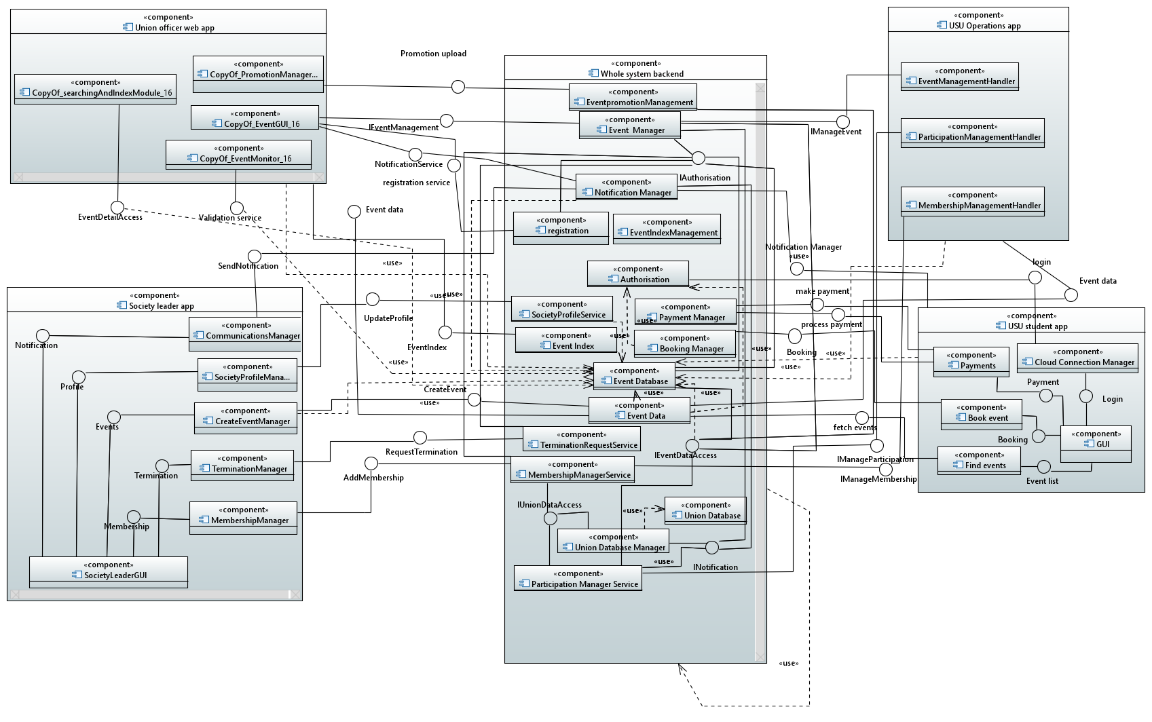
- The “backend” component in the middle is the cloud which provides interfaces to the 4 individual apps/subsystems to allow them to fulfil their functions.
Textual Documentation of the System:
USU Operation App:
USU Operation System: Specification of Microservices
Component | MembershipManagementHandler
Description | Runs on the user’s device to provide the front end for managing memberships and processing user input.
Stereo Type | Service
Required Interfaces | IManageMembership
Provided Interfaces | ApproveMembershipRequest, ApproveRegistrationDataUpdateRequest, ApproveTerminationRequest

Component | EventManagementHandler
Description | Runs on the user’s device to provide the front end for managing events and processing user input.
Stereo Type | Service
Required Interfaces | IManageEvent
Provided Interfaces | CreateEventRequest, UpdateEventRequest, PostAnnouncementRequest

Component | ParticipationManagementHandler
Description | Runs on the user’s device to provide the front end for managing participation and processing user input.
Stereo Type | Service
Required Interfaces | IManageParticipation
Provided Interfaces | SubscribeToEventRequest, StudentParticipationRequest, UnionEndorseEventRequest

Component | MembershipManagerService
Description | Runs on the system backend/cloud. Judiciously performs the membership management operation requested by the user.
Stereo Type | Service
Required Interfaces | IUnionDataAccess
Provided Interfaces | IManageMembership

Component | UnionDatabaseManager
Description | Runs on the system backend/cloud. Handles all input and output to the UnionDatabase, providing an entry to other services.
Stereo Type | Service
Required Interfaces | None
Provided Interfaces | IUnionDataAccess

Component | UnionDatabase
Description | A database in the system backend/cloud. Stores all union specific data such as union members and their required information.
Stereo Type | Database
Required Interfaces | None
Provided Interfaces | None

Component | EventManager
Description | Runs on the system backend/cloud. Judiciously performs the event management operation requested by the user.
Stereo Type | Service
Required Interfaces | INotification, IEventDataAccess
Provided Interfaces | IManageEvent

Component | EventDatabase
Description | A database in the system backend/cloud. Stores all event specific data such as name of event, venue, date, etc.
Stereo Type | Database
Required Interfaces | None
Provided Interfaces | IEventDataAccess

Component | NotificationManager
Description | Runs on the system backend/cloud. Handles all the sending notification functionality of other services such as letting unions know when their membership application request has been updated or letting users subscribed to an event know when its been updated
Stereo Type | Service
Required Interfaces | None
Provided Interfaces | INotification

Component | ParticipationManagerService
Description | Runs on the system backend/cloud. Judiciously performs the participation management operation requested by the user. This could be a student user requesting to subscribe to an event or a union operator endorsing an event.
Stereo Type | Service
Required Interfaces | IEventDataAccess, INotification, IUnionDataAccess
Provided Interfaces | IManageParticipation

USU Operation System: Specification of Interfaces
Name | IManageMembership
Provider | MembershipManagerService
Operation Signature | membershipRequest(request_type: String, request_data: String, id: int)
Operation Function | Decides which operation needs to be performed using the request_type string (such as approve/reject membership application or approve a data update request) using the data in the request_data string (data could be application information or the data that needs to be updated etc). Id is the id of the membership which will be left empty for a new membership but needs to be provided to modify an existing membership.

Name | IManageEvent
Provider | EventManager
Operation | Signature | eventRequest(request_type: String, request_data: String, id: int)
Operation | Function | Decides which operation needs to be performed using the request_type string (such as create or update event) using the data in the request_data string (data could be all event data or the data that needs to be updated etc). Id is the id of the event which will be left empty for a new event but needs to be provided to modify an existing event.
Operation | Signature | makeAnnouncement(request_type: String, data: string, id: int)
Operation | Function | Decides which operation needs to be performed using the request_type string (such as announcement for a new event or an event update etc). Data and id can be left empty but should be populated for most cases. Data stores any other information the operator wants to be sent with the notification and id can be used to link the notification with a specific event.

Name | IManageParticipation
Provider | ParticipationManagerService
Operation | Signature | studentRequest(request_type: String, id: int)
Operation | Function | Decides which operation needs to be performed using the request_type string (subscribe or participate). Decides which event to subscribe or add the student to using the id int.
Operation | Signature | unionEndorse(data: string, id: int)
Operation | Function | Allows a union officer to endorse an event. Data stores the data they want to store/send and id is used to identify which event they are endorsing.

Name | IUnionDataAccess
Provider | UnionDatabaseManager
Operation | Signature | getData(id: int, field: string)
Operation | Function | Returns a member’s data using the id int. If the field parameter is empty, returns all data, if it’s provided (such as name), just returns that specific field’s data.
Operation | Signature | setData(id: int, data: string, field: string)
Operation | Function | Sets a member’s data (such as approval status) using the data string, finding the correct member by using the id int. If the field parameter is provided, then only that specific field will be modified if not then it’s expected for the data string to provide data for all fields (parsing the string will be handled in this function).

Name | INotification
Provider | NotificationManager
Operation Signature | sendNotification(eventID: int, data: string)
Operation Function | Sends notifications to users. Linked to an event with eventID. The users that notifications need to be sent to are also obtained from the event using it’s id. Data contains all information that needs to be sent to users.

Name | IEventDataAccess
Provider | EventDatabaseManager
Operation | Signature | getData(id: int, field: string)
Operation | Function | Returns an event’s data using the id int. If the field parameter is empty, returns all data, if it’s provided (such as name), just returns that specific field’s data.
Operation | Signature | setData(id: int, data: string, field: string)
Operation | Function | Sets an event’s data (such as time of event or participating students list) using the data string, finding the correct event by using the id int. If the field parameter is provided, then only that specific field will be modified if not then it’s expected for the data string to provide data for all fields (parsing the string will be handled in this function).

Student Union Management System:
Interfaces:
Component | EventGuiManagement
Description | This is a microservice running on the cloud to process the event creation.
Stereo Type | Service
Required Interface | IAuthorization, Istorage
Provided Interface | IEventManagement

Component | EventPromotionManagement
Description | This is a microservice running on the cloud to process the event promotion material uploads.
Stereo Type | Service
Required Interface | Istorage
Provided Interface | PromotionUpload

Component | EvevntRegistrationManagement
Description | This is a microservice running on the cloud to process and configure the ticketing/registration
Stereo Type | Service
Required Interface | IAuthorisation
Provided Interface | RegistrationService

Component | NotificationManagement
Description | This is a microservice running on the cloud to process and notify the creation of events or changes
Stereo Type | Service
Required Interface | Inotification
Provided Interface | ValidationService

Component | Database
Description | This is a microservice running on the cloud to store all notifications, event details/updates, ticketing, promotion etc.
Stereo Type | Service
Required Interface | Inotification
Provided Interface | Istorage, IAuthorization

Components:

