Customer Loyalty Program – White Box Testing Report
Student Name: HAMZA AHMED SIDDIQUI
Roll No: 22FA-043-SE
Course: SQE (Software Quality Engineering)
Instructor: Sir Talha Ahmed
University: UIT University
Submission Date: 20th November 2025
Full Project: SQE-REP-GITHUB

1. Program Code (Under Test)
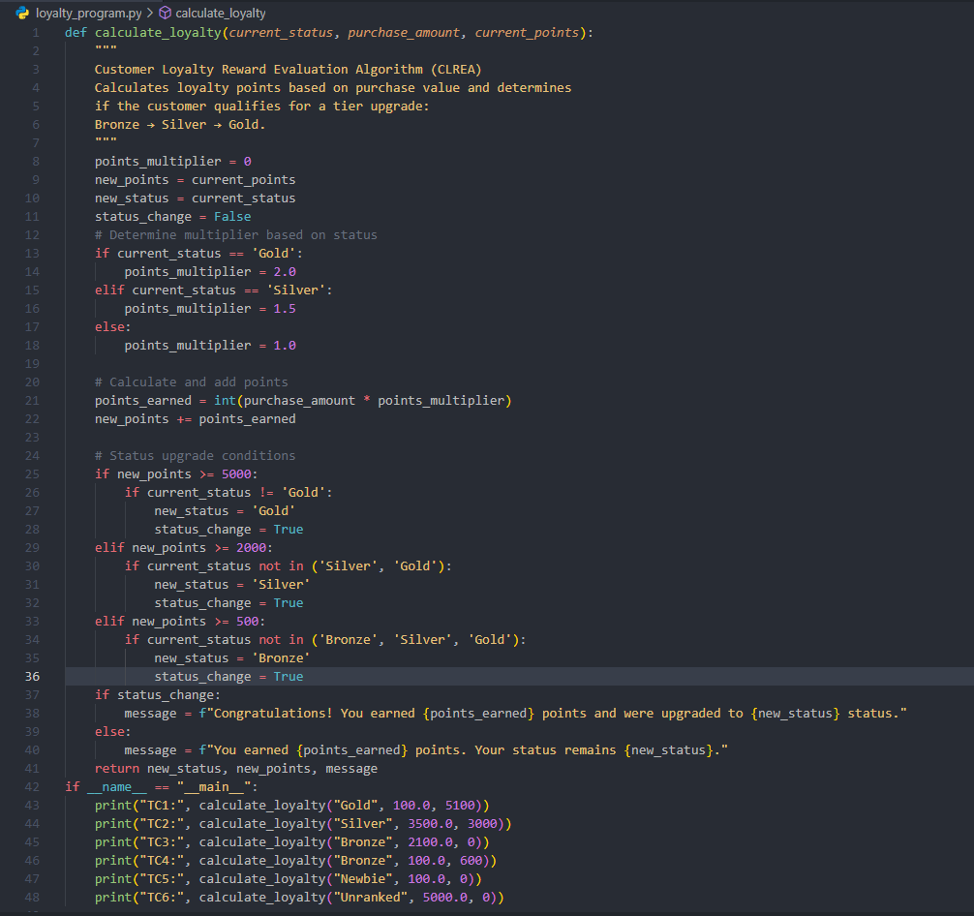
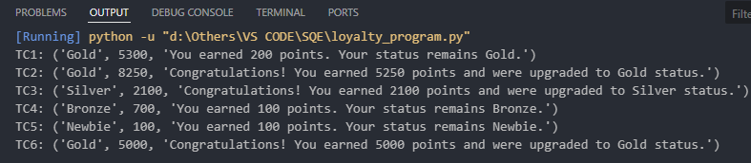

2. Cyclomatic Complexity
Cyclomatic Complexity measures the number of linearly independent paths through the program.
Number of decisions = 5
Cyclomatic Complexity V(G) = Decisions + 1 = 5 + 1 = 6

3. Independent Test Paths
Path 1 → Gold → no upgrade
Path 2 → Silver → upgrade to Gold
Path 3 → Bronze → upgrade to Silver
Path 4 → Bronze → remain Bronze
Path 5 → Unknown status → remain same
Path 6 → Unknown status → upgrade to Gold

4. White-Box Test Cases
TC1: Gold, 5100 pts → no upgrade
TC2: Silver, 3000 pts + 3500 purchase → upgrade to Gold
TC3: Bronze, 2100 purchase → upgrade to Silver
TC4: Bronze, low purchase → remain Bronze
TC5: Newbie, low purchase → remain same
TC6: Unranked, huge purchase → upgrade to Gold

5. Conclusion
The Customer Loyalty Program contains 6 unique execution paths and provides a strong basis for White‑Box Testing. All branches were covered using six test cases ensuring full branch coverage and validation of reward logic and status upgrade logic.

