Project documentation
Hamza Awais l1f24bscs0229

Project Title: CV-Based Job Suitability and Domain Prediction System

1. Introduction
The CV-Based Job Suitability and Domain Prediction System is a computer program made to help students find the right career path. Today, the job market is very competitive, and many new graduates don't know which job matches their skills. For example, they might not know if they should be a Data Scientist, a Web Developer, or a Game Developer. When students apply for the wrong jobs, they get rejected many times, which is very frustrating. Usually, HR workers have to check resumes by hand, but this is slow and can lead to mistakes. This project offers a better way. Created using C++, the system reads a resume file and uses a "Random Forest" voting method to decide which job is best for the candidate. This project also shows how Object-Oriented Programming (OOP) works in real life by using concepts like classes, inheritance, and memory management. It helps bridge the gap between school learning and a real professional career.

2. Motivation
The motivation stems from the need to turn theoretical computer science concepts into a functional tool that assists career development. Many students possess the required skills but lack the "domain identity" needed for specialized job applications. This project aims to provide that clarity while helping the developer master complex OOP patterns like Abstract Base Classes and Dynamic Polymorphism.

3. Problem Statement and Elaboration

Overview
The disconnect between a candidate's self-perception and their actual market suitability often results in inefficient hiring processes for both the employer and the applicant.

Problem Statement
"Students and fresh graduates often struggle to find jobs that match their skills, education, and experience, leading to repeated rejections."

Problem Elaboration & Project Solution
The core problem is that a resume contains multi-dimensional data (Education, Skills, and Projects) that are hard to weigh manually. For example, a candidate might have a BSCS degree (General) but specialized projects in "Unity" (Game Dev).
The Solution: My project solves this by breaking the CV into three analytical components:
- SkillTree: Analyzes the skills and experience duration.
- EducationTree: Maps specific degrees (e.g., BSDS, BSAI) to their respective domains.
- ProjectTree: Scans project descriptions for technical indicators like "Firebase" or "Machine Learning". By using a Random Forest model, the system aggregates these different perspectives to produce a "Majority Vote," ensuring a balanced and accurate prediction.

4. Goals and Objectives

Project Goal
The primary goal is to help students and fresh graduates identify suitable job domains based on their resume through a simple, academic-level predictive system.

Objectives
- Modular Design: Create a maintainable C++ application utilizing class-based structures.
- Data Processing: Implement file handling to read and parse structured .txt resumes.
- Domain Prediction: Apply "Random Forest" logic to suggest the best-fit job role.
- OOP Mastery: Demonstrate inheritance, polymorphism, and dynamic memory management.

5. Project Scope
- Included: Analyzing structured CV data, console-based output, prediction for four specific domains (Data Science, Web, Game, and App Development), and manual memory cleanup.
- Not Included: Processing PDF/Docx files, advanced machine learning libraries, GUI, or web-based interfaces.

6. Project Architecture

UML Diagram & Class Roles

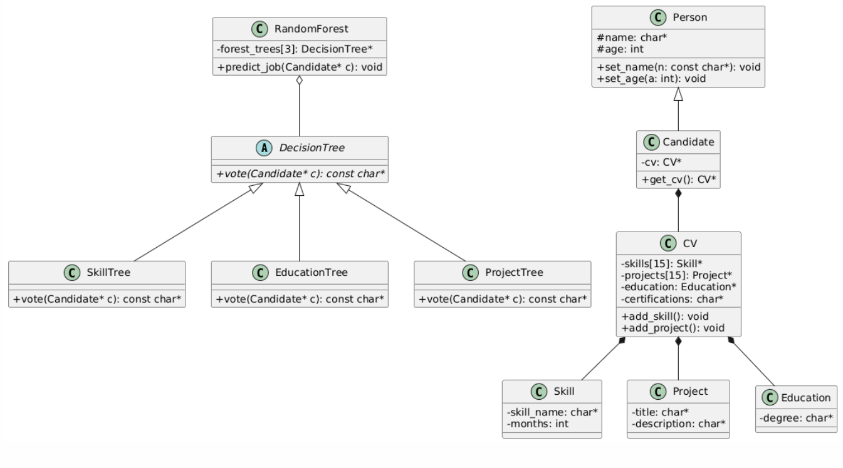

Key Class Roles & Relationships
- Person (Base Class): Stores shared attributes like name and age.
- Candidate (Derived Class): Inherits from Person and "has-a" CV object.
- CV (Composition): Acts as a container for arrays of Skill and Project objects.
- DecisionTree (Abstract Class): Defines the vote() interface using a pure virtual function to enable Dynamic Polymorphism.
- RandomForest: The "Manager" class that holds pointers to different DecisionTree objects and calculates the final result.

7. Future Recommendations and Conclusion

Future Recommendations
- NLP Integration: Enhance the SEARCH_FOR_KEYWORD function with Natural Language Processing to understand context better.
- Expanded Domains: Add support for Cybersecurity and Cloud Engineering roles.
- File Support: Implement libraries to read PDF and Word document formats directly.

Conclusion
This project successfully applies the core principles of Object-Oriented Programming—Encapsulation, Inheritance, and Polymorphism—to a practical career-guidance tool. By utilizing a voting-based logic, the system provides a reliable and transparent way for candidates to understand their professional standing, bridging the gap between their academic efforts and industry expectations.

