Student Performance Evaluation System
Object Oriented Programming (OOP) - Final Project
Student Name: Hamza Awais
Registration No: l1f24bscs0229

1. Introduction
In academic institutions, evaluating student performance accurately and at an early stage is essential to improve learning outcomes. Manual evaluation methods are time-consuming, prone to inconsistency, and often fail to provide timely insights into student progress.
The Student Performance Evaluation System is a C++ based console application developed using Object-Oriented Programming (OOP) principles. The system collects each student's assignment, quiz, mid-exam marks and study hours, normalizes them into a feature vector, and passes that vector through a simplified Logistic Regression model to produce a performance score. The score is then mapped to a category: Excellent, Good, Average or Poor.
The project emphasizes strong OOP design, modularity, dynamic memory management, file handling and basic machine-learning logic, making it suitable for students with foundational knowledge of Programming Fundamentals (PF) and Object Oriented Programming (OOP).

2. Problem Statement
Educational institutions often lack automated tools to analyze student academic data and identify performance levels early. Manual assessment can delay academic interventions and may not always reflect an accurate overall evaluation.
There is a need for a software system that can:
- Automatically analyze student academic records
- Apply logical and data-driven evaluation
- Categorize students based on performance
- Support instructors in academic decision-making

3. System Architecture
The system follows a layered architecture in which each layer has a clear responsibility and interacts with the others through well-defined interfaces. Internally it is fully object-oriented, applying abstraction, inheritance and polymorphism.

A. User Interface Layer
Purpose: acts as the interaction point between the user (teacher/admin) and the system.
- Displays prompts, student details, scores and categories on the console
- Validates all input through the helper functions getValidatedInt, getValidatedFloat and getValidatedName
- Has no direct access to the raw data or the ML logic

B. Application (Business Logic) Layer
Purpose: controls the system workflow and decision-making logic.
- PerformanceEvaluator: calls the ML model and converts the returned score into a performance category
- ReportGenerator: walks the whole dataset and writes the formatted report.txt
Why this layer is important: it separates the decision logic from the data and from the presentation, keeping the system modular and maintainable.

C. Machine Learning Layer
Purpose: implements the simplified Logistic Regression model.
- MLModel: abstract base class declaring the common interface train() and predict()
- LogisticRegression: holds the feature weights, applies the sigmoid function and calculates the normalized performance score

D. Data Management Layer
Purpose: handles all student-related data and its organization.
- Student: stores personal information (ID and name)
- PerformanceRecord: stores the academic inputs (assignments, quiz, exam, study hours) and normalizes them into a feature vector
- PerformanceResult: stores the final score and category
- DataSet: aggregates parallel dynamic arrays of Student and PerformanceRecord objects and releases them in its destructor

E. Utility and System Layer
Purpose: provides supporting services to the entire system.
- FileManager: appends each evaluated student and result to results.txt
- Logger: appends activity messages to system_log.txt

4. Class Diagram and Class Roles
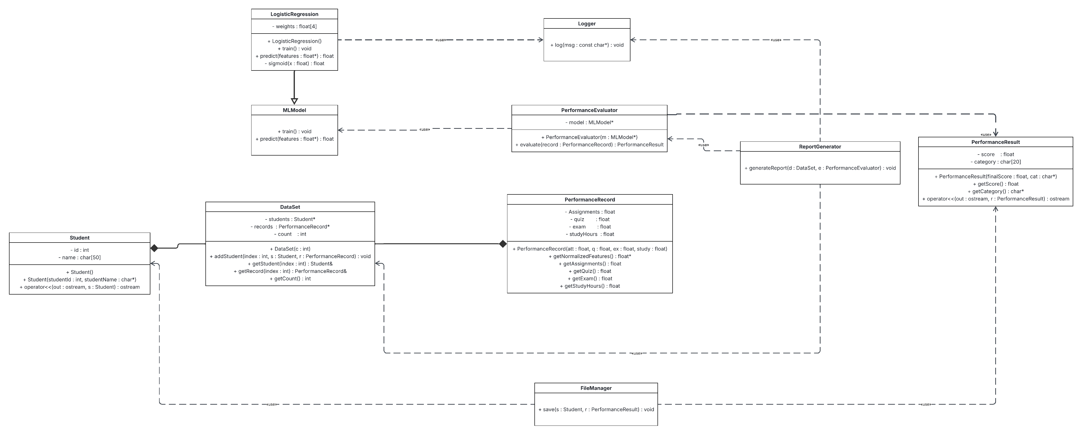
The diagram above shows the ten classes of the system and how they relate to one another.

5. Object Relationships
- Composition: DataSet owns the dynamic arrays of Student and PerformanceRecord and deletes them in its destructor
- Association: PerformanceEvaluator holds a pointer to an MLModel and uses it for prediction
- Inheritance: LogisticRegression derives from the abstract class MLModel
- Polymorphism: predict() is invoked at run time through an MLModel base-class pointer

6. OOP Concepts Used
1. Classes and Objects: ten interconnected classes (Student, PerformanceRecord, PerformanceResult, DataSet, MLModel, LogisticRegression, PerformanceEvaluator, FileManager, Logger, ReportGenerator) each encapsulate the attributes and behaviour relevant to them.
2. Encapsulation and Data Hiding: all data members are private and are exposed only through public getters, protecting the internal state of every object.
3. Inheritance: LogisticRegression inherits the interface of MLModel, allowing the model to be swapped without changing the evaluator.
4. Polymorphism: dynamic polymorphism is achieved with the virtual functions train() and predict() and a virtual destructor in the base class, so the correct overridden function is chosen at run time.
5. Abstraction: MLModel is an abstract class with pure virtual functions, serving as a blueprint that cannot be instantiated directly.
6. Operator Overloading: the stream insertion operator << is overloaded as a friend for Student and PerformanceResult so objects can be printed directly to the console and to files.
7. Dynamic Memory Management: the feature vector is allocated with new[] inside getNormalizedFeatures and released with delete[] after prediction; DataSet allocates its object arrays with new[] and frees them in its destructor, preventing memory leaks.
8. Static Members: Logger::log, FileManager::save and ReportGenerator::generateReport are static, so these services are available without creating an object.
9. Const Correctness: getters and other read-only operations are declared const so they cannot modify object state.
10. Friend Functions: the overloaded << operators are friends of their classes, granting them access to private members only where it is strictly needed for output.

7. Classification Logic
Each PerformanceRecord is normalized into a four-element feature vector: assignments/100, quiz/100, exam/100 and studyHours/10. LogisticRegression combines the features with fixed weights (0.25, 0.25, 0.35, 0.15) into a single value z, passes z through a clamped sigmoid function, and returns a score between 0 and 1. PerformanceEvaluator then maps the score to a category:
- score >= 0.70 : Excellent
- score >= 0.66 : Good
- score >= 0.61 : Average
- otherwise : Poor

8. File Handling and Logging
- results.txt: opened in append mode; one line per evaluated student written by FileManager
- report.txt: rewritten on every run by ReportGenerator with the full formatted report
- system_log.txt: opened in append mode by Logger to record training, report generation and program completion

9. Input Validation
- getValidatedInt and getValidatedFloat repeat the prompt until a numeric value inside the allowed range is entered, recovering from cin.fail() each time
- getValidatedName accepts letters and spaces only and rejects empty or invalid names

10. Conclusion and Future Improvements
This project successfully implemented the Student Performance Evaluation System in C++. Key OOP principles - encapsulation, inheritance, polymorphism and abstraction - were applied to create a modular and efficient application. The system manages student records with file handling for permanent storage and dynamic memory for resource optimization, bridging the gap between theoretical concepts and practical software development.
Future improvements proposed:
- GUI Implementation: upgrade from the console interface to a graphical user interface
- Database Integration: replace simple file handling with a structured database such as SQL for larger datasets
- Advanced Analytics: improve the prediction logic with better machine-learning algorithms beyond simple logistic regression
- Role-Based Security: add login levels (admin vs student) to restrict access to sensitive data

11. Output Screenshots
All program output screenshots (Excellent, Good, Average, Poor, a four-student run, results.txt, report.txt and system_log.txt) are provided in the separate file Output_Screenshots.docx.

