

24
Fitness-Tracker
e-Project Document
Mr. Muhammed Hamza Hanif Ms. Sawaira Adnan Ms. Mehak Naseer Mr. SYED SAIFULLAH HUSSAINY

Table of Content:

CERTIFICATE OF COMPLETION 3
THIS IS TO CLARIFY 3
Acknowledgement: 5
Abstract: 6
Customer Requirement Specification: 7
Hardware: 12
Flow chart: 13
Checklist of Validations: 15
Submission Checklist: 16
Task sheet: 17
Screenshot 18
of 18
Frontend 18
Home Screen: 19
About-Us Screen: 20
Contact-Us Page: 21
Login Screen: 22
Register Screen: 23
Not-Found Screen: 24
Dashboard Screen: 25
Workouts Screen: 26
Nutritions Screen: 27
Conclusion: 28

CERTIFICATE OF COMPLETION

THIS IS TO CLARIFY
Hamza Hanif , Sawaira Adnan , Syed Saifullah , Mehak Naseer
Has successfully Designed & Developed

Fitness-Tracker

Submitted By:
Sir Taimoor

Date : 15-07-2024 AUTHORIZEDSIGNATURE

Acknowledgement:

I would like to acknowledge all those given moral support and helped me make the project a success.

I wish to express my gratitude to the e -projects team at the head office who guided
And helped me I would also like to express my gratitude to all the staff member of my
Center for not only providing me with the opportunity to work with them on this project
But also for their support and encouragement throughout to process

I also express my sincere gratitude to my project guide at the organization for our valuable guidance and support for the completion of this project

And finally I would like to offer many thanks to all my colleagues for their valuable
Suggestion and constructive feedback

Abstract:
In recent years, there has been a significant surge in health and fitness consciousness among individuals worldwide. With the advent of technology and the proliferation of smartphones, people are increasingly turning to digital solutions to help them manage and monitor their fitness journeys. The demand for comprehensive fitness tracking applications has grown exponentially, leading to opportunities for innovative solutions that cater to the diverse needs of fitness enthusiasts. The Fitness Tracker application is needed to help users track their fitness activities, such as workouts, nutrition, and progress over time.

Customer Requirement Specification:

Functional Requirement-

User Management:
User Registration:
Users can create an account with a unique username and password.
Registration should include basic profile information (e.g., name, email, profile picture).
User Login:
Registered users can log in with their credentials securely.
User Profiles:
Users have personalized profiles displaying their profile picture, name, and basic information.
Users can update their profile information.
Fitness Tracking:
Workout Tracking:
Users can create, edit, and delete workout routines.
Each workout routine can include exercise name, sets, reps, weights, and notes.
Workouts can be categorized (e.g., strength, cardio) and tagged for easy organization.
Nutrition Tracking:
Users can log their daily food intake, specifying meal types (e.g., breakfast, lunch, dinner, snacks).
Each entry includes food items, quantities, and nutritional details (calories, macros).
Progress Tracking:
Users can record their fitness progress, including weight, body measurements, and
performance metrics (e.g., run times, lifting weights).
The application should generate graphs and visual representations of users’s progress
over time.
Dashboard:
User Dashboard:
A personalized dashboard provides an overview of the user’s fitness journey.
The dashboard displays recent workouts, nutrition logs, and fitness progress.
Data Visualization:
Workout Analytics:
Users can view charts and graphs of their workout data, including progress in lifting
weights, workout frequency, and exercise history.
Nutrition Analytics:
Users can see nutritional insights, such as calorie intake, macronutrient distribution, and daily consumption trends.
Activity Notifications:
Users receive notifications for actions like workout completion, goal achievement, new followers, or forum responses.
Search and Filtering:
Search and Filter:
Users can search for specific workouts, nutrition entries, or other users.
Filters are available to sort and narrow down search results.
Mobile Compatibility:
Mobile Responsiveness:
The application is responsive and functional on various devices, including smartphones and tablets.
Reporting and Export:
Users can generate reports for their fitness progress and nutrition data, including the option to export data in various formats (e.g., PDF, CSV).
Notifications and Alerts:
Alerts and Reminders:
Users can set reminders and alerts for workouts, meal times, and fitness goals.
Settings and Preferences:
User Preferences:
Users can customize their application settings, including notification preferences, units of measurement, and theme preferences.
Feedback and Support:
User Support:
A support system for users to contact for assistance, report issues, and provide feedback.
Non-Functional Requirements-
Performance:
Response Time: The application should respond to user interactions within 1-2 seconds for most operations.
Scalability: The system should be able to handle a growing number of users and data without
significant performance degradation.
Concurrent Users: The application should support hundreds of concurrent users without
performance bottlenecks.
Security:
Data Encryption: All sensitive user data, including passwords and personal information, must be securely encrypted during storage and transmission.
Authentication: User authentication should be secure and use industry-standard practices to
prevent unauthorized access.
Authorization: Access control must be implemented to ensure users can only access their own
data or public data, as per their settings.
Privacy:
Data Privacy: The application must comply with data privacy regulations such as GDPR, ensuring user data is handled and stored with care.
User Consent: Users should have control over the data they share and provide informed
consent for data processing and sharing.
Reliability:
Uptime: The application should aim for a minimum of 99% uptime, with scheduled maintenance communicated in advance.
Data Backup: Regular automated data backups must be performed to prevent data loss in case of system failures.
Usability:
User Interface Design: The application should have an intuitive, user-friendly interface with
consistent navigation and a responsive design that works on various devices.
Accessibility: The application must adhere to accessibility standards (e.g., WCAG) to ensure it is usable by individuals with disabilities.
Compatibility:
Cross-Browser Compatibility: The application should function correctly on popular web
browsers, including Chrome, Firefox, Safari, and Edge.
Mobile Compatibility: The application should be responsive and work well on various mobile
devices and screen sizes.
Scalability:
Horizontal Scalability: The architecture should support horizontal scaling to accommodate
increased user loads as the user base grows.
Performance Monitoring:
Logging and Monitoring: The system should include logging and monitoring tools to track
application performance, errors, and user activity for debugging and analysis.
Testing and Quality Assurance:
Test Coverage: A comprehensive test suite should be maintained, covering unit testing,
integration testing, and end-to-end testing.
Security Testing: Regular security assessments, including penetration testing, must be
conducted to identify vulnerabilities.
Documentation:
User Documentation: Provide user guides, FAQs, and tutorials to help users understand and
navigate the application.
Developer Documentation: Maintain developer documentation to assist in further development and maintenance.
Video: Provide video displaying complete working of the application.

Hardware:
- A minimum computer system that will help you access all the tools in the
- courses is a Pentium Core 2 Duo or better
- 2 Gigabytes of RAM or better

Software :
Either or combination of the following Software’s are to be used:
Windows OS//MongoDB/Express/React/Node.js/Notepad

Flow chart:
A flow chart is a picture of the separate steps of a process in sequential order it is a generic tool that can be adapted for a wide variety of purposes, and can be used to describe various processes, such as a manufacturing process, an administrative or service process, or a project plan.
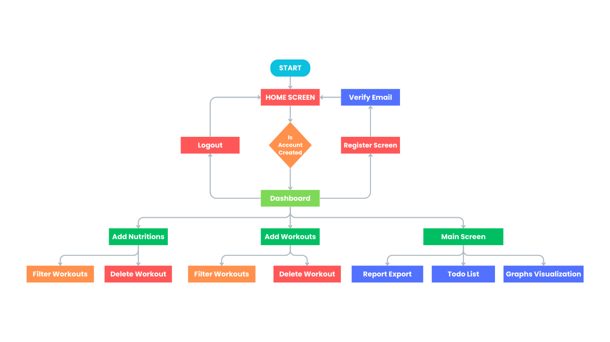
Architecture Diagram:

The process of creating visual representation of software system components.



Checklist of Validations:
Cc | Validated
Do all numeric variables have a default value of zero? | Yes
Does the administrator have all the rights to create and delete the records? | Yes
Are all the records properly fed into the appropriate database? | Yes
Have all the modules been properly integrated and are completely functional? | Yes
Have all the design and coding standards been followed and implemented? | Yes
Is the GUI design consistent all over? | Yes
Is the navigation sequence correct through all the forms/screens in application? | Yes
Is exception handling mechanism implemented in all the screens? | Yes
Are all the program codes working? | Yes
Is the budget plan sufficient and verified?s | Yes

Submission Checklist:

Sr. | Particulars | Yes | No | NA
1. | Are all users able to search for a particular record? | Yes
2. | Are all old records properly saved and retrieved when required? | Yes
3. | Have all modules been properly integrated and are completely functional? | Yes
4. | Are GUI contents devoid of spelling mistakes? | Yes
5. | Is the application user-friendly? | Yes
6. | Is the project published properly into a setup file? | Yes

Task sheet:
Project Ref. NO.: |  | Project  Title: | Activity Plan  Prepared By: | Data of Preparation of Activity Plan:
Sr. No. | Task
 |  |  |  | Actual start  Data | Actual  Days | Team Mate  Names
1. | Frontend | Fitness Tracker | ______ | 15 June 2024 | 30 | Hamza
2. | Backend |  |  |  |  | Hamza
3. | Authentication |  |  |  |  | Hamza
4. | Testing |  |  |  |  | Hamza
5. | Internet researching |  |  |  |  | SYED SAIFULLAH HUSSAINY
6. | Research work |  |  |  |  | Mehak
7. | Data insert work |  |  |  |  | Sawaira

Screenshot

of

Frontend

Home Screen:
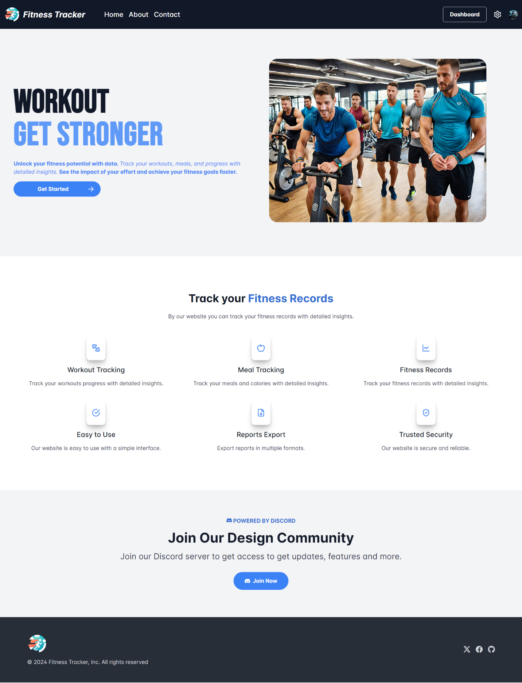

About-Us Screen:
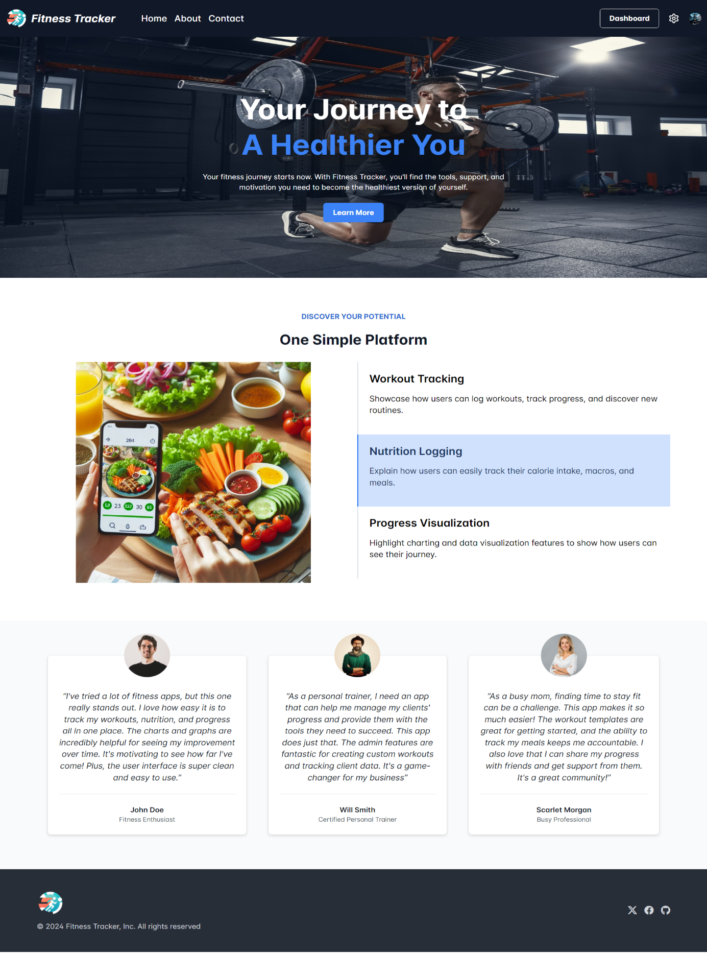

Contact-Us Page:

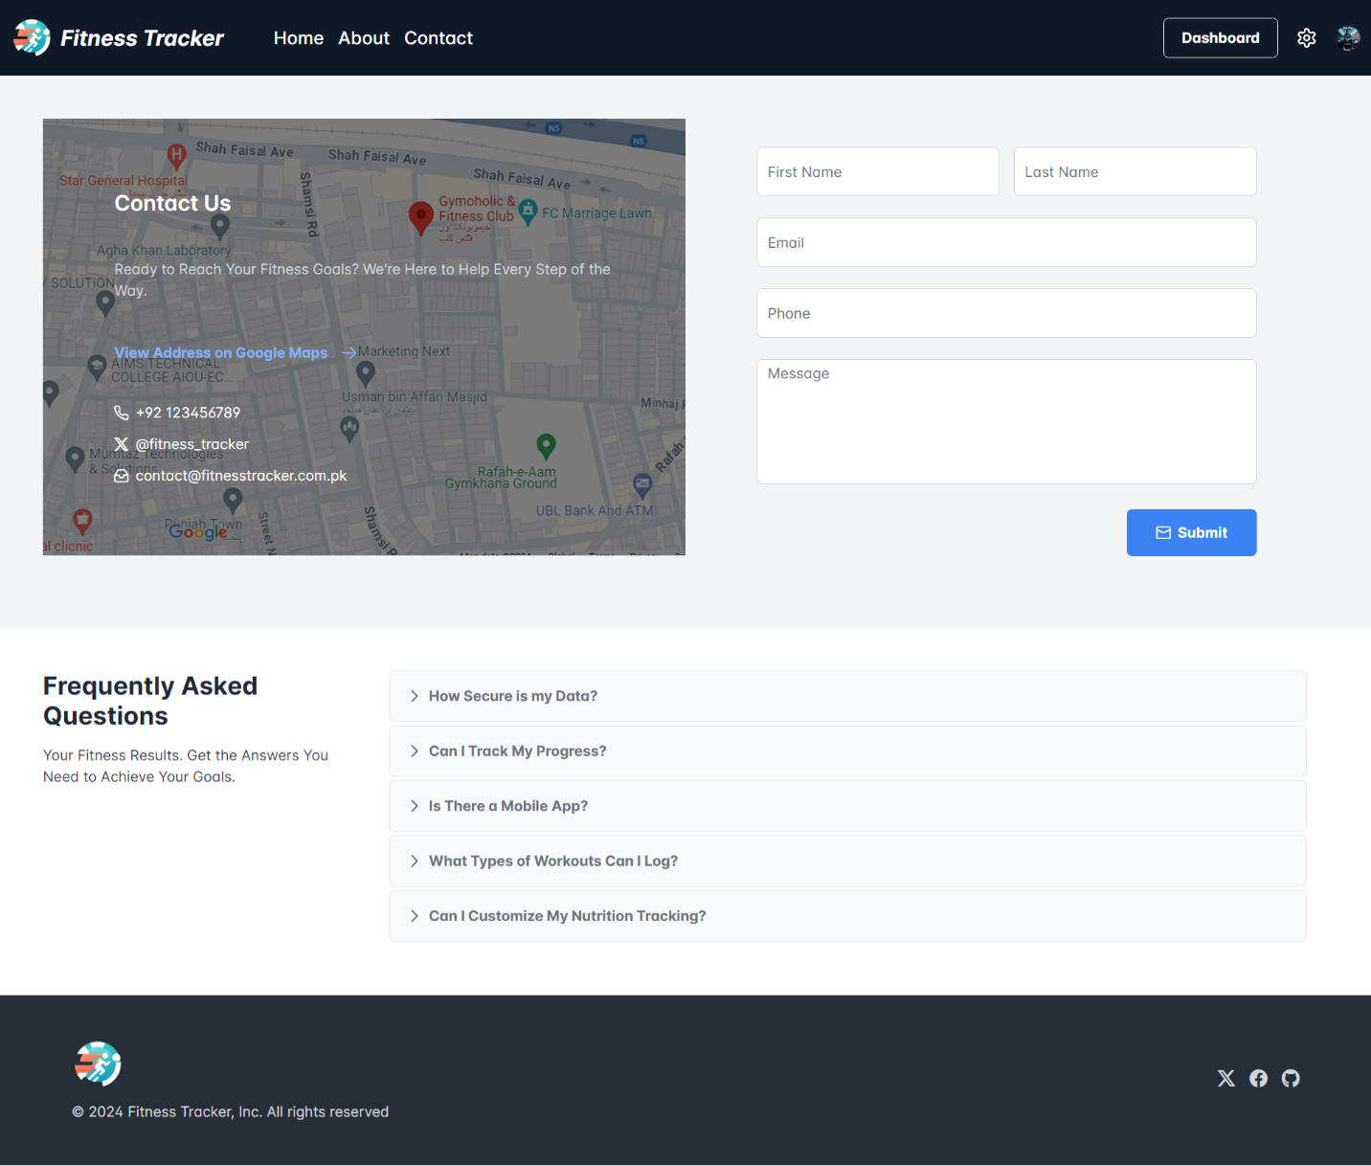

Login Screen:
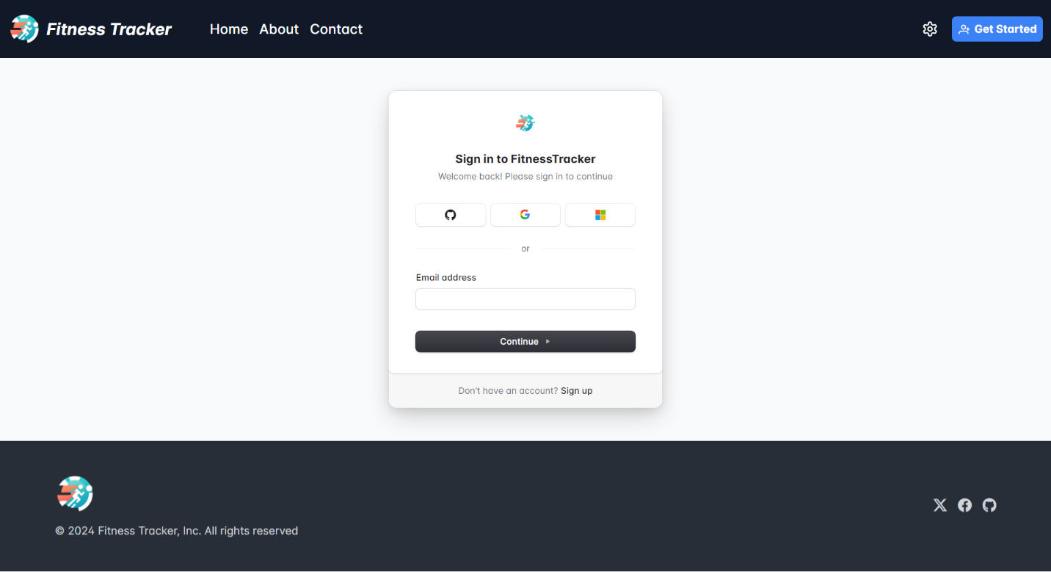

Register Screen:

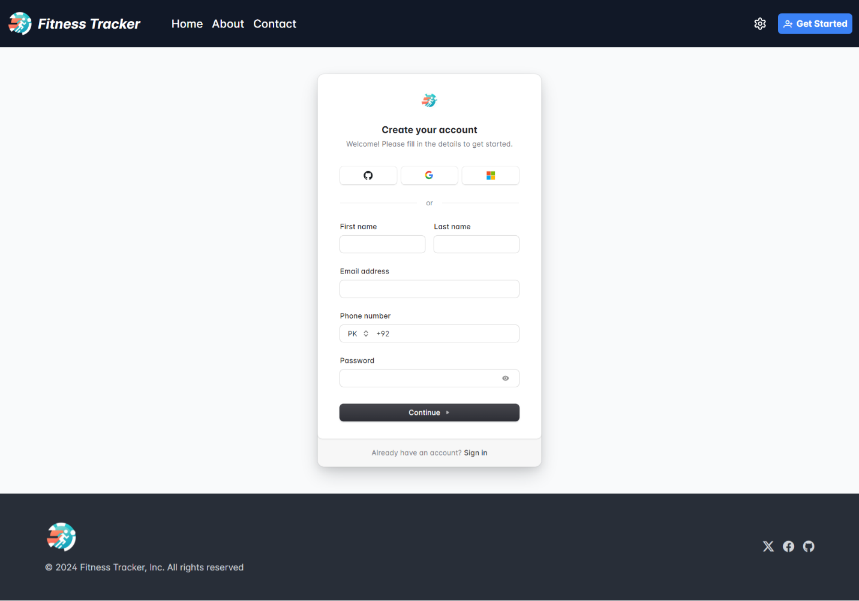

Not-Found Screen:
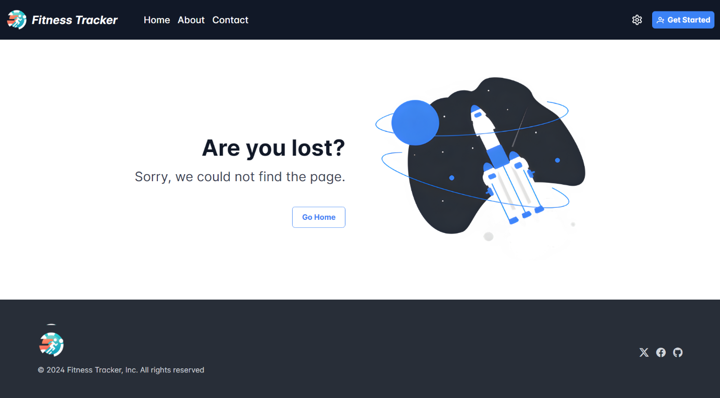

Dashboard Screen:
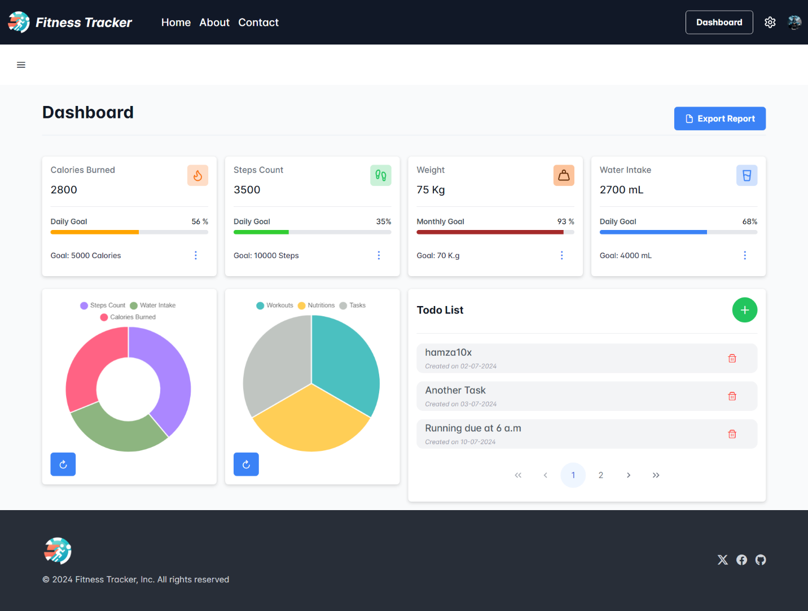

Workouts Screen:
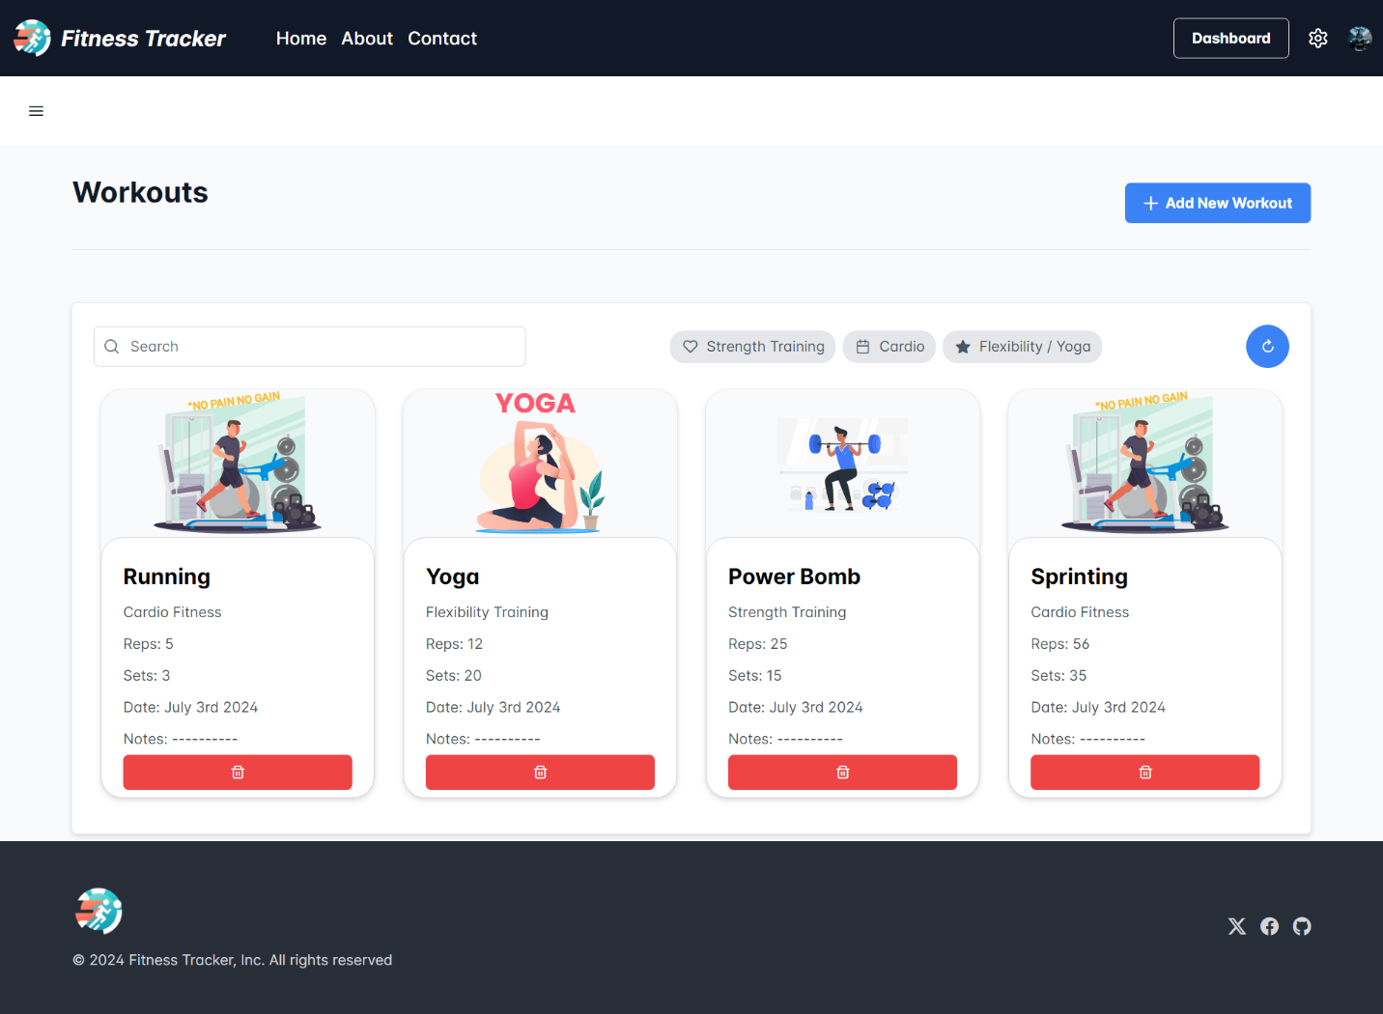

Nutritions Screen:
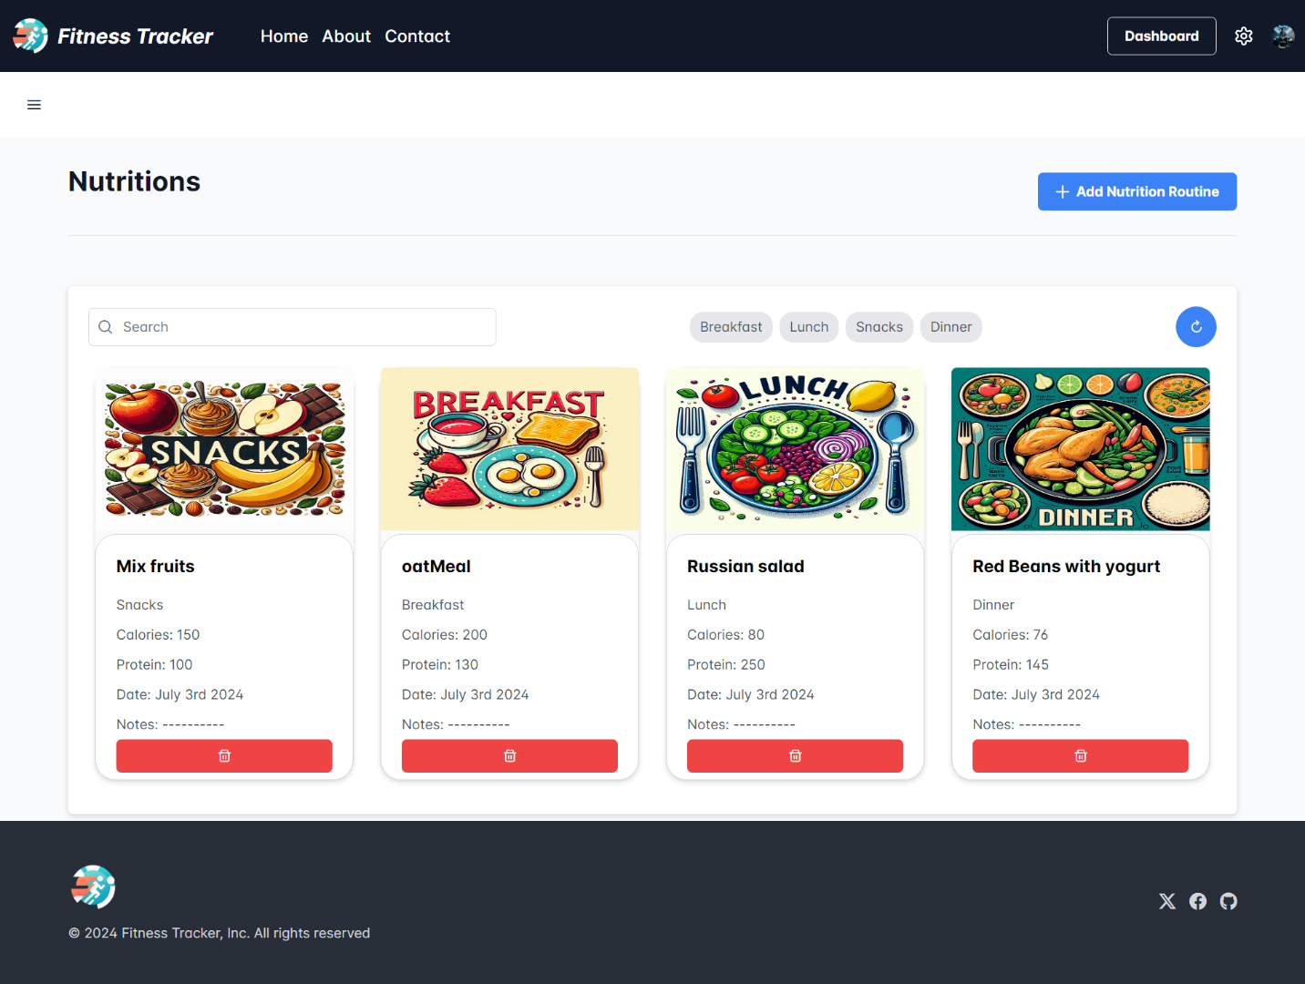

Conclusion:
Here, I have come to the end of the project on the topic of Fitness Tracker. I tried my best to include all the customer requirements that are required in relation to the scope of my project. Some of the pages for the project were downloaded from the internet. I am hoping that my project will be interesting and even informative
Thank You

