**DESCRIPTION:**

This problem requires us to make a program for an elevator which displays a menu to the user to which floor they want to go and is all demonstrated in our cpp file

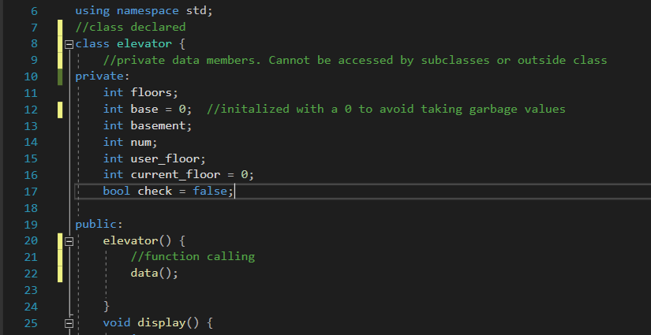

Class named elevator is declared which has some private data members and some public data members. Private data members are not accessible to subclasses or outside class so we need some other methods like constructor or setters and getters, it’s your choice. Public member functions are also made which use function calling or recursion to call other functions inside a function.

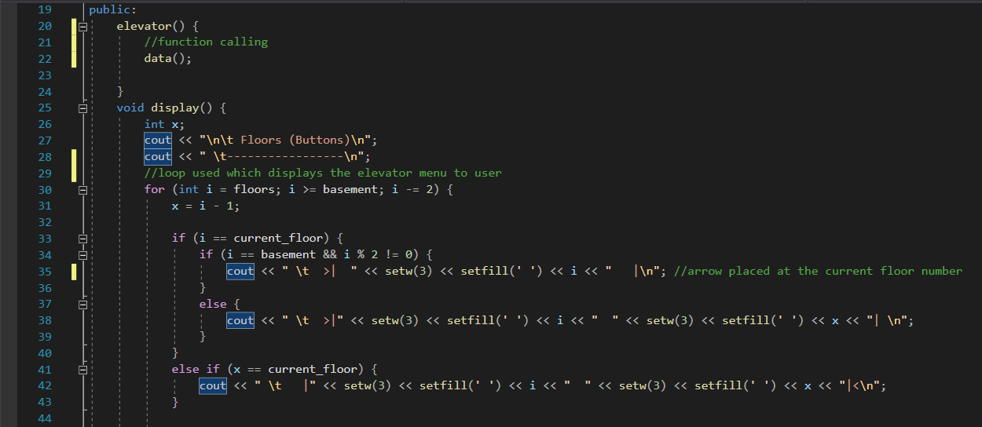

Default constructor is automatically called when an object is made inside driver function. We made use of back to back recursion. Firstly, the data function is called which takes in data from the user about floor and if they want to go up or down. In order to do that user needs to see the options first through which they decide where they have to go, so we called display() function which gives user the menu and they choose from it.

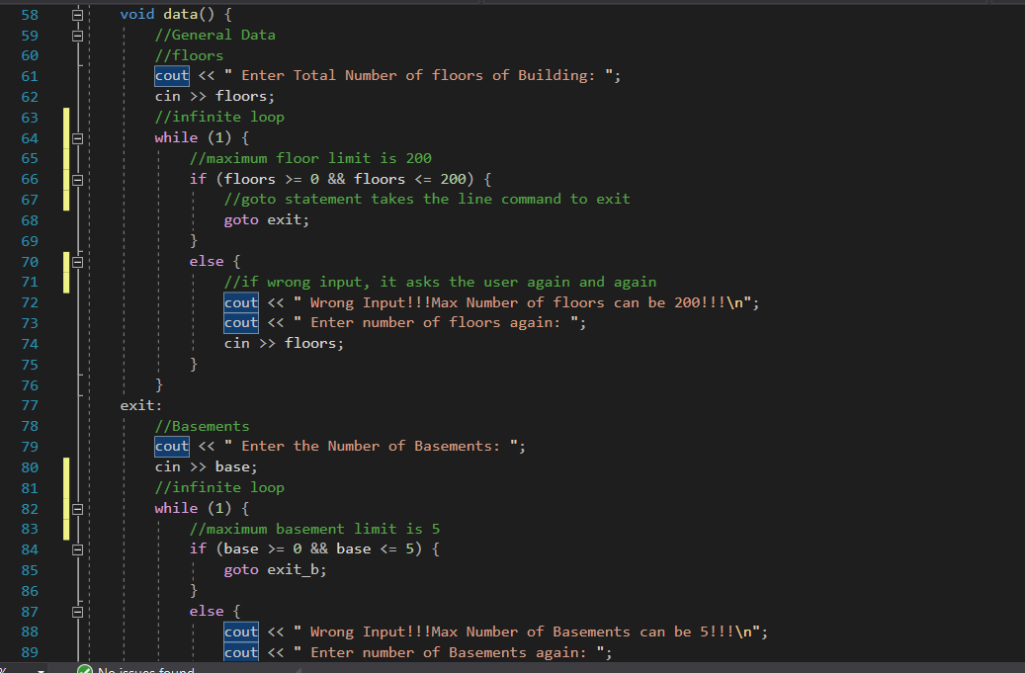

As talked earlier about the data() function, it asks user the total number of floors in their building. After knowing that, a button menu is displayed from inside the function with maximum floor limit of 200 and maximum basement limit of 5.

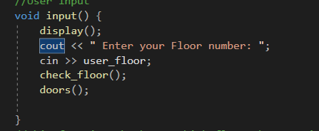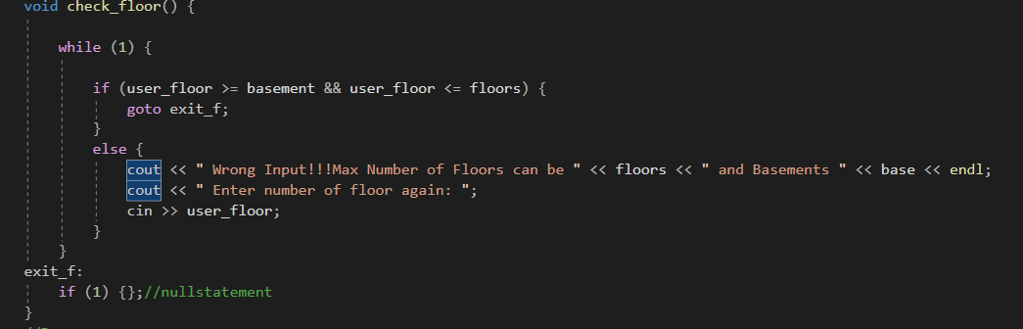

The input() function asks user the floor number at which they want to go, then that input is used in the check_floor() function which checks if the input is true or not, an error is generated for wrong input.

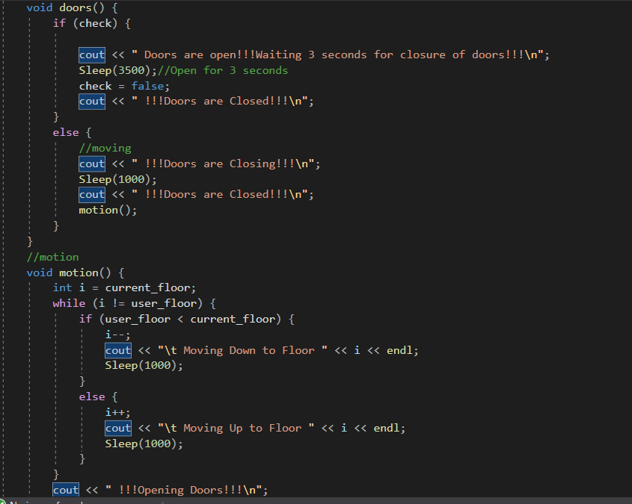

To fulfill the time properties, doors() and motion() functions are made which come into action when user enters the floor number at which they want to go, it does not matter if the elevator is going up or going down. When floor number entered, program window simultaneously showing user the movement of the elevator as it goes up or comes down, sleep command is used which delays the next command by the user defined time in Nano seconds.

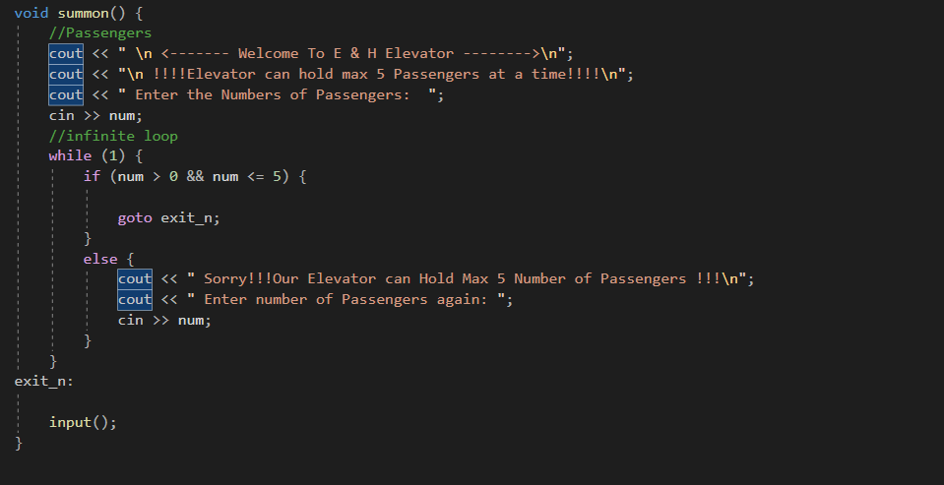

After user requests the elevator once and reaches his/her desired floor, the summon function gets called which again asks the same details again if they want to go to some other floor which is totally up to them.

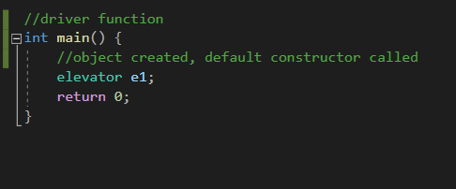

Finally, after our class finished, the driver code is made which only makes an object and everything automatically happens because the default constructor was called and it was making use of recursion which automatically calls another function of use and elevator function is successfully made.