| | **Software Design Specifications**  **PHARMACY POS**  **Version: 1.0**   | Project Code | SE-2002 | | --- | --- | | Supervisor | Rubab Jaffer | | Co Supervisor |  | | Project Team | Abdullah Ellahi [22k-5190]  Adnan Sajid [22K-5175]  Hamza [22K-4825] | | Submission Date | 03/05/2024 | | | --- | --- | --- | --- | --- | --- | --- | --- | --- | --- | --- |   **Document History**   | Version | Name of Person | Date | Description of change | | --- | --- | --- | --- | | 0.1 | Adnan Sajid |  | Added Introduction | | 0.2 | Abdullah Ellahi |  | Added Design Considerations | | 0.3 | Hamza |  | Added System Architecture | |  |  |  |  | |  |  |  |  | |  |  |  |  | |  |  |  |  |         **Distribution List**   | **Name** | **Role** | | --- | --- | | Rubab Jaffar | Supervisor | |  |  | |  |  |   **Document Sign-Off**   | **Version** | **Sign-off Authority** | **Project Role** | **Signature** | **Sign-off Date** | | --- | --- | --- | --- | --- | | 1.0 | Rubab Jaffar |  |  |  | |  |  |  |  |  | |  |  |  |  |  | |  |  |  |  |  | |  |  |  |  |  | |  |  |  |  |  | |  |  |  |  |  | |
| --- | --- | --- | --- | --- | --- | --- | --- | --- | --- | --- | --- | --- | --- | --- | --- | --- | --- | --- | --- | --- | --- | --- | --- | --- | --- | --- | --- | --- | --- | --- | --- | --- | --- | --- | --- | --- | --- | --- | --- | --- | --- | --- | --- | --- | --- | --- | --- | --- | --- | --- | --- | --- | --- | --- | --- | --- | --- | --- | --- | --- | --- | --- | --- | --- | --- | --- | --- | --- | --- | --- | --- | --- | --- | --- | --- | --- | --- | --- | --- | --- | --- | --- | --- | --- | --- | --- | --- | --- | --- | --- | --- |

**Document Information**

| **Category** | **Information** |
| --- | --- |
| Customer | FAST-NU |
| Project | Pharmacy POS |
| Document | Software Design Specification |
| Document Version | 1.0 |
| Status | Final Version |
| Author(s) | Abdullah Ellahi [22k-5190]  Adnan Sajid [22K-5175]  Hamza [22K-4825] |
| Approver(s) |  |
| Issue Date |  |
| Document Location |  |
| Distribution | Advisor  Project Coordinator’s Office (through Advisor) |

**Definition of Terms, Acronyms and Abbreviations**

| **Term** | **Description** |
| --- | --- |
| ASP | Active Server Pages |
| DD | Design Specification |
| DBMS | Database Management System |
|  |  |
|  |  |
|  |  |
|  |  |
|  |  |

**Table of Contents**

**1** **Introduction 8**

*1.1* *Purpose of Document 8*

*1.2* *Intended Audience 8*

*1.3* *Document Convention 8*

*1.4* *Project Overview 8*

*1.5* *Scope 8*

**2** **Design Considerations 9**

*2.1* *Assumptions and Dependencies 9*

*2.2* *Risks and Volatile Areas 9*

**3** **System Architecture 10**

*3.1* *System Level Architecture 10*

*3.2* *Software Architecture 10*

**4** **Design Strategy 11**

**5** **Detailed System Design 12**

*5.1* *Database Design 12*

5.1.1 ER Diagram 12

5.1.2 Data Dictionary 12

5.1.2.1 Data 1 12

5.1.2.2 Data 2 12

5.1.2.3 Data n 12

*5.2* *Application Design 14*

5.2.1 Sequence Diagram 14

5.2.1.1 <Sequence Diagram 1> 14

5.2.1.2 <Sequence Diagram 2> 14

5.2.1.3 <Sequence Diagram n> 14

5.2.2 State Diagram 14

5.2.2.1 <State Diagram 1> 14

5.2.2.2 <State Diagram 2> 14

5.2.2.3 <State Diagram n> 14

**6** **References 15**

**7** **Appendices 16**

# Introduction

*1.1. Purpose of Document*

*The purpose of this document is to define the requirements and specifications for the development of a comprehensive pharmacy point of sales (POS) system. This document serves as a blueprint for the development team, stakeholders, and other relevant parties involved in the project. It outlines the functional and nonfunctional requirements, system capabilities, constraints, and interfaces necessary for the successful design, implementation, and deployment of the pharmacy POS solution.*

*The primary objectives of this document are as follows:*

* *To clearly articulate the functional and non-functional requirements of the pharmacy POS system, including its features, functionalities, and performance criteria.*
* *To establish a common understanding among stakeholders regarding the scope, purpose, and expectations of the pharmacy POS system.*
* *To provide a basis for communication and collaboration between the development team, project stakeholders, and end-users throughout the software development lifecycle.*
* *To facilitate the assessment of the pharmacy POS system's compliance with specified requirements and its alignment with business goals and user needs*
* *To serve as a reference document for future enhancements, maintenance activities, and system upgrades.*

*It is subject to updates and revisions as the project progresses and additional insights are gained from stakeholder feedback, regulatory requirements, and evolving industry standards.*

*1.2. Intended Audience*

*This document is intended for:*

* ***Software developers*** *involved in the design, implementation, and testing of the pharmacy point of sales system.*
* ***Project managers*** *responsible for overseeing the development process and ensuring project objectives are met.*
* ***Quality assurance professionals*** *involved in testing and validating the functionality and performance of the system.*
* *Stakeholders, including* ***pharmacy owners, managers, and staff,*** *who will utilize or be impacted by the pharmacy POS system.*
* ***Regulatory authorities*** *or* ***compliance officers*** *responsible for ensuring adherence to relevant industry standards and regulations.*

***1.3 Abbreviations***

*This section provides a list of abbreviations and acronyms used throughout the document to facilitate clarity and understanding:*

* *POS: Point of Sales*
* *SRS: Software Requirements Specification*
* *QA: Quality Assurance*
* *UI: User Interface*
* *API: Application Programming Interface*
* *DB: Database*
* *GUI: Graphical User Interface*
* *FDA: Food and Drug Administration*
* *ERP: Enterprise Resource Planning*
* *HIPAA: Health Insurance Portability and Accountability Act*
* *CRUD: Create, Read, Update, and Delete operations*

*Additional abbreviations may be introduced and defined within specific sections of the document as necessary for clarity and comprehension.*

*1.4 Document Convention*

*This document follows the convention of using a standard font and font size for readability and consistency. The font and font size used in this document are as follows:*

* *Font: Times New Roman*
* *Font Size: 12 point*

*Consistency in font and font size helps maintain clarity and uniformity throughout the document, ensuring ease of reading and comprehension for all stakeholders.*

# Design Considerations

*This section outlines crucial factors to consider when designing the pharmacy management system, ensuring a robust and adaptable solution for the Pharmacy Management System.*

## 2.1 Assumptions and Dependencies

*This subsection identifies specific design-related assumptions and dependencies critical for shaping the architecture and functionality of the system. While some assumptions and dependencies are outlined in the Software Requirements Specification (SRS) document, this section addresses new design-specific considerations:*

***Assumptions****:*

* *The availability of stable internet connectivity for online functionalities.*
* *Compliance with relevant regulations and standards governing pharmacy operations.*
* *The existence of reliable vendor APIs for integrating product data into the system.*
* *The majority of those who access and use the Pharmacy Management System will be authorized personnel or trained pharmacy staff.*
* *The system's users will be familiar with computers on a basic level and will get enough training to make good use of it.*
* *In compliance with data protection laws and regulations, the system will securely handle and store sensitive patient information.*
* *To guarantee data integrity and system availability, disaster recovery plans and routine backups are available.*
* *Comprehensive reporting features for sales tracking, inventory management, and regulatory compliance will be offered by the system.*
* *Users will receive documentation and training materials to help them navigate and use the system effectively.*

***Dependencies****:*

* *Integration with third-party payment gateways for secure transaction processing.*
* *Compatibility with existing hardware infrastructure, including POS terminals and barcode scanners.*
* *Reliance on external libraries or frameworks for implementing specific functionalities, such as report generation or data visualization.*
* *Integration for electronic prescriptions and medication dispensing with pharmacy management software.*
* *compatibility with the web browsers and operating systems that pharmacy employees use to access the system.*
* *strict compliance to industry standards for medical device and healthcare system interoperability.*
* *Integration with inventory management systems to enable automatic reordering and real-time stock level tracking.*
* *cooperation with regulatory agencies to secure the system's required certifications or approvals.*
* *Integration with accounting software to facilitate reporting and record-keeping of financial data.*
* *reliance on encryption techniques and secure communication protocols to safeguard private information while it's being transmitted.*

## 2.2 Risks and Volatile Areas

*For the purpose of proactively addressing issues during the development and implementation of the Pharmacy Management System, it is crucial to identify potential risks and volatile areas. Here are some important risks that and inconsistent areas to think about:*

1. ***Data Security Breach****: The possibility that private patient data may be compromised due to cyberattacks, illegal access, or other circumstances. To reduce this risk, it is crucial to put strong security measures, encryption, and access controls in place.*
2. ***Regulatory Compliance****: There may be fines, penalties, or reputational harm if healthcare rules and standards, such as HIPAA, GDPR, and FDA requirements, are not followed. To reduce regulatory risks, it is essential to conduct routine audits, compliance reviews, and adherence to industry best practices.*
3. ***Challenges of Integration****: Workflow disruptions, data inconsistencies, and interoperability problems could result from the Pharmacy Management System's inability to integrate with third-party APIs, external vendors' platforms, or current healthcare IT systems. To solve integration issues, thorough testing, stakeholder collaboration, and API documentation review are crucial.*
4. ***Business Continuity and Disaster Recovery****: Operations in pharmacies may be disrupted and patient care may be jeopardized by risks related to natural disasters, system malfunctions, or infrastructure outages. Creating thorough backup plans, contingency plans, and disaster recovery strategies is essential to maintaining business continuity and reducing the impact of unanticipated events.*
5. ***System Downtime and Performance Problems****: Pharmacy operations, patient care, and employee productivity may be impacted by unscheduled system downtime, slow performance, or service disruptions. The risk of system failures and performance problems can be reduced by putting in place redundancy, failover procedures, and performance monitoring tools.*
6. ***User Adoption and Training****: Adoption of the Pharmacy Management System by pharmacy staff may be restricted by resistance to change, a lack of user training, or insufficient user support. Encouraging user adoption and reducing resistance to the new system requires extensive training, user-friendly interfaces, and continuous support.*
7. ***Scalability and Growth****: The system's capacity to handle future increases in data volume, user load, or transaction volume may be restricted by inadequate scalability or capacity planning. Scalability risks can be reduced by planning the system with scalability in mind, keeping an eye on performance indicators.*
8. ***New Requirements****: Changes in regulatory requirements or industry standards may necessitate adjustments to the system's functionality or data handling processes.*

***9. Emerging market trends****: New Market Trends or customer preferences may introduce new requirements for product categorization, pricing strategies, or reporting metrics.*

1. ***Technological Risks****: Rapid advancements in technology, particularly in data security and encryption, may require updates to the system's architecture to maintain compliance and protect sensitive information.*

# System Architecture

*This section highlights the high-level architecture of the pharmacy management system, detailing the partitioning of functionality and the relationships between subsystems or components.*

## 3.1 System Level Architecture

*The system architecture decomposes the pharmacy management system into various elements and discusses their relationships and roles. At this level the detailed internal design is not provided, but the architecture lays the foundation for subsequent design activities. Key considerations include:*

* ***System Decomposition****: The system is decomposed into various key components, including User Management, Search Bar, POS, Carts, Products Management/Inventory, Reports, Vendor/Distributor Management, Transaction History, and Others.*
* ***Relationships between Elements****: To fulfill specific functions, such as processing transactions, managing inventory, and generating reports, each component interacts with others. Interfaces define how these interactions occur*
* ***Interfaces to External Systems****: The system interfaces with external entities like payment gateways for transaction processing and vendor APIs for product data retrieval. To facilitate seamless integration, secure communication protocols and data exchange formats are established.*
* ***Physical Design Considerations****: Elements may execute on distributed hardware infrastructure, with considerations for scalability, fault tolerance, and performance optimization.*
* ***Global Design Strategies****: Mechanisms for error handling are implemented to ensure robustness and reliability, including error logging, exception handling, and graceful degradation under exceptional conditions.*

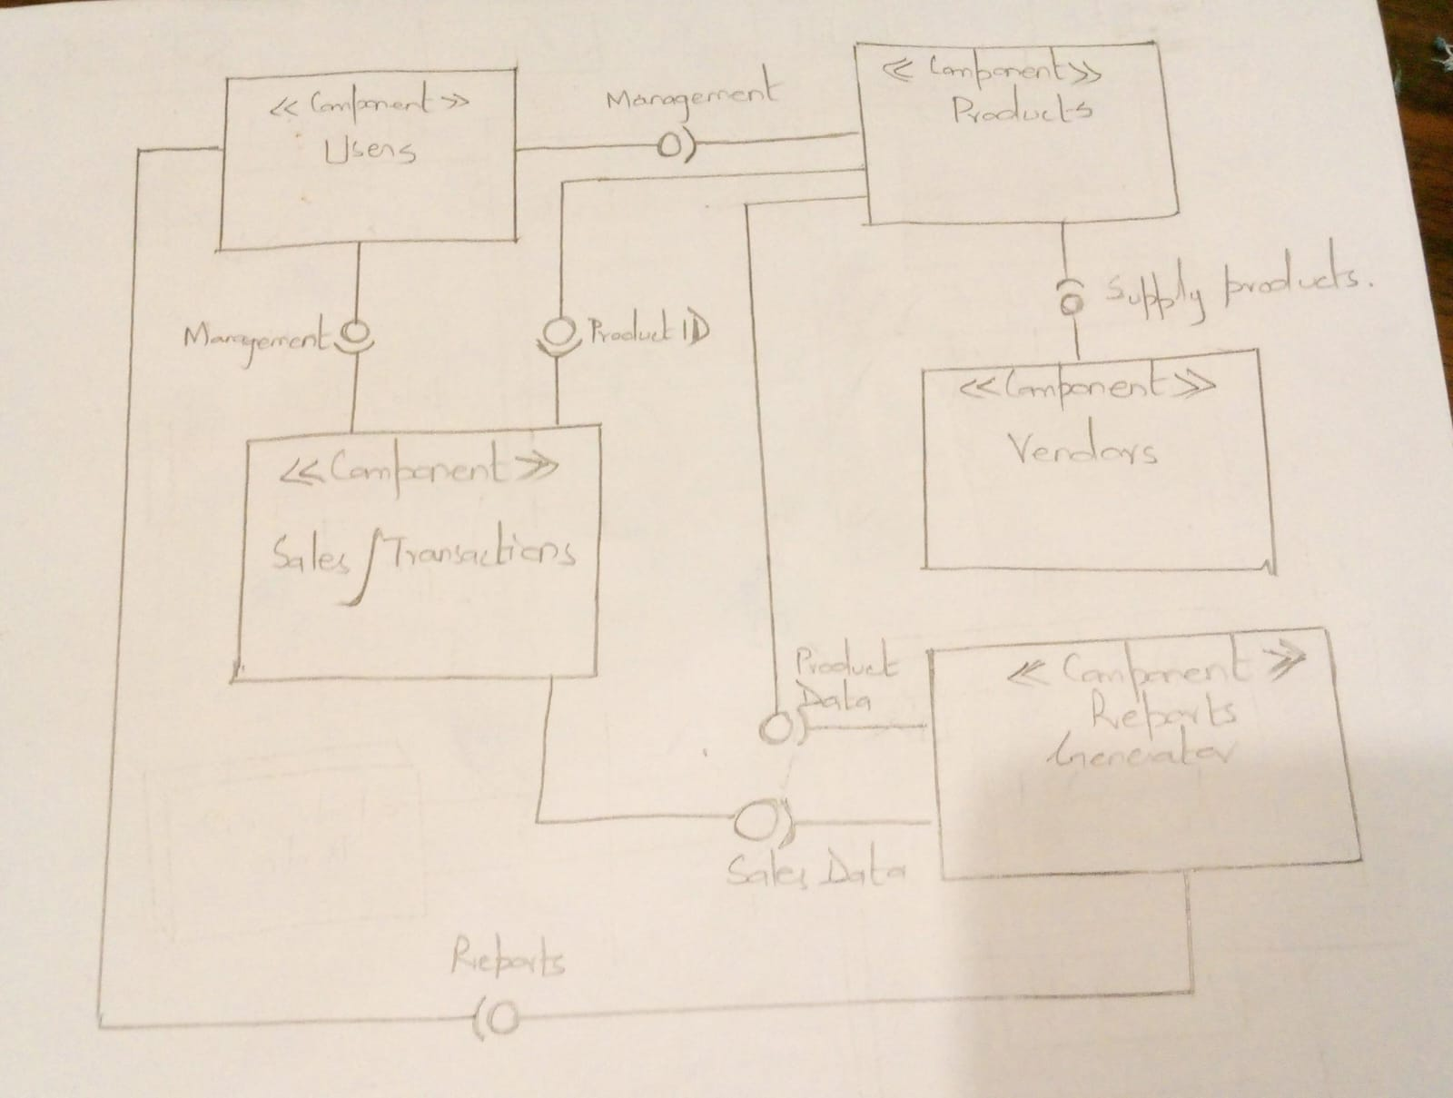

## *3.2 Software Architecture:*

*The software architecture describes the interaction between different layers of the system, namely the user interface layer, middle tier, and data access layer.*

* ***User Interface Layer****: This layer encompasses the graphical user interface (GUI) components through which users interact with the system. It includes functionalities for user authentication, navigation, and data input/output.*
* ***Middle Tier****: It plays the role of intermediary between the user interface and the database layer, the middle tier comprises business logic components which are responsible for processing user requests, executing business rules, and orchestrating interactions between different system modules.*
* ***Data Access Layer****: it facilitates communication with the underlying database management system (DBMS) and abstracts the complexities of data retrieval, storage, and manipulation. It includes components for executing database queries, transaction management, and data mapping.*
* ***Other Components****: Some more components like external APIs for integration with third-party systems, may also be included.*

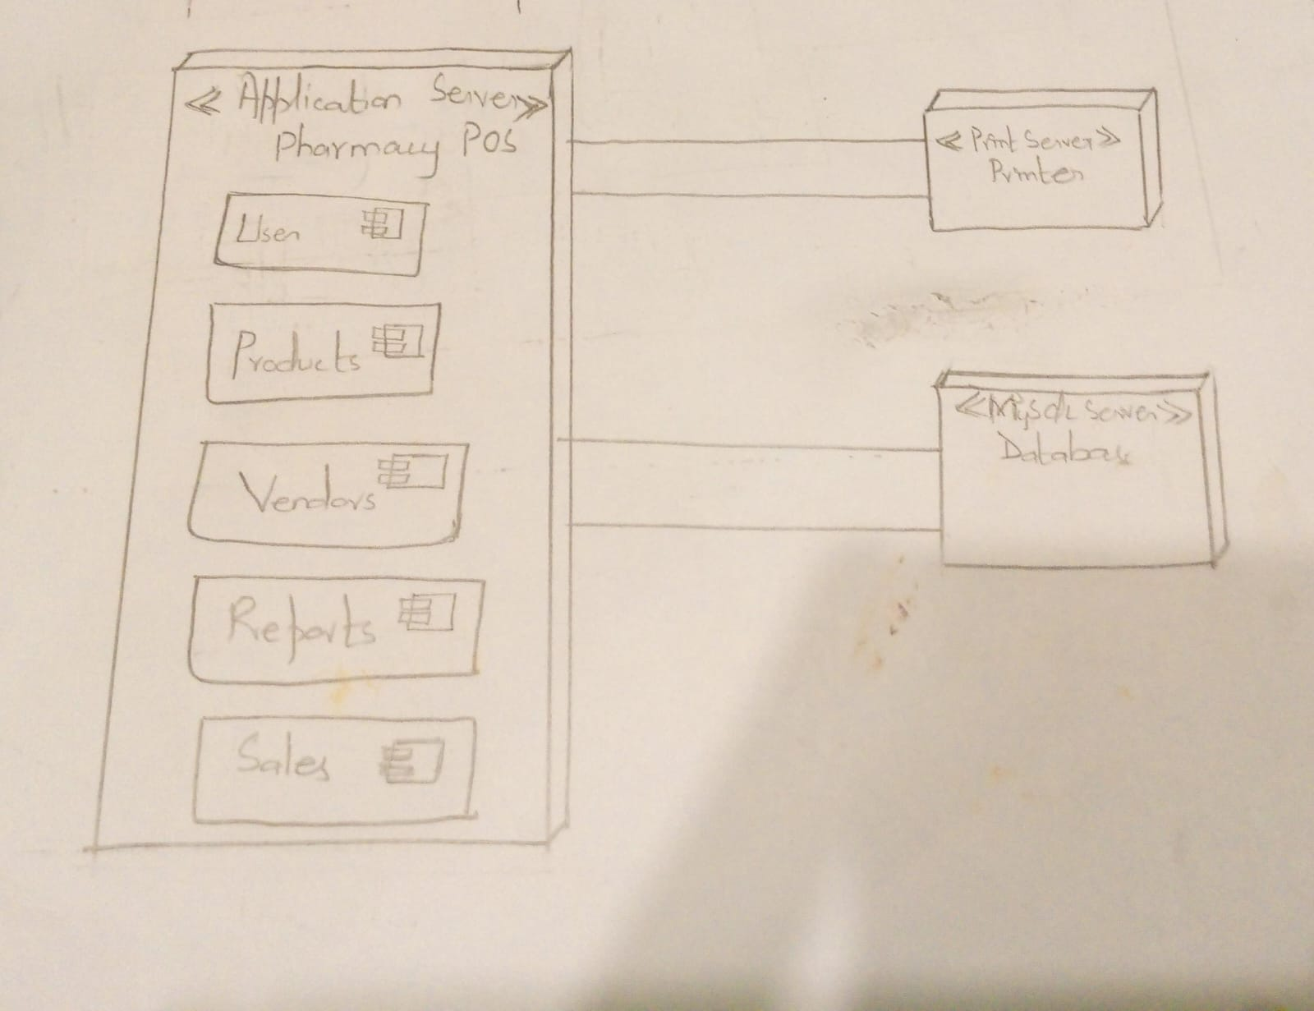

# Design Strategy

*This section outlines the design strategies and decisions that shape the overall organization of the pharmacy management system, including key abstractions and mechanisms used in the system architecture.*

*4.1* ***Future System Improvements or Extensions****:*

*It is essential that modular design principles and loosely coupled components be prioritized in order to enable future improvements or extensions to the system. To further improve modularity and scalability, think about implementing design patterns like event-driven architecture or microservices architecture. To reduce dependencies and facilitate the smooth integration of new features, make sure that system modules have explicit interfaces and API contracts.*

*4.2* ***System Reuse****:*

*To further promote code reuse and interoperability, address utilizing open-source frameworks, third-party libraries, and industry standards in addition to encapsulating common functionalities into reusable modules. To optimize reuse opportunities and perform consistency in coding practices, promote a culture of code review and knowledge sharing within the development team.*

*4.3* ***User Interface Paradigms****:*

*To improve the user experience across different platforms and interaction modalities, investigate new trends in user interface design, such as progressive web applications (PWAs), voice user interfaces (VUIs), and responsive design, while staying true to established usability principles. Conduct user feedback sessions and usability testing to confirm the design decisions and iteratively improve the interface.*

*4.4* ***Data Management****:*

*To address the scalability and performance requirements for handling large volumes of data, think about integrating NoSQL databases or distributed storage systems in addition to relational database management techniques. Analyze data modeling strategies to ensure flexibility in data management and proper alignment of data structures with business domains, such as event sourcing and domain-driven design (DDD).*

*4.5* ***Concurrency and Synchronization****:*

*For high availability and scalability in distributed environments, further enhance concurrency and synchronization mechanisms with strategies like eventual consistency, distributed transactions, or optimistic concurrency control. Put monitoring and alerting systems in place to identify and address concurrent access-related performance bottlenecks and contention problems.*

*4.6* ***Rationale and Trade-offs****:*

*Provide a thorough explanation of the factors that influenced each design decision, taking into account all relevant trade-offs and constraints. To help stakeholders make well-informed decisions, document how design decisions will influence system performance, scalability, maintainability, and cost. Establishing design principles or guidelines can help to ensure that the system architecture remains coherent and consistent over time.*

# Detailed System Design:

## *5.1 Application Design*

### 5.2 Sequence Diagrams

#### User Login

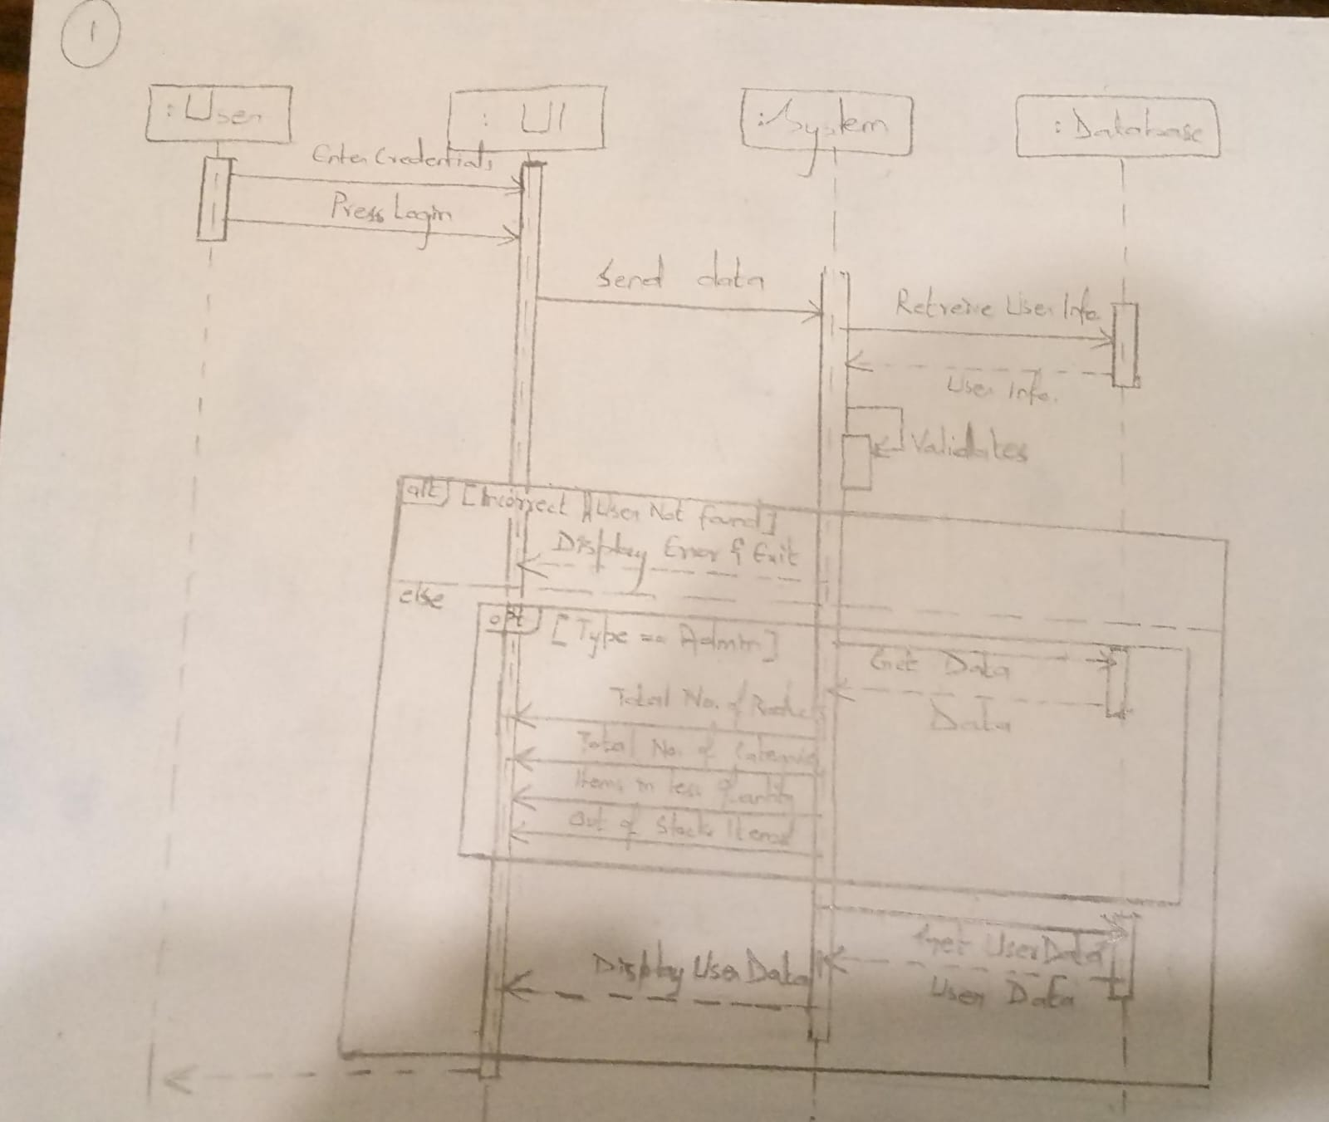

#### <Sequence Diagram 2>

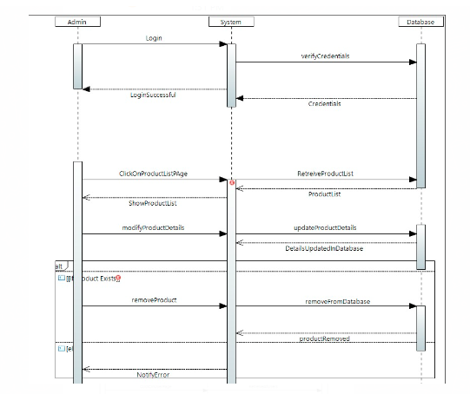

#### <Sequence Diagram 3>

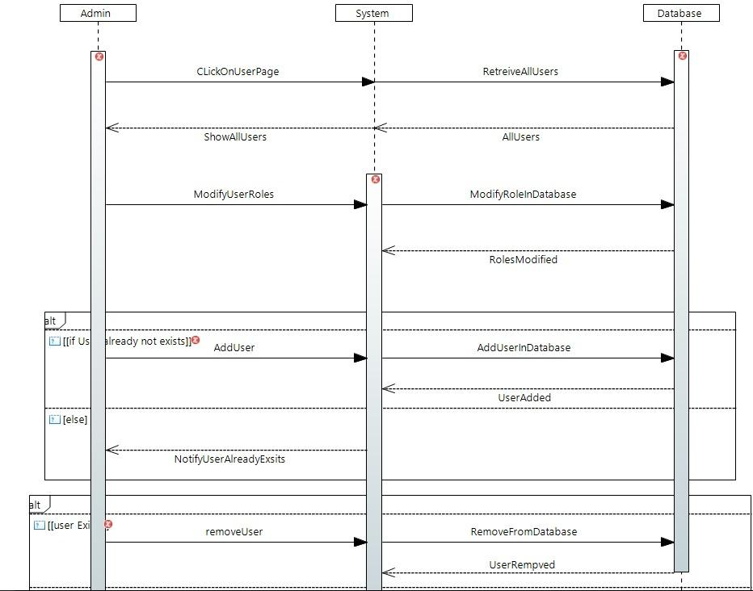

#### <Sequence Diagram 4>

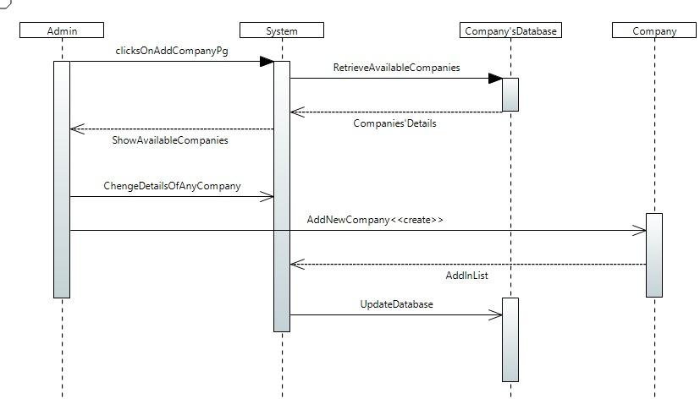

#### <Sequence Diagram 5>

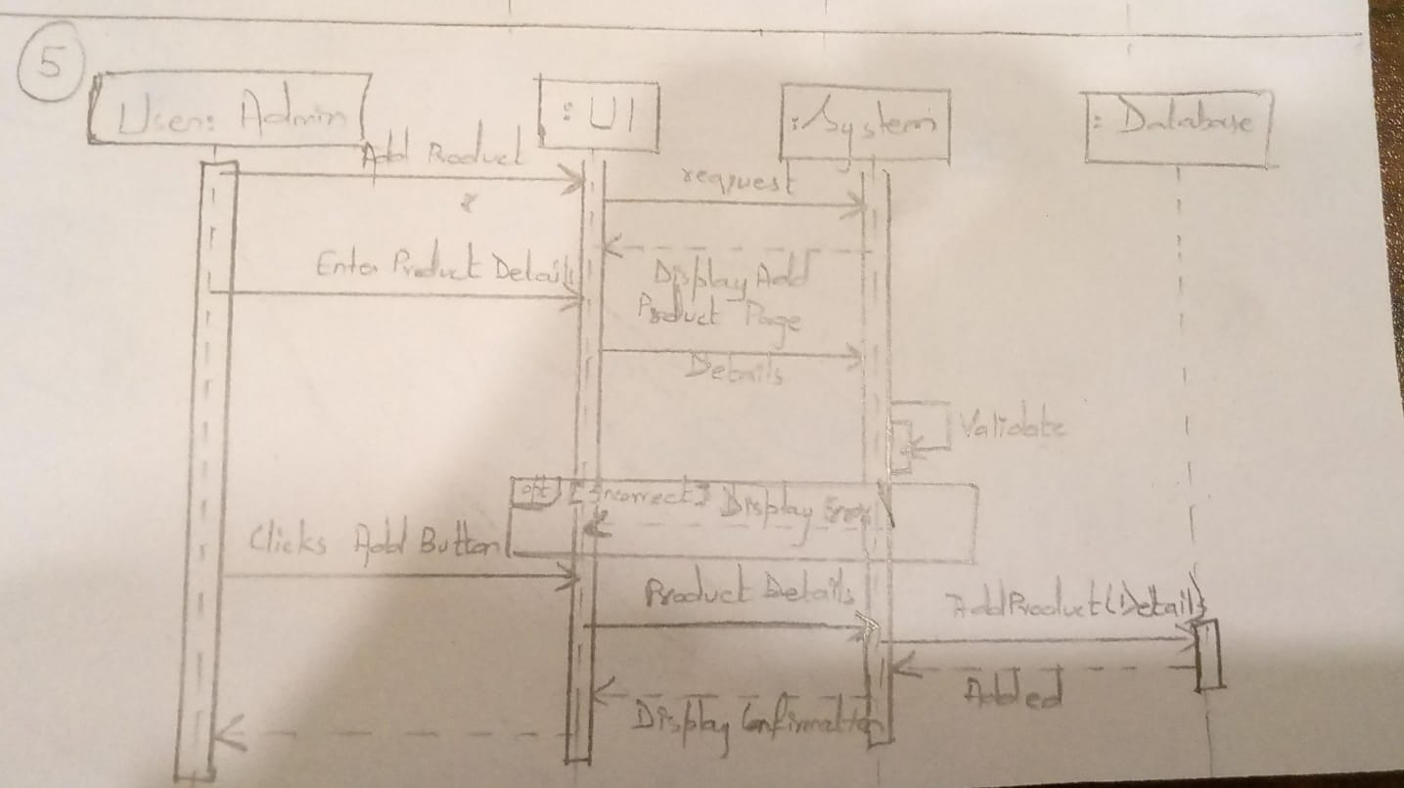

#### <Sequence Diagram 6>

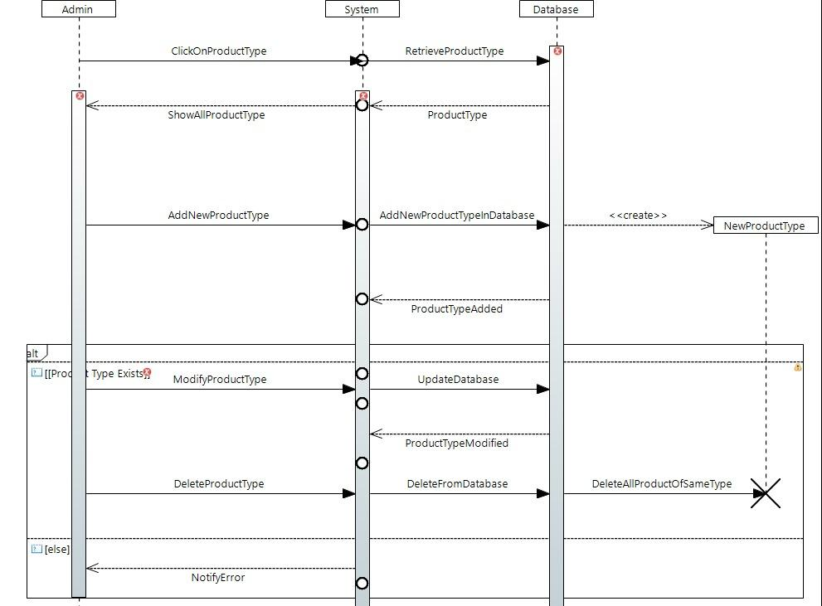

#### <Sequence Diagram 7>

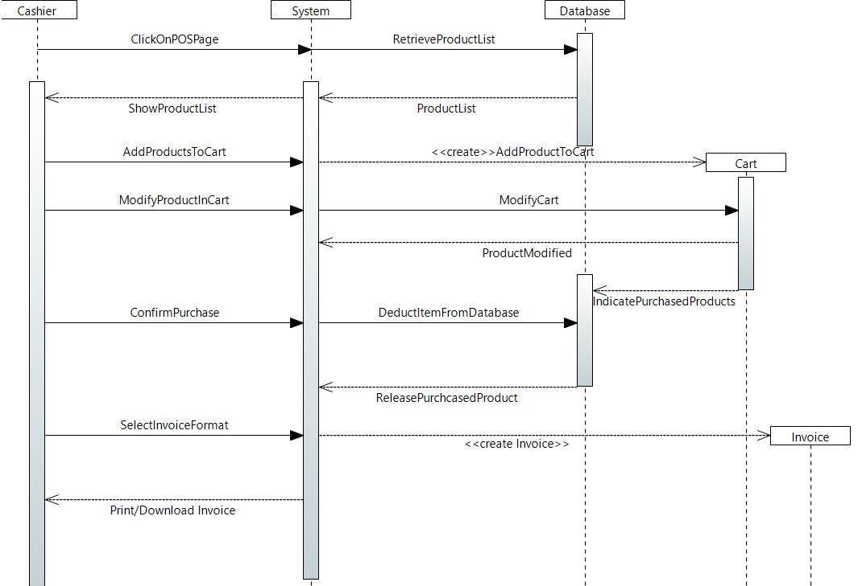

#### <Sequence Diagram 8>

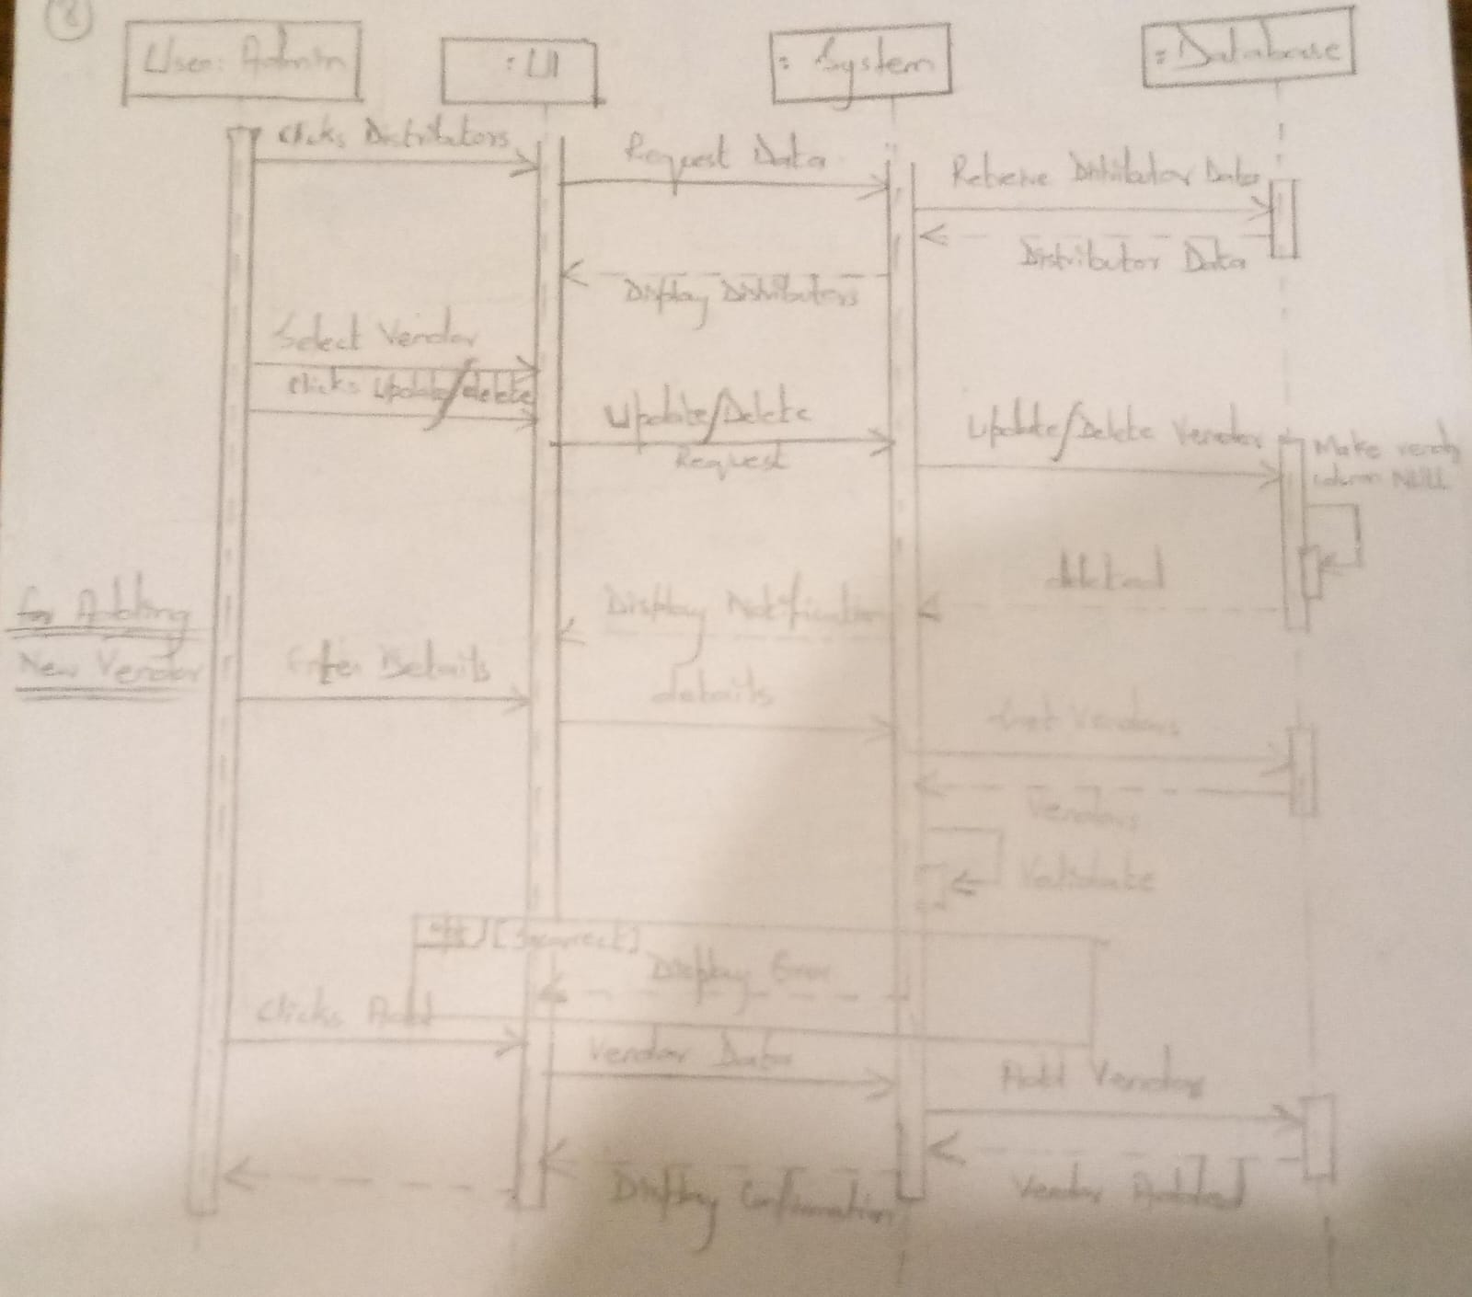

#### <Sequence Diagram 9>

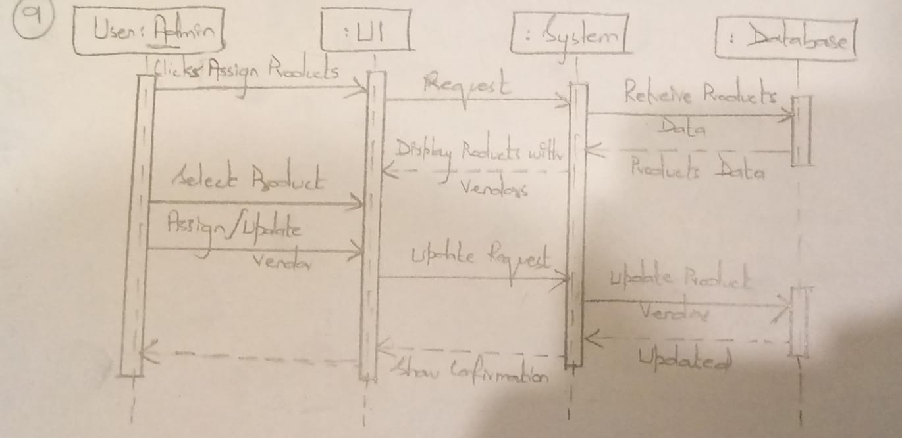

#### <Sequence Diagram 10>

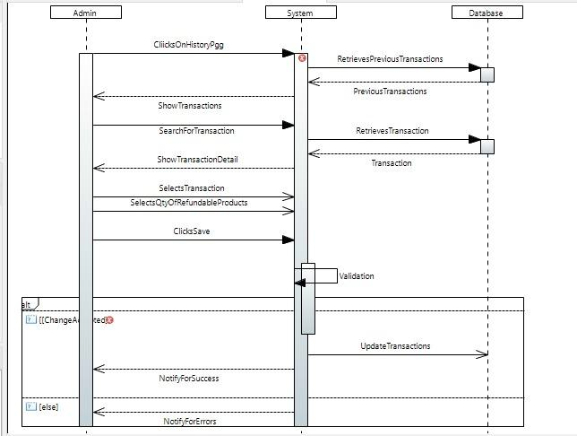

#### <Sequence Diagram 11>

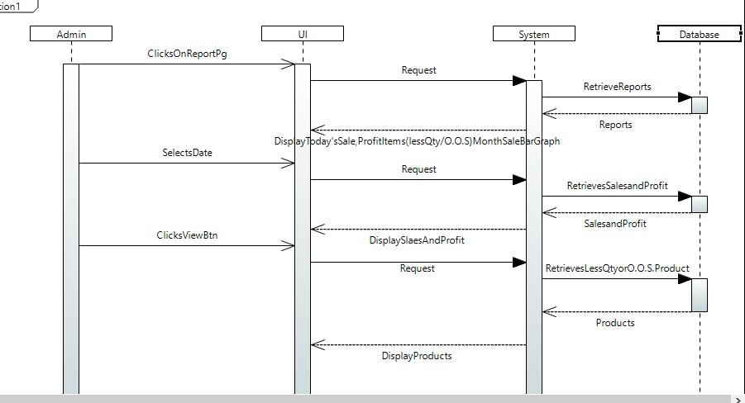

#### <Sequence Diagram 12>

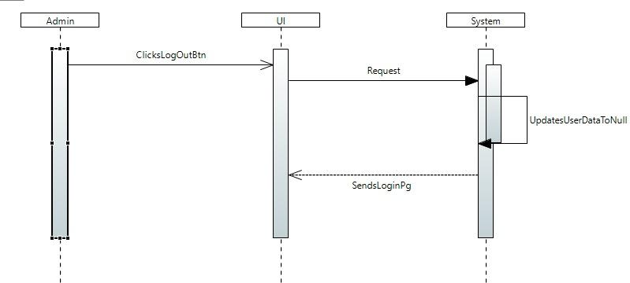

### State Diagram

#### Invoice

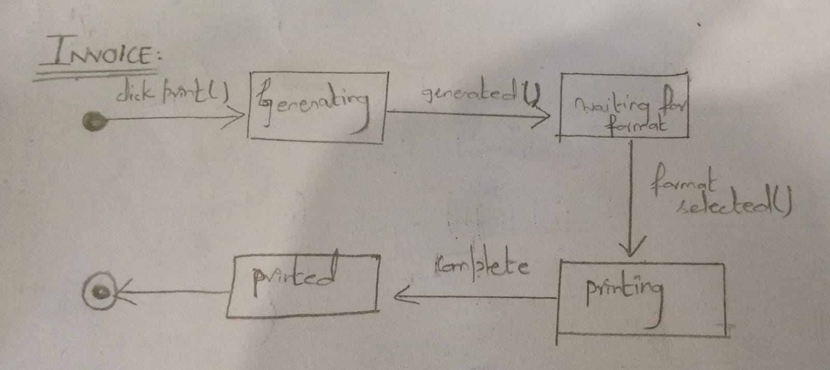

#### Cart

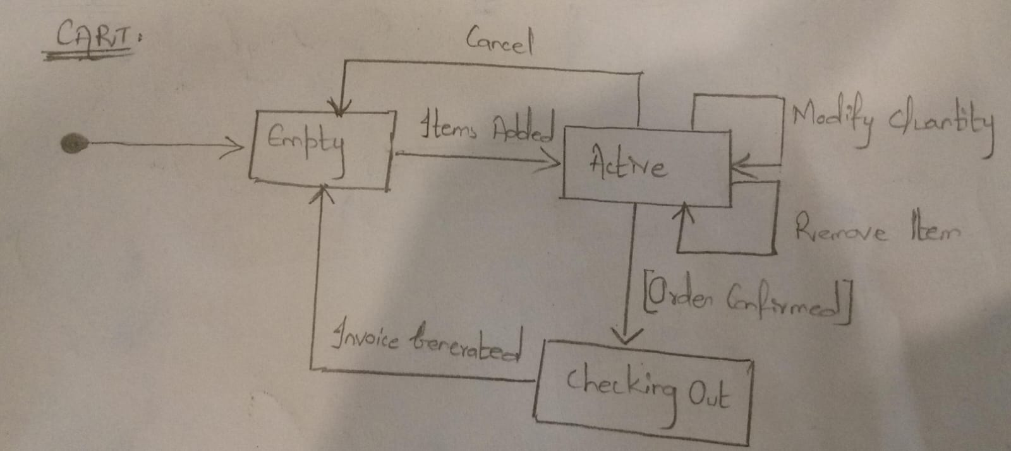

#### Transaction

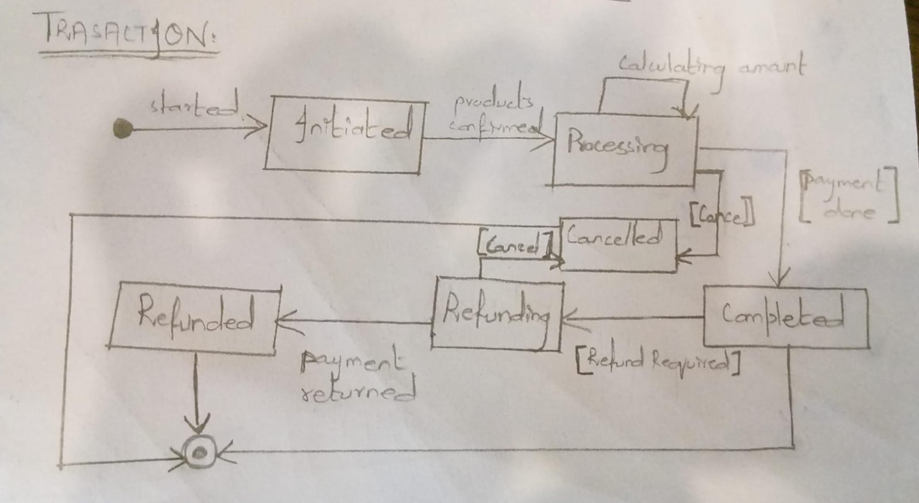

* + - 1. 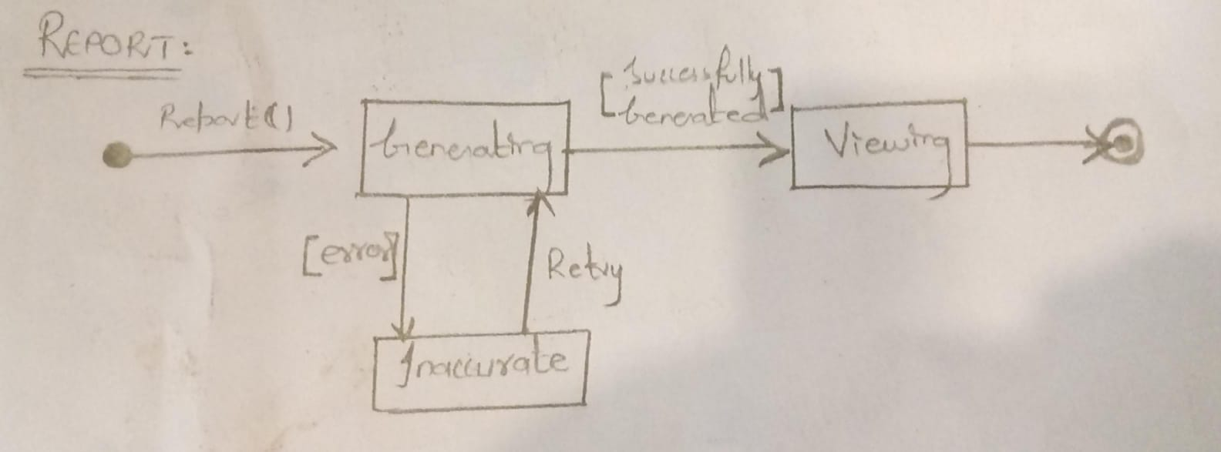

Collaboration Diagram:  
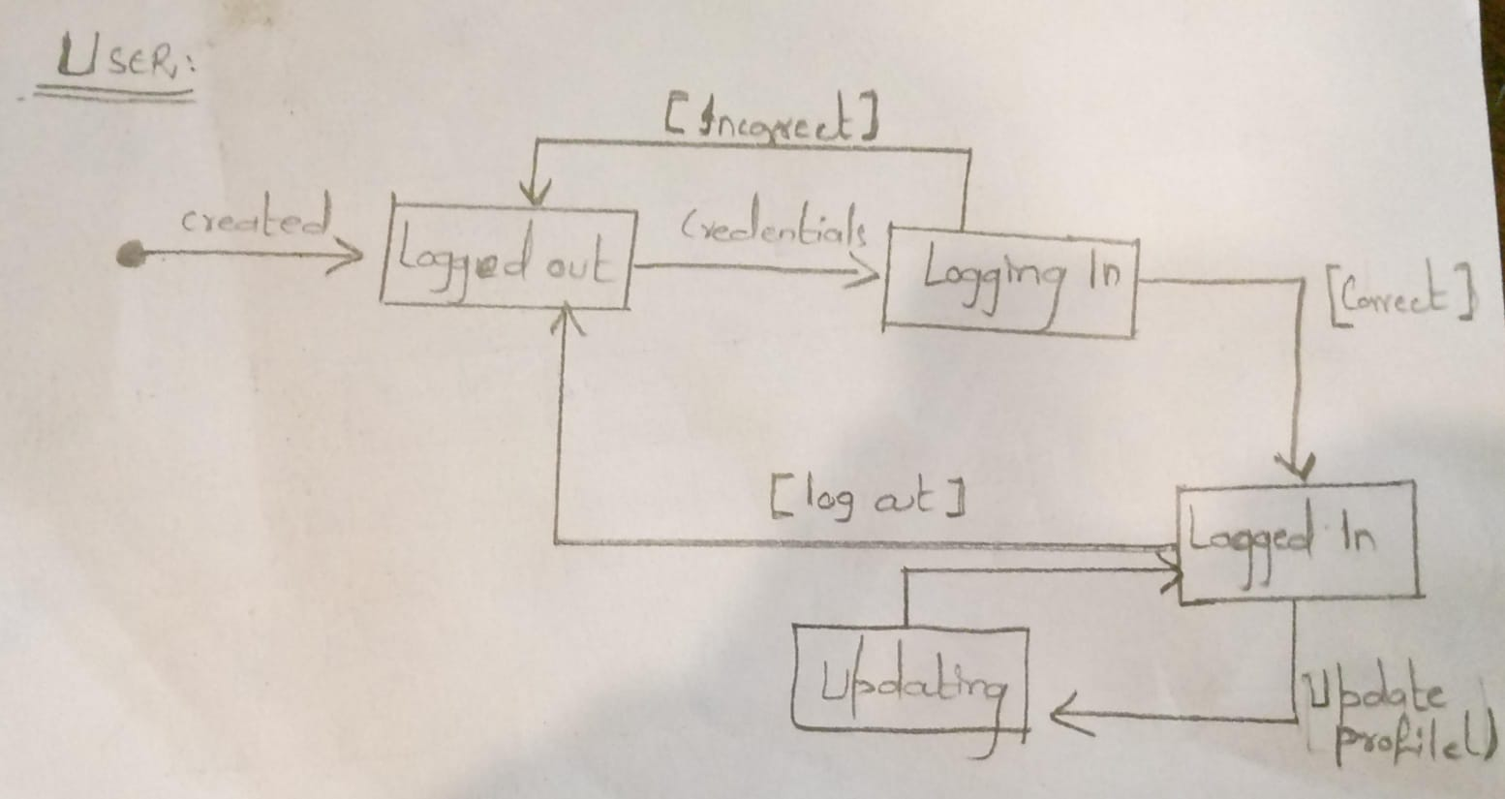

# References

* Design Patterns: Elements of Reusable Object-Oriented Software" by Erich Gamma, Richard Helm, Ralph Johnson, and John Vlissides.
* Clean Architecture: A Craftsman's Guide to Software Structure and Design" by Robert C. Martin.
* Patterns of Enterprise Application Architecture" by Martin Fowler.
* <https://ieeexplore.ieee.org/document/917550>
* Software architecture: introducing IEEE Standard 1471.

# Appendices

# **Appendix A: Analysis Models**

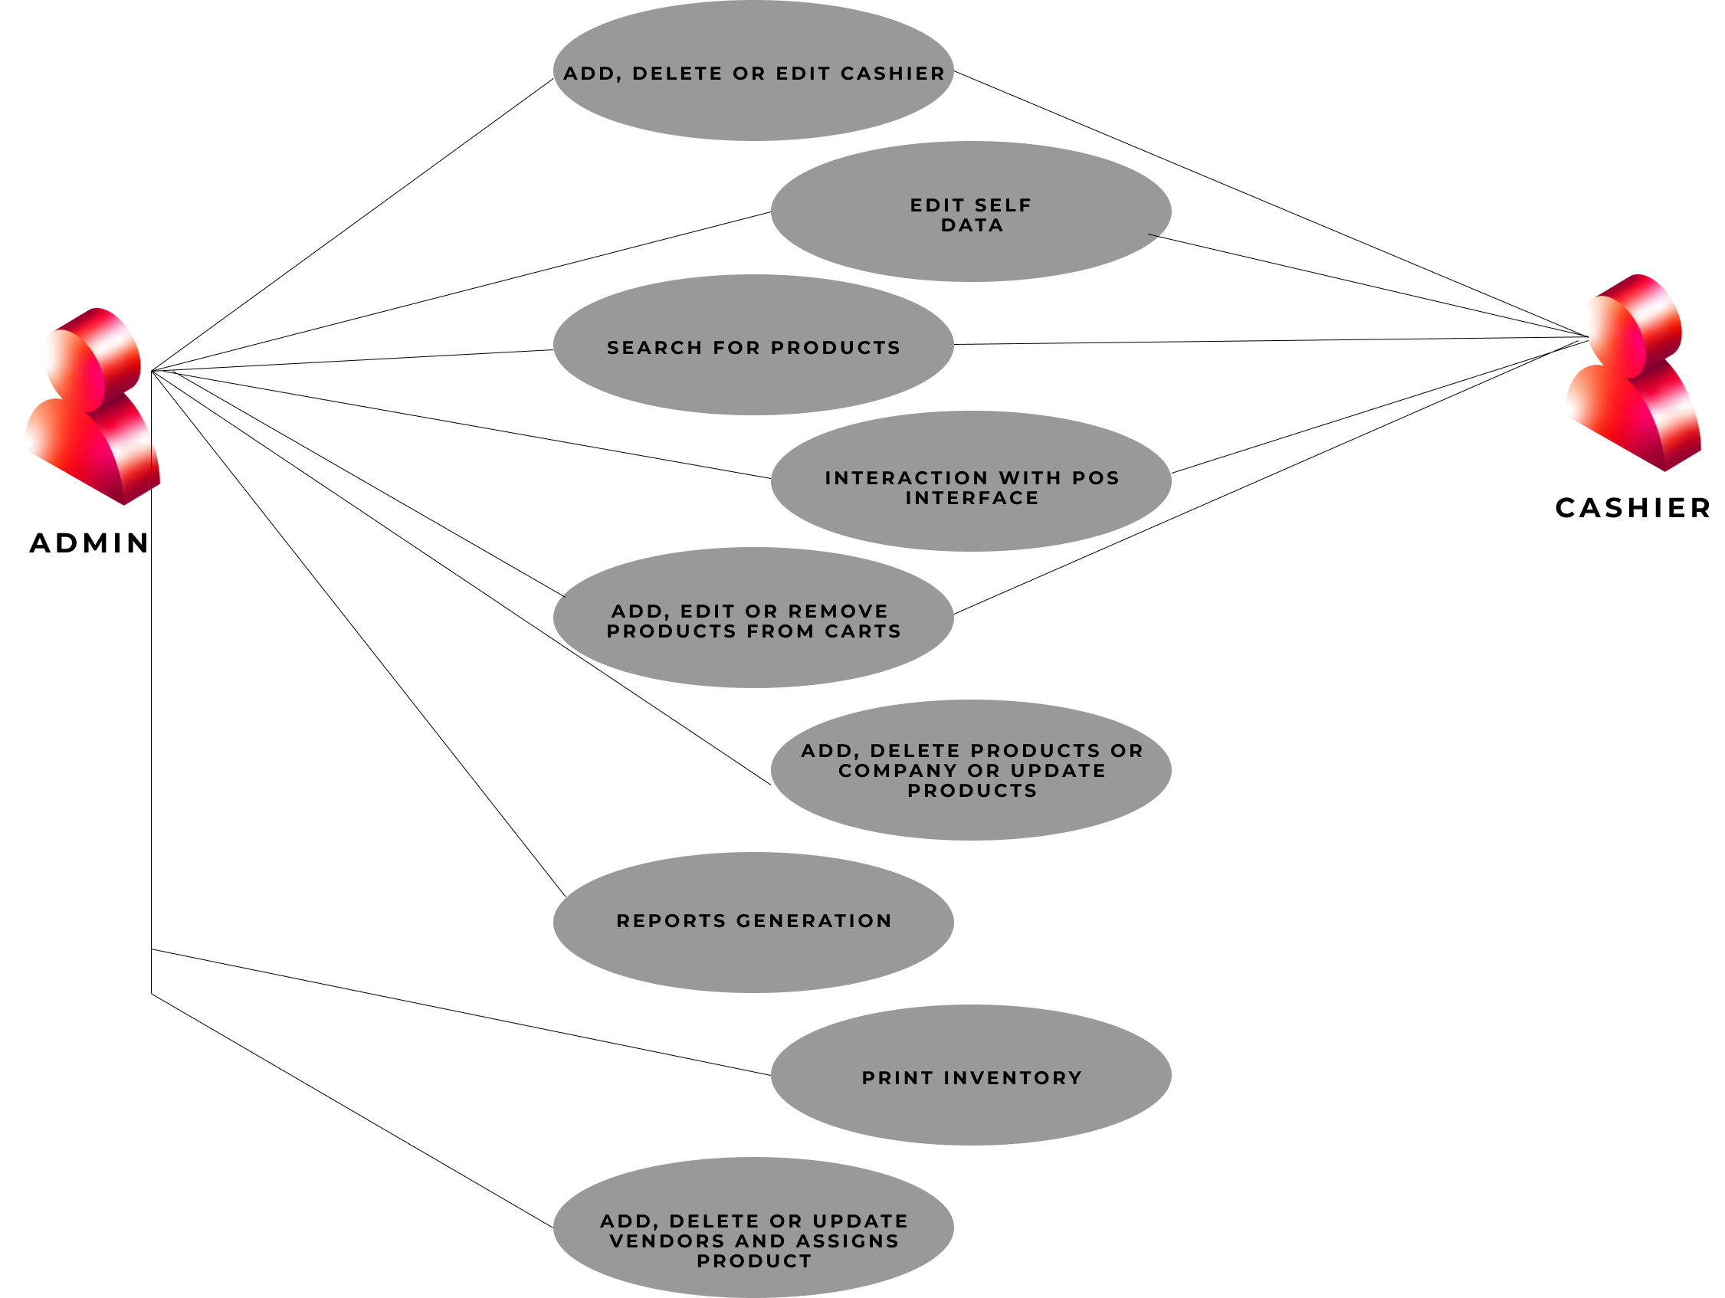

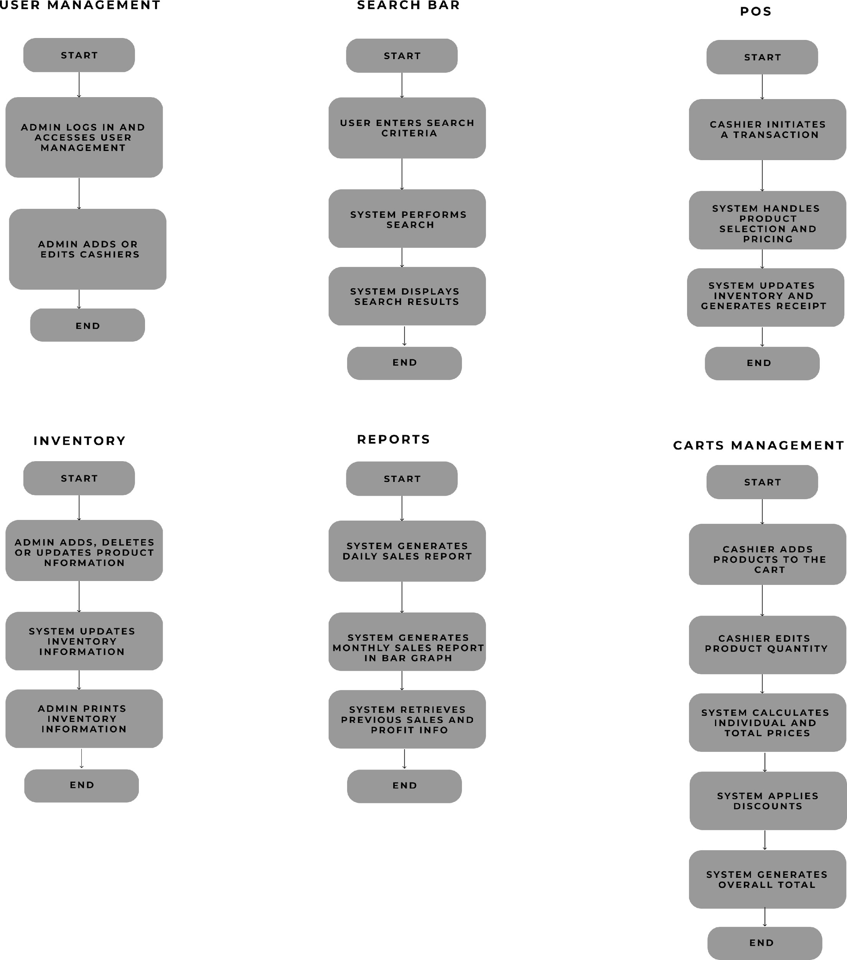

# **Appendix B: Prototype**

# 

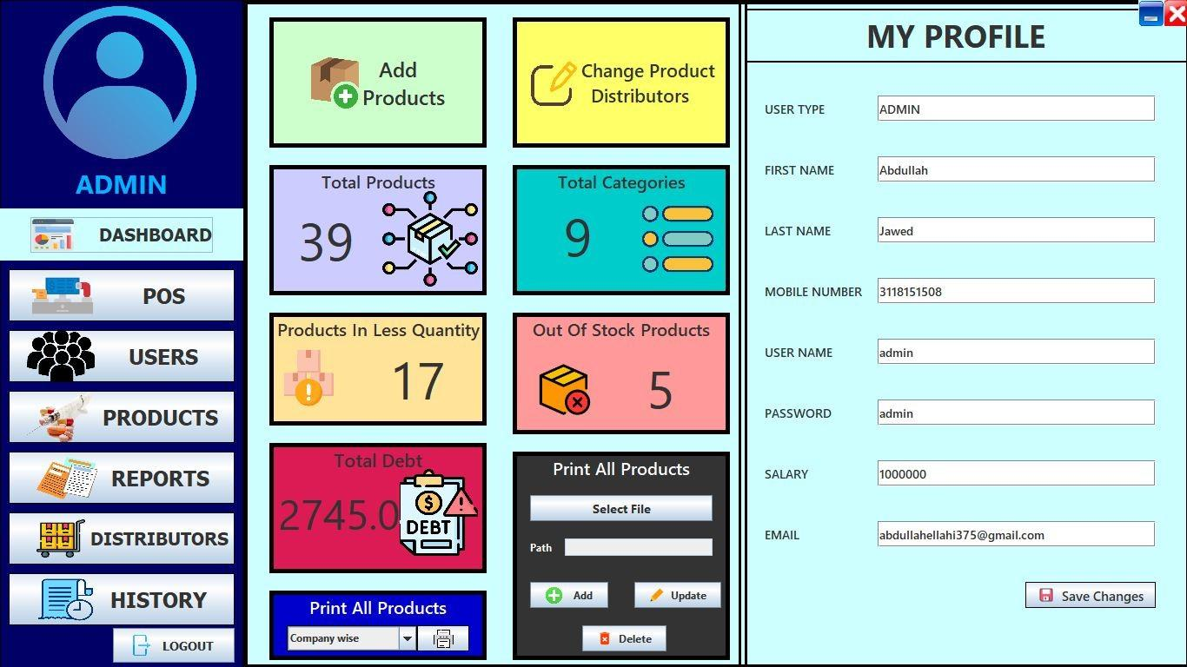

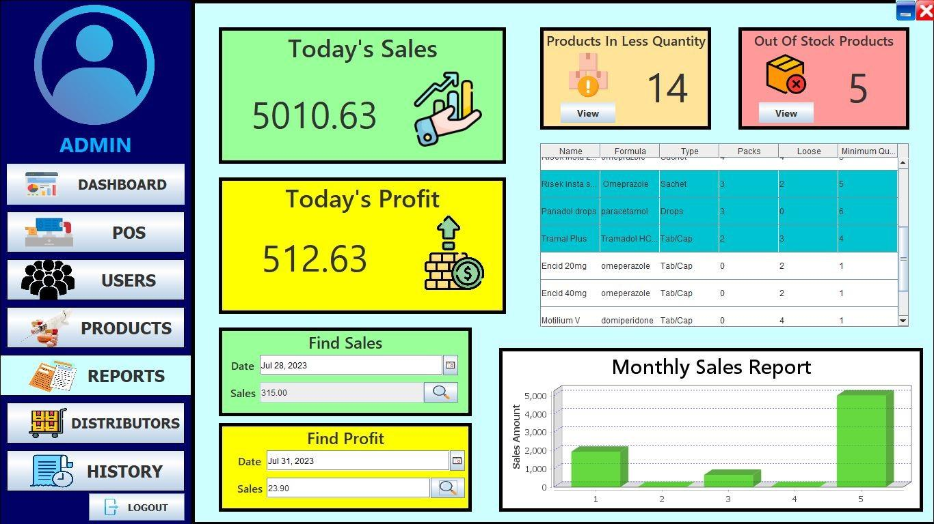

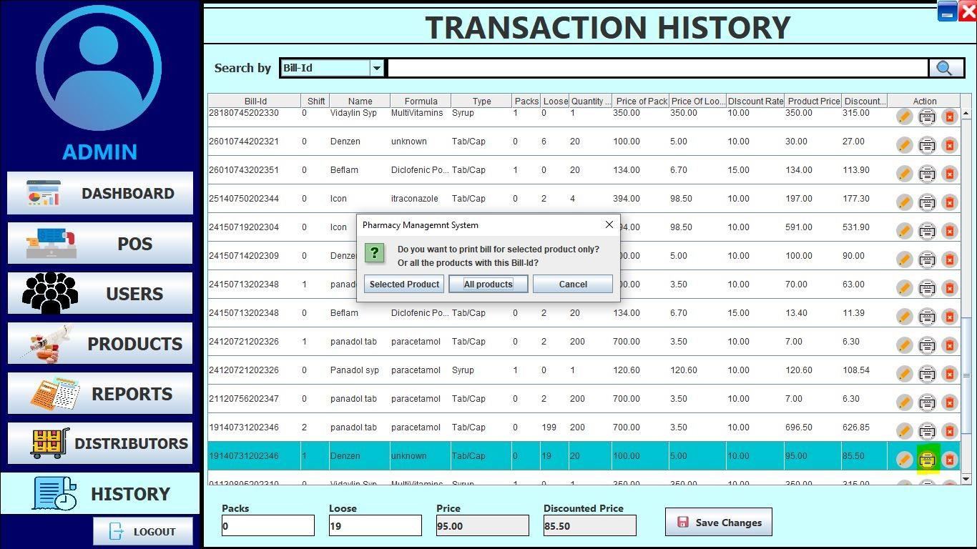

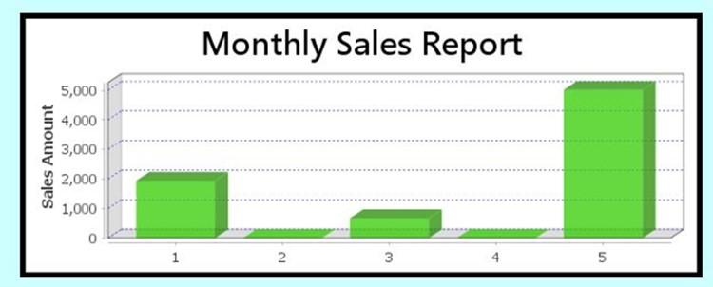

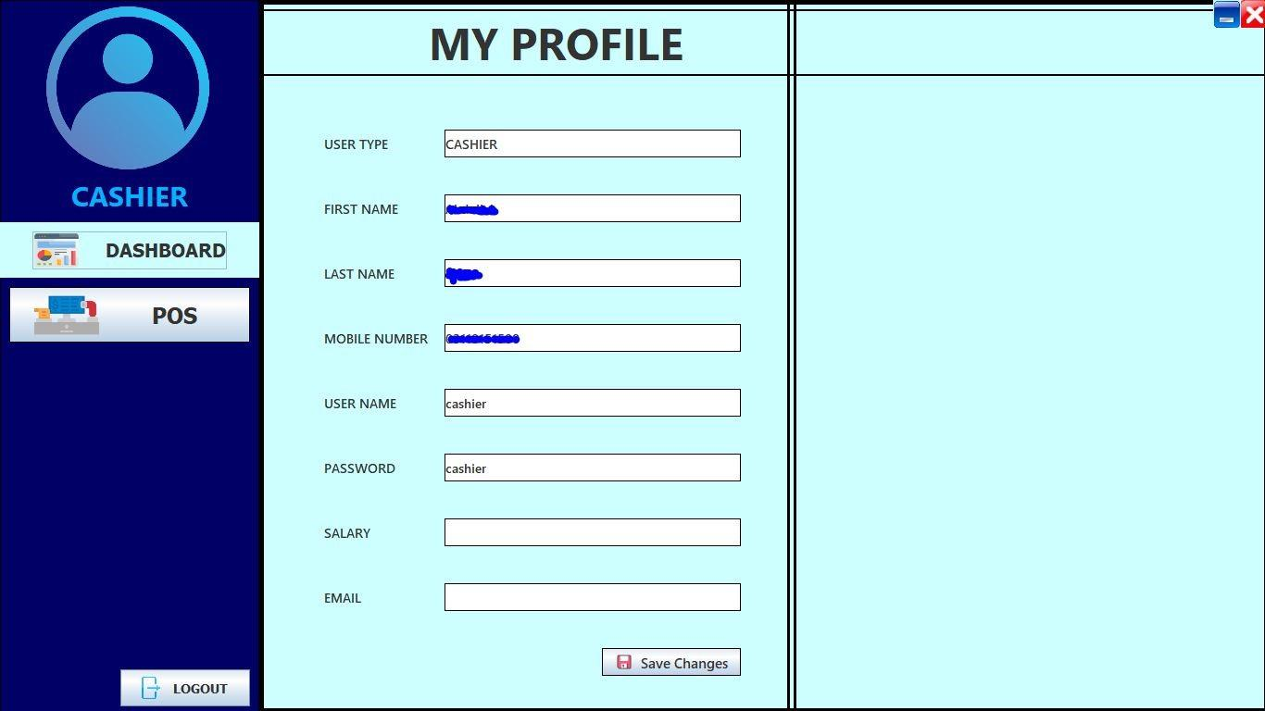

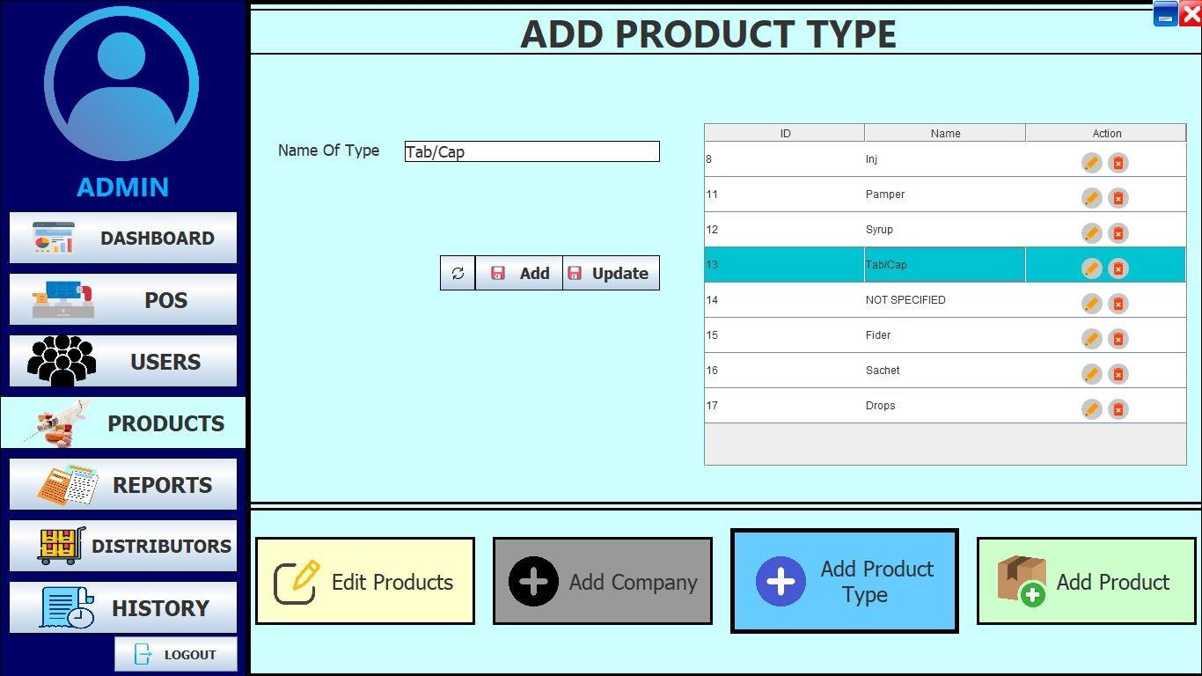

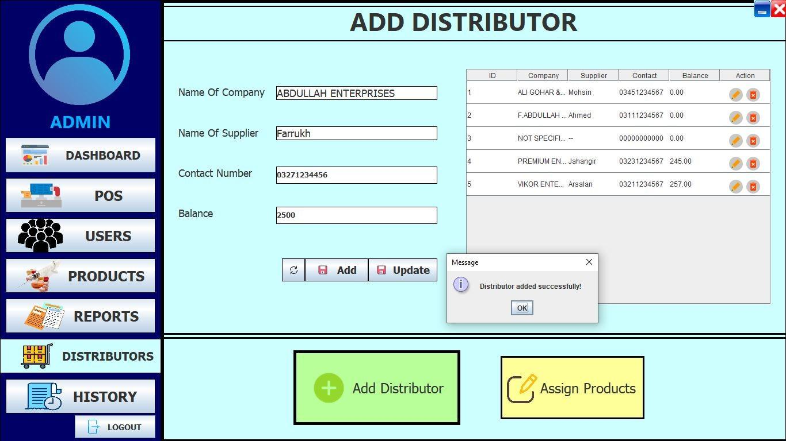

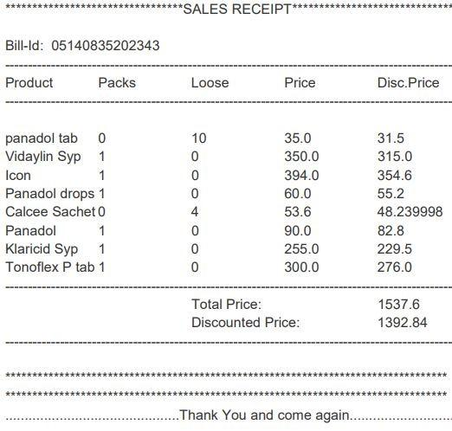

*THAT’S IT!*