

Web development report

[Document subtitle]



January 14, 2017

Hamza Mehmood

15418599

Contents

[Getting Started 2](#_Toc472096902)

[Designs 2](#_Toc472096903)

[Wireframes 2](#_Toc472096904)

[Wireframe for my home page 2](#_Toc472096905)

[Wireframe for my about page 3](#_Toc472096906)

[Wireframes for CV page 3](#_Toc472096907)

[Wireframes for contact page 4](#_Toc472096908)

[Sketches 4](#_Toc472096909)

[Sketch for my about page 4](#_Toc472096910)

[Sketches for my home pages 5](#_Toc472096911)

[Sketches for my CV 5](#_Toc472096912)

[Sketches of my contact page 6](#_Toc472096913)

[Logo I used 6](#_Toc472096914)

[Models I used for good practise 6](#_Toc472096915)

[Visual Appeal 6](#_Toc472096916)

[Navigation 7](#_Toc472096917)

[Progression of website over 12 weeks 7](#_Toc472096918)

[Week 1-3 7](#_Toc472096919)

[Week 3-5 7](#_Toc472096920)

[Week 5-7 8](#_Toc472096921)

[After Christmas holidays 9](#_Toc472096922)

[Conclusion 9](#_Toc472096923)

# Getting Started

Before I started my portfolio, I looked at the others people’s work to get an idea about my website format. Mostly the people used bootstrap to make their website effective but I wasn’t allowed to use bootstrap so I only used HTML5 and CSS to design my website. There are some websites I used to get an idea about format:

• <http://joel.sh/>

# Designs

## Wireframes

### Wireframe for my home page

Navigation bar(Header)

Background Image

Contact Info (Footer)

### Wireframe for my about page

Navigation bar(Header)

Contact Info (Footer)

Profile Image

Description about myself

### Wireframes for CV page

Name and Address(Header)

My other CV details

### Wireframes for contact page

Navigation Bar(Header)

Enter

Name

Message

Email

Contact info(Footer)

## Sketches

### C:\Users\Hamza Malik\AppData\Local\Microsoft\Windows\INetCacheContent.Word\IMG_3918 (1).jpgSketch for my about page

For my about page, I used a very simple format. Navigation bar will include logo, name, and link to my other web pages. Centre of about page is divided into two parts one contain the text and the other one contains profile image and the end , footer contains my contact information. Moreover, the header and footer are similar for my home and contact page.

### Sketches for my home pages

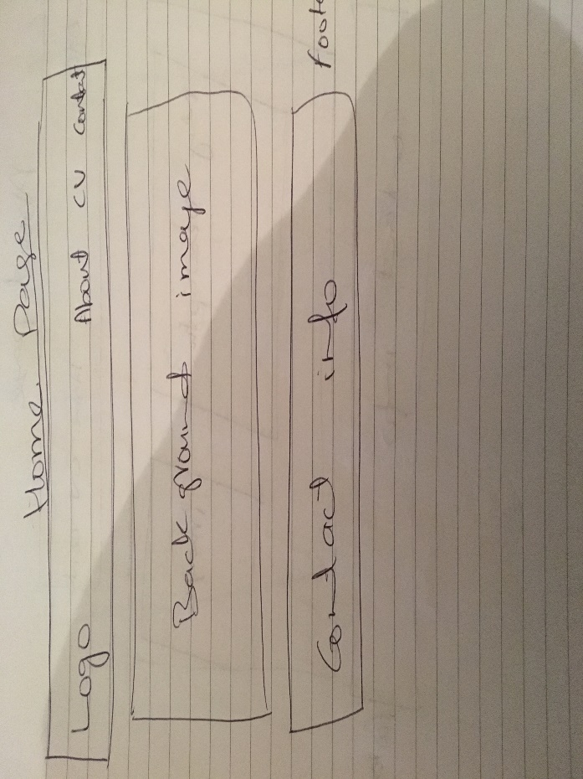

I tried to make my home page as simple as I can. The header and footer will be the same as my about page. After that I added background image.

### Sketches for my CV

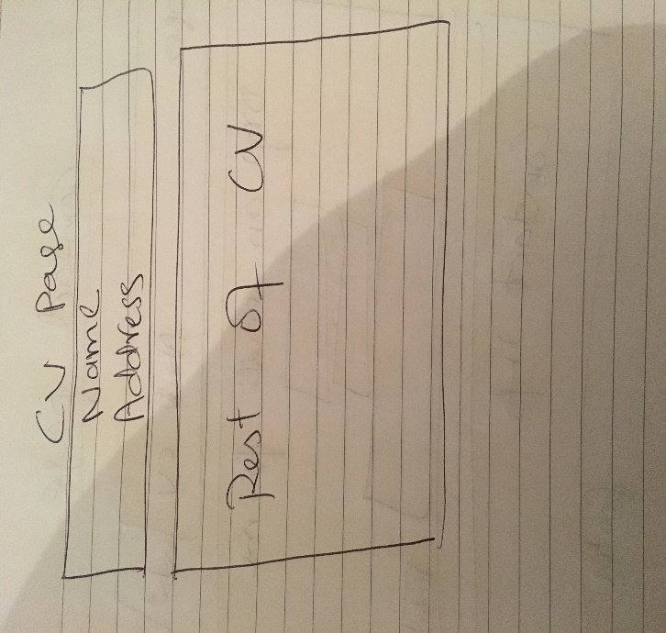

I used a very simple format to design my CV page. In this page, header includes my name and address and there is no footer for this page.

### Sketches of my contact page

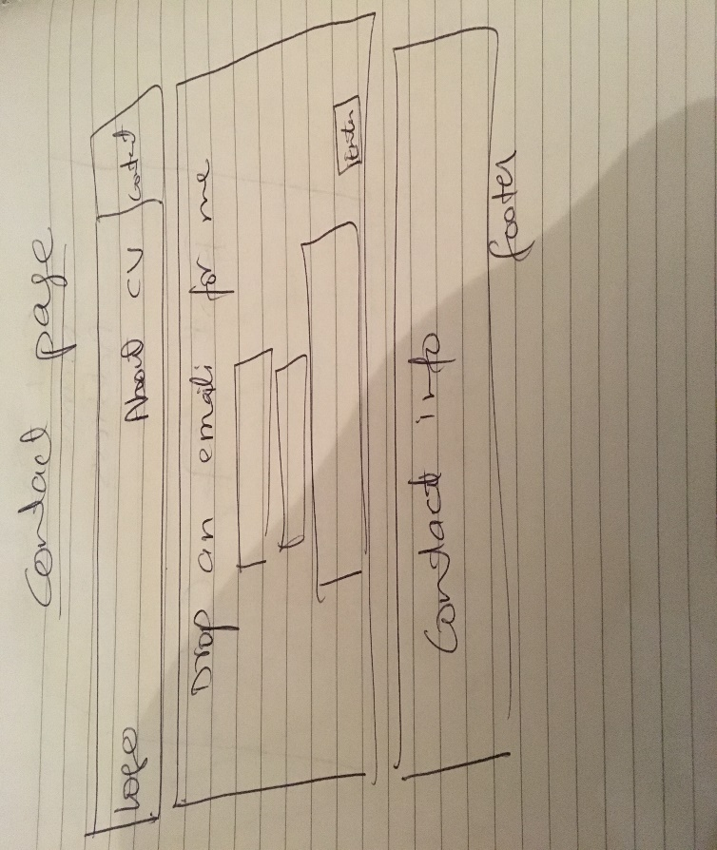

My contact page has the same header and footer as my about and home page. In the middle I designed some text boxes to design an email page format .

### Logo I used

I used this logo on my header besides my name. This logo is simple and unique. I got this logo from [www.iconfinder.com](http://www.iconfinder.com).

# Models I used for good practise

## Visual Appeal

Visual appeal of my website is simple and easy to readable. Style is simple. I didn’t add any Bootstrap

### Navigation

Navigation is one of the important things in any website. I made my navigation easy to use and simpler that links my other pages.

# Progression of website over 12 weeks

## Week 1-3

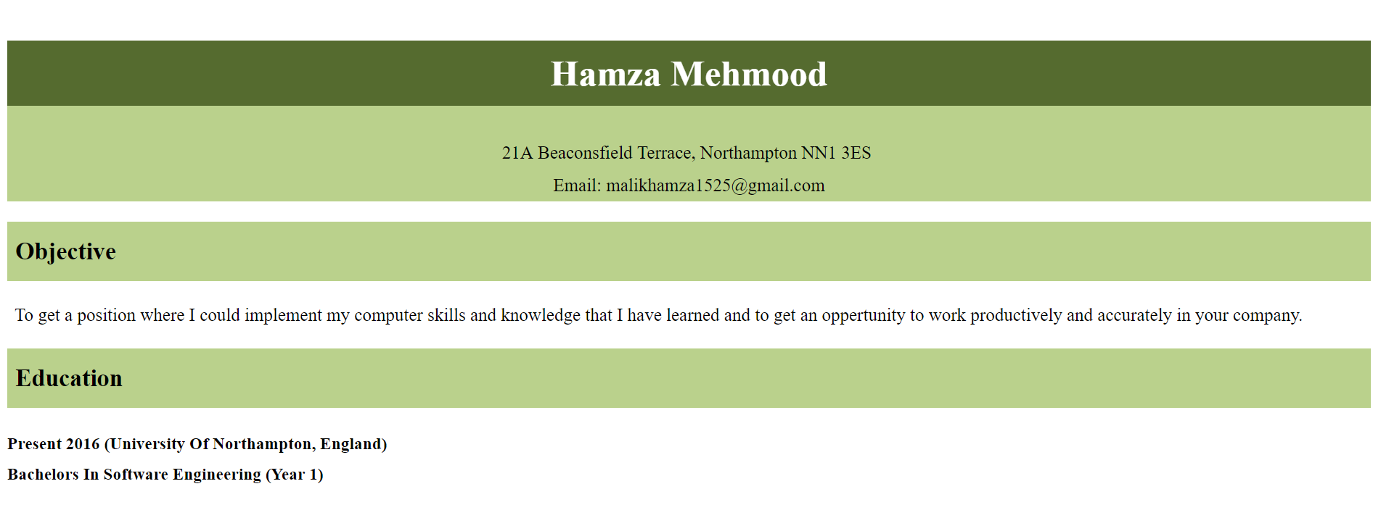

First three weeks I focused only one my CV page. The things I studied in classes I tried to implement those on my website. I made the header of my CV page in these weeks.

## Week 3-5





In these weeks I designed header and footers for my home, about and contact page. Before that I designed wireframes for each page.

## Week 5-7

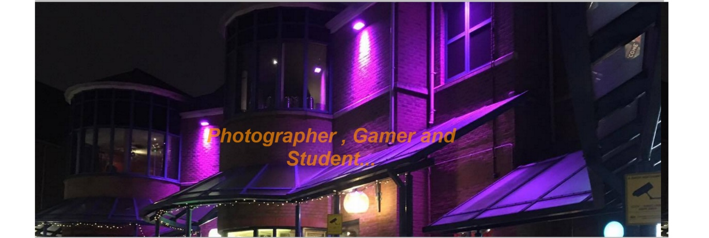

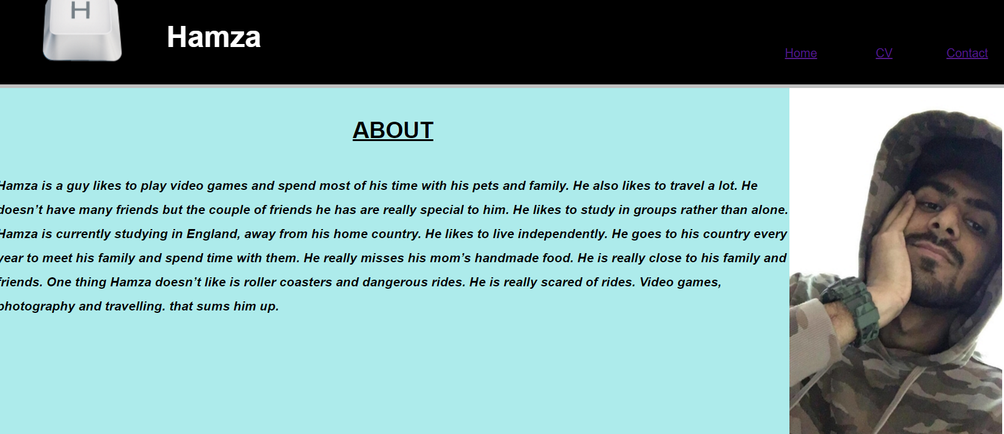

For these weeks I added a background image on my home page between header ad footer and designed my about page which includes information about myself. After these weeks I had only my contact page left to design. So I decided to do rest of the work once I get back from my Christmas holidays.

## After Christmas holidays

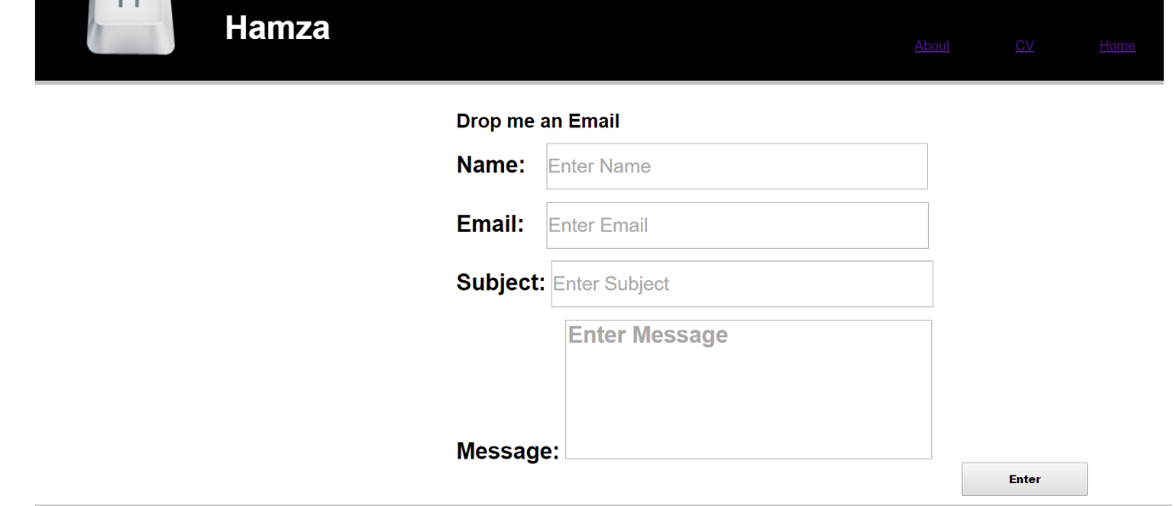

After my Christmas week I finished my contact page and committed all pages at the same time. I also completed my report at the same weeks.

# Conclusion

To sum up, I used Atom software to design the code for my pages. This IDE proved very helpful for me.