Linear Regression
Python Project

Linear Regression

الكود | الاسم
22010038 | احمد محمد محمود محمود محمدى
22010162 | عمر ايهاب محمد جنيدي حسن
22010056 | الحسين ياسر إبراهيم السيد
22010183 | فارس صلاح الدين عبدالفتاح النحاس
22011562 | عمر حافظ مأمون محمد حسن
22011680 | محمد محمود محمد حسانين
22011501 | حمزة حسين يوسف عمران
22010182 | فارس احمد ابو الفتوح عبد الفضيل
20225926030 | أحمد حسين حسن دويدار
22010124 | طارق مصطفى محمد عز الدين
22010263 | معاذ مصطفى عبدالحميد مصطفى

1.Introduction:
We provide an overview of the dataset, detailing the various attributes and their distributions. Next, we delve into the methodology of multiple linear regression, elucidating the underlying principles and techniques employed. Subsequently, we present the results of our regression analyses, including model performance metrics and interpretations of coefficient estimates. Finally, we conclude with a discussion of key findings, implications, and potential avenues for further exploration.

Used Dataset and its Parameters:
dataset contains the prices and other attributes of almost 54,000 diamonds.
There are 53,940 diamonds in the dataset with 10 features (carat, cut, color, clarity, depth, table, price, x, y, and z). Most variables are numeric in nature, but the variables cut, color, and clarity are categorical data.

Cleaning and Preprocessing:
Phase 1:
1. We encode categorical data into numerical form for further analysis purposes using Python’s “pandas” library.
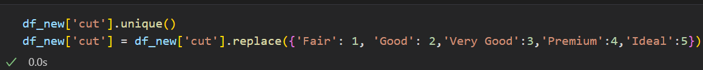
Like column “cut” we made the same thing to the columns ('color’, 'clarity')

2.We found that there are no duplicates or nulls in the dataset.

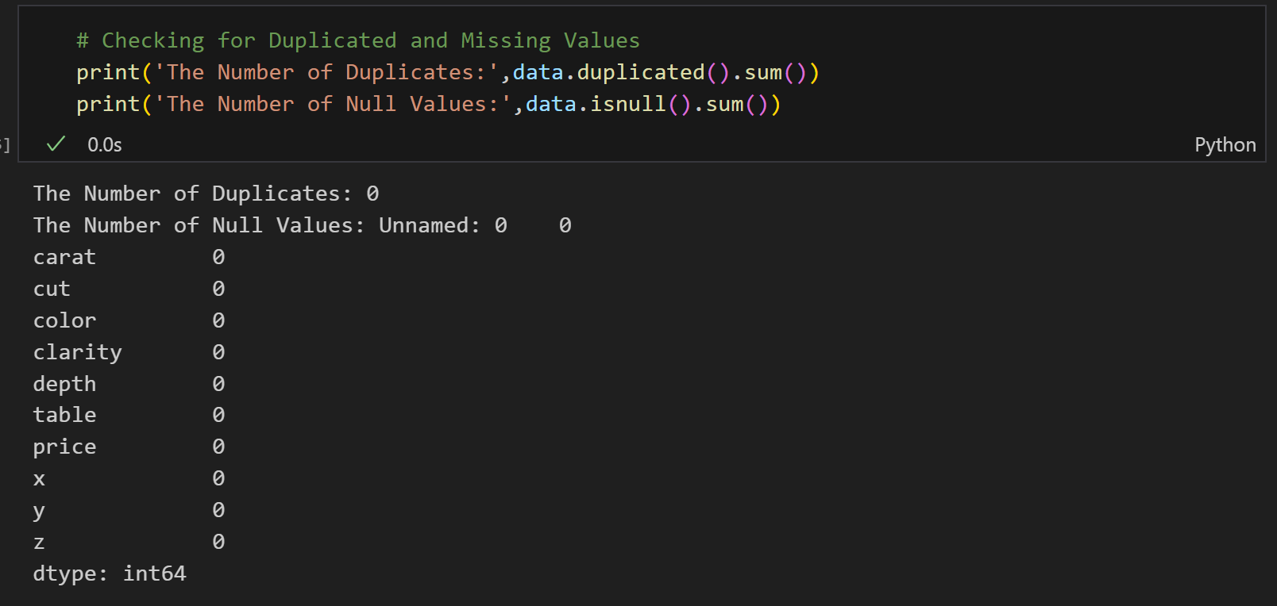

Phase 2:
1.We check if there are any outliers by Boxplot.
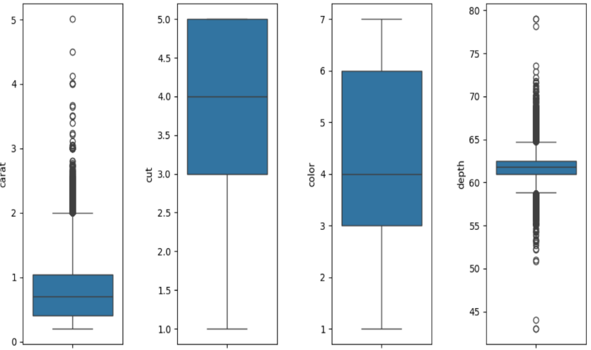

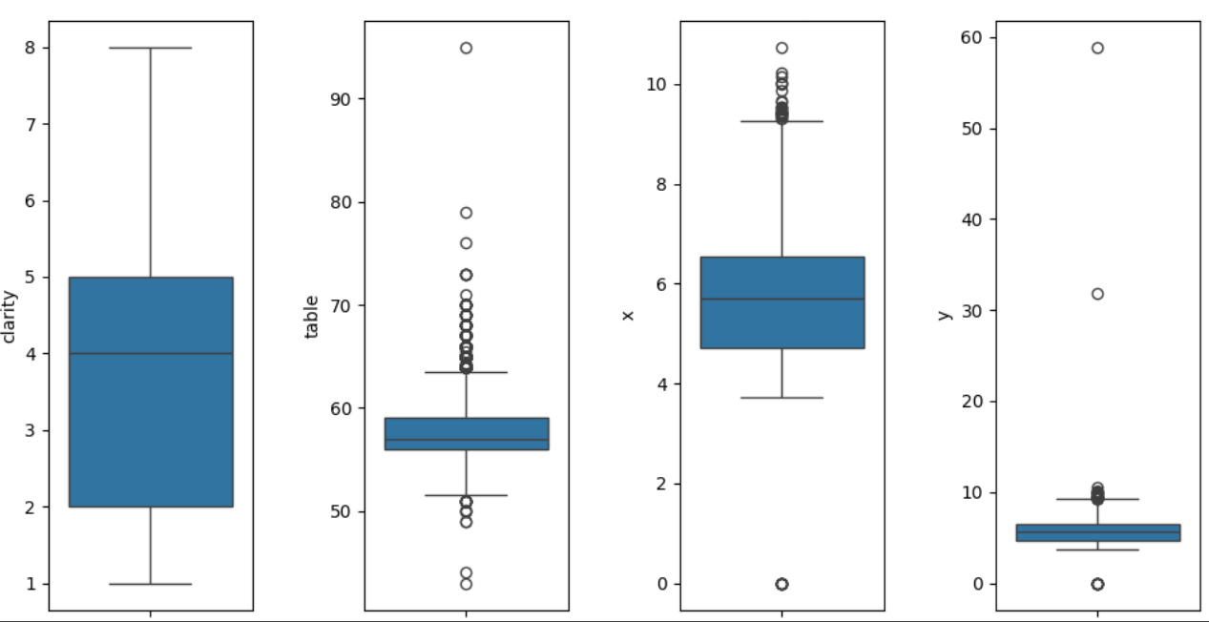

Then we replace lower outliers with minimum value and upper ones with the maximum value using this function:
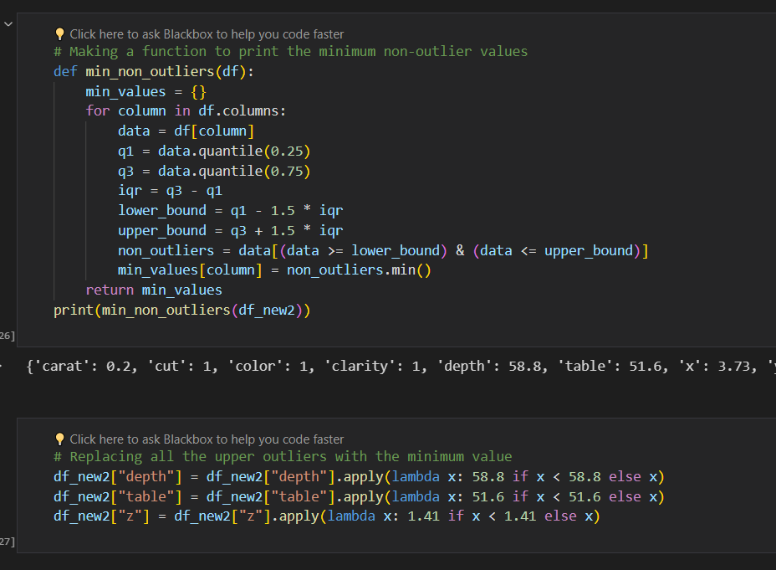
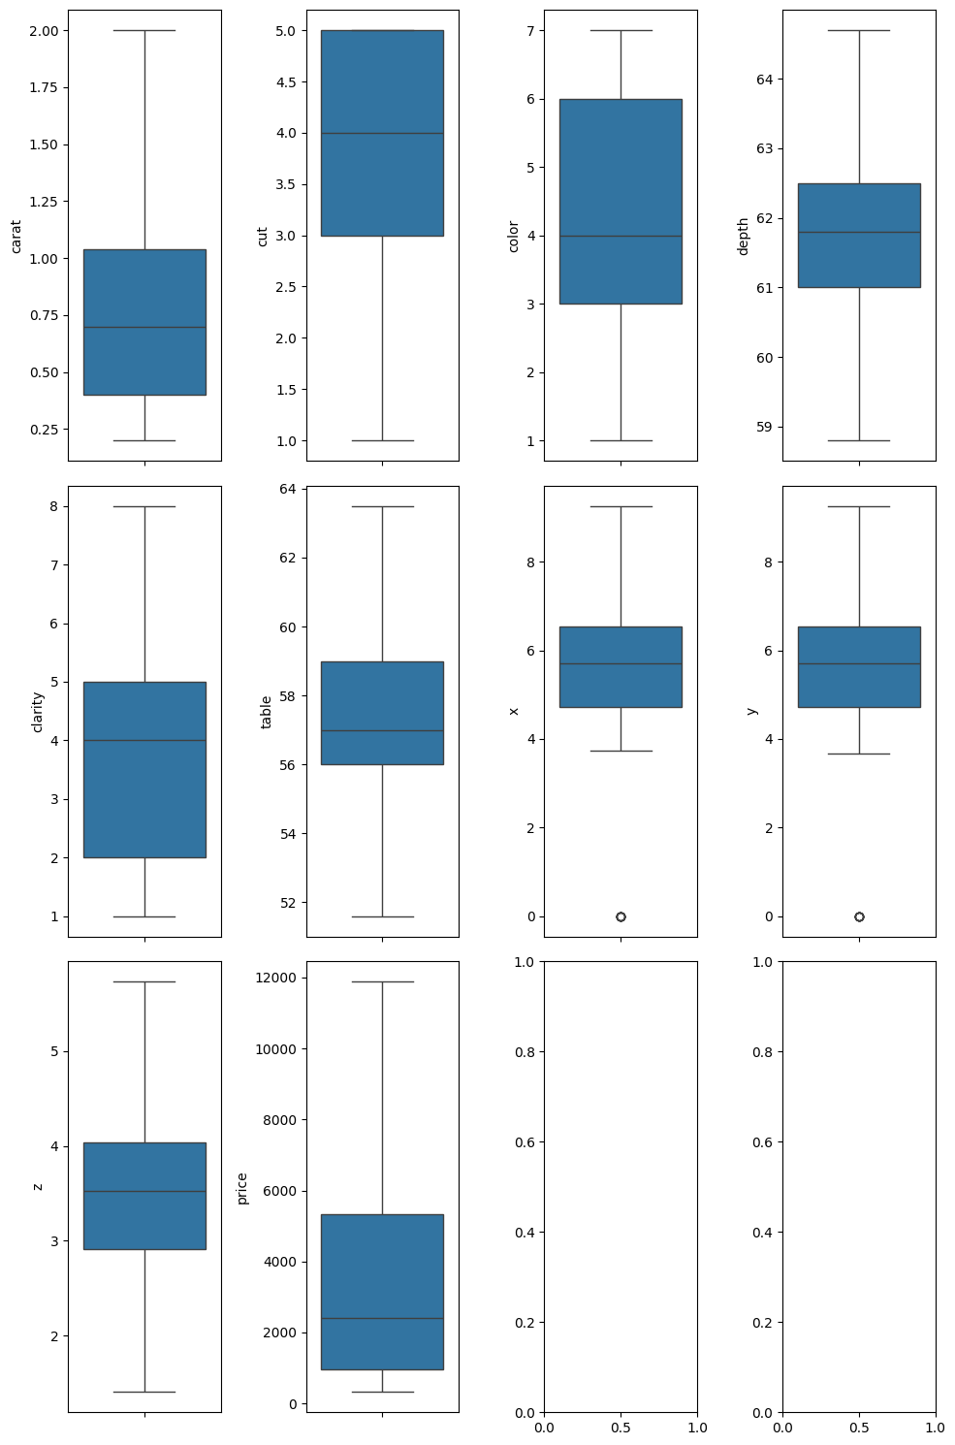

The above picture shows the Boxplot of our features after replacing outliers.

2.Checking the correlation between the columns and the price.
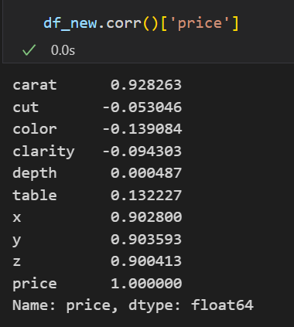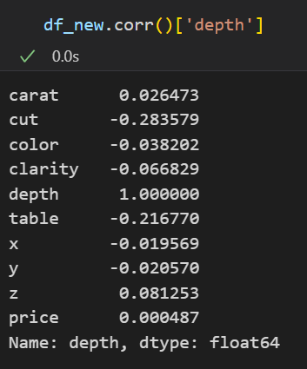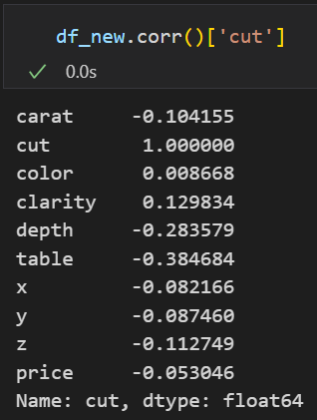

After that we didn’t remove any feature from the data frame. Because there is no
multi-collinearity between any one of them and the other variables, meaning they are independent (orthogonal).
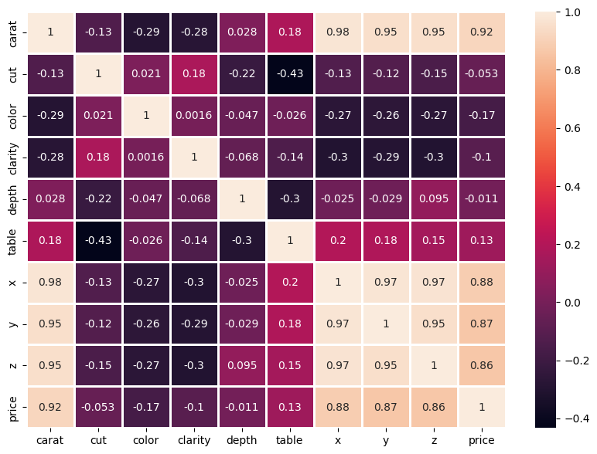
A Heatmap showing the correlation between features.

Implementation:
We implement fundamental operations in linear regression analysis using NumPy like getting design matrix, beta hat vector and F test parameters. We manually implemented these calculations.
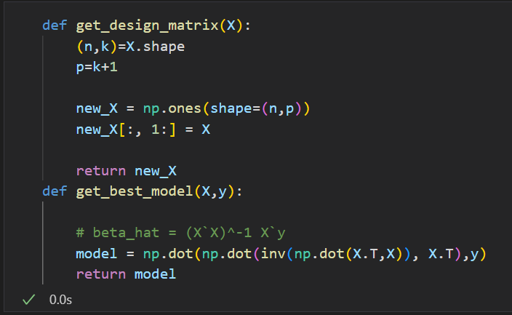
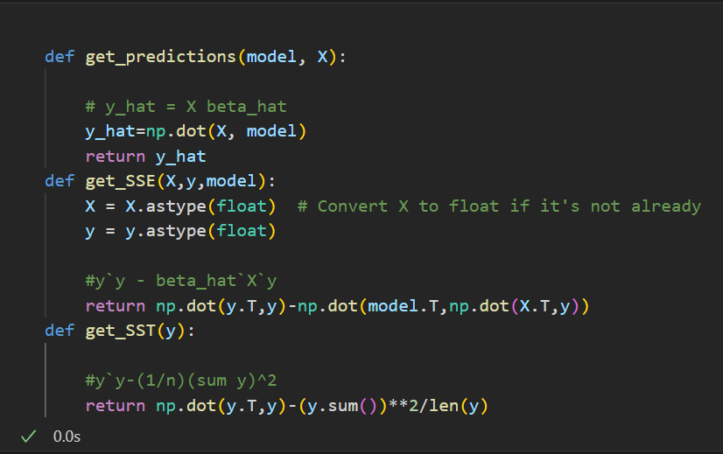

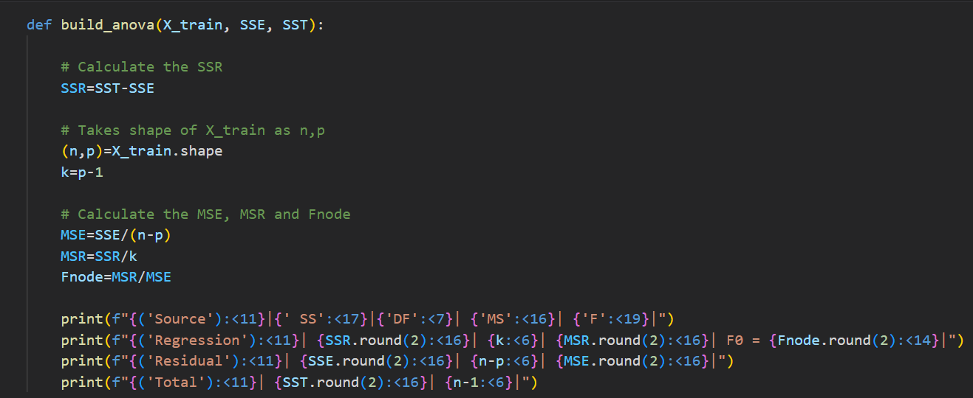

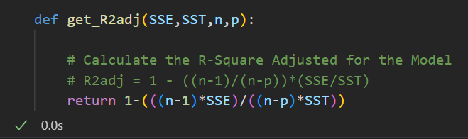

Results:
1.The following snippet shows the output of the ANOVA table and the R squared /Accuracy (Before Preprocessing)
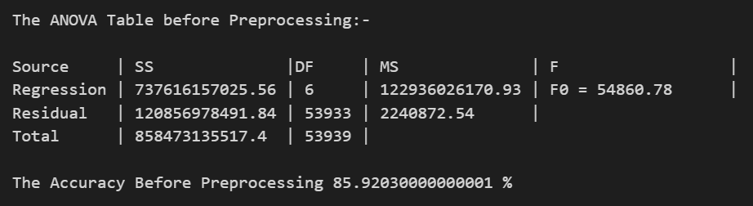

2. After Phase 1:
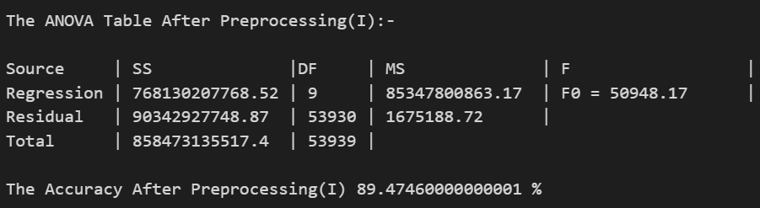

3. After Phase 2:
We reached the highest accuracy in this Phase.
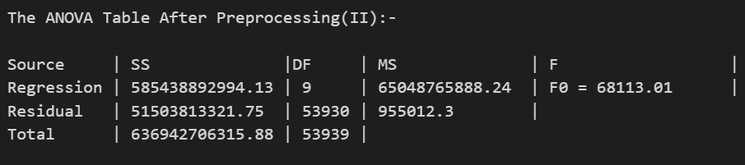

As for calculating accuracy we did an extra step to make sure we're using the standard methods for the calculation of accuracy, so we imported r2_score from “sklearn.metrics” to recalculate the accuracy and the results were as follows.
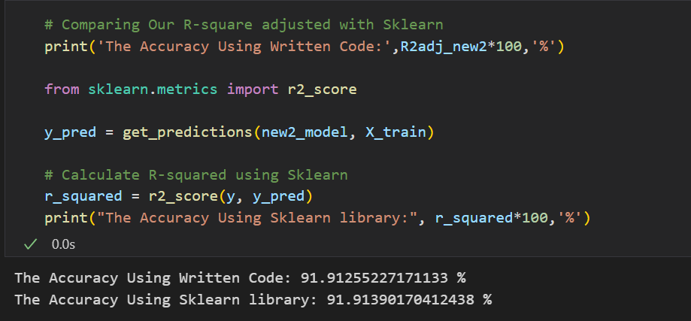

Visualization:
From the histogram we conclude that positive values are more than negative values
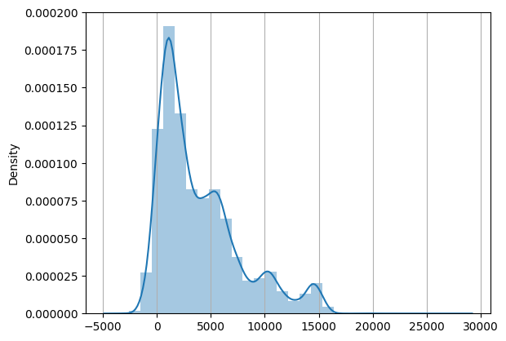

From scatter plots we can say it is obvious that the variables x, y, z, and carat exhibit a strong correlation with the price. but, variables such as cut, color, clarity, table, and depth demonstrate a weaker correlation with the price.
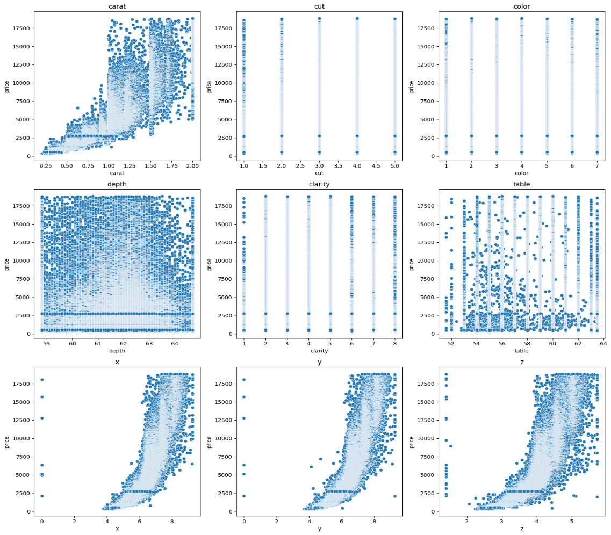

Now that the model is trained, we should be able to use it to make our predictions and evaluate our model. The scatter plot below plots the actual y values to the model's predictions. The model seems to behave accurately.
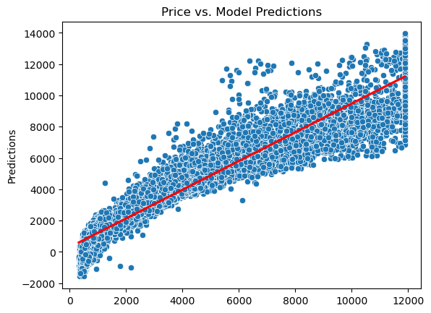
Distribution plot of the residuals of the model's predictions. It appears that they have a normal distribution.
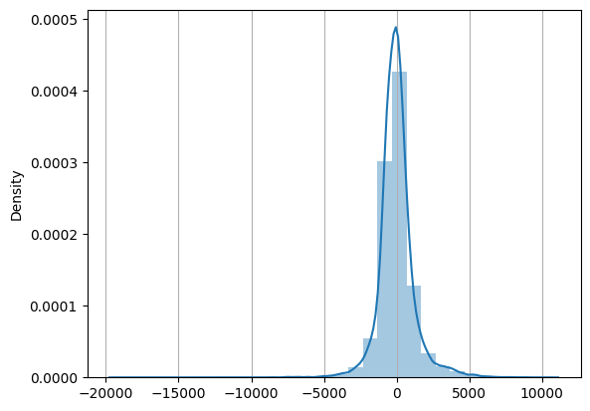
The closer the data points are to this line, the more closely they follow a normal distribution.
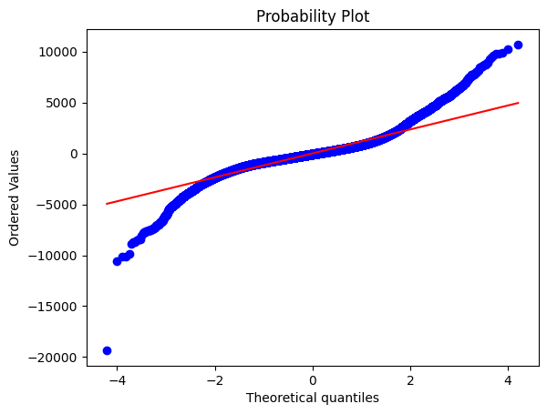
Conclusion:
Throughout our iterative process of refining the multiple linear regression model applied to diamond pricing, we've made concerted efforts to enhance accuracy. By strategically adding pertinent features and implementing outlier removal techniques, we've significantly improved model performance. Our endeavors have borne fruit, culminating in a noteworthy increase in accuracy from an initial 85.92% to a commendable 91.91%.
This elevated accuracy underscores the efficacy of our approach in capturing the intricate relationships between diamond attributes and pricing. The refined model not only provides a robust framework for predicting diamond prices but also offers valuable insights into the factors driving pricing dynamics within the diamond market.
Moving forward, the heightened accuracy achieved serves as a testament to the efficacy of meticulous feature engineering and outlier management in bolstering predictive modeling endeavors. Leveraging these insights, stakeholders in the diamond industry can make more informed decisions regarding pricing strategies, inventory management, and consumer engagement, thereby fostering greater efficiency and competitiveness in the market landscape.

