Supply–Demand Gap Analysis for Rental Platform

Comprehensive Technical Documentation

Vodafone International Foundation – Faculty of Engineering

Prepared By
- Hamza Omran
- Ahmad Khalifa
- Moaz Mostafa

Abstract
This document presents a comprehensive Supply–Demand Gap Analysis conducted for a rental business platform. The project identifies supply shortages across product categories by computing gap scores derived from the ratio of customer demand to available product listings. Using a data-driven methodology, the analysis integrates eight datasets covering products, sales, returns, customer demographics, and geographic territories across three years (2020–2022).
The multi-phase pipeline includes data exploration, cleaning, supply–demand computation, gap score calculation, visualization, business insight generation, and weekly monitoring with action planning. The project outputs interactive dashboards, Excel reports, PNG charts, structured JSON files, and an API-ready analytics layer.
The findings highlight severe shortages in multiple subcategories, with gap scores exceeding 200, signaling critical supply deficits. The implemented monitoring framework enables ongoing tracking and provides prioritized operational and strategic recommendations for decision-makers.

Table of Contents
- Introduction 1.1 Project Overview 1.2 Problem Statement 1.3 Objectives 1.4 Scope and Limitations
- Literature Review 2.1 Supply–Demand Analysis 2.2 Gap Score Methodology 2.3 Data-Driven Decision Making
- Methodology 3.1 Data Pipeline Architecture 3.2 Data Sources and Structure 3.3 Gap Score Formula 3.4 Classification Criteria
- Implementation 4.1 Phase 1: Data Preparation 4.2 Phase 2: Supply–Demand Computation 4.3 Phase 3: Gap Score Calculation 4.4 Phase 4: Visualization and Insights 4.5 Phase 5: Monitoring and Action Planning
- Technical Architecture 5.1 Python Modules 5.2 Notebook Workflow 5.3 Output Files and Deliverables
- Results and Analysis 6.1 Category-Level Findings 6.2 Subcategory-Level Findings 6.3 Territory-Level Findings 6.4 Gap Severity Distribution
- Visualizations 7.1 Supply vs Demand 7.2 Gap Severity 7.3 Heatmaps 7.4 Category Rankings 7.5 Gap Distribution
- Business Insights 8.1 Critical Gaps 8.2 Balanced Categories 8.3 Strategic Recommendations
- Monitoring Framework 9.1 Weekly Snapshots 9.2 KPI Tracking 9.3 Alert System
- Action Plans 10.1 Operational Actions 10.2 Strategic Actions 10.3 Platform Optimization 10.4 User Engagement
- API Integration 11.1 Endpoint Recommendations 11.2 Data Export Formats 11.3 Usage Examples
- Conclusion
- Future Work
- Appendices

1. Introduction

1.1 Project Overview
This project addresses the challenge of identifying supply–demand imbalance within a rental marketplace by computing gap scores that quantify shortages at category, subcategory, and territorial levels. The analysis uses transactional data comprising:
- 56,046 sales transactions
- 293 unique products
- 18,148 customers
- 1,809 returns
- 37 subcategories
- 10 territories and 6 countries
The pipeline transforms raw multi-source data into actionable insights using a modular architecture of notebooks and Python modules.

1.2 Problem Statement
Many rental platforms struggle with:
- Lack of quantitative measurement of supply shortages
- Missing visibility into which subcategories experience high unmet demand
- Absence of automated monitoring mechanisms
- Difficulty in allocating inventory budgets
- Limited understanding of territory-level demand patterns
This project delivers a full analytical framework to solve these challenges.

1.3 Objectives
- Develop a gap score methodology to quantify supply deficits
- Implement an automated end-to-end data pipeline
- Compute supply–demand metrics across all categories and territories
- Generate insights through visualization and interpretation
- Build a weekly monitoring system
- Produce prioritized action plans
- Deliver API-ready datasets for integration

1.4 Scope and Limitations

Scope
- Category, subcategory, and territory-level analysis
- Data cleaning, gap computation, visualization, insights
- Action planning and monitoring

Limitations
- Historical (not predictive) analysis
- Linear assumption in demand/supply relationships
- Does not incorporate pricing or time-of-day patterns
- Excludes external market influences

2. Literature Review

2.1 Supply–Demand Analysis
Supply–demand modeling is fundamental in resource allocation, revealing where inventory shortages constrain customer satisfaction and revenue potential.

2.2 Gap Score Methodology
Ratio-based methods quantify shortages effectively, enabling clear action prioritization.

2.3 Data-Driven Decision Making
Modern commerce relies on analytical pipelines integrating data cleaning, computation, visualization, and automation — which this project implements.

3. Methodology

3.1 Data Pipeline Architecture
The pipeline consists of five phases, each implemented in Jupyter notebooks with modular Python code:
Phase 1 – Data Preparation
Phase 2 – Supply–Demand Computation
Phase 3 – Gap Score Calculation
Phase 4 – Visualization and Insights
Phase 5 – Monitoring and Action Planning

3.2 Data Sources
Eight sheets from “Project Data.xlsx,” including:
- Products
- Product Categories
- Sales
- Customers
- Returns
- Territories

3.3 Gap Score Formula
Gap Score = (Total Demand + 1) / (Total Supply + 1)

3.4 Classification Criteria
Gap Level | Range | Meaning
Low | < 50 | Balanced
Moderate | 50–100 | Mild shortages
High | 100–200 | Significant shortages
Critical | > 200 | Severe shortages

4. Implementation

4.1 Phase 1 – Data Preparation
Handled in notebooks:
- DataUnderstandingAndExploration.ipynb
- DataCleaningAndMerging.ipynb
Tasks:
- Missing value handling
- Customer gender inference
- Prefix generation
- Date type consistency
- Export cleaned dataset

Color Cleaning Summary
Color | Count (Before) | Count (After)
Black | 88 | 88
Mixed | 0 (50 NaN) | 50
Red | 37 | 37
Silver | 36 | 36
Yellow | 36 | 36

Style Cleaning Summary
Style | Count (Before) | Count (After)
U (Unisex) | 174 | 258
W | 28 | 28
M | 7 | 7
NaN | 84 | 0

Prefix Generation Summary
Prefix | Before | After
Mr. | 9,126 | 9,206
Mrs. | 6,422 | 6,426
Ms. | 2,470 | 2,516
Missing | 130 | 0

4.2 Phase 2 – Supply–Demand Computation
Calculates:
- Category supply (unique products)
- Category demand (quantity sold)
- Returns adjustment
- Monthly trends
Output: Category_Supply_Demand_Analysis.xlsx

4.3 Phase 3 – Gap Score Calculation
Notebooks:
- MOAZ_Define_Metrics_GapScore.ipynb
- GapScoreImplementation.ipynb
Outputs:
- Category-level gap scores
- Subcategory-level gap scores
- Territory-level gap scores
- Cross-analysis (subcategory × territory)
Stored in:
comprehensive_gap_analysis.xlsx

4.4 Phase 4 – Visualization and Insights
Generates:
- Supply vs Demand chart
- Gap severity chart
- Heatmap of normalized metrics
- Category/subcategory rankings
- Gap distribution pie chart
Placeholder images included below.

4.5 Phase 5 – Monitoring and Action Planning
Creates:
- Weekly snapshots
- KPI calculations
- Alerts for categories with rising gaps
- Action plans (operational, strategic, technical)
Outputs stored in:
results/monitoring_reports/ results/monitoring_dashboards/

5. Technical Architecture

5.1 Python Modules
The project consists of 21 modules, including:
- Data processing (loader, cleaner, relationships)
- Supply–demand computation
- Gap score engine
- Visualization modules (Plotly + Matplotlib)
- Monitoring engine
- Action planner
- Dashboard and chart builders
- Data exporters

5.2 Notebook Workflow
Executed in exact order:
- Understanding
- Cleaning
- Supply–Demand
- Metrics definition
- Gap score implementation
- Visualization
- Insights
- Monitoring and action planning

5.3 Output Files
- Excel reports
- PNG charts
- Interactive HTML dashboards
- JSON and CSV exports
- Insights reports

6. Results and Analysis

6.1 Category-Level Findings
Certain categories show stable supply–demand balance, while others indicate severe shortages requiring immediate product acquisition.

6.2 Subcategory-Level Findings
Multiple subcategories exhibit critical gap scores > 200, signaling extremely high unmet demand.

6.3 Territory-Level Findings
Across 10 territories, regional shortages were identified, informing localized supply expansion strategies.

6.4 Gap Severity Distribution
The analysis shows a high proportion of High and Critical categories.

7. Visualizations

7.1 Supply vs Demand

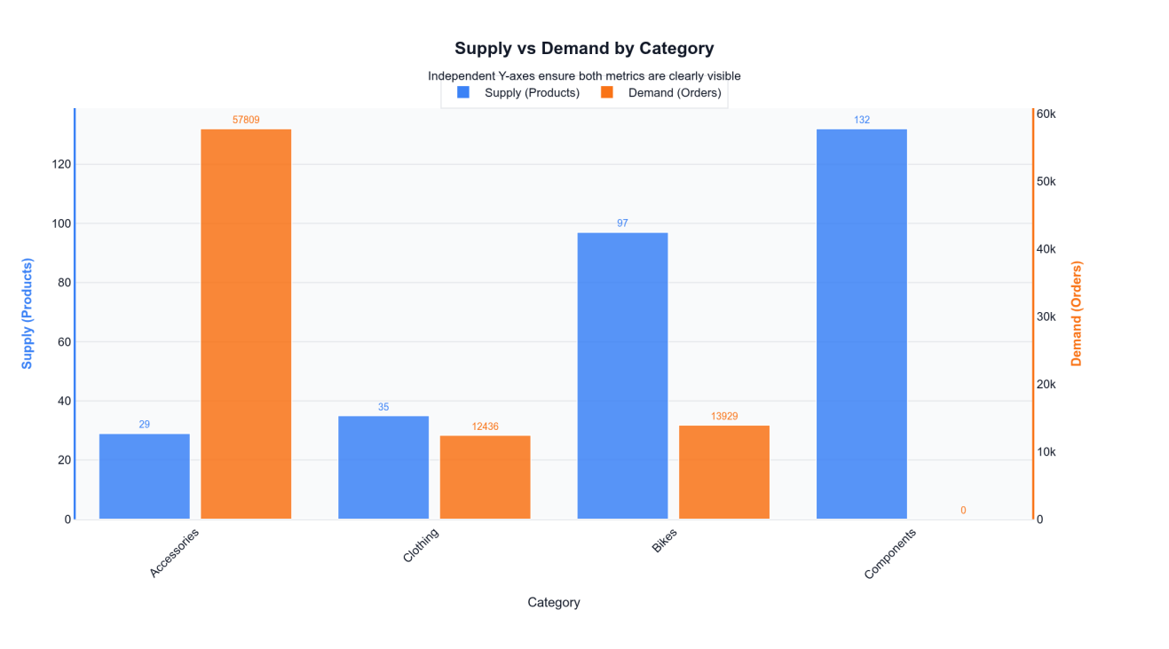

7.2 Gap Severity Chart

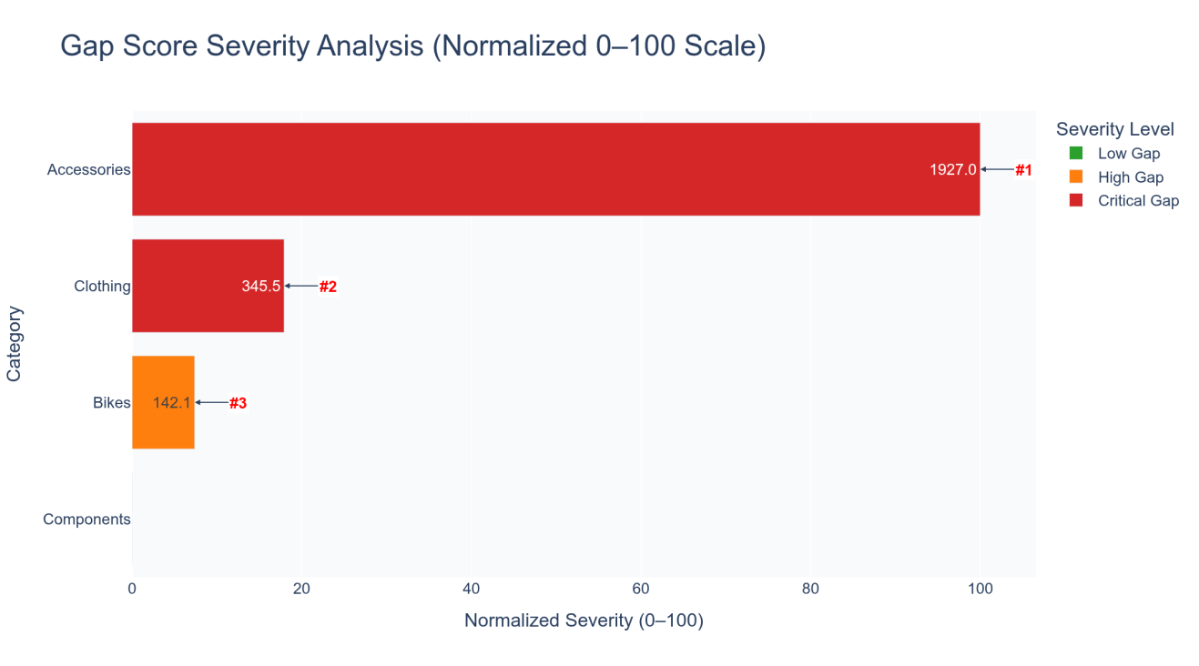

7.3 Heatmap

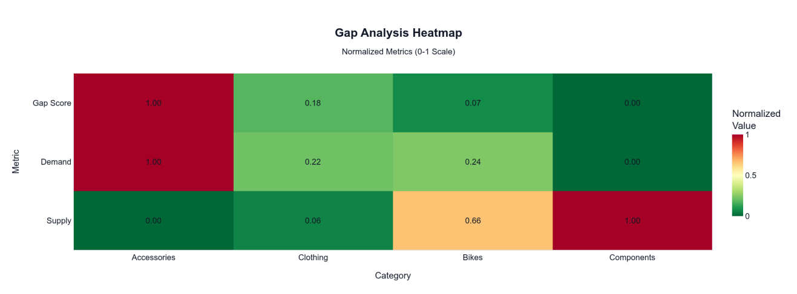

7.4 Category Rankings

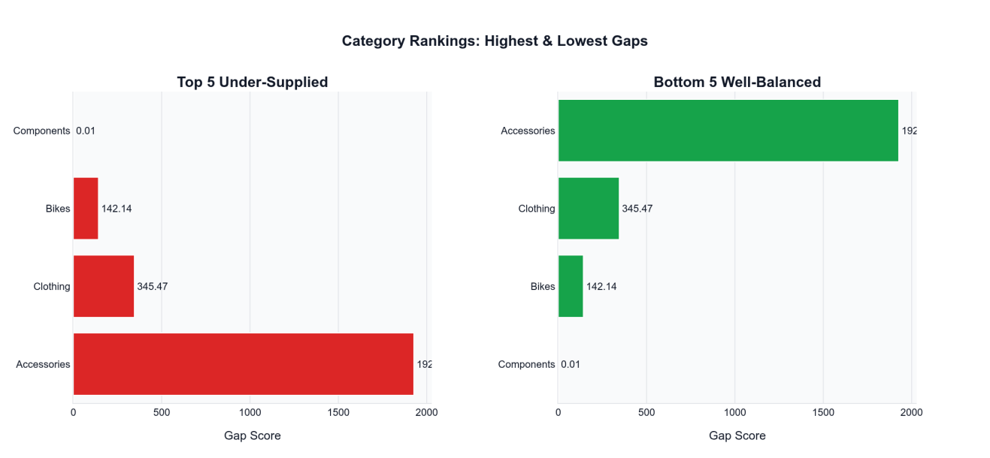

7.5 Gap Distribution
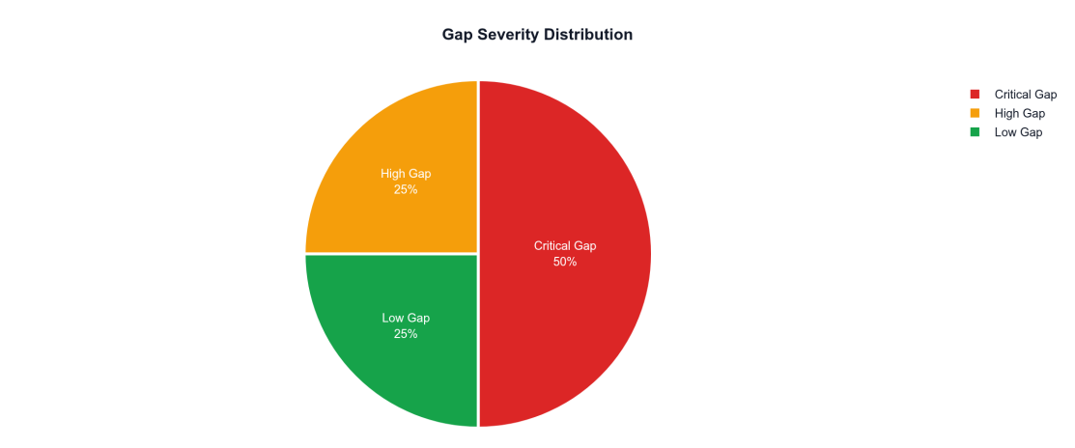

8. Business Insights

8.1 Critical Gaps
- Several subcategories exceed gap scores of 200–350.
- Immediate action required for these areas.

8.2 Balanced Categories
- A minority of categories show balanced supply-demand conditions.

8.3 Recommendations
- Supplier recruitment
- Inventory diversification
- Regional expansion
- Return reduction policies
- Demand-driven sourcing

9. Monitoring Framework

9.1 Weekly Snapshots
Automatically stored as JSON and CSV.

9.2 KPI Tracking
KPIs include:
- Average gap score
- Supply deficit indicators
- Territory alerts
- Change week-over-week

9.3 Alert System
Flags categories whose gap scores increase beyond thresholds.

10. Action Plans

10.1 Operational Actions
- Immediate inventory expansion
- Supplier renegotiation

10.2 Strategic Actions
- Category-level sourcing strategy
- Market expansion

10.3 Platform Optimization
- Improve product discovery
- Enhance supplier dashboards

10.4 User Engagement
- Targeted customer outreach
- Recommendation engine integration

11. API Integration

11.1 Recommended Endpoints
Sample:
GET /api/gaps/categories
GET /api/gaps/subcategories
GET /api/monitoring/kpis
GET /api/actions/current-week

11.2 Export Formats
- Excel
- CSV
- JSON
- HTML visualizations

11.3 Usage Example
gaps = compute_gap_score(df)
actions = planner.generate_category_action_plan(gaps)

12. Conclusion
This project delivers a complete analytical framework for identifying and addressing supply shortages within a rental platform. Through a robust pipeline, modular codebase, interactive visualizations, and monitoring tools, stakeholders gain actionable insights to guide operational and strategic decisions.

13. Future Work
- Predictive modeling
- Dynamic pricing
- Real-time alert systems
- ML-based gap prediction
- Automated supplier notifications

14. Appendices
- Data Dictionary
- Module API documentation
- Full gap score tables
- All action plans
- Installation guide

