Hamza Rauf:
I use google test framework for unit testing.
Google Test is a unit testing library for the C++ programming language, based on the xUnit architecture. The library is released under the BSD 3-clause license. It can be compiled for a variety of POSIX and Windows platforms, allowing unit-testing of C sources as well as C++ with minimal source.
Installation:
sudo apt-get install libgtest-dev
compile the library source file and copy it to the usr/lib/
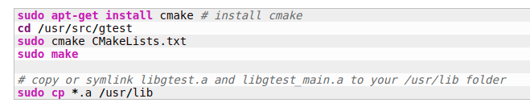
main code file which contains functions as a units:

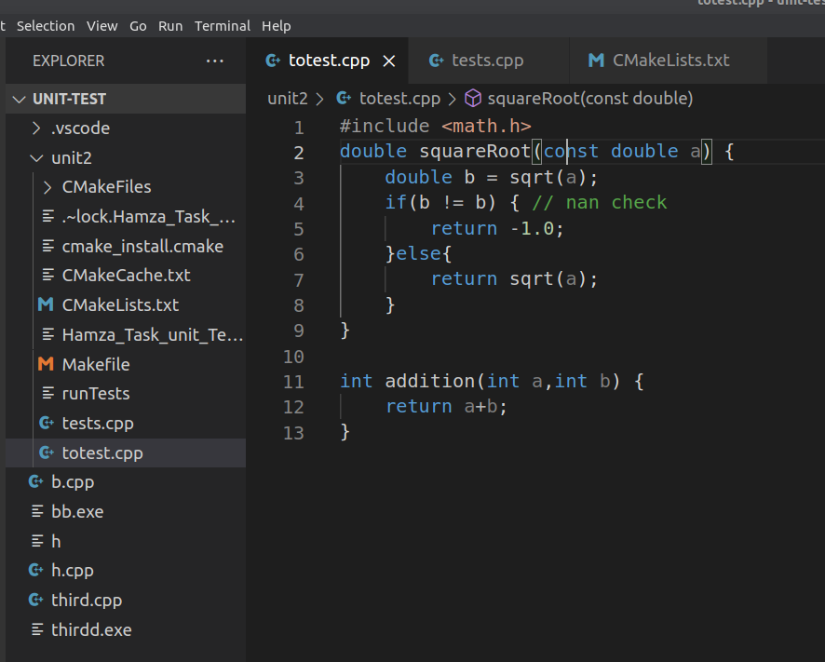
writing test as an assertions:
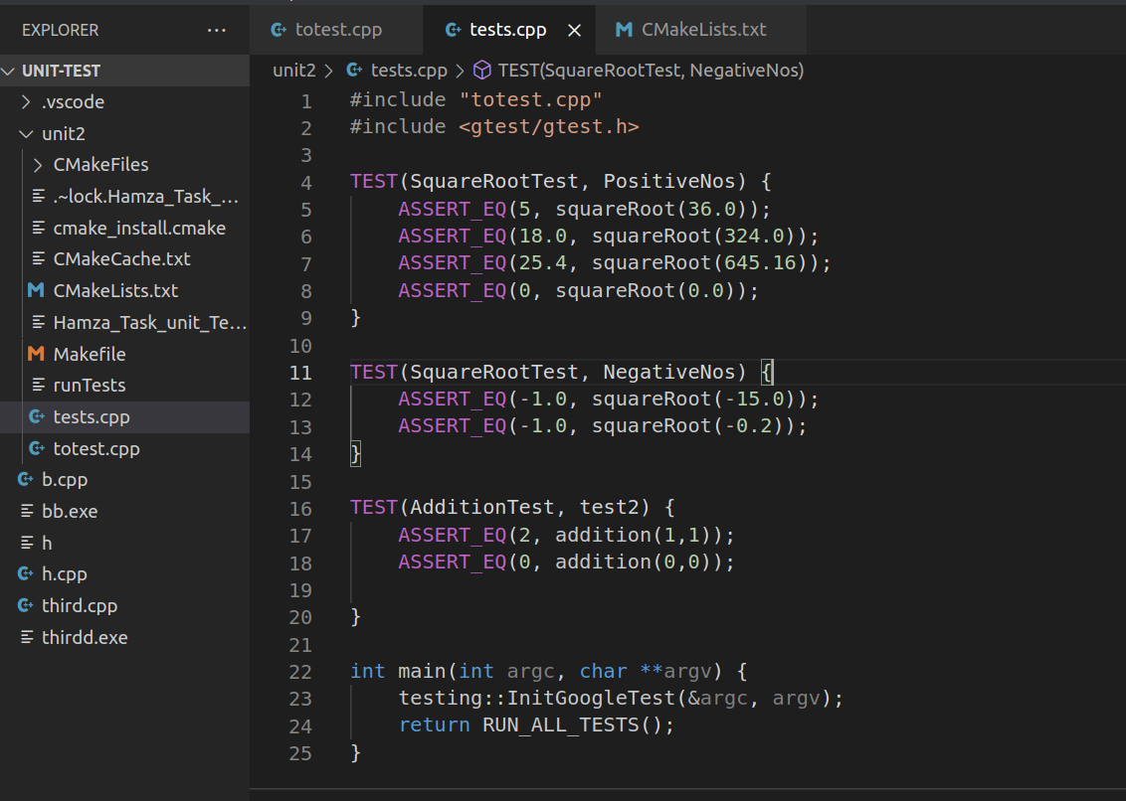
the making cmake file to add the directives and instructions to add google test source files :

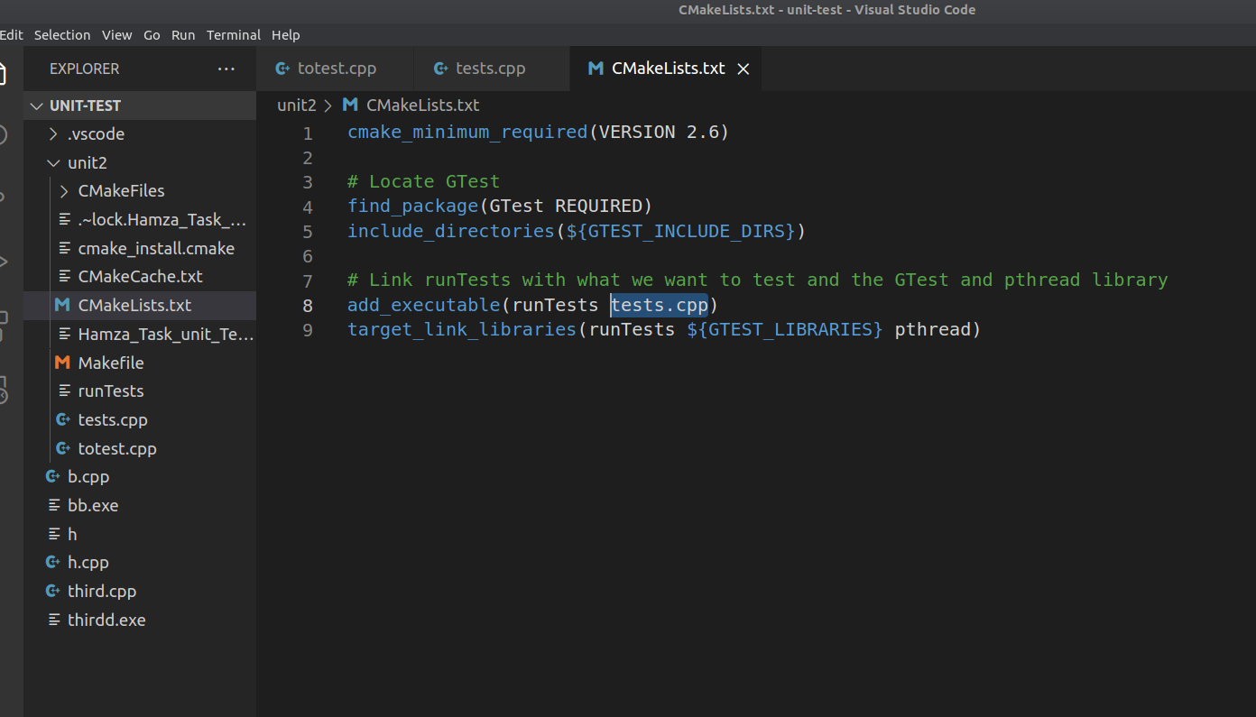
make our project:
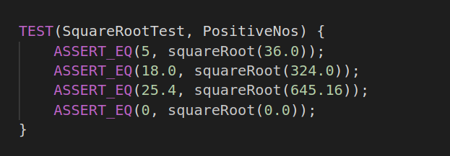
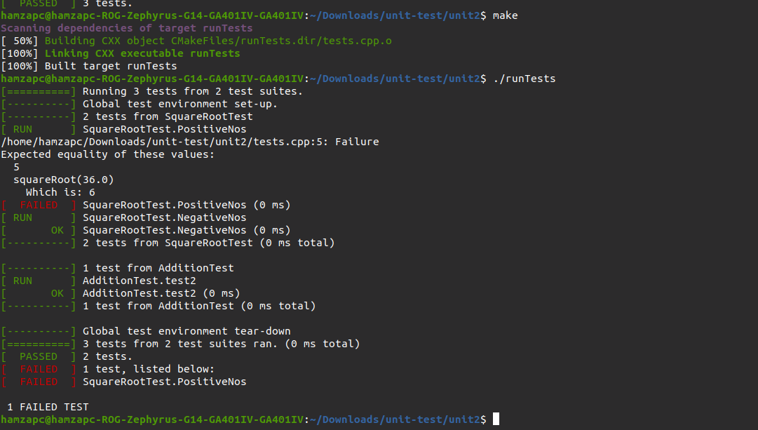
and execute the runtest executables file to run all the tests:
as 1 test failed cause the square root of 36 is 6 we assume it to be 5.

