CN Project – SDN
Name: Hamza Shabbir Sahapurwala
SRN: PES2UG24CS177
Section: C
Semester: 4th
Scenario 1:
Allowed vs Blocked:
Allowed:
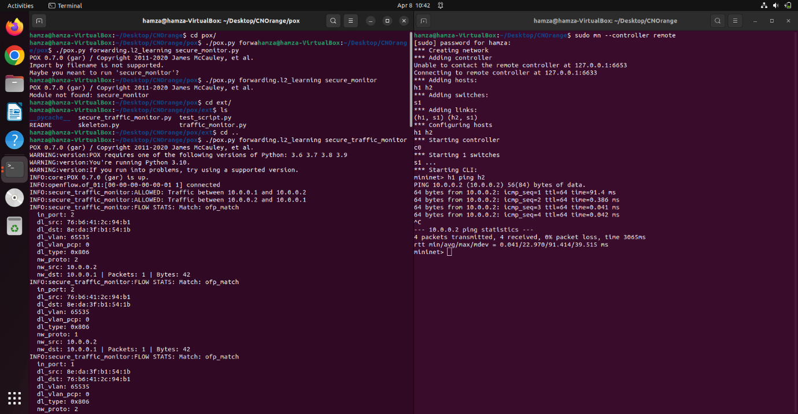
POX controller knows that H1 can connect with H2, so the connection is allowed to be established.
Blocked:
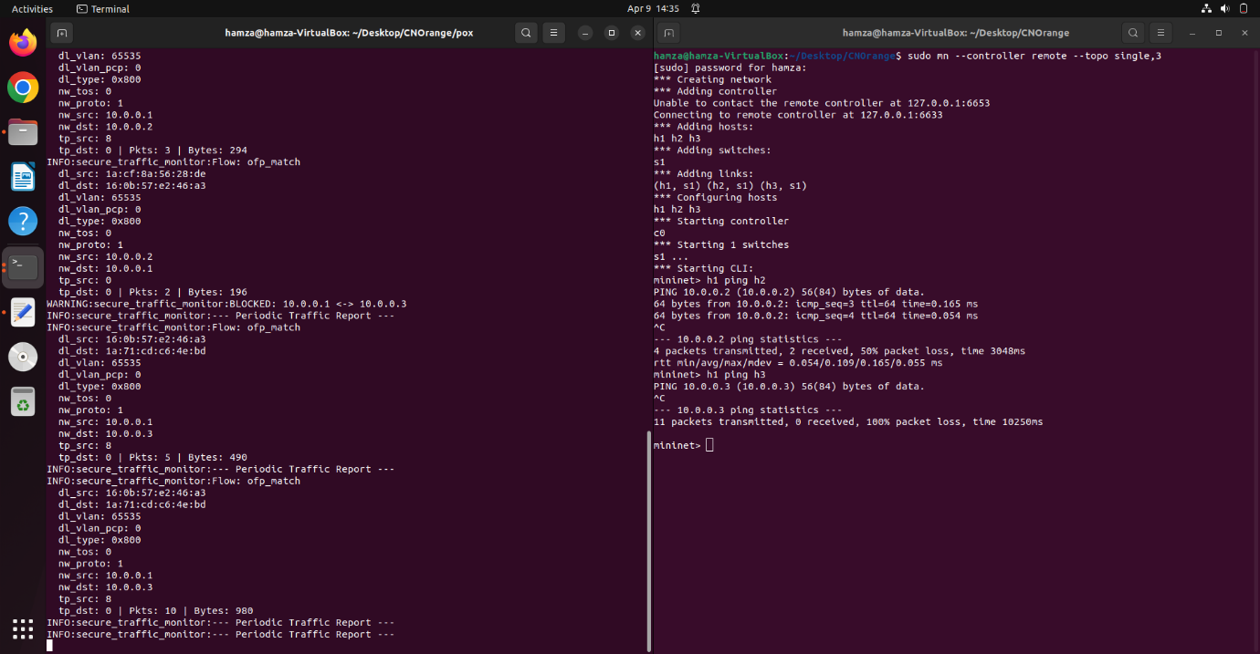
The POX controller knows that H1 can’t connect to H3 so it stops the connection from happening by calling it a blocked connection where all the packets time out.
Scenario 2:
Normal vs Failure:
Normal:
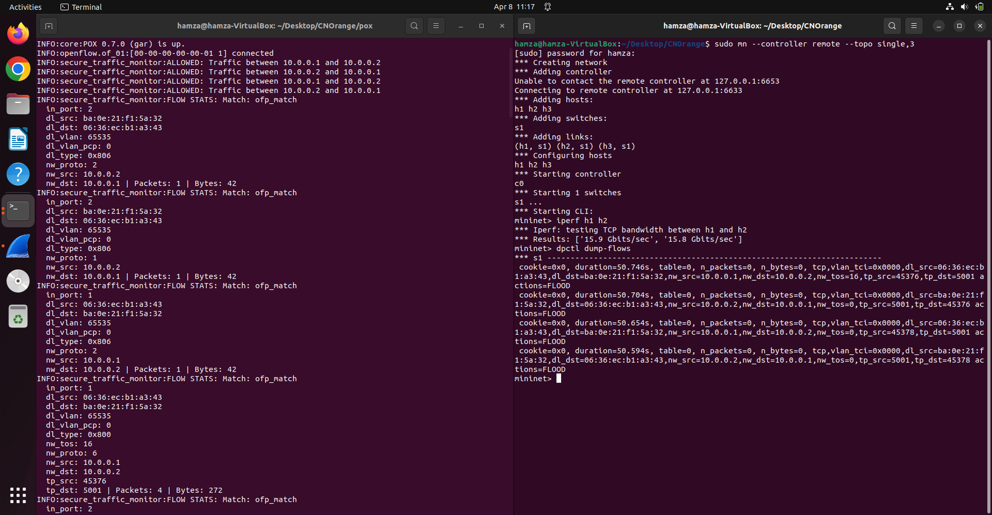
The packets are sent and received correctly.
Failure:
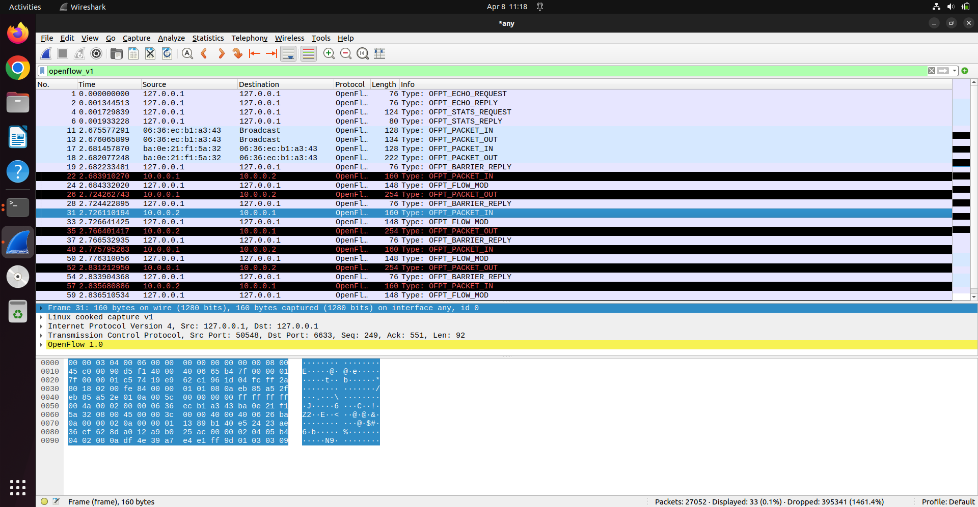
The POX controller is switched off leading to the packets are not being received and being recent by the sender(as shown by the error messages).

