**Digital Design and Computer Organisation Laboratory**

**3rd Semester, Academic Year 2025**

Date:11/8/2025

|  |  |  |
| --- | --- | --- |
| Name: Hamza Shabbir Sahapurwala | SRN:PES2UG24CS177 | Section  C |

Week Number: 2 Program Number:

TITLE:

Deliverables

1. Verilog Code Screenshot
2. Verilog VVP Output Screen Shot
3. GTKWAVE Screenshot
4. Output Table to be completed and included

Circuit 1:

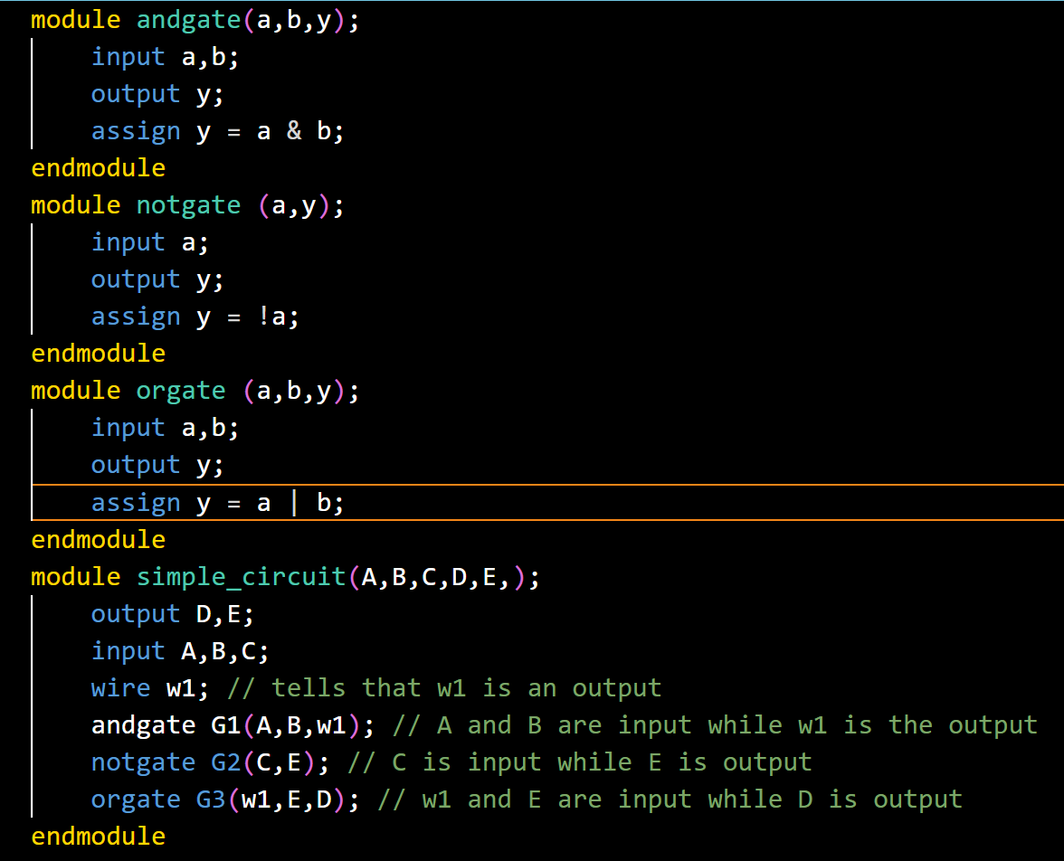

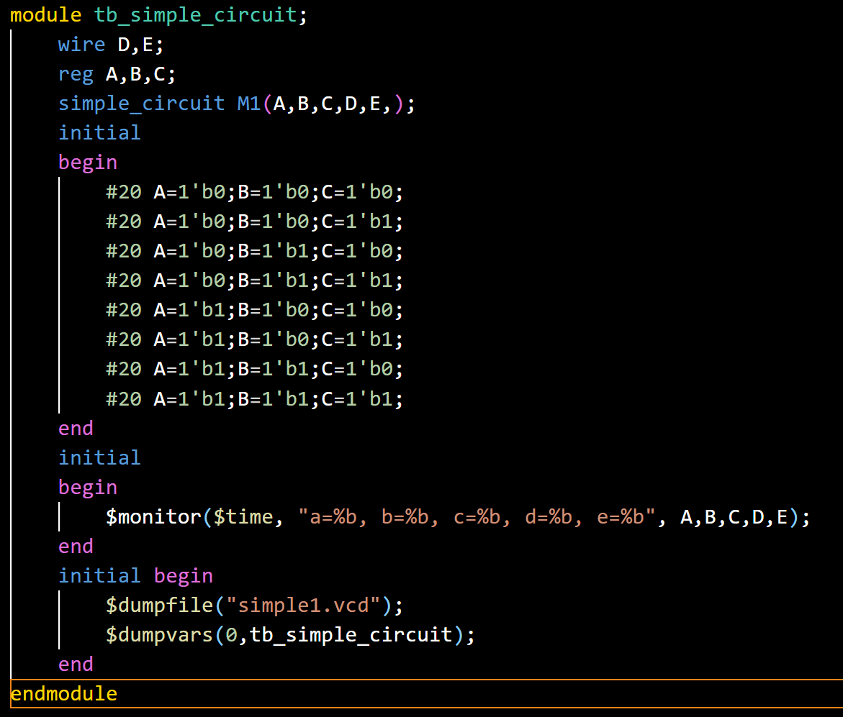

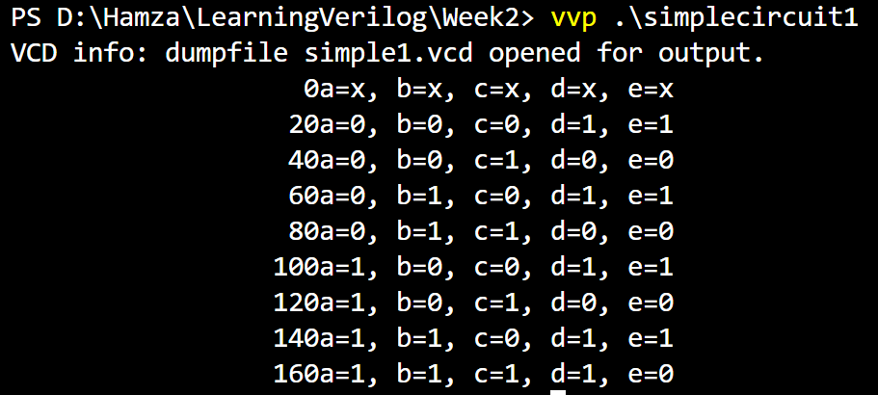

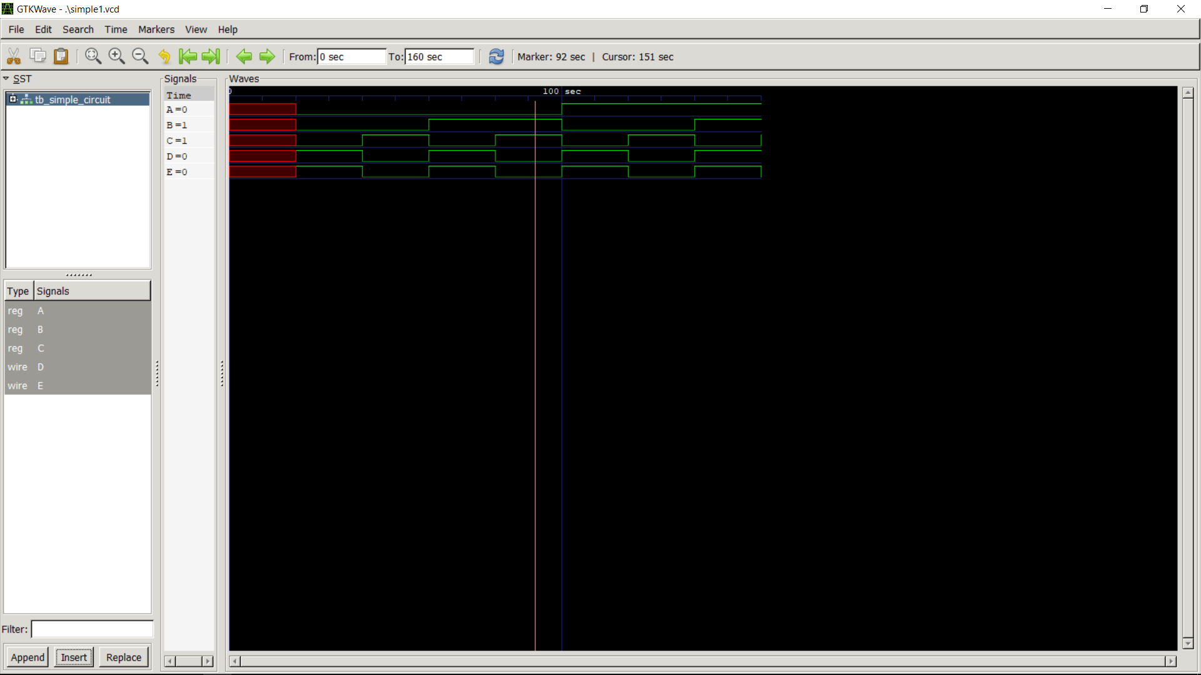

Circuit 2:

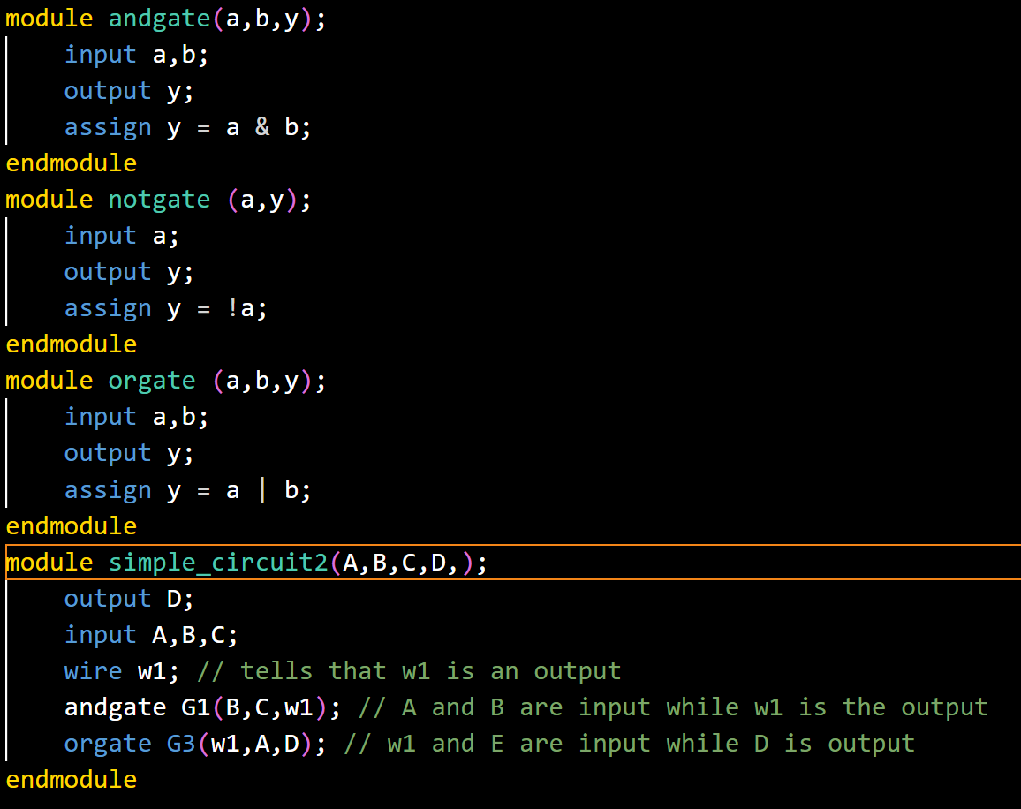

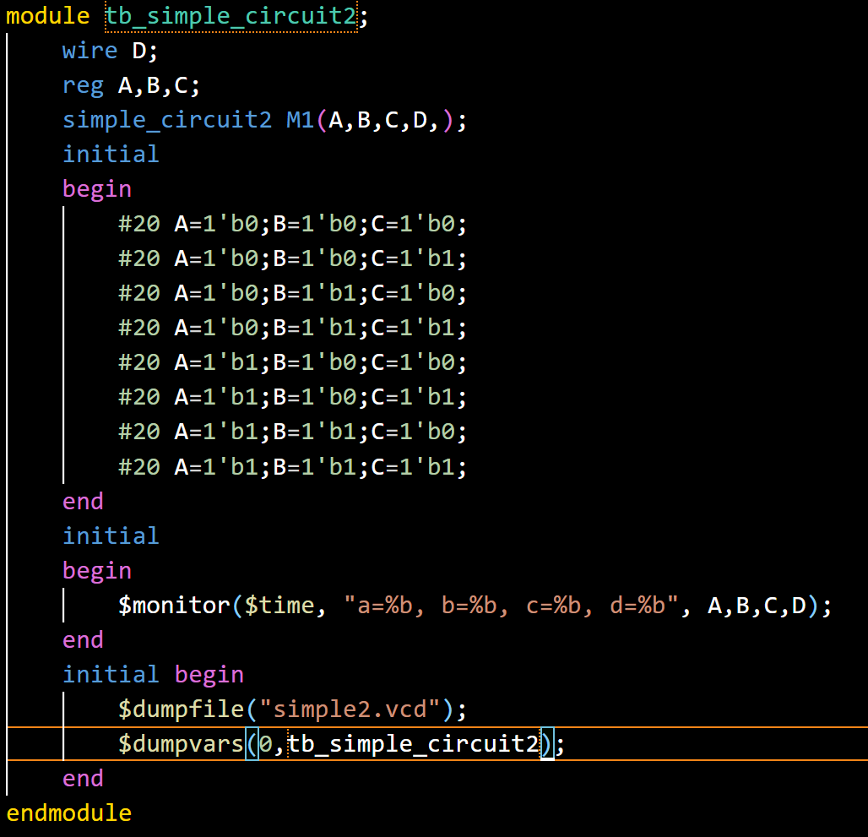

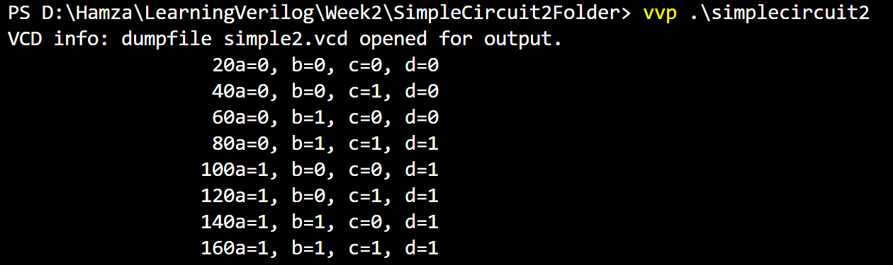

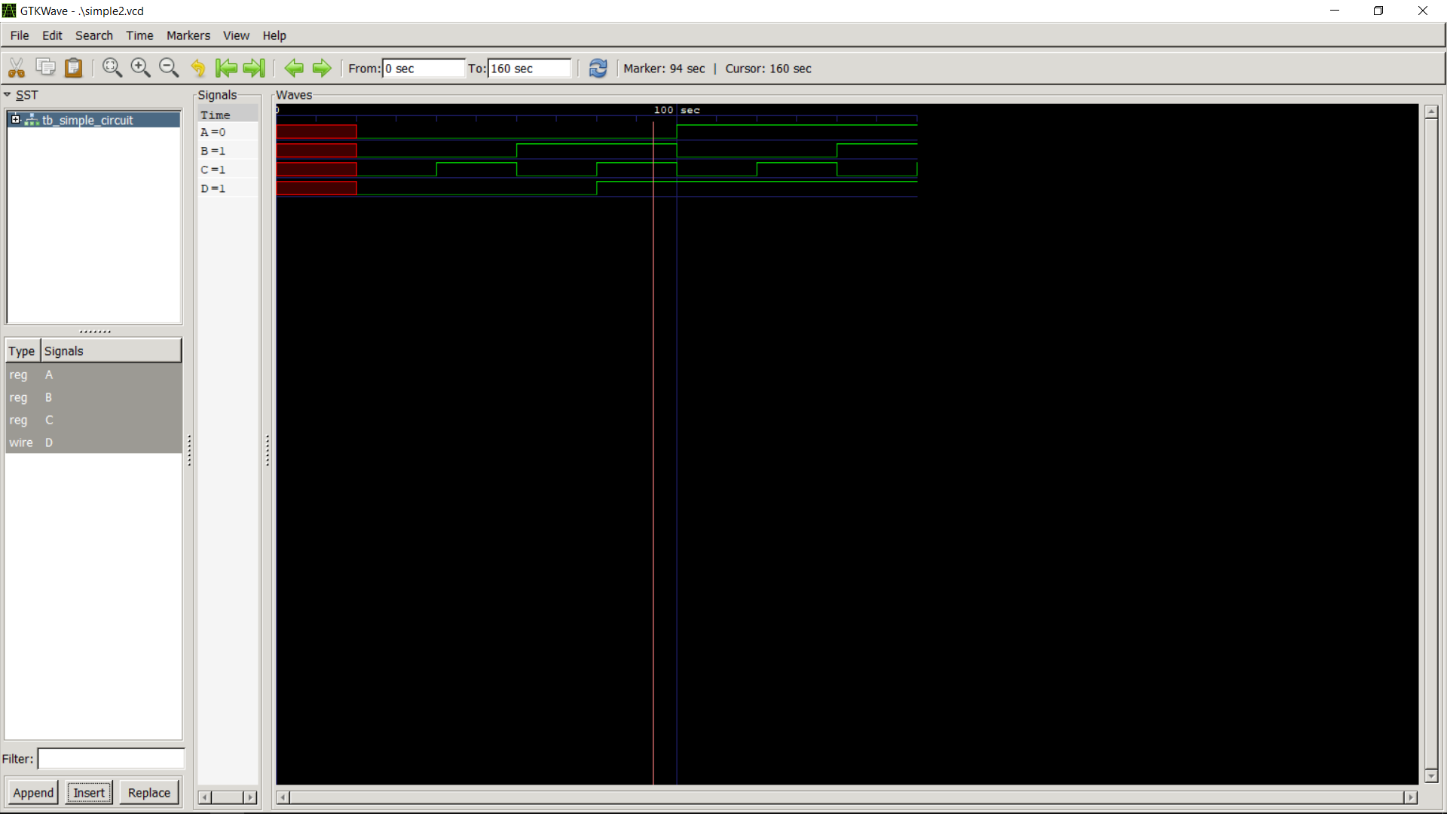

Circuit 3:

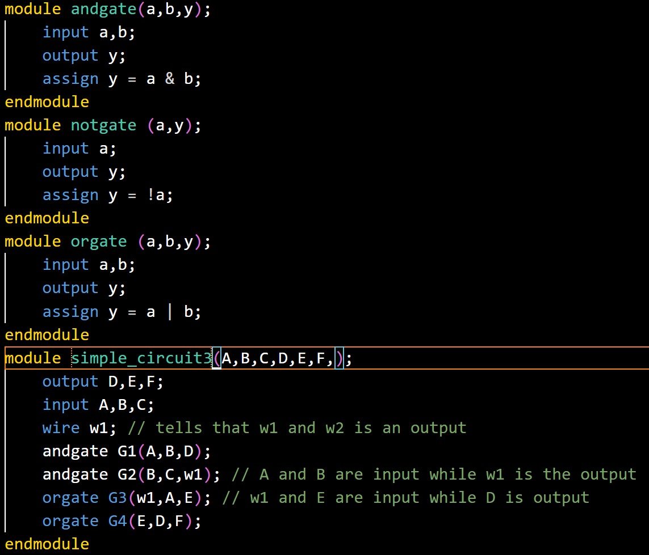

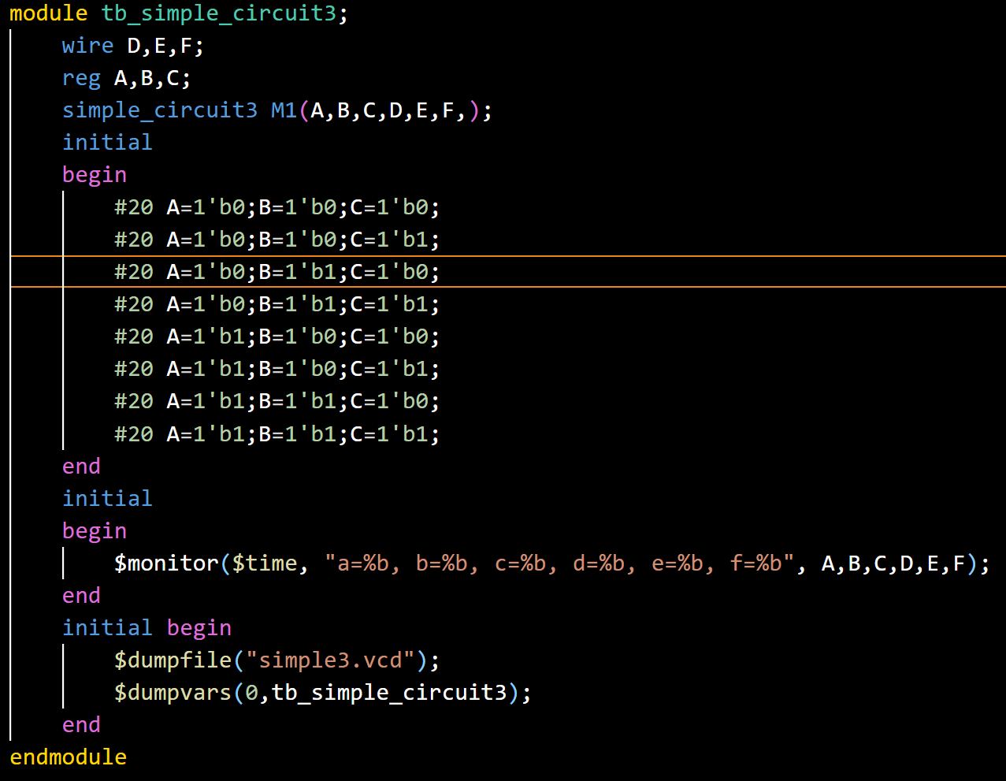

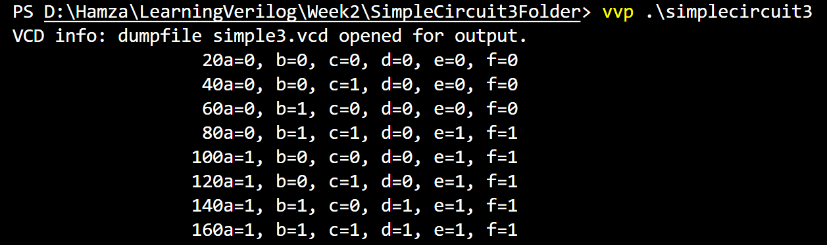

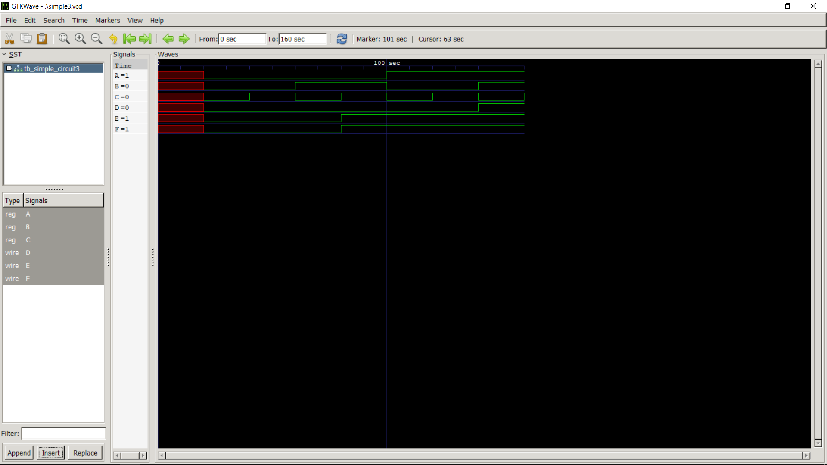

Circuit 4:

