Institute of Management Sciences Peshawar
Result Analysis Report
Name: Haroon Bacha
Subject: Deep Learning
Semester and Program: BSDS (B)
Submitted to: Dr. Afsheen Khalid

CNN with Data Augmentation on Chest X-ray Dataset

1. Dataset Information and Source
The dataset used for this assignment is the Chest X-Ray Pneumonia dataset, which is a publicly available medical imaging dataset sourced from Kaggle. The dataset contains labeled chest X-ray images categorized into two classes: NORMAL and PNEUMONIA. The images are collected from pediatric patients and are commonly used in academic research to evaluate deep learning models for medical image classification.
Dataset source: Kaggle – Chest X-Ray Images (Pneumonia)
https://www.kaggle.com/datasets/paultimothymooney/chest-xray-pneumonia
The dataset is structured into three subsets: training, validation, and testing. This split allows effective training of the model, tuning of hyperparameters, and unbiased performance evaluation.

2. Data Loading and Preprocessing
The dataset was downloaded directly using the Kaggle API and extracted in the Google Colab environment. Image preprocessing involved resizing all images to a fixed resolution of 224×224 pixels to ensure uniform input dimensions for the Convolutional Neural Network (CNN). Pixel values were normalized by rescaling them to the range [0,1] to improve numerical stability during training.

3. Data Augmentation
To improve model generalization and reduce overfitting, data augmentation techniques were applied to the training dataset using Keras ImageDataGenerator. Augmentation operations included random rotation, zooming, width and height shifting, and horizontal flipping. These transformations artificially increase the diversity of training samples without collecting new data, which is particularly important for medical datasets where data availability is limited.

4. CNN Architecture and Training
A Convolutional Neural Network was designed using multiple convolutional layers followed by max-pooling layers to extract hierarchical features from chest X-ray images. The network includes fully connected layers for classification, with a sigmoid activation function in the output layer to perform binary classification. The model was compiled using the Adam optimizer and binary cross-entropy loss function. Training was performed for multiple epochs, and both training and validation metrics were recorded.

5. Results and Performance Analysis
The training and validation accuracy and loss were plotted across epochs to analyze model behavior. The training accuracy shows a steady increase with a corresponding decrease in training loss, indicating effective learning. Validation accuracy fluctuates across epochs, which is expected due to the limited size of the validation dataset and the complexity of medical images. However, the overall trend suggests that data augmentation helped mitigate overfitting and improved generalization.

6. Figures
Figure 1: Training vs Validation Accuracy
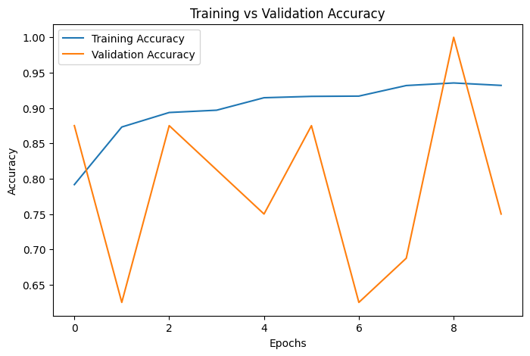
Figure 2: Training vs Validation Loss
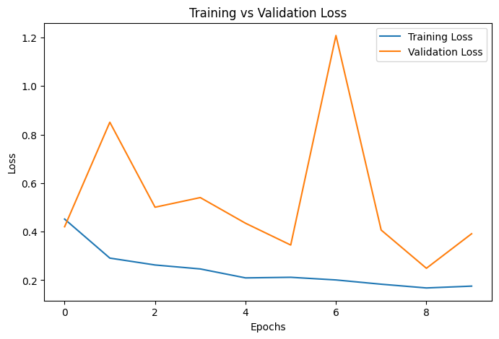

7. Conclusion
In this assignment, a CNN-based approach was successfully implemented to classify chest X-ray images into NORMAL and PNEUMONIA categories. Data augmentation played a crucial role in enhancing model performance and reducing overfitting. The plotted accuracy and loss graphs demonstrate effective learning behavior, making this approach suitable for medical image classification tasks.

