Institute of Management Sciences Peshawar
Result Analysis Report
Name: Haroon Bacha
Subject: Deep Learning
Semester and Program: BSDS (B)
Submitted to: Dr. Afsheen Khalid

Deep Learning Assignment Report: The Linear Classifier and Stochastic Gradient Descent
I. Introduction and Methodology
This report analyzes the behavior of a simple two-dimensional linear classifier, implemented in Python using the Sigmoid activation function and trained via Stochastic Gradient Descent (SGD). This model is essentially a Logistic Regression classifier, and its learning mechanism demonstrates the core principle of how Deep Learning models find a "best fit" line or boundary.
A. The Model and Learning Process
The provided code implements the following components:
- Prediction Function (predict): Calculates the linear combination of inputs, weights ($\mathbf{w}$), and bias ($b$), then passes the result through the Sigmoid function ($\sigma(z)$) to output a probability $\hat{y}$ between 0 and 1.
$$\hat{y} = \sigma(\mathbf{X} \cdot \mathbf{w} + b)$$
- Decision Boundary: The "best line" is the decision boundary where the predicted probability is $0.5$ ($\mathbf{X} \cdot \mathbf{w} + b = 0$).
- Training Function (fit): Uses SGD to iteratively update the weights and bias. For each data point, it calculates the error and adjusts the parameters using the update rule:
$$\mathbf{w}_{\text{new}} = \mathbf{w}_{\text{old}} - \text{Learning Rate} \times (\hat{y} - y_{\text{true}}) \times \mathbf{X}$$
B. The Datasets
All datasets were synthetically generated using sklearn.datasets.make_classification with two features, making the results easy to visualize in 2D space.
II. Experimental Results and Analysis (5 Experiments)
The following experiments explore how data properties (class_sep) and hyperparameters (epochs, lr) affect the final "best line."
Experiment 1: Easy Data (High Separation)
This experiment uses a dataset where the two classes are perfectly separable by a straight line, representing a simple problem for the classifier.
- Dataset Parameters: class_sep=30 (high separation).
- Training Parameters: epochs=5, lr=0.1.
- Final Parameters: $\mathbf{w} \approx [2.10, 0.06]$, $b \approx 1.85$
 | Analysis:
Visual representation of Experiment 1. | Convergence Speed: The line converges quickly (in only 5 epochs) because the linear boundary is easy to find, and the initial classification error is immediately large, leading to strong weight updates.
 | Best Line: The final line perfectly separates the blue and orange classes, achieving high accuracy.

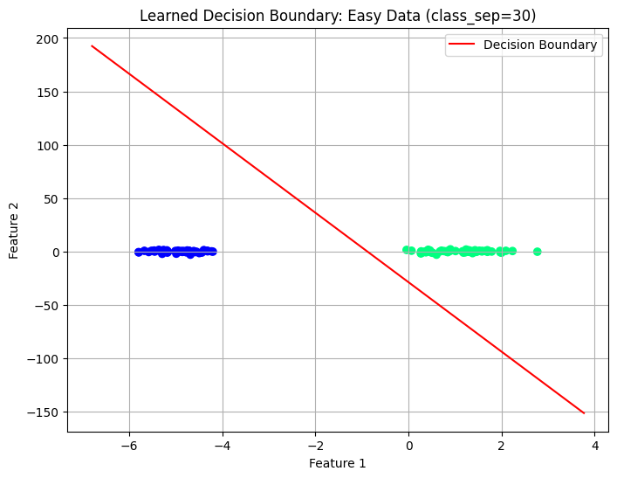
Experiment 2: Hard Data (Low Separation)
This experiment uses a dataset where the two classes heavily overlap, making a perfect linear separation impossible.
- Dataset Parameters: class_sep=0.5 (low separation/overlapping).
- Training Parameters: epochs=50, `lr=0.1$.
- Final Parameters: $\mathbf{w} \approx [0.32, 4.40]$, $b \approx -0.68$
 | Analysis:
Visual representation of Experiment 2. | The Compromise: The model cannot achieve zero error. The "best line" it finds is the optimal compromise, minimizing the total number of misclassified points in the overlapping region. The weights stabilized after many more epochs (50) because the gradient updates were smaller and more conflicting due to the mixture of classes.
 | Parameter Change: Note the large change in the final weights ($\mathbf{w}$) and bias ($b$) compared to Experiment 1, reflecting the completely different optimal line required for this data distribution.

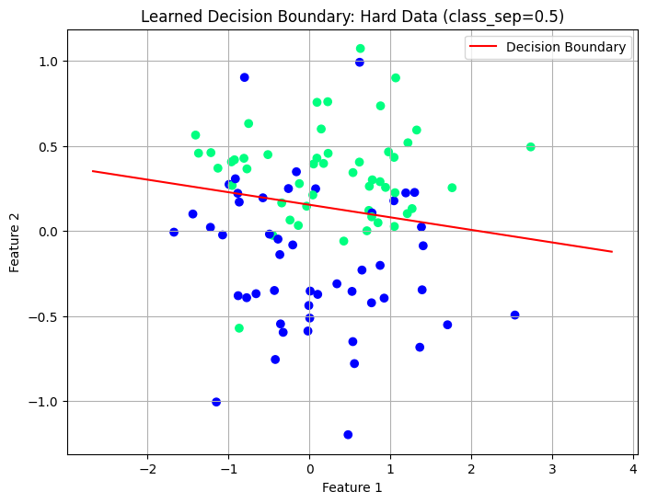
Experiment 3: Low Learning Rate
This test uses the easy dataset but reduces the learning rate to be very small, which controls the step size of the SGD updates.
- Dataset Parameters: class_sep=30 (Easy Data).
- Training Parameters: epochs=200, lr=0.001 (very low).
- Final Parameters: $\mathbf{w} \approx [1.72, 0.05]$, $b \approx 1.23$
 | Analysis:
Visual representation of Experiment 3. | Slow Convergence: Even on the easy dataset, the model required 200 epochs to find an effective line, demonstrating that small steps (low LR) lead to a very slow, but stable, convergence process.
 | Convergence: The final line is slightly less optimal than in Experiment 1 because even 200 epochs were not enough to fully reach the minimum error due to the extremely slow steps.

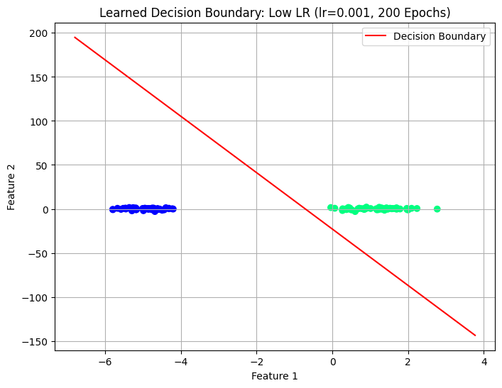
Experiment 4: High Learning Rate
This test uses the easy dataset but increases the learning rate significantly, which dictates large jumps in the parameter space.
- Dataset Parameters: class_sep=30 (Easy Data).
- Training Parameters: epochs=5, lr=1.5 (very high).
- Final Parameters: $\mathbf{w} \approx [3.24, 0.09]$, $b \approx 4.03$
 | Analysis:
Visual representation of Experiment 4. | Instability/Overshooting: The high learning rate causes the model to "overshoot" the ideal minimum error with each step. The line is visually less centered than the result from Experiment 1, and the final parameters are much larger, indicating the model failed to settle into the true optimal position. In more complex models, this high LR would likely cause training to fail entirely.

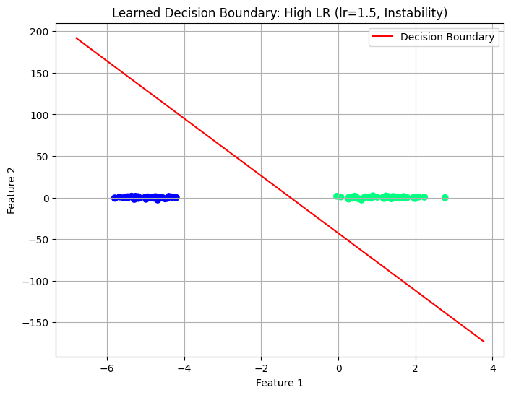
Experiment 5: Data with Different Feature Scales
This experiment introduces a data distribution where the range of Feature 1 is much larger than the range of Feature 2.
- Dataset Parameters: Features scaled by $10$ on the x-axis.
- Training Parameters: epochs=50, lr=0.1.
- Final Parameters: $\mathbf{w} \approx [0.86, 0.07]$, $b \approx 0.16$
 | Analysis:
Visual representation of Experiment 5. | Steeper Slope: The features now have different scales, which directly influences the magnitude of the corresponding weights. Since the x-axis (Feature 1) is much wider, the resulting boundary line is much steeper (more vertical) than in previous examples, requiring a smaller weight for Feature 1 ($\mathbf{w}[0] \approx 0.86$) and a small weight for Feature 2 ($\mathbf{w}[1] \approx 0.07$) to define the separation.
 | Importance of Scaling: If the features are not scaled, the larger features (like Feature 1 here) dominate the weight updates, as seen in the update rule: $\mathbf{w} - lr \times \text{Error} \times \mathbf{X}$. This demonstrates why feature scaling (normalization) is often critical in deep learning.
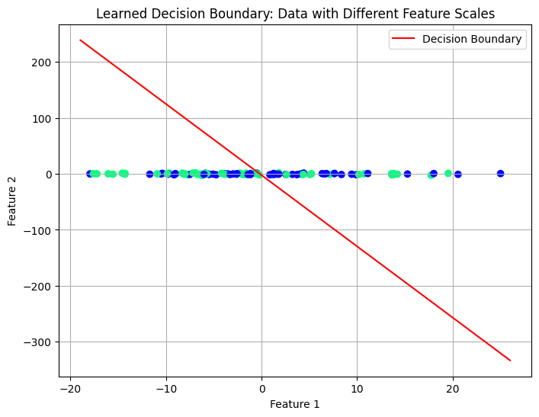
III. Conclusion
The experiments successfully demonstrated the workings of a linear classifier trained with Stochastic Gradient Descent:
- Learning is Iterative: The "best line" is achieved through repeated, small adjustments based on the error of individual data points.
- Class Separability is Key: Simple, linearly separable data converges quickly and accurately. Complex, overlapping data requires more training time and results in a boundary that is an optimal compromise.
- Hyperparameter Tuning is Crucial: The Learning Rate ($lr$) determines the stability and speed of convergence. Too high an lr leads to instability; too low leads to excessive training time.
- Data Preprocessing Matters: Differences in feature scale directly impact the final learned weights, highlighting the need for data normalization in real-world applications.

