Freight Rate Prediction
Machine Learning Engineer Assessment
48,000 labelled loads (Jan-Oct 2025) | 12,000 predictions (Nov-Dec 2025)

1. Summary
Rates are multiplicative in their drivers, so the model predicts log(posted_rate) with gradient-boosted trees and converts back with a smearing correction. The work that mattered was not the estimator: it was identifying which labels are corrupted, and separating the two time effects that a tree model cannot extrapolate on its own. Everything to be predicted (November and December 2025) sits after the last training date, so those effects are handled analytically.
On a forward holdout of September-October 2025, trained only on January-August, the model reaches 1.394% MAPE and R² = 0.99895. That is at the noise floor of the data — the residual standard deviation after removing lane, day and equipment effects is about 1.8% in log space.

2. What the data looks like
Four findings shaped the model.
- Strong, clean structure. posted_rate scales with distance at an elasticity near 0.87, so rate per mile falls on long hauls — $2.80/mile under 200 miles, $1.87/mile above 2,500. Modelling in log space makes this linear.
- A persistent drift: net of everything else, rates ratchet up about +2% per quarter (+7.4% annualised). It is steady enough across the ten months to be extrapolated.
- A repeating within-quarter ramp: net of that drift, the rate level is roughly flat for the first two months of a quarter and then climbs 4-5% through the third month, resetting at the quarter boundary. The shape is nearly identical in Q1, Q2 and Q3. December is the third month of Q4, so this effect is the single largest driver of the December chart.
- market_index is a day-level signal: between-day sd is 0.17 against a within-day sd of only 0.025, so the field is a daily series observed with row noise. It carries a weekly cycle of ±0.09 on top of an annual swing from 0.89 to 1.30, and moves rates by about 0.14 per unit in log space. quote_signal is statistically real but small, worth under 1%.

3. Data quality issues and how they were handled
Issue | Rows | Diagnosis | Handling
weight stored negative | 292 | Magnitudes match the healthy distribution exactly; only the sign is wrong | Absolute value — no rows discarded
weight missing | 300 | No pattern by date, lane or equipment | Equipment-level median + a missingness flag
market_index missing | 374 | Field is a day-level series observed with row noise | That day's mean across all loads
posted_rate corrupted | 677 (1.41%) | Loads priced 2-6x too high or too low with healthy neighbours on the same lane, day and equipment | Excluded from training only, never from the submitted predictions

The corrupted labels are worth spelling out because they are unambiguous and because they cost the most. A Huber regression of log(rate) on the structural drivers leaves a residual distribution with a tight core (|r| < 0.16) and two detached wings that start past |r| ≈ 0.8, with nothing in between. Any cut-off inside that gap selects the same rows; 0.4 was used. Leaving them in training nearly triples holdout error (1.394% → 3.972% MAPE).
One more property drove a feature decision rather than a cleaning one: 12.1% of the validation loads touch a city that never appears in the training data. Origin and destination are therefore given to the model as coordinates as well as labels. The origin premium is spatially smooth — Texas origins price about 3% high, Great Lakes origins about 3% low — so latitude and longitude let the model place a city it has never seen.

4. Train/validation approach and how the data was split

Why the split is time-based
The development data runs 1 January to 31 October 2025; the loads to be priced run 1 November to 31 December 2025. Every prediction is therefore an extrapolation forward in time. A random split would put loads from the same day on both sides of the split, letting the model read that day's market conditions off its training rows — a leak that does not exist in the real task and that would flatter every metric. The split used for model selection is a forward holdout: train on everything before a cut-off, score the months after it.
Four cut-offs were run to see how error grows with the forecast horizon. The 1 September cut-off is the design decision point, because it reproduces the real task most closely: eight months of history, two months to predict.
Forward holdout | Rows | MAE | RMSE | MAPE | MedAPE | R²
Jul-Oct (4 months ahead) | 18,917 | $62.53 | $92.26 | 2.623% | 2.230% | 0.99539
Aug-Oct (3 months ahead) | 14,070 | $52.80 | $78.91 | 2.309% | 1.847% | 0.99663
Sep-Oct (2 months ahead) | 9,379 | $30.97 | $44.54 | 1.394% | 1.156% | 0.99895
Oct (1 month ahead) | 4,773 | $31.45 | $44.86 | 1.428% | 1.182% | 0.99892

Random 5-fold cross-validation was run alongside, not as the selection criterion but to price the leak: it averages 1.236% MAPE against the forward holdout's 1.394%. The gap is the entire cost of predicting forward in time, which is small evidence that the drift and quarter-phase terms are doing their job.
Corrupted labels are removed from the holdout as well as from training. They are unpredictable by construction, so scoring against them measures the corruption, not the model. They are never removed from the submitted predictions — all 12,000 validation loads are priced.

Handling time explicitly
Gradient-boosted trees cannot extrapolate a trend: past the last split point they return a constant. With ten months of rising rates and two months to predict, that is a systematic under-prediction that grows every day of the forecast. Two changes fix it:
- The drift is removed analytically: estimated by OLS with day-of-quarter dummies and full structural controls, then subtracted from the target before fitting and added back at prediction time. Using day-of-quarter controls in that regression matters — without them the within-quarter ramp inflates the slope.
- The within-quarter ramp is learned in a form that repeats: day_of_quarter is a model feature and the absolute date is not. Three complete quarters of training data cover all 92 positions, so the shape is learned from Q1-Q3 and applied to Q4, including the 61-91 range that December occupies. Feeding the absolute date to the trees instead is what produces a flat December.

Ablations
Each design decision was measured on the September-October holdout.
Configuration | MAE | RMSE | MAPE | R²
Final model | $30.97 | $44.54 | 1.394% | 0.99895
Corrupted labels left in training | $89.00 | $148.34 | 3.972% | 0.98837
Absolute date as a tree feature (no drift term) | $44.38 | $63.70 | 1.874% | 0.99785
No smearing correction | $30.97 | $44.54 | 1.394% | 0.99895

The smearing factor comes out at 1.00003 — the residual variance is small enough that it changes nothing here. It is kept because it is the correct retransformation from log space to the mean, not because it earns its place on this dataset.

Final model
HistGradientBoostingRegressor on the detrended log target, 1,500 iterations at learning rate 0.04, 63 leaves, with native categorical handling for equipment, origin and destination. Features: log distance and distance, weight, weight-per-mile and a missingness flag, row-level and day-level market_index and quote_signal, origin and destination coordinates with midpoint and bearing, day-of-quarter, day-of-week and a weekend flag. The submitted predictions come from a model trained on the full development set with these settings.

5. The fixed December prediction chart
Produced by the provided score.py from data/december_chart_inputs.csv. Every input is held fixed — Lexington to Fort Wayne, 360 miles, Dry Van, 32,000 lb — so the only thing moving the line is the date.
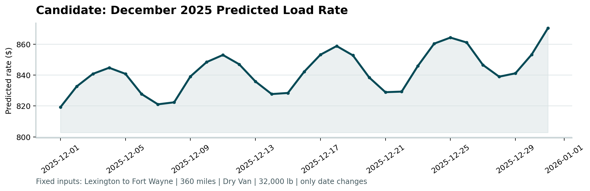
scorer_results/candidate_december.png
Three effects are visible, and each one is a structure found in the training data rather than a modelling artefact:
- The weekly wave: the seven-day oscillation is market_index, which peaks midweek and troughs at the weekend with an amplitude of about ±0.09, worth roughly ±1.3% on the rate.
- The upward slope: the line ends the month about 6% above where it starts, $819 on 1 December against $870 on 31 December. December is the third month of Q4, which is where the within-quarter ramp does most of its work; the +2%-per-quarter drift adds the rest.
- The level: the same lane in the training data prices at $757-$934 across 2025, with Dry Van loads near 32,000 lb sitting in the $790-$865 band. December landing at $819-$870 is consistent with that history plus ten months of drift.
A model that fed the raw date to the trees would draw this chart as a flat line with the weekly wiggle and no December ramp — which is the main reason the time structure is handled the way it is.

6. Reproducing
python -m pip install -r requirements.txt
python run.py # writes validation_predictions.csv and fills the December template
python score.py --predictions validation_predictions.csv --december-predictions data/december_chart_inputs.csv
python evaluate.py # forward holdouts, random CV and the ablation table above
Raw output of the validation study is in report/validation_report.txt. Model code is in src/pipeline.py.

