

PUCIT

Human Computer Interaction

SUBMITTED TO: | Dr Mudassira Arshad
SUBMITTED BY: | Hamza Zahoor | BSEF22M531

Table of Contents:
Tool Name: 3
Deployment 3
Steps to deploy the tool 3
Usage 3
List of functionality it provides 3
Stepwise screenshots to perform functionality 3
Ease of use 3
Pros and Cons of using the tool 3

Tool Name:
- Polarion ALM

Deployment:
- First of all go to link https://myaccount.polarion.com/
- The following screen will appear

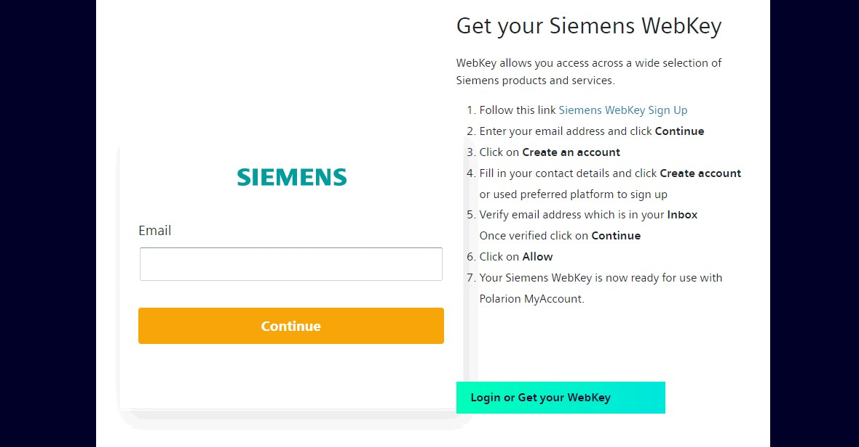

  - Now by clicking on Login or Get your WebKey, the following screen will appear.

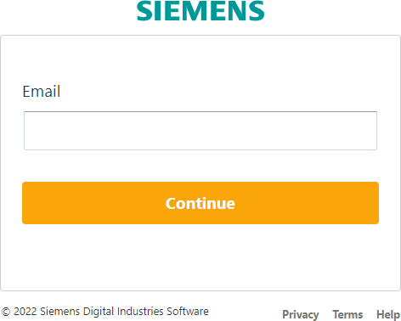

  - Now when we write the email address and click on continue, we reach the screen where we have to sign up, if we have not sign up already. We can sign up with Google, LinkedIn directly or by providing the following details.

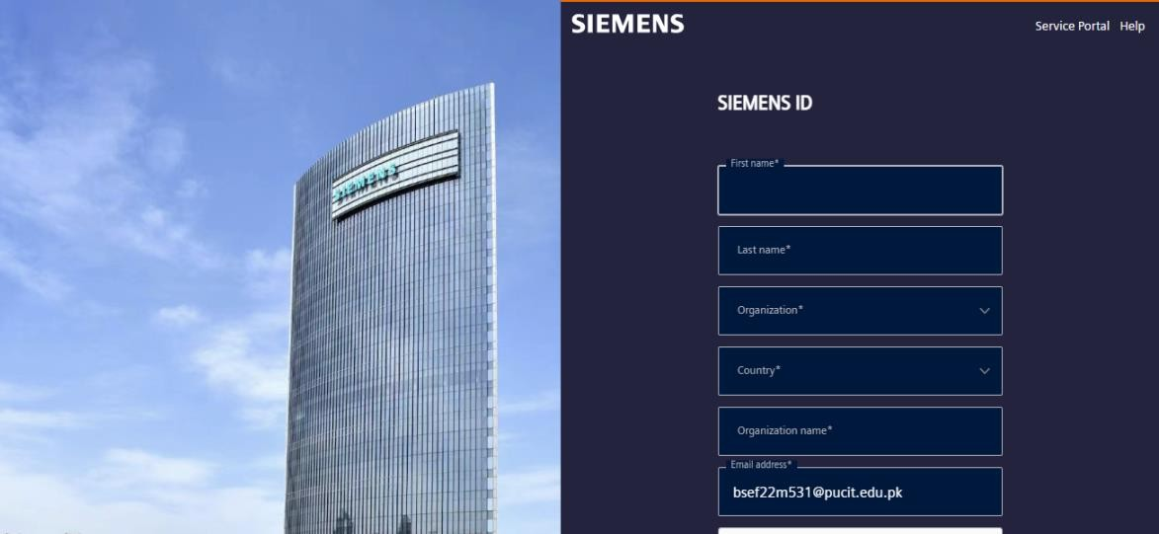

  - After writing the detail, proceed with signup process. Write email and password. After this a verification code will be sent to you on your email.

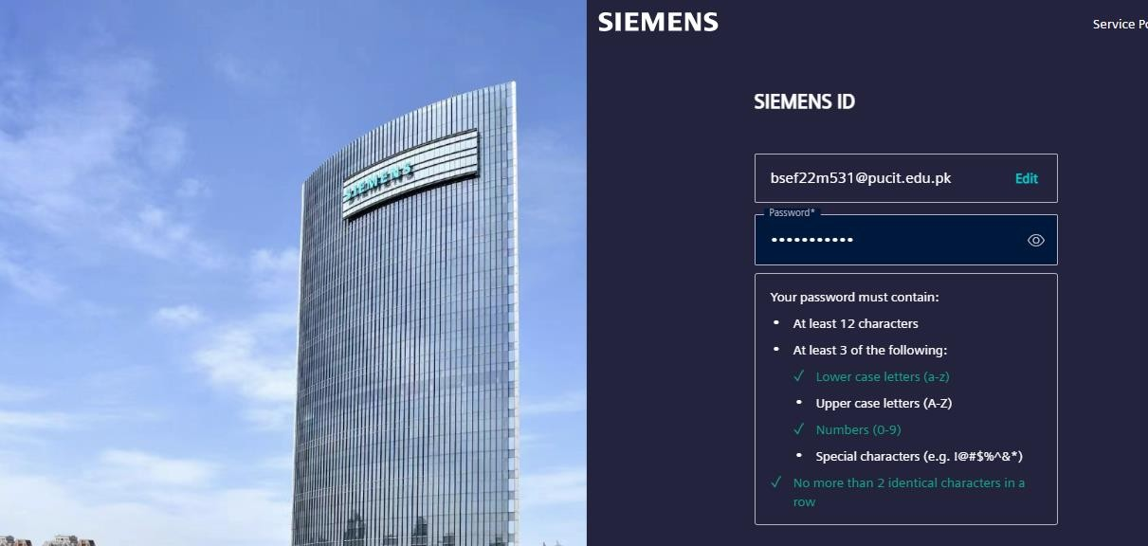

  - Now for free Trial, click on Polarion ALM launch and it will lead to the homepage of the Polarion Tool. This is the Free version of the tool available for 30 days.
  - This was the procedure of the deployment of the tool.

List of Functionality it Provides:

Usage:

Polarion is a comprehensive requirement management tool that offers a wide range of functionalities designed to support the entire lifecycle of software development projects. These functionalities include:

Requirement Management:
- Capture and manage requirements in a centralized repository.
- Support for requirement traceability and versioning.
- Requirement prioritization and categorization.

Collaboration and Communication:
- Facilitate team collaboration with threaded discussions and comments.
- Share and review documents in real-time.
- Notifications and alerts for changes and updates.

Test Management:
- Define and manage test cases linked to requirements.
- Test execution tracking and reporting.
- Integration with automated testing tools.

Change and Configuration Management:
- Track and manage changes to requirements.
- Version control for documents and artifacts.

Reporting and Analytics:
- Generate customizable reports and dashboards.
- Real-time project status and progress tracking.
- Metrics and KPI tracking for project performance.

Stepwise Screenshots to Explain Functionality:

- In the homepage, there are two default projects named Open Drive Pilot Project and Open E-Library Project based on V-Model (Waterfall model) and agile model respectively.
- We have to create a NEW PROJECT by clicking on + sign.

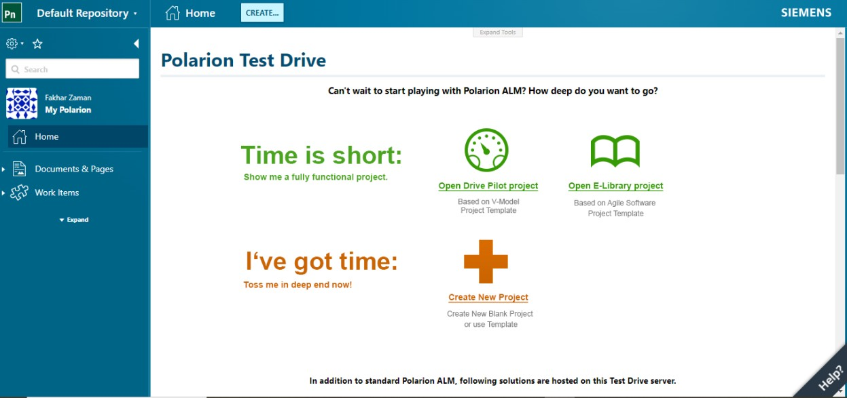

- Now we have to fill the information about project including its ID, Location and tracker prefix. After specifying it and proceeding to next you have to choose the process model which you want to use.

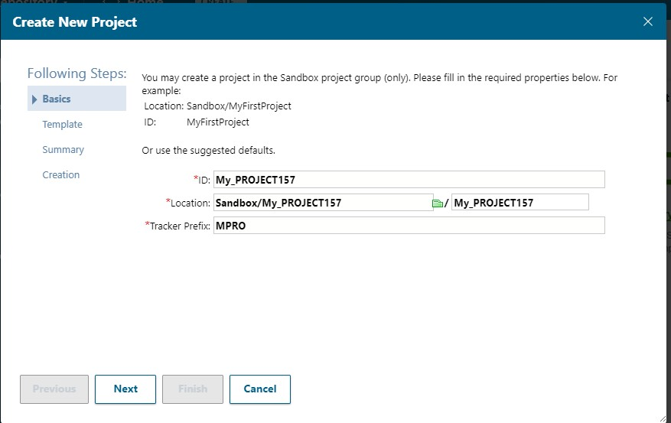

- There is a dropdown menu including many options of different process models including agile, V-model, and model of default projects of e-library and drive pilot project.

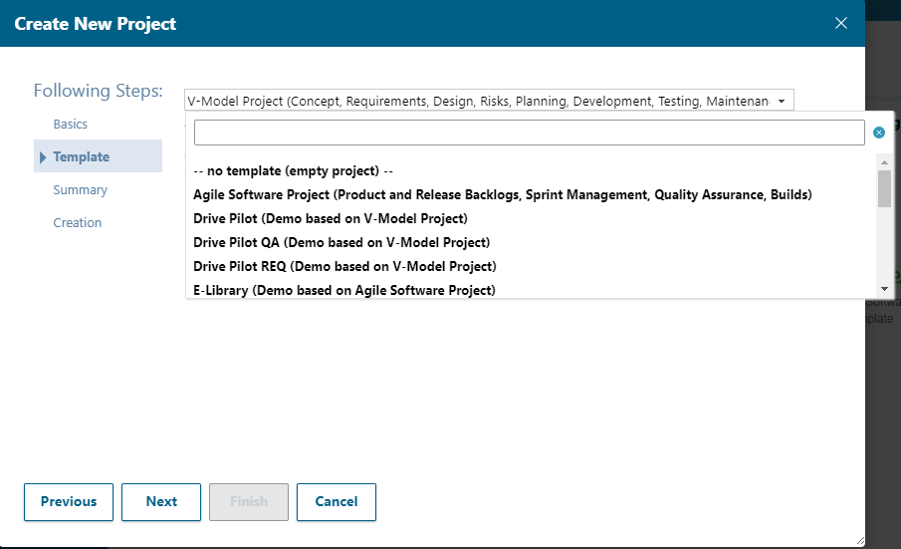

- Here I have chosen Agile process Model, and by proceeding next summary will contain all the project details and after proceeding to next again our project will be created.
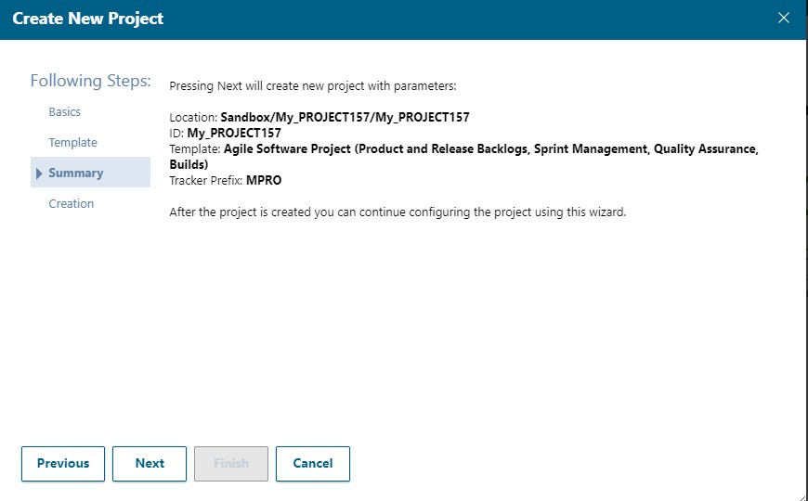

- After creating a project, following screen appears. On the right side is workspace while on the left side is the navigation area. Firstly, It has a search functionality which searches the results throughout the whole project including all the work items (requirements, features, test cases), Documents and Pages. In the following example I have searched requirements so results related to requirement appear on the screen.
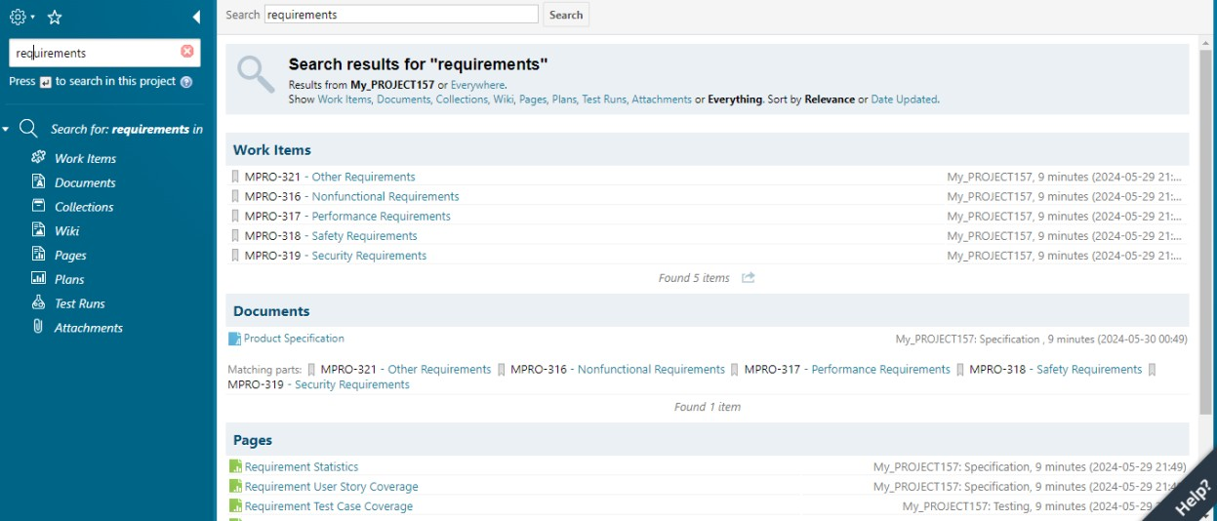

- On clicking user dashboard (My Polarion), it will lead to following interface where we can see the tasks and defects assigned to us, documents and work items awaiting our approval and our activities.

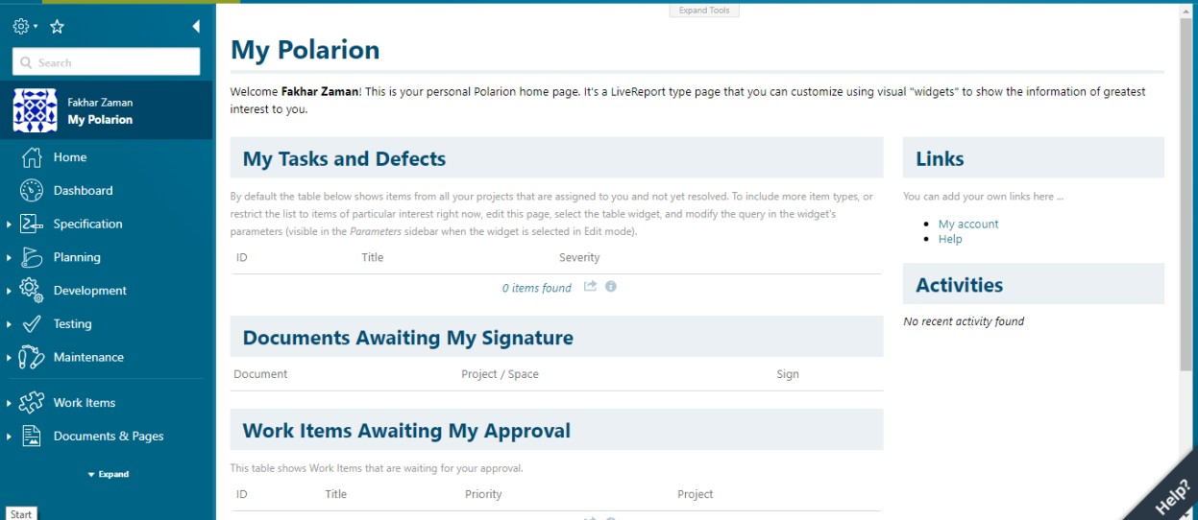

- Now just focusing on requirement management, we have a section of work items in a navigation area where we can search with respect to each work item i.e., Task, requirement, test case, epic, issue etc.

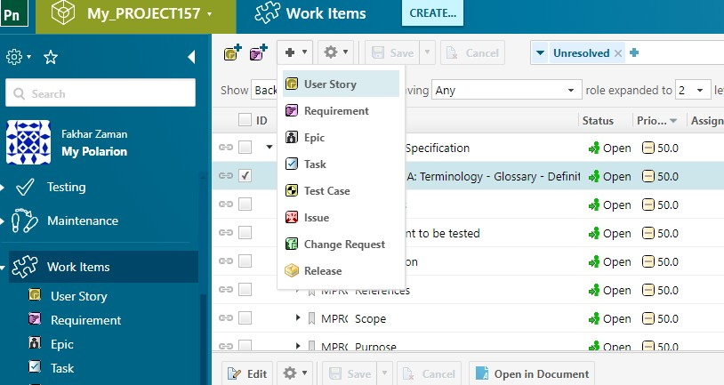

- We can create any work item of above. Let us create a requirement from scratch. When we will create a requirement we will be given following interface:

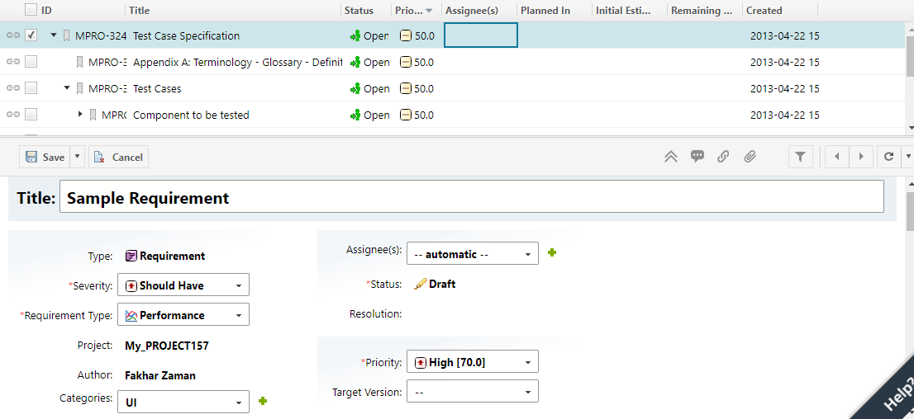

- Here is the interface above in which first of all we will write its topic, then we’ll move towards its severity which has four default options i.e., Must have, should have, nice to have, will not have.
- Next we will determine the requirement type and given options in the dropdown are

performance, safety, security, software quality and other.
- Next we will have to select category of requirement in which we can select API, dashboard, security, user management, project, UI, searching and Database.
- We can assign the requirements to the any project member or group of members.
- The status of requirement consists of draft, pending, reviewed.
- Next we have to select priority of the requirement which can be set manually by entering a float value from scale of 0.0 to 100.0. The default values are lowest [10.0], low [30.0], medium [50.0], high [70.0], highest [90.0].

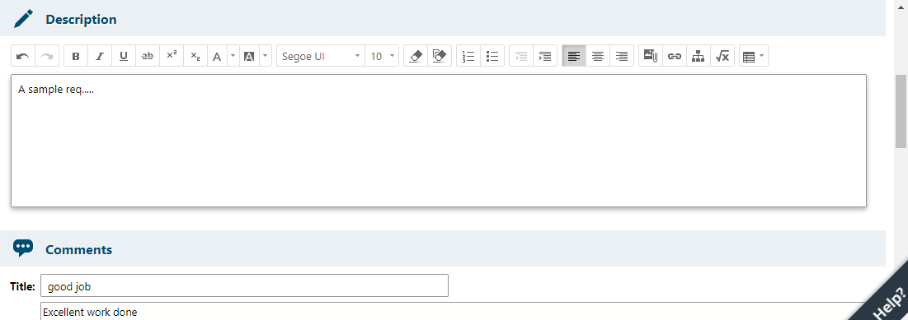

- We can add description to the requirement and for this purpose we have also an editor which provides many functionalities. Similarly we can add, view or reply to comments in the comment sections in which project members can give reviews about particular requirement and suggest some changes, in short communicate with each other.

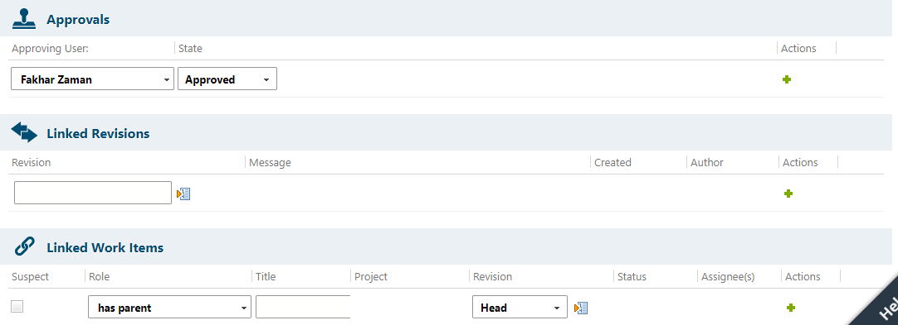

- We can check for approvals and approval status by one or more people on specific requirement. Similarly we can also ensure traceability by linking the work items.

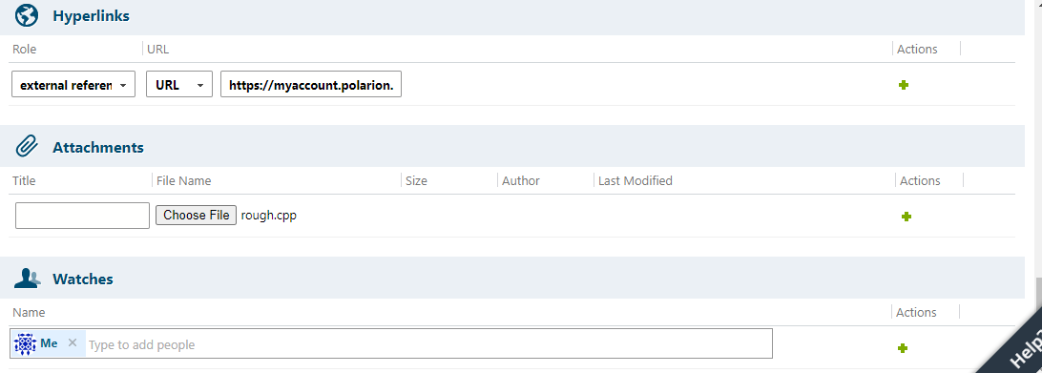

- We can add hyperlinks as reference from different sites or repositories as well as link different attachments to our requirements. We can also select and add people who can watch the specification of requirements.
- Also we can search work items on the basis of following filters i.e., status, assigned to me, severity etc, which makes it easier to manage all the respective work items.

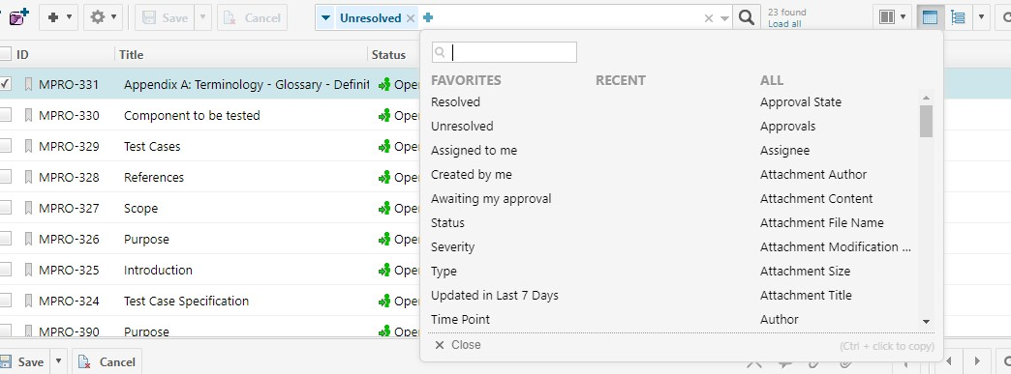

- There is also a Documentation and Pages section in the navigation bar, we can create a document, a live report page in any of the projects.
- For example if we have to create a live report page we have to go to Document and Pages section and then click on create and following screen will appear.

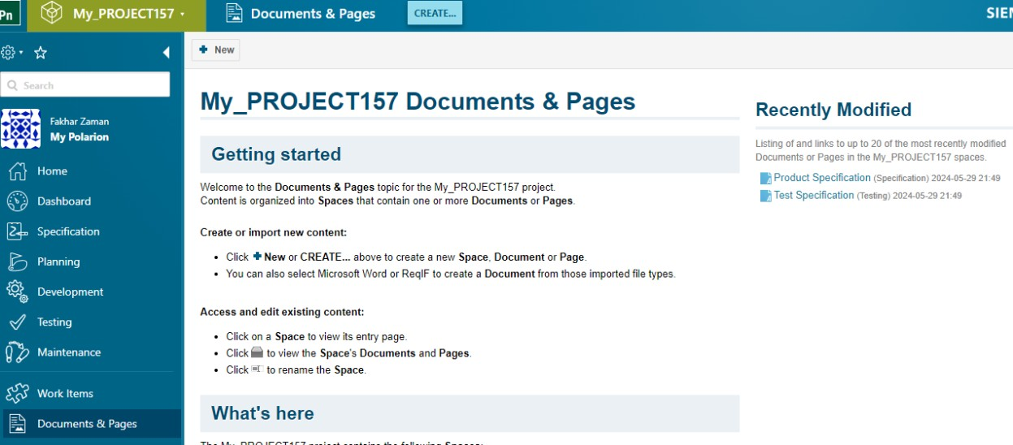

- Click on create and then select Live Report Page.

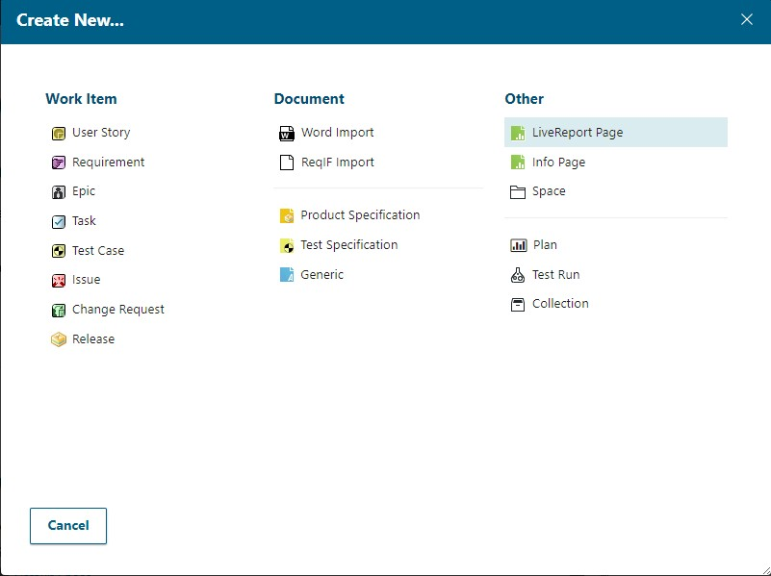

- Name the Live report page and then select a space where that report page should be created which includes options like default space, development, maintenance, planning, reports, specification and testing.

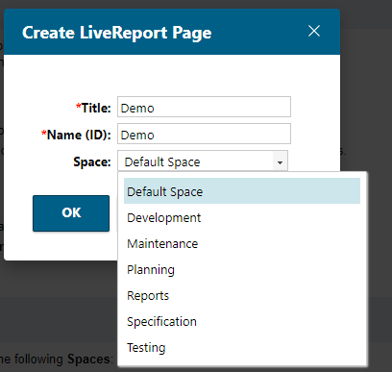

- After creating this page, it will lead to an interface where it would be broken down into certain sections on which we can write free text as well as add widgets which are present on the right side there are many widgets that allow us to generate reports e.g., pie charts, traecibilty table, trend charts etc.

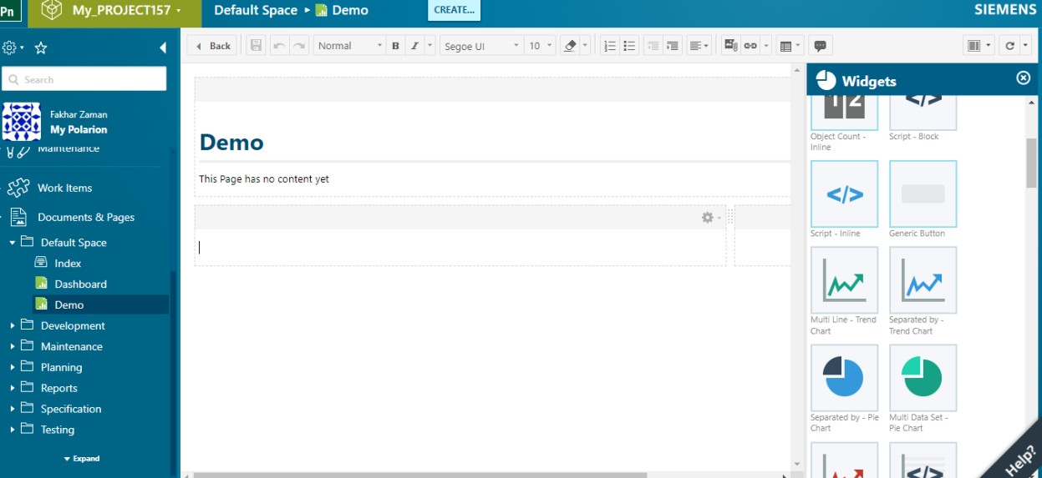

- Another benefit of using this tool is that you can import the word document in Polarion, edit it and it will help us in the extraction of requirements form the document and its categorization etc.
- In order to import the document, first of all we have to navigate to Documents and Pages, the click on create, then click on import word document, and import the document from our directory as follows:

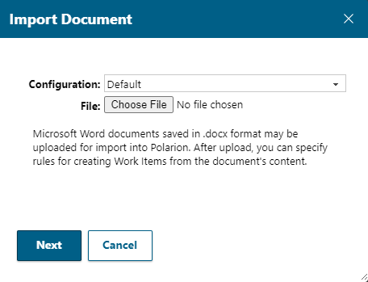
- When you choose the directory of file and import it, the following screen appears:
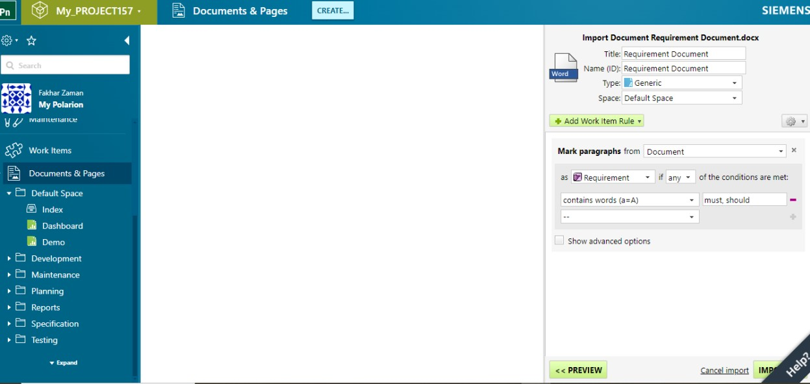

- On the top right side, the details about the document are written, whereas below it, there is an option of making paragraphs from the imported document.
- We can classify details in the document as requirements, tasks, system requirement, test case etc.
- The classification will occur if any or all conditions below are met, we have to select any or all
option.
- Then first condition is that if it contains words (a = A), doesn’t contains words, is heading, isn’t heading, is list item, isn’t list item, is table, isn’t table etc.
- Next we can categorize and calculate its severity according to the words like must, should , nice to have, will not have etc.
- From settings option, we can also import configuration.
- Now click on preview and following screen will appear:

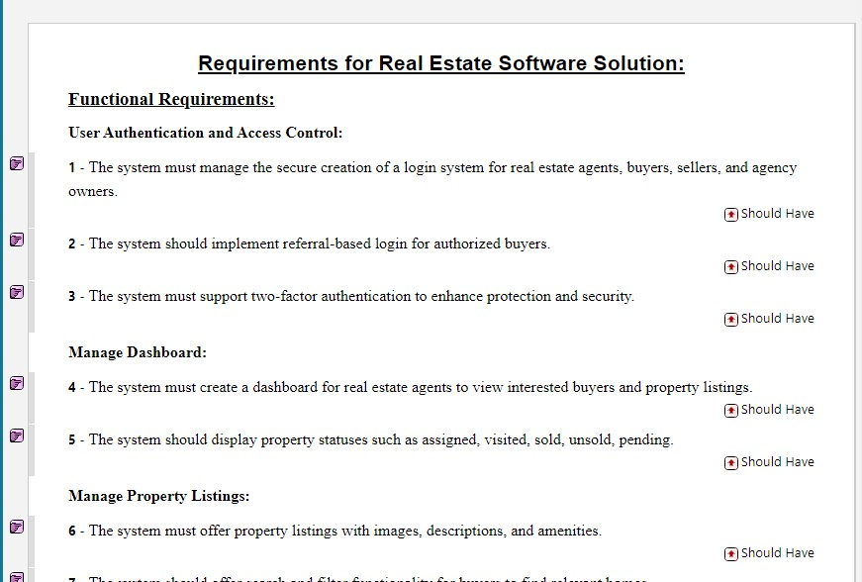

- Like this all the requirements are listed and there severity is written in front of them according to the text in the line and is completely configurable, it is just for convenience.
- Now by clicking on advanced option, we can determine severity of the requirement according to the text we wrote by setting value of set field to Severity and then choosing should have as an option as the text written above is must.

- In above picture, firstly the advanced field was checked, set field was set to severity but there are many options including priority, requirement type, description time spent etc. Now click on preview and view the updated severity of requirements.
- By clicking on +Add Work Item Rule, we can select another rule like another value of severity if any text appears e.g., must and for example on another work item rule, we can add value of severity as nice to have.
- It should be like as follows before previewing:
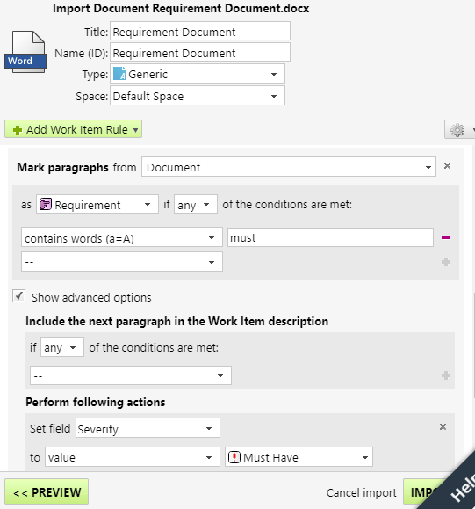

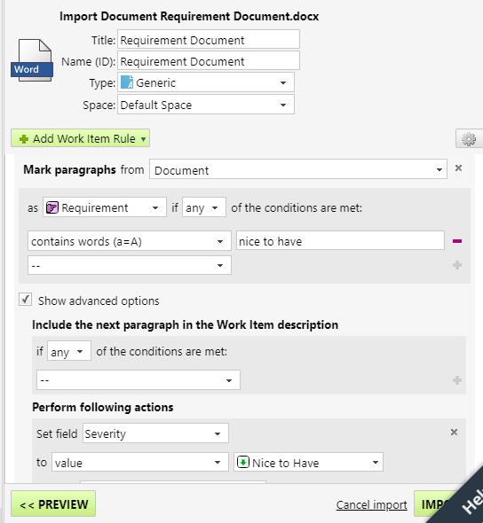

- Now when we will click on preview, The following screen will appear categorizing requirements in terms of severity. Similarly we can also categorize them in terms of priority by setting the set field to priority.

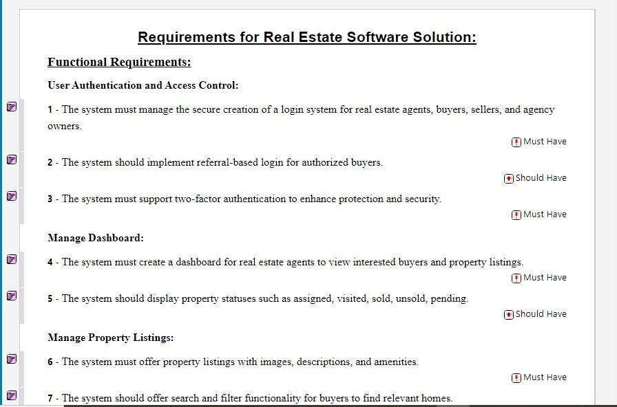

- After the configuration, we can save it by clicking on small settings option available, and two options appear load and save. We can load or import the previous document’s configuration or save the present document’s configuration for using in more documents to come.
- We will now import the document when we are satisfied with it, when we will click on import button, It will categorize different work items and give them unique reference numbers against them as follows:

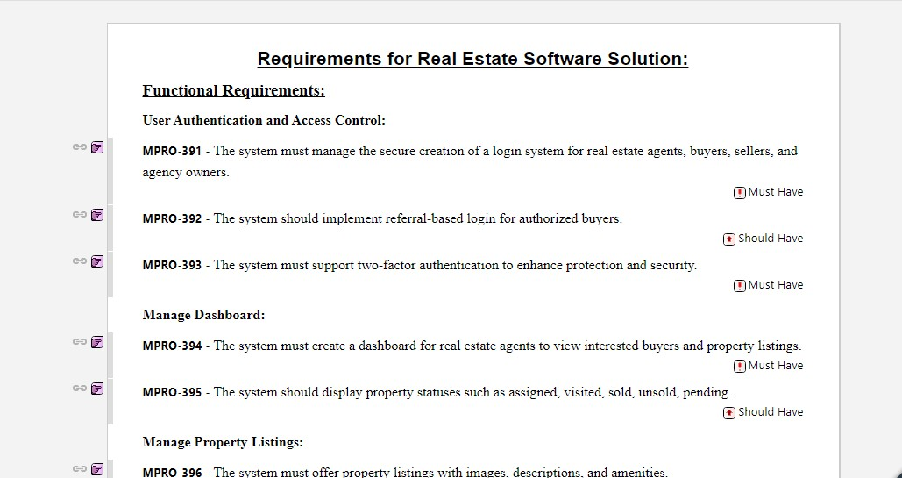

- As in this case, I imported only requirements and categorized on the basis of only requirements, the only work item which will show up is requirement, along with the unique reference numbers and severity.
- We can also edit the document and add new requirements by simple clicking on and writing a requirement. If we want to add its child requirement, then we will have to press enter to get to next line, and then a tab key to ensure that the following one is a child requirement.
- I added a requirement and its 3 sub requirements by following above procedure and the following screen appears:

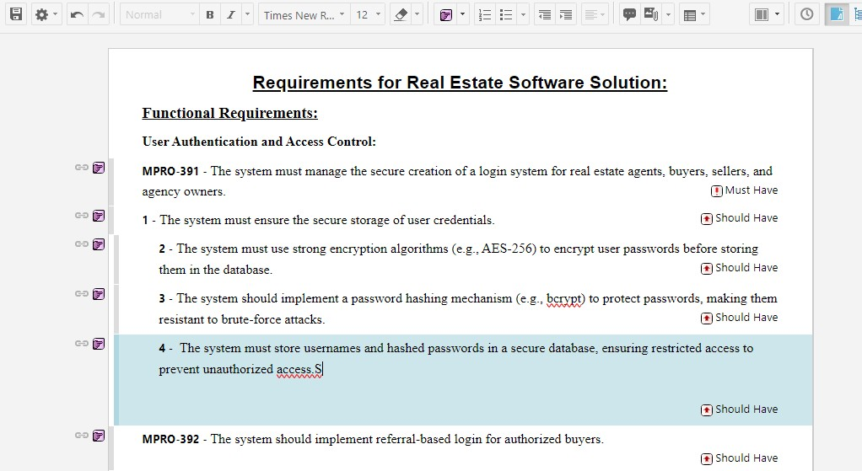

- Now if I click on save button in the top left of edit section, then the unique reference numbers will be assigned to the respective requirement and sub requirement and it appears as follows:

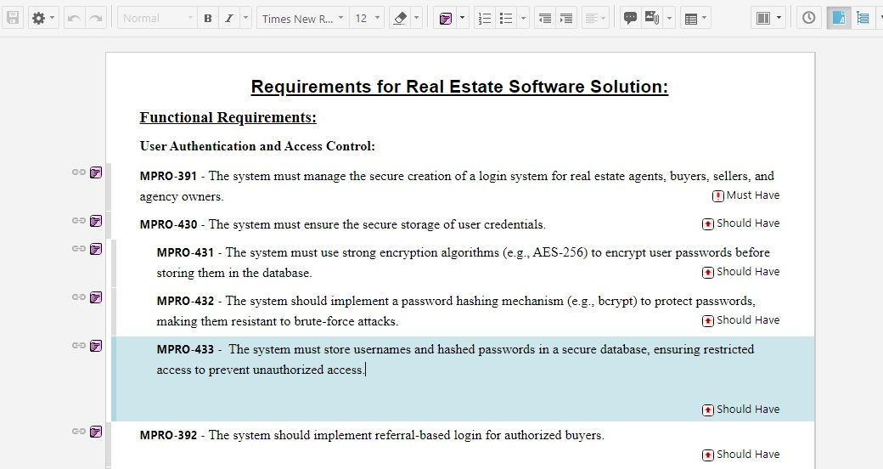

- Hence the unique reference numbers were assigned to the requirements.
- One more facility this tool has that we can create diagrams and import images in our requirement document from the edit section present on the top of the document. For example:
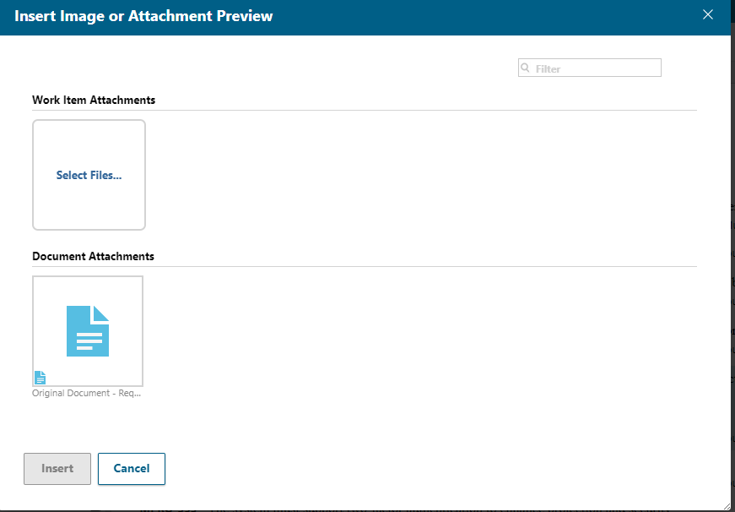
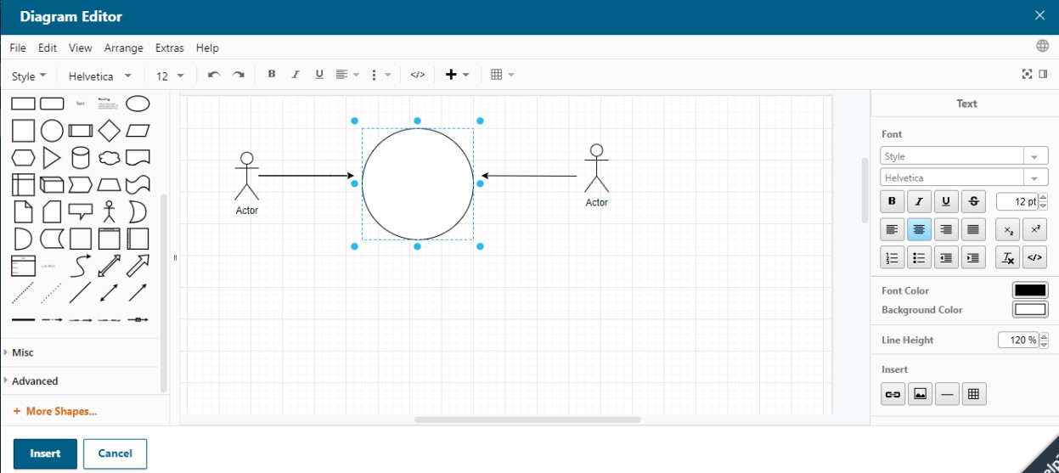

- From diagram editor, we can create a diagram needed and then insert it in our document. Similarly, we can insert the images as per our need.
- Now moving towards the configuration of the document, we can add multiple fields in addition to severity e.g., priority, created by, due date etc.
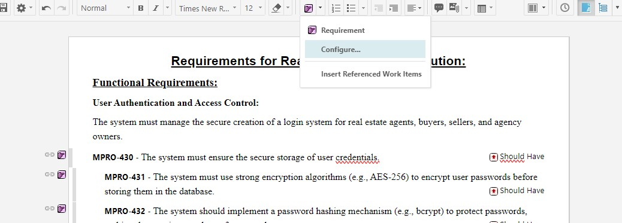

- When we click on configure the following screen appears and then we select fields to be shown.
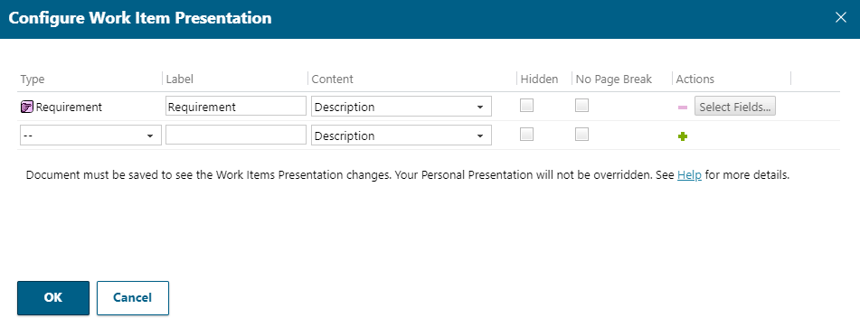

- We select fields which we want to be shown and check that whether we want them to show in the document, sidebar or both. We can also create a table at the end of the document according to all the selected fields.

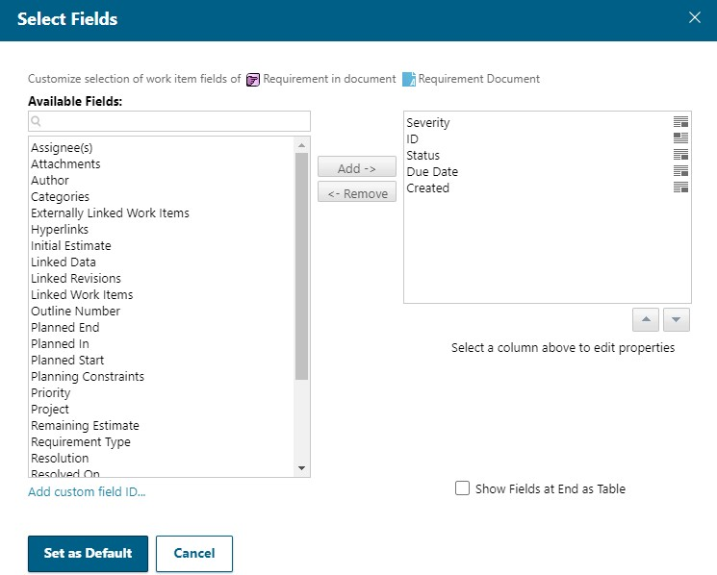

- By clicking on Set as Default and then Ok, we will get our document updated according to these filters. The updated document will look as follows:

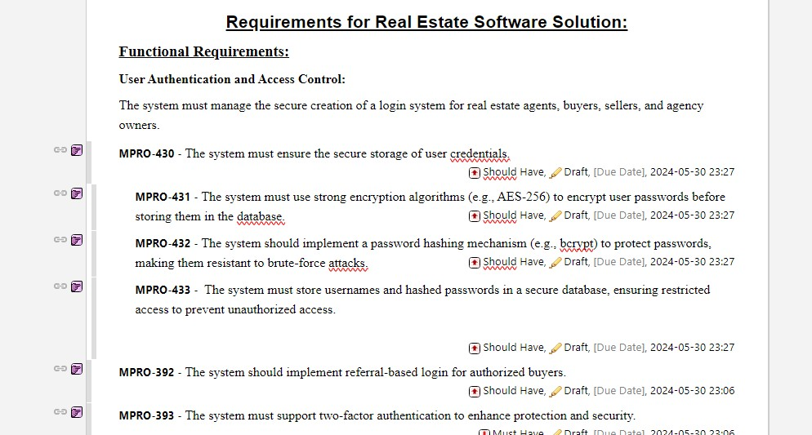

- Here the requirements are classified according to its severity, status, due date and creation.
- We can export this document to word, make changes on word and then again import on Polarion and visualize the changes we made. To export it, go to settings and then word round trip and select Export document.

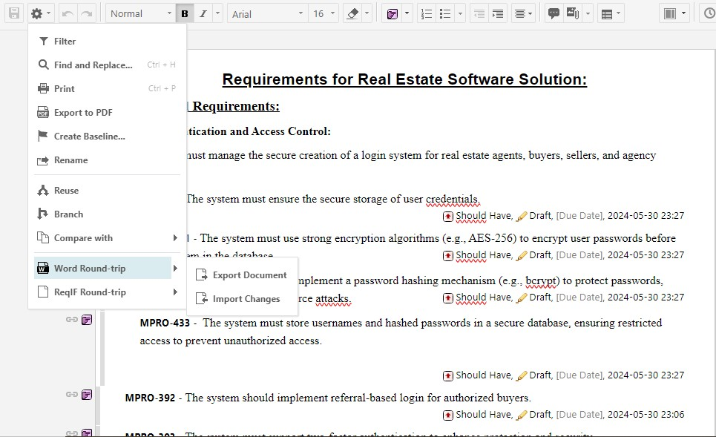

- There are three types of export options. First one is Review on which organization or entity receiving the document can only add comments using word functionality and only view the document and cannot do anything else.

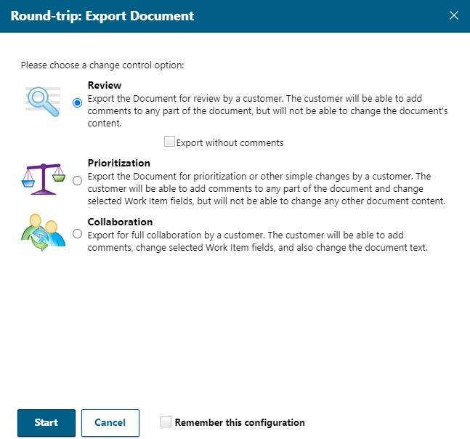

- Secondly, In prioritization, the organization or entity can undergo changes only in the fields on which you allow them to e.g., they can only change severity of the work item.

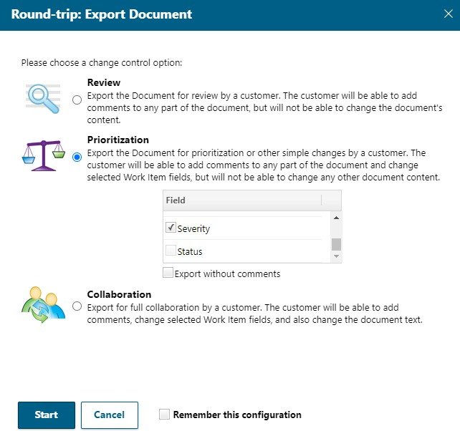

- Lastly, in case of the collaboration, they can make changes to the document text also in addition to the selected fields.

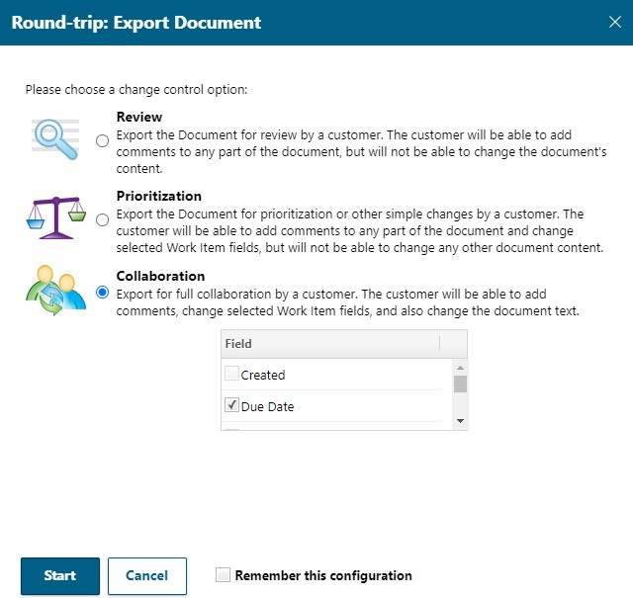

- We will do prioritization to visualize changes In the selected fields after and before export.
- As we chose prioritization, we can only undergo changes in the selected fields, i.e., severity can be changed to any of the values that were present in polarion which is shown as follows:

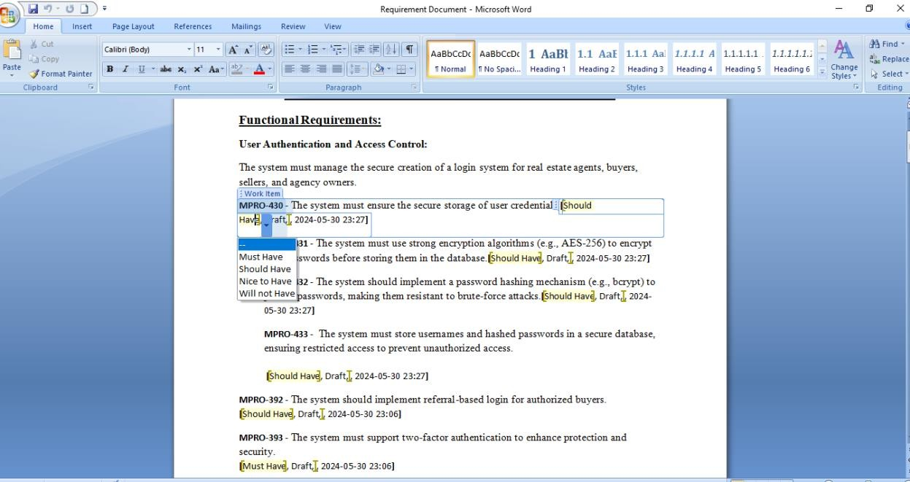

- After making necessary changes, then we should import the edited document back to polarion similarly by clicking on import changes and then selecting the directory of the document which was exported and then made changes in.
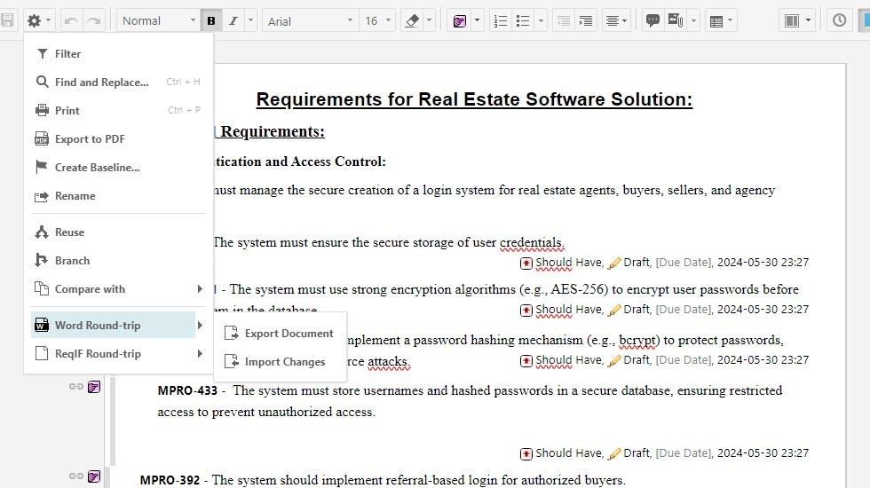

- After importing, we can see the changes which are being made but we can also check the previous versions and compare it with current version by using Polarion History functionality.
- After clicking on clock ( history ) button and selecting the two fields and comparing two versions we can see it as follows:
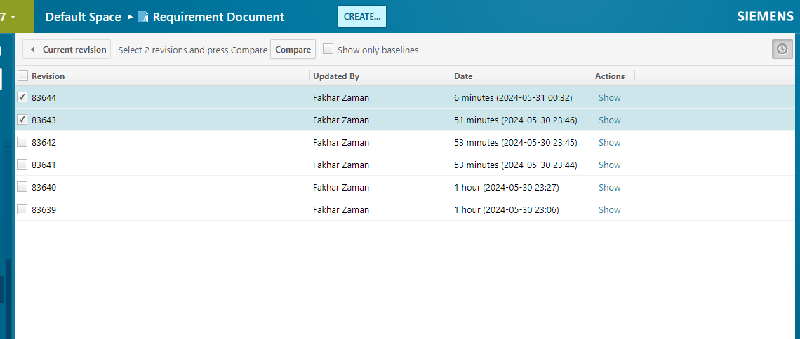

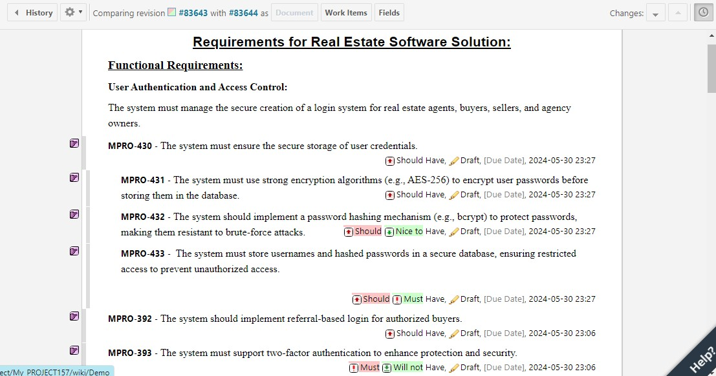

- In the red, is the previous version before review while in green is the current version after the revision of document.

- Now, we can also put this document under review. Its current status is draft, by moving it to the review state, each and every work item in the document will also move automatically to the in review state.

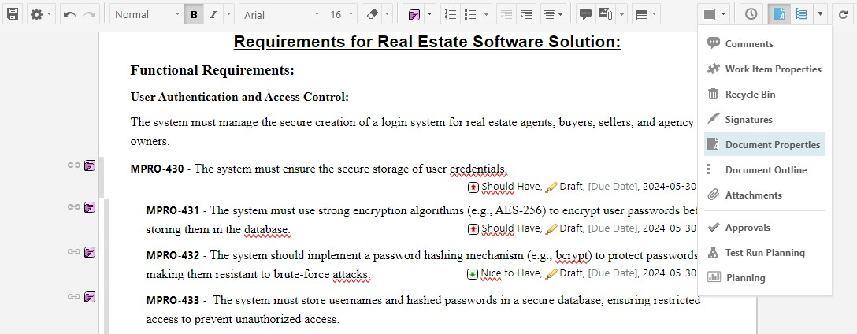

- Go and update status from draft to perform action mark active and also write the version of the document and then Save the document. After this, the document and its work items all will be sent in review state.

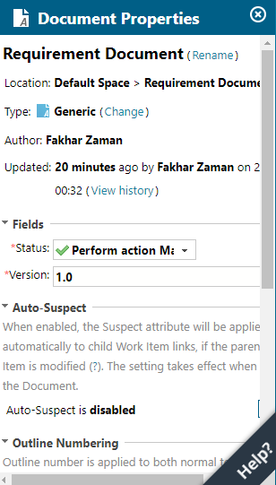

- After all this, now we can approve or disapprove each of the work item by going to my approvals.

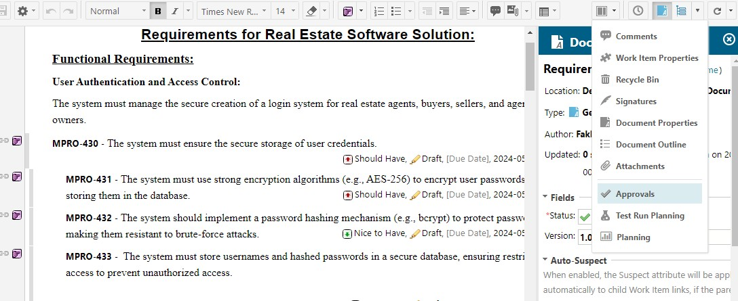

- We can approve and disapprove the work items and can also comment the reasoning behind disapproval of the requirement.

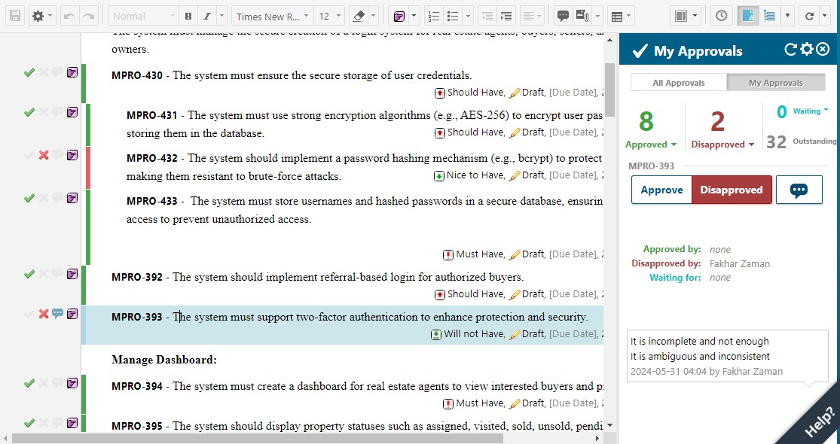

- To obtain screen shown above, you have to check tick or cross on the extreme left side and add comment on the extreme right side. By saving the document it will appear as the screen shown above.
- We can also see all the work items in table view which will make it easy for us to approve or disapprove the work item as follows:

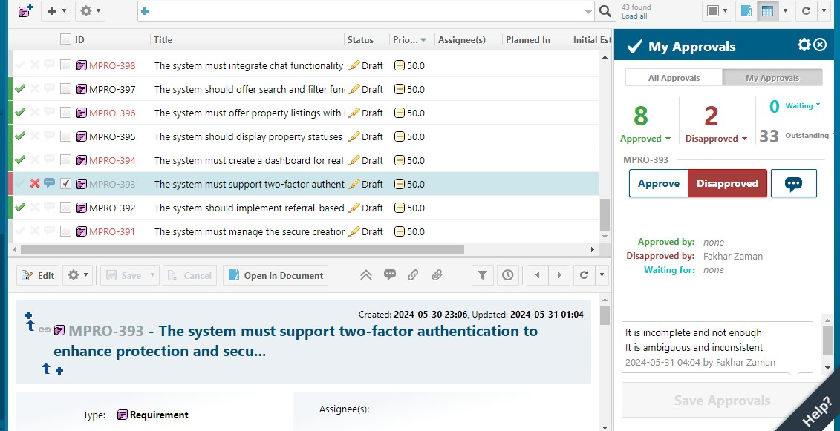

Ease of Use:

Polarion is designed to be user-friendly, with an intuitive interface that simplifies the management of complex projects. Key aspects contributing to its ease of use include:
User Interface: The clean and organized UI allows users to navigate easily between different modules and functionalities.
Customizability: Users can tailor the workspace to suit their specific needs, enhancing efficiency.

Documentation and Support: Comprehensive help resources and customer support ensure users can resolve issues and maximize the tool’s capabilities quickly.

Pros and Cons of Using the Tool:
Pros:

Comprehensive Feature Set: Polarion offers a wide range of features that cover all aspects of requirement management and beyond.
Integration Capabilities: The tool integrates well with other popular development tools, providing a seamless workflow.
Customization: High level of customization to adapt the tool to specific project needs and processes.

Cons:

Complexity for New Users: The extensive functionality may be overwhelming for beginners and require a steep learning curve.
Performance Issues: In large projects, the tool might experience performance lags.

Cost: The pricing can be high, especially for small to medium-sized enterprises.

