General Introduction
KTS (Kabelbaum Test Systems), a company that specializes in cable harness test systems, utilizes paper-based work orders for production management. The work order follows eight stages (SALES, CAD, CAM, STORE, CNC, ASSEMBLY, QUALITY, and DELIVERY), and at every stage, it is manually updated. This style of management by KTS has led to problems in information circulation, tasks, and workers and resources coordination.
The key issue that is being addressed in this project is the absence of a unified system for production tracking and work order management. More specifically, KTS requires a system that will manage the workflow, provide role-based access, monitor stages in work order processing, and integrate stock reservation with work order processing.
This report will discuss the entire process that was conducted for analyzing, designing, and developing the system in order to address this problem in the context of an end-of-studies internship.
Report Structure
- Chapter 1 – Context and Objectives: introduces the host organization, internship context, and project objectives.
- Chapter 2 – Analysis and Specifications: defines user needs and presents functional and non-functional requirements.
- Chapter 3 – System Design: details the proposed architecture, data model, and main design choices.
- Chapter 4 – Implementation: describes the development environment and the implementation approach followed during the project.
- General Conclusion: provides a synthesis of the work carried out and outlines possible future improvements.

Context and Objectives

Introduction
This chapter aims to situate our project within its broader context. We begin with a presentation of the host company, KTS (Kabelbaum Test Systems). Next, we address the problem that prompted the host organization to develop this platform. We evaluate existing solutions to identify their shortcomings and propose the direction of our solution. Finally, we present the methodology adopted for the development of our project.

Presentation of the Host Organization
KTS Kabelbaum Test Systems is a Turkey-based company founded in 2019 in Bursa, operating within a 2000 m² facility. The company specializes in designing and manufacturing test systems, assembly modules, and boards for wiring harness manufacturers, providing reliable and customized industrial solutions.
KTS aims to establish itself as a trusted solution partner in the sector by focusing on high quality, cost-effective production, and fast delivery. Through its commitment to customer satisfaction, innovation, and durability, the company delivers flexible solutions tailored to the specific needs of its clients.
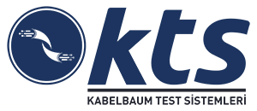
Host organisation logo

Domain of Activity and Organization
KTS (Kabelbaum Test Systems) is a manufacturing company specializing in the design and production of cable harness test systems. The company operates in the industrial automation sector, serving automotive, and electronics industries. Its primary activity centers on crafting custom test solutions that verify the integrity and functionality of complex cable assemblies used in high-reliability applications.
The company is organized around several functional departments including Sales, Engineering (CAD/CAM), Production, Quality Assurance, and Logistics. Production operations are structured sequentially through eight key stages: Sales order intake, CAD design, CAM programming, Material Storage, CNC machining, Assembly, Quality inspection, and final Delivery.

IT Infrastructure and Information Systems
From an IT perspective, KTS supports its operations through a combination of legacy systems and modern infrastructure. The company maintains enterprise resource planning capabilities, though current production tracking remains heavily dependent on manual processes and paper-based documentation.
The IT department, where this internship was conducted, is responsible for system maintenance, infrastructure management, and digital transformation initiatives. The internship focused specifically on the Production Engineering and Management domain, with the objective of developing scalable software solutions to modernize operational workflows.

Study of Existing Processes

Description of Current State
Production tracking at KTS currently operates through a paper-based workflow. Work orders are created by the Sales department and circulate physically through all eight production stages. At each stage, workers manually record updates on paper forms, documenting completion of tasks, resource allocation, and readiness for the next phase.
Inventory management is similarly manual: workers consult physical stock records and update them by hand when materials are reserved or consumed. Communication between stages relies primarily on direct contact and physical documentation, with no centralized system to track overall project progress or resource availability in real-time.

Critique of Existing System
The current paper-based system presents several significant limitations:
- Lack of Traceability: Information is scattered across multiple physical documents, making it difficult to track the complete history of a work order’s progression.
- Communication Delays: Manual handoffs between stages introduce delays and create bottlenecks in the production workflow.
- Visibility Constraints: Management has limited real-time visibility into production status, resource allocation, and inventory levels.
- Error Prone: Manual data entry and documentation increases the risk of transcription errors and inconsistencies.
- Scalability Issues: As production volume increases, the manual system becomes increasingly difficult to manage efficiently.
The benefits associated with the paper-based system include ease-of-use and low costs, but unfortunately, these aspects no longer suffice for the company’s purposes.

Proposed Solution
Two alternatives were considered:

Alternative 1: Incremental Digitization
Deploy a simple digital logbook system to replace paper forms while maintaining existing organizational workflows. This approach minimizes disruption but offers limited capability for process optimization.

Alternative 2: Comprehensive Production Management Platform
Develop an integrated web-based application that standardizes workflows, implements role-based access control, provides real-time production visibility, and integrates inventory management with work order operations.
The chosen approach is Alternative 2, a comprehensive platform, because it addresses not only the symptom (paper dependency) but also the underlying process gaps. The implementation includes:
- Centralized Tracking: A unified platform where all work orders and tasks are digitally recorded and monitored.
- Real-Time Visibility: Administrators and workers access current status immediately, reducing communication delays.
- Role-Based Interfaces: Tailored views and permissions for administrators, production workers, and management.
- Integrated Inventory: Stock management features linked directly to work orders, with automatic reservation and deduction.
- Scalability: A web-based architecture that grows with the company’s production volume without proportional manual effort increase.
This solution justifies the development effort through measurable improvements in process efficiency, data accuracy, and organizational scalability.

Work Methodology

Agile Scrum Method
To ensure smooth progress through the project’s various phases, we adopted the Agile Scrum methodology. The word "SCRUM" (from rugby) refers to the scrum formation, emphasizing teamwork and collective advancement toward a common goal.
If we had to summarize the SCRUM method in one sentence: SCRUM is an iterative incremental method centered on delivering a functional product (rather than non-directly useful products such as certain documentation).
This method is built around three key actors:
- Product Owner: Has complete vision of the product
- Scrum Master: Ensures smooth project progress and reinforces the methodology
- Scrum Team: Develops the product
The Product Owner defines the product backlog, which is the prioritized list of target features for the product. This list is intended to evolve as the product definition is built.
The first sprint can then begin. Before starting, the Scrum Team must define and prioritize the features it will tackle during this iteration. All these tasks are called the "sprint backlog."
During the sprint, the team, accompanied by a Scrum Master, iterates on development and starts each day with a "scrum" during which they review the day’s objectives.
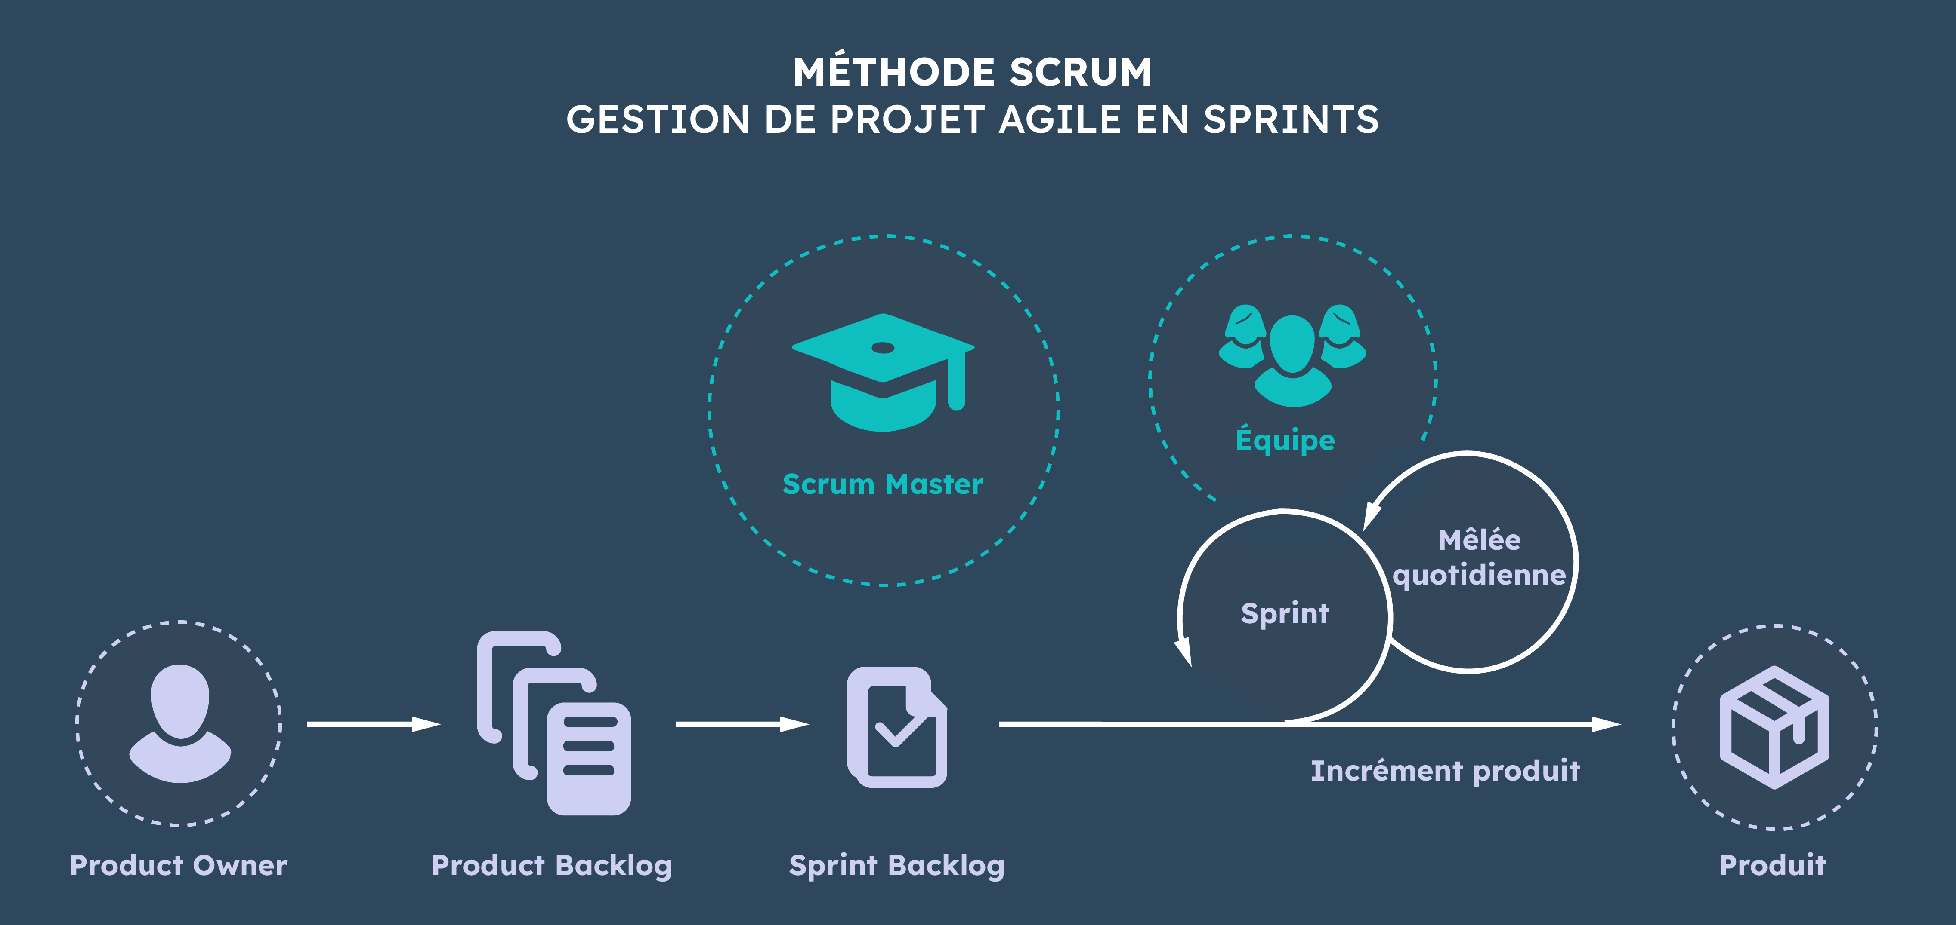
SCRUM methode

Work Methodology: Scrum Sprint Breakdown
The development process was organized into five weekly Scrum sprints. Each sprint delivered a usable increment of the Production Tracker platform and prepared the next iteration.
A summary of sprint objectives and key tasks is shown below:
Task Breakdown by Scrum Sprint
Sprint | Objective | Main Tasks
1 | Technical initialization | Git repository setup, Next.js/Node.js structure, Prisma configuration, initial database migration
2 | Access control layer | Authentication routes, JWT handling, role-based middleware, protected admin/worker pages
3 | Production management core | Work order CRUD, stage management, stock routes, worker and admin operational views
4 | Real-time collaboration | Chat threads and messages, socket integration, notification service and notification pages
5 | Stabilization and delivery | QR code generation/scanning, integration testing, bug fixes, performance and deployment preparation

Conclusion
KTS represents a manufacturing company undergoing digital transformation. The internship project addresses a critical operational need: replacing paper-based production tracking with a modern, integrated digital system. The comprehensive platform approach balances the elimination of legacy constraints against the feasibility and scope of development resources, positioning the company for sustainable growth in production capacity and operational excellence.

Analysis and Technical Specifications

Introduction
This chapter presents the technical foundations of the Production Tracker web application, detailing the system architecture, analyzing existing solutions in the market, and specifying both functional and non-functional requirements of the proposed system. We examine current industrial solutions, justify our technical choices, and establish the framework for the implementation phase.

Study of Existing Solutions

Current Market Solutions
Several production tracking systems exist in the market, each offering different levels of functionality and scalability:
- Enterprise ERP Systems (SAP, Oracle): These comprehensive solutions provide extensive production management capabilities but require significant investment, extensive customization, and complex deployment processes. They are often over-engineered for small to medium enterprises.
- Cloud-Based Manufacturing Platforms: Solutions such as Shopfloor.ai and MES (Manufacturing Execution Systems) offer cloud accessibility and real-time monitoring but often come with high subscription costs and limited customization options.
- Legacy In-House Systems: Many facilities rely on custom-built systems that lack modern user interfaces, scalability, and integration capabilities. These systems often require extensive maintenance and legacy technology stack knowledge.

Justification of Our Approach
Our Production Tracker application addresses the limitations of existing solutions by providing:
- A lightweight, modern web-based solution requiring minimal infrastructure
- Real-time communication and notifications for immediate issue awareness
- Scalable architecture supporting growth without major overhauls
- Role-based access control for different user types (administrators, workers)
- Cost-effective deployment on standard cloud platforms

Functional Specifications

Core Functional Requirements

User and Authentication Management
- System shall provide secure user authentication with email and password
- System shall implement role-based access control (Admin, Worker)
- System shall support user session management with token-based authentication
- System shall allow administrators to manage user accounts and permissions

Stock Management
- System shall track inventory items with unique identifiers and serial numbers
- System shall maintain stock levels and provide low-inventory alerts
- System shall record stock movement history and transactions

Work Order Management
- System shall allow creation and assignment of work orders to workers
- System shall track work order status through different stages (Pending, In Progress, Completed)
- System shall generate QR codes for work orders for tracking
- System shall associate work orders with required materials and resources

Chat and Communication
- System shall provide real-time messaging between administrators and workers
- System shall support file attachments in chat messages
- System shall maintain message history and conversation threads
- System shall implement chat notifications for new messages

Notification System
- System shall notify users of work order assignments in real-time
- System shall alert users to inventory status changes
- System shall provide notifications for chat messages and mentions

Production Stages
- System shall define production stages and workflows
- System shall track stage progression and duration
- System shall assign workers to specific production stages

Administrator Features
- System shall provide dashboard with production overview and statistics
- System shall generate reports on production progress and worker performance
- System shall enable configuration of system parameters and settings

Use Cases
The primary use cases include:
- Administrator creates and assigns work orders to workers
- Worker receives work order notification and begins production
- Administrator monitors production progress in real-time
- Worker and administrator communicate through integrated chat system
- System tracks inventory usage and generates alerts for low stock
- QR code scanning enables quick work order and stock identification

Non-Functional Specifications

Performance Requirements
- System shall respond to user requests within 2 seconds under normal load
- System shall support concurrent users up to 500 without performance degradation
- Real-time notifications shall be delivered within 1 second of triggering event
- Page load time shall not exceed 3 seconds for desktop and 4 seconds for mobile

Scalability Requirements
- System architecture shall support horizontal scaling for increased load
- Database shall efficiently handle queries with up to 10 million records
- System shall support adding new features without major restructuring

Security Requirements
- All user passwords shall be hashed using industry-standard algorithms
- User data shall be protected with proper access control mechanisms
- API endpoints shall require proper authentication and authorization

Usability Requirements
- User interface shall follow modern UX/UI principles with consistent design
- System shall be accessible on desktop and mobile devices
- Navigation shall be intuitive requiring minimal training
- System shall provide clear error messages and help documentation

Compatibility Requirements
- System shall be compatible with modern web browsers (Chrome, Firefox, Safari, Edge)
- System shall work on iOS and Android mobile devices
- Backend APIs shall be independent of frontend implementation

Maintainability Requirements
- Code shall follow established coding standards and best practices
- System components shall be modular and loosely coupled
- Comprehensive documentation shall be maintained for code and APIs

Conclusion
This chapter has established the technical and functional framework for the Production Tracker application. By analyzing existing solutions, we identified key gaps that our system addresses: cost-effectiveness, ease of use, real-time communication, and scalability. The functional specifications define clear user stories and system capabilities, while non-functional specifications ensure the system meets performance, security, and usability standards.
The architecture supports both immediate needs and future expansion, with modular components that can be independently updated and scaled. Following these specifications, the implementation phase will focus on delivering a robust, user-friendly production tracking solution that enhances operational efficiency and facilitates communication within the production environment.

System Design

Introduction
This chapter describes the design of the Production Tracker web application based on the requirements defined in the previous chapter. The objective is to transform functional and non-functional needs into a coherent technical design that is maintainable, scalable, and secure.
The system design covers five complementary views: architecture choice, UML modeling, database design, and security design. Together, these views provide a clear blueprint for implementation and future evolution.

Architecture Choice
The Production Tracker was designed using a client-server architecture with clear separation between presentation, business logic, and data persistence. This choice supports modular development, easier maintenance, and independent scaling of frontend and backend services.

Adopted Architectural Style
The selected style is a three-layer web architecture:
- Presentation Layer (Frontend): Implemented with Next.js for responsive user interfaces dedicated to administrators and workers.
- Application Layer (Backend API): Implemented with Node.js and Express to expose REST endpoints, execute business rules, and orchestrate real-time interactions.
- Data Layer (Database): Implemented with PostgreSQL and Prisma ORM for relational data modeling, consistency, and migration management.

Rationale for Technology Selection
The technology stack was chosen according to project constraints and expected usage:
- Next.js: Provides component-based development, routing, and optimized rendering, improving user experience for operational dashboards.
- Node.js/Express: Lightweight and event-driven runtime suitable for APIs and real-time features such as chat and notifications.
- Socket.IO: Enables bidirectional communication between clients and server, required for instant message and notification delivery.
- Prisma + PostgreSQL: Offers strong data integrity, explicit schema management, and maintainable database access patterns.

High-Level Component Interaction
At runtime, users interact with the frontend interface. The frontend sends authenticated requests to backend REST endpoints for CRUD operations (users, stock, work orders, stages). For real-time events, the frontend establishes a WebSocket connection to receive immediate updates (chat messages, assignments, alerts). The backend validates requests, enforces authorization rules, persists data through Prisma, and emits events to relevant connected users.

UML Modeling
UML modeling was used to formalize the system behavior and structure before implementation. The main diagrams considered are use case, class, and sequence diagrams.

Use Case View
Two main actors interact with the system:
- Administrator: Manages users, creates and assigns work orders, supervises production progress, manages stock, and communicates with workers.
- Worker: Consults assigned tasks, updates work order progress, interacts with stock operations permitted by role, receives notifications, and communicates through chat.
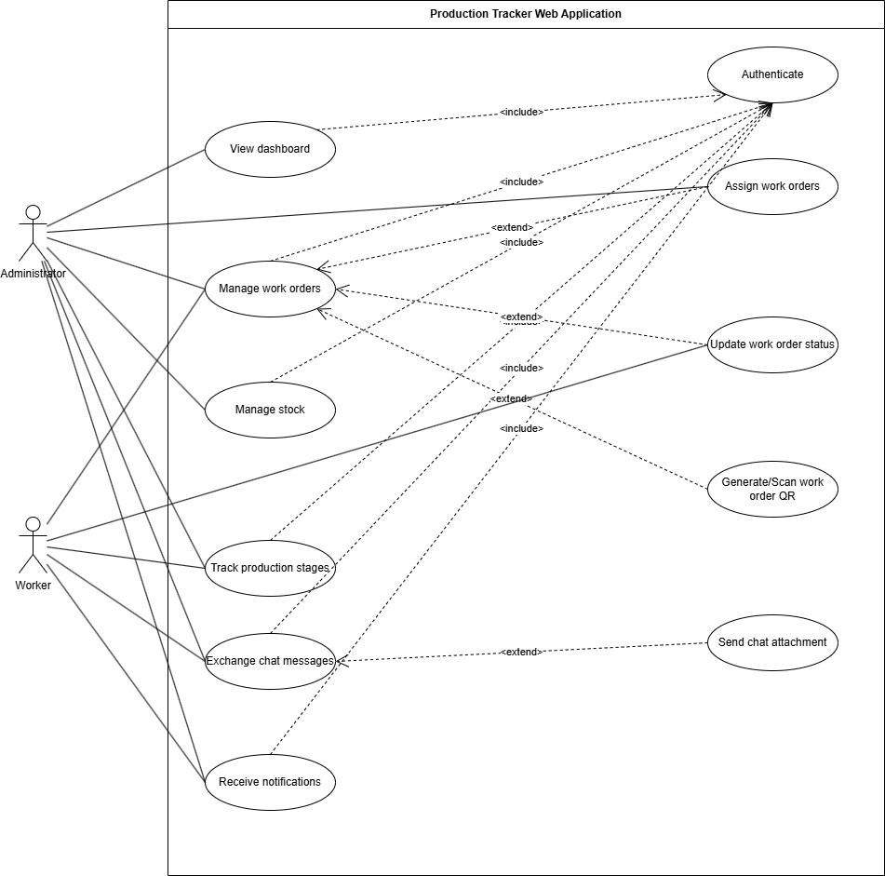
Use Case Diagram

Class Diagram View
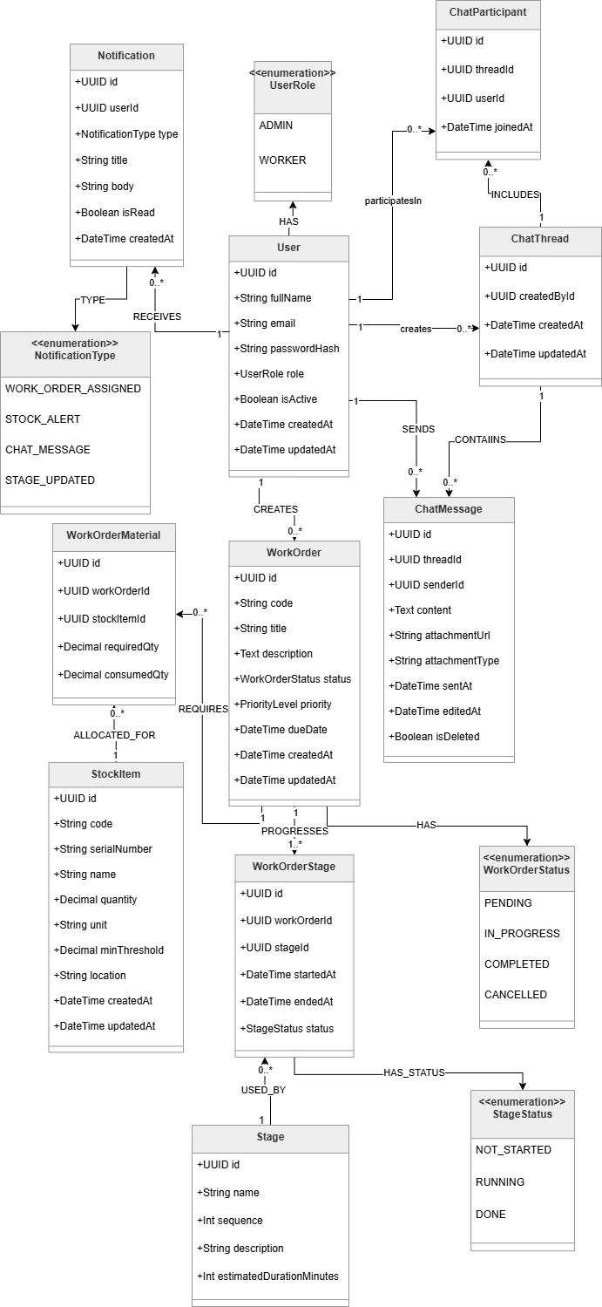
Class Diagram

Sequence Diagram View

Authentication and role check Sequence Diagram
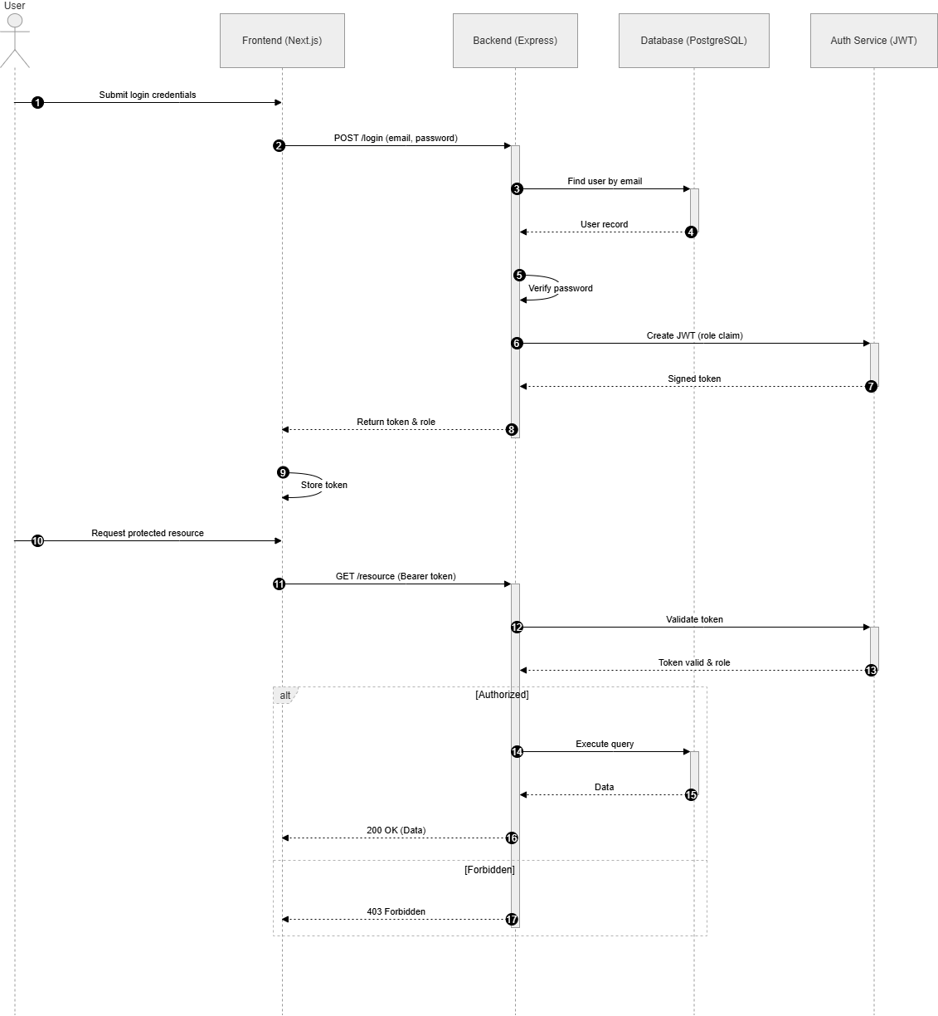
Authentication and role check - Sequence diagram

Work order stage/progress update Sequence Diagram
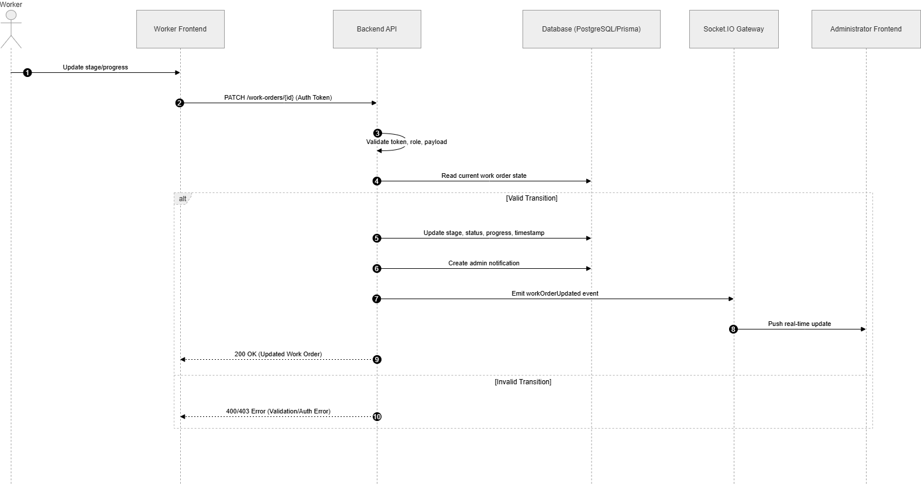
Work order stage progress update - Sequence diagram

Stock operation in/out/adjustment with validation Sequence Diagram
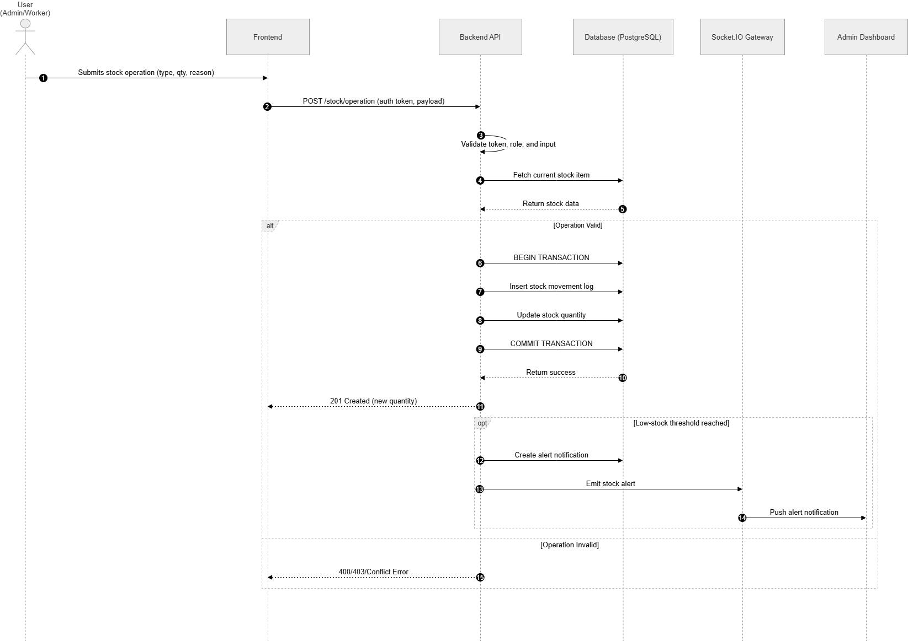
Stock Operations with Validation – Sequence Diagram

Real-time chat message flow Sequence Diagram
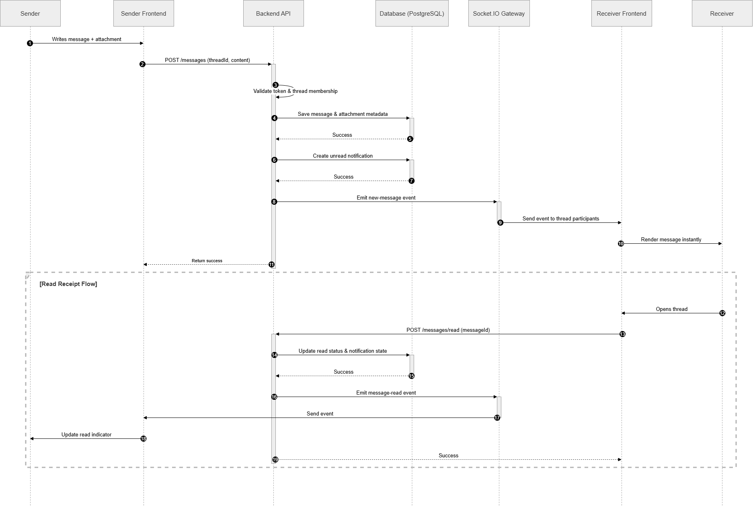
Real-time chat message flow – Sequence Diagram

Database Design
The data model follows a relational design to ensure integrity, consistency, and efficient querying for operational workflows.

Design Principles
The schema was designed with the following principles:
- Normalization: Minimize redundancy while keeping practical query performance.
- Referential Integrity: Use primary and foreign keys to preserve relationship consistency.
- Auditability: Include timestamps and event history fields where needed.
- Extensibility: Keep schema adaptable for future modules (reporting, analytics, advanced permissions).

Main Tables and Relationships
The main relational entities of the database are organized around users, production management, stock management, communication, and notifications:
- users: stores authentication data, roles, and account information.
- user_sub_roles: stores the detailed sub-roles assigned to each user.
- work_orders: stores production orders, reference data, status, quantity, and the user who created each order.
- work_order_stages: stores the stages associated with each work order, including assignment, status, and timestamps.
- stock_items: stores inventory items, categories, quantities, units, thresholds, locations, and the user who created each item.
- stock_reservations: links stock items to work orders and records reservations made by users.
- chat_threads: stores chat conversations, including direct or work-order-related threads.
- chat_participants: links users to chat threads and defines who can access each conversation.
- chat_messages: stores the messages exchanged inside each thread, together with the sender and timestamps.
- chat_attachments: stores files attached to chat messages.
- notifications: stores system alerts sent to users, including work order, stage, or stock-related events.
- notification_reads: records which users have read each notification.
- message_reads: records which users have read each chat message.
The relationships between these tables reflect the operational logic of the system. A user can create work orders, stock items, and chat threads. A work order can contain multiple stages, reservations, and related notifications. Each stock reservation links one stock item to one work order and one reserving user. Chat threads contain participants and messages, while messages can have attachments and read receipts. Notifications can reference users, work orders, stages, or stock items depending on the event being reported.
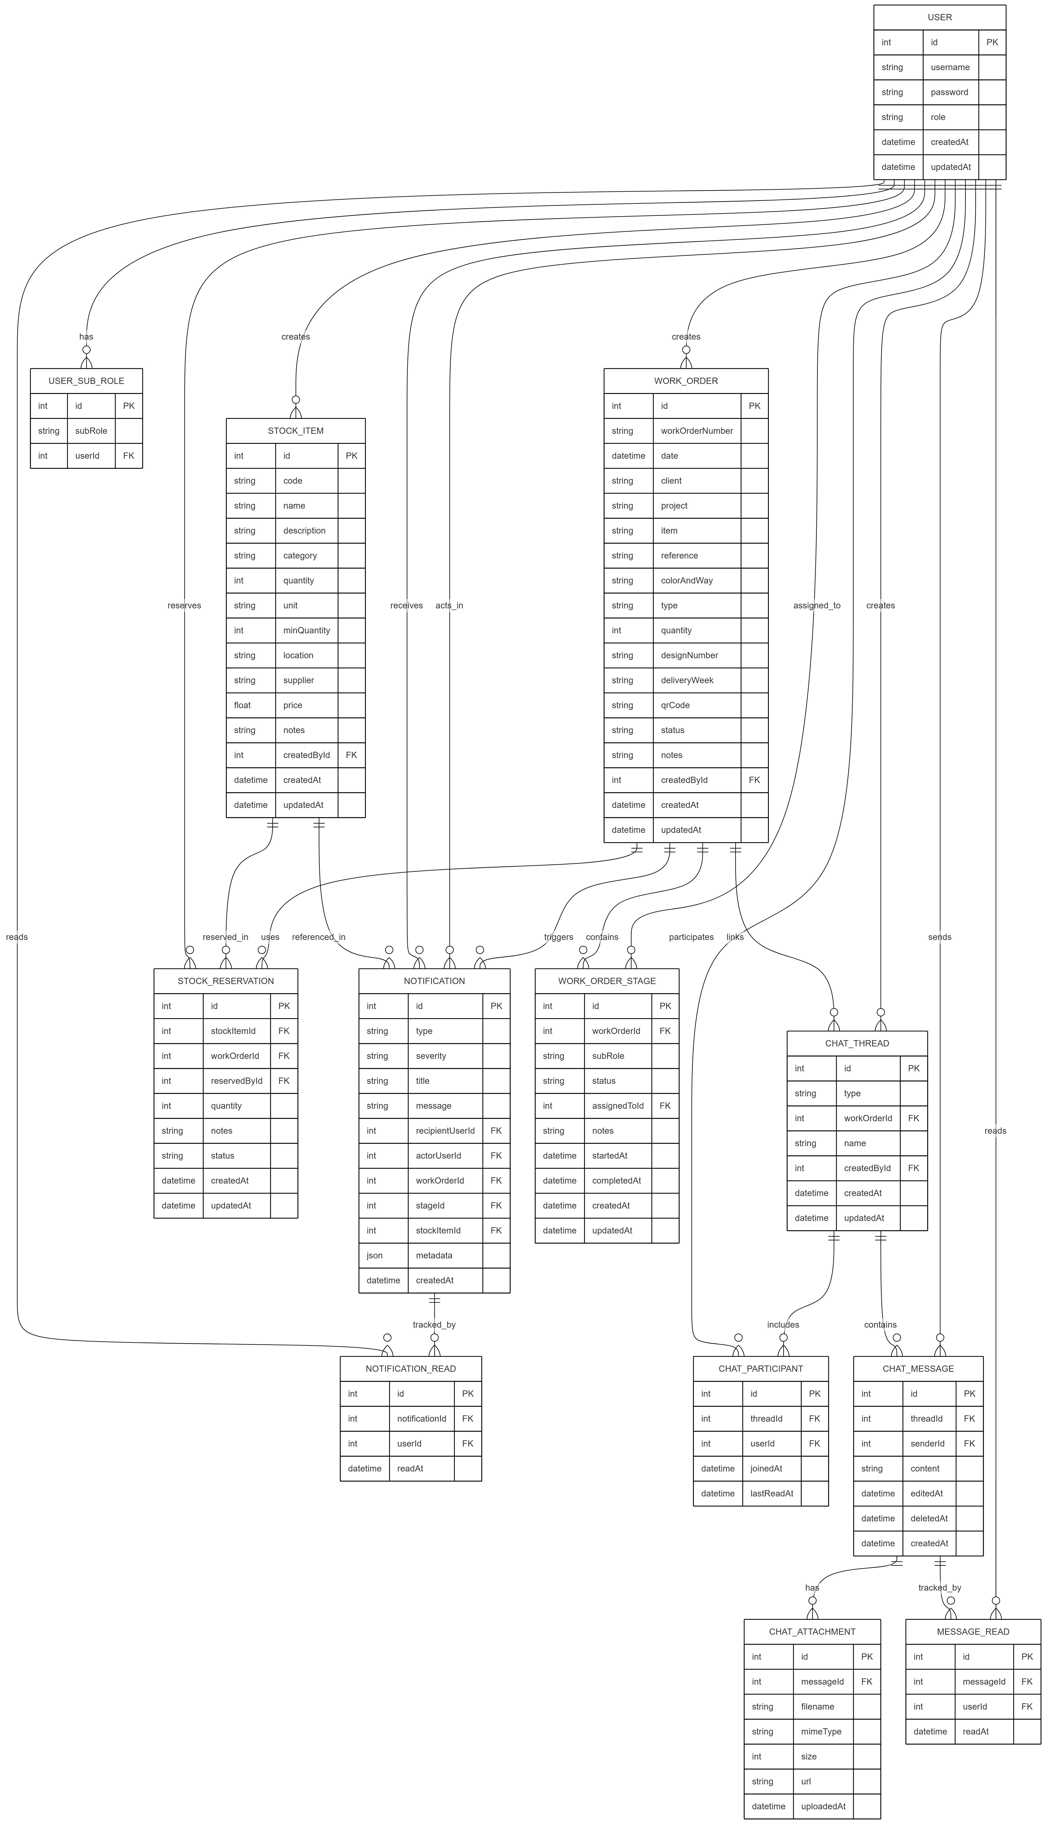
DataBase Schema – Entity Relationship Diagram

Migration and Versioning Strategy
Schema evolution is controlled through Prisma migrations. Each structural change (new table, new field, constraints, indexes) is versioned and reproducible across environments. This strategy ensures consistent deployment between development and production and reduces regression risks during updates.

Security
Security is integrated at design level to protect data confidentiality, integrity, and access control.

Authentication and Authorization
The system uses token-based authentication for session management.Authorization is role-based, with explicit restrictions between administrator and worker operations. Protected API routes verify both token validity and user role before executing business actions.

Data Protection and Validation
Security controls include:
- Password hashing using strong cryptographic algorithms.
- Input validation and sanitization at API boundaries.
- ORM-based query handling to reduce SQL injection risk.
- Controlled file upload handling for chat attachments.

Operational Security Considerations
Additional measures improve resilience and traceability:
- Secure environment variable management for secrets.
- Logging of critical actions for monitoring and audit.
- Error handling that avoids leaking sensitive internal details.
- Access restrictions to administrative endpoints.

Conclusion
This chapter presented the complete system design of the Production Tracker application. The chosen architecture ensures modularity and supports real-time operations, while UML modeling clarifies behavior and structure before implementation. The relational database design guarantees data consistency and scalability, and the security design enforces robust protection mechanisms across all application layers.
With this design foundation established, the next chapter can focus on implementation details, integration decisions, and practical deployment of the proposed solution.

Implementation

Introduction
This chapter presents the realization of the Production Tracker application, meaning the final software product developed during the project. The purpose is to show how the solution proposed in the previous chapters was implemented in practice and how the main interfaces of the system were built.
The chapter is divided into two main parts. The first part describes the development environment used to build and test the application. The second part presents the main graphical interfaces of the solution, with a short explanation of the role of each interface in the overall workflow of the platform.

Development Environment

Hardware Environment
The programming and development of our platform was carried out on an MSI computer with the following specifications:
 | - Brand: MSI Thin GF63 12UDX  - Processor: 12th Gen Intel(R) Core(TM) i7-12650H (2.30 GHz)  - RAM: 16GB  - Hard Drive: 477GB  - Operating System: Windows 11 Pro  - Graphics Card: NVIDIA GeForce RTX 3050 6GB Laptop GPU

Software Environment
The software environment was organized around the technologies used to build, run, and maintain the platform. Each tool is briefly described below, and the numbered marker links to the references page at the end of the report.

Next.js
According to the official documentation, Next.js is a React framework for building full-stack web applications. It provides routing, rendering strategies, and built-in optimizations while automatically configuring lower-level tooling. This helped us build the frontend faster with a clear project structure and production-ready defaults [1].
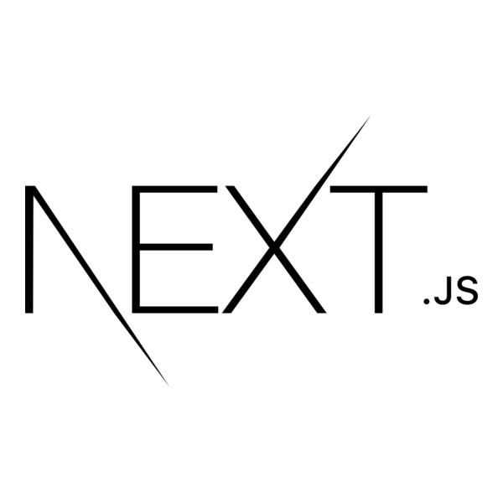
Next.js logo

Node.js
Node.js is officially presented as a free, open-source, cross-platform JavaScript runtime environment. It allows developers to create servers, web applications, command-line tools, and scripts with JavaScript. In this project, it provided the execution environment for backend services and API logic [2].
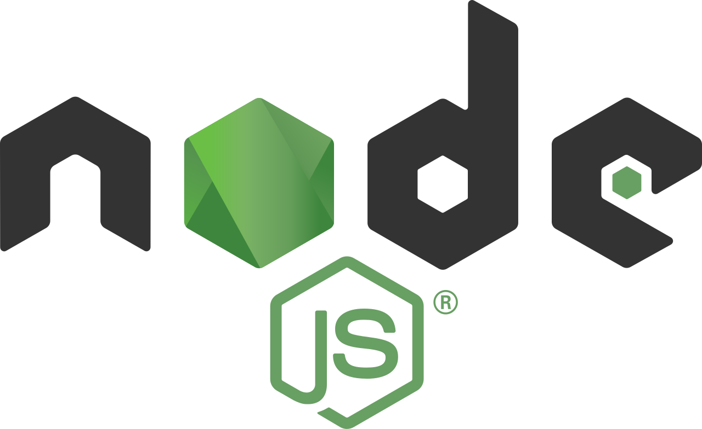
Node.js logo

Express
The Express official site describes it as a fast, unopinionated, minimalist web framework for Node.js. It offers a flexible routing and middleware model with essential features for web and mobile APIs. We used Express to implement REST endpoints, middleware pipelines, and role-protected routes [3].

Express logo

PostgreSQL
PostgreSQL is described by its official project as a powerful, open-source object-relational database system. It is recognized for reliability, data integrity, SQL support, and extensibility for complex workloads. In our platform, PostgreSQL stores users, work orders, stock records, notifications, and chat data [4].
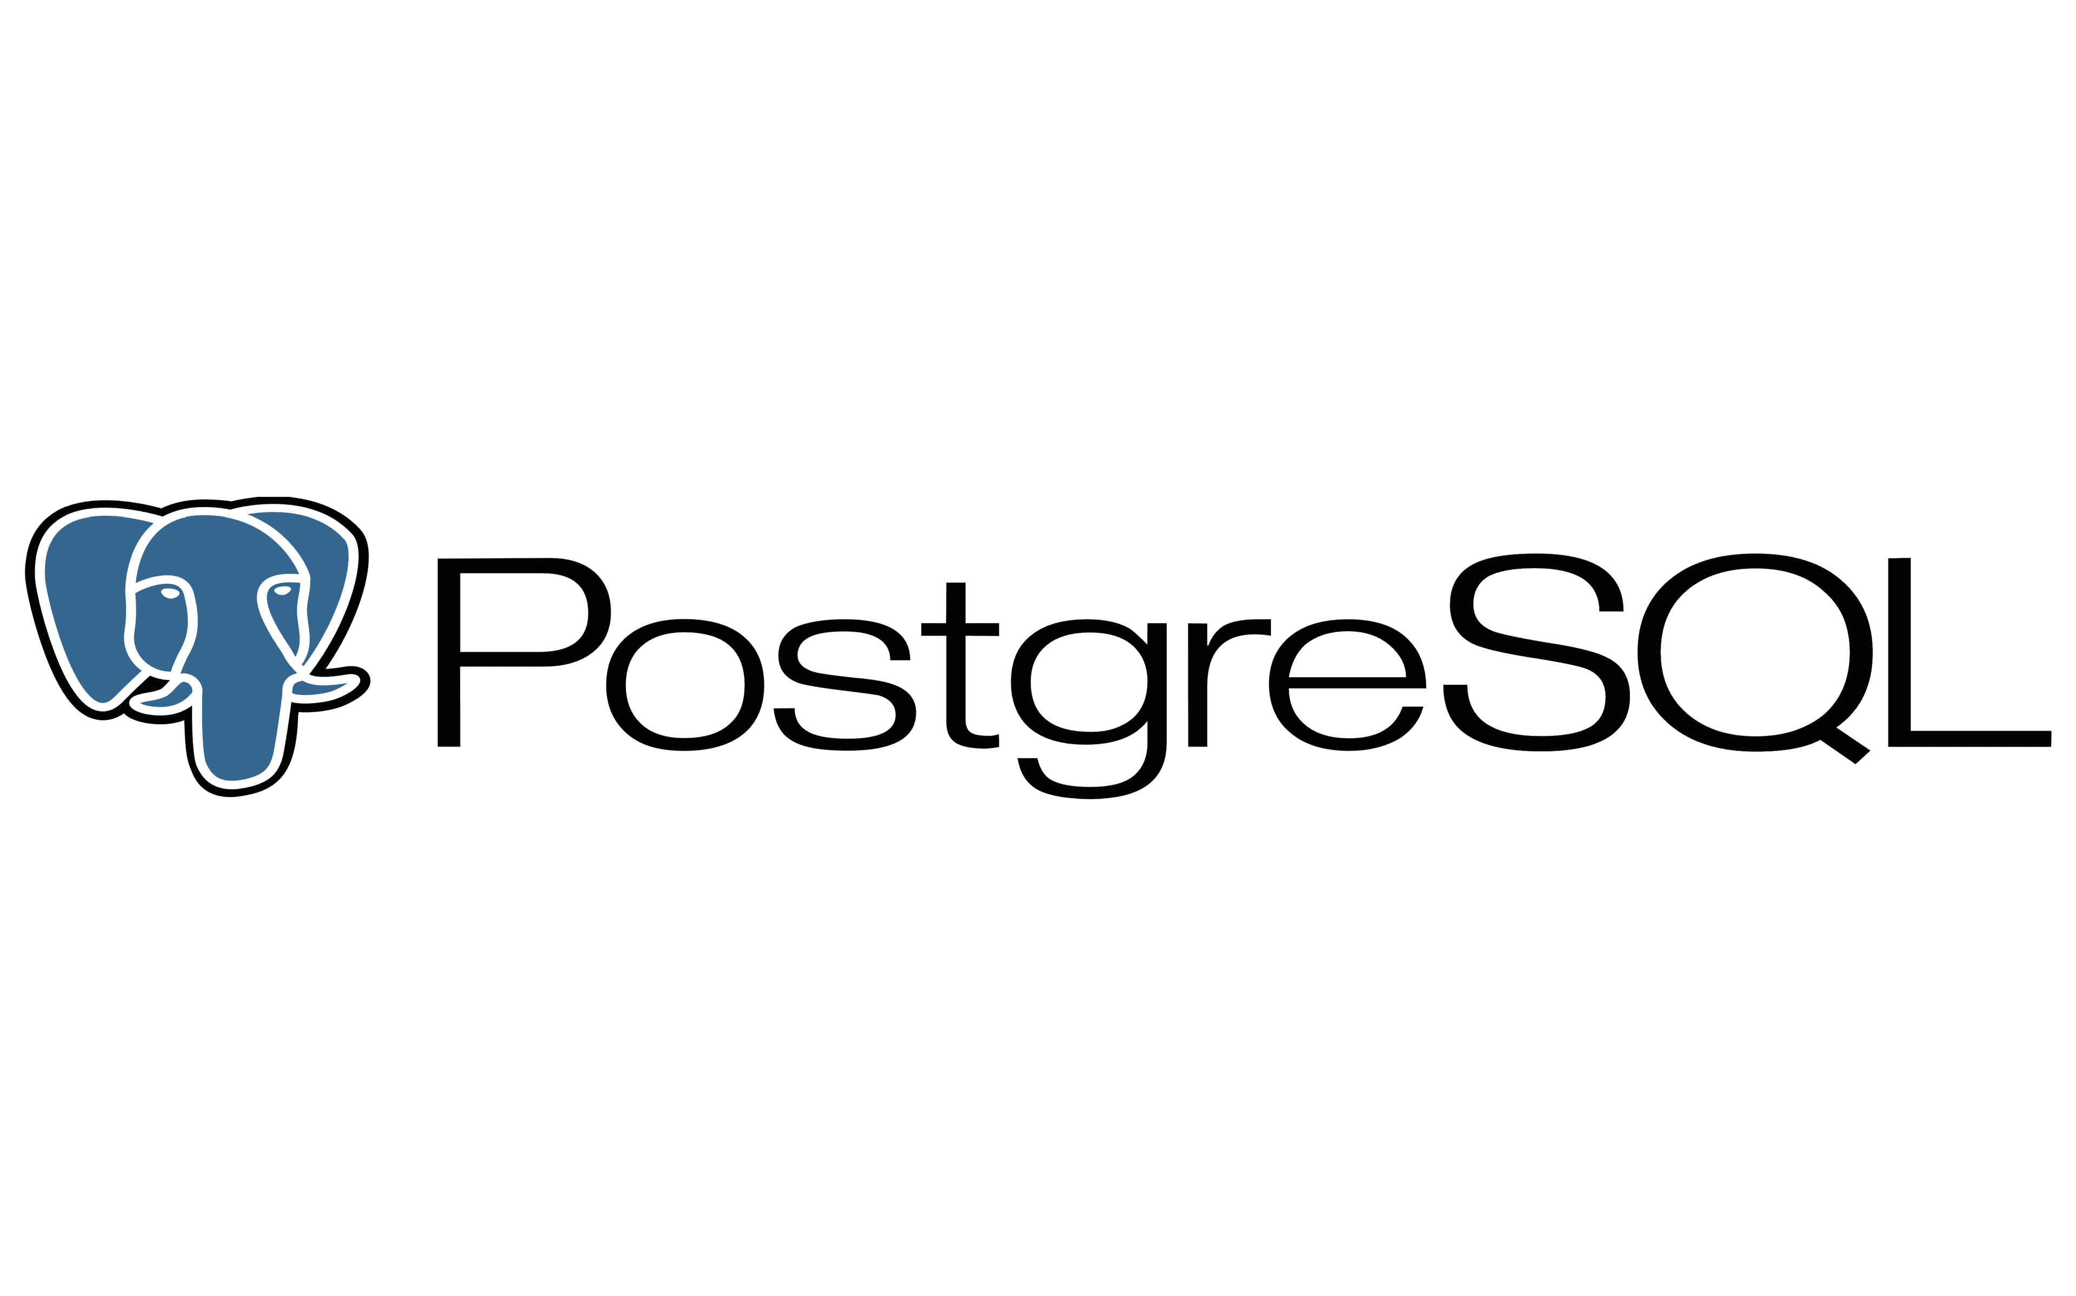
PostgreSQL logo

Prisma ORM
Prisma ORM is documented as a next-generation ORM for Node.js and TypeScript that provides type-safe database access. Its toolkit includes Prisma Client, Prisma Migrate, and Prisma Studio for querying, migrations, and data inspection. We used Prisma as the main data access layer to keep schema evolution and queries maintainable [5].

Prisma ORM logo

Socket.IO
Socket.IO is officially introduced as a library for low-latency, bidirectional, event-based communication. It supports transport fallback and includes features such as automatic reconnection and event acknowledgements. This was essential for real-time chat updates and immediate notification delivery in the application [6].

Socket.IO logo

Visual Studio Code
The official VS Code website presents it as an open-source AI code editor and a world-class editor core used by millions of developers. It provides extension support, integrated terminal, debugging features, and rich language tooling. It was our primary development environment for frontend and backend implementation tasks [7].
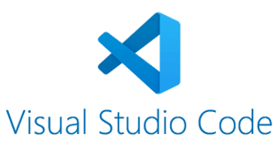
Visual Studio Code logo

Main Graphical Interfaces

Login Interface
The login interface is the entry point to the application. It authenticates the user, validates credentials against the backend, and redirects the session to the appropriate area according to the assigned role.
The interface is intentionally simple so that users can access the platform quickly without unnecessary navigation steps.
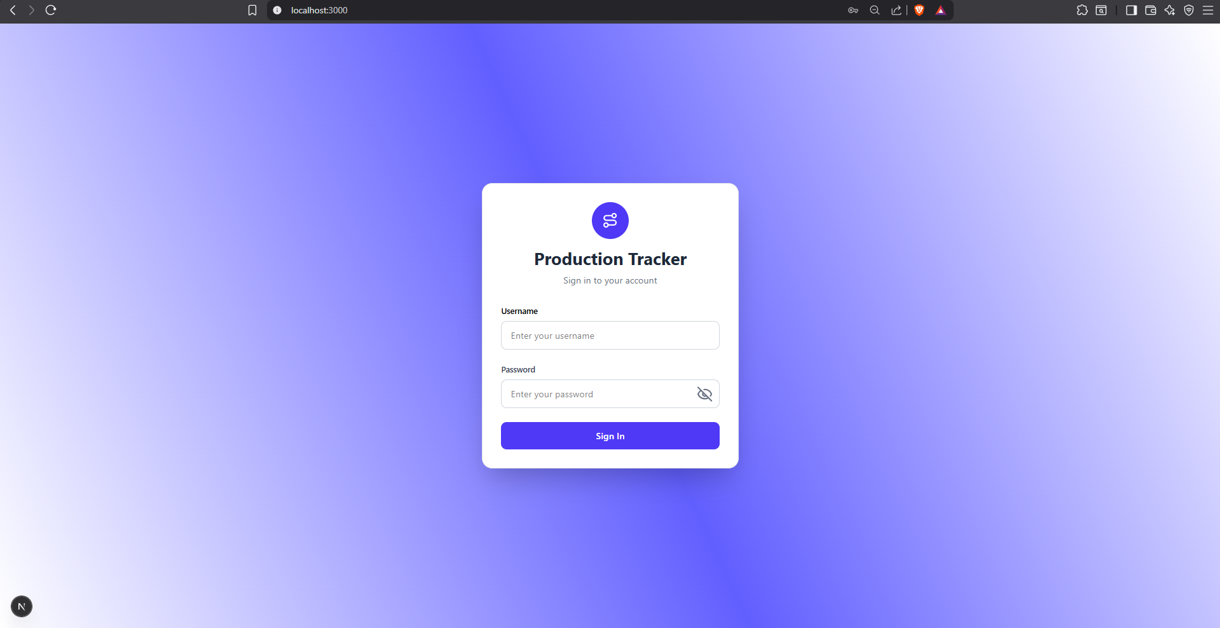
Login Interface

Administrator Dashboard
The administrator dashboard provides a global view of the production workflow. It is used to supervise work orders, track progress, manage stock, review notifications, and access communication features.
This screen acts as the central control panel of the system. It groups the most important operational indicators and offers quick access to management tasks.
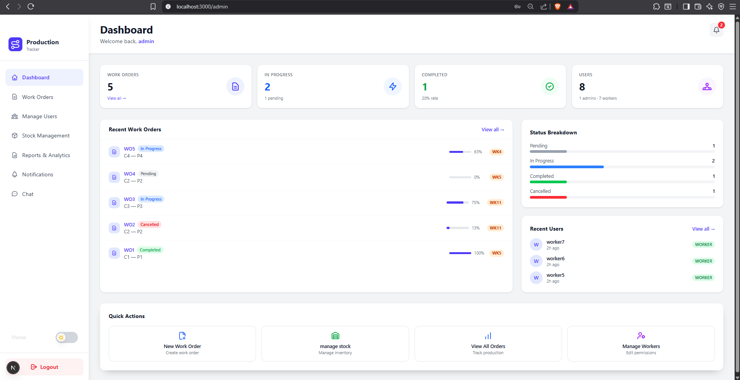
Administrator Dashboard

User Management Interface
The user management interface enables administrators to create user accounts, assign roles, and manage access rights according to operational responsibilities. This module centralizes user administration and supports secure role-based access across the platform.
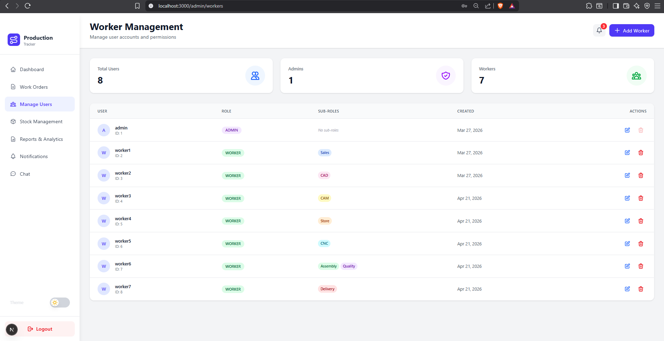
User Management Interface

Work Order Management Interface
The work order management interface allows administrators to create, update, assign, and monitor production orders. Each work order follows the workflow defined in the design chapter, including its stages, quantities, status, and responsible users.
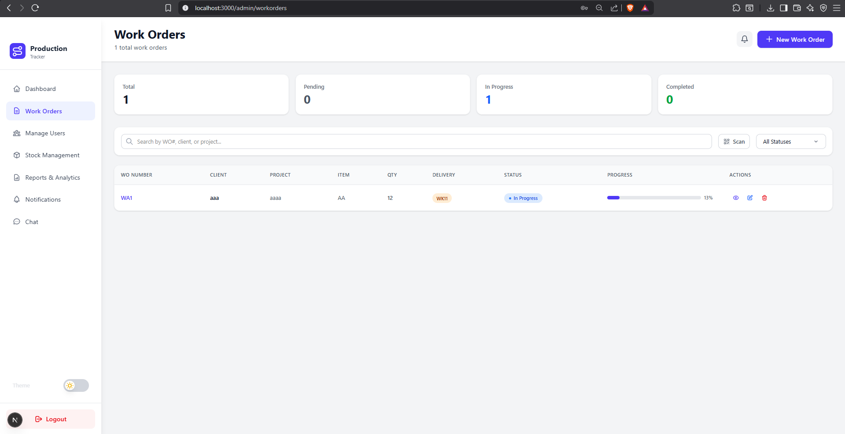
Work Order Management Interface

Stock Management Interface
The stock management interface is used to maintain inventory visibility and support material reservations for production needs. It provides access to stock items, quantities, thresholds, and operations such as entry, exit, or adjustment depending on the user role and business rules.
This area of the application helps reduce material shortages by keeping the inventory data synchronized with production activity.
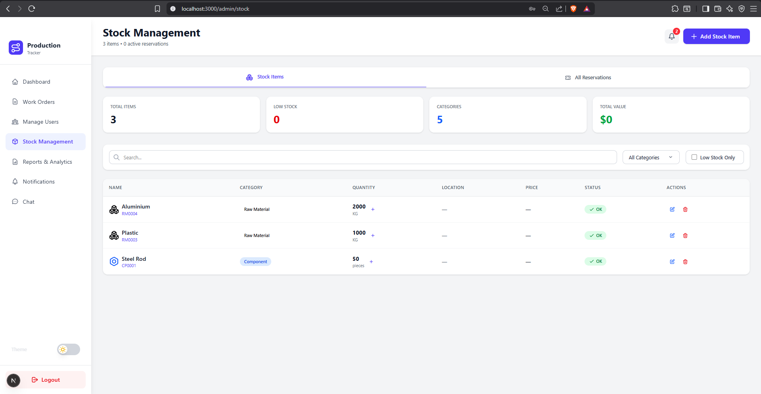
Stock Management Interface

Notifications Interface
The notifications interface lists the alerts generated by the system when important events occur, such as work order updates, stock movements, assignments, or chat-related actions.
It gives users a centralized view of the events that require attention and helps ensure that operational changes are not missed.
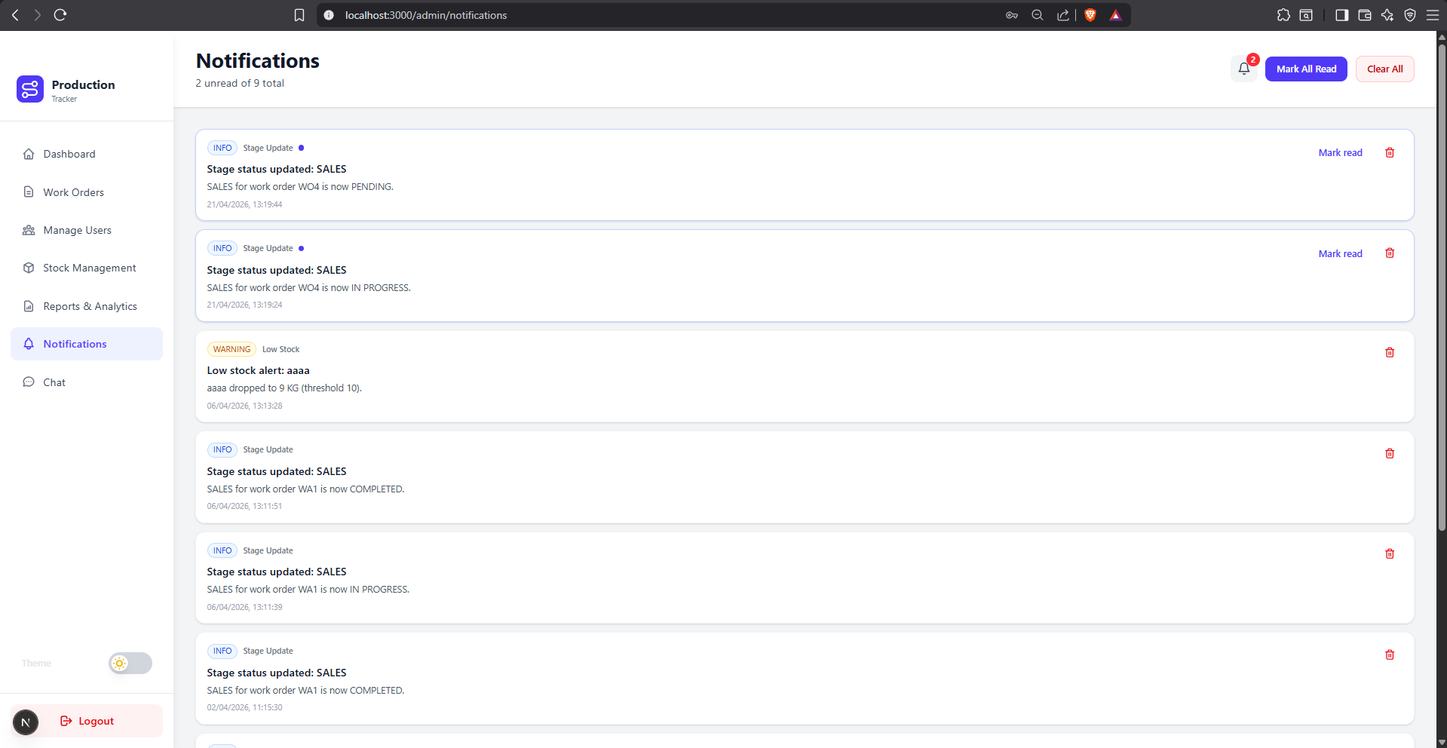
Notifications Interface

Chat Interface
The chat interface supports direct communication between users and work-order-related discussions. It was implemented to speed up coordination between administrators and workers, especially when clarifications or quick decisions are needed during production.
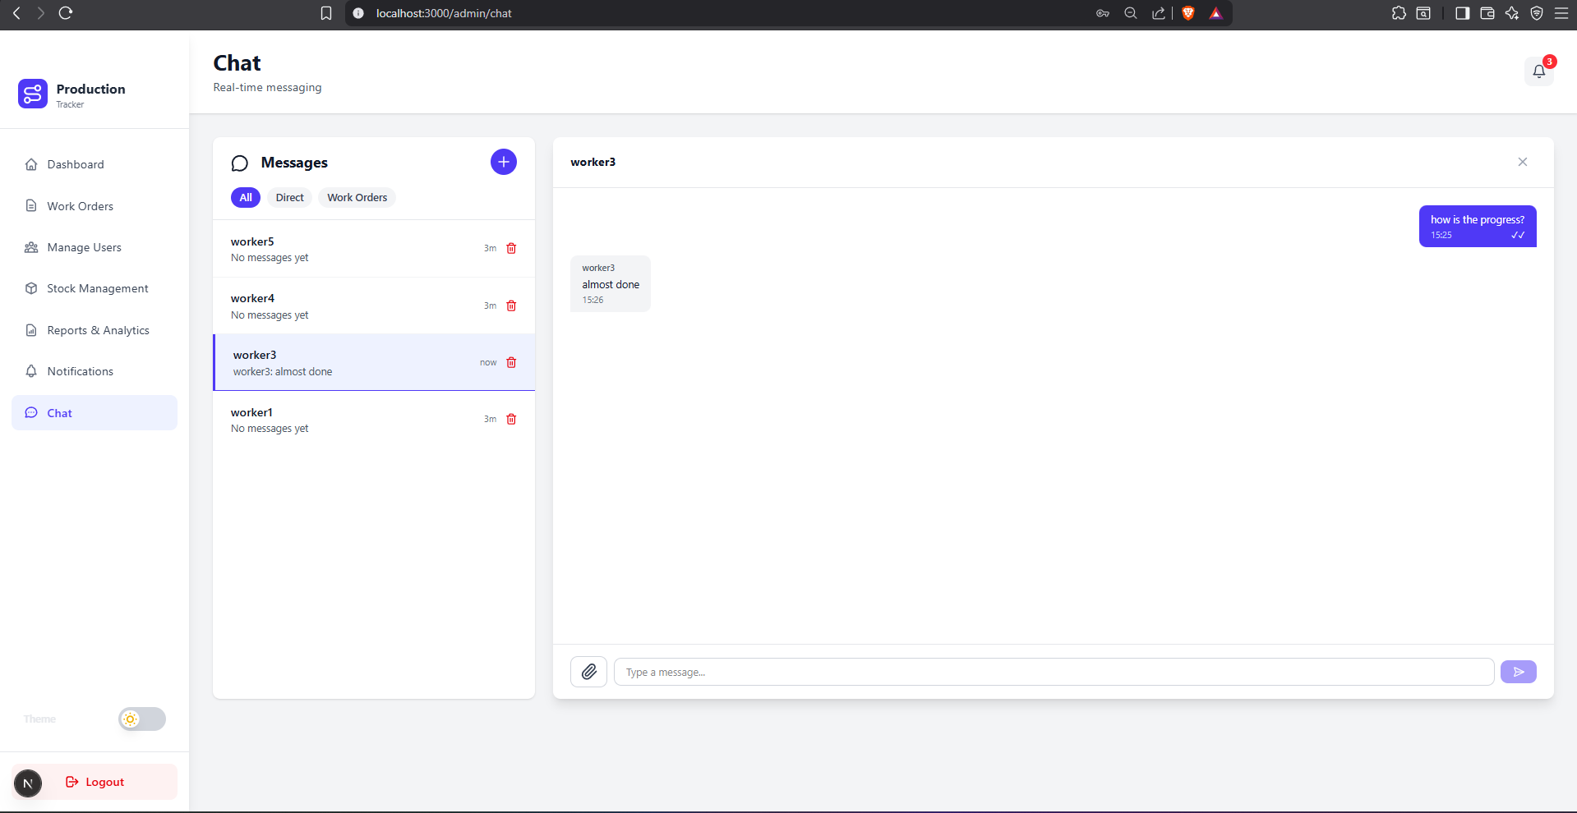
Chat Interface

Reports & Analytics Interface
The reports and analytics interface gives administrators consolidated indicators about production progress, stock trends, and operational performance. It supports monitoring and decision-making by transforming operational data into readable summaries and visual insights.
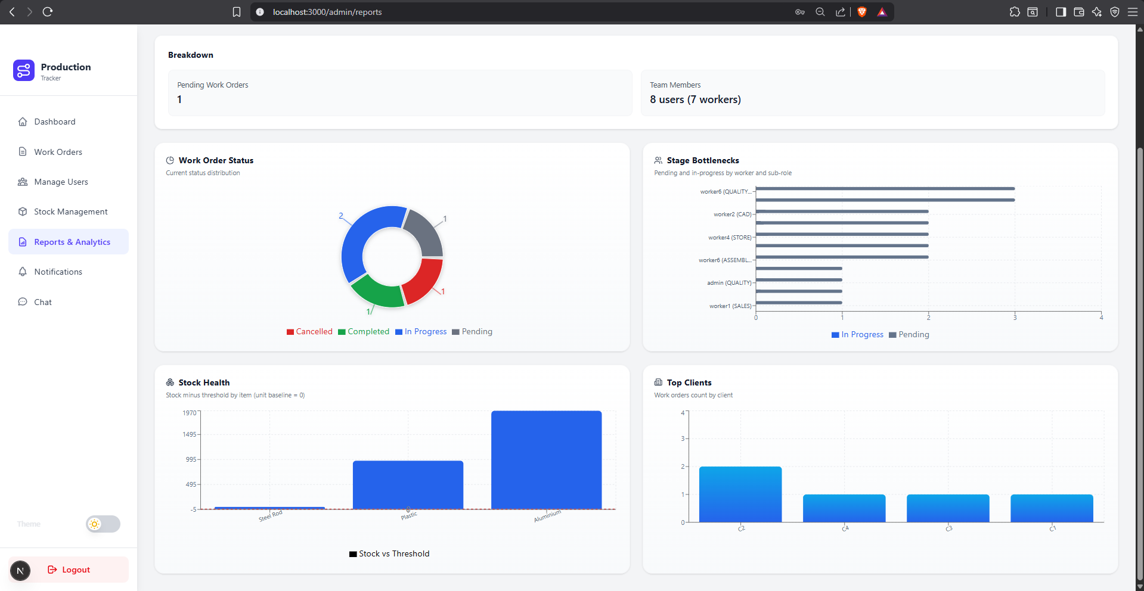
Reports and Analytics Interface

Worker Interface
The worker interface is designed for operational use on the production floor. It allows workers to consult assigned tasks, follow stage instructions, update progress, and receive alerts related to their responsibilities.
The layout focuses on clarity and speed of use so that workers can access the essential information without interacting with the administrative modules.
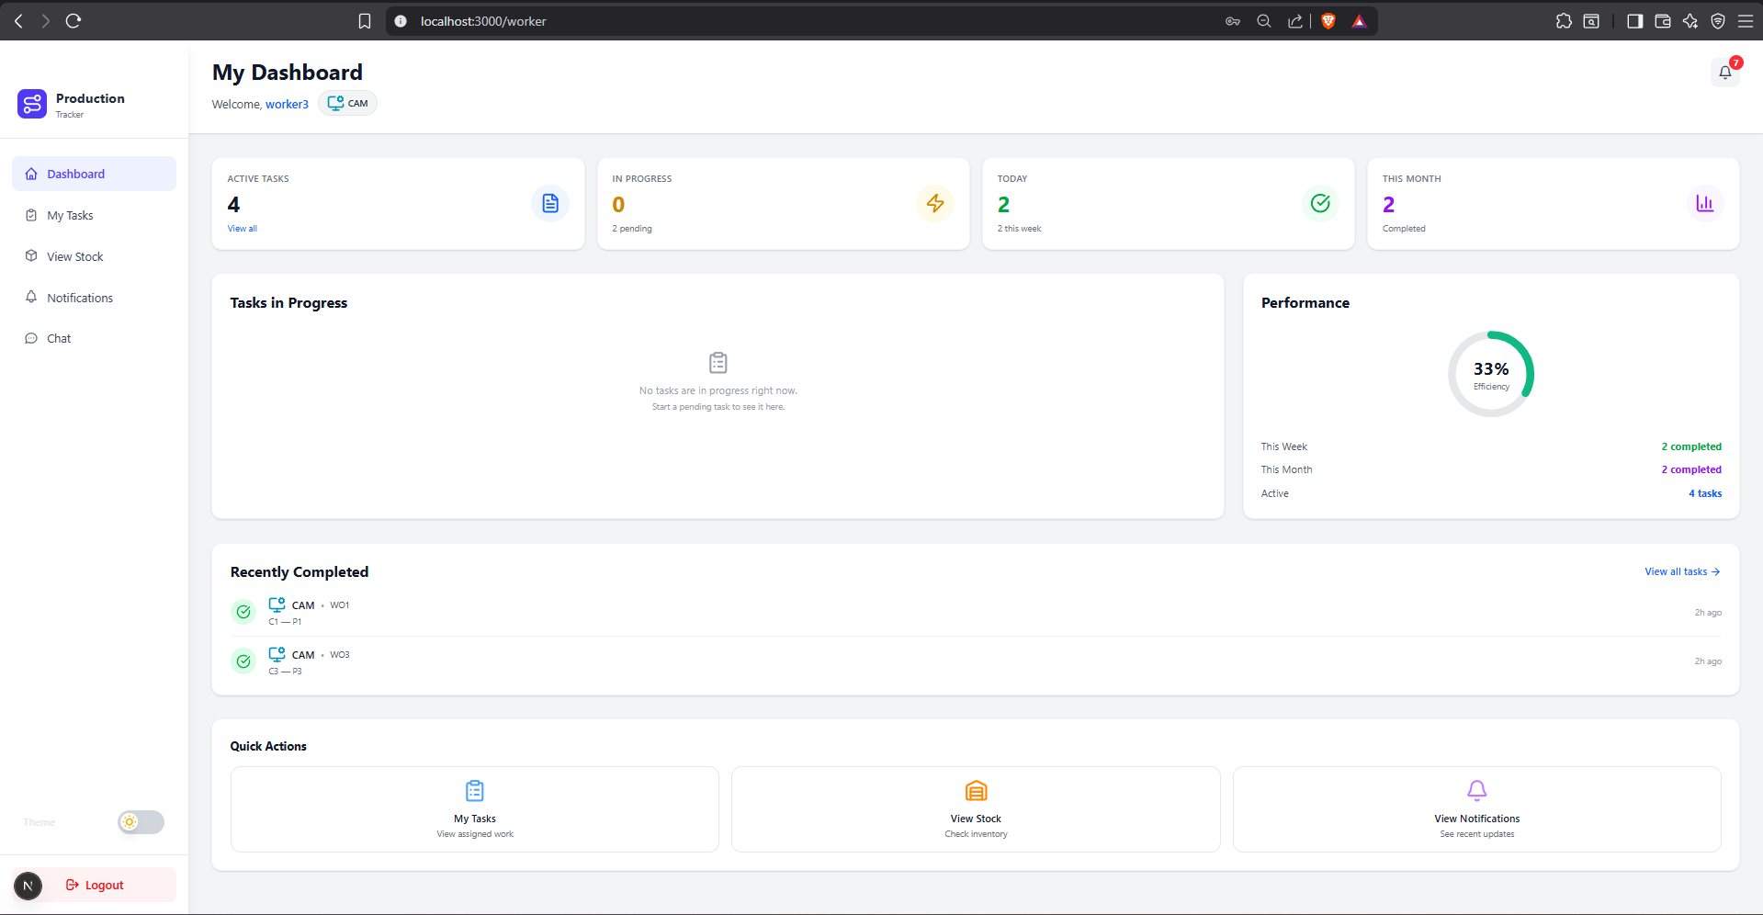
Worker Interface

Conclusion
This chapter introduced the implementation of the Production Tracker application and described the main execution environment as well as the primary user interfaces. The current version provides a structured base for the final report and includes representative screenshots of the implemented interfaces.

General Conclusion
This end-of-studies project addressed a concrete operational need at KTS: replacing a paper-based production tracking process with an integrated digital platform. Throughout this report, we moved from problem analysis to technical design and practical implementation of a web application capable of structuring daily production activities and improving coordination between stakeholders.
The developed solution, Production Tracker, covers the core business workflows identified during the analysis phase. It supports role-based authentication, work order management across the main production stages, stock monitoring and reservation, real-time notifications, and instant communication through chat. By centralizing these functions in a single system, the platform reduces information dispersion, limits manual errors, and improves traceability of production operations.
From a technical perspective, the selected stack (Next.js, Node.js/Express, PostgreSQL, Prisma, and Socket.IO) proved coherent with project objectives. It enabled a modular architecture, clear separation of responsibilities between frontend and backend, and efficient development of both transactional and real-time features. The resulting system provides a solid foundation for maintainability and future evolution.
Beyond technical implementation, this work demonstrates measurable organizational value for the host company. Administrators gain better visibility over production progress, workers receive clearer task guidance, and communication delays are reduced through shared real-time information. In this sense, the project contributes directly to KTS’s digital transformation effort and supports more reliable day-to-day decision making.
Like any first complete version, the current platform can be further improved. Future work may include advanced analytics dashboards, richer KPI reporting, tighter integration with ERP systems, mobile-first access for shop-floor usage, and additional automation for planning and forecasting. These extensions would strengthen strategic monitoring while preserving the operational gains already achieved.
In conclusion, this internship project successfully transformed a real industrial problem into a functional and scalable software solution. It also represented an important personal and professional milestone, combining software engineering practices, system design, and iterative delivery in a real business context.

References
Next.js Documentation. https://nextjs.org/docs
Node.js Official Website. https://nodejs.org/en
Express Official Website. https://expressjs.com/
PostgreSQL About Page. https://www.postgresql.org/about/
Prisma ORM Documentation. https://www.prisma.io/docs/orm/overview/introduction/what-is-prisma
Socket.IO Documentation (v4). https://socket.io/docs/v4/
Visual Studio Code Official Website. https://code.visualstudio.com/

