M1: Project Kick-off and Requirements Gathering

AI-Powered Customer Support Workspace
Salesforce CRM Implementation for an E-Commerce Business

Team: Fahad, Hamza, Khaled, Shatha
Date: August 2026

1. Project Overview
This project builds an AI-Powered Customer Support Workspace on the Salesforce Platform for NoorCart, an online retailer selling electronics, home goods, and beauty products. The CRM brings the entire support operation into one place: customer records, orders, support cases, returns, and knowledge articles. Support agents work from a single Lightning console instead of moving between a shared mailbox, an order system, and a refund spreadsheet, and an Agentforce AI agent assists them by summarising cases, answering questions from the company's own data, and drafting replies.
The key features of the CRM are:
- A data model covering customers, contacts, orders, order products, cases, returns, and AI interaction logging.
- A Lightning console application for support agents, built with Lightning App Builder and Dynamic Forms.
- An Agentforce AI agent grounded in Salesforce records and published Knowledge articles, using prompt engineering to produce accurate, context-aware responses.
- Automation of case routing, escalation, return creation, refund approval, and satisfaction surveys using Flows.
- A security model built on a minimum-access profile, permission sets, a role hierarchy, and sharing rules.
- Reports and dashboards for case volume, resolution time, and customer satisfaction.
The business need is straightforward. Support volume grows with order volume, but the team cannot grow at the same rate. Most incoming contacts are repetitive questions about order status and return policy, which consume agent time without adding value. Answers are inconsistent because there is no knowledge base, refunds are approved without an audit trail, and management has no reporting on service quality. This CRM addresses all of these problems.

2. Objectives
The main goal of this project is to deliver a secure, well-structured Salesforce CRM that reduces the effort required to resolve a customer support case while improving the speed and consistency of the answers customers receive. Each objective is linked to the business value it delivers.
- Design a scalable and secure application architecture, so that the system can absorb higher case volume and new channels without being redesigned.
- Build an intuitive agent workspace using Lightning pages and Dynamic Forms, so that agents handle cases faster and new agents need less training.
- Implement Agentforce with defined topics, prompts, and actions, so that routine enquiries are answered or drafted automatically.
- Automate the support process with Flows and an approval process, so that no case is lost and refund spending is controlled.
- Secure the application with least-privilege access, so that customer and financial data is protected and every approval is traceable.
- Test the solution before release, so that the business can rely on the features that were built.
- Deploy the solution using a repeatable process, so that future changes can be released safely.

3. Phase 1: Requirement Analysis and Planning

3.1 Understanding Business Requirements
The support team currently works without a CRM. The following problems were identified and the solution is designed to solve each of them.
- Customer requests arrive in a shared mailbox and a web form, so there is no single queue and no clear ownership of a request.
- Agents open three or four separate systems to answer one question, which makes every case slow to handle.
- Most contacts are repetitive questions about order status, delivery, and returns, which occupy experienced agents.
- There is no knowledge base, so answers depend on the individual agent and are inconsistent.
- Escalation to specialists happens informally, leaving no record and no way to measure response times.
- Refunds are approved verbally and recorded in a spreadsheet, which creates financial risk and no audit trail.
- There is no reporting on case volume, response time, or customer satisfaction.

3.2 Defining Project Scope and Objectives

Key User Stories for Support Agents
- As a support agent, I want to manage all customer inquiries from a single Lightning console so that I don't have to switch between different systems.
- As a support agent, I want Agentforce to draft replies and summarise cases so that I can respond to customers faster.
- As a support agent, I want a standardised process to create return requests directly from a Case so that refunds are tracked accurately.
- As a support agent, I want access to a Knowledge Base within my workspace so that I can provide consistent and accurate answers.
- As a team lead, I want refunds above a set amount to require my approval so that spending stays controlled.

Data Points Required for Customer Inquiries
Answering a customer enquiry requires specific information to be held in the system. The data points below were identified from the user stories and determine the fields built into the data model.
- Customer: name, customer tier, loyalty number, and address.
- Order: order number, order date, total value, status, tracking number, and delivery dates.
- Case: category, subject, description, status, priority, origin, the related order, service level target, escalation reason, resolution summary, AI summary, and satisfaction score.
- Return request: the related order and case, return reason, return type, status, requested and approved amounts, refund method, and approver.
- AI interaction: the case it relates to, the type of interaction, whether it was handled by the AI or a human, the grounding source, and whether the agent accepted the output.

Project Scope
The following functionality is included in the project:
- Case management from the web form and the support email address, with five case categories.
- Lightning Knowledge with data categories, used by agents and as the grounding source for the AI agent.
- Custom and standard objects for customers, orders, cases, returns, and AI interaction logging.
- A Lightning console application with record pages, Dynamic Forms, Dynamic Actions, and dynamic visibility.
- An Agentforce agent with topics, instructions, prompt engineering, and actions.
- Flow automation, an approval process for refunds, reports and dashboards, and deployment.
The following items are excluded and are listed as future enhancements:
- Live chat, messaging, and telephony channels.
- Integration with a real payment gateway or courier tracking system.
- A customer self-service portal on Experience Cloud.
- Full Arabic localisation of the user interface.

3.3 Data Model Design
The data model uses standard Salesforce objects wherever one exists, and custom objects only where the platform has no equivalent. This approach ensures high maintainability and scalability, allowing the architecture to absorb increasing case volumes and support future workflows while preserving standard reporting and automation.

Object | Type | Purpose
Account | Standard | The customer record, including customer tier and loyalty number.
Contact | Standard | The individual shopper, used for email matching and replies.
Order | Standard | Customer orders, including status, tracking number, and delivery dates.
Order Product | Standard | The line items of an order, in a master-detail relationship with Order.
Product | Standard | The product catalogue.
Case | Standard | The core support object, with five record types for the different request categories.
Return Request | Custom | Return and refund requests, with their own status, amounts, and approver.
Return Line Item | Custom | The individual lines of a return request, supporting partial returns.
Support Interaction | Custom | A log of each AI interaction, its source, and whether the agent accepted it.
Knowledge | Standard | Support articles used by agents and by the AI agent.

The main relationships in the model are:
- An Account has many Contacts, Orders, and Cases.
- An Order has many Order Products through a master-detail relationship, which allows the order total to be rolled up.
- A Case has a lookup to the Order it relates to, so agents and the AI agent can see order information directly on the case.
- A Return Request has a required lookup to an Order and an optional lookup to a Case, so that returns can also be created without a case in future.
- A Return Line Item is a master-detail child of a Return Request. This relationship allows a roll-up summary field on the Return Request to total the refund across all of its lines automatically.
- A Support Interaction has a required lookup to a Case.
Two design decisions were recorded because they cannot easily be reversed. Person Accounts were not enabled, since the setting is permanent and an Account with a related Contact models an online shopper adequately for this project. The standard Order object was chosen over a custom alternative, so that the solution inherits order products, the automatic roll-up of order value, and native reporting without additional configuration.
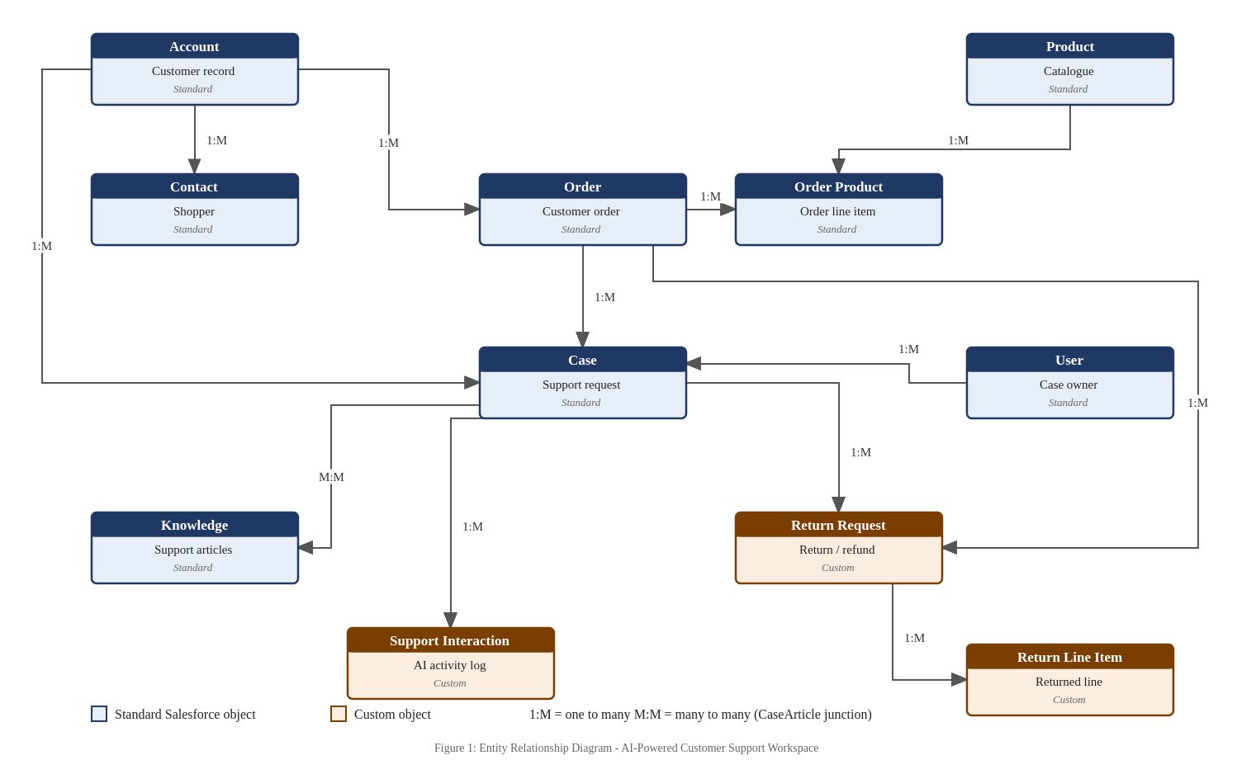
Figure 1 - Entity relationship diagram of the data model

3.4 Security Model Design
Access is granted on a least-privilege basis. Users receive a minimum-access profile that grants no object permissions, and all access is given through permission sets.
- Profile: a single profile, NoorCart Support Base, cloned from Minimum Access - Salesforce.
- Permission sets: one for Tier 1 agents and one for Tier 2 specialists, granting the object and field access each role requires.
- Role hierarchy: Support Manager, Support Team Lead, and Support Agent.
- Organisation-wide defaults: Account and Case are Private; Contact and Order are Controlled by Parent; Product is Public Read Only.
- Sharing rules: escalated cases are shared with the Tier 2 group, so that a specialist can work a case they do not own.
- Field-level security: the approved refund amount is hidden from Tier 1 agents and editable only by team leads.
- AI data privacy: the Einstein Trust Layer ensures that no sensitive customer data is retained by generative AI models through zero data retention, maintaining data privacy during all Agentforce interactions.

4. Conclusion
Milestone 1 established what the AI-Powered Customer Support Workspace has to achieve and how it will be structured, before any configuration work began. The current support operation was analysed and seven specific problems were identified, ranging from the absence of a single queue for incoming requests to the lack of any audit trail for refunds. Each of these problems is answered by a defined part of the proposed solution, so that the system being built can be judged against the difficulties it was meant to remove.
The requirements were expressed as user stories written from the point of view of the support agent, which keeps the focus on the work the system has to make easier rather than on the features it happens to contain. From those stories, the data points needed to answer a customer enquiry were identified, and these determined the objects and fields in the data model. The model favours standard Salesforce objects and introduces custom objects only for the return request, the return line item, and the log of AI interactions, for which the platform offers no equivalent. The security model was designed alongside it on a least-privilege basis.
The scope of the project was fixed at the end of this milestone, together with the items excluded from it, so that the schedule remains achievable and any later request can be measured against an agreed boundary. With the process, the requirements, the data model, and the security model defined and documented, the project moved into Milestone 2, in which the Salesforce organisation was created and this design was implemented as working configuration.

