Abstract
This report outlines our catapult design, the way it works, and the process of its construction. Our model was drawn in Fusion 360. We developed a complete set of drawings and an exploded drawing containing a parts list.
The bottom and side plates are made of acrylic that is laser cut. The main pivot shaft is supported by two side plates (Right Legs). The primary pivot is a rod that’s 3D printed (Item 4). An arm (Item 2) is a printed rotating arm that is attached to the main pivot. The projectile is fitted in a printed marble holder (Item 3) which is attached to the rotating arm. Item 2,3,4 are 3D printed together
The box part is made of aluminium steel bar (Item 6) and the print arm (Item 2) is attached to each other with a rubber band. As the arm is pulled, the rubber band stretches and retains energy. When you pull the trigger the band pulls the arm and shoots the projectile. Metal screws (Item 5) stop the pivot shaft (Item 4) from sliding out and keep the assembly tight.
Out of the drawing set, the total size would be approximately 130 mm x 130.15 mm x 111.95 mm which is contained within the requirements of 200 x 200 x 200 mm. We had three production processes, which consisted of laser cutting, 3D printing, and a manual lathe.

Table of Contents
Abstract
- Introduction
- Design Concept and Approach
2.1 Overall Configuration
2.2 Bill of Materials (BOM)
2.3 Key Dimensions from Drawings
- Manufacturing and Assembly
3.1 Manufacturing Processes (Laser Cut + 3D Print + Lathe)
3.2 Tools and Equipment
3.3 Assembly Procedure (Referenced to Exploded View)
3.4 Quality Control and Dimensional Checks
- Discussion
- Conclusion
- Contributions Sheet
Appendix A: Engineering Drawings
1. Introduction
Catapult is the devices which are capable of storing energy and transforming it into the kinetic energy to shoot a projectile. The catapult project MMMB203 develops practical CAD modelling, engineering drawings, and manufacturing planning. The catapult was developed in Fusion 360 and recorded with orthographic drawings and exploded view with parts list in this project. The design is small, stagnant, can be produced via a variety of processes and fits within the size restriction of 200 x 200 x 200 mm.

2. Design Concept and Approach
2.1 Overall Configuration
This is an assembly founded on a Base Project (Item 7) which is rigid. There are 2 acrylic Right Legs (Item 1, Qty 2) which are attached to the base and hold the main support frame in an upright position. The holes in the Right Legs are penetrated by pivot shaft (Item 4) and forms central axis of rotation. Item 2 3D-printed rotating shaft is connected to the pivot shaft Item 4. The projectile is contained in the Marble Holder Item 3 attached to Item 2. The pivot shaft Item 4 has Two Holders Item 5 attached on the ends of the pivot shaft as screws- that is, to ensure that Item 4 is not pulled out of the Right Leg plates during pull-back and launch. The Box component Item 6 is a steel bar that serves to anchor the rubber band rigidly and also helps to maintain a steady course in that it serves as a stop/ outrigger towards making the catapult less likely to tip over during operation. The overall geometry, dimension, and order of assembly are given in the engineering drawing which is accompanied with the exploded view and is in Appendix A.
2.2 Parts List (BOM) + Function Table
Item | Qty | Part Name (from drawing) | Material | Process | Function in this mechanism
1 | 2 | Right Leg | Acrylic | Laser cut | Side plates supporting the pivot shaft and maintaining alignment.
2 | 1 | Shaft | PLA | 3D print | Rotating shaft mounted on Item 4; connects to rubber band and carries Item 3.
3 | 1 | Marble Holder | PLA | 3D print | Cup that holds the projectile, attached to Item 2.
4 | 1 | Shaft | PLA | 3D print | Main pivot shaft passing through both Right Legs, Item 2 rotates around this axis.
5 | 2 | Holder | Metal | Screws | Holds parts together and prevents Item 4 from sliding out during use.
6 | 1 | Box | Steel bar | Manual lathe | Rubber band anchor + stabilizing stop/outrigger to reduce tipping.
7 | 1 | Base Project | Acrylic | Laser cut | Base plate supporting the full mechanism.

2.3 Mechanism of Operation
The catapult is powered by a rubber band connected between Item 6 (Box) and Item 2 (Shaft):
- Pivot axis: Item 4 is inserted through the two Right Legs (Item 1) and acts as the pivot axle.
- Rotating element: Item 2 mounts onto Item 4 and rotates about it.
- Projectile holder: Item 3 is connected to Item 2 and holds the projectile.
- Energy storage: Pulling Item 2 backward stretches the rubber band between Item 2 and Item 6, storing elastic potential energy.
- Launch: Releasing Item 2 allows the rubber band to contract, producing torque around Item 4. This accelerates Item 2 forward and launches the projectile from Item 3.
- Safety/stability: Item 5 prevents Item 4 from sliding out during operation. Item 6 also acts as a stabilizer/stop to help prevent tipping when the band is stretched.
2.4 Key Dimensions from Drawings
From the drawing set, the assembled design occupies:
- Width:130 mm
- Base length:130.15 mm
- Height:111.95 mm
This is under 200x200x200mm which is the limit. The other sizes that are important such as the Right Legs, the pivot position, the diameter of the shafts, and the size of the marble holder cups are also indicated in the drawings. These are sizes that are important since they determine whether the arm is going to rotate in a smooth manner and whether the components will fit during the process.
3. Manufacturing and Assembly
3.1 Manufacturing Processes
Process A — Laser Cutting (Acrylic)
Items manufactured: Base Project (Item 7), Right Legs (Item 1, Qty 2)
Steps:
- Import DXF files from Fusion 360 into the laser cutter software.
- Set acrylic sheet thickness to 6 mm and settings according to the lab guidelines.
- Cut the profiles for Item 1 and Item 7.
- Remove protective film, check the edges, and check hole dimensions against drawings.
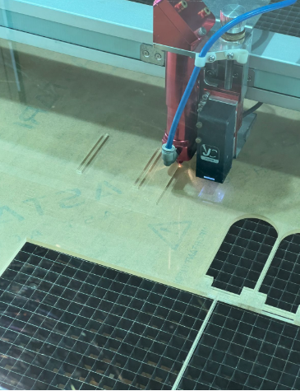
Figure 3.1: Laser cutting acrylic used to manufacture Item 7 (Base).
Process B — 3D Printing
Items manufactured: Shaft (Item 2), Marble Holder (Item 3), Shaft (Item4)
Steps:
- Export STL files and slice with 0.2 mm layer height for smooth surfaces.
- Print using PLA with 15% infill to support loading during printing.
- Remove support material and inspect the final product where required.
- Check fits with Item 4 and confirm tolerances match drawings.
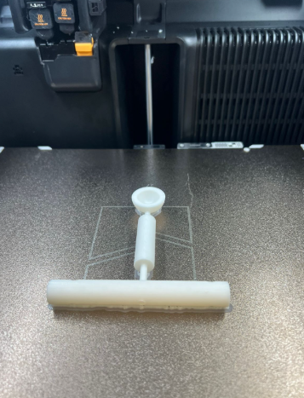
Figure 3.2: 3D printing process used to manufacture Item 2, Item 3, and Item 4.
Process C — Manual Lathe Machine (Steel Parts)
Items manufactured: Box anchor (Item 6)
Steps:
- Cut the aluminum bar to 8cm.
- Faced the ends.
- Smoothed sharp edges.
- Checked length so it fits the assembly.
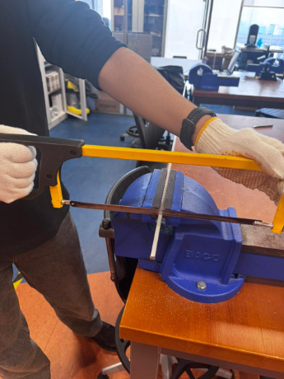
Figure 3.3: Manual lathe operation used to cut Item 6 (metal rod) to final size.
3.2 Tools and Equipment
- Laser Cutter for Base and Legs of the Catapult
- Creality H2D 3D printer with PLA filament
- Grinder to smooth edges
- Vernier calipers and micrometers for measurement
- Sandpaper and files for minor adjustments
- Safety gear including safety glasses, gloves, and lab coat

3.3 Assembly Procedure (Step-by-step using Item numbers)
- Place the base (Item 7) on a flat surface.
- Mount the Right Legs (Item 1) to the base. Ensure both plates are vertical and parallel.
- Insert the 3D printed part, pivot shaft (Item 4) that’s attached to item 2 and 3 through both Right Legs.
- Use the metal screws (Item 5) to secure the assembly and prevent the pivot shaft (Item4) from sliding out.
- Install the steel box anchor (Item 6) in its position.
- Hook the rubber band between Item 6 and Item 2.
- Test for movement by pulling Item 2 back. Verify that it rotates easily and the base remains stable.

3.4 Quality Control and Checks
- Ensure Item 2 rotates smoothly on Item 4.
- Confirm Right Legs remain parallel after tightening.
- Deburr acrylic edges and steel ends for safety.
- Check (Item 5) screws prevent any side-to-side movement of Item 4.
- Ensure the rubber band anchor points do not slip.
- Verify the projectile sits securely in Item 3 and releases cleanly.
4. Discussion
During the build, we 3D printed Item 2, Item 3, and Item 4 first so we could test the moving mechanism early. We originally planned one Left Leg and one Right Leg, but the Left Leg fit was too loose, so the frame was not stable. Since the legs have the same geometry, we fixed this by printing the Right Leg twice and used them as the two side plates (Item 1).
We also faced a fit issue with Item 6 (metal rod). It did not pass through the holes in the leg plates. The ends were slightly rough. We solved this by using a grinder to smooth the ends, then the rod could slide through properly.
These issues showed us that fit and tolerance matter a lot, especially when mixing laser-cut acrylic, 3D prints, and metal parts.
5. Conclusion
In Fusion 360, we designed a small rubber-band catapult. We produced a full set of drawings and an exploded view with a parts list. We laser cut the base (Item 7) and the side legs (Item 1) from acrylic. We 3D printed Item 2, Item 3, and Item 4 using PLA. We used metal screws (Item 5) as fasteners. We manufactured Item 6 as a metal rod using the manual lathe. During assembly, we replaced the original left–right leg idea by using two Right Legs because the Left Leg fit was too loose. We also used a grinder to smooth the ends of Item 6 so it could pass through the holes in Item 1.
The mechanism works like this: the two side plates (Item 1) support the pivot axis for Item 4. Item 2 rotates around Item 4. Item 3 holds the projectile on Item 2. A rubber band connects between Item 2 and Item 6. Pulling back stores energy in the rubber band. Releasing makes Item 2 swing forward and launch the projectile. The screws (Item 5) keep the assembly tight and prevent parts from sliding out. Item 6 also improves stability and reduces tipping. The full assembly fits within the required 200 × 200 × 200 mm size limit.

Appendix A: Engineering Drawings
A1. Exploded View + Parts List
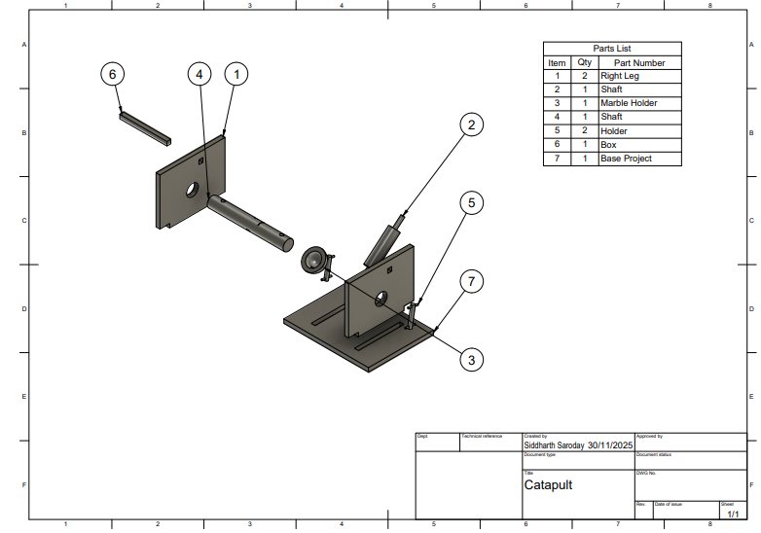

A2. Drawing Set (Sheets 1–6)
