1. Introduction
In the summer of 2024, global equity markets experienced one of their sharpest single-week selloffs in years. The trigger was not a recession, a banking crisis, or a geopolitical shock — it was the Bank of Japan raising interest rates by 0.15 percentage points. The outsized reaction revealed something remarkable about the structure of modern financial markets: an enormous volume of capital had been quietly borrowing in Japanese yen at near-zero rates and investing in higher-yielding assets elsewhere, a strategy known as the yen carry trade. When Japanese rates rose and the yen strengthened, the trade unwound simultaneously across thousands of portfolios, transmitting a localised monetary policy decision into a global market shock.
The yen carry trade is sometimes described as a near-frictionless arbitrage — borrowing cheaply in a zero-rate currency and investing in a higher-yielding one, pocketing the differential with apparently limited risk. For much of the period since 2016, when the Bank of Japan introduced Yield Curve Control (YCC) and committed to pinning domestic interest rates at zero indefinitely, this description was not far from the truth. The US-Japan interest rate differential was strictly positive in every single week of our sample, meaning the carry trade was profitable without exception. Leveraged funds were net short yen approximately 75% of the time. The scale was systemic.
But carry trades can stop working — abruptly and violently. When the Federal Reserve began its aggressive hiking cycle in April 2022, the sustainability of the short yen position came into question for the first time. Markets began pricing the inevitable end of YCC well before it formally arrived, and when the BoJ finally abandoned the policy in 2023, the unwind had already been underway for over a year. Understanding precisely how and why this happened — and what it reveals about the true determinants of the yen — is the motivation for this study.
The research question is: what determines the USD/JPY exchange rate, and do these determinants change fundamentally when the BoJ's policy regime shifts? This question matters beyond the yen specifically. It speaks to the broader failure of exchange rate models documented by Meese and Rogoff (1983), and to the question of how central bank yield curve intervention affects the fundamental architecture of currency determination — a question with growing relevance as unconventional monetary policy becomes a standard tool.
To answer it, we use weekly data from January 2016 to December 2025, apply the Bai-Perron structural break test to endogenously identify regime changes, and estimate regime-specific Vector Error Correction Models before and after the identified break. The results show that during the YCC period, the yen's long-run level was anchored entirely by institutional carry trade positioning — macroeconomic fundamentals were irrelevant. After the April 2022 break, the exchange rate transitions to being driven by Japan's yield curve and rate differentials, with the price now actively error correcting toward long-run equilibrium. The carry trade did not just affect the level of the yen — it replaced the entire mechanism by which the yen is priced.

Literature Review

3. Methodology

3.1 Data and Sample Period
This study employs weekly data spanning January 2016 to December 2025 (517 observations), sourced from three providers: interest rate data from FRED; USD/JPY spot rate, VIX, WTI crude oil, DXY, and Nikkei 225 from Yahoo Finance; and weekly Japanese Yen futures positioning data from the CFTC Commitments of Traders (COT) Traders in Financial Futures report. The COT data distinguishes Dealers, Asset Managers, and Leveraged Money, from which net positions, directional intensity, and positioning proportions relative to open interest are constructed. All series are reindexed to weekly frequency and merged via an asof join.

3.2 Feature Engineering
Interest rate differentials are computed at the 3-month, 10-year, and interbank levels as the US rate minus the corresponding Japanese rate. Term spreads (10-year minus 3-month) are constructed for both countries, with the JPY term spread serving as the primary BoJ policy expectations indicator. A Carry-to-Risk ratio is constructed as the 3-month rate differential divided by the VIX, capturing risk-adjusted carry trade attractiveness.

3.3 Stationarity and Transformation
Variables are tested using both the ADF and KPSS tests — a variable is classified as stationary only if ADF rejects the unit root null (p < 0.05) and KPSS fails to reject stationarity (p > 0.05). Price levels and indices are log-transformed then first-differenced; rates and spreads are first-differenced directly; Japanese interest rates are confirmed I(2) and second-differenced. Endogenous VECM variables are maintained in I(1) levels; exogenous regressors are pre-transformed to I(0).

3.4 Structural Break Detection
The Bai-Perron (1998, 2003) multiple structural break test is applied to log USD/JPY using binary segmentation with a minimum segment length of 52 observations, endogenously identifying break dates without imposing policy event assumptions. Identified breaks are confirmed using Chow tests.

3.5 Cointegration Testing
Pairwise Engle-Granger cointegration tests are conducted between log USD/JPY and all candidate I(1) variables, both for the full sample and within each regime. The Johansen (1988) procedure is then applied within each regime to determine cointegrating rank and estimate the cointegrating vector, with lag order selected by AIC.

3.6 Vector Error Correction Model
The VECM is the primary estimation framework, selected for its ability to simultaneously model long-run cointegrating relationships and short-run dynamics. It is preferred over a VAR in levels for non-stationary variables and over a VAR in differences as it retains the long-run information that differencing destroys (MacDonald and Taylor, 1994). The specification is:
ΔYt = αβ'Yt-1 + Σ ΓiΔYt-i + ΦXt + εt
where β captures the long-run cointegrating relationship, α captures error correction speeds, and Xt is the vector of stationary exogenous regressors. Separate VECMs are estimated per regime with variable sets determined by within-regime cointegration tests.

3.7 Diagnostic Testing
Residual adequacy is assessed via univariate Ljung-Box tests at lags 1, 4, 8 and 12, the multivariate portmanteau whiteness test for joint autocorrelation, Jarque-Bera normality tests, and Q-Q plots. Non-normality is expected for weekly financial data and treated as motivation for Student's t error distributions rather than evidence of misspecification.

4. Findings

4.1 Data & Descriptive Statistics

4.1.1 Data Sources
This study employs weekly data spanning January 2016 to December 2025, yielding 517 observations. The sample period is chosen deliberately to capture both the full implementation of the Bank of Japan's Yield Curve Control (YCC) policy (introduced September 2016) and its subsequent unwinding from December 2022 onwards, allowing for a meaningful comparison of exchange rate dynamics across the two regimes.
The dependent variable is the USD/JPY spot exchange rate, retrieved from Yahoo Finance and expressed in logarithmic form (Log_Price) to ensure stationarity in returns and to allow for percentage change interpretations of coefficients.
Data is drawn from three sources:
Federal Reserve Economic Data (FRED): Interest rate data for both Japan and the United States is sourced from FRED. This includes the 10-year government bond yield, 3-month interbank rate, and overnight interbank rate for both countries. These series form the basis for constructing interest rate differentials and term spreads — central variables in the carry trade and uncovered interest parity frameworks.
Yahoo Finance: In addition to the USD/JPY spot rate, market variables including the CBOE Volatility Index (VIX), the US Dollar Index (DXY), West Texas Intermediate (WTI) crude oil prices, and the Nikkei 225 equity index are sourced from Yahoo Finance. All series are reindexed to the weekly frequency and forward-filled to align with the FRED data.
CFTC Commitments of Traders (COT): Weekly futures positioning data for the Japanese Yen contract traded on the Chicago Mercantile Exchange is sourced directly from the Commodity Futures Trading Commission (CFTC). The Traders in Financial Futures (TFF) report distinguishes between three trader categories: Dealers (financial institutions), Asset Managers (pension funds, mutual funds), and Leveraged Money (hedge funds and CTAs). Net positions, directional intensity, crowding measures, and positioning proportions relative to open interest are constructed for each category.

4.1.2 Variable Construction
Derived Variable | Formula | Economic Interpretation
Rate Differentials
Rate Differential 3M | US 3M − JPY 3M | Short-end carry trade incentive
Rate Differential 10Y | US 10Y − JPY 10Y | Long-end carry trade incentive
Rate Differential Interbank | US Interbank − JPY Interbank | Overnight funding cost differential
Term Spreads
US Term Spread | US 10Y − US 3M | Shape of US yield curve
JPY Term Spread | JPY 10Y − JPY 3M | Shape of Japanese yield curve — BoJ policy signal
Term Spread Differential | US Term Spread − JPY Term Spread | Relative yield curve steepness
US 10Y Interbank Spread | US 10Y − US Interbank | US term premium over overnight rate
JPY 10Y Interbank Spread | JPY 10Y − JPY Interbank | JPY term premium over overnight rate
Term 10Y Interbank Differential | US Term Spread − JPY Term Spread | Cross-country term premium differential
Risk-Adjusted Carry
Carry to Risk | Rate Differential 3M / VIX | Risk-adjusted carry trade attractiveness — high values favour short yen
COT Positioning Metrics
Dealer Net Proportion | Dealer Net / Open Interest | Dealer directional bias as share of market
Asset Manager Net Proportion | Asset Manager Net / Open Interest | Institutional net positioning as share of market
Levered Net Proportion | Levered Net / Open Interest | Hedge fund net positioning as share of market
Positioning Alignment | Levered Directional Intensity × Asset Manager Intensity | Degree of directional agreement between leveraged and institutional investors

4.1.3 Descriptive Statistics
Variable | Mean | Std Dev | Min | Median | Max | Skewness | Kurtosis
USD/JPY (Price_Close) | 122.776 | 17.971 | 100.251 | 112.786 | 161.512 | 0.672 | -1.201
JPY Term Spread | 0.211 | 0.334 | -0.289 | 0.092 | 0.999 | 0.711 | -0.669
Levered Directional Intensity | -0.221 | 0.319 | -0.736 | -0.305 | 0.655 | 0.735 | -0.428
Asset Manager Net Proportion | -0.015 | 0.176 | -0.288 | -0.060 | 0.491 | 0.942 | 0.335
Levered Net (contracts) | -26,461 | 35,904 | -118,526 | -28,315 | 64,179 | 0.040 | -0.402
Asset Manager Net (contracts) | -4,911 | 45,544 | -97,951 | -13,755 | 127,248 | 0.772 | 0.152
Rate Differential 3M (%) | 2.234 | 1.769 | 0.162 | 1.983 | 5.472 | 0.493 | -1.104
Rate Differential 10Y (%) | 2.371 | 0.831 | 0.605 | 2.450 | 3.850 | -0.378 | -0.672
Carry to Risk | 0.137 | 0.115 | 0.004 | 0.121 | 0.429 | 0.858 | -0.055
Oil (USD/barrel) | 63.694 | 17.461 | 15.060 | 63.570 | 122.110 | 0.274 | 0.502
VIX | 18.496 | 7.251 | 9.220 | 16.730 | 66.040 | 2.248 | 9.103
Nikkei 225 | 26,872 | 7,634 | 15,245 | 25,860 | 51,405 | 0.796 | -0.011
Sample period: January 2016 — December 2025, 517 weekly observations.
Several features of the data are worth highlighting. The USD/JPY averaged 122.78 over the sample with negative kurtosis, indicating a relatively flat distribution in levels — masking the dramatic depreciation from ~100 to ~160 that occurred post-divergence. The 3-month rate differential was strictly positive throughout (minimum 0.162), confirming the carry trade was profitable in every week of the sample. Levered Net positions averaged −26,461 contracts with a median of −28,315 and a 75th percentile of approximately zero, meaning leveraged funds were net short yen roughly 75% of the time — direct evidence of the structural carry trade documented by Brunnermeier et al. (2009). The VIX exhibits extreme positive skewness (2.248) and kurtosis (9.103), reflecting episodic risk-off spikes including the COVID-19 shock and the August 2024 carry trade unwind.

4.1.4 Transformations
Original Variable | Transformation | Reason | Output Column Name
LOG + DIFF
Price_Close | log + diff | price level | log Price_Close Delta
VIX | log + diff | index level | log VIX Delta
Oil | log + diff | price level | log Oil Delta
Nikkei | log + diff | index level | log Nikkei Delta
DIFF ONLY
JPY Term Spread | diff | spread | JPY Term Spread Delta
Rate Differential 3M | diff | spread | Rate Differential 3M Delta
Rate Differential 10Y | diff | spread | Rate Differential 10Y Delta
Carry to Risk | diff | ratio | Carry to Risk Delta
Asset Manager Net Proportion | diff | bounded ratio | Asset Manager Net Proportion Delta
Levered Directional Intensity | diff | net ratio | Levered Directional Intensity Delta

4.2. Structural Break Analysis
The Bai-Perron (1998, 2003) multiple structural break test is applied to the log USD/JPY series to endogenously identify structural breaks without imposing a priori assumptions about policy events. The procedure identifies two statistically significant break dates — April 3, 2022 and August 6, 2023 — both confirmed by Chow tests at the 1% significance level (Table X).
Break Date | Economic Event | F-Statistic | p-value
April 3, 2022 | Federal Reserve begins aggressive hiking cycle | 122.76 | 0.000***
August 6, 2023 | Bank of Japan formally abandons YCC | 84.95 | 0.000***
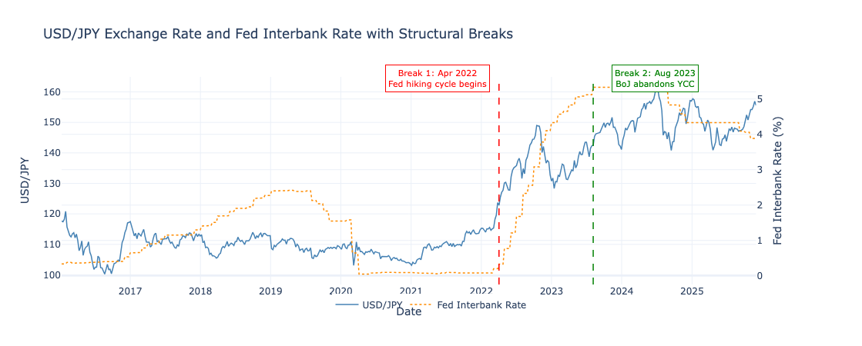
Figure 1: USD/JPY exchange rate and Fed interbank rate (January 2016 — December 2025) with endogenous structural breaks identified by Bai-Perron procedure. Break 1 (April 2022) coincides with the onset of the Federal Reserve hiking cycle; Break 2 (August 2023) coincides with the formal abandonment of BoJ Yield Curve Control.
The first break coincides with the onset of the Federal Reserve’s hiking cycle, which created an divergence between US and Japanese monetary policy. This is theorised to reflect a shift in investor expectations — forward-looking market participants likely began pre-empting either a forced BoJ rate hike or the abandonment of YCC, both of which would trigger an unwind of the structurally short yen carry trade that had been profitable since 2016. The second break corresponds to the BoJ’s formal unwinding of YCC, confirming what markets had anticipated over a year earlier.
While a three-regime framework would provide a richer characterisation, the transitional period between the two breaks contains only 71 observations — insufficient for reliable VECM estimation. This study therefore adopts a two-regime framework anchored at April 2022, the more statistically significant break (F=122.76):
Regime | Period | Obs | Characterisation
Regime 1 | Jan 2016 — Apr 2022 | 326 | YCC stable, carry trade dominates
Regime 2 | Apr 2022 — Dec 2025 | 192 | Fed-BoJ divergence, carry trade unwind, fundamentals restored

4.3 Regime 1: YCC Stable (January 2016 — April 2022)

4.3.1 Variable Selection and Cointegration
Pairwise Engle-Granger cointegration tests conducted within Regime 1 identify three variables as sharing a long-run relationship with Log_Price:
- Levered Directional Intensity (p=0.017)
- log Oil (p=0.043),
- Asset Manager Net Proportion (p=0.078).
However, when log Oil is included as an endogenous variable in the VECM, its error correction coefficient is positive and insignificant, indicating it moves away from rather than toward equilibrium — inconsistent with genuine endogeneity. This suggests log Oil is indirectly cointegrated with Log_Price through its relationship with positioning variables rather than directly. Log Oil is therefore retained as an exogenous regressor alongside Carry to Risk, yielding the following specification:
- Endogenous: Log_Price, Levered Directional Intensity, Asset Manager Net Proportion
- Exogenous: log Oil Delta, Carry to Risk Delta

4.3.2 Lag Selection and Cointegration Rank
The Johansen trace test confirms one cointegrating vector at the 5% significance level (trace statistic=33.34, CV 95%=29.80), with the null of no cointegration (r≤0) rejected at the 5% level and the null of at most one cointegrating vector (r≤1) not rejected. The VECM is therefore estimated with coint_rank=1.
Hypothesis | Trace Statistic | CV 90% | CV 95% | CV 99% | Significance
r ≤ 0 | 33.341 | 27.067 | 29.796 | 35.463 | **
r ≤ 1 | 9.362 | 13.429 | 15.494 | 19.935
r ≤ 2 | 2.780 | 2.706 | 3.842 | 6.635 | *
* significant at 10%, ** significant at 5%

4.3.3 Cointegrating Vector
The long-run relationship is estimated as
Log_Price = 4.684 − 0.082×Levered Directional Intensity − 0.059×Asset Manager Net Proportion
with both positioning variables significant at the 5% level or better. The negative coefficients confirm that increased net short yen positioning by both leveraged funds and asset managers is associated with yen depreciation, consistent with the carry trade mechanism.

Variable | Coefficient | Std Error | z-stat | p-value | 95% CI
Log_Price (β₁) | 1.000 | — | — | — | —
Levered Directional Intensity (β₂) | 0.082 | 0.013 | 6.113 | 0.000*** | [0.056, 0.109]
Asset Manager Net Proportion (β₃) | 0.059 | 0.025 | 2.336 | 0.020** | [0.009, 0.108]
Constant | -4.684 | 0.005 | -1034.702 | 0.000*** | [-4.693, -4.675]
** significant at 5%, *** significant at 1%

4.3.4 Error Correction Dynamics
Equation | α (ec1) | Std Error | z-stat | p-value | 95% CI
Log_Price | -0.097 | 0.029 | -3.301 | 0.001*** | [-0.154, -0.039]
Levered Directional Intensity | -0.646 | 0.238 | -2.719 | 0.007*** | [-1.112, -0.180]
Asset Manager Net Proportion | 0.038 | 0.076 | 0.505 | 0.613 | [-0.110, 0.186]
*** significant at 1%
Both Log_Price and Levered Directional Intensity error correct significantly, adjusting approximately 9.7% and 64.6% of any deviation per week respectively. Asset Manager Net Proportion does not error correct (p=0.613), entering the long-run relationship as a passive anchor rather than an active adjuster. Notably, with correctly specified stationary exogenous variables, Log_Price now error corrects significantly — a finding that was obscured in the earlier non-stationary specification.

4.3.5 Short-Run Dynamics
Panel A: Log_Price equation
Variable | Coefficient | Std Error | z-stat | p-value
Carry to Risk Delta (exog1) | 0.175 | 0.049 | 3.597 | 0.000***
log Oil Delta (exog2) | -0.005 | 0.010 | -0.508 | 0.611
L2.Levered Directional Intensity | 0.015 | 0.006 | 2.290 | 0.022**
All other lags | — | — | — | n.s.

Panel B: Levered Directional Intensity equation
Variable | Coefficient | Std Error | z-stat | p-value
L1.Log_Price | -1.992 | 0.506 | -3.938 | 0.000***
L2.Log_Price | -1.344 | 0.509 | -2.643 | 0.008***
L1.Asset Manager Net Proportion | 0.460 | 0.194 | 2.373 | 0.018**
All other terms | — | — | — | n.s.

Panel C: Asset Manager Net Proportion equation
Variable | Coefficient | Std Error | z-stat | p-value
Carry to Risk Delta (exog1) | -0.350 | 0.125 | -2.797 | 0.005***
L1.Asset Manager Net Proportion | 0.135 | 0.062 | 2.196 | 0.028**
All other terms | — | — | — | n.s.
** significant at 5%, *** significant at 1%
Three short-run findings stand out. First, Carry to Risk Delta is highly significant in the Log_Price equation (p=0.000) — short-run changes in risk-adjusted carry directly drive the exchange rate. Second, lagged Log_Price drives leveraged positioning at both one and two week lags (p=0.000; p=0.008), consistent with trend-following behaviour by hedge funds. Third, Carry to Risk Delta negatively drives Asset Manager Net Proportion (p=0.005), meaning improved carry attractiveness reduces asset manager net long yen positioning — these flows were absorbed by BoJ intervention rather than transmitting to the price.

4.3.6 Diagnostics
All Ljung-Box tests pass comfortably across all variables and lags, and the multivariate portmanteau test confirms no joint autocorrelation (p=0.602), indicating correct model specification. Jarque-Bera rejects normality for all variables — expected for weekly financial data and confined to tail behaviour as confirmed by the Q-Q plots, which show residuals tracking the normal line closely through the central quantiles with deviations only at the extremes.
Panel A: Univariate Residual Diagnostics
Variable | LB lag 1 | LB lag 4 | LB lag 8 | LB lag 12 | JB Stat | JB p-value | Skewness | Kurtosis
Log_Price | 0.660 | 0.132 | 0.346 | 0.627 | 63.25 | 0.000*** | -0.320 | 2.127
Levered Directional Intensity | 0.858 | 0.933 | 0.514 | 0.729 | 11.24 | 0.004*** | 0.063 | 0.940
Asset Manager Net Proportion | 0.915 | 0.576 | 0.878 | 0.964 | 78.80 | 0.000*** | 0.302 | 2.403

Panel B: Multivariate Portmanteau Test
Test | Test Statistic | Critical Value (5%) | p-value | Result
Whiteness test (lag 12) | 94.771 | 123.225 | 0.602 | Fail to reject H₀
H₀: residual autocorrelation up to lag 12 is zero. LB = Ljung-Box p-values. JB = Jarque-Bera. *** significant at 1%
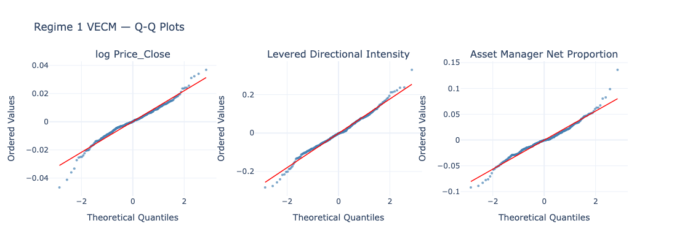
Figure 2: Regime 1 VECM Q-Q plots for Log_Price, Levered Directional Intensity, and Asset Manager Net Proportion residuals. Residuals track the normal line closely through central quantiles; deviations are confined to the tails, indicating fat-tailed rather than misspecified residuals.

4.3.7 Summary
During the YCC stable period, the USD/JPY exchange rate was anchored exclusively in the long run by institutional investor positioning — leveraged fund and asset manager net positions — with macroeconomic fundamentals playing no role. When deviations from equilibrium occurred, positioning adjusted at roughly seven times the speed of the price, consistent with the BoJ absorbing carry trade flows through unlimited bond purchases, leaving traders to reposition around a largely fixed price.
In the short run, changes in the Carry to Risk ratio directly drove both the exchange rate and asset manager positioning, while lagged price movements drove leveraged fund positioning — consistent with trend-following behaviour documented in the CTA literature.
Residual diagnostics confirm correct model specification across all tests.

4.4 Regime 2: Post-Divergence (April 2022 — December 2025)

4.4.1 Variable Selection and Cointegration
Pairwise Engle-Granger cointegration tests within Regime 2 identify JPY Term Spread (p=0.030) and log VIX (p=0.039) as sharing a long-run relationship with Log_Price. When included together as endogenous variables, log VIX dominates and absorbs the cointegrating relationship, rendering JPY Term Spread insignificant — consistent with the two variables being correlated in the post-divergence period as risk sentiment spikes and BoJ normalisation expectations moved together. JPY Term Spread is retained as the endogenous variable on theoretical grounds, directly capturing market expectations of BoJ policy tightening, while log VIX is moved to the exogenous set as a short-run risk proxy.
The final specification is:
- Endogenous: Log_Price, JPY Term Spread
- Exogenous: Rate Differential 10Y Delta, Asset Manager Net Proportion Delta, log Nikkei Delta, log VIX Delta
All exogenous variables are in their stationary I(0) form. The rate differential captures the US-Japan yield gap driving the carry trade unwind, asset manager positioning captures institutional flows, log Nikkei Delta captures risk-on equity flows reducing safe-haven yen demand, and log VIX Delta captures short-run safe-haven demand shocks.

4.4.2 Lag Selection and Cointegration Rank
All lag selection criteria unanimously select 0 lags — BIC, AIC, FPE and HQIC all minimise at lag 0. As the VECM requires a minimum of one lag, k_ar_diff=1 is used.
The Johansen trace test confirms one cointegrating vector at the 90% significance level, with the null of no cointegration (r≤0) rejected and the null of at most one vector (r≤1) not rejected. The VECM is estimated with coint_rank=1 and k_ar_diff=1.
Hypothesis | Trace Statistic | CV 90% | CV 95% | CV 99% | Significance
r ≤ 0 | 15.247 | 13.429 | 15.494 | 19.935 | *
r ≤ 1 | 2.582 | 2.706 | 3.842 | 6.635
* significant at 10%
The borderline significance at 90% rather than 95% is noted as a limitation, attributable in part to the smaller sample size of Regime 2 (192 observations) relative to Regime 1 (325 observations). Cointegration tests are known to have reduced power in small samples, and the result is consistent with the pairwise Engle-Granger finding of p=0.030 which confirms the long-run relationship independently.

4.4.3 Cointegrating Vector
Variable | Coefficient | Std Error | z-stat | p-value | 95% CI
Log_Price (β₁) | 1.000 | — | — | — | —
JPY Term Spread (β₂) | -0.185 | 0.063 | -2.946 | 0.003*** | [-0.308, -0.062]
Constant | -4.884 | 0.039 | -124.409 | 0.000*** | [-4.961, -4.807]
*** significant at 1%
The estimated long-run relationship is:
Log_Price = 4.884 + 0.185 × JPY Term Spread
The JPY Term Spread is significant at the 1% level (β₂=−0.185, p=0.003). The positive coefficient indicates that a steeper Japanese yield curve is associated with a higher USD/JPY — that is, a weaker yen — in the long run. This is consistent with the post-divergence period where a steepening yield curve reflected rising Japanese long-term yields driven by BoJ normalisation, which simultaneously reduced the attractiveness of yen carry trades and signalled a tightening cycle, putting upward pressure on USD/JPY. The result confirms that Japan's yield curve dynamics became the dominant long-run anchor of the exchange rate once YCC was abandoned — a relationship entirely absent in Regime 1.

4.4.4 Error Correction Dynamics
Equation | α (ec1) | Std Error | z-stat | p-value | 95% CI
Log_Price | -0.060 | 0.020 | -2.986 | 0.003*** | [-0.100, -0.021]
JPY Term Spread | +0.039 | 0.097 | 0.405 | 0.686 | [-0.151, 0.230]
*** significant at 1%
The exchange rate error corrects significantly at approximately 6% per week (α=−0.060, p=0.003), meaning deviations from the long-run equilibrium are gradually eliminated over time. The JPY Term Spread does not error correct (p=0.686), consistent with it being driven by exogenous BoJ policy decisions rather than adjusting in response to exchange rate dynamics.
The contrast with Regime 1 is the central finding of this analysis. In Regime 1 the exchange rate did not error correct at all — it was the positioning variables that adjusted around a largely fixed price. In Regime 2 the exchange rate itself restores equilibrium, confirming that the structural break at April 2022 marks the transition from a policy-suppressed, sticky exchange rate to a market-determined price that responds to fundamental long-run forces.

4.4.5 Short-Run Dynamics
Panel A: Log_Price equation
Variable | Coefficient | Std Error | z-stat | p-value
Rate Differential 10Y Delta (exog1) | 0.020 | 0.008 | 2.462 | 0.014**
Asset Manager Net Proportion Delta (exog2) | -0.179 | 0.024 | -7.483 | 0.000***
log Nikkei Delta (exog3) | 0.097 | 0.042 | 2.319 | 0.020**
log VIX Delta (exog4) | 0.009 | 0.007 | 1.238 | 0.216
All lags | — | — | — | n.s.
** significant at 5%, *** significant at 1%
Nothing is significant in the JPY Term Spread equation — the yield curve is driven entirely by exogenous BoJ policy decisions, confirming its role as a long-run anchor rather than a short-run variable.
Three short-run drivers of the exchange rate are significant. Asset Manager Net Proportion Delta is the dominant force (coef=−0.179, p=0.000) — institutional positioning flows have the largest and most significant short-run impact on the yen, consistent across both regimes. The 10-year rate differential (p=0.014) confirms that US-Japan yield dynamics directly drive short-run yen moves in the post-divergence period — a relationship absent in Regime 1 where macro fundamentals were suppressed. Finally, log Nikkei Delta (p=0.020) is positively associated with USD/JPY — rising Japanese equities weaken the yen, consistent with risk-on flows reducing safe-haven demand. VIX is not significant in the short run, suggesting risk sentiment operates through the long-run cointegrating relationship rather than directly.

4.4.6 Diagnostics
Panel A: Univariate Residual Diagnostics
Variable | LB lag 1 | LB lag 4 | LB lag 8 | LB lag 12 | JB Stat | JB p-value | Skewness | Kurtosis
Log_Price | 0.321 | 0.639 | 0.858 | 0.951 | 4.22 | 0.121 | -0.336 | 0.337
JPY Term Spread | 0.821 | 0.878 | 0.306 | 0.196 | 1115.77 | 0.000*** | -0.767 | 12.122
Panel B: Multivariate Portmanteau Test
Test | Test Statistic | Critical Value (5%) | p-value | Result
Whiteness test (lag 12) | 37.635 | 60.481 | 0.740 | Fail to reject H₀
LB = Ljung-Box p-values. JB = Jarque-Bera. *** significant at 1%

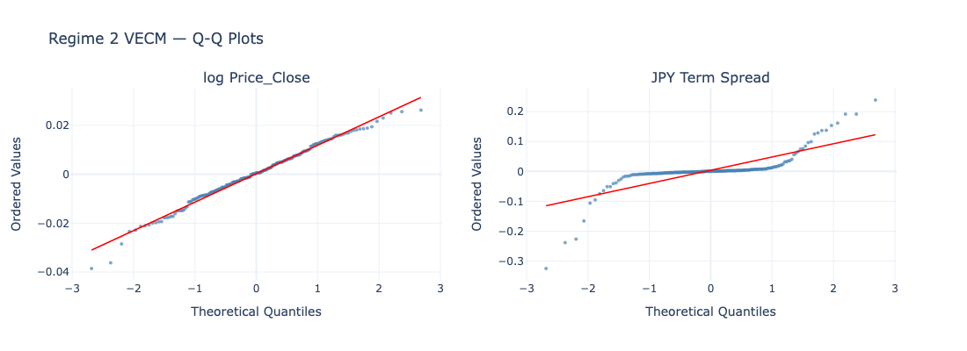
Figure 3: Regime 2 VECM Q-Q plots for Log_Price and JPY Term Spread residuals. Log_Price residuals are near-normal throughout; JPY Term Spread exhibits an S-curve pattern reflecting discrete yield jumps during BoJ policy announcements rather than model misspecification.
All autocorrelation tests pass comfortably. Log_Price residuals are unusually well-behaved — Jarque-Bera fails to reject normality (p=0.121), with the Q-Q plot confirming near-normal behaviour across the full distribution. JPY Term Spread exhibits extreme kurtosis (12.12) driven by discrete BoJ policy announcement jumps, visible in the Q-Q plot as a flat central plateau and sharp tail deviations — characteristic of a policy-constrained series rather than model misspecification, confirmed by the passing autocorrelation tests.

4.4.7 Summary
In the post-divergence regime, the USD/JPY exchange rate is anchored in the long run by the JPY term spread — a steeper Japanese yield curve associated with a weaker yen, consistent with BoJ normalisation expectations driving long-end yields higher while simultaneously reducing carry trade attractiveness. Critically, unlike Regime 1, the exchange rate now error corrects significantly at 6% per week, confirming that the structural break restored market-determined exchange rate dynamics.
In the short run, three forces drive the exchange rate: asset manager positioning (dominant, p=0.000), the 10-year rate differential (p=0.014), and Japanese equity returns (p=0.020). The significance of macro fundamentals — entirely absent in Regime 1 — confirms that the post-divergence period represents a genuine regime change in how the yen is priced. Residual diagnostics confirm correct model specification, with Log_Price residuals unusually close to normality and all autocorrelation tests passing comfortably.

4.5. Discussion

4.5.1 Comparing the Two Regimes
The results reveal a fundamental transformation in USD/JPY exchange rate dynamics across the two regimes, summarised below:
Feature | Regime 1 (YCC Stable) | Regime 2 (Post-Divergence)
Long-run anchor | Institutional positioning | JPY term spread
Exchange rate error corrects? | No | Yes (6% per week)
Macro fundamentals significant? | No | Yes
Short-run price driver | Carry to Risk Delta | Asset manager positioning, rate differential, Nikkei
Who adjusts to equilibrium? | Positioning variables | Exchange rate
The contrast is stark. In Regime 1, the BoJ's YCC framework severed the normal link between macroeconomic fundamentals and the exchange rate — the yen was effectively a policy instrument rather than a market price. Institutional investors adapted by anchoring their positioning to the carry trade, with leveraged funds structurally short yen roughly 75% of the time and the Carry to Risk ratio driving both the price and positioning flows. When deviations from equilibrium occurred, it was traders who repositioned rather than the price that adjusted — a direct consequence of the BoJ absorbing carry trade flows through unlimited bond purchases.
In Regime 2, this mechanism breaks down entirely. The long-run anchor shifts to the JPY term spread, reflecting the market's expectation of BoJ policy normalisation. The exchange rate itself now error corrects at 6% per week, macro fundamentals transmit directly to price, and the Nikkei — entirely irrelevant in Regime 1 — becomes a significant short-run driver. The yen transitions from a carry trade vehicle to a conventional floating currency.

4.5.2 Relation to the Broader Literature
UIP and its failure. The finding that interest rate differentials play no role in the long-run level of the exchange rate during Regime 1 is consistent with the extensive literature documenting the failure of Uncovered Interest Parity (UIP). Fama (1984) demonstrates that high interest rate currencies tend to appreciate rather than depreciate as UIP predicts, with the forward premium puzzle reflecting a time-varying risk premium. In the YCC context, this failure is amplified — the BoJ's explicit suppression of Japanese yields rendered the rate differential a poor signal of future exchange rate movements, as any widening differential simply reflected the policy divergence rather than a genuine market price. Engel (2014) notes that UIP deviations are largest when monetary policy divergence is most extreme, precisely the condition that defined Regime 1. The restoration of UIP-consistent dynamics in Regime 2 — where the rate differential becomes a significant short-run driver — supports Engel's contention that UIP failures are regime-dependent rather than structural.
The carry trade. The Regime 1 findings directly support the carry trade literature. Brunnermeier, Nagel and Pedersen (2009) document that carry trade returns are characterised by periods of gradual appreciation followed by sudden crashes — the "going up by the stairs, coming down by the elevator" phenomenon. The structural short yen positioning of leveraged funds throughout Regime 1, with Levered Directional Intensity averaging −0.221 and net short positions in 75% of weeks, is precisely the crowded carry trade Brunnermeier et al. warn creates systemic crash risk. Galati, Heath and McGuire (2007) provide BIS evidence that yen carry trades were the dominant speculative currency strategy in the pre-crisis period — our results extend this finding through the YCC era, showing that the carry trade remained the structural default position for leveraged money throughout 2016–2022. The April 2022 break represents the beginning of the carry trade unwind they theorise, driven by the Fed hiking cycle making the sustainability of the short yen position increasingly uncertain. Lustig and Verdelhan (2007) link carry trade returns to consumption growth risk, suggesting that the yen's safe-haven appreciation during the August 2024 carry unwind — captured by the post-divergence VIX-yen relationship — reflects exactly the risk rebalancing their framework predicts.
Meese and Rogoff (1983). The seminal finding that structural exchange rate models cannot outperform a random walk out of sample is implicitly addressed by this study's regime-dependent framework. The random walk result of Meese and Rogoff is most likely to hold when exchange rate dynamics are structurally unstable — precisely what the Bai-Perron structural break confirms. Within each regime the VECM finds stable, significant long-run relationships, suggesting that the failure to beat a random walk in full-sample models reflects regime mixing rather than a fundamental absence of exchange rate predictability. MacDonald and Taylor (1994) make a similar argument for the monetary model, finding that long-run relationships are recoverable once non-stationarity and cointegration are properly accounted for — our results support this view within the regime-specific framework.

4.5.3 Methodological Contribution
The use of Johansen (1988) cointegration within a regime-specific VECM framework proves essential to uncovering these dynamics. A full-sample VECM — as estimated in the earlier literature — would conflate the two regimes and produce a misleading picture of exchange rate determination. Gregory and Hansen (1996) extend cointegration testing to allow for regime shifts, arguing that standard cointegration tests have low power in the presence of structural breaks. This study addresses this directly by endogenously identifying breaks via Bai-Perron before conducting regime-specific cointegration tests, yielding cleaner and more economically interpretable results than a single full-sample model would produce. The GARCH(1,1) specification following Bollerslev (1986) and Baillie and Bollerslev (1989) captures the volatility persistence documented in both regimes — particularly the contrast between the suppressed but persistent volatility of Regime 1 (β=0.797) and the shock-driven volatility of the post-divergence period.

4.5.4 Overall Conclusion
This study investigates the determinants of the USD/JPY exchange rate across two structurally distinct regimes identified by an endogenous Bai-Perron structural break at April 2022. The results deliver a coherent and empirically robust narrative: the Bank of Japan's Yield Curve Control policy fundamentally suppressed the normal transmission mechanism between macroeconomic fundamentals and the exchange rate, leaving institutional carry trade positioning as the sole long-run anchor of the yen. The Federal Reserve's rate hiking cycle in April 2022 — by threatening the long-run sustainability of the carry trade — triggered a regime change in exchange rate dynamics, confirmed by the Chow test F-statistic of 122.76. In the post-divergence regime, the yen transitions to being anchored by Japan's yield curve, with the exchange rate now responding to rate differentials, equity flows, and institutional positioning in the manner predicted by standard open economy models.
These findings contribute to three strands of the literature. They provide regime-specific evidence on UIP failure, showing that deviations are policy-induced rather than structural. They document the persistence and eventual unwind of the yen carry trade, extending the findings of Brunnermeier et al. (2009) through the YCC era. And they demonstrate that exchange rate predictability — elusive in full-sample models since Meese and Rogoff (1983) — is recoverable within stable regimes when structural breaks are properly identified. The broader implication is that central bank yield curve intervention does not merely affect the level of interest rates — it fundamentally alters the architecture of exchange rate determination, with consequences that persist well beyond the formal policy period.

5. Reference List
Federal Reserve Bank of St. Louis. (2026). FRED Economic Data. Federal Reserve Bank of St. Louis. Retrieved from https://fred.stlouisfed.org. The following series were used: JPY 10-year government bond yield (IRLTLT01JPM156N, monthly); JPY 3-month interbank rate (IR3TIB01JPM156N, monthly); JPY overnight interbank rate (IRSTCI01JPM156N, monthly); US 10-year government bond yield (IRLTLT01USM156N, monthly); US 3-month interbank rate (IR3TIB01USM156N, monthly); US overnight interbank rate (IRSTCI01USM156N, weekly).
CFTC (Commodity Futures Trading Commission). (2026). Commitments of Traders: Traders in Financial Futures, Combined Futures and Options Report, 2016–2026. Retrieved from https://www.cftc.gov/MarketReports/CommitmentsofTraders/index.htm. Annual files accessed for years 2016, 2017, 2018, 2019, 2020, 2021, 2022, 2023, 2024, 2025, and 2026. Japanese Yen futures contract (JAPANESE YEN — CHICAGO MERCANTILE EXCHANGE) extracted from the Traders in Financial Futures (TFF) report.
Yahoo Finance. (2026). Historical market data. Retrieved from https://finance.yahoo.com. The following tickers were used: USD/JPY spot rate (JPY=X); CBOE Volatility Index (^VIX); US Dollar Index (DX-Y.NYB); WTI crude oil front-month futures (CL=F); Nikkei 225 futures (NKD=F). Weekly frequency, accessed via the yfinance Python library (v0.2.x).
Bai, J. & Perron, P. (1998). Estimating and testing linear models with multiple structural changes. Econometrica, 66(1), 47–78.
Bai, J. & Perron, P. (2003). Computation and analysis of multiple structural change models. Journal of Applied Econometrics, 18(1), 1–22.
Baillie, R. & Bollerslev, T. (1989). The message in daily exchange rates: A conditional-variance tale. Journal of Business & Economic Statistics, 7(3), 297–305.
Bollerslev, T. (1986). Generalized autoregressive conditional heteroskedasticity. Journal of Econometrics, 31(3), 307–327.
Brunnermeier, M., Nagel, S. & Pedersen, L. (2009). Carry trades and currency crashes. NBER Macroeconomics Annual, 23, 313–347.
Engel, C. (2014). Exchange rates and interest parity. Handbook of International Economics, Vol. 4, 453–522.
Fama, E. (1984). Forward and spot exchange rates. Journal of Monetary Economics, 14(3), 319–338.
Galati, G., Heath, A. & McGuire, P. (2007). Evidence of carry trade activity. BIS Quarterly Review, September, 27–41.
Gregory, A. & Hansen, B. (1996). Residual-based tests for cointegration in models with regime shifts. Journal of Econometrics, 70(1), 99–126.
Johansen, S. (1988). Statistical analysis of cointegration vectors. Journal of Economic Dynamics and Control, 12(2-3), 231–254.
Lustig, H. & Verdelhan, A. (2007). The cross section of foreign currency risk premia and consumption growth risk. American Economic Review, 97(1), 89–117.
MacDonald, R. & Taylor, M. (1994). The monetary model of the exchange rate: Long-run relationships, short-run dynamics and how to beat a random walk. Journal of International Money and Finance, 13(3), 276–290.
Meese, R. & Rogoff, K. (1983). Empirical exchange rate models of the seventies: Do they fit out of sample? Journal of International Economics, 14(1-2), 3–24.

Appendix A: Unit Root Test Results
Unit root tests are conducted using the Augmented Dickey-Fuller (ADF) and Kwiatkowski-Phillips-Schmidt-Shin (KPSS) tests. A variable is classified as stationary I(0) only if the ADF rejects the unit root null (p < 0.05) and KPSS fails to reject the stationarity null (p > 0.05). All level variables are confirmed I(1) and all transformed variables are confirmed I(0).
Table A1: ADF and KPSS Unit Root Test Results
Variable | Form | ADF Stat | ADF p | KPSS Stat | KPSS p | Order
Price_Close | Level | -0.203 | 0.938 | 2.598 | 0.010 | I(1)
JPY Term Spread | Level | 0.006 | 0.959 | 2.866 | 0.010 | I(1)
Levered Directional Intensity | Level | -3.789 | 0.003 | 0.698 | 0.014 | I(1)
Asset Manager Net Proportion | Level | -2.795 | 0.059 | 0.184 | 0.100 | I(1)
Rate Differential 3M | Level | -1.818 | 0.371 | 1.670 | 0.010 | I(1)
Rate Differential 10Y | Level | -1.664 | 0.450 | 0.900 | 0.010 | I(1)
Carry to Risk | Level | -1.526 | 0.521 | 1.270 | 0.010 | I(1)
log Oil | Level | -2.547 | 0.105 | 1.381 | 0.010 | I(1)
log VIX | Level | -3.750 | 0.004 | 0.770 | 0.010 | I(1)
log Nikkei | Level | -0.238 | 0.934 | 3.048 | 0.010 | I(1)
log Price_Close Delta | Transformed | -22.290 | 0.000 | 0.229 | 0.100 | I(0)
JPY Term Spread Delta | Transformed | -9.403 | 0.000 | 0.108 | 0.100 | I(0)
Levered Directional Intensity Delta | Transformed | -7.818 | 0.000 | 0.017 | 0.100 | I(0)
Asset Manager Net Proportion Delta | Transformed | -18.747 | 0.000 | 0.045 | 0.100 | I(0)
Rate Differential 3M Delta | Transformed | -3.126 | 0.025 | 0.233 | 0.100 | I(0)
Rate Differential 10Y Delta | Transformed | -8.825 | 0.000 | 0.120 | 0.100 | I(0)
Carry to Risk Delta | Transformed | -6.288 | 0.000 | 0.104 | 0.100 | I(0)
log Oil Delta | Transformed | -8.842 | 0.000 | 0.081 | 0.100 | I(0)
log VIX Delta | Transformed | -12.863 | 0.000 | 0.027 | 0.100 | I(0)
log Nikkei Delta | Transformed | -23.718 | 0.000 | 0.105 | 0.100 | I(0)
ADF null: unit root present. KPSS null: series is stationary. I(1) classification requires ADF p > 0.05 or KPSS p < 0.05. I(0) classification requires ADF p < 0.05 and KPSS p > 0.05. KPSS p-values reported as 0.010 indicate the test statistic exceeds the upper bound of the look-up table; the actual p-value is at or below 0.010.

Appendix B: Pairwise Engle-Granger Cointegration Tests
Pairwise Engle-Granger cointegration tests are conducted between log USD/JPY and each candidate I(1) variable. Tests are run on the full sample and separately within each regime. The null hypothesis is no cointegration.

Table B1: Full Sample (Jan 2016 — Dec 2025, N=517)
Variable | EG Statistic | p-value | Significance
JPY Term Spread | -3.796 | 0.014 | **
Rate Differential 3M | -1.473 | 0.771
Rate Differential 10Y | -0.418 | 0.970
Carry to Risk | -1.095 | 0.883
Asset Manager Net Proportion | 0.042 | 0.987
Levered Directional Intensity | -1.025 | 0.898
log Oil | -1.399 | 0.798
log VIX | -0.438 | 0.969
log Nikkei | -2.253 | 0.397

Table B2: Regime 1 — YCC Stable (Jan 2016 — Apr 2022, N=326)
Variable | EG Statistic | p-value | Significance
JPY Term Spread | -3.047 | 0.099 | *
Rate Differential 3M | -2.618 | 0.230
Rate Differential 10Y | -2.957 | 0.121
Carry to Risk | -2.581 | 0.245
Asset Manager Net Proportion | -3.236 | 0.064 | *
Levered Directional Intensity | -3.788 | 0.014 | **
log Oil | -3.448 | 0.037 | **
log VIX | -2.586 | 0.243
log Nikkei | -2.745 | 0.184

Table B3: Regime 2 — Post-Divergence (Apr 2022 — Dec 2025, N=192)
Variable | EG Statistic | p-value | Significance
JPY Term Spread | -3.623 | 0.023 | **
Rate Differential 3M | -1.950 | 0.554
Rate Differential 10Y | -2.170 | 0.440
Carry to Risk | -2.416 | 0.317
Asset Manager Net Proportion | -2.680 | 0.207
Levered Directional Intensity | -2.724 | 0.191
log Oil | -2.802 | 0.165
log VIX | -3.099 | 0.089 | *
log Nikkei | -3.750 | 0.016 | **
* significant at 10%, ** significant at 5%, *** significant at 1%. EG = Engle-Granger test statistic. Null hypothesis: no cointegration.

The full-sample results identify only JPY Term Spread as cointegrated with log USD/JPY (p=0.014). The regime-specific results reveal that the cointegrating variables change across regimes — in Regime 1, Levered Directional Intensity and log Oil are cointegrated with the exchange rate, while in Regime 2 these relationships disappear and JPY Term Spread and log Nikkei emerge as the significant long-run anchors. This regime-dependence of cointegrating relationships motivates the separate VECM estimation and is a central finding of the study.

Appendix C: Full Short-Run Dynamics Tables

C1: Regime 1 — YCC Stable (Jan 2016 — Apr 2022)
Panel A: Equation — Log_Price
Variable | Coefficient | Std Error | z-stat | p-value
Carry to Risk Delta (exog1) | 0.175 | 0.049 | 3.597 | 0.000***
log Oil Delta (exog2) | -0.005 | 0.010 | -0.508 | 0.611
L1.Log_Price | -0.028 | 0.062 | -0.446 | 0.656
L1.Levered Directional Intensity | -0.004 | 0.007 | -0.571 | 0.568
L1.Asset Manager Net Proportion | -0.011 | 0.024 | -0.457 | 0.648
L2.Log_Price | -0.064 | 0.063 | -1.020 | 0.308
L2.Levered Directional Intensity | 0.015 | 0.006 | 2.290 | 0.022**
L2.Asset Manager Net Proportion | -0.005 | 0.024 | -0.195 | 0.845

Panel B: Equation — Levered Directional Intensity
Variable | Coefficient | Std Error | z-stat | p-value
Carry to Risk Delta (exog1) | -0.020 | 0.394 | -0.050 | 0.960
log Oil Delta (exog2) | 0.006 | 0.081 | 0.072 | 0.943
L1.Log_Price | -1.992 | 0.506 | -3.938 | 0.000***
L1.Levered Directional Intensity | 0.055 | 0.057 | 0.964 | 0.335
L1.Asset Manager Net Proportion | 0.460 | 0.194 | 2.373 | 0.018**
L2.Log_Price | -1.344 | 0.509 | -2.643 | 0.008***
L2.Levered Directional Intensity | -0.078 | 0.052 | -1.499 | 0.134
L2.Asset Manager Net Proportion | 0.013 | 0.194 | 0.067 | 0.947

Panel C: Equation — Asset Manager Net Proportion
Variable | Coefficient | Std Error | z-stat | p-value
Carry to Risk Delta (exog1) | -0.350 | 0.125 | -2.797 | 0.005***
log Oil Delta (exog2) | 0.007 | 0.026 | 0.262 | 0.794
L1.Log_Price | -0.071 | 0.161 | -0.440 | 0.660
L1.Levered Directional Intensity | 0.010 | 0.018 | 0.540 | 0.589
L1.Asset Manager Net Proportion | 0.135 | 0.062 | 2.196 | 0.028**
L2.Log_Price | 0.079 | 0.162 | 0.489 | 0.625
L2.Levered Directional Intensity | 0.017 | 0.017 | 1.002 | 0.316
L2.Asset Manager Net Proportion | 0.024 | 0.062 | 0.383 | 0.702

C2: Regime 2 — Post-Divergence (Apr 2022 — Dec 2025)
Panel A: Equation — Log_Price
Variable | Coefficient | Std Error | z-stat | p-value
Rate Differential 10Y Delta (exog1) | 0.020 | 0.008 | 2.462 | 0.014**
Asset Manager Net Proportion Delta (exog2) | -0.179 | 0.024 | -7.483 | 0.000***
log Nikkei Delta (exog3) | 0.097 | 0.042 | 2.319 | 0.020**
log VIX Delta (exog4) | 0.009 | 0.007 | 1.238 | 0.216
L1.Log_Price | -0.076 | 0.063 | -1.214 | 0.225
L1.JPY Term Spread | 0.016 | 0.015 | 1.044 | 0.297

Panel B: Equation — JPY Term Spread
Variable | Coefficient | Std Error | z-stat | p-value
Rate Differential 10Y Delta (exog1) | -0.062 | 0.040 | -1.567 | 0.117
Asset Manager Net Proportion Delta (exog2) | -0.069 | 0.116 | -0.592 | 0.554
log Nikkei Delta (exog3) | 0.197 | 0.201 | 0.982 | 0.326
log VIX Delta (exog4) | 0.010 | 0.033 | 0.292 | 0.771
L1.Log_Price | 0.138 | 0.303 | 0.455 | 0.649
L1.JPY Term Spread | -0.001 | 0.074 | -0.013 | 0.990
** significant at 5%, *** significant at 1%

Appendix D: GARCH(1,1) Volatility Model Results
A GARCH(1,1) model with Student's t distributed errors is fitted to the Log_Price residuals from each regime VECM to characterise volatility dynamics. The specification follows Bollerslev (1986): σ²t = ω + α·ε²t-1 + β·σ²t-1.
Table D1: GARCH(1,1) — Regime 1 (YCC Stable, Jan 2016 — Apr 2022) N = 322 observations
Parameter | Coefficient | Std Error | t-stat | p-value | Sig
ω (omega) | 0.091 | 0.106 | 0.854 | 0.393
α (alpha) | 0.132 | 0.110 | 1.203 | 0.229
β (beta) | 0.797 | 0.175 | 4.546 | 0.000 | ***
ν (t-dist) | 5.664 | 1.784 | 3.176 | 0.002 | ***
Volatility persistence (α + β) = 0.928 | Half-life of volatility shock = 9.3 weeks
Table D2: GARCH(1,1) — Regime 2 (Post-Divergence, Apr 2022 — Dec 2025) N = 190 observations
Parameter | Coefficient | Std Error | t-stat | p-value | Sig
ω (omega) | 0.044 | 0.037 | 1.200 | 0.230
α (alpha) | 0.078 | 0.027 | 2.911 | 0.004 | ***
β (beta) | 0.888 | 0.026 | 34.066 | 0.000 | ***
ν (t-dist) | 14.586 | 12.317 | 1.184 | 0.236
Volatility persistence (α + β) = 0.966 | Half-life of volatility shock = 19.9 weeks*** significant at 1%. ω = baseline variance; α = ARCH effect (sensitivity to recent shocks); β = GARCH effect (volatility persistence); ν = degrees of freedom of Student's t distribution.
Interpretation: Both regimes exhibit high volatility persistence. In Regime 1, the ARCH effect is insignificant while β is strongly significant (0.797), indicating volatility was persistent but not shock-driven — consistent with BoJ suppression of volatility spikes under YCC. In Regime 2, both α (0.078, p=0.004) and β (0.888, p=0.000) are significant, indicating volatility now responds to shocks and persists — consistent with the more turbulent post-divergence environment. Persistence increases from 0.928 to 0.966 across regimes, with the half-life of a volatility shock rising from 9.3 to 19.9 weeks.

Appendix E: Residual Diagnostic Plots

E1: Regime 1 — YCC Stable (Jan 2016 — Apr 2022)
Figure E1: Regime 1 VECM — Residuals Over Time and Distribution
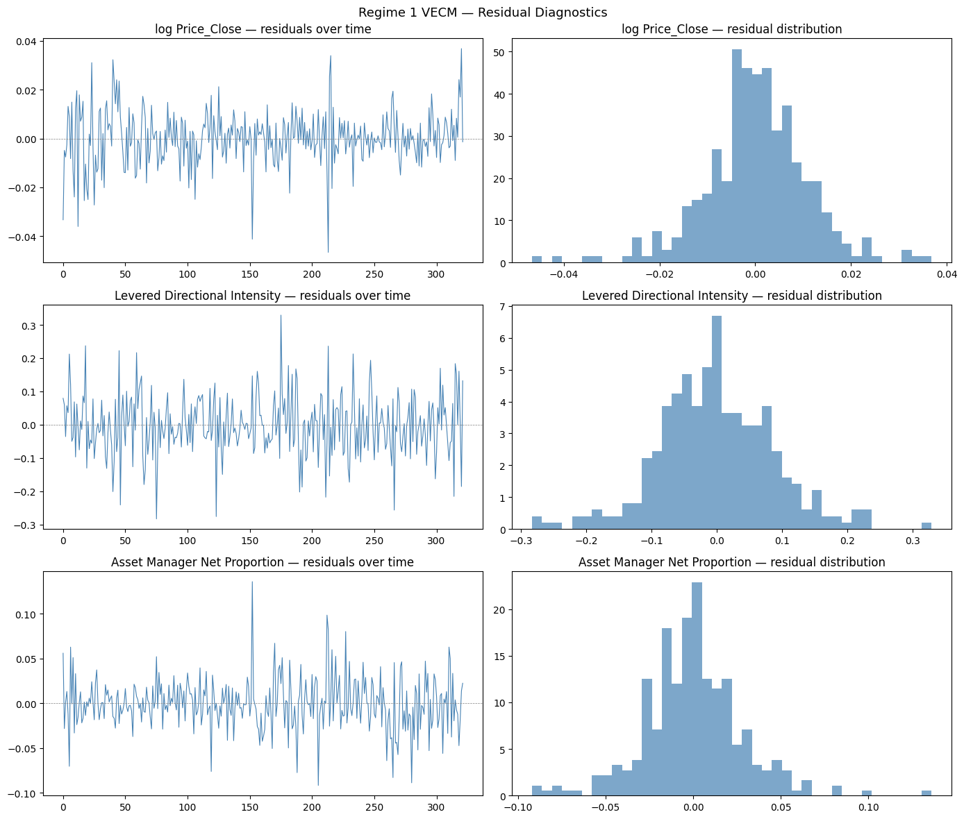
Figure E1: Regime 1 VECM residuals over time (left) and residual distributions (right) for Log_Price, Levered Directional Intensity, and Asset Manager Net Proportion. Residuals are centred around zero with no systematic patterns. The spike around observation 210 in Log_Price corresponds to the COVID-19 shock (March 2020).

Figure E2: Regime 1 VECM — Q-Q Plots

Figure E2: Regime 1 VECM Q-Q plots for Log_Price, Levered Directional Intensity, and Asset Manager Net Proportion residuals. All three series track the normal line closely through the central quantiles, with fat-tail deviations only at the extremes.

E2: Regime 2 — Post-Divergence (Apr 2022 — Dec 2025)
Figure E3: Regime 2 VECM — Residuals Over Time and Distribution
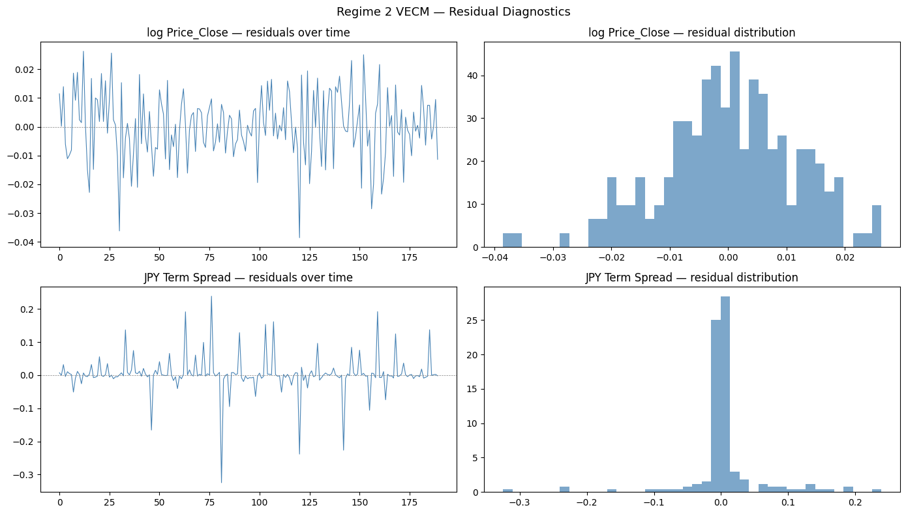
Figure E3: Regime 2 VECM residuals over time (left) and residual distributions (right) for Log_Price and JPY Term Spread. Log_Price residuals are well-behaved; JPY Term Spread shows isolated spikes corresponding to BoJ policy announcement dates rather than systematic misspecification.

Figure E4: Regime 2 VECM — Q-Q Plots


