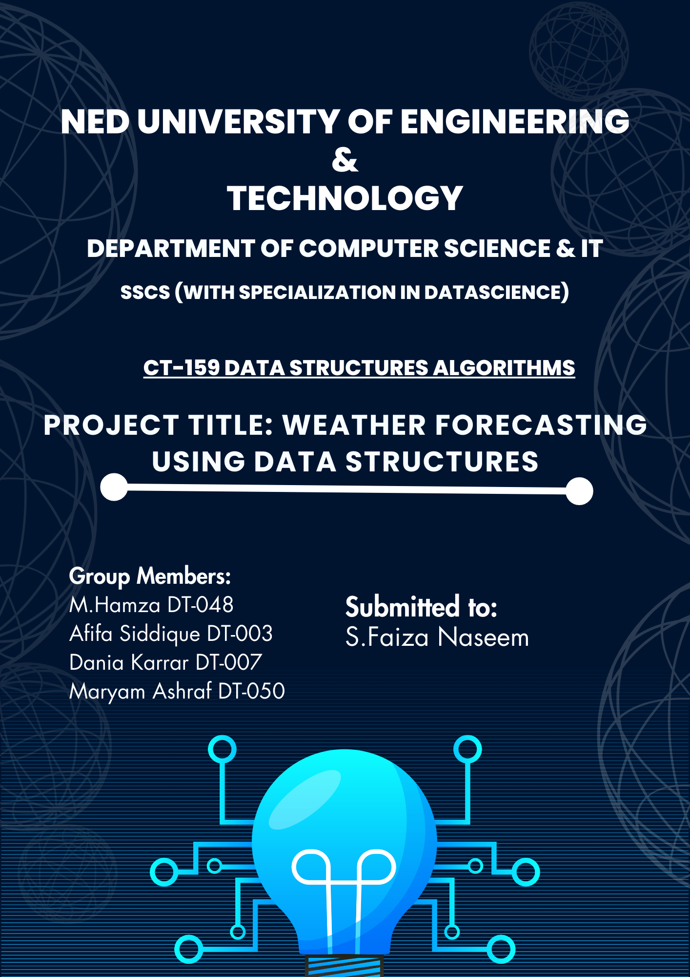

- Introduction:
The "MDAH Weather App" is a Python-based weather application that allows users to retrieve real-time weather information for various cities. The application features a graphical user interface (GUI) built using the Tkinter library. Users can input a city name, and the application fetches weather data from the OpenWeatherMap API, displaying details such as weather conditions, temperature, and pressure.

2. Tools and Techniques Used:
Tools:
- Python: The primary programming language used for development.
- Tkinter: A Python GUI toolkit used for creating the application's graphical interface.
- Requests: A library for making HTTP requests, utilized for fetching weather data from the OpenWeatherMap API.
- JSON: Used for handling and parsing data obtained from the API.
- CSV: Utilized for reading city coordinates from a CSV file.
- Datetime: Employed for obtaining the current date and time.

Techniques:
- Linked List: Implemented a linked list data structure to store and manage a list of searched cities.
- Stacks: To switch pages, push and pop opeartions have been used.
- Insertion Sort: Used for sorting the list of searched cities alphabetically.
- Linear Search: For searching the city name.
- File Handling: Created functions to save weather data to a text file and read/display content from it.
- Canvas and Scrollbar: Incorporated a canvas widget with a scrollbar to display stored data with scrolling capability.
- Graphical Visualization: Developed a graphical representation of temperature-pressure relations for searched cities.
- Combobox: Implemented a dropdown list for city selection using the Tkinter Combobox widget.
- API Integration: Fetched weather data from the OpenWeatherMap API using HTTP requests.
- Event Handling: Employed event handling to update the Combobox dynamically as the user types.
- City Coordinates CSV File: A dataset containing latitude and longitude coordinates for various cities. This data is utilized for displaying the coordinates of a selected city in the application.

- Flow Diagram:

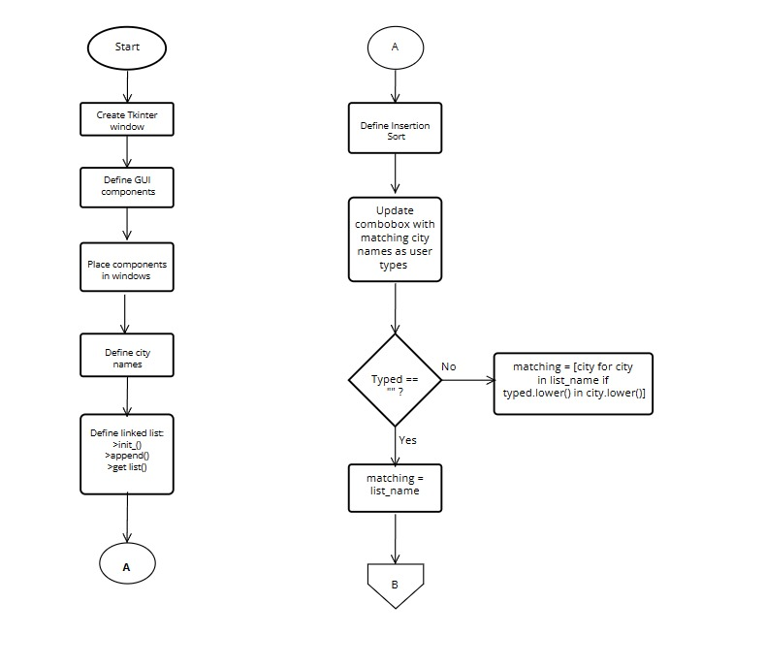

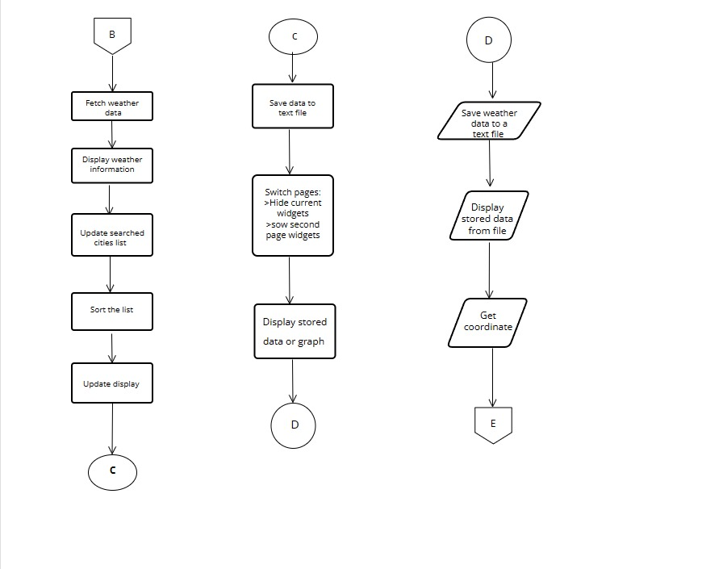

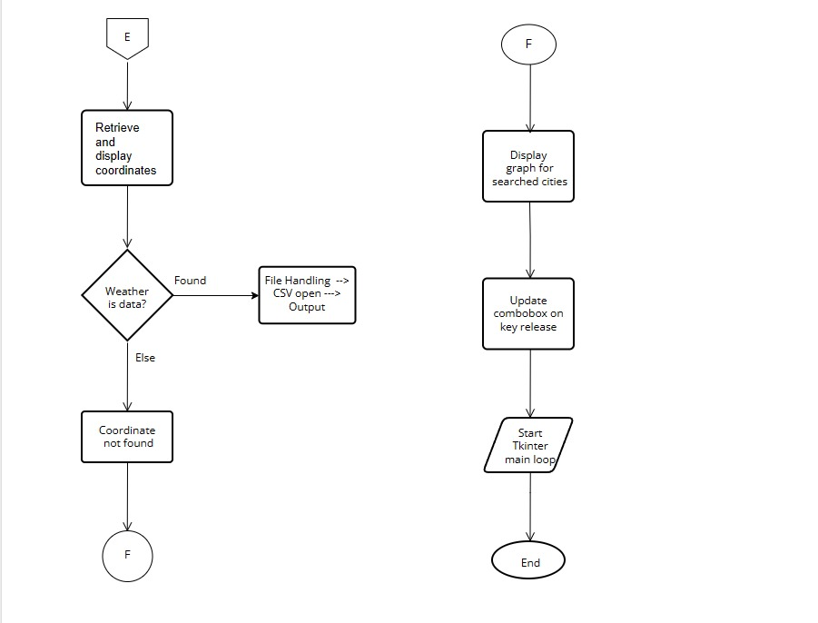
4. Main Algorithms Implemented in the Project:
- Insertion Sort Algorithm:
Description: Used to sort the list of searched cities alphabetically.
Implementation: The insertion sort algorithm iterates through the list, comparing and rearranging elements to maintain the sorted order.
- Linear Search Algorithm:
Description: Used to search city names
Implementation: The algorithm updates the combobox suggestions by filtering the list of city names based on a case-insensitive substring match with the user's input. It then dynamically displays the matching cities in the combobox and searching co-ordinates from the csv files and then saving the co-ordinates in the text file

- Fetch Weather Data Algorithm:
Description: Retrieves weather data from the OpenWeatherMap API for a given city.
Implementation: Utilizes the Requests library to make an HTTP request to the API, providing the city name and API key. The obtained data is then processed and returned.
- Get Coordinates Algorithm:
Description: Retrieves latitude and longitude coordinates for a given city from a CSV file.
Implementation: Reads the city coordinates from a CSV file using the CSV library, searching for a match based on the city name.
- Display Graph Algorithm:
Description: Generates a graphical representation of the temperature-pressure relations for searched cities.
Implementation: Uses the Canvas widget to draw circles at specific coordinates based on temperature and pressure values. City names are displayed next to the corresponding points, creating a scatter plot.

5. OUTPUT:
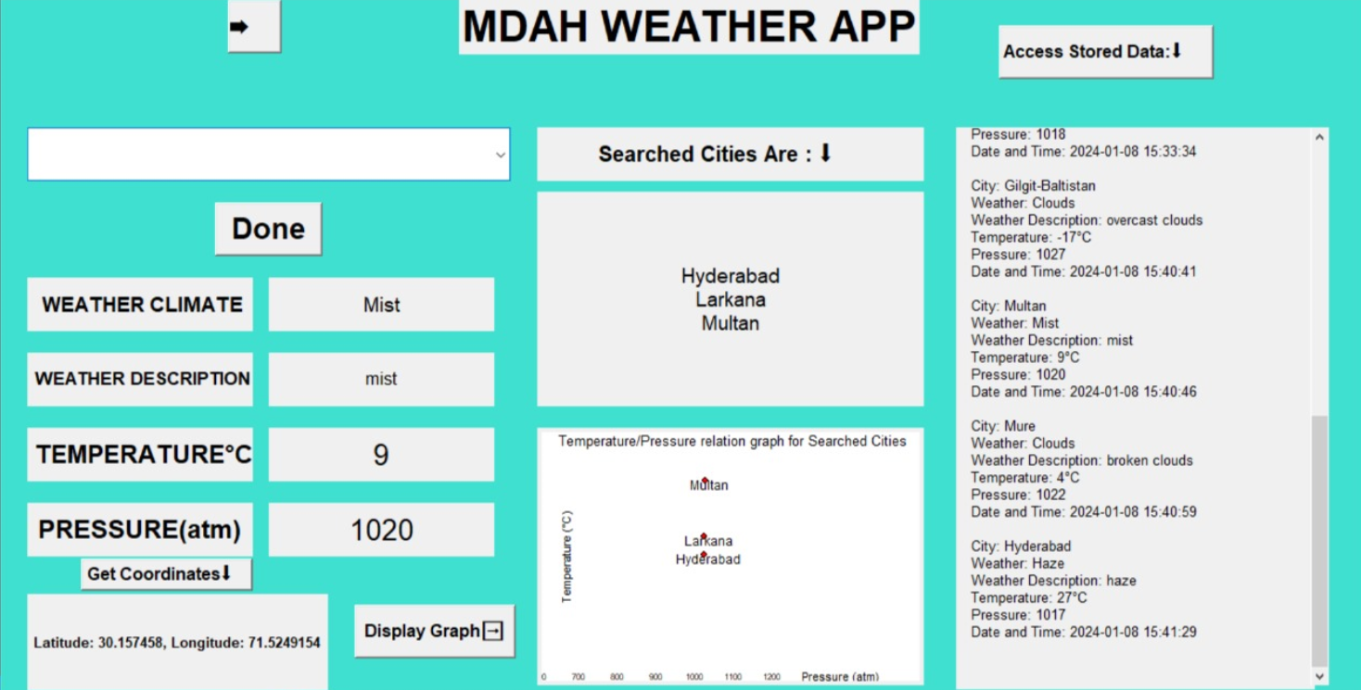

Conclusion:
In conclusion, this weather application demonstrates the integration of GUI development, API usage, and basic data handling. The project provides a user-friendly interface for fetching and visualizing weather data, along with features for data persistence and graphical representation. The implementation highlights the use of various programming concepts and techniques to create a comprehensive weather application.

