
Air University - Islamabad
Islamabad, Pakistan

Software Requirements Specification (SRS)
[FitTrack --> Fitness Tracking Application]


Project: FitTrack - Fitness Tracking Application

Student Name | ID
Muhammad Irfan | 232013
Hamza Khan | 232039
Mohsin Khan | 231965
Dilawar Said | 233116

Table of Contents
- Introduction ................................................................................ 1
1.1 Purpose ..................................................................................... 1
1.2 Scope .......................................................................................... 1
1.3 Definitions, Acronyms, and Abbreviations ............... 1
1.4 References ............................................................................... 2
1.5 Overview .................................................................................. 2
- Overall Description ............................................................ 3
2.1 Product Perspective ......................................................... 3
2.2 Product Functions ............................................................ 3
2.3 User Characteristics ........................................................ 4
2.4 Constraints ....................................................................... 4
2.5 Assumptions and Dependencies ................................. 5
2.6 Apportioning of Requirements .................................... 5
2.7 Requirements Engineering Techniques ..................... 6
2.8 System Modeling Diagrams ......................................... 6
- Specific Requirements ..................................................... 7
- Appendices ............................................................................. 8
- Index .......................................................................................... 9

1. Introduction
1.1 Purpose
The purpose of this Software Requirements Specification (SRS) document is to define the software requirements for the development of the FitTrack mobile application. This document outlines the purpose, scope, functionality, and constraints of the app and is intended for all stakeholders including the development team, UI/UX designers, testers, project managers, and end-users.
The main goal of FitTrack is to provide users with a personalized and engaging fitness experience by offering workout plans, activity tracking, and real-time health monitoring. The app stands out by introducing an emotion-based workout suggestion feature that tailors workout routines to the user’s emotional state, detected using AI through voice, text input, or facial expressions.
This document will serve as a basis throughout the project lifecycle for:
- Validating user and system requirements
- Providing input for design and testing phases
- Serving as a reference for any future development or enhancements

1.2 Scope
FitTrack is a mobile application designed to improve users’ health and fitness through:
- Personalized workout plans
- Activity tracking (e.g., steps, calories, duration)
- Health monitoring (e.g., heart rate, BMI integration via wearables)
- AI-based emotional state detection for customized mental and physical wellness routines
The app targets a broad user base, including beginners, intermediate users, and advanced fitness enthusiasts. It integrates with popular wearable devices (e.g., Apple Watch, Fitbit, etc.) to collect real-time health data and adapt workout suggestions accordingly.
Key features include:
- User authentication and profile setup
- Goal-based onboarding (weight loss, muscle gain, maintenance)
- Daily and weekly personalized training plans
- Workout activity suggestions based on user mood/emotions
- Syncing with health trackers for automatic input
- Visual analytics for tracking progress
The system will be implemented as a cross-platform mobile application (iOS and Android), with potential backend services hosted on cloud infrastructure to ensure scalability and availability.

1.3 Definitions, Acronyms, and Abbreviations
Term/Acronym | Definition
SRS | Software Requirements Specification
UI | User Interface
UX | User Experience
AI | Artificial Intelligence
API | Application Programming Interface
OTP | One-Time Password
BMI | Body Mass Index
Wearable Devices | Health tracking gadgets like smartwatches (e.g., Apple Watch, Fitbit)
Emotion-Based Suggestion | The system of recommending workouts based on detected emotional state
SDK | Software Development Kit
CRUD | Create, Read, Update, Delete

1.4 References
The following documents and tools were referenced in the creation of this SRS:
- IEEE Standard 830-1998 – IEEE Recommended Practice for Software Requirements Specifications
- Figma Design File (UI Mockups for FitTrack App)
- Android and iOS Human Interface Guidelines
- Google Fit and Apple HealthKit documentation
- Fitbit and Garmin API documentation
- OpenCV & TensorFlow documentation (for mood/emotion detection)
- Agile Methodology Principles

1.5 Overview
The rest of the SRS is structured as follows:
- Section 2: Overall Description – Provides a high-level view of the FitTrack app, its environment, and users.
- Section 3: Specific Requirements – Details all functional and non-functional requirements of the system.
- Appendices – Includes supplementary information such as UI designs, technical references, and potential future enhancements.
- Index – For easy navigation through the document.

2. Overall Description
2.1 Product Perspective
FitTrack is a standalone mobile application designed to operate on iOS and Android platforms. It is not a part of a larger system but does interact with external services such as:
- Wearable device APIs (e.g., Apple HealthKit, Google Fit, Fitbit, Garmin)
- AI libraries (e.g., OpenCV, TensorFlow) for mood/emotion detection
- Backend services for data storage, user profile management, and analytics
- Cloud services for hosting, scalability, and backup
The app follows a modular architecture where each feature (e.g., emotion detection, workout planner, user profile, activity tracker) is a loosely coupled, highly cohesive module. This ensures scalability, maintainability, and ease of testing.
FitTrack will support both online and offline modes, where core functionalities like accessing saved workouts will be available offline, while emotion detection and syncing require network connectivity.

2.2 Product Functions
The key functional capabilities of FitTrack include:
- User Registration and Authentication
  - Sign-up/login using email or social accounts
  - OTP-based phone number verification
- Personal Profile Setup
  - Input personal data: gender, age, height, weight
  - Select fitness goals (e.g., lose weight, gain muscle, stay fit)
  - Choose preferred units (metric/imperial)
- Customized Workout Planning
  - Generate personalized training plans based on fitness level and user goal
  - Selection of workout activities by interest (e.g., Yoga, Cardio, Power Training)
- Emotion-Based Workout Recommendations
  - Detect user emotion through voice, text, or facial recognition
  - Recommend workouts suited to emotional state (e.g., yoga for stress, cardio for energy)
- Activity Tracking and Analytics
  - Track daily activity (steps, calories, distance)
  - Visual progress reports and statistics
- Health Monitoring via Wearables
  - Sync with smart devices for real-time heart rate, sleep, and fitness data
  - Use data to auto-adjust training intensity
- Notifications and Reminders
  - Send workout reminders and motivational messages
  - Notify user about emotional health and suggest breaks or meditation
- User Dashboard
  - Overview of today’s goals, progress, recommended activities
  - Visual progress indicators and quick access to workouts

2.3 User Characteristics
The expected users of the FitTrack app include:
User Type | Characteristics
Beginners | No prior fitness experience; prefer guided, low-intensity workouts.
Intermediate Users | Some fitness background; looking for structured plans and tracking.
Advanced Users | Regular gym-goers or athletes; prefer customization and high-intensity workouts.
Health-Conscious Individuals | Interested in both mental and physical wellness.
Tech-savvy Users | Likely to own wearables and appreciate integration features.
General traits:
- Age: 16–60+
- Comfortable with mobile apps
- Health-conscious, motivated by visual progress and personalized content

2.4 Constraints
The following constraints apply to the FitTrack system:
- Platform Constraints: App must function smoothly on Android (API 26+) and iOS (iOS 12+)
- Hardware Constraints: Some features (e.g., emotion detection via facial recognition) require camera and microphone access
- Privacy Constraints: Must comply with data privacy regulations (e.g., GDPR, HIPAA) when handling health-related and emotional data
- Connectivity: Internet connection required for real-time data sync, emotion detection via server AI
- Performance: Emotion detection and plan generation must respond within 2 seconds
- Battery Efficiency: App must avoid high battery consumption, especially when syncing with wearables or using camera features

2.5 Assumptions and Dependencies
- Users have smartphones with functioning camera, microphone, and sensors
- Users will provide accurate input during onboarding to ensure workout effectiveness
- Users will have access to stable internet for syncing and AI-based services
- External APIs (Google Fit, Apple HealthKit, Fitbit) will remain stable and accessible
- The backend infrastructure (cloud server) will be maintained and available with 99% uptime
- Emotion detection model will be pre-trained and hosted on a secure server
- App will be developed using a hybrid framework like Flutter or React Native (assumed for cross-platform support)

2.6 Apportioning of Requirements
This section outlines the features and requirements identified as valuable but are not planned for the initial release of the FitTrack application. These features may be implemented in future versions based on time, budget, technical feasibility, and user feedback.
2.6.1 Deferred Functional Requirements
Feature | Description | Reason for Delay
Group Workouts / Community Feature | Allow users to create or join fitness groups, challenge friends, and view group progress. | Requires complex user interaction and social features not critical for MVP.
AI-Based Diet Recommendations | Suggest meals and dietary adjustments based on fitness goals and mood. | Requires integration with nutrition databases and meal planning logic.
In-App Video Demonstrations | Add professional video guides for all workout categories. | High media content requires additional storage and streaming infrastructure.
Mood Detection via Voice Analysis | Use tone and speech analysis to detect emotional state in real-time. | Advanced NLP model and privacy considerations require more research.
Integration with Smart Scales & Blood Pressure Monitors | Collect more health metrics for precise fitness tracking. | Requires partnership and technical integration with hardware vendors.
Offline Workout Logging | Allow users to log workouts manually while offline and sync later. | Requires advanced caching and background syncing mechanisms.
Gamification | Add badges, points, and levels to boost motivation and user retention. | Increases development complexity and needs extensive UI/UX design.
2.6.2 Deferred Non-Functional Requirements
Requirement | Description | Reason for Delay
Multi-language Support | Support for multiple languages for global accessibility. | Can be added incrementally based on market adoption.
Advanced Accessibility Features | Support for screen readers, high-contrast modes, etc. | Usability improvement planned for future versions.
AI Personal Trainer Chatbot | Conversational AI assistant to answer fitness queries and provide guidance. | Requires natural language understanding and large-scale training data.
Data Export and Reports | Allow users to export their fitness data in PDF/CSV formats. | Not core to MVP; intended for professional users in later versions.

These deferred requirements will be re-evaluated post-MVP launch and prioritized based on:
- User feedback
- Market demand
- Technical feasibility
- Resource availability
2.7 Requirements Engineering Techniques
This section outlines the methodologies used throughout the software requirements process for the FitTrack application, covering how requirements were elicited, analyzed, specified, validated, and prioritized. These techniques ensure the requirements are complete, consistent, feasible, and aligned with the stakeholders' needs.
2.7.1 Requirements Elicitation Techniques
Elicitation involves gathering requirements from all relevant stakeholders and understanding what they expect from the system.
Techniques Used:
- Stakeholder Interviews:
Conducted structured interviews with fitness trainers, health experts, and potential users to understand their expectations and pain points related to fitness tracking and mood-based wellness apps.
- Questionnaires and Surveys:
Online surveys were distributed among frequent fitness app users to collect data on commonly used features and desired improvements.
- Market Research and Competitive Analysis:
Existing fitness apps such as Fitbit, MyFitnessPal, and Nike Training Club were reviewed to identify feature gaps and trends.
- Brainstorming Sessions:
The development team, UI/UX designers, and business analysts participated in ideation sessions to define core and innovative features, including emotion-based workout suggestions.
- Observation and Shadowing:
Observed users interacting with fitness apps to discover usability pain points and behavior patterns, especially regarding onboarding, workout tracking, and motivation triggers.

2.7.2 Requirements Analysis Techniques
Requirements analysis refines the raw data from elicitation into clearly defined, categorized, and actionable requirements.
Techniques Used:
- Use Case Modeling:
Created use cases to define user-system interactions for primary functions such as registration, workout planning, and emotion detection.
- Functional Decomposition:
Broke down major system goals (e.g., personalized plans, activity tracking) into smaller, manageable features and sub-functions.
- SWOT Analysis:
Identified strengths (AI integration), weaknesses (limited initial content), opportunities (growing health awareness), and threats (competition from mature apps).
- Prototyping (via Figma):
Visual mockups were used to gather early feedback and validate user flow and UI expectations.
- Data Flow Diagrams (DFDs):
Outlined the flow of information between modules (e.g., mood detection input → workout recommendation engine → user dashboard).

2.7.3 Requirements Specification Techniques
Specification translates analyzed requirements into formal, documented, and structured format for development and validation.
Techniques Used:
- IEEE SRS Standard (830-1998):
The current SRS document follows the IEEE standard, ensuring clear structure and universal comprehension.
- User Stories Format:
Some functional requirements were documented as user stories (e.g., “As a user, I want to receive personalized workouts based on my mood”).
- Natural Language Descriptions:
Requirements were written in plain English for easy understanding by both technical and non-technical stakeholders.
- Requirements Categorization:
Requirements were grouped as Functional, Non-Functional, and Future Enhancements for better traceability.
2.7.4 Requirements Validation and Verification Techniques
Validation ensures the requirements meet the stakeholders' actual needs, while verification checks for correctness, completeness, and feasibility.
Techniques Used:
- SRS Reviews and Walkthroughs:
Conducted multiple peer and stakeholder reviews of the SRS to identify ambiguities, conflicts, or missing elements.
- Prototyping Feedback Loop:
Figma-based UI mockups were shared with test users and stakeholders for feedback on design, flow, and feature expectations.
- Checklist Validation:
Used IEEE-based checklists to ensure that all necessary components (performance, security, usability) were covered in the SRS.
- Traceability Matrix:
A mapping matrix was created to trace each requirement back to its source and corresponding use case, ensuring full coverage and minimizing untracked items.

2.7.5 Requirements Prioritization Techniques
Since not all features can be implemented at once, requirements were prioritized based on business value, user needs, and feasibility.
Techniques Used:
- MoSCoW Method:
Each requirement was tagged as Must have, Should have, Could have, or Won’t have for MVP.
- 100-Dollar Test:
Stakeholders allocated a fictional $100 budget to features they found most important, helping quantify their preferences.
- Kano Model Analysis:
Used to categorize features into:
  - Basic Needs (e.g., tracking, reminders)
  - Performance Needs (e.g., personalized plans)
  - Excitement Needs (e.g., emotion-based suggestions)

2.8 System Modeling Diagrams
This keeps all visual modeling artifacts in one place and helps stakeholders and developers get a full visual overview before jumping into detailed requirements.
Break it down as:
- 2.8.1 Use Case Diagram
Describes high-level interactions between actors (e.g., user, wearable device, system) and the system features.
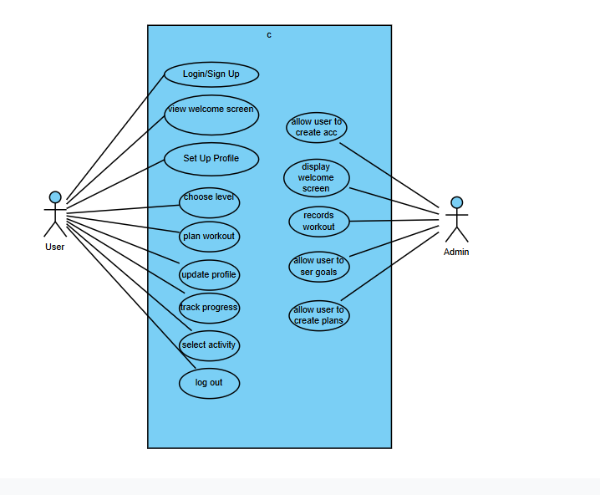
- 2.8.2 Class Diagram
Shows the system’s classes, attributes, relationships, and methods at a conceptual level.
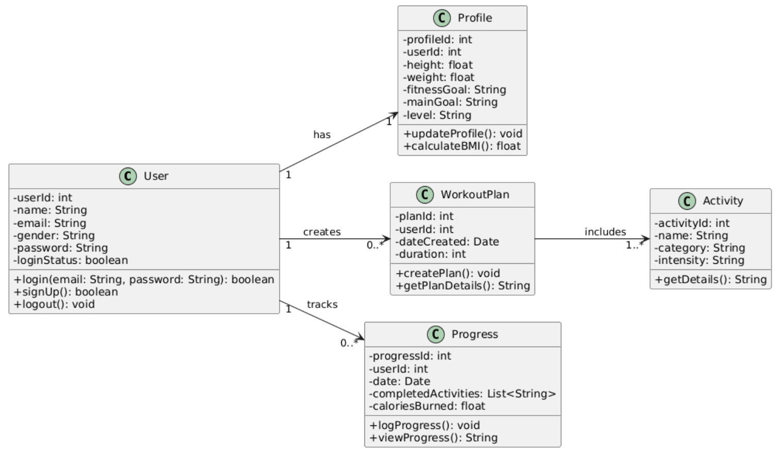
- 2.8.3 Domain Model
Represents real-world entities and relationships relevant to the application domain (e.g., User, Workout Plan, Mood, etc.).
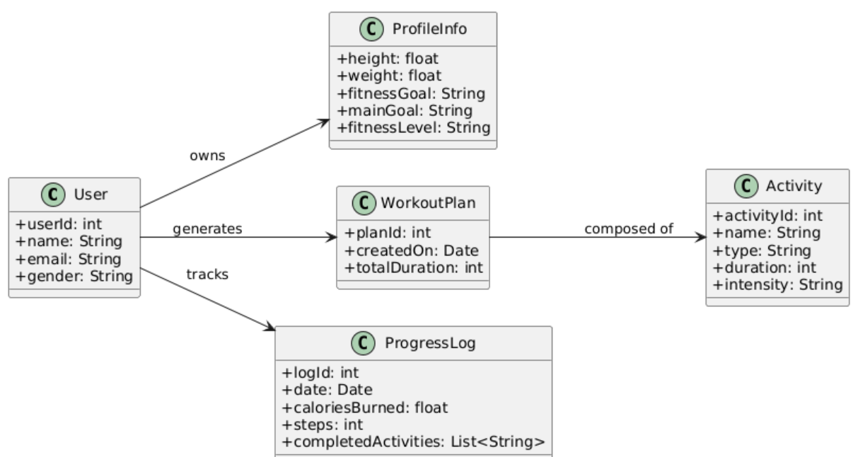

3. Specific Requirements
This section describes the detailed functional and non-functional requirements of the FitTrack application.
3.1 Functional Requirements
FR1. User Registration and Authentication
- FR1.1 The system shall allow users to register using email, password, name, phone number, and OTP verification.
- FR1.2 The system shall allow users to log in using email and password.
- FR1.3 The system shall provide an option to log in via Apple, Google, or social media.
- FR1.4 The system shall send OTP codes for phone verification during sign-up.
- FR1.5 The system shall handle forgotten passwords through password reset via email.
FR2. User Profile and Setup
- FR2.1 The system shall collect user profile information: gender, height, weight, goal weight, and fitness goals.
- FR2.2 The system shall allow users to select preferred measurement units (kg/lbs, cm/inches).
- FR2.3 The system shall store and allow updates to profile data.
FR3. Personalized Workout Plan
- FR3.1 The system shall allow users to choose their workout level: beginner, medium, advanced.
- FR3.2 The system shall allow users to select preferred workout categories (e.g., Yoga, Cardio, Power Training).
- FR3.3 The system shall generate a personalized training plan based on user input and preferences.
FR4. Emotion-Based Recommendation
- FR4.1 The system shall capture user emotion using one or more of the following: facial expressions, voice input, or typed text.
- FR4.2 The system shall map detected emotional states to corresponding workout suggestions (e.g., yoga for stress, cardio for energy).
- FR4.3 The system shall allow manual override of emotion-based suggestions.
FR5. Activity Tracking
- FR5.1 The system shall track steps, distance, calories burned, and active time.
- FR5.2 The system shall sync data from connected wearable devices using APIs (e.g., Google Fit, Apple HealthKit).
FR6. Notifications
- FR6.1 The system shall send workout reminders based on user-selected schedules.
- FR6.2 The system shall send motivational quotes or tips based on usage patterns and emotional status.
FR7. Dashboard and Reports
- FR7.1 The system shall display daily goals, activity summary, and emotional wellness score.
- FR7.2 The system shall provide weekly and monthly progress charts.

3.2 Non-Functional Requirements
NFR1. Performance
- NFR1.1 The system shall generate personalized plans and emotion-based suggestions within 2 seconds.
- NFR1.2 The system shall load dashboard screens within 1.5 seconds under normal network conditions.
NFR2. Usability
- NFR2.1 The system shall have a user-friendly UI based on mobile app usability standards.
- NFR2.2 The onboarding process shall not exceed 7 steps and should allow skipping non-mandatory inputs.
NFR3. Security
- NFR3.1 All user data shall be encrypted in transit (HTTPS) and at rest.
- NFR3.2 The system shall implement user authentication and secure password storage (e.g., salted hashes).
NFR4. Availability
- NFR4.1 The backend services shall maintain 99% uptime monthly.
- NFR4.2 Offline access to previously downloaded workouts shall be supported.
NFR5. Compatibility
- NFR5.1 The application shall be compatible with Android 8.0+ and iOS 12+.
- NFR5.2 The system shall support syncing with wearables via Google Fit, Apple HealthKit, and Fitbit APIs.

Appendices
Appendix A: Figma Design Reference
Screenshots and flowcharts from the app’s Figma design have been used to align functional requirements. Key screens:
- Welcome, Home screens
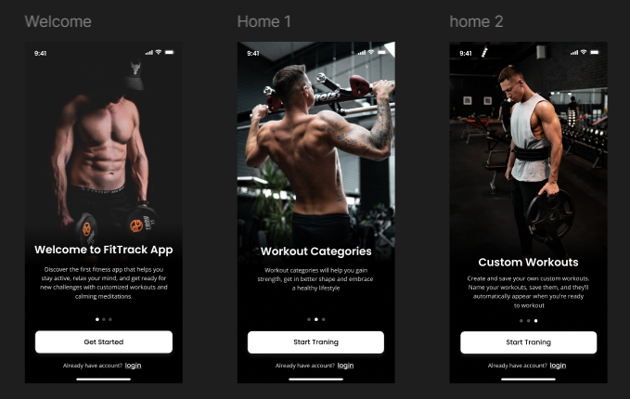

- Login/ Sign up, Gender Screens
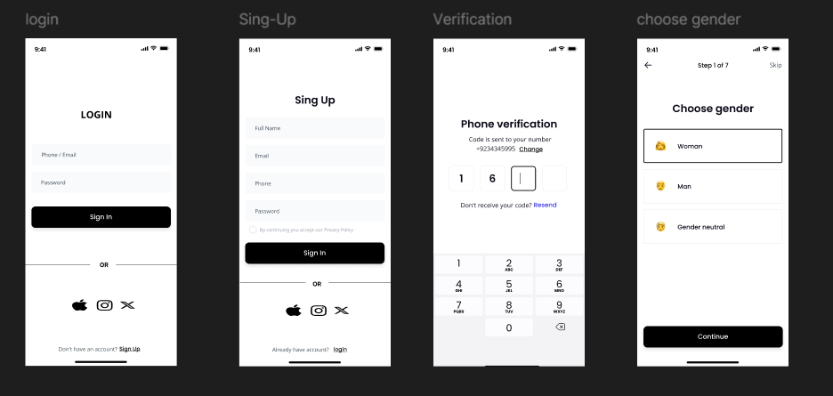
- Goal, Select Height, Select Weight

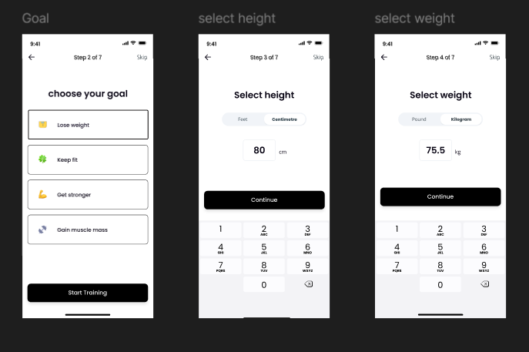

- Main Goal, Level
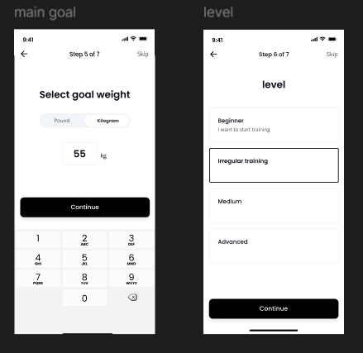

Select Activities, Create Plan
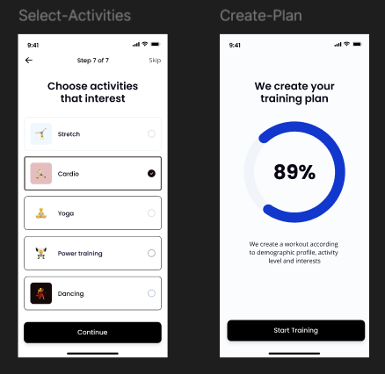
Figma File Link: Click Here

Appendix B: Acronyms
Term | Meaning
API | Application Programming Interface
UI | User Interface
OTP | One-Time Password
AI | Artificial Intelligence
MVP | Minimum Viable Product
HTTPS | Hypertext Transfer Protocol Secure

Index
Topic | Section
Introduction | 1
Product Perspective | 2.1
Activity Tracking | 2.2, 3.1.5
Non-Functional Requirements | 3.2

