Exercice 1

hamza

2024-12-17

setwd("C:/Users/hamyo_t0x1ze0/OneDrive/Terminale/IAE/TD1")  
data <- read.table("ozone.txt", header = TRUE)

plot(data$T12, data$maxO3, xlab = "Température à 12h (°C)", ylab = "Concentration maximum d'ozone (μg/m3)",  
 main = "Nuage de points : Température vs Ozone", pch = 16, col = "blue")

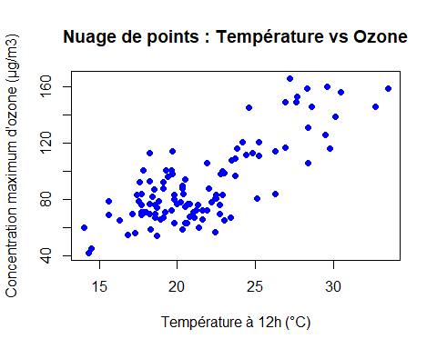

model <- lm(maxO3 ~ T12, data = data)  
summary(model)

##   
## Call:  
## lm(formula = maxO3 ~ T12, data = data)  
##   
## Residuals:  
## Min 1Q Median 3Q Max   
## -38.079 -12.735 0.257 11.003 44.671   
##   
## Coefficients:  
## Estimate Std. Error t value Pr(>|t|)   
## (Intercept) -27.4196 9.0335 -3.035 0.003 **   
## T12 5.4687 0.4125 13.258 <2e-16 ***  
## ---  
## Signif. codes: 0 '***' 0.001 '**' 0.01 '*' 0.05 '.' 0.1 ' ' 1  
##   
## Residual standard error: 17.57 on 110 degrees of freedom  
## Multiple R-squared: 0.6151, Adjusted R-squared: 0.6116   
## F-statistic: 175.8 on 1 and 110 DF, p-value: < 2.2e-16

plot(data$T12, data$maxO3, xlab = "Température à 12h (°C)", ylab = "Concentration maximum d'ozone (μg/m3)",  
 main = "Nuage de points : Température vs Ozone", pch = 16, col = "blue")  
  
model <- lm(maxO3 ~ T12, data = data)  
abline(model, col = "red", lwd = 2)

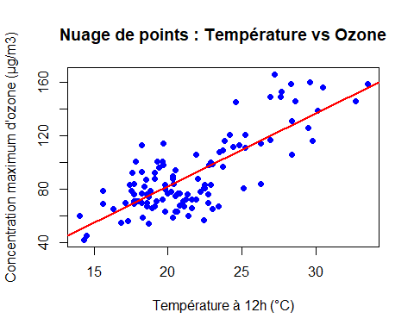

residuals <- model$residuals  
plot(data$T12, residuals, xlab = "Température à 12h (°C)", ylab = "Résidus",  
 main = "Analyse des résidus", pch = 16, col = "darkgreen")  
abline(h = 0, col = "red", lty = 2)

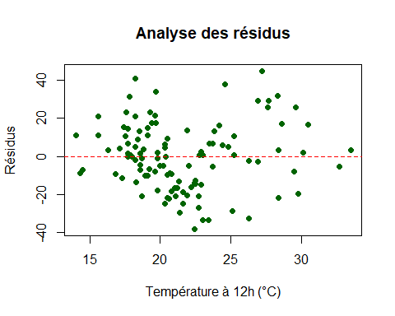

new_temp <- data.frame(T12 = 25)   
predicted_ozone <- predict(model, newdata = new_temp)  
cat("La concentration prévue pour une température de 25°C est :", predicted_ozone, "μg/m3\n")

## La concentration prévue pour une température de 25°C est : 109.2975 μg/m3