***HAMZA SAIF***

***481070***

1. ***Make 2D Array in C++ and print left diagonal and right diagonal sum of a 3x3 matrix.***

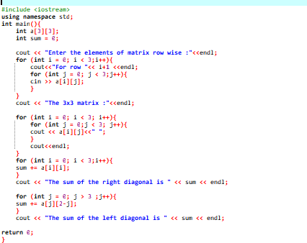

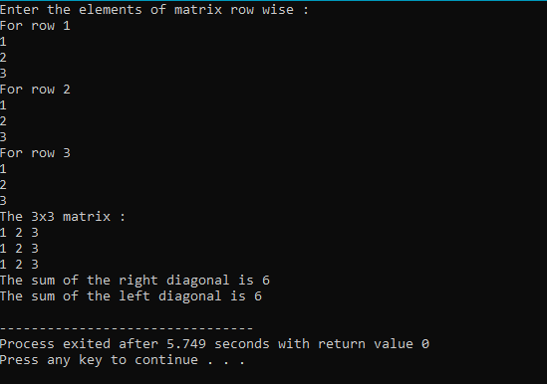

1. ***Write a function to add two 2D arrays of size 3x3.***

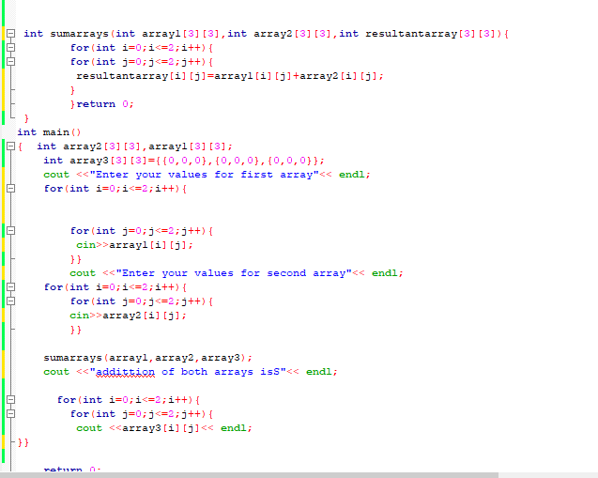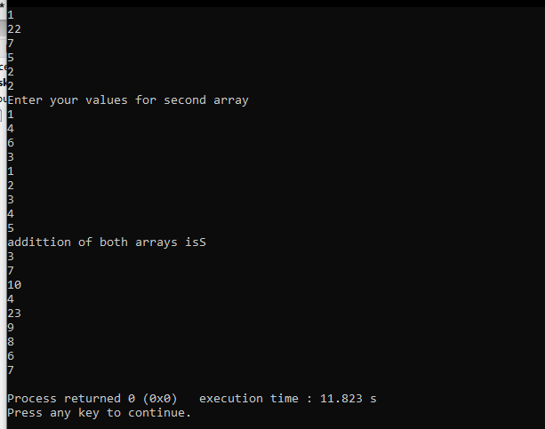

1. ***Using 2D arrays in C++, take transpose of a 3x3 matrix. Make a transpose function***

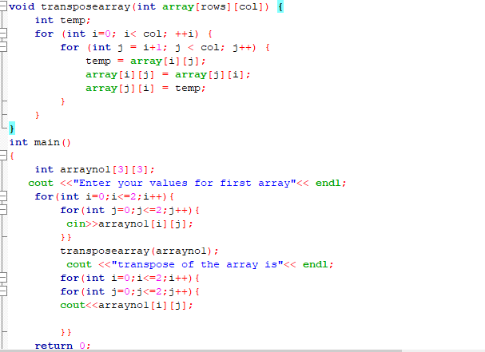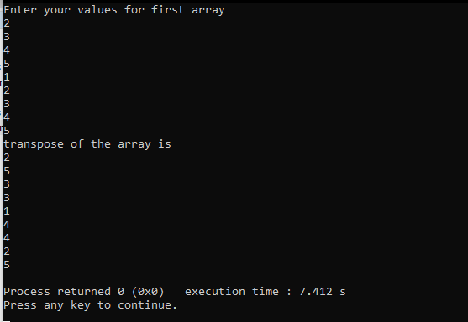

1. ***Using 2D arrays in C++, implement 3x3 matrix multiplication. Make a function.***

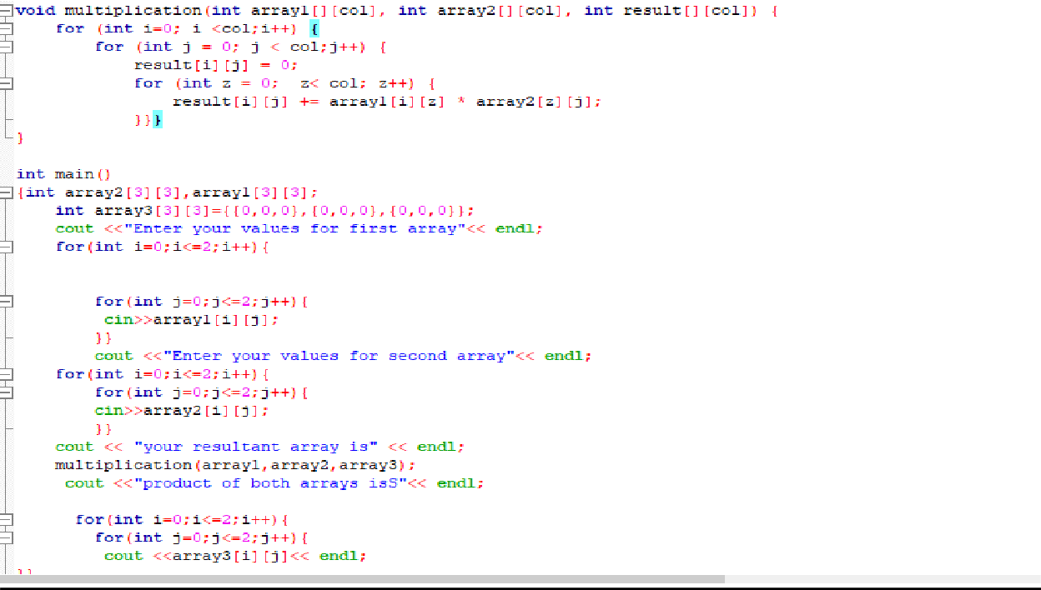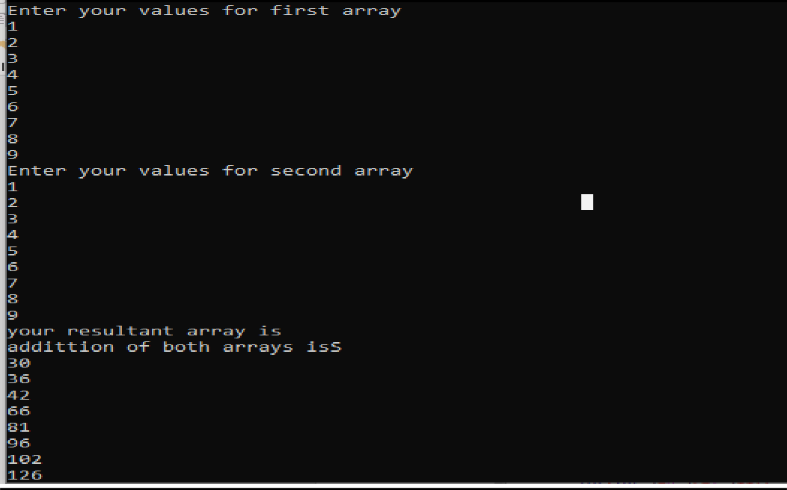

1. ***Print the multiplication table of 15 using recursion.***

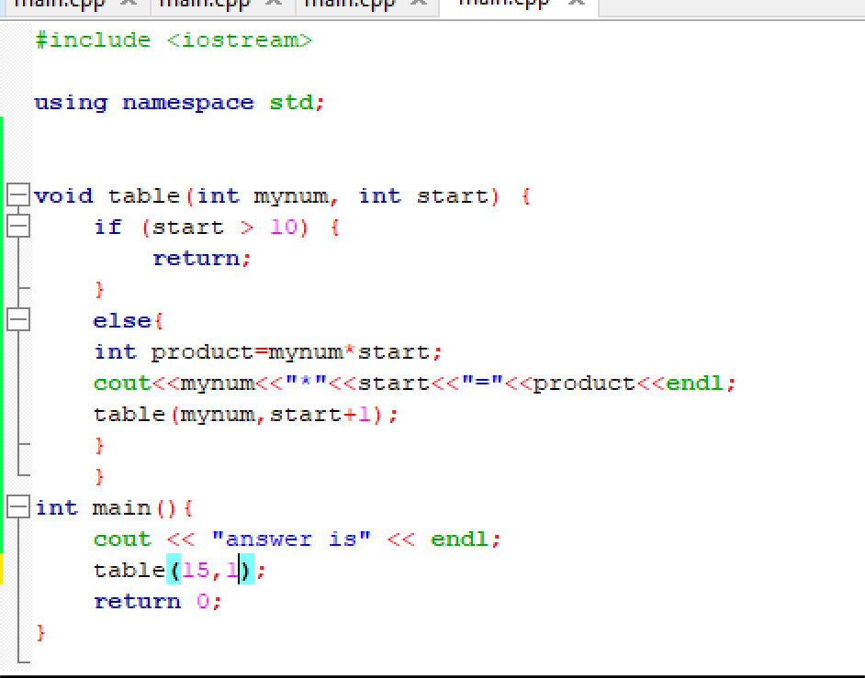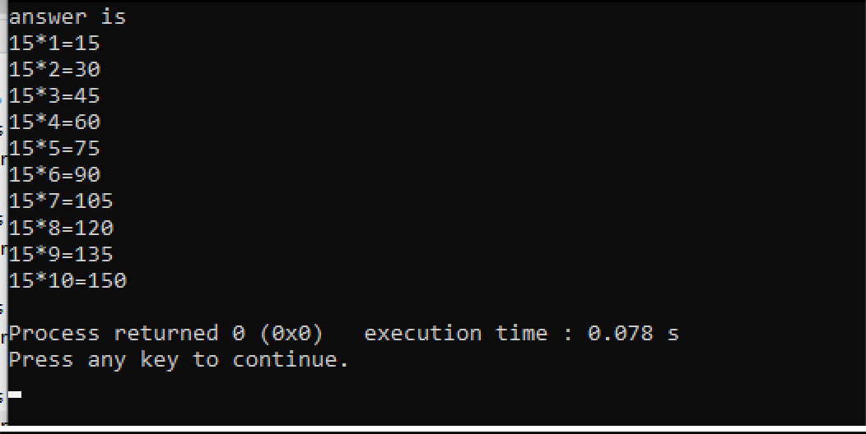

***HOME TASK***

***1. Write a C++ program to take inverse of a 3x3 matrix using its determinant and adjoint.***

