Contents
1. EXPERIMENT1: Getting to know Word 2016 2
1.1 The Word interface 2
1.2 Working with the Word environment 3
1.3 Using the Tell me feature 5
1.4 The Quick Access Toolbar 5
1.5 The Ruler 6
1.6 Document views and zooming 7

EXPERIMENT1: Getting to know Word 2016

Objective
- Getting to know MS Word
- Lean basic ribbon commands
Time Required : 3 hrs
Programming Language : NIL
Software Required : MS Office 2016 or above
Hardware Required : NIL

Word 2016 is similar to Word 2013 and Word 2010. If you've previously used either version, then Word 2016 should feel familiar. But if you are new to Word or have more experience with older versions, you should first take some time to become familiar with the Word 2016 interface.

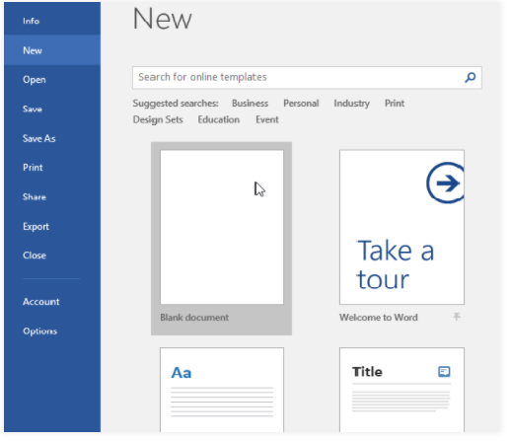
The Word interface
When you open Word for the first time, the Start Screen will appear. From here, you'll be able to create a new document, choose a template, and access your recently edited documents. From the Start Screen, locate and select Blank document to access the Word interface.
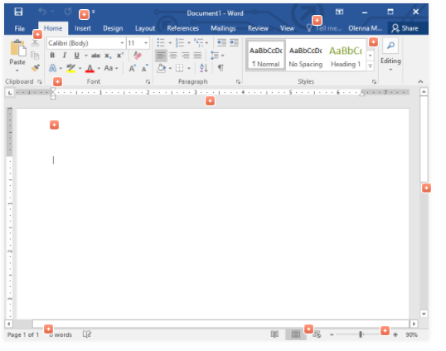

Working with the Word environment
Like other recent versions, Word 2016 continues to use features like the Ribbon and the Quick Access Toolbar—where you will find commands to perform common tasks in Word—as well as Backstage view.
- The Ribbon
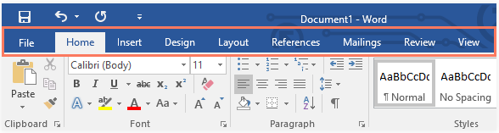
Word uses a tabbed Ribbon system instead of traditional menus. The Ribbon contains multiple tabs, which you can find near the top of the Word window.

Each tab contains several groups of related commands. For example, the Font group on the Home tab contains commands for formatting text in your document.
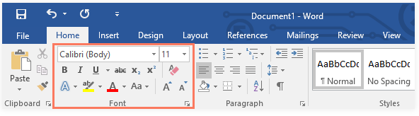

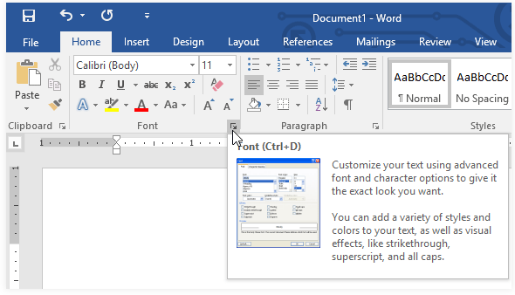
Some groups also have a small arrow in the bottom-right corner that you can click for even more options.
- Showing and hiding the Ribbon
If you find that the Ribbon takes up too much screen space, you can hide it. To do this, click the Ribbon Display Options arrow in the upper-right corner of the Ribbon, then select the desired option from the drop-down menu:
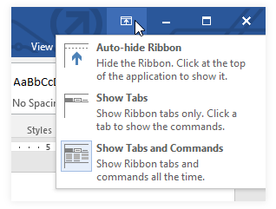
- Auto-hide Ribbon:
Auto-hide displays your document in full-screen mode and completely hides the Ribbon from view. To show the Ribbon, click the Expand Ribbon command at the top of screen.
- Show Tabs:
This option hides all command groups when they're not in use, but tabs will remain visible. To show the Ribbon, simply click a tab.
- Show Tabs and Commands:
This option maximizes the Ribbon. All of the tabs and commands will be visible. This option is selected by default when you open Word for the first time.

Using the Tell me feature
If you're having trouble finding command you want, the Tell Me feature can help. It works just like a regular search bar: Type what you're looking for, and a list of options will appear. You can then use the command directly from the menu without having to find it on the Ribbon.
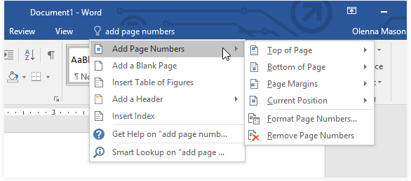

The Quick Access Toolbar
Located just above the Ribbon, the Quick Access Toolbar lets you access common commands no matter which tab is selected. By default, it shows the Save, Undo, and Redo commands, but you can add other commands depending on your needs.
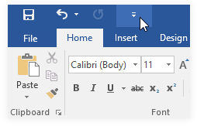
- To add commands to the Quick Access Toolbar:
- Click the drop-down arrow to the right of the Quick Access Toolbar.

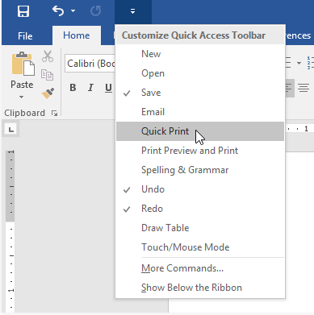
- Select the command you want to add from the menu.

- The command will be added to the Quick Access Toolbar.
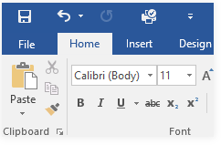

The Ruler
The Ruler is located at the top and to the left of your document. It makes it easier to adjust your document with precision. If you want, you can hide the Ruler to create more screen space.
- To show or hide the Ruler:
- Click the View tab.
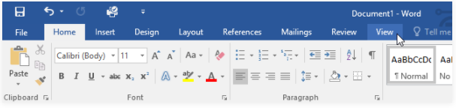

- Click the checkbox next to Ruler to show or hide the Ruler.
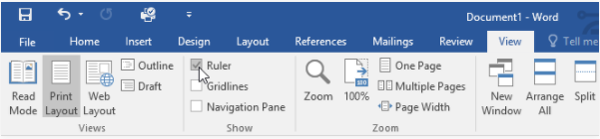

Document views and zooming
Word has a variety of viewing options that change how your document is displayed. You can choose to view your document in Read Mode, Print Layout, or Web Layout. These views can be useful for various tasks, especially if you're planning to print the document. You can also zoom in and out to make your document easier to read.
- Switching document views
Switching between different document views is easy. Just locate and select the desired document view command in the bottom-right corner of the Word window.
- Read Mode: This view opens the document to a full screen. This view is great for reading large amounts of text or simply reviewing your work.

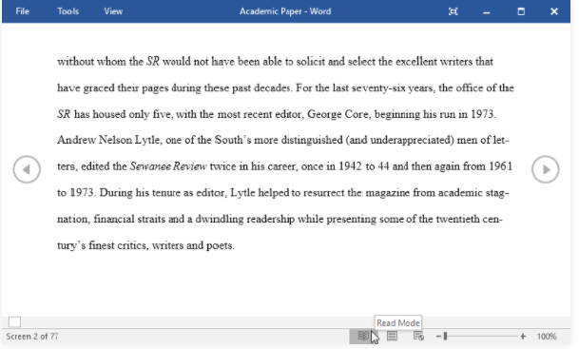

- Print Layout: This is the default document view in Word. It shows what the document will look like on the printed page.
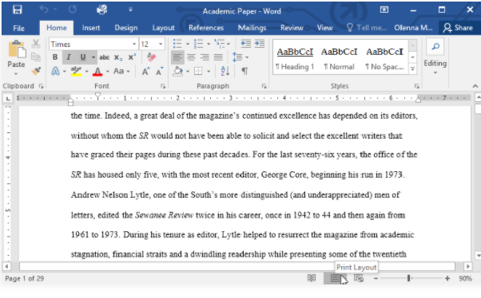
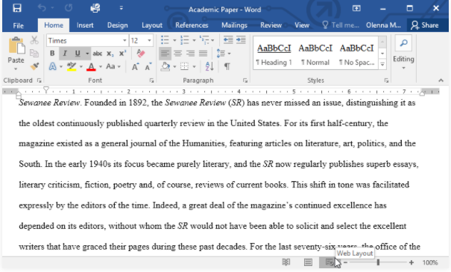
- Web Layout: This view displays the document as a webpage, which can be helpful if you're using Word to publish content online.

- Zooming in and out
To zoom in or out, click and drag the zoom control slider in the bottom-right corner of the Word window. You can also select the + or - commands to zoom in or out by smaller increments. The number next to the slider displays the current zoom percentage, also called the zoom level.
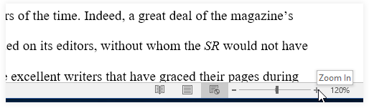

EXERCISES
- Open Word 2016, and create a blank document.
- Change the Ribbon Display Options to Show Tabs.
- Using Customize Quick Access Toolbar, add New, Quick Print, and Spelling & Grammar.
- In the Tell me bar, type Shape and press Enter.
- Choose a shape from the menu, and double-click somewhere on your document.
- Show the Ruler if it is not already visible.
- Zoom the document to 120%.
- Change the Document view to Web Layout.

Web Resource
- https://edu.gcfglobal.org/en/word2016/getting-started-with-word/1/

EXPERIMENT2: Working with the Text
Objective
- Learn Text Basics
- Formatting text
- Using Find and Replace
- Indents and Tabs
- Line and Paragraph spacing
- Lists and hyperlinks

Time Required : 3 hrs
Programming Language : NIL
Software Required : MS Office 2016 or above
Hardware Required : NIL

  - Learn Text Basics
    - Using the insertion point to add text
- The insertion point is the blinking vertical line in your document. It indicates where you can enter text on the page.
- Press the spacebar to add spaces after a word or in between text.
- Press Enter on your keyboard to move the insertion point to the next paragraph line.
- you can use the mouse to move the insertion point to a specific place in your document. Simply click the location in the text where you want to place it.
- You can also use the arrow keys on your keyboard to move the insertion point.

    - Selecting Text delete text
- O select Text click and drag your mouse over the text, then release the mouse. A highlighted box will appear over the selected text.
- To select all of the text in your document, choose the Select command on the Home tab, then click Select All. Alternatively, you can press Ctrl+A on your keyboard.
- To delete text to the left of the insertion point, press the Backspace key on your keyboard. Also use delete key from key board

    - Copy and moving text
- Select the text you want to copy. Click the Copy command on the Home tab. Alternatively, you can press Ctrl+C on your keyboard. Place the insertion point where you want the text to appear. Click the Paste command on the Home tab. Alternatively, you can press Ctrl+V on your keyboard.

    - Drag and drop text
- Select the text you want to move.
- Click and drag the text to the location where you want it to appear. A small rectangle will appear below the arrow to indicate that you are moving text.
- Release the mouse, and the text will appear.
- Undo and redo text
- To do this, locate and select the Undo command on the Quick Access Toolbar. Alternatively, you can press Ctrl+Z on your keyboard. You can continue using this command to undo multiple changes in a row.
- By contrast, the Redo command allows you to reverse the last undo. You can also access this command by pressing Ctrl+Y on your keyboard.
    - Symbols
- Place the insertion point where you want the symbol to appear.
- Locate and select the Symbol command, then choose the desired symbol from the drop-down menu. If you don't see the one you want, select More Symbols.
- The symbol will appear in the document.

EXERCISES

- Refer practice document name “text basics practice”.
- Scroll to page 2.
- Place the insertion point at the top of the document and type Now Introducing...
- Use your arrow keys to move the insertion point to the Signature Detail Plan's price and change it to $99.99/mo.
- At the bottom of the document, use drag and drop to move Just leave the details to us to the end of the last line.
- At the end of the line you just moved, insert the trademark symbol. If you cannot find the trademark symbol, insert a different symbol of your choice.
- When you're finished, your document should look something like this:
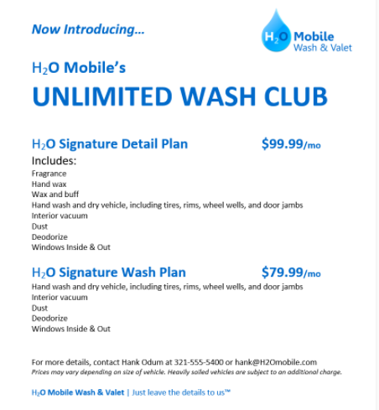

  - Formatting text
- Font Size:Select the text you want to modify. On the Home tab, click the Font size drop-down arrow. Select a font size from the menu. if the font size you need is not available in the menu, you can click the Font size box and type the desired font size, then press Enter.
- Font Style:On the Home tab, click the drop-down arrow next to the Font box. A menu of font styles will appear.Select the font style you want to use. The font will change in the document.
- Font Colour: On the Home tab, click the Font Color drop-down arrow. The Font Color menu appears.Select the font color you want to use. The font color will change in the document.
- Bold, Italics, Underline text: On the Home tab, click the Bold (B), Italic (I), or Underline (U) command in the Font group. In our example, we'll click Bold.
- Text Case: Select the text you want to modify. On the Home tab, click the Change Case command in the Font group. A drop-down menu will appear. Select the desired case option from the menu.
- High Light Text: Highlighting can be a useful tool for marking important text in your document. Highlighting can be a useful tool for marking important text in your document. Select the desired highlight color. The selected text will then be highlighted in the document.
- text alignment: By default, Word aligns text to the left margin in new documents. However, there may be times when you want to adjust text alignment to the center or right. On the Home tab, select one of the four alignment options from the Paragraph group. In our example, we've selected Center Alignment.

Exercise
- Open our practice document.
- Scroll to page 2.
- Select the words For Rent and change the font size to 48 pt.
- With the text still selected, change the font to Franklin Gothic Demi. Note: If you don't see this font in the menu, you can select a different one.
- Use the Change Case command to change For Rent to UPPERCASE.
- Change the color of the words For Rent to Gold, Accent 4.
- Remove the highlight from the phone number (919-555-7237).
- Select all of the text from For Rent to (919-555-7237) and Center Align.
- Italicize the text in the paragraph below About Villa Piña.
- When you're finished, your page should look like this:
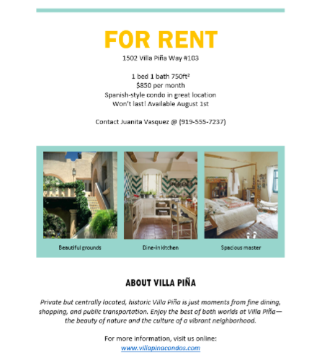

  - Lists and hyperlinks

  - Using Find and Replace
  - Indents and Tabs
  - Line and Paragraph spacing

