

SubMitted TO Submitted by

**MR. Sujan Sarkar MD. amir hamza** | 15-01-04-118 (Lecturer, AUst) **Md. Masud Rana** | 15-01-04-134

**MR. Sk. Murad hassan anik KAZI Hasib ahmed** | 15-01-04-135

(Lecturer, Aust)

**MicroCOntroller Based SYSTEM DESIGN LAB**

Project report

SMART HOME SECURITY

Face and Password Protected Home

Section- C Group- C1

CSE 3216

## Overview:

This project is all about a smart home, which is secured by face and password. The person who wants enter the home can enter after the system recognition that person face or after giving the password.

## Instruments:

* Raspberry Pi 3
* Pi Camera
* Arduino Mega 2500
* 2*16 LCD Display
* Servo Motor
* Keypad
* Breadboard
* Wires
* Potentiometer

## Features:

* Done:
  + Enter home by Face Recognition.
  + Also can enter home by password.
  + Can change entering password.
* Undone:

There is no undone features.

## Working Principle:

We have connected Arduino with keypad and LCD display. To control the brightness of the LCD display we used a Potentiometer to the Vo of the LCD display. Keypad is used for input and LCD display is used show outputs. We have used servomotor to Arduino to open the door.

Pi camera is connected to Raspberry Pi.

We have used Raspberry Pi as master and Arduino as slave. Therefore, we have connected Ground, SCL and SDA by wires for serial communication.

To open the door any person should press ‘B’ key to active the Pi camera to take image. Then Pi camera take images and try to recognize that person’s face. If it recognize the person than Raspberry Pi sends data to Arduino to open the door. If it does not recognize the person Raspberry Pi sends data to Arduino to inform the person that he is not recognized and he can try again or he can open the door by password.

Press ‘A’ to go to main menu. Then enter password from keypad and press ’*’ to submit. If given password is matched with user’s password then Arduino opens door else he informs to try again.

Arduino open the door rotating the servomotor and gives information to user by LCD display.

User can change password by pressing ‘C’ key. Then enter previous password and press ’*’ to submit. Then enter new password and press ‘*’ to submit. If given previous password matches users password then it saves the given new password as users password else informs password is not changed.

This project will only recognize one person’s face who is trained. To train user first user need to create dataset by Pi camera taking images and then training it.

## Pictures of Project:

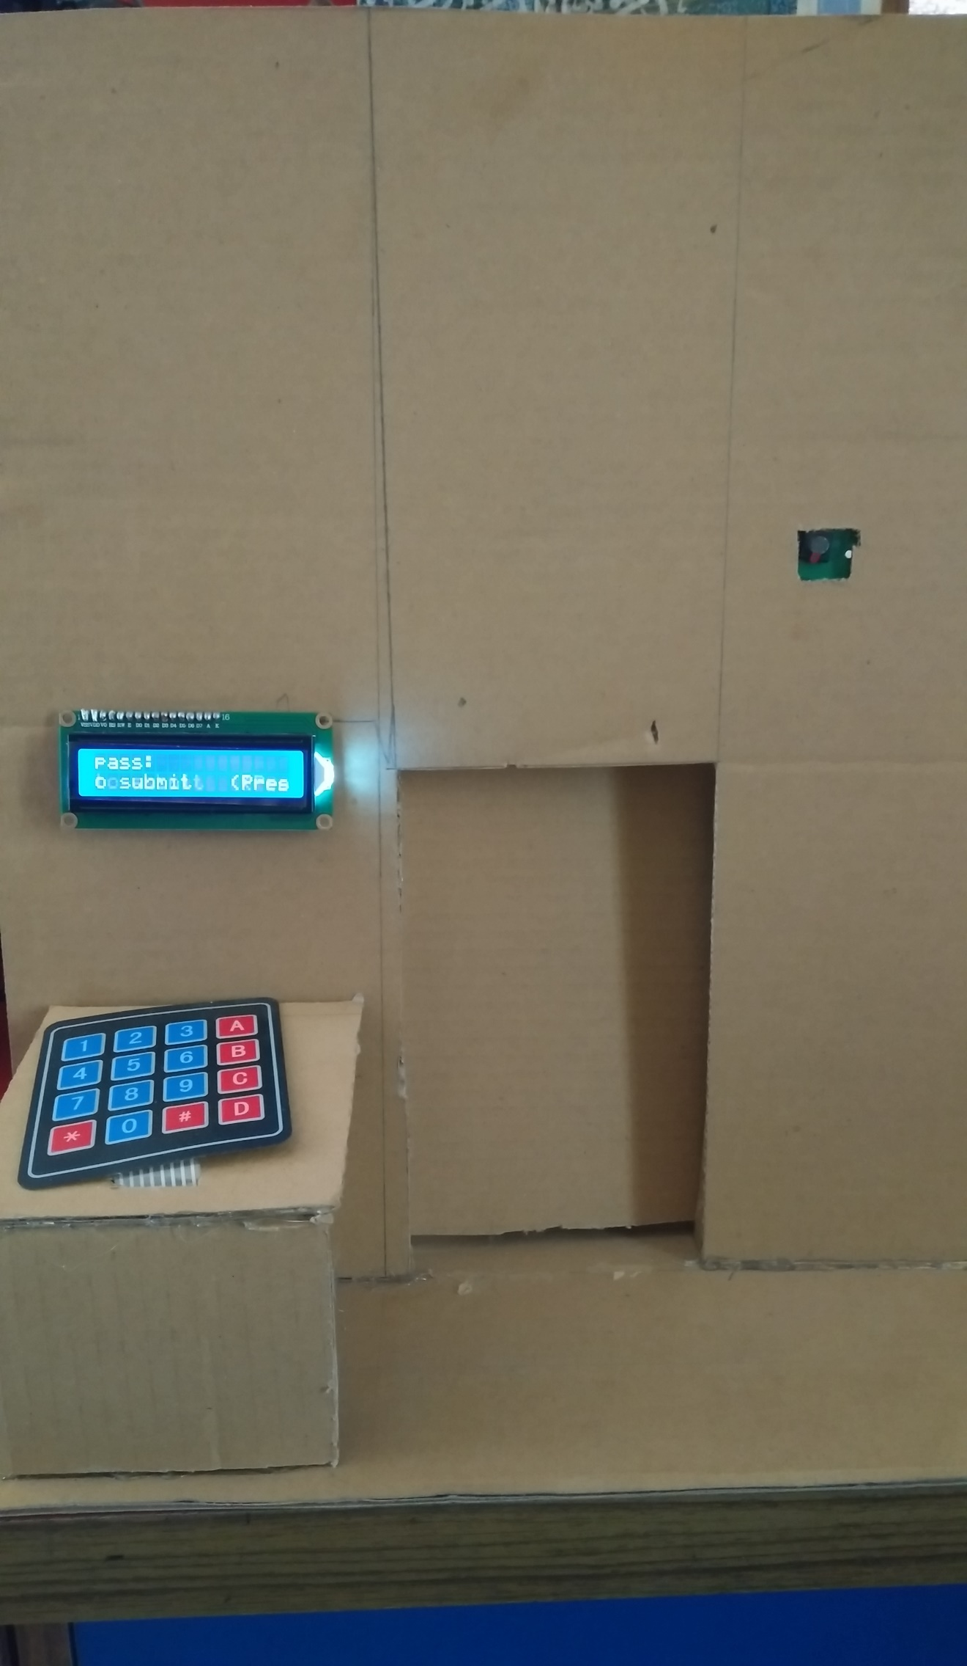

Front view of the project.

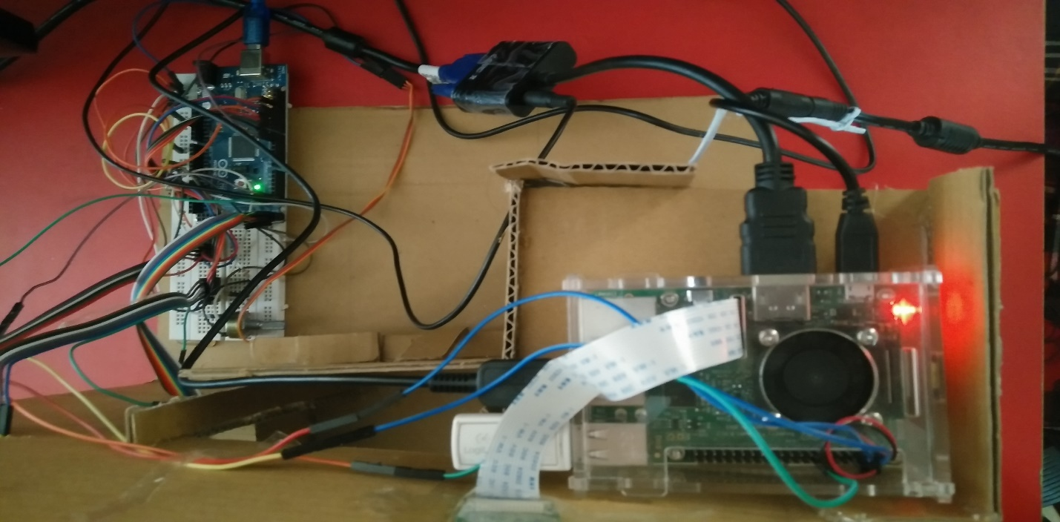

The back view of the project.

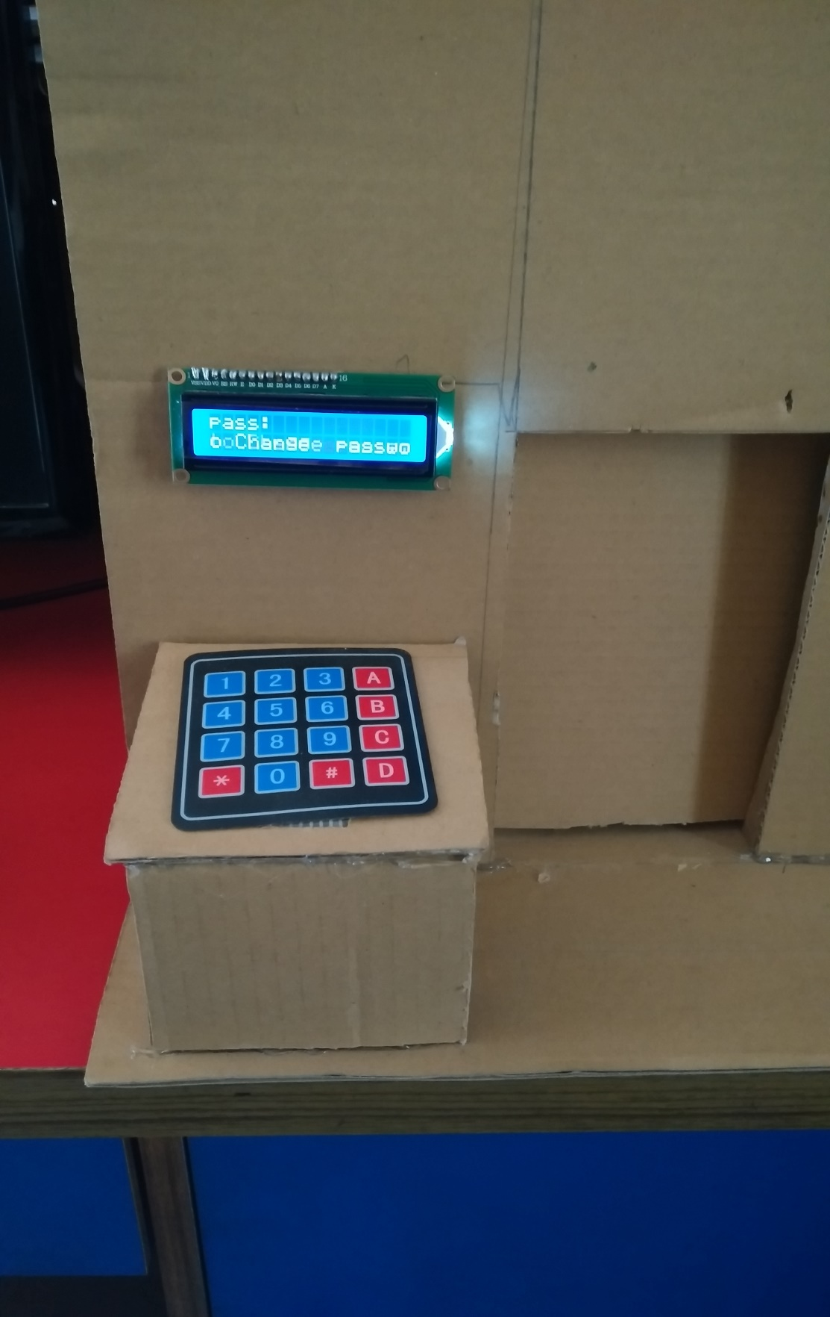

Closer view of keypad and LCD display. This is the menu where user can enter his password.

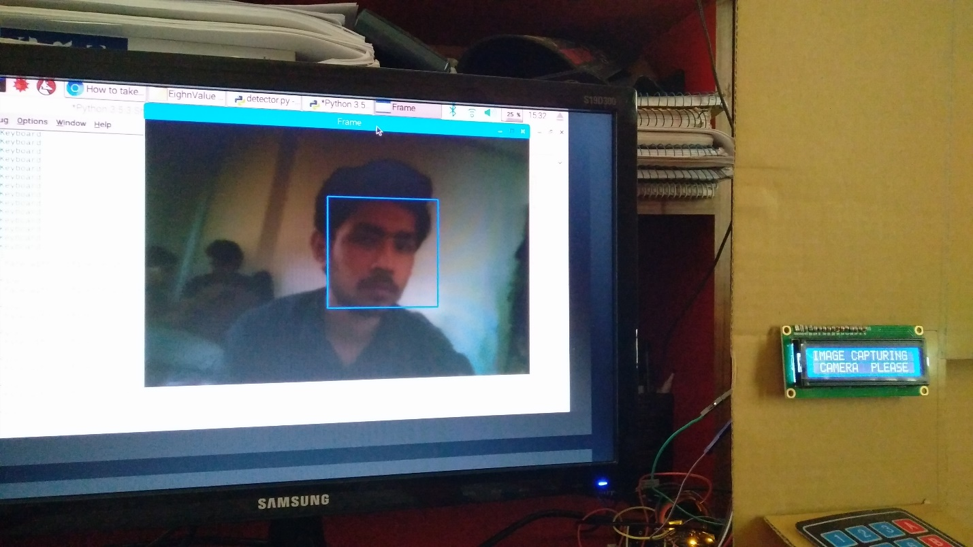

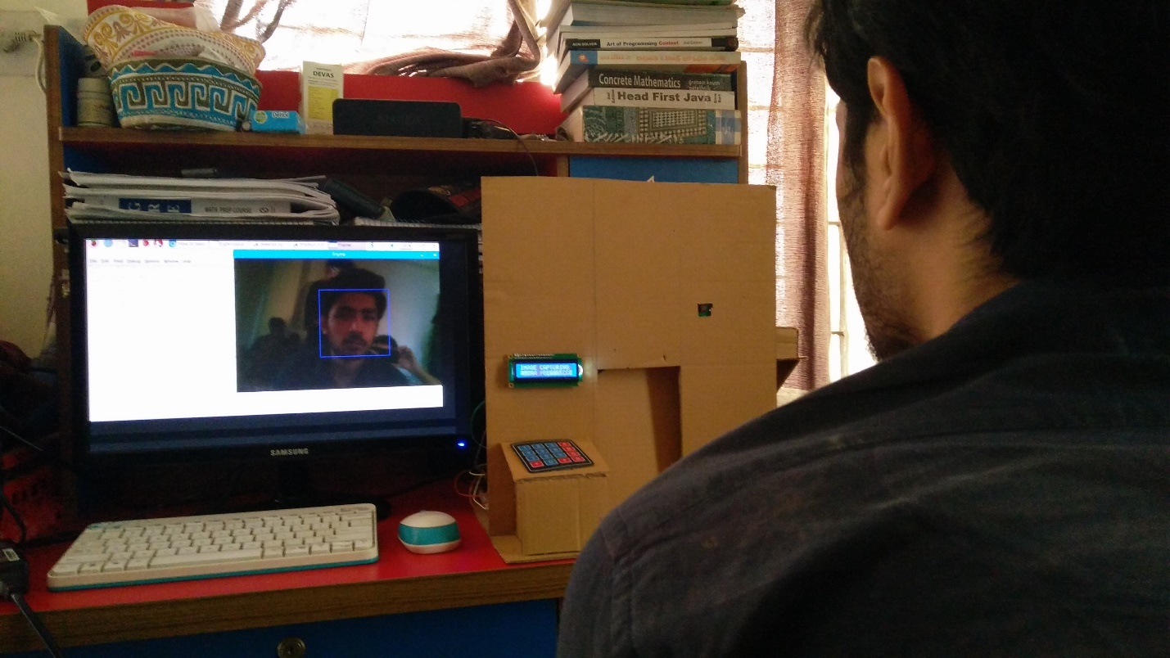

Views of camera and LCD display when capturing image.

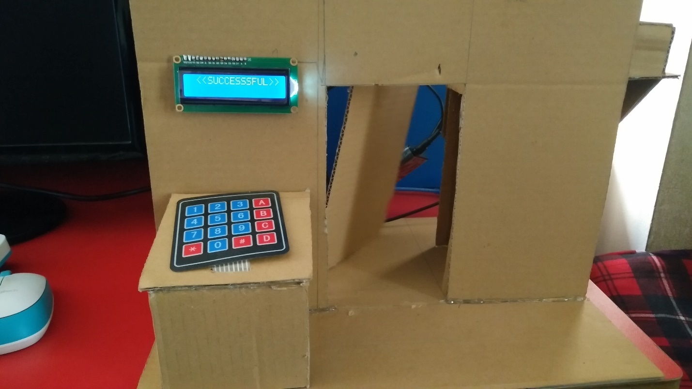

View of opening the door.

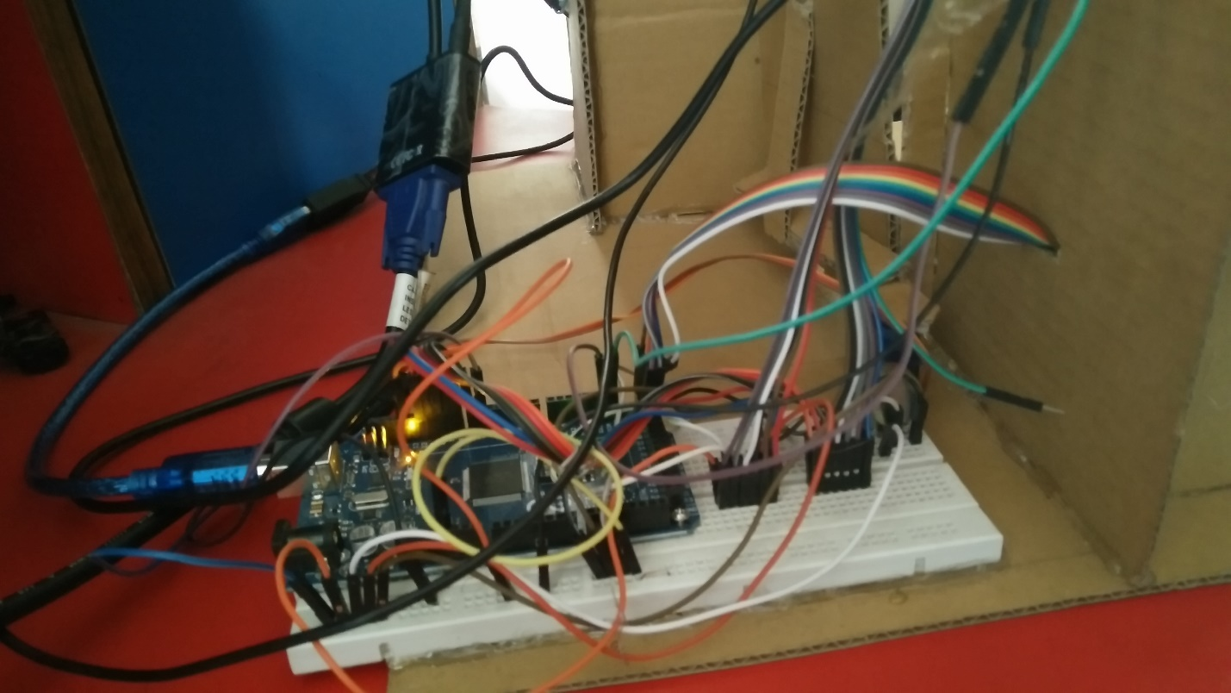

Close View of Arduino connections with LCD display and Keypad.

## Conclusion:

In this project, we tried to organize a smart home security with face lock/recognition. Now it is not accurate yet because accuracy changes in different lighting condition. Therefore, in future we want to improve accuracy of face recognition and run the system immediate after the booting of Raspberry Pi. We will also work on adding more user to system.