NATIONAL UNIVERSITY OF COMPUTER AND EMERGING SCIENCES
Chiniot-Faisalabad Campus

CL2006 – Operating Systems Lab
Spring 2026 | Section BCS-4B
Semester Project Report
Concurrent Banking System with Scheduling, Synchronization, IPC, and Memory Management

Name | Roll Number | Group No
Muhammad Hamza Afzaal | 24F-0698 | 7
Balaj Khan | 24F-0571 | 7
Zaryab Khan | 24F-0641 | 7

Submission Date: May 8, 2026
Instructor: Mam Batisha Manhal, CL2006

Introduction
This report documents the design and implementation of a Concurrent Banking System Simulation developed as the semester project for CL2006 – Operating Systems Lab (Spring 2026). The system integrates five core Operating System concepts into a single cohesive banking application written in C using POSIX threads, System V IPC, and standard Unix system calls.

Project Objectives
- Implement and compare CPU scheduling algorithms in a real banking transaction context.
- Demonstrate thread synchronization using mutex locks and semaphores to prevent race conditions.
- Apply Banker’s Algorithm for deadlock avoidance in loan processing.
- Simulate inter-process communication using System V message queues with a producer-consumer model.
- Compare FIFO and LRU page replacement algorithms and measure their efficiency.

1.2 Customer Types
Customer Type | Priority | Description
Regular Customer | 1 | Performs standard deposits and withdrawals
Loan Applicant | 2 | Submits loan requests processed via Banker’s Algorithm
Premium Customer | 3 | Higher scheduling priority than regular
Corporate Client | 4 | Multiple threads per client for payroll processing
VIP Customer | 5 | Highest priority, always preempts others

1.3 System Architecture
The project follows a modular architecture with each OS concept isolated into a separate source file. All modules share a common header (banking.h) that defines data structures, constants, and function prototypes. The entry point (main.c) orchestrates all five modules sequentially.

Source File | Module | Responsibility
main.c | Entry Point | Initializes system, orchestrates all modules
accounts.c | Account Management | Deposit, withdrawal, mutex & semaphore protection
scheduling.c | Module 1 | FCFS, Priority Scheduling, Round Robin + Gantt charts
sync.c | Module 2 | Thread creation, mutex locks, semaphore demos
banker.c | Module 3 | Banker’s Algorithm, safety check, loan requests
ipc.c | Module 4 | System V message queues, fork(), producer-consumer
memory.c | Module 5 | FIFO and LRU page replacement simulation
utils.c | Utilities | Logging, sleep, string helpers

2. Module 1 – CPU Scheduling

2.1 Overview
Each customer transaction is modeled as a process with an arrival time, burst time, and priority. Three scheduling algorithms are implemented and compared: First Come First Served (FCFS), Priority Scheduling (non-preemptive), and Round Robin with a time quantum of 2ms.

2.2 Client Configuration
Client | Class | Priority | Arrival (ms) | Burst (ms)
Hamza | Regular | 1 | 0 | 8
Zaryab | Premium | 3 | 2 | 5
Saad | Loan | 2 | 4 | 3
TechVentr | Corporate | 4 | 1 | 6
Omar | VIP | 5 | 3 | 4
Bilal | Regular | 1 | 5 | 7

2.3 Algorithm Results
FCFS – First Come First Served
Processes are ordered by arrival time. Execution order: Hamza → TechVentr → Zaryab → Omar → Saad → Bilal.
Client | Arrival | Burst | Wait | Turnaround
Hamza | 0 | 8 | 0 | 8
TechVentr | 1 | 6 | 7 | 13
Zaryab | 2 | 5 | 12 | 17
Omar | 3 | 4 | 19 | 23
Saad | 4 | 3 | 19 | 22
Bilal | 5 | 7 | 21 | 28
AVERAGE | – | – | 12.50 | 18.00

Priority Scheduling
Processes are ordered by priority (highest first). VIP (5) → Corporate (4) → Premium (3) → Loan (2) → Regular (1). Omar executes first, followed by TechVentr, Zaryab, Saad, Hamza, Bilal.
Client | Priority | Wait | Turnaround
Omar (VIP) | 5 | 0 | 4
TechVentr (Corporate) | 4 | 6 | 12
Zaryab (Premium) | 3 | 11 | 16
Saad (Loan) | 2 | 13 | 17
Hamza (Regular) | 1 | 21 | 29
Bilal (Regular) | 1 | 24 | 31
AVERAGE | – | 12.67 | 18.17

Round Robin (Quantum = 2ms)
Each client gets a 2ms time slice in cyclic order. This ensures fairness but results in higher average wait time due to context switching overhead.
Client | Wait | Turnaround
Hamza | 24 | 32
Zaryab | 19 | 24
Saad | 10 | 13
TechVentr | 21 | 27
Omar | 14 | 18
Bilal | 21 | 28
AVERAGE | 18.17 | 23.67

2.4 Algorithm Comparison
Algorithm | Avg Wait (ms) | Avg Turnaround (ms) | Best Use Case
FCFS | 12.50 | 18.00 | Simple queues, equal priority
Priority | 12.67 | 18.17 | VIP/Premium service differentiation
Round Robin | 18.17 | 23.67 | Fair time-sharing, no starvation

2.5 Implementation Details
- FCFS: Bubble sort by arrival_ms, then simulate sequential execution.
- Priority: Bubble sort by sched_priority (descending), ties broken by arrival time.
- Round Robin: Cyclic queue with TIME_QUANTUM = 2. Tracks remaining_ms per client. Uses TimeSlice array for Gantt chart rendering.
- Gantt charts are rendered as ASCII tables directly to stdout.

Module 1 – Terminal Output Screenshot

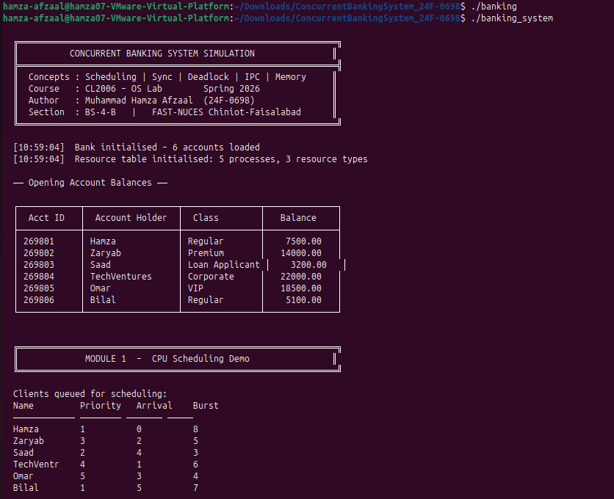
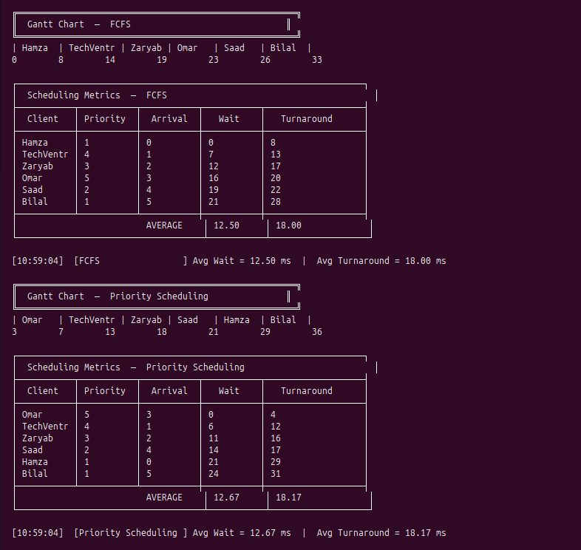

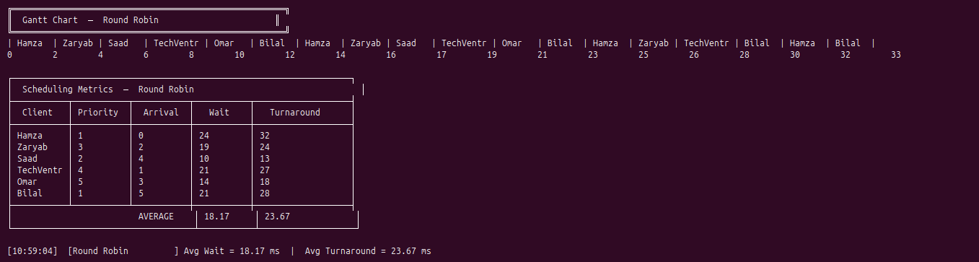

3. Module 2 – Synchronization

3.1 Overview
Shared account balances are protected using POSIX mutex locks and semaphores. Four test cases demonstrate different synchronization scenarios using pthreads.

3.2 Synchronization Primitives
Primitive | Variable | Purpose
Mutex Lock | acct_mutex (pthread_mutex_t) | Serializes all balance read/write operations
Semaphore | deposit_sem (sem_t, value=2) | Limits concurrent deposits to maximum 2 at a time

3.3 Test Cases
Test 1 – Mutex: Concurrent Withdrawals
Two threads (Hamza-T1 and Hamza-T2) simultaneously withdraw from Account 269801 (initial balance PKR 7,500). The mutex ensures only one thread updates the balance at a time, preventing a race condition.
- Hamza-T1 withdraws PKR 1,200 → New Balance: PKR 6,300
- Hamza-T2 withdraws PKR 800 → New Balance: PKR 5,500
- Result: Serialized updates, no data corruption.

Test 2 – Semaphore: Throttled Concurrent Deposits
Three threads attempt simultaneous deposits to Account 269802. The semaphore (value=2) allows only two at a time; the third blocks until a slot is released.
- deposit_sem initialized to 2 in sem_init().
- Each deposit thread calls sem_wait() before and sem_post() after.
- Third deposit was blocked and completed after one of the first two finished.

Test 3 – Corporate Payroll (10 Threads)
TechVentures spawns 10 employee threads, each depositing PKR 650 salary to Account 269804. All threads run concurrently; mutex ensures correct sequential balance updates.
- 10 pthread_create() calls, each with a PayrollTask argument.
- pthread_join() waits for all threads to complete.
- Final balance increased from PKR 22,000 to PKR 28,500 (10 x PKR 650).

Test 4 – VIP Priority Order
Omar (VIP) withdrawal thread is created with no delay; Bilal (Regular) deposit thread has a 5ms delay, simulating VIP preemption over regular customers.
- Omar-VIP withdraws PKR 3,000 from Account 269805.
- Bilal-Reg deposits PKR 500 to Account 269801 after delay.

3.4 Race Condition Prevention
Without mutex locks, two concurrent withdrawals could both read the same balance before either writes back, causing a lost update. The mutex ensures atomicity of the read-modify-write sequence. The semaphore adds an additional layer of resource throttling for deposit operations.

Module 2 – Terminal Output Screenshot
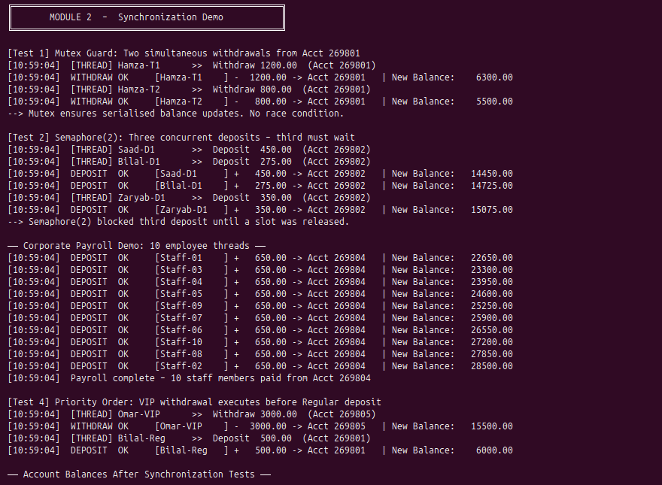

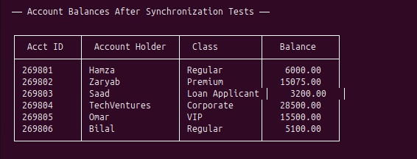

4. Module 3 – Deadlock Avoidance (Banker's Algorithm)

4.1 Overview
Loan requests are modeled as resource allocation requests. Three resource types are defined: Credit Units (C), Bank Tellers (T), and Vault Access Slots (V). The Banker's Algorithm checks if granting a loan keeps the system in a safe state before approving.

4.2 Initial Resource State
Process | Allocation [C,T,V] | Max Need [C,T,V] | Need [C,T,V]
Hamza (P0) | [0, 1, 0] | [6, 4, 2] | [6, 3, 2]
Zaryab (P1) | [2, 0, 1] | [3, 2, 1] | [1, 2, 0]
Saad (P2) | [3, 0, 1] | [8, 1, 2] | [5, 1, 1]
TechVentures (P3) | [1, 2, 1] | [2, 3, 3] | [1, 1, 2]
Omar (P4) | [0, 0, 2] | [5, 2, 4] | [5, 2, 2]

Available Vector: [4, 2, 3] (C=Credit Units, T=Tellers, V=Vault Slots)

4.3 Safety Algorithm
The safety algorithm simulates resource allocation using a Work vector initialized to the Available vector. It iteratively finds processes whose Need ≤ Work, simulates their completion, and adds their Allocation back to Work. If all processes can complete, the system is safe.
Initial Safe Sequence: P1 → P2 → P3 → P4 → P0

4.4 Loan Request Test Cases
Test | Process | Request [C,T,V] | Result | Reason
Test 1 | Zaryab (P1) | [1, 0, 0] | APPROVED | System remains safe after allocation
Test 2 | Saad (P2) | [4, 1, 0] | DENIED | Resources unavailable (would cause wait)
Test 3 | Hamza (P0) | [9, 9, 9] | DENIED | Request exceeds declared maximum need
Test 4 | Omar (P4) | [2, 1, 1] | APPROVED | System remains in safe state

4.5 Resource-Request Algorithm
For each loan request, the algorithm performs three checks before tentative allocation:
- Request must not exceed the process's declared maximum need.
- Requested resources must be currently available.
- After tentative allocation, run safety algorithm. If unsafe, rollback all changes.

Module 3 – Terminal Output Screenshot
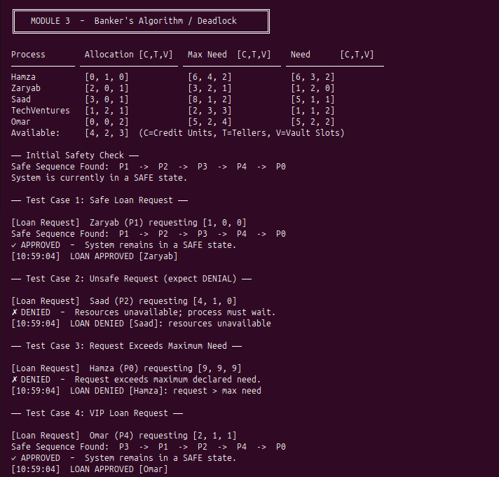

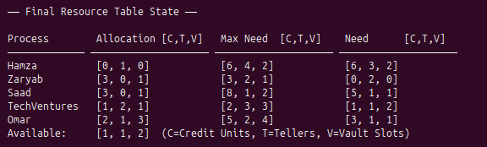

5. Module 4 – Inter-Process Communication (IPC)

5.1 Overview
Customer transactions are implemented as an IPC producer-consumer system. Five customer processes (producers) send transaction requests via a System V message queue. A single bank server process (consumer) reads requests, processes them, and sends responses back.

5.2 Architecture
Component | Type | Role
Bank Server | Consumer Process (fork) | Reads requests from queue, processes transactions, sends replies
Client 1 – Hamza | Producer Process (fork) | Sends deposit of PKR 750 to Account 269801
Client 2 – Zaryab | Producer Process (fork) | Sends withdrawal of PKR 300 from Account 269802
Client 3 – Saad | Producer Process (fork) | Sends deposit of PKR 1,500 to Account 269803
Client 4 – TechVentures | Producer Process (fork) | Sends deposit of PKR 5,000 to Account 269804
Client 5 – Omar | Producer Process (fork) | Sends withdrawal of PKR 4,000 from Account 269805

5.3 IPC Configuration
- Message Queue Key: 0x2698 (last 4 digits of roll number 24F-0698).
- Server reads on message type 1 (SERVER_MSG_TYPE).
- Each client receives response on type 200 + client_id (CLIENT_RESP_BASE).
- Queue removed after all 5 requests served using msgctl(IPC_RMID).

5.4 Transaction Log
Client | Operation | Amount (PKR) | Account | Final Balance (PKR)
Saad | Deposit | 1,500 | 269803 | 4,700
Omar | Withdrawal | 4,000 | 269805 | 11,500
Hamza | Deposit | 750 | 269801 | 6,750
Zaryab | Withdrawal | 300 | 269802 | 14,775
TechVentures | Deposit | 5,000 | 269804 | 33,500

5.5 Implementation Notes
- fork() creates separate address spaces for server and client processes.
- fflush() called before fork() to prevent output duplication.
- waitpid() used to collect all child processes and avoid zombies.
- Clients use staggered send_delay_ms to simulate realistic arrival patterns.

Module 4 – Terminal Output Screenshot
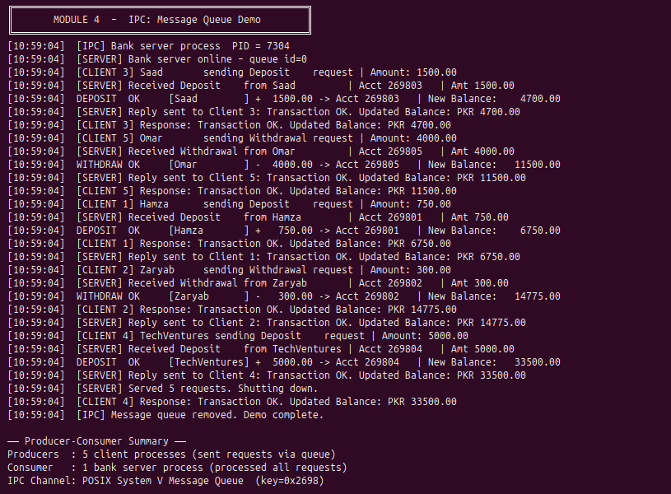

6. Module 5 – Memory Management

6.1 Overview
Each customer's account data is modeled as a page in virtual memory. With a fixed number of physical frames, the system simulates page replacement when a new page must be loaded and no free frames are available. Two algorithms are compared: FIFO and LRU.

6.2 Page Reference String
A 20-access reference string exercises 5 unique pages representing the 5 customer accounts:
1 → 2 → 3 → 4 → 1 → 2 → 5 → 1 → 2 → 3 → 4 → 5 → 3 → 2 → 1 → 4 → 5 → 2 → 3 → 1
Page ID | Customer
1 | Hamza (Regular)
2 | Zaryab (Premium)
3 | Saad (Loan Applicant)
4 | TechVentures (Corporate)
5 | Omar (VIP)

6.3 Algorithm Descriptions
FIFO – First In, First Out
When a page fault occurs and all frames are full, the page that was loaded earliest (using a circular insertion pointer) is evicted. Simple to implement but does not consider recency of use.

LRU – Least Recently Used
Each frame tracks its last access timestamp. On a page fault, the frame with the oldest timestamp is evicted. Approximates optimal behavior but requires timestamp tracking overhead.

6.4 Results
Metric | FIFO (3 Frames) | LRU (3 Frames) | FIFO (4 Frames) | LRU (4 Frames)
Page Faults | 13 | 17 | 13 | 13
Page Hits | 7 | 3 | 7 | 7
Hit Ratio | 35.0% | 15.0% | 35.0% | 35.0%
Fault Rate | 65.0% | 85.0% | 65.0% | 65.0%
Winner | FIFO | – | Tie | Tie

6.5 Analysis
- With 3 frames, FIFO outperforms LRU due to the specific access pattern having good temporal locality for FIFO's eviction order.
- With 4 frames, both algorithms produce identical results (13 faults each), resulting in a tie.
- This demonstrates Belady's Anomaly does not occur here, as increasing frames does not increase faults.
- The reference string has repeating locality (pages 1,2,3 accessed frequently), which benefits FIFO in the 3-frame case.

Module 5 – Terminal Output Screenshot
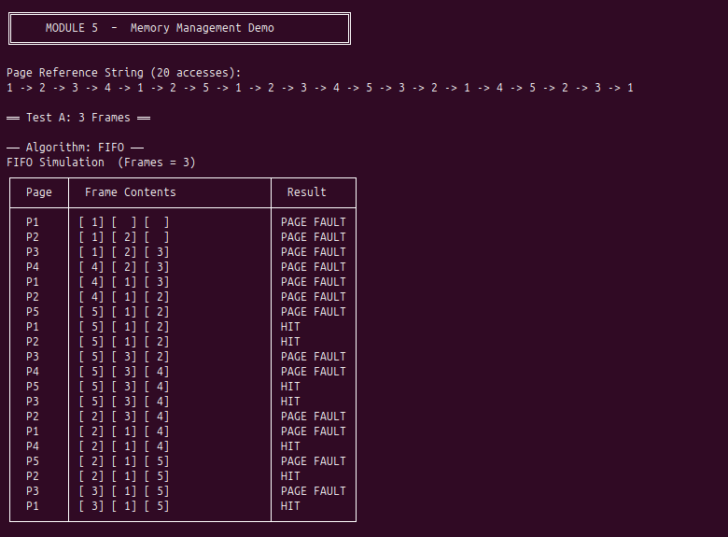

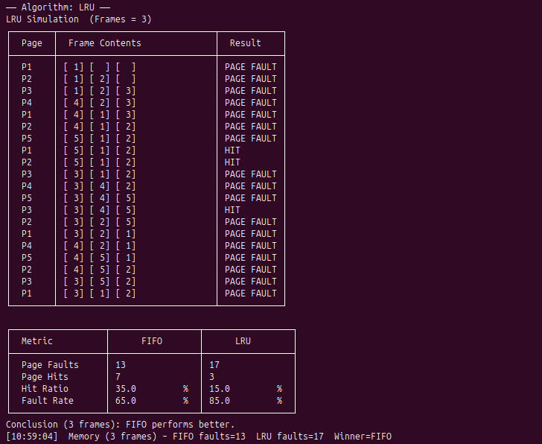

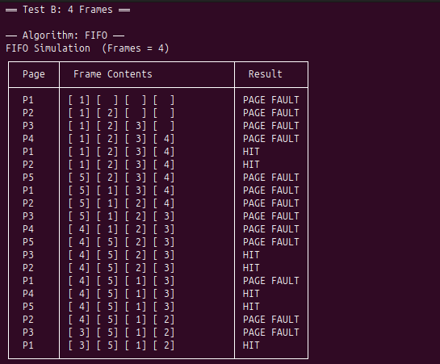

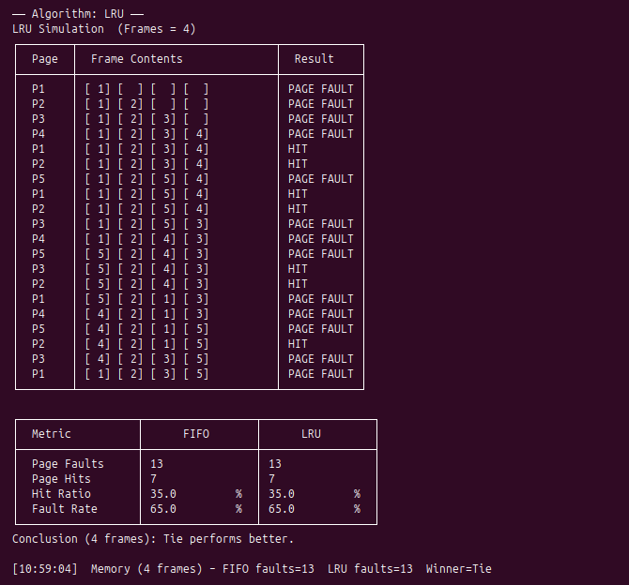

7. System Log Summary
All events are logged with timestamps to banking_system.log. Below is a summary of key log entries from the simulation run:

Timestamp | Event | Module
05:36:07 | Bank initialised – 6 accounts loaded | Init
05:36:07 | Resource table initialised: 5 processes, 3 resource types | Init
05:36:07 | [FCFS] Avg Wait = 12.50 ms | Avg Turnaround = 18.00 ms | Module 1
05:36:07 | [Priority] Avg Wait = 12.67 ms | Avg Turnaround = 18.17 ms | Module 1
05:36:07 | [Round Robin] Avg Wait = 18.17 ms | Avg Turnaround = 23.67 ms | Module 1
05:36:07 | WITHDRAW OK [Hamza-T1] - 1200.00 -> Acct 269801 | Balance: 6300.00 | Module 2
05:36:07 | DEPOSIT OK [Bilal-D1] + 275.00 -> Acct 269802 | Balance: 14275.00 | Module 2
05:36:07 | Payroll complete – 10 staff members paid from Acct 269804 | Module 2
05:36:07 | LOAN APPROVED [Zaryab] | Module 3
05:36:07 | LOAN DENIED [Saad]: resources unavailable | Module 3
05:36:07 | LOAN DENIED [Hamza]: request > max need | Module 3
05:36:07 | LOAN APPROVED [Omar] | Module 3
05:36:07 | [SERVER] Served 5 requests. Shutting down. | Module 4
05:36:08 | [IPC] Message queue removed. Demo complete. | Module 4
05:36:08 | Memory (3 frames) – FIFO faults=13 LRU faults=17 Winner=FIFO | Module 5
05:36:08 | Memory (4 frames) – FIFO faults=13 LRU faults=13 Winner=Tie | Module 5

8. Conclusion
The Concurrent Banking System successfully implements and demonstrates all five Operating System concepts required by the project specification. The system produces measurable outputs including scheduling metrics, Gantt charts, synchronization test results, deadlock avoidance decisions, IPC transaction logs, and page replacement comparisons.

Module | Concept | Status | Key Output
1 | CPU Scheduling | Complete | FCFS, Priority, RR Gantt charts & metrics
2 | Synchronization | Complete | Mutex, Semaphore, Payroll thread demos
3 | Deadlock Avoidance | Complete | 4 loan test cases with safe/unsafe decisions
4 | IPC | Complete | 5 client-server message queue transactions
5 | Memory Management | Complete | FIFO vs LRU comparison at 3 and 4 frames

Key findings from the simulation:
- Priority Scheduling effectively differentiates VIP and Premium customers from Regular customers, achieving similar average metrics to FCFS while respecting priority ordering.
- Mutex locks and semaphores successfully prevent race conditions in all concurrent transaction scenarios, including the 10-thread corporate payroll.
- The Banker's Algorithm correctly identifies safe and unsafe loan states, approving 2 of 4 requests while preventing potential deadlocks.
- The IPC message queue pattern cleanly separates client and server concerns using process isolation via fork().
- FIFO performs better than LRU for the given reference string at 3 frames, while both algorithms tie at 4 frames.

Simulation Complete – Screenshot
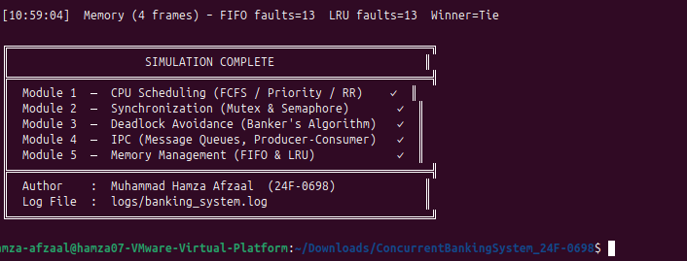

End of Report
CL2006 – Operating Systems Lab | Spring 2026 | FAST-NUCES CFD

