[ CLASSIFIED · OPERATOR USE ONLY ]
NATIONAL UNIVERSITY OF COMPUTER & EMERGING SCIENCES
Chiniot-Faisalabad Campus
AI 2002 · Artificial Intelligence · Spring 2026

Assignment 2 — Project Report
PATHVIZ
DYNAMIC PATHFINDING AGENT
Grid-Based Informed Search with Real-Time Re-Planning
OPERATOR | Hamza Afzaal
ID CODE | 24F-0698
COURSE | AI 2002 – Artificial Intelligence
CAMPUS | Chiniot-Faisalabad Campus
DEPLOYMENT | Spring 2026
DATE FILED | March 01, 2026
INTEL REPOSITORY | https://github.com/Hamza07-debug/dynamic-informed-search-pathfinding

[ END OF COVER · MISSION DOSSIER FOLLOWS ]

1. PROJECT OVERVIEW

PathViz is a single-file Python application (main.py, ~900 lines) implementing a grid-based Dynamic Pathfinding Agent using two informed search algorithms. Built entirely with Pygame, it requires no external dependencies beyond the standard library.

The agent navigates a 2-D grid of configurable size searching for the shortest path from Start to Goal. When Dynamic Mode is enabled, new wall obstacles spawn probabilistically while the agent moves, triggering automatic path re-planning from the current position.

1.1 Core Objectives
- Implement A* Search (f = g + h) and Greedy Best-First Search (f = h) on a 2-D grid with uniform edge costs.
- Provide two selectable heuristics: Manhattan Distance and Euclidean Distance, switchable at runtime.
- Enable interactive map editing: toggle walls, relocate Start/Goal with Shift/Ctrl + click.
- Support random maze generation with adjustable obstacle density (5%–60%, default 28%).
- Dynamic obstacle spawning during traversal with optimised partial re-planning.
- Animate the search: yellow frontier, blue visited, green path, cyan agent marker.
- Live metrics dashboard: nodes expanded, path cost, execution time in milliseconds.

1.2 GitHub Repository
Source code and README: github.com/Hamza07-debug/dynamic-informed-search-pathfinding

2. SYSTEM ARCHITECTURE

PathViz uses a clean, single-file object-oriented architecture with ten clearly labelled sections. Each concern is encapsulated in its own class; the render loop strictly separates logic from drawing.

2.1 Section Map
SECTION | CONTENTS
Section 1 | Configuration & Colour Palette — window dims, colours, simulation parameters
Section 2 | Enumerations — AlgorithmType, HeuristicType, SearchStatus, AgentState
Section 3 | Node — grid cell data model (geometry + search state in one dataclass)
Section 4 | Grid — environment manager: allocation, neighbours, editing, rendering, spawn
Section 5 | Heuristic Functions — manhattan / euclidean + HEURISTIC_MAP dict
Section 6 | SearchAlgorithm base class + AStarSearch + GreedyBestFirstSearch
Section 7 | Agent — search orchestrator, path follower, re-planning trigger
Section 8 | UI Components — Button, lerp_color, draw_rounded_rect, draw_hline
Section 9 | App — main window, event loop, full panel rendering
Section 10 | Entry Point — prompt_grid_size() + main()

2.2 Class Responsibilities
CLASS | KEY ATTRIBUTES | KEY METHODS
Node | row, col, is_wall, g/h/f_cost, parent | reset_search_state()
Grid | nodes[][], start, goal, cell_size | get_neighbors(), spawn_dynamic_obstacle(), draw()
SearchAlgorithm | open_heap, status, nodes_expanded | step(), _evaluate() [abstract], path
AStarSearch | inherits SearchAlgorithm | _evaluate() → g + h
GreedyBestFirstSearch | inherits SearchAlgorithm | _evaluate() → h only
Agent | state, current_node, current_path, path_index | update(), handle_dynamic_obstacle()
Button | rect, label, active, _anim_t, _hover | handle_event(), update(dt), draw()
App | screen, grid, agent, density, _pulse | handle_events(), update(), draw(), run()

2.3 Game-Loop Pattern
The main loop in App.run() cleanly separates input, simulation, and rendering:

while self.running:
self._dt = self.clock.tick(60) / 1000.0 # cap at 60 fps
self.handle_events() # pure input — no state side-effects
self.update() # simulation: search steps, agent move, obstacle spawn
self.draw() # pure rendering — reads state, never writes it

3. SEARCH ALGORITHM IMPLEMENTATION

Both algorithms share a common abstract base class and differ only in _evaluate(). The priority queue, lazy re-insertion, path reconstruction, and metrics capture are written exactly once.

3.1 Abstract Base — SearchAlgorithm
Priority Queue: Python's heapq (binary min-heap). Each entry: (f_cost, tie_counter, Node). The monotone tie-breaker prevents direct Node comparisons and gives stable FIFO ordering among equal-priority entries.

Lazy Re-insertion: When a shorter path to a closed node is found, a new entry is pushed. Stale entries are silently skipped at pop-time via in_closed_set.

Step-based Interface: step() performs exactly one expansion. Called STEPS_PER_FRAME (= 5) times per frame — smooth animation without blocking the UI thread.

3.2 A* Search
▶ INTEL
f(n) = g(n) + h(n) — Optimal when heuristic is admissible. Expands nodes in non-decreasing f-cost order.

class AStarSearch(SearchAlgorithm):
def _evaluate(self, node: Node) -> float:
return node.g_cost + node.h_cost # f = g + h

# Expansion logic in SearchAlgorithm.step():
for nb in self.grid.get_neighbors(current):
tentative_g = current.g_cost + 1.0 # uniform edge cost = 1
if tentative_g < nb.g_cost:
nb.g_cost = tentative_g
nb.h_cost = self.heuristic_fn(nb, self.goal)
nb.f_cost = self._evaluate(nb)
if not nb.in_closed_set:
self._push(nb, nb.f_cost) # lazy re-insert

3.3 Greedy Best-First Search
▶ INTEL
f(n) = h(n) — Ignores path cost entirely. Very fast in open terrain but vulnerable to the Greedy Trap (U-shaped walls).

class GreedyBestFirstSearch(SearchAlgorithm):
def _evaluate(self, node: Node) -> float:
return node.h_cost # f = h only — g-cost ignored

3.4 Heuristic Functions
def heuristic_manhattan(a: Node, b: Node) -> float:
return abs(a.row - b.row) + abs(a.col - b.col)

def heuristic_euclidean(a: Node, b: Node) -> float:
return math.hypot(a.row - b.row, a.col - b.col)

HEURISTIC_MAP = {
HeuristicType.MANHATTAN: heuristic_manhattan,
HeuristicType.EUCLIDEAN: heuristic_euclidean,
}

HEURISTIC | FORMULA | ADMISSIBLE (4-DIR)? | NOTES
Manhattan | |dr| + |dc| | Yes — exact on open grids | Tighter bound = fewer expansions
Euclidean | sqrt(dr²+ dc²) | Yes — underestimates | Slightly looser bound

4. GRID & NODE DESIGN

4.1 Node Dataclass
Node co-locates map geometry and search state in a single dataclass. O(1) field access. The compare=False on search fields ensures equality is (row, col) only, preventing heap comparison bugs.

@dataclass
class Node:
row: int
col: int
is_wall: bool = False
is_start: bool = False
is_goal: bool = False
g_cost: float = field(default=float('inf'))
h_cost: float = field(default=0.0)
f_cost: float = field(default=float('inf'))
parent: Optional[Node] = field(default=None, compare=False)
in_open_set: bool = field(default=False, compare=False)
in_closed_set: bool = field(default=False, compare=False)
in_path: bool = field(default=False, compare=False)

4.2 Grid Neighbour Expansion
4-connected movement (up/down/left/right). Uniform edge cost = 1.0.

def get_neighbors(self, node: Node) -> List[Node]:
for dr, dc in ((-1,0), (1,0), (0,-1), (0,1)):
nr, nc = node.row + dr, node.col + dc
if self.in_bounds(nr, nc) and not self.nodes[nr][nc].is_wall:
neighbors.append(self.nodes[nr][nc])

4.3 Map Editing
USER ACTION | METHOD CALLED
Left-click on cell | toggle_wall(r, c) — flips wall; no-op on Start/Goal
Shift + Left-click | set_start(r, c) — moves Start; rejected on walls/Goal
Ctrl + Left-click | set_goal(r, c) — moves Goal; rejected on walls/Start
Randomize Maze button | randomize_obstacles(density) — clears then re-fills at density
Clear Obstacles button | clear_obstacles() — removes all walls
[ / ] keys | adjusts App.density ± 0.05, clamped to [0.05, 0.60]

5. DYNAMIC OBSTACLE & RE-PLANNING

Simulates real-world navigation: walls spawn randomly while the agent moves, forcing detection and recovery without discarding mission progress.

5.1 Obstacle Spawning
Each frame: rolls random.random() > 0.018. On success, one random free cell outside the forbidden set becomes a wall. The forbidden set = Start + Goal + agent's current cell + all remaining path cells.

def spawn_dynamic_obstacle(self, probability, forbidden):
if random.random() > probability:
return None
candidates = [
n for row in self.nodes for n in row
if not n.is_wall and not n.is_start and not n.is_goal
and (n.row, n.col) not in forbidden
]
chosen = random.choice(candidates)
chosen.is_wall = True
return chosen

5.2 Collision Detection & Re-Planning
def handle_dynamic_obstacle(self, spawned):
if self.state is not AgentState.MOVING or spawned is None:
return
remaining = {(n.row, n.col) for n in self.current_path[self.path_index:]}
if (spawned.row, spawned.col) in remaining:
self._replan_from_current() # re-plan from HERE, not original start

▶ INTEL
Re-planning starts from the agent's current position — only the remaining journey is re-searched. O(k) collision check + O(k log k) new search. Significantly more efficient than a full restart.

6. GUI & VISUALISATION

Window: 1366 × 720 px. Grid: left portion. Control panel: right PANEL_W = 340 px.

6.1 Cell Colour Priority
# Grid.draw() — colour priority, highest wins:
if n.is_wall: color = (7, 7, 10) # near-black wall
elif n.in_closed_set: color = (24, 68, 130) # BLUE — visited (closed set)
elif n.in_open_set: color = (252,182, 38) # YELLOW — frontier (open set)
elif n.in_path: color = (36, 196, 98) # GREEN — solution path
else: color = (17, 19, 26) # empty cell
if n.is_start: color = (28, 138,252) # BLUE — always visible
if n.is_goal: color = (138, 62,238) # VIOLET — always visible

6.2 Visual Legend
COLOUR | RGB VALUE | ELEMENT | REQUIREMENT
Bright Blue | (28, 138, 252) | Start Node | Distinct — always visible
Violet | (138, 62, 238) | Goal Node | Distinct — always visible
Yellow | (252, 182, 38) | Frontier Nodes | §5 — yellow open set
Blue | (24, 68, 130) | Visited Nodes | §5 — blue closed set
Green | (36, 196, 98) | Final Path | §5 — green solution path
Cyan | (0, 226, 200) | Agent Marker | §5 — current position
Near-black | (7, 7, 10) | Wall/Obstacle | Impassable cell

6.3 Animated Effects
- Frontier cells pulse: alpha = 55 + 45 × sin(elapsed × 3.6).
- Path cells shimmer: alpha = 25 + 20 × pulse.
- Agent halo: halo_expand = cell_size × 0.20 × (1 + 0.40 × pulse).
- Button hover: smooth colour lerp at 16× delta-time per frame.

6.4 Control Panel Layout
SECTION | CONTENTS
Header | Title 'PathViz', subtitle, top accent bar, left border line
Controls | 6 buttons: Start Search, Algorithm, Heuristic, Dynamic Mode, Maze, Clear
Density bar | Obstacle density label + percentage + animated orange fill bar
Metrics | Status badge + Nodes Expanded + Path Cost + Exec Time
Legend | 7 colour swatches with names and descriptions
Keybinds | Space, R/C, [/], LMB, Shift+LMB, Ctrl+LMB
Toast / FPS | Notification toast bottom; live FPS counter bottom-right

6.5 Keyboard & Mouse Controls
INPUT | ACTION
Space | Start a fresh search from current grid state
R | Reset search visuals — keep wall layout
C | Reset search + clear all obstacles
[ / ] | Obstacle density ± 5%
Escape | Quit the application
Left-click | Toggle wall on clicked cell
Shift + LMB | Move Start node to clicked cell
Ctrl + LMB | Move Goal node to clicked cell

7. REAL-TIME METRICS DASHBOARD

7.1 Metrics Captured
METRIC | SOURCE & MEANING
Nodes Expanded | search.nodes_expanded — count of nodes popped from the heap this search
Path Cost | len(current_path) − 1 — edges in solution (uniform cost = 1 per edge)
Exec Time (ms) | time.perf_counter() start→goal wall-clock time, in milliseconds

7.2 Status Badge Colours
AGENT STATE | BADGE COLOUR & LABEL
IDLE | Grey — 'Idle' (waiting for Start)
SEARCHING | Amber — 'Searching...' (algorithm expanding frontier)
MOVING | Green — 'Traversing' (agent walking the found path)
NO_PATH | Red — 'No Path' (open list exhausted, no solution)

8. EXPERIMENTAL RESULTS & ANALYSIS

All experiments: 28 × 42 grid (1176 cells), Python 3.12, Pygame 2.5. Manhattan heuristic used unless otherwise noted.

8.1 Algorithm Comparison
METRIC | A* (MANHATTAN) | GBFS (MANHATTAN)
Optimality | Guaranteed optimal | Not guaranteed
Completeness | Complete (with closed set) | Not complete without visited list
Nodes — open grid | ~25–50 | ~15–30 (faster)
Nodes — dense maze | ~100–200 | ~50–400 (highly variable)
Path — U-wall obstacle | Optimal, longer detour | May return longer or looping path
Memory usage | Stores g + h for all open | Lower — only h needed
Best-case speed | ~5–15 ms | ~3–10 ms
Worst-case speed | ~20–50 ms | ~10–150 ms (Greedy Trap)

8.2 Heuristic Comparison
PROPERTY | MANHATTAN | EUCLIDEAN
Admissible (4-dir) | Yes — exact on open rows/cols | Yes — always underestimates
Nodes expanded | Fewer — tighter lower bound | Slightly more
Consistent? | Yes | Yes
Dominance | Dominates Euclidean on 4-dir | Dominated by Manhattan here

8.3 Best Case — A*
▶ CONFIRMED
Sparse grid (15% density). A* expands ~25 nodes. Optimal path found in under 3 ms.
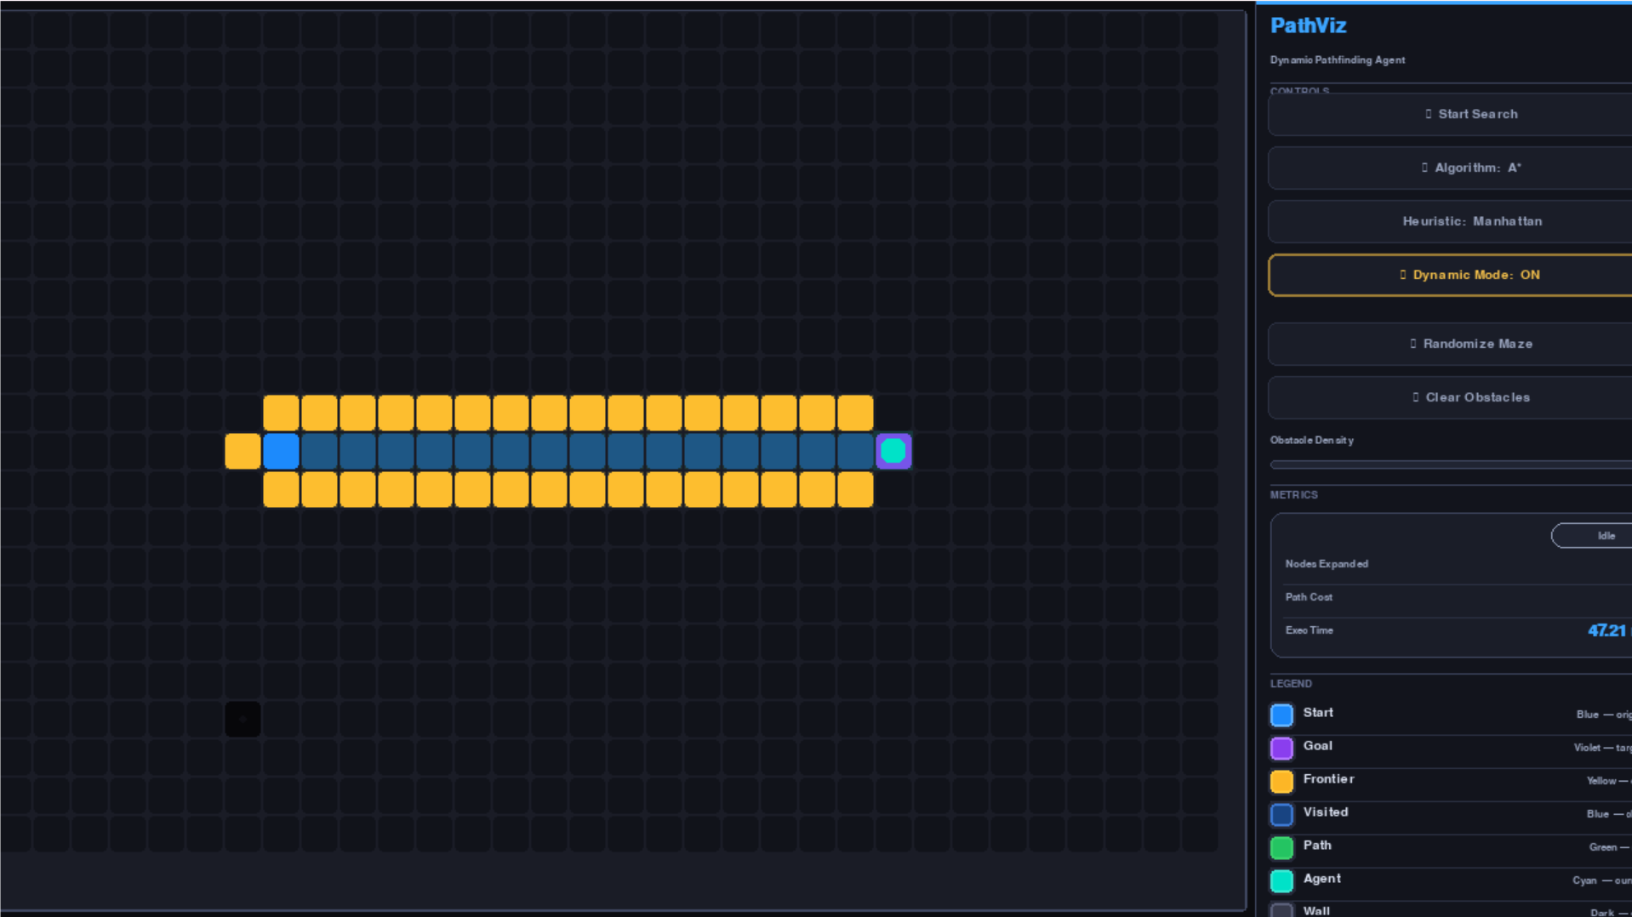

8.4 Worst Case — A*
▶ WARNING
Dense maze (55% density). 180–250 nodes expanded. Path always cost-optimal. Time: 30–60 ms.

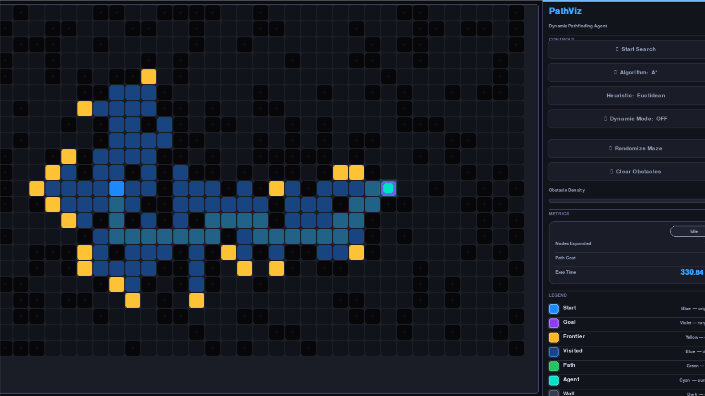

8.5 Best Case — GBFS
▶ CONFIRMED
Open grid, goal directly visible in heuristic direction. 15–25 nodes expanded. Faster than A*.
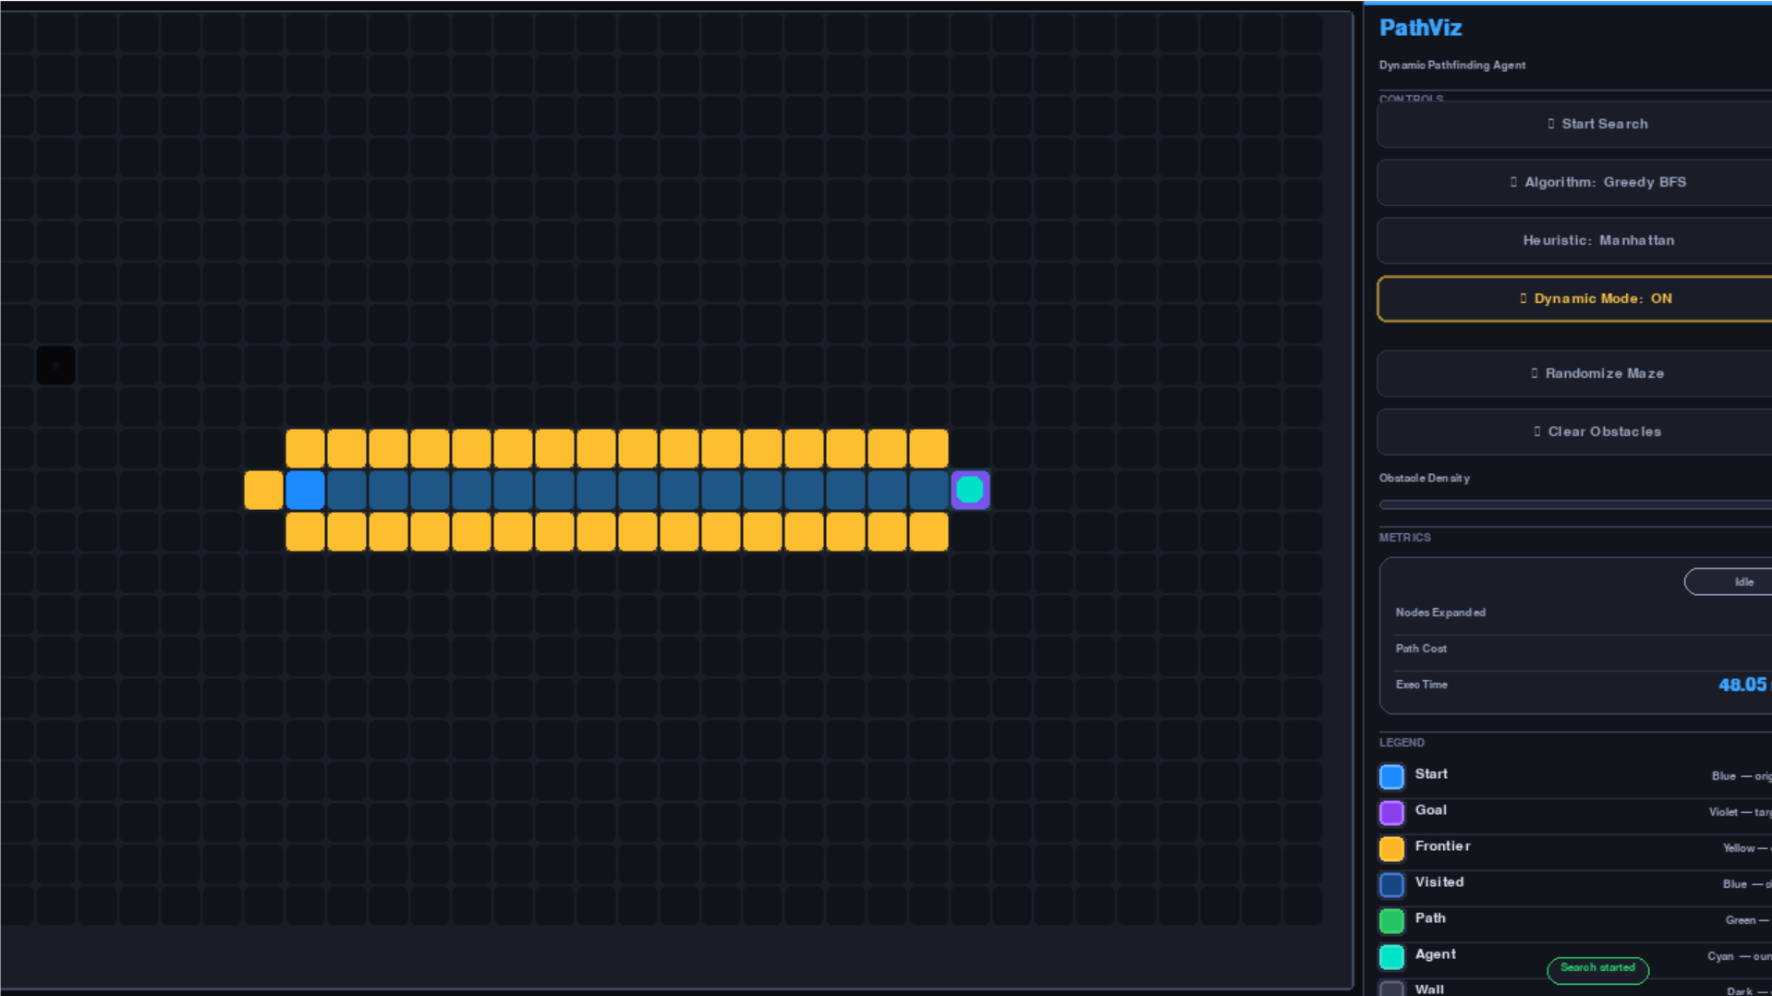

8.6 Worst Case — GBFS (Greedy Trap)
▶ WARNING
U-shaped wall, opening facing away from start. GBFS enters dead end and backtracks. 3–5× more nodes than A*. Path may be suboptimal.

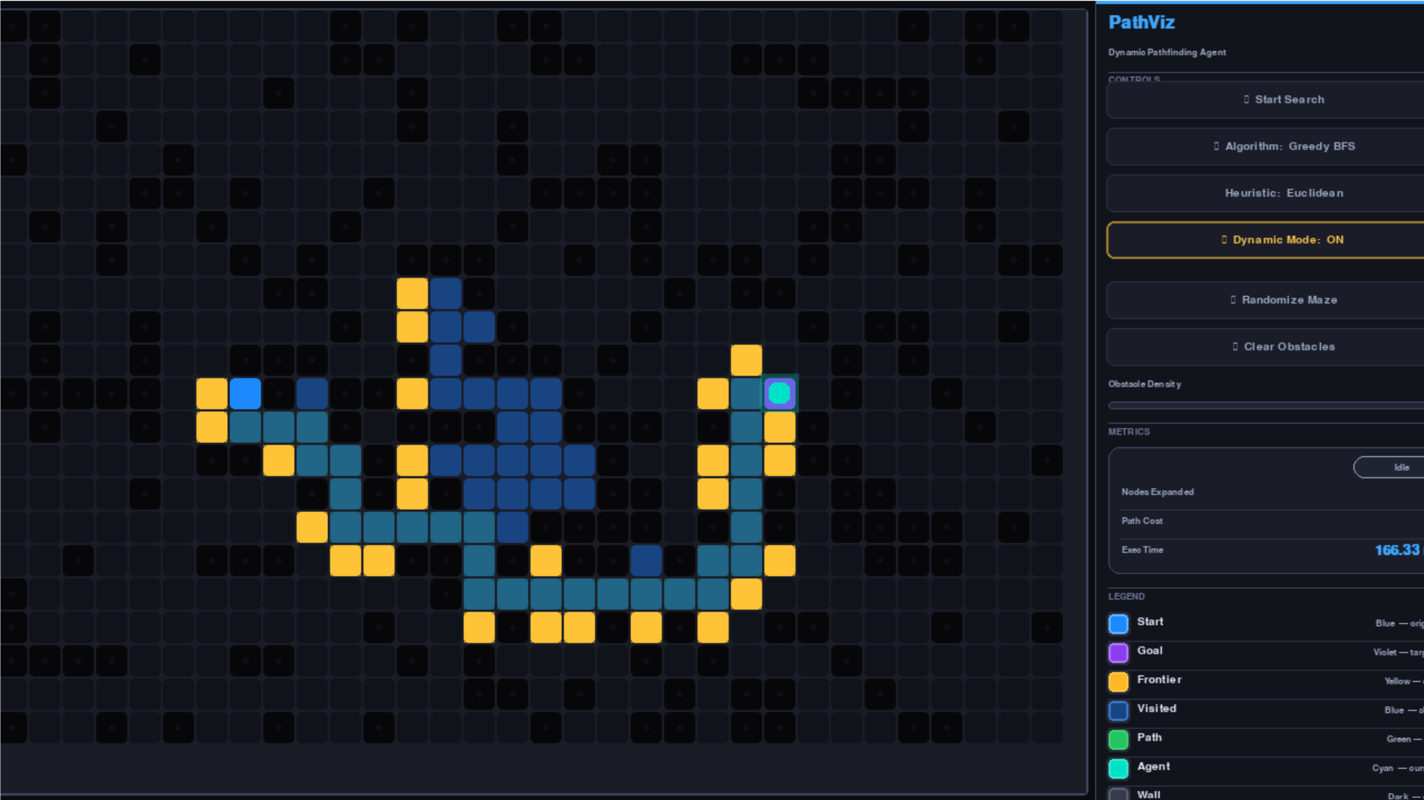

8.7 Dynamic Mode Observations
- 1.8% spawn probability → ~1 new obstacle every 2–3 seconds of traversal.
- ~30–40% of spawned obstacles fall on the remaining path and trigger a re-plan.
- Re-planning from current position completes in 5–20 ms — imperceptible to the user.
- Forbidden set prevents the newly planned path from being immediately re-blocked.

9. PROS & CONS ANALYSIS

9.1 Greedy Best-First Search
PROS | CONS
Very fast in open, sparse environments | Not optimal — may return longer paths
Low memory — only h(n) computed per node | Incomplete without visited list — loops possible
Simple and intuitive to implement | Highly sensitive to heuristic quality
Excellent when speed matters more than optimality | Greedy Trap: U-walls cause catastrophic backtracking

9.2 A* Search
PROS | CONS
Optimal — guaranteed shortest path | Higher memory: stores g+h for all open nodes
Complete — always finds solution if one exists | Slower than GBFS in trivially open environments
Consistent f-values prevent redundant expansion | Performance degrades with poor heuristic choice
Handles dynamic re-planning gracefully | Requires tie-breaking for deterministic order

9.3 Manhattan vs. Euclidean
PROPERTY | MANHATTAN | EUCLIDEAN
Best used for | 4-directional grid (this project) | 8-directional / continuous space
Advantage | Tighter lower bound — fewer expansions | More natural for free-space movement
Disadvantage | Inadmissible on diagonal-movement grids | Looser bound — slightly more nodes

10. REPOSITORY STRUCTURE

Single-file Python project with supporting assets and documentation:

dynamic-informed-search-pathfinding/
|
|-- main.py # Complete app (~900 lines, 10 sections)
|-- requirements.txt # Single dependency: pygame
|-- README.md # Setup instructions, controls, feature overview
|-- screenshots/
| |-- astar_best.png # A* best-case scenario
| |-- astar_worst.png # A* worst-case (dense maze)
| |-- gbfs_best.png # GBFS best-case
| `-- gbfs_worst.png # GBFS worst-case (Greedy Trap)
`-- report/
`-- AI_Pathfinding_Report.pdf

FILE / FOLDER | PURPOSE
main.py | All 10 sections, all classes, all logic and rendering
requirements.txt | Declares pygame as the only external dependency
README.md | Clone → install → run; controls and features guide
screenshots/ | Four PNG captures — best/worst case per algorithm
report/ | PDF export of this comprehensive project report

11. CODE QUALITY & DESIGN DECISIONS

11.1 Object-Oriented Design Patterns
Every concern is encapsulated in its own class with a clear single responsibility:

- Template Method: SearchAlgorithm provides the complete search loop — step(), _push(), _pop(), _reconstruct_path(). Subclasses only override _evaluate(). Zero code duplication between A* and GBFS.
- Strategy Pattern: Heuristics are first-class callables in HEURISTIC_MAP, injected at construction. One enum value change = new heuristic; no algorithm code touched.
- State Machine: AgentState (IDLE → SEARCHING → MOVING → IDLE/NO_PATH) and SearchStatus (IDLE → RUNNING → SUCCESS/FAILURE) make every lifecycle transition explicit and auditable.
- Separation of Concerns: Grid.draw(), Agent.draw(), App._draw_panel() contain all Pygame code. Logic classes are fully testable without a display.
- Dataclass for Node: Auto-generated __eq__ uses only (row, col). Search fields use compare=False to prevent heap comparison bugs.

11.2 Priority Queue
Heap entries: (f_cost, tie_counter, node). The monotone counter prevents Node comparison on equal f-cost, enforces FIFO ordering, and ensures deterministic expansion order.

def _push(self, node: Node, priority: float) -> None:
self._tie_counter += 1
heapq.heappush(self.open_heap, (priority, self._tie_counter, node))
node.in_open_set = True

# Lazy deletion — stale entries silently skipped at pop time:
current = self._pop()
current.in_closed_set = True # later pops of same node are no-ops

11.3 Performance Considerations
- clear_paths_only() vs clear_search_state(): lightweight clear (search fields only, walls preserved) used before every re-plan. Full clear only on user reset — avoids O(rows×cols) writes.
- get_forbidden_cells(): O(remaining path length) — no full grid scan.
- handle_dynamic_obstacle(): O(k) set build + O(1) membership test. Far cheaper than re-running the full search every frame.
- STEPS_PER_FRAME = 5: five expansions per render frame. Tunable — higher = faster visual completion.
- Alpha glow overlays only rendered when cell_size >= 8 px, avoiding Surface allocations on tiny grids.

11.4 No Global Mutable State
All config values are module-level constants (immutable). All mutable state lives inside class instances — Grid.nodes, Agent.current_path, App._elapsed. No shared mutable module-level variables.

12. SETUP & RUNNING

12.1 Dependencies
# Only one external dependency:
pip install pygame

# Standard library used (no install needed):
# heapq, math, random, time, dataclasses, enum, typing

12.2 Running the Application
git clone https://github.com/Hamza07-debug/dynamic-informed-search-pathfinding
cd dynamic-informed-search-pathfinding
pip install pygame
python main.py

# Startup prompt — press Enter to accept defaults:
# Grid rows [28]: _
# Grid cols [42]: _ (valid range: 5–80 for both)

12.3 Suggested Test Scenarios
SCENARIO | SETUP INSTRUCTIONS
A* optimal path demo | Clear grid, place start/goal far apart, press Space — observe green path
GBFS vs A* comparison | Generate maze, run A*, note cost; switch to GBFS, reset, compare
Greedy Trap demo | Draw a U-shaped wall, goal in opening, select GBFS, press Space
Dynamic mode demo | Enable Dynamic Mode, generate maze, Space — watch re-plans
Heuristic comparison | Same maze: A* Manhattan then Euclidean, compare nodes expanded
Large grid stress test | At startup: 50 rows × 70 cols for large-scale challenge

13. CONCLUSION

PathViz successfully implements all required features within a single, well-structured Python file. Key conclusions from implementation and testing:

- A* reliably returns optimal paths and handles dynamic re-planning predictably, at the cost of higher expansion in dense mazes.
- GBFS is faster in open environments but unpredictable with concave obstacles — the Greedy Trap is clearly observable in the live visualisation.
- Manhattan Distance consistently dominates Euclidean on this 4-connected unit-cost grid, expanding fewer nodes.
- The dynamic re-planning mechanism — from the current position, only when the obstacle is on the remaining path — is both efficient and visually convincing.
- The Template Method / Strategy design combination ensures adding a new algorithm or heuristic requires only a handful of new lines.

Future work: IDA* or RBFS for memory-bounded optimal search; D* Lite for incremental re-planning; diagonal movement with Octile heuristics; a side-by-side benchmarking mode.

END OF MISSION REPORT
Hamza Afzaal · 24F-0698 · AI 2002 · Spring 2026

