KUVIS
Karachi Urban Vulnerability Intelligence System

Complete project guide: architecture, logic, methods, results and presentation notes
5th-semester Data Mining lab project · November 2026
How to use this guide
Read Part I first: it explains the whole project in a few pages and gives you the four findings to remember.
Parts II–VI explain every layer in depth: the background concepts, the data, the architecture, each data-mining method, and each module's logic and results.
Part VII covers testing, the mistakes the project caught in itself, and the limitations. Part VIII tells you how to run the software, gives a 12-minute presentation plan with a live-demo script, and prepares you for 30 likely questions.
Every number in this guide comes from the KUVIS experiment records (research/experiments/*.json) and the final report (research/reports/FINAL_REPORT.md). Look for the green Say it in class boxes for short, ready-to-use explanations.

Contents
Part I — The big picture 3
1. KUVIS in one page 3
2. Motivation and research questions 4
3. Ground rules and evidence types 5
Part II — Background concepts 7
4. Concept primer 7
Part III — Data 9
5. Data sources 9
6. The analysis grid and preprocessing 10
7. The 79 features 12
Part IV — Architecture 13
8. System architecture 13
9. The data pipeline 15
10. The database 16
11. The backend API 17
12. The web application 18
Part V — Data-mining methods 21
13. The methods explained 21
Part VI — The five modules: logic and results 24
14. Module B — Urban heat 24
15. Module A — Flood susceptibility 25
16. Module C — Urbanization and land change 27
17. Module D — Infrastructure (supply, not traffic) 27
18. Module E — Composite vulnerability (UVI) 28
19. The discovery engine 29
Part VII — Quality, lessons and limitations 30
20. Testing and validation 30
21. Mistakes the project caught in itself 30
22. Limitations 31
23. Future work 31
Part VIII — Running and presenting 32
24. Running the software 32
25. Presenting in class 32
26. Questions you may be asked 33
Appendices 37
A. The 24 experiments 37
B. Abbreviations 38

Part I — The big picture

1. KUVIS in one page
KUVIS (Karachi Urban Vulnerability Intelligence System) is a geospatial data-mining system. It collects eleven open satellite and map datasets, places all of them on one common grid of 500 m × 500 m squares covering the whole Karachi Division, and then applies data-mining algorithms to find patterns in urban heat, flood susceptibility, urban growth, infrastructure and combined vulnerability. The results are stored in a spatial database and explored through an interactive web map with location reports and PDF export.

The problem it addresses
Karachi faces three overlapping environmental stresses: extreme pre-monsoon surface heat, recurrent monsoon flooding (2020 and 2022 were severe) and very fast, largely informal urban growth. Existing evidence is fragmented: heat studies look at the urban core with Landsat, flood knowledge is mostly reports and news, and land-use maps are separate projects. Nobody had put all of these on one spatial unit and mined them together. KUVIS asks: what patterns appear when these hazards and their drivers are analysed together, and how reliable are those patterns?

Key numbers
Item | Value
Study area | Karachi Division (geoBoundaries ADM2, 2019): 3,560 km²
Analysis grid | 500 m × 500 m cells in UTM zone 42N: 14,701 cells, of which 13,187 are land cells
Data | 11 open datasets (Landsat, Sentinel-2, Sentinel-1, NASADEM, WorldCover, JRC water, CHIRPS rainfall, WorldPop, OpenStreetMap, EO4SD land use, geoBoundaries); 19 sources investigated, 13 registry entries acquired
Features | 79 features per cell, each documented (unit, source, period, evidence type)
Data mining | K-means, DBSCAN, FP-Growth association rules, Isolation Forest (+ LOF), Decision Tree; plus Getis–Ord Gi*, Moran's I, Theil–Sen trends, Spearman/OLS
Experiments | 24 experiments in 5 modules (heat, flood, urbanization, infrastructure, vulnerability)
Outputs | 81 cluster profiles · 494 anomalous cells · 53 association rules · 53 automatically generated discoveries
Software | Python pipeline → PostgreSQL 17 + PostGIS → FastAPI → React + MapLibre web app (12 pages), portable Windows release
Quality checks | 27 automated tests + a browser test of all 12 pages, the location report and PDF export

The four findings to remember
- Daytime surface heat in Karachi is not urban. Built-up land is cooler at the surface than bare land in every epoch from 2001 to 2024, and the gap widens from −3.6 °C to −6.1 °C. The hottest places (up to 57 °C mean surface temperature) are bare desert in Gadap. This is the known arid “surface cool island” effect.
- Heat and flood susceptibility are spatially opposed (Spearman ρ = −0.61): low coastal land is cooler but flood-prone; high inland desert is hot but dry. Therefore any single vulnerability score depends heavily on its weights — only 22 % of top-quintile cells stay there under 95 % of random weightings. KUVIS reports stress regimes alongside the index.
- Where open water appears is predictable from terrain (spatially cross-validated balanced accuracy 0.85, ROC-AUC 0.90; elevation ≤ 8 m carries 80 % of importance), and this transfers to radar-observed storm water after the 2020 and 2022 rains (ROC-AUC 0.85). But precision is low and neither optical nor radar satellites see water between buildings.
- OpenStreetMap is too incomplete to measure infrastructure: 66 % of densely built-up cells have fewer than 50 mapped buildings per km².
Say it in class
“KUVIS puts eleven open datasets about Karachi onto one 500-metre grid — almost fifteen thousand cells — and runs five data-mining techniques on them to find patterns in heat, flooding, growth and infrastructure. Every pattern comes with its evaluation and its limitations. The biggest surprise is that Karachi's built-up areas are actually cooler at the surface than the surrounding desert, and that heat and flood risk sit in opposite parts of the city, which makes a single ‘risk score’ fragile.”

2. Motivation and research questions
The project is framed as a data-mining question rather than a mapping exercise. A map shows one variable at a time; data mining looks for structure across many variables at once — groups of similar places (clustering), conditions that occur together (association rules), places that do not fit their context (anomaly detection), and variables that separate one outcome from another (classification).
Main question: Can geospatial data-mining techniques discover previously hidden spatial, temporal and environmental patterns associated with urban vulnerability across Karachi? It is broken into seven supporting questions, each answered by specific experiments:
# | Research question | Answered by
RQ1 | Are there clusters of places with similar vulnerability profiles? | heat_kmeans, flood_kmeans, urban_kmeans, vulnerability_kmeans, DBSCAN experiments
RQ2 | Which conditions are associated with observed water and with high surface heat? | flood_association, heat_association
RQ3 | Which places are anomalous compared with their geographic or historical context? | heat_isolation_forest, urban_isolation_forest
RQ4 | How have built-up land and vegetation changed? | urban_lulc_change, urban_ndvi_trend, urban_kmeans
RQ5 | Which characteristics are most informative? | flood_tree (importance), heat_correlation (standardised β)
RQ6 | Can the dimensions be combined into an interpretable index? | vulnerability_index
RQ7 | Where do several stresses overlap? | vulnerability_dbscan_geographic, vulnerability_gi_star, vulnerability_association

3. Ground rules and evidence types
The project specification set strict honesty rules. They shape almost every design decision, so you should be able to state them and explain why they matter.
Rule | Why it matters
Never fabricate or impute values as if measured. | A data-mining result is only as trustworthy as its inputs. Every value traces back to a downloaded file recorded in the provenance registry.
Land surface temperature (LST) is not air temperature. | Satellites measure the radiating temperature of the ground surface (roofs, soil, roads) at about 10:30 local time. Air temperature, which people feel, can behave differently.
Road density is not congestion. | OpenStreetMap shows how many roads are mapped, not how many cars use them. No open traffic data exists for Karachi.
Missing is not zero. | A cell with no rainfall reading has unknown rainfall, not 0 mm. Missing values stay missing (NaN) and are never filled with zero.
The index is not an official risk assessment. | The vulnerability index is a relative research construct for comparing places inside Karachi.
Evidence types stay distinct. | Users must be able to tell a measurement from a model output or a statistical pattern.

Evidence types used throughout the system
Every feature and every sentence in a location report carries a type. In the web app each type has its own coloured badge.
Type | Meaning | Example
observed | Measured directly by a sensor or survey, summarised per cell | Land surface temperature 2024, elevation, built-up share
derived | Calculated from observed values | Relative LST (cell minus city median), NDVI change 2001→2024
modelled | Produced by someone else's model | WorldPop population estimates
assigned | Value of a coarser source given to every cell inside its pixel | CHIRPS rainfall (≈5.5 km pixels)
cluster | Group membership from K-means or DBSCAN | “High built-up · low LST” thermal profile
statistic | Result of a spatial statistical test | Getis–Ord Gi* hot spot
anomaly | Flagged as unusual by Isolation Forest | Cell much cooler than its 1.5 km neighbours
association | Matches a mined co-occurrence rule | {Heat=Low, Urbanization=High} ⇒ Flood=High
model prediction | Output of the decision tree | Predicted class and probability of intermittent water
composite | The vulnerability index | UVI 0.46, 70th percentile, rank range under other weights

Part II — Background concepts

4. Concept primer
These are the technical ideas you need to explain the project confidently. If someone in class asks “what does that mean?”, the answer is here.
Concept | Plain explanation
Raster vs vector | A raster is a grid of pixels, each holding a value (e.g. a satellite image). A vector layer stores shapes: points, lines (roads) and polygons (boundaries).
Spatial resolution | The ground size of one pixel: Sentinel-2 is 10–20 m, Landsat thermal is 100 m, CHIRPS rainfall ≈ 5.5 km.
Coordinate reference system (CRS) | How coordinates map to the Earth. WGS 84 (EPSG:4326) uses latitude/longitude in degrees. UTM zone 42N (EPSG:32642) is a flat projection in metres; Karachi (≈67° E) lies inside zone 42 (66–72° E), so distances and areas are accurate. Web maps use Web Mercator (EPSG:3857).
Cloud-Optimised GeoTIFF (COG) | A raster file organised so a program can download just the part (window) and zoom level (overview) it needs over HTTP, instead of the whole file.
STAC / Planetary Computer | STAC is a standard catalogue format for satellite scenes. Microsoft Planetary Computer hosts Landsat, Sentinel-1/2, NASADEM, WorldCover and JRC water as COGs with a free STAC API, without needing an account.
Zonal statistics | Summarising all pixels that fall inside each zone (here, each grid cell): mean, percentiles, class fractions, sums, and the fraction of valid pixels (coverage).
Land surface temperature (LST) | Temperature of the ground surface derived from thermal infrared bands. It is skin temperature, not air temperature.
NDVI | Normalised Difference Vegetation Index = (NIR − Red) / (NIR + Red). Ranges −1 to 1; higher means greener vegetation.
NDBI and NDWI | NDBI = (SWIR − NIR) / (SWIR + NIR), meant to highlight built-up land. NDWI = (Green − NIR) / (Green + NIR), highlights water. In arid Karachi NDBI turns out to track bare soil (see section 21).
Synthetic Aperture Radar (SAR) | Sentinel-1 sends microwaves and measures the echo (backscatter), in decibels (dB). It sees through clouds. Calm water reflects the signal away like a mirror, so it looks dark (low dB). VV means vertical send, vertical receive.
Percentile rank | The share of cells with a lower value. A cell at the 80th percentile is higher than 80 % of Karachi's land cells. Used to put very different variables on one 0–1 scale.
Spatial autocorrelation | Nearby places tend to be similar (Tobler's first law). It makes ordinary statistics over-confident and is why KUVIS uses spatial cross-validation and permutation tests.
Spearman ρ | Rank correlation from −1 to +1. Measures whether two variables rise together, without assuming a straight line.
Vector tiles | The map is cut into small square tiles per zoom level; each tile carries the shapes and attributes for that area in a compact binary format (Mapbox Vector Tile / protobuf). The browser draws and colours them itself.

Part III — Data

5. Data sources
All data are real and openly available. Each acquisition is recorded in a provenance registry (datasets/metadata), and the registry refuses to mark a source as acquired unless its files exist on disk. An automated test checks this.
Domain | Source | Resolution / period | Used for
Surface temperature, NDVI, NDBI | Landsat Collection 2 Level-2 (Landsat 5 TM; Landsat 8/9 OLI-TIRS), Planetary Computer | 30 m (thermal 100 m native), read at 60 m; April–June epochs 2001 · 2010 · 2015 · 2020 · 2024 | Heat, history, change
Vegetation / built-up indices | Sentinel-2 Level-2A | 20 m; Nov 2023 – Feb 2024 | Current surface state
Terrain | NASADEM (reprocessed SRTM) | 30 m | Elevation, slope, topographic position
Land cover | ESA WorldCover v200 | 10 m; 2021 | Built-up / bare / vegetation / water shares
Surface water history | JRC Global Surface Water v1.4 | 30 m; 1984–2021 | Flood proxy label (intermittent water)
Storm flood water | Sentinel-1 RTC (VV), Planetary Computer | 10 m, read at 40 m; 8 passes ≤ 48 h after 2020/2022 heavy-rain days | Independent validation of the flood models
Rainfall | CHIRPS v3 (CHC, UC Santa Barbara) | ≈5.5 km; monthly 1981–2025; daily Jun–Sep 2020 and 2022 | Monsoon normals, anomalies, event days
Population | WorldPop R2025A (constrained) | 100 m; 2015, 2025 | Exposure, growth
Infrastructure | OpenStreetMap via Overpass API | Vector snapshot | Roads, drains, waterways, buildings, coastline
Land use | World Bank EO4SD Karachi | 2005, 2017 | Land-use transitions
Boundaries | geoBoundaries ADM2 / ADM3 | 2019 boundary; census-2017 subdivisions | Study area and town names

Sources investigated but not used — and why
Source | Status | Reason
Google Earth Engine | requires authentication | Needs a personal Google Cloud project; Planetary Computer serves the same Landsat/Sentinel products without credentials, so anyone can reproduce the pipeline.
TomTom traffic | requires payment | Commercial licence. As a result there is no traffic dimension anywhere in KUVIS.
Pakistan Meteorological Department station data | requires manual request | Not openly downloadable.
GHSL built-up history, GPM IMERG rainfall, Sentinel-1 GRD | alternative selected | Covered by WorldCover/EO4SD, CHIRPS daily, and Sentinel-1 RTC respectively. IMERG and GHSL remain possible future additions.

Data availability decisions
- No Landsat 5 for 2005. The archive has no usable Landsat 5 scenes over Karachi in 2003–2008 (only striped Landsat 7 SLC-off), so the baseline epoch is 2001 (April–June 2000–2002).
- CHIRPS rainfall is too coarse for neighbourhoods. Each cell gets the value of the pixel containing its centre, flagged assigned, and neighbouring cells are never compared on rainfall.
- No real traffic data. Module D therefore describes infrastructure supply (roads, intersections), never congestion.
- Sentinel-1 only around storms. Radar was read for passes within 48 hours after the heaviest rain days of 2020 and 2022, plus same-orbit dry-season reference passes.

6. The analysis grid and preprocessing

The 500 m grid
- Square 500 m cells in UTM 42N, anchored on exact multiples of 500 m so the grid is reproducible. A cell is kept if any part intersects the Karachi Division boundary; the fraction inside (frac_inside) is stored.
- Each cell has an ID like KHI_008771, a centre point (lat/lon), a census-2017 subdivision (the one it overlaps most) and a dominant land-cover class.
- Land cells (used for most analysis) have at least half their area inside the boundary and less than half water/wetland: 13,187 of the 14,701 cells.
- Why 500 m: fine enough to separate neighbourhoods and the 100 m thermal data, coarse enough that rainfall and population are meaningful per cell and that ~15,000 cells can be mined, stored and drawn interactively.

Exact zonal statistics on native pixels
A key design choice: data values are never resampled before aggregation. Instead, the grid-cell IDs are rasterised onto each source's own pixel grid (each pixel belongs to the cell containing its centre), and statistics are computed from the original pixel values. Each satellite feature also records its valid-pixel coverage, so a cell that was mostly cloud-masked is known to be weak evidence. Sources coarser than a cell (CHIRPS) are assigned from the pixel containing the cell centre.

Landsat surface temperature
Epoch | Years pooled (April–June) | Sensor
2001 | 2000–2002 | Landsat 5 TM
2010 | 2009–2011 | Landsat 5 TM
2015 | 2014–2016 | Landsat 8
2020 | 2019–2021 | Landsat 8
2024 | 2023–2025 | Landsat 8 and 9

- April–June is the hot, low-cloud pre-monsoon season — when surface heat matters most and images are clearest.
- Per epoch the clearest three scenes per tile are selected, clouds/shadows/cirrus/snow are masked with the QA_PIXEL band, pixels with temperature uncertainty above 4 K (ST_QA) are dropped, and the per-pixel median is taken.
- Temperature in °C = DN × 0.00341802 + 149 − 273.15 (the USGS Collection 2 scaling, checked by a unit test).

Sentinel-2 and the other sources
- Sentinel-2: clearest five scenes per tile in the dry winter (Nov 2023 – Feb 2024), masked with the scene classification layer, the processing-baseline 04.00 reflectance offset (−1000) removed, 20 m median composite → NDVI, NDWI, NDBI.
- NASADEM: mosaic, slope by the Horn method, topographic position = cell elevation minus the mean within 2 km (negative = local depression).
- WorldCover: class fractions at native 10 m. WorldPop: sum of 100 m counts. OSM: road/drain lengths by exact overlay in UTM. JRC: occurrence and seasonality fractions at 30 m. EO4SD: exact polygon–cell overlay.

Relative indices — the most important preprocessing idea
Different epochs were imaged on days with different weather and by different sensors, so absolute values are not comparable across time. KUVIS therefore expresses every epoch's LST, NDVI and NDBI relative to that epoch's median over Karachi land cells (cell value − city median). All change analysis uses these relative values. Section 16 shows the false “greening of Karachi” that this prevents.

Missing data and quality
Values stay missing unless zero is a genuine observation (e.g. “0 km of mapped road”). Each cell gets a data_quality_score = the share of 7 core evidence features that are available. Heat analysis requires LST coverage ≥ 0.5.

7. The 79 features
All features are defined in one place (kuvis/features/dictionary.py) with label, unit, source, period, evidence type and definition, and published as the feature_dictionary table. The location report and map legends read their labels and units from it. By type: 18 observed, 46 derived, 7 modelled, 8 assigned.
Group | Examples
Terrain | elev_mean, elev_min/max, slope_mean, tpi_2km_m (topographic position)
Land cover | built_frac, veg_frac_wc, bare_frac, water_frac, dominant_cover
Surface indices (Sentinel-2) | s2_ndvi_mean, s2_veg_frac, s2_ndwi_mean, s2_ndbi_mean
Heat (Landsat, per epoch) | lst_mean_2024, lst_p90_2024, lst_rel_2024, lst_rel_change_2001_2024
Change | ndvi_rel_change_2001_2024, ndvi_change_2001_2024, ndbi_rel_change_2001_2024, lulc_built_change_2005_2017
Rainfall (assigned) | rain_annual_normal_mm, rain_jjas_normal_mm (June–Sept, 1991–2020 normal), rain_jjas_cv, rain_jjas_2022_anom_pct, rain_aug_2020_mm, rain_trend_mm_decade
Water | gsw_occurrence_mean, gsw_seasonal_frac, gsw_permanent_frac, s1_flood_frac_2020/2022/max
Distances | dist_coast_m, dist_waterway_m, dist_drain_m
Population (modelled) | pop_2015, pop_2025, pop_density_2025, pop_change_2015_2025
Infrastructure (OSM) | road_density_km_km2, major_road_density_km_km2, intersection_density_km2, osm_building_density_km2

Part IV — Architecture

8. System architecture
KUVIS is built as five layers. Data flow one way: from the internet sources, through an offline Python pipeline, into a spatial database, out through a web API, to the browser. The heavy computation happens once in the pipeline; the web app only reads stored results, so it is fast and every number it shows is reproducible.
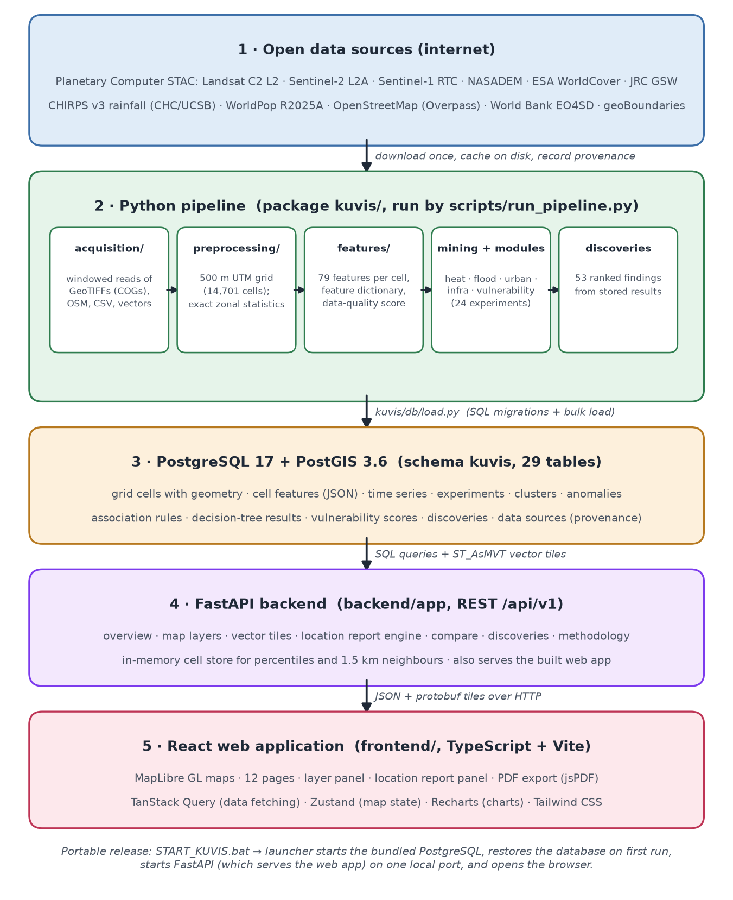
Figure 1. The five layers of KUVIS and what flows between them.

Technology stack and why each piece was chosen
Layer | Technology | Why
Pipeline | Python 3.12: rasterio, geopandas/shapely, pyproj, numpy/pandas, scikit-learn, mlxtend, esda/libpysal, statsmodels, pystac-client | Standard open geospatial and machine-learning stack; windowed COG reads keep memory low on a 16 GB laptop.
Database | PostgreSQL 17 + PostGIS 3.6 | Spatial types and indexes, spatial SQL (point-in-cell lookup, simplification) and vector-tile generation (ST_AsMVT) inside the database.
API | FastAPI + Uvicorn, psycopg 3 connection pool | Fast, typed Python web framework with automatic interactive documentation at /docs.
Web app | React 18 + TypeScript + Vite, MapLibre GL, TanStack Query, Zustand, Recharts, Tailwind CSS, jsPDF | MapLibre renders vector tiles on the GPU; TanStack Query caches API calls; Zustand keeps map state simple; jsPDF exports reports.
Release | Portable bundle: embedded Python runtime + PostgreSQL/PostGIS + database dump + launcher | Runs on any 64-bit Windows 10/11 PC without installing anything.

Key design decisions
Decision | Reason
Planetary Computer instead of Google Earth Engine | Same products (Landsat C2 L2, Sentinel-2 L2A, NASADEM, WorldCover, JRC) as COGs without credentials, so the pipeline is reproducible by anyone. Processing happens locally.
UTM 42N as the analysis CRS | Karachi lies in zone 42; Landsat and Sentinel-2 tiles over Karachi are natively UTM 42N, so composites need no reprojection; metres for distances and areas.
Exact zonal statistics on native grids | No up- or down-sampling of data values; coarse sources are assigned and labelled as such.
Vector tiles generated by PostGIS through FastAPI | Avoids a separate tile server while never sending the whole grid as heavy GeoJSON.
Numbered SQL migrations | The schema is SQL-first (PostGIS types, spatial indexes); numbered files with a schema_migrations ledger are transparent.
Experiments as JSON first, database second | Every algorithm run writes research/experiments/<id>.json (inputs, parameters, metrics computed by code, limitations, code version). The database, the Methodology page and RESULTS.md are generated from these files, so documentation cannot drift from results.

Repository layout
KUVIS/
config/kuvis.yaml all analytical parameters
kuvis/ Python package
acquisition/ one module per data source
preprocessing/ grid.py, zonal.py (zonal statistics)
features/ build.py, dictionary.py (79 features)
mining/ clustering, anomaly, association,
classification, spatial, experiment
modules/ heat, flood, urban, infra,
vulnerability, discoveries
db/ migrate.py, load.py
scripts/ run_pipeline, generate_results,
ui_check, build_release
backend/app/ FastAPI: api/, services/, core/
frontend/src/ React: pages/, maps/, reports/ ...
infrastructure/ SQL migrations, docker-compose
packaging/windows/ portable-release launcher
research/ methodology, experiments/*.json,
RESULTS.md, final report
tests/ pytest: algorithms + live API

9. The data pipeline
The pipeline is a sequence of named steps run by scripts/run_pipeline.py. Each step can be run on its own, and downloads are cached on disk, so re-running a later step is cheap.
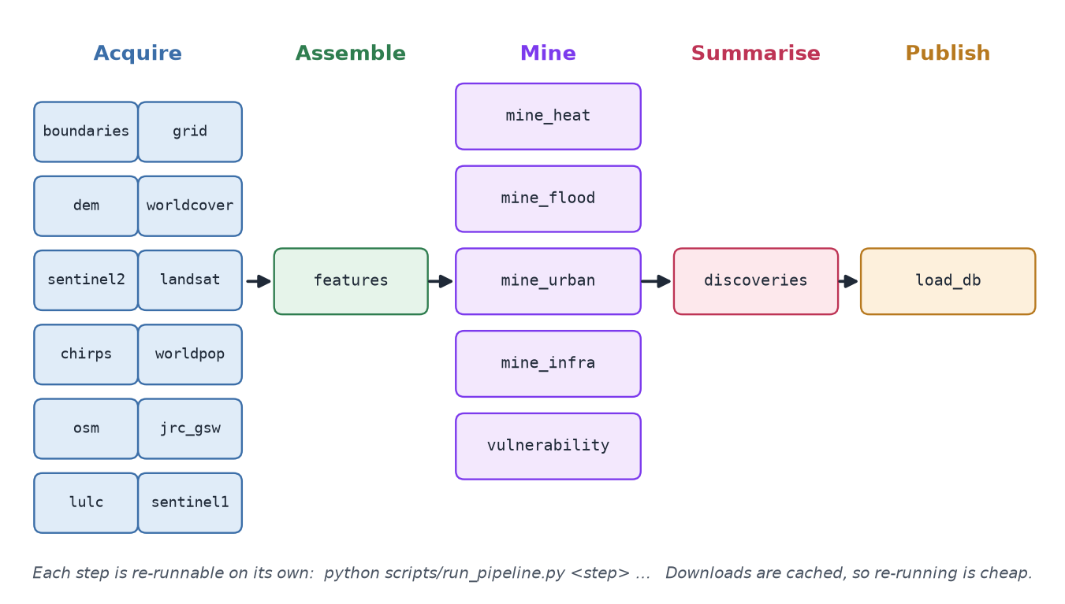
Figure 2. The 20 pipeline steps, grouped into five stages.
Step | What it does
boundaries | Downloads geoBoundaries; builds the study area (Karachi Division) and the census-2017 subdivisions
grid | Generates the 500 m analytical grid (14,701 cells)
dem | NASADEM elevation, slope and topographic position per cell
worldcover | ESA WorldCover class fractions per cell
sentinel2 | Sentinel-2 dry-season composite → NDVI, NDWI, NDBI
landsat | Landsat LST and NDVI/NDBI composites for the five epochs, plus single-date cell values
chirps | CHIRPS monthly rainfall 1981–2025 at native pixels (normals, variability, anomalies)
worldpop | WorldPop population per cell (2015, 2025)
osm | OpenStreetMap roads, waterways, drains, buildings, coastline; densities and distances
jrc_gsw | JRC surface-water occurrence and seasonality
lulc | World Bank EO4SD land use 2005/2017 and transitions
sentinel1 | Sentinel-1 post-storm flood water for 2020/2022 (event days from CHIRPS daily)
features | Assembles all per-source features into the 79-feature table with quality scores
mine_heat … vulnerability | The five mining modules (sections 14–18); each writes experiment records and result tables
discoveries | Turns stored results into ranked, evidence-carrying findings
load_db | Applies SQL migrations and loads everything into PostGIS

Provenance and experiment records
- Provenance registry: for each source, the URL, access time, licence, CRS, resolution, files on disk and limitations. Visible on the Data Sources page.
- Experiment record (research/experiments/<id>.json): module, algorithm, purpose, input features, sample size, parameters, metrics computed by code, interpretation notes, limitations, run time and the git commit of the code. Visible on the Research & Methodology page.
- Configuration (config/kuvis.yaml): every parameter that affects a result (epochs, K range, DBSCAN settings, rule thresholds, index weights, random seed 42).

10. The database
PostgreSQL with the PostGIS extension stores every result in a schema called kuvis (29 tables). Using a real spatial database instead of files lets the API answer spatial questions directly (“which cell contains this point?”), simplify boundaries on the fly and generate map tiles.
Group | Tables
Spatial frame | study_areas, administrative_boundaries, spatial_cells (geometry in 4326 and 3857), roads, waterways
Features | cell_features (all 79 features as JSON per cell), feature_dictionary, map_cells (flat columns for map layers)
Time series | temperature_observations (epoch composites), temperature_scene_observations (single dates), rainfall_pixels, rainfall_observations
Mining results | mining_experiments, model_evaluation_metrics, cluster_profiles, cluster_memberships, anomaly_observations, hotspot_statistics, association_rules, cell_transactions, decision_tree_results
Vulnerability | vulnerability_weights, vulnerability_indicators, vulnerability_scores
Findings and provenance | discovery_reports, data_sources, processing_logs, dataset_versions, schema_migrations

How the map tiles are made
When the browser needs tile (z, x, y), the API runs one SQL query: ST_TileEnvelope gives the tile's square, the cells intersecting it are clipped and converted to tile coordinates with ST_AsMVTGeom, and ST_AsMVT encodes them into one binary vector tile containing only the attributes of the layers currently switched on. The browser then colours the cells itself. This is why switching layers is instant and the whole 14,701-cell grid is never downloaded at once.

11. The backend API
The FastAPI service (backend/app) exposes a REST API under /api/v1. Every response is assembled from database records; there is no hard-coded finding in the code. Interactive documentation is generated automatically at /docs.
Endpoint | Returns
GET /api/v1/overview | Headline counts for the Overview page (cells, experiments, clusters, anomalies, rules, top discoveries)
GET /api/v1/map/layers | The layer catalogue: label, group, evidence type, palette, value range — only layers that have data
GET /api/v1/tiles/cells/{z}/{x}/{y}.pbf?props=… | Vector tile of grid cells with the requested layer attributes
GET /api/v1/map/boundaries | Study area and subdivisions as GeoJSON (simplified)
GET /api/v1/areas/search?q=… | Search by subdivision name, grid ID or “lat, lon”
GET /api/v1/areas/at?lon=&lat= | The cell containing a clicked point
GET /api/v1/areas/{grid_id}/report | The full location intelligence report for one cell
GET /api/v1/compare?ids=… | Side-by-side values for 2–6 cells
GET /api/v1/discoveries | Ranked discoveries with evidence and geometry
GET /api/v1/methodology, /experiments/{id} | Experiment records, cluster profiles and rules
GET /api/v1/history/epochs, /history/rainfall | City-wide statistics per Landsat epoch; annual and monsoon rainfall
GET /api/v1/data/sources, /data/status | Provenance registry, migrations, processing logs, feature dictionary

What happens when you click a cell
- The map sends the click position to /areas/at; PostGIS finds the cell whose polygon contains the point (ST_Contains).
- The web app requests /areas/{grid_id}/report.
- The report engine loads all cells into an in-memory store once (≈15,000 rows) with a k-d tree of cell centres.
- For each feature in ten report sections (terrain, land cover, vegetation, heat, rainfall, water history, radar flood events, population, infrastructure, change) it computes: the value, the city median and percentile among land cells, the subdivision mean, and the mean of neighbours within 1.5 km (skipped for assigned values such as rainfall, because neighbours share the same pixel).
- It collects the cell's mining results: cluster memberships with names, Gi* hot/cold spot status, anomaly flags with persistence, association rules whose conditions the cell satisfies, and the decision tree's prediction with its decision path.
- An explanation is generated sentence by sentence from those values; every sentence carries its evidence type. Limitations specific to the cell are appended (e.g. “Only 40 % of this cell lies inside the study boundary”).
- The web app renders the report panel; the PDF button exports it with jsPDF.

Safety details worth mentioning
- Grid IDs are validated with a regular expression (KHI_ + 6 digits) before any query.
- All SQL uses parameters, never string concatenation of user input. Tile attribute names are checked against a whitelist of real map_cells columns.
- Database credentials come only from environment variables / a local .env file that is never committed.
- The connection pool checks each connection before use, so the API recovers if the database restarts.

12. The web application
The frontend is a single-page React application. In the portable release it is compiled to static files and served by the same FastAPI server, so everything runs on one port.
Page | What it shows
Intelligence Overview | Headline numbers, a composite-vulnerability map, the top discoveries, Landsat epochs available
Explore Karachi | Full-screen map with the layer panel (grouped by heat, environment, urbanization, population, terrain, infrastructure, flood, vulnerability), search, and the location report panel
Flood / Heat / Urbanization / Infrastructure / Vulnerability Intelligence | One page per module: map of the module's layers next to experiment cards (parameters, metrics, cluster tables, rule tables, caveats)
Discovered Patterns | The 53 discoveries, filterable by category, each with statistics, evidence and limitations, and a zoom-to-location link
Historical Analysis | City-wide LST/NDVI per epoch and CHIRPS rainfall history
Compare Locations | 2–6 cells side by side (shift-click cells on the map to add them)
Research & Methodology | Every experiment record: purpose, inputs, parameters, metrics, limitations
Data Sources | The provenance registry and feature dictionary

- Layer badges show the evidence type of every layer (observed, derived, cluster, anomaly, statistic, assigned, modelled, composite). Up to three layers can be shown at once; each has a legend with its value range.
- Basemaps (dark, light, satellite) come from Esri and need internet; the KUVIS data layers do not.
- A footer reminds users that the outputs are historical satellite and open data — not real time, and not an official risk assessment.
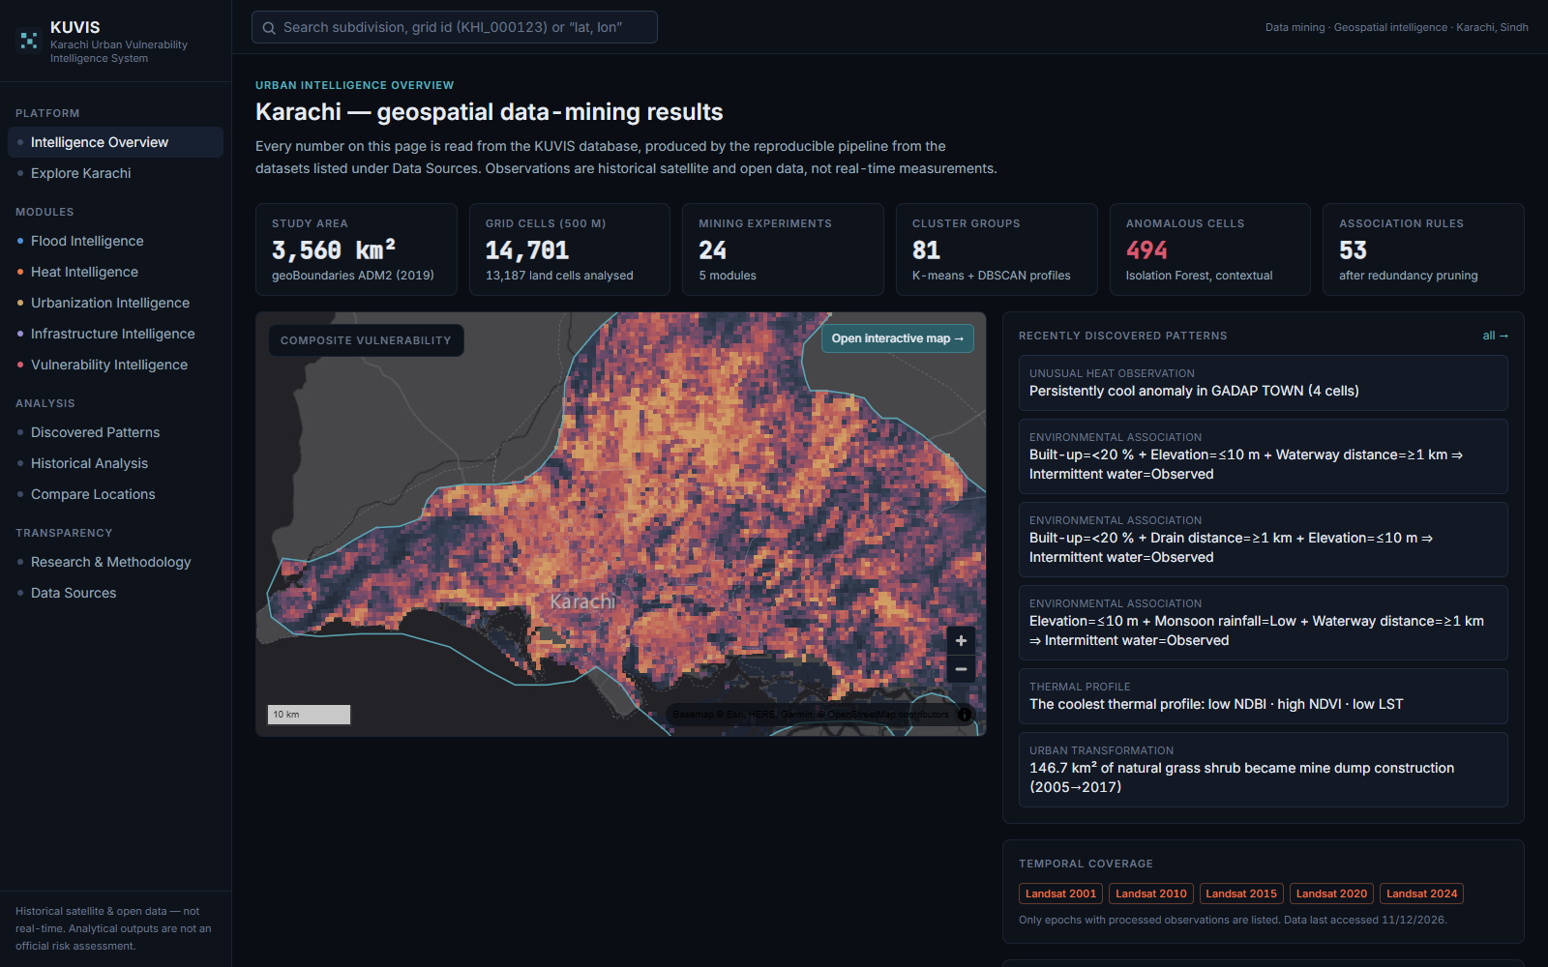
Figure 3. Intelligence Overview page.
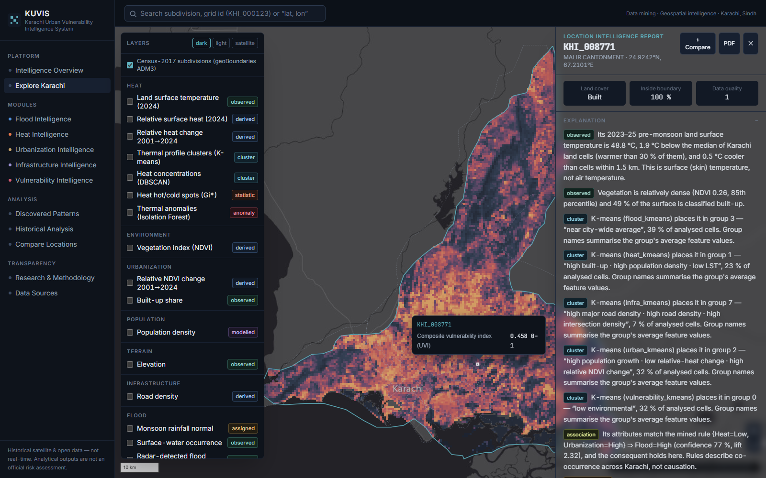
Figure 4. Explore Karachi with the vulnerability layer and an open location report. Each sentence carries its evidence badge.

Part V — Data-mining methods
For each method: the idea, how KUVIS uses it, and how the result is evaluated. Evaluation is the part examiners care about most — every method in KUVIS has an explicit check.

13. The methods explained

13.1 K-means clustering
Idea. Split the cells into K groups so that each cell is close to the average (centroid) of its group. It minimises the within-group sum of squared distances. Features are standardised (z-scores) first so that no variable dominates because of its units.
Choosing K. For every K from 2 to 10 KUVIS computes four quality measures, then picks the K with the highest silhouette among K ≥ 3 where no cluster is smaller than 2 % of cells:
- Inertia / elbow: total within-cluster distance; look for the bend.
- Silhouette (−1 to 1, higher is better): for each point, s = (b − a) / max(a, b), where a is the mean distance to its own cluster and b to the nearest other cluster.
- Davies–Bouldin (lower is better): average similarity of each cluster to its most similar other cluster.
- Calinski–Harabasz (higher is better): ratio of between-cluster to within-cluster dispersion.
Naming. Each cluster is named automatically from its features' average z-scores (e.g. “high built-up · high population density · low LST”), so names describe the data, not an opinion. Used in all five modules (81 cluster profiles in total with DBSCAN).

13.2 DBSCAN
Idea. Density-based clustering: a point with at least min_samples neighbours within distance ε is a core point; clusters grow from connected core points; points in sparse areas are labelled noise. It does not need K and finds clusters of any shape.
- Feature space: ε is chosen at the knee of the sorted 10-nearest-neighbour distance curve (heat: ε = 0.48 on z-scores, min_samples 10). Compared with K-means by the Adjusted Rand Index (ARI); noise share reported.
- Geographic space: run on the coordinates of the hottest 10 % of cells (or top-decile vulnerability) with ε = 750 m — just more than the 707 m diagonal between neighbouring 500 m cells — to find contiguous concentrations. Cross-checked against Gi* hot spots.

13.3 FP-Growth association rules
Idea. Treat each cell as a shopping basket of conditions (“items”), e.g. Elevation=≤10 m, Built-up=<20 %, Intermittent water=Observed. Find rules A ⇒ B where the conditions in A frequently co-occur with B. Continuous variables become items by tertiles (Low/Medium/High) or documented physical thresholds.
Measure | Formula | Meaning
Support | P(A and B) | How common the whole pattern is
Confidence | P(B | A) = support(A∪B) / support(A) | How often B holds when A holds
Lift | confidence / P(B) | How many times more likely B is given A than in general; > 1 means positive association
Leverage | P(A and B) − P(A)·P(B) | Extra co-occurrence beyond independence
Conviction | (1 − P(B)) / (1 − confidence) | How much more often A without B would occur if independent

- Thresholds: support ≥ 0.05, lift ≥ 1.2; the confidence threshold follows the base rate of the consequent (with a fixed 0.6 threshold a label present in 7 % of cells produced no rules at all).
- Redundancy pruning: a rule is dropped if a more general rule (subset of its conditions, same consequent) has a lift at least as high (within 2 %).
- FP-Growth finds the same frequent itemsets as Apriori but without generating candidate sets, using a compact prefix tree — faster.
- Rules describe co-occurrence, never causation. 53 rules are kept: heat 14, flood 28, vulnerability 11.

13.4 Isolation Forest (with LOF for comparison)
Idea. Build many random trees that split the data at random values. Unusual points are isolated in few splits, so a short average path length means a high anomaly score. KUVIS uses 300 trees and flags the most unusual 2 % (contamination).
Contextual anomalies. A cell should be unusual for what it is and where it is, not just hot. So the inputs are context residuals:
- robust z-score of relative LST within the cell's land-cover class (median and MAD instead of mean and SD);
- relative LST minus the mean of land cells within 1.5 km;
- relative LST 2024 minus the cell's own earlier epochs.
Evaluation. Local Outlier Factor (LOF, density-based) is run as a second opinion and the overlap measured with the Jaccard index. Persistence: a flagged cell should deviate on many individual satellite dates, not one bad scene; a date counts only when the neighbour residual exceeds 1 SD in the anomaly's direction.

13.5 Decision tree with spatial cross-validation
Idea. A tree of yes/no questions (“elevation ≤ 8.1 m?”) chosen to make the classes as pure as possible (Gini impurity). It is fully interpretable: every prediction comes with its decision path.
- Spatially blocked cross-validation: cells are grouped into 5 km × 5 km blocks (162 blocks) and GroupKFold(5) keeps whole blocks together, so the model is always tested on areas it has not seen. Random cross-validation would leak information between neighbouring, near-identical cells and overstate accuracy.
- Depth tuned inside cross-validation (best depth 3); class weights balanced; leaves must hold ≥ 1 % of cells.
- Metrics: balanced accuracy (mean of recall on each class — fair when one class is rare), ROC-AUC (probability a random positive is ranked above a random negative), precision, recall, F1, confusion matrix.
- Importance: Gini importance and permutation importance. Sensitivity: the label threshold is varied (1 %, 2 %, 5 %).

13.6 Spatial statistics: Getis–Ord Gi* and Moran's I
- Global Moran's I measures whether similar values cluster in space overall (+1 strong clustering, 0 random).
- Getis–Ord Gi* is local: for each cell it compares the sum of values in its neighbourhood (1 km distance band) with what would be expected, giving a z-score. Significantly high = hot spot, low = cold spot.
- Significance by 499 random permutations; two-sided; Benjamini–Hochberg false discovery rate correction for the thousands of simultaneous tests.
- Gi* is defined for non-negative values, so it runs on absolute LST; the code refuses negative input (see section 21).

13.7 Trends, correlation and regression
- Theil–Sen slope (median of all pairwise slopes, robust to outliers) and Kendall τ significance test, per cell across the five Landsat epochs (≥ 4 epochs required).
- Spearman ρ between LST and each candidate driver, and a standardised OLS regression with HC3 robust standard errors to compare driver strengths (β). Residual Moran's I is reported because spatial autocorrelation makes the confidence intervals optimistic.

13.8 Composite index with Monte-Carlo weight sensitivity
Covered in detail in section 18: percentile-normalised indicators, equal-weight mean, coverage rule, and 1,000 random weight vectors from a flat Dirichlet distribution to measure how stable each cell's rank is.
Say it in class
“We used five data-mining techniques and every one has its own check: K-means is chosen by silhouette and Davies–Bouldin, DBSCAN is compared with K-means by ARI, association rules are filtered by lift and pruned for redundancy, Isolation Forest is checked against LOF and for persistence over many satellite dates, and the decision tree is tested with spatial block cross-validation so it is always evaluated on unseen areas.”

Part VI — The five modules: logic and results
The modules are labelled A–E in the project specification: A flood, B heat, C urbanization, D infrastructure, E vulnerability. They run in the order heat, flood, urban, infra, vulnerability, because the vulnerability module uses outputs of the others.

14. Module B — Urban heat

Logic
- Inputs: land cells with LST coverage ≥ 0.5 (n = 11,889). Variables: LST 2024 and relative LST, NDVI, built-up/bare shares, elevation, distance to coast, population density.
- Spatial structure: Moran's I and Gi* on LST; geographic DBSCAN on the hottest decile (relative LST ≥ 3.53 °C).
- Drivers: Spearman correlations and standardised OLS. Profiles: K-means and feature-space DBSCAN. Rules: FP-Growth with consequent Surface heat=High/Low. Anomalies: contextual Isolation Forest. History: epoch comparison 2001–2024.

Results
Analysis | Result
Spatial structure | Relative LST strongly autocorrelated: Moran's I = 0.922 (pseudo-p 0.002). Gi*: 3,604 hot-spot and 2,430 cold-spot cells; 3,210 hot-spot cells survive FDR.
Concentrations (DBSCAN) | 20 contiguous hot concentrations. Largest: 113 km² around Gadap, mean 55.2 °C (+4.5 °C above city median). Hottest: 91.5 km², mean 57.3 °C (+6.5 °C). Both bare land, every cell also a Gi* hot spot.
Drivers (Spearman ρ with LST) | Distance to coast +0.68 · elevation +0.64 · built-up share −0.56 · NDBI +0.55 · population density −0.49
Regression (standardised OLS) | R² = 0.67. Distance to coast β = +0.76, built-up share β = −0.76, NDVI −0.59, bare −0.36, elevation −0.24 (collinear with coast distance; do not read alone). Residual Moran's I = 0.65.
Profiles (K-means, K = 3) | Silhouette 0.531, Davies–Bouldin 0.657: vegetated (413 cells, 37.3 °C), built-up and dense (2,746, cooler than average), remaining land (8,730, 51.7 °C). DBSCAN agrees only weakly (ARI 0.13).
History | Median land LST 44.3 °C (2001) and 50.7 °C (2024), but absolute differences mostly reflect weather on image dates. Built-up minus bare: −3.6 °C (2001) → −6.1 °C (2024), widening in every epoch.
Rules (14) | Low bare share + low elevation + sparse vegetation ⇒ low heat (confidence 0.93, lift 2.80). Far from coast + sparse vegetation ⇒ high heat (0.74, lift 2.22).
Anomalies | 238 cells flagged (74 warmer, 164 cooler than context). Median persistence 100 % of dates vs 0 % for unflagged cells. Isolation Forest vs LOF Jaccard 0.25.

Interpretation: the arid surface cool island
In humid cities, built-up areas are hotter than their vegetated surroundings (the urban heat island). In arid cities the surroundings are bare, dry soil that heats up enormously by day, while the city has some vegetation, shade and irrigated land. So the daytime surface of the city is cooler than the desert — a known effect in desert cities (Imhoff et al. 2010; Rasul et al. 2017; Peng et al. 2012). KUVIS compares cells with the whole Division, including about 1,600 km² of bare Gadap desert, which earlier core-focused Karachi studies did not.
Be careful
This finding is about daytime surface temperature only. Night-time surface temperature and air temperature can behave differently, and KUVIS has data on neither — so it does not mean people in dense neighbourhoods feel less heat.

15. Module A — Flood susceptibility

The label problem
No validated cell-level record of urban flooding exists for Karachi. The supervised label is therefore intermittent surface water: at least 2 % of the cell's 30 m JRC pixels show seasonal water (1–11 water months). Permanent water is excluded, and no water-derived variable is used as a predictor. The model predicts “where satellites have seen water come and go”, never “flooding”. Base rate: 6.9 % of cells.

Results
Analysis | Result
Association rules (28) | Elevation ≤ 10 m + built-up < 20 % + ≥ 1 km from mapped waterways ⇒ intermittent water, confidence 64 %, lift 9.4 — coastal flats and creek margins, not river overflow.
Decision tree (162 spatial blocks, depth 3) | Balanced accuracy 0.852, ROC-AUC 0.896, recall 0.86, precision 0.26 (638 true vs 1,778 false positives). Stable across label thresholds 1–5 % (balanced accuracy 0.833–0.853).
Importance | First split elevation ≤ 8.1 m carries 80 % of Gini importance; distance to waterways 12 %, built-up share 4 %.
Profiles (K-means, K = 7) | Silhouette 0.34. The “vegetated, low-lying and flat” profile (592 cells) has intermittent water in 34 % of cells — 5.0× the base rate — although water was not a clustering input.
Rainfall context (CHIRPS) | June–September 2022 rainfall was a median 280 % above the 1991–2020 normal across all 170 pixels; 2022, 1994 and 2020 are the wettest monsoons since 1981.

Independent check with Sentinel-1 radar
Because the label is a proxy, KUVIS tests the flood models against real storm water that none of them saw: radar images taken just after the heaviest rains of 2020 and 2022.
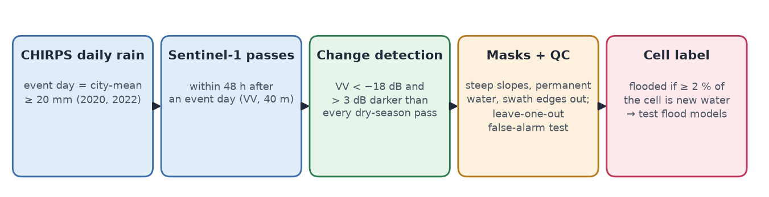
Figure 5. How radar flood water is mapped and turned into an independent validation label.
- Event days from CHIRPS daily rainfall (city mean ≥ 20 mm): 6 days in 2020 (largest 59 mm on 27 August), 12 in 2022 (largest 73 mm on 24 July). 8 usable radar passes followed within 48 h.
- Detection: a 40 m pixel is new water if VV backscatter < −18 dB and more than 3 dB darker than every dry-season (January–May) pass of the same orbit. Steep slopes (> 5°), normally-wet pixels and a 320 m swath-edge strip are excluded.
- False-alarm test: running the detector on dry passes against the other dry passes (leave-one-out) gives a median 0.2 km² of false “flood” per pass; two of 24 dry passes still show 11 and 21 km² (coastal). Coastal detections therefore carry more doubt.
- What radar saw: 40.6 km² of new open water the morning after 27 August 2020, mostly inland along the north-western edge of Gadap; 1–12 km² per pass in 2022. 159 of 11,097 evaluated cells (1.4 %) are radar-flooded (≥ 2 % of the cell).
Scorer of radar-flooded cells | ROC-AUC
Decision tree (out-of-fold probabilities) | 0.845 (2020: 0.85, 2022: 0.83)
Elevation alone | 0.766
JRC intermittent-water label | 0.875
JRC seasonal-water share | 0.914
Tree within strata | below 10 m: 0.68 · above 10 m: 0.72 · inland ≥ 2 km from coast (96 positives): 0.81

Reading: the tree transfers to real storm water (better than elevation alone), but the water history it was trained on scores even higher by itself, and within low or high ground its skill drops — most of its skill is separating low from high ground. All 25 top rules also raise the radar flood rate (median lift 5.2), and the K-means profiles rank the same way under both labels (Spearman ρ = 0.96).
Be careful
Only 2 of 1,880 mostly built-up cells are radar-flooded. That is not evidence that dense neighbourhoods stay dry: buildings reflect radar strongly back to the satellite and hide the streets, so C-band radar cannot see water between buildings. Street flooding — the hazard residents experience — needs street-level records to validate.

16. Module C — Urbanization and land change
Analysis | Result
NDVI trend (Theil–Sen + Kendall τ) | Absolute NDVI: 58.8 % of cells show “significant greening” and the city median rises 0.066 → 0.157 (2001 → 2024). Relative NDVI: only 2.2 % significantly greener and 3.8 % significantly browner.
Concentrated change | Vegetation loss: 67.5 km² in Korangi and Landhi, 26.5 km² in Orangi and SITE. Vegetation gain in small 6–10 km² clusters, where relative surface heat fell by 3.4–4.3 °C.
Land-use transitions 2005 → 2017 (EO4SD) | 146.7 km² of natural grass/shrub became construction or mine/dump land; 48.2 km² of that class became urban fabric; 15.3 km² of discontinuous urban became continuous urban; 1,072 cells gained > 25 percentage points of built-up share.
Trajectories (K-means, K = 3) | Silhouette 0.38: established built-up with relative vegetation loss (2,106 cells), growing periphery with high population growth (4,127), stable undeveloped land (6,544).
Anomalies (Isolation Forest) | 256 cells whose 2001→2024 change is unusual for cells with a similar 2001 state (same NDVI decile × built-up band): 163 unusual vegetation gains, 93 unusual losses.

Say it in class
“If we had used absolute NDVI we would have announced that Karachi got greener everywhere — even in the desert. That uniform rise comes from switching from Landsat 5 to Landsat 8 and from weather differences between image dates. Using values relative to each year's city median removed the artefact, and that is why every change analysis in KUVIS uses relative indices.”

17. Module D — Infrastructure (supply, not traffic)
- Road-network profiles (K-means, K = 8, silhouette 0.585 — the best-separated clustering in the project): from unmapped periphery (4,633 cells) to dense arterial grids, using road, major-road and intersection densities.
- OSM completeness check: mapped building density correlates only moderately with built-up share (ρ = 0.56) and population (ρ = 0.52); 1,264 of 1,907 densely built-up cells (66 %) have fewer than 50 mapped buildings per km². OSM buildings are therefore used only as a completeness indicator, never as a measure of building stock.
- No traffic, congestion or travel-time claim is made anywhere, because no open traffic observations exist for Karachi.

18. Module E — Composite vulnerability (UVI)
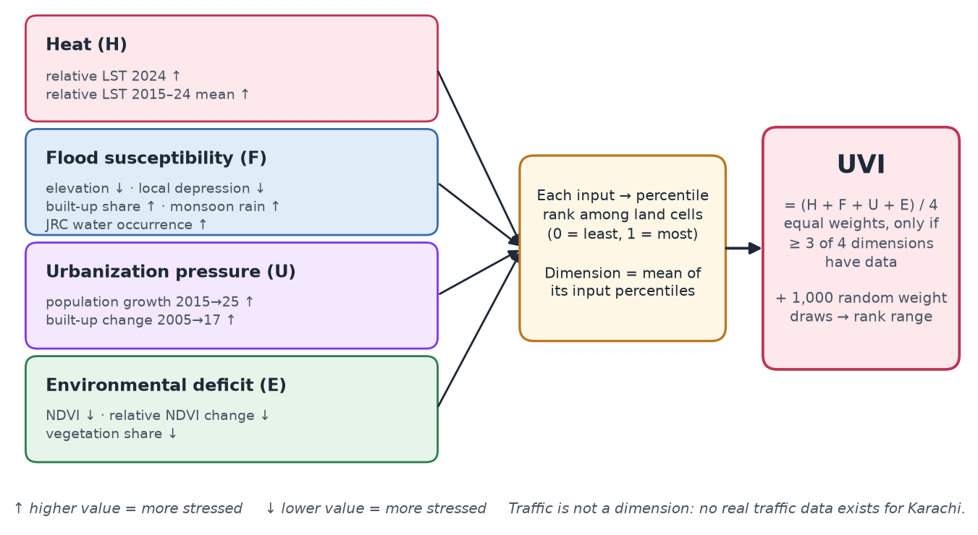
Figure 6. How the Urban Vulnerability Index is built.

Construction
- Each input is converted to a percentile rank among land cells, with its sign set so that 1 = most stressed (e.g. low elevation is more flood-susceptible, so elevation enters with a minus sign).
- A dimension is the mean of its input percentiles, available when at least half its inputs exist.
- UVI = Σ wᵢ·Dᵢ / Σ wᵢ over available dimensions, equal weights (0.25 each), computed only when ≥ 75 % of the weight is available (at least 3 of 4 dimensions). All 13,187 land cells are scored; mean evidence quality 0.999.
- Sensitivity: 1,000 weight vectors from a flat Dirichlet(1,1,1,1) distribution; for each cell the 5th–95th percentile range of its rank is stored and shown in reports.
- Population is exposure, not vulnerability: it is summarised separately and is not an input.

Results
Analysis | Result
How dimensions relate | Heat vs flood ρ = −0.61 (strongly opposed); flood vs urbanization ρ = +0.58.
Stability | Equal-weight UVI correlates 0.86–0.93 with alternative weightings, so the overall ranking holds. But only 21.8 % of top-quintile cells stay in the top quintile under 95 % of the random weightings, and the median cell's rank moves across 55 percentiles.
Stress regimes (K-means, K = 3) | Hot inland (5,691 cells, 43 %: heat high, flood low, urbanization low) · Low-lying urban (3,284, 25 %: heat low, flood high, urbanization high, environmental stress high) · Low environmental stress (4,160, 32 %).
Rules (11) | Heat=Low ⇒ Flood=High, confidence 0.68, lift 2.03 — confirms the opposition.
Spatial clustering | Moran's I = 0.70. Most stable overlapping-stress area: 13 cells in Kiamari (92 % stay top quintile). Largest: 102 km² across Gadap and Gulshan-e-Iqbal, ≈786,000 people (WorldPop), 55 % stable.
Exposure | WorldPop places 14.2 million of 18.9 million modelled residents in the two highest UVI classes — mostly because flood and urbanization are high where people live; not an independent measure of harm.

Say it in class
“Heat and flood follow the same terrain gradient in opposite directions: the hot places are high, bare inland desert; the flood-prone places are low, coastal and built-up. If you add two opposed things together, the result mostly measures the weights you chose. So instead of trusting one number, KUVIS shows each cell's rank range under a thousand random weightings and groups the city into three stress regimes.”

19. The discovery engine
The final mining step turns stored results into human-readable findings. Each discovery is produced by a rule over the stored results with an explicit quality threshold; titles and descriptions are templates filled with computed numbers, and a category produces nothing if its threshold is not met. For example, overlapping-stress discoveries require at least 10 contiguous cells with at least half of them stable in the weight-sensitivity test. Each discovery stores its statistics, the experiment it came from, its cells and geometry, its limitations, and a 0–1 strength used only for ranking.
Category | Count
Spatial heat concentration | 9
Environmental association | 9
Overlapping environmental stress | 8
Unusual heat observation | 6
Vegetation change | 6
Urban transformation | 6
Statistical relationship | 4
Thermal profile | 2
Flood-related profile | 1
Rainfall | 1
Historical change | 1
Total | 53

Part VII — Quality, lessons and limitations

20. Testing and validation
Test group | What is checked
Mining algorithms (12 tests) | K-means sweep recovers three planted groups; profile names come from z-scores; DBSCAN reports noise; Isolation Forest finds a planted outlier; robust z within groups; neighbour residual; association-rule metrics and pruning; Gi* detects a hot block and rejects negative values; Landsat temperature scaling matches USGS; NDVI bounds and NaN handling
Zonal statistics (4 tests) | Pixel centres assigned to the right cell; mean and coverage with missing pixels; class fractions ignore nodata; population sums
Sentinel-1 detection (3 tests) | Detection needs both the dark and the drop condition; masks and missing values respected; median filter keeps holes
Live API (8 tests) | Overview counts match the grid; layers published only with data; grid-ID validation; report structure and evidence types; points outside the study area return 404; vector tiles served; compare needs ≥ 2 cells; no source marked acquired without files
Browser test (scripts/ui_check.py) | Drives Microsoft Edge through all 12 pages, waits for data and map tiles, records console errors and failed requests, opens a location report and exports its PDF

Reproducibility: each experiment record stores parameters, inputs, sample size, run time and the git commit; scripts/generate_results.py regenerates research/RESULTS.md from those records, so the results document cannot be edited by hand to disagree with the code.

21. Mistakes the project caught in itself
These are strong material for a presentation: they show the results were tested, not just produced.
What looked wrong | Cause | Fix
Gi* showed hot spots where the city is cool | Gi* needs non-negative values; it was run on zero-centred relative LST, which inverted hot and cold | Run on absolute LST; the function now rejects negative input; regression test added
Every cell, even desert, “greened” 2001→2024 | Sensor change (Landsat 5 → 8) and weather on image dates shift absolute NDVI city-wide | All change analysis uses values relative to each epoch's city median
NDBI rose where there were no buildings | In arid land NDBI tracks bare soil (ρ = 0.72 with bare share, −0.46 with built-up) | Built-up comes from WorldCover/EO4SD; NDBI dropped from the urbanization dimension
Flood tree looked too good under random CV | Neighbouring cells are near-copies, so random folds leak information | Spatial block cross-validation (5 km blocks)
No flood rules at all | A fixed 0.6 confidence threshold is unreachable for a 7 % base-rate label | Confidence threshold relative to the base rate, plus a lift threshold
Radar “found” up to 43 km² of flooding on dry days | Comparing against the dry-season median; tides and salt pans change between passes | Compare against every dry pass (per-pixel minimum) + leave-one-out false-alarm test
Vertical stripe of false flood | Low-quality data at radar swath edges | 320 m strip along swath edges removed
Built-up stratum AUC 0.956 | Computed from only 2 positive cells | AUC withheld when a stratum has fewer than 10 positives
Heat results changed after a rerun | Saved records predated the distance-to-coast feature | Records refreshed; the report's heat section corrected (R² 0.55 → 0.67)

22. Limitations
- Resolution: 500 m cells average streets, roofs and open plots; a 30 m elevation model cannot represent drains.
- Time: Landsat is cloud-limited in the monsoon and only sees about 10:30 local time; no night-time temperature.
- Fixed land cover: WorldCover 2021 classes are applied to every epoch.
- Modelled population: WorldPop is a model, not a census, and its 2015–2025 period differs from the Landsat change period.
- Coarse rainfall: CHIRPS barely varies inside the city.
- Uneven OSM coverage: missing roads or drains may be unmapped rather than absent.
- Proxy flood label: intermittent water seen by satellites, not street flooding; radar cannot see water between buildings.
- Spatial dependence: permutation tests, FDR correction and blocked cross-validation reduce but do not remove over-confidence.
- Boundaries: geoBoundaries town names are the pre-2011 towns, which differ from current administrative units.
- Relative index: percentile-based scores compare places within Karachi only.

23. Future work
- Night-time land surface temperature (Landsat night scenes or ECOSTRESS).
- IMERG half-hourly rainfall for storm intensity (available on Planetary Computer).
- GHSL built-up history for a longer, consistent built-up time series.
- Validation against municipal drainage records or complaint data if they become available.

Part VIII — Running and presenting

24. Running the software

Portable release (any Windows PC, nothing to install)
- Download KUVIS-1.0.0-windows-x64.zip from the GitHub Releases page of the repository and extract the whole zip (e.g. to the Desktop). Needs Windows 10/11 64-bit and about 3 GB of free space.
- Double-click START_KUVIS.bat. The first start builds the local database from the included dump (a few minutes, once); later starts take seconds.
- The browser opens KUVIS automatically, normally at http://localhost:8000 (the next free port if 8000 is busy). Keep the black window open.
- To stop, press Ctrl+C in the window or close it; STOP_KUVIS.bat stops the database if a window was closed abnormally.
What the launcher does: it starts the bundled PostgreSQL + PostGIS on a free local port (listening on this computer only), on first run creates the database with a random password and restores the results into it, then starts the FastAPI server — which also serves the compiled web app — and opens the browser. Internet is needed only for the background map.

Developer setup (this computer)
# PowerShell, from the KUVIS folder
# 1. database
..\_tools\pgsql\bin\pg_ctl.exe -D ..\_tools\pgdata `
-l ..\_tools\pg.log -o "-p 5433" start
# 2. API (terminal 1)
.\.venv\Scripts\python.exe -m uvicorn backend.app.main:app --port 8000
# 3. web app (terminal 2), then open http://localhost:5173
cd frontend; npm run dev

# tests, browser check, pipeline steps, release build
.\.venv\Scripts\python.exe -m pytest tests -q
.\.venv\Scripts\python.exe scripts\ui_check.py
.\.venv\Scripts\python.exe scripts\run_pipeline.py --list
.\.venv\Scripts\python.exe scripts\build_release.py --version 1.0.0

25. Presenting in class

Suggested 12-minute structure
Time | Section | What to say | What to show
0:00–1:00 | Hook | Karachi: extreme heat, 2020/2022 floods, fast growth; evidence is scattered | Overview page
1:00–2:00 | What KUVIS is | 11 datasets → one 500 m grid → 5 mining methods → web app; honesty rules | Key numbers table (section 1)
2:00–3:30 | Data and grid | Satellite sources, native-pixel zonal statistics, relative indices | Figure 2 (pipeline)
3:30–5:00 | Architecture | Pipeline → PostGIS → FastAPI → React/MapLibre; vector tiles; experiment records | Figure 1
5:00–7:00 | Methods | One sentence per method + its evaluation; spatial cross-validation | Methodology page / section 13
7:00–9:30 | Findings | Cool island; heat–flood opposition and fragile index; terrain predicts water + radar check; OSM gaps | Heat, Flood, Vulnerability pages
9:30–11:00 | Live demo | Click a cell, read the report, export PDF | Explore Karachi
11:00–12:00 | Limitations and close | LST ≠ air temperature; proxy flood label; not an official risk map; future work | Section 22

Live demo script
- Before class: run START_KUVIS.bat once so the first-time database setup is already done, and check the internet connection (for the basemap).
- Overview: point to 14,701 cells, 24 experiments, 53 discoveries; note the footer “not an official risk assessment”.
- Explore Karachi: switch on “Land surface temperature (2024)” — Gadap glows hot. Switch it off and switch on “Built-up share” — the dense city is where the surface is cooler.
- Click a cell in the dense city (or search a town name such as “Saddar” or a grid ID). Read two report sentences aloud and point to their evidence badges (observed, cluster, association, composite). Click PDF to export.
- Flood Intelligence: show “Surface-water occurrence” and “Radar-detected flood water (2020/2022)”; mention the AUC 0.85 check and the radar blind spot in dense areas.
- Vulnerability Intelligence: show the UVI layer and the rules table (Heat=Low ⇒ Flood=High); explain the rank-range idea.
- Discovered Patterns and Research & Methodology: show that each finding links to an experiment with parameters, metrics and limitations.

Tips
- Lead with the surprise (the cool island) — it keeps attention and shows real data mining rather than confirming expectations.
- Always attach a caveat to a strong claim: “surface, not air temperature”, “intermittent water, not street flooding”, “co-occurrence, not causation”.
- If the demo fails, the screenshots in this guide (Figures 3 and 4) show the same screens.

26. Questions you may be asked
Q1. What is the main contribution of the project?
Putting eleven open datasets on one common 500 m grid for the whole Karachi Division and mining them together with evaluated methods, which surfaced patterns single-hazard studies miss — the surface cool island, the heat–flood opposition and the fragility of composite scores — delivered as a reproducible pipeline and an interactive platform.
Q2. Why the whole Division and not just the city core?
Patterns are relative: comparing the city with its desert surroundings is exactly what reveals the cool island. The Division boundary is also an official, reproducible unit.
Q3. Why a 500 m grid?
A balance: fine enough for neighbourhoods and 100 m thermal data, coarse enough for rainfall and population to be meaningful, and about 15,000 cells that can be mined and drawn interactively. Cells are anchored on multiples of 500 m so the grid is reproducible.
Q4. Isn't it wrong that built-up areas are cooler?
Not for an arid city by day. The surroundings are bare soil that heats strongly; the city has more vegetation and shade. This “surface cool island” is documented for desert cities. It concerns daytime surface temperature only.
Q5. What is the difference between LST and air temperature?
LST is the radiating temperature of the ground surface measured by satellite at about 10:30; air temperature is measured about 2 m above ground. They can differ by many degrees, so KUVIS never calls LST air temperature.
Q6. Is all the data real? How can you prove nothing was invented?
Every source is a public dataset; the provenance registry records URL, access time, licence and files, and refuses “acquired” status without files on disk (tested). Every number comes from experiment records written by code with the git commit.
Q7. How did you choose the number of clusters?
A sweep from K = 2 to 10 with inertia, silhouette, Davies–Bouldin and Calinski–Harabasz; the K with the highest silhouette among K ≥ 3 with no cluster under 2 % of cells.
Q8. Why both K-means and DBSCAN?
K-means forces every cell into one of K round groups; DBSCAN finds dense regions of any shape and labels outliers as noise. Their agreement (ARI) shows how sharp the structure really is — for heat it was weak (0.13), which we report.
Q9. What does lift mean? Give an example.
Lift = confidence ÷ base rate. Intermittent water occurs in 6.9 % of cells, but in 64 % of cells that are low, little built-up and far from waterways — lift 9.4, i.e. 9.4 times more likely than in general.
Q10. Why FP-Growth and not Apriori?
Both find the same frequent itemsets; FP-Growth avoids generating candidate sets by compressing transactions into a prefix tree, so it is faster.
Q11. What is an anomaly in KUVIS?
A cell that is statistically unusual for its context — its land-cover class, its 1.5 km neighbours and its own history — found by Isolation Forest. It is unusual, not necessarily dangerous.
Q12. Why spatial cross-validation?
Neighbouring cells are nearly identical; random folds would put near-copies in training and test sets and overstate accuracy. Grouping cells into 5 km blocks tests the model on unseen areas.
Q13. The flood tree has precision 0.26 — is it a bad model?
It finds 86 % of water cells, but most cells it flags do not show water, because water is rare (6–7 %) and many low cells stay dry. It is a screening tool for where water is plausible, not a predictor of floods.
Q14. How did you validate flood results without ground truth?
With an independent label from Sentinel-1 radar after the 2020 and 2022 storms. The tree ranks radar-flooded cells with ROC-AUC 0.85, better than elevation alone (0.77), though the training proxy alone scores 0.91.
Q15. Why can't radar see flooding in dense neighbourhoods?
Buildings reflect radar strongly back to the satellite and hide narrow streets in shadow, so water between buildings does not appear dark. Only 2 of 1,880 built-up cells were radar-flooded, which reflects this blind spot, not dry streets.
Q16. Why not deep learning or a random forest?
The goal is discovering and explaining patterns; a shallow tree gives a readable decision path for every cell. With a proxy label and spatial dependence, extra model complexity would add accuracy on the proxy, not understanding.
Q17. Why is the vulnerability index so sensitive to weights?
Heat and flood are strongly anti-correlated (ρ = −0.61), so combining them mostly reflects the weights. That is why KUVIS shows rank ranges under 1,000 random weightings and stress regimes.
Q18. Why is there no traffic dimension?
No open traffic observations exist for Karachi (TomTom needs a commercial licence). Road density measures supply, not congestion, so the dimension is absent and documented rather than faked.
Q19. What does “assigned” mean?
A value from a source coarser than a cell (CHIRPS ≈ 5.5 km) given to every cell inside the pixel. Neighbouring cells share it, so they are never compared on it.
Q20. Why relative indices?
Absolute values differ between epochs because of sensor changes and weather on image dates; absolute NDVI suggested the whole city, even the desert, got greener. Values relative to each epoch's city median remove that shift.
Q21. What are Gi* and Moran's I?
Moran's I is one global number for how clustered a variable is; Gi* tests each cell's neighbourhood for significantly high (hot spot) or low (cold spot) values, with permutations and false-discovery-rate correction.
Q22. Why PostGIS instead of files?
It answers spatial queries directly (which cell contains a point), simplifies boundaries and generates vector tiles, and keeps all results in one consistent place for the API.
Q23. How does the map show 14,701 cells smoothly?
Vector tiles: PostGIS sends only the cells in view, only with the attributes of the active layers, in compact binary form; the GPU draws and colours them.
Q24. What happens when I click a cell?
PostGIS finds the cell, the report engine computes percentiles, subdivision and 1.5 km neighbour comparisons, gathers clusters, anomalies, rules and the tree's prediction, and writes evidence-labelled sentences.
Q25. Can it be reused for another city?
Largely yes: most sources are global (Landsat, Sentinel, NASADEM, WorldCover, JRC, CHIRPS, WorldPop, OSM) and parameters live in one config file; the boundary and UTM zone change, EO4SD land use is Karachi-specific, and the pipeline must be rerun.
Q26. Is this an official risk map?
No. The index is a relative research construct for comparing places within Karachi; the app and reports say so on every page.
Q27. What is the biggest limitation?
The flood label: satellites see intermittent open water, not the short street flooding residents suffer. Validating that needs street-level records.
Q28. What would you add next?
Night-time surface temperature, IMERG half-hourly rainfall, GHSL built-up history, and validation against municipal drainage records.
Q29. How do you make sure the documentation matches the results?
The results document and the Methodology page are generated from the experiment records written by the code; nothing is typed in by hand.
Q30. How does it run on another computer?
The portable release bundles Python, PostgreSQL/PostGIS, the database dump and the web app; START_KUVIS.bat sets up and starts everything locally.

Appendices

A. The 24 experiments
Module | Experiment | Method | n
flood | flood_association | FP-Growth association rules | 13,184
flood | flood_dbscan_feature | DBSCAN (feature space) | 11,913
flood | flood_kmeans | K-means | 11,913
flood | flood_sar_validation | Independent validation against Sentinel-1 flood extent | 11,097
flood | flood_tree | Decision tree (spatially blocked CV) | 11,913
heat | heat_association | FP-Growth association rules | 11,889
heat | heat_correlation | Spearman correlation + standardised OLS (HC3) | 11,889
heat | heat_dbscan_feature | DBSCAN (feature space) | 11,889
heat | heat_dbscan_geographic | DBSCAN (geographic, hot cells) | 1,189
heat | heat_gi_star | Getis–Ord Gi* + global Moran's I | 11,889
heat | heat_history | Epoch comparison of LST composites | 14,701
heat | heat_isolation_forest | Isolation Forest (+ LOF comparison) | 11,887
heat | heat_kmeans | K-means | 11,889
infra | infra_kmeans | K-means | 13,187
infra | infra_osm_completeness | Spearman correlation (completeness check) | 13,187
urban | urban_isolation_forest | Isolation Forest (+ LOF comparison) | 12,777
urban | urban_kmeans | K-means | 12,777
urban | urban_lulc_change | Land-use change (transition matrix) | 9,110
urban | urban_ndvi_trend | Theil–Sen trend + Kendall τ | 13,184
vulnerability | vulnerability_association | FP-Growth association rules | 13,187
vulnerability | vulnerability_dbscan_geographic | DBSCAN (geographic, top-decile UVI) | 1,319
vulnerability | vulnerability_gi_star | Getis–Ord Gi* + global Moran's I | 13,187
vulnerability | vulnerability_index | Composite index + weight sensitivity | 13,187
vulnerability | vulnerability_kmeans | K-means | 13,135

B. Abbreviations
Term | Meaning
ARI | Adjusted Rand Index — agreement between two clusterings, corrected for chance
AUC / ROC-AUC | Area under the receiver operating characteristic curve
CHIRPS | Climate Hazards Group InfraRed Precipitation with Station data
COG | Cloud-Optimised GeoTIFF
CRS | Coordinate reference system
DBSCAN | Density-Based Spatial Clustering of Applications with Noise
EO4SD | Earth Observation for Sustainable Development (World Bank / ESA programme)
FDR | False discovery rate (Benjamini–Hochberg correction)
GSW / JRC | Global Surface Water dataset of the European Commission's Joint Research Centre
LOF | Local Outlier Factor
LST | Land surface temperature
MVT | Mapbox Vector Tile format
NDVI / NDBI / NDWI | Normalised difference vegetation / built-up / water index
OLS (HC3) | Ordinary least squares regression with heteroscedasticity-robust standard errors
OSM | OpenStreetMap
RTC | Radiometrically terrain-corrected (Sentinel-1 product)
SAR | Synthetic aperture radar
STAC | SpatioTemporal Asset Catalog
UTM | Universal Transverse Mercator projection
UVI | Urban Vulnerability Index (KUVIS composite)

