
Spring 2026
GIFT School of Engineering and Applied Sciences

SE-317L: Software Project Management

Lab Manual 8
Click Up
Introduction
Agile methodology is a modern software development approach that focuses on flexibility, collaboration, and continuous improvement. Instead of completing the entire project at once, Agile divides work into small cycles called sprints, allowing teams to deliver working features step by step and adapt to changes easily.

In this lab, students will learn how to implement Agile practices using ClickUp, a powerful project management tool. By using ClickUp’s Agile Project Management Template, students will organize tasks, create a product backlog, plan sprints, and track progress through a Kanban board.

The lab is based on a real-world case study of the University Examination & Management System (UEMS). Students will simulate how a software team manages tasks, prioritizes work, and delivers features using Agile/Scrum methodology.

Objectives of This Lab
After completing this lab, students will be able to:
- Understand the basic concepts of Agile methodology and Scrum framework
- Use ClickUp for project management
- Create and manage a Product Backlog
- Write effective User Stories
- Assign priorities, statuses, and story points to tasks
- Plan and organize a Sprint
- Track task progress using a Kanban Board
- Apply Agile practices to a real-world software project (UEMS)
3-Hour Lab Breakdown
Time | Activity
0–30 min | Concept recap
30–90 min | Guided hands-on task
90–150 min | Independent student work
150–180 min | Evaluation + viva + submission

Agile Methodology
Agile is an iterative software development approach that delivers work in short cycles called sprints. Instead of planning everything at the start, the team continuously plans, builds, tests, and reviews — making it easy to adapt to changes throughout the project. Agile is guided by the Agile Manifesto which values individuals, working software, customer collaboration, and responding to change.

What is ClickUp?
ClickUp is an all-in-one project management platform that supports Agile, Scrum, and Kanban methodologies. It provides Spaces, Folders, Lists, and Tasks to organize any type of project. Its Agile Project Management Template gives teams a ready-made structure with pre-built lists for Getting Started, Agile Ceremonies, Backlog, and a Kanban Board.
Key Concepts in This Lab
Term | Explanation
Space | The top-level container in ClickUp. Represents your entire project. Example: 'SPM Lab Project'.
List | A collection of tasks inside a Space. The template gives you 4 lists: Getting Started, Agile Ceremonies, Backlog, and Kanban Board.
Getting Started | A pre-built list in the template that guides you through how to use the space. It has 6 tutorial tasks.
Agile Ceremonies | A list for sprint meetings — Sprint Planning, Daily Standup, Sprint Review, Retrospective (4 tasks).
Backlog | A prioritized list of all work to be done. Contains user stories and tasks waiting to be picked up.
Kanban Board | A visual board with columns (Open, In Progress, In Review, Closed) to track task progress in real time.
User Story | A feature request written from the user's perspective: 'As a student, I want to register online so I can save time.'
Sprint | A 2-week time box in which the team picks tasks from backlog and completes them.
Task Status | Each task moves through statuses: Open → In Progress → In Review → Closed.
Case Study Scenario
Read this scenario carefully. All your backlog tasks, sprint tasks, and board activities will be based on this real project.
University Examination & Management System (UEMS)
The University of Punjab has over 40,000 students enrolled across 120 departments. Every semester, students must visit the university in person to register for exams, pay fees by hand, and collect roll number slips from the office. The entire process takes weeks and causes long queues, lost paperwork, and many mistakes in student records.
When exam results are ready, the university takes 45 to 60 days to calculate grades manually. Students have no way to check their results online — they must go to the notice board or wait for a letter in the post. Marks are often entered incorrectly due to human error.
To solve all these problems, the university has hired TechBridge Solutions to build an online portal called UEMS. This web-based system will allow students to register for exams online, pay fees using their phones, download roll number slips instantly, and check results the moment they are published.
Teachers will enter marks online and the system will automatically calculate GPA and CGPA. The Examination Controller will generate reports and publish results in just 15 days. Total project cost: PKR 28,00,000. Duration: 6 months (March 2025 – August 2025).
Project Summary Table
Detail | Information
Client | University of Punjab
Developer | TechBridge Solutions
System Name | University Examination & Management System (UEMS)
Type | Web-Based Portal
Budget | PKR 28,00,000
Duration | 6 Months — March 2025 to August 2025
Methodology | Agile / Scrum (2-week sprints)
Sprint Duration | 2 Weeks per Sprint (Total: ~12 Sprints)
Team Size | 8 Members (Developer, Designer, QA, DB Admin, PM, etc.)

Step 1— Create Account
- Open ClickUp Website https://clickup.com/
- Create Account or Click 'Log In' button.
- You will be redirected to your ClickUp workspace dashboard.

Step 2—Create Workspace
- On the left sidebar, you will see 'Spaces'. Click the '+' icon next to it.
- Click on Use Template
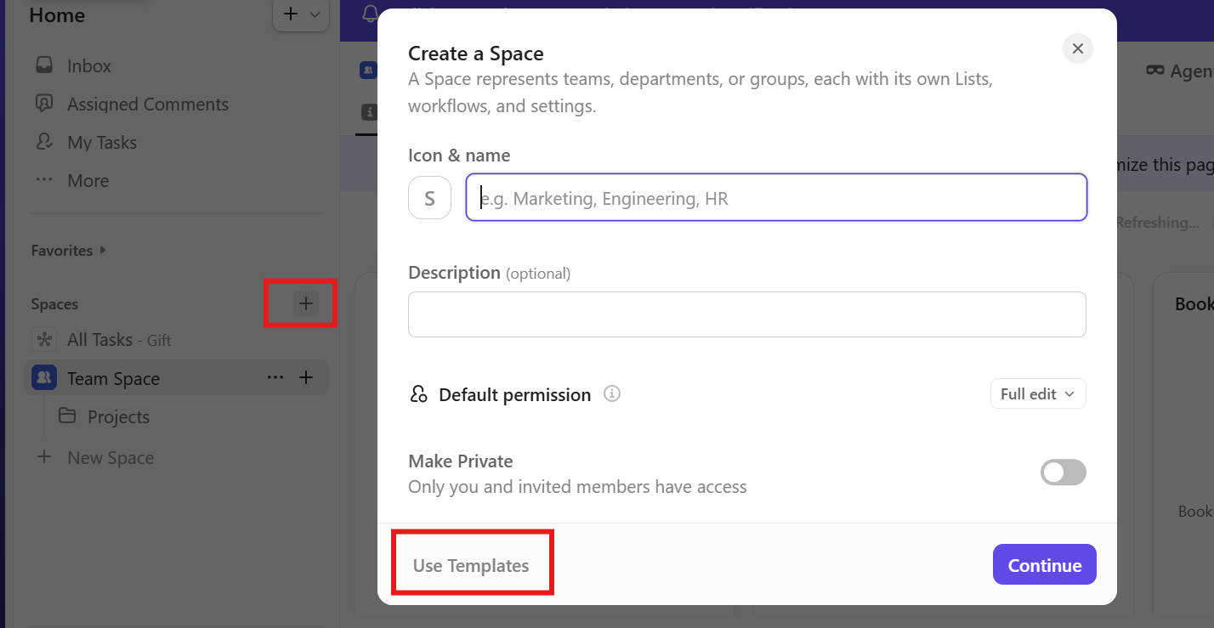
- Search Agile Project Management Template. It used to quickly set up a structured workflow with ready-made backlogs, sprints, and task statuses. It helps save time and ensures teams follow standard Agile practices efficiently.
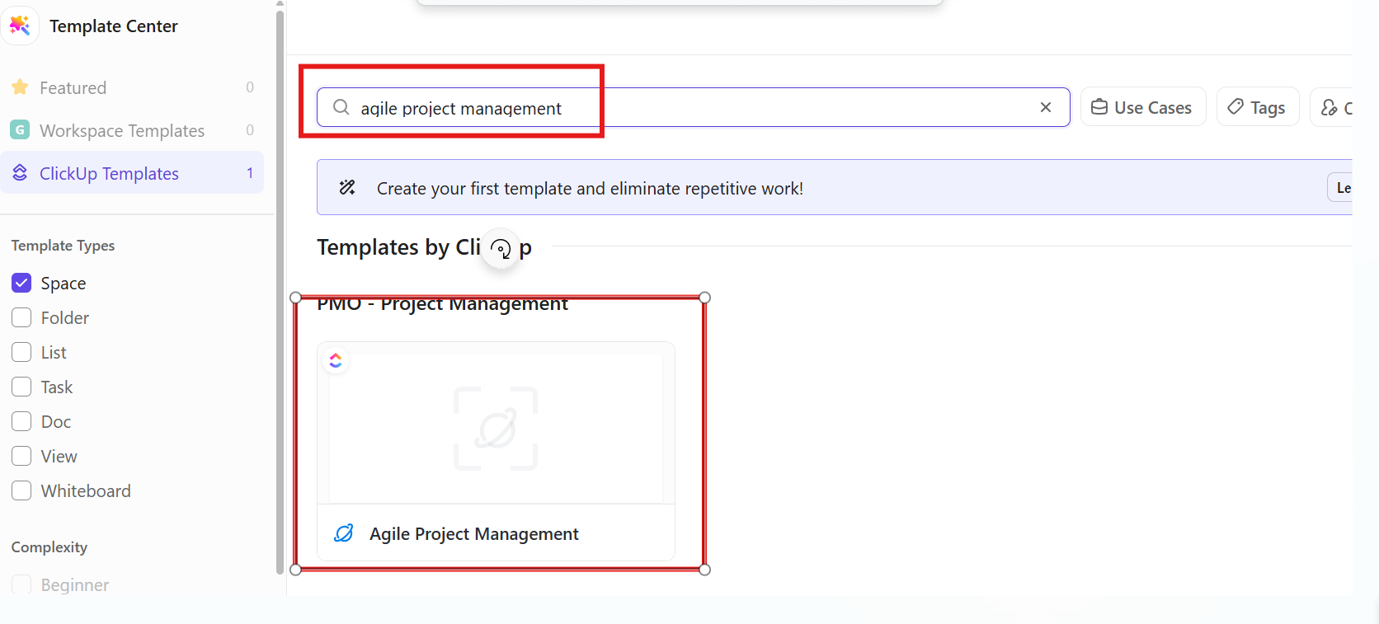
- Click on “Use Template”
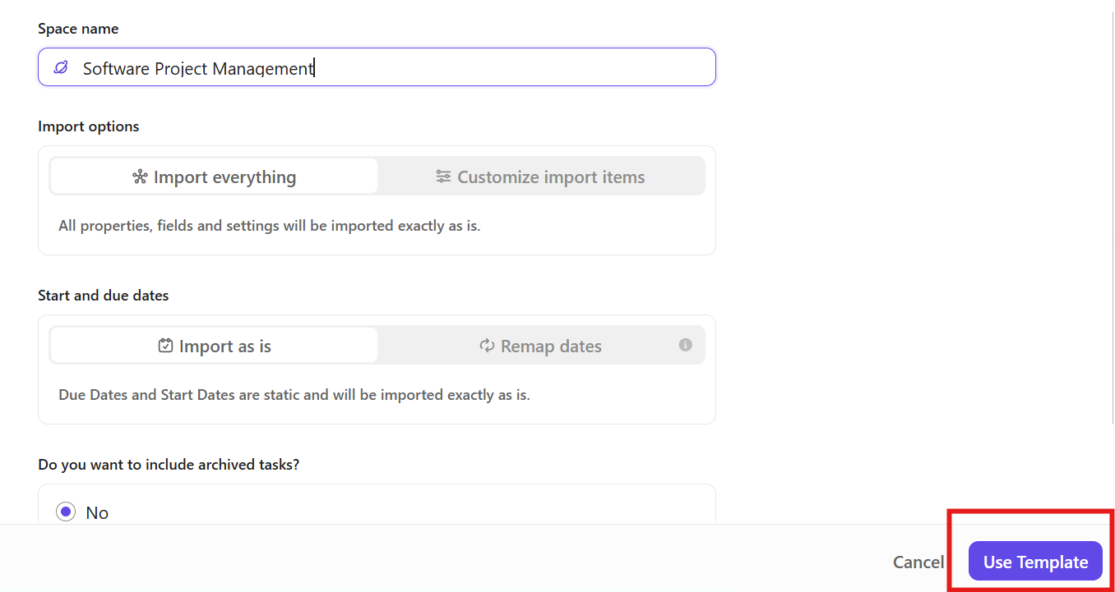
Step 3 — Build the UEMS Product Backlog
The Backlog list already has 3 sample tasks from the template. You will DELETE those and add your own UEMS backlog tasks based on the case study scenario.
Add UEMS Backlog Tasks (User Stories)
- Click '+ Add Task' at the bottom of the Backlog list.
- Add the following UEMS backlog tasks one by one:
- Student Online Exam Registration
- Online Fee Payment via Mobile
- After typing each task name, press Enter to save and continue to the next.
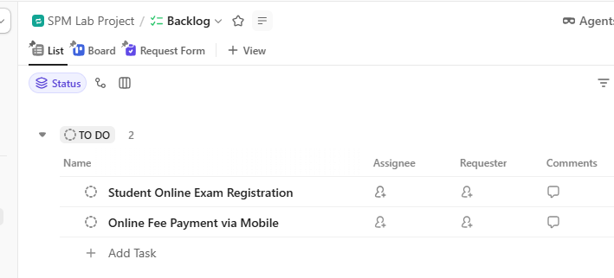
Activity:
Identify 10 tasks in the UEMS scenario and add them to the backlog.
Step 4 — Add Details to Each Backlog Task
Click on Task 1: 'Student Online Exam Registration' to open it.
- In the Description field, type the User Story: 'As a student, I want to register for exams online so that I do not have to visit the university in person.'
- Set Priority
- Set Status
- Set Due Date.
- Add Assignee: Click 'Assignee' → Assign to yourself or a team member.
- Add a tag: Click 'Tags' → Type 'Sprint 1' and press Enter.
- Close the task panel when done.
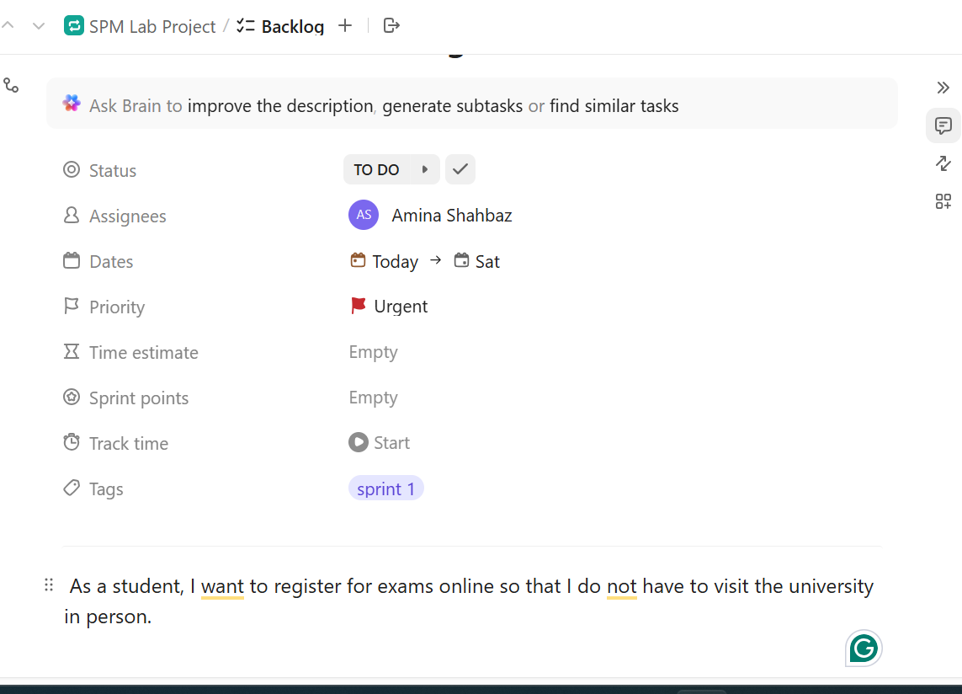
Activity:
You have already identified 10 backlog tasks.
Select each backlog item and perform the following actions in your project management tool (e.g., ClickUp):
- Write a proper User Story using the format:
  - “As a [user], I want [functionality] so that [benefit].”
- Set the following attributes for each task:
- Priority
  - Assign High Priority to Tasks 1–5
  - Assign Medium/Normal Priority to Tasks 6–10
- Status
- Due Date
- Assignee (assign to yourself or a team member)
- Tag (add “Sprint 1/2/3”)
- Ensure all tasks are properly updated and saved
Step 5 — Add Custom Field: Story Points
- At the top of the Backlog list, click the '+' icon to add a column (Custom Field).
- From the list, choose 'Number' field type.
- Name the field: 'Story Points'.
- Click 'Create Field' to add it.
- Now enter estimated story points: Example scale (commonly Fibonacci):
  - 1 → Very small task
  - 3 → Small
  - 5 → Medium
  - 8 → Complex
  - 13 → Very complex
Story points is a simple way to estimate how much effort, time, and complexity a task will take compared to other tasks. They help teams plan and prioritize work more effectively without focusing on exact hours.
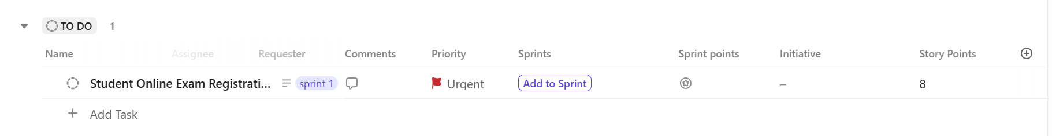
Activity:
Assign Story Points to each backlog task based on its estimated complexity, effort, and time required to complete it.
Step 6 — Define Sprint
In Agile, a Sprint is a 2-week work cycle. For Sprint 1 (March 1–14, 2025), your team will pick the highest priority tasks from the backlog and commit to completing them.
- In the left sidebar, hover over 'SPM Lab Project' space. Click the '+' icon that appears next to the space name.
- Select 'New List'. Name the list: 'Sprint 1 — Mar 1–14, 2025'.
- Click 'Create List' to save.
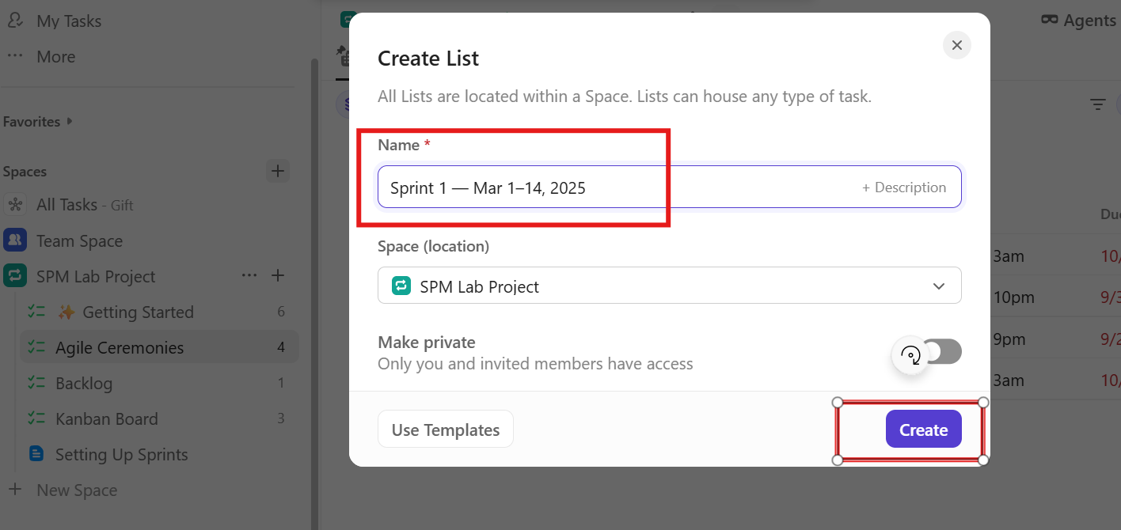
- Then move Tasks from Backlog to Sprint 1
  - Right-click on 'Student Online Exam Registration' → select 'Move to'.
  - Choose 'Sprint 1 — Mar 1–14, 2025' as the destination
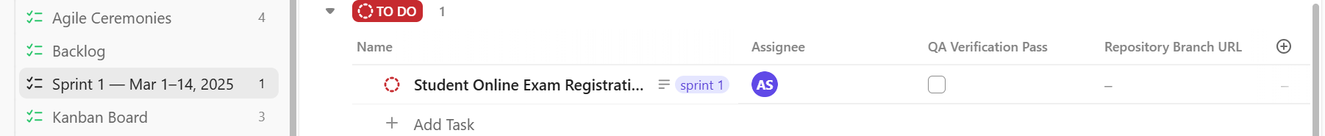
Activity:
- Sprint Creation
- Create a new list: “Sprint 2 ” AND “Sprint 3”
- Move selected high-priority backlog tasks into these Sprints.
Step 7 — Update Sprint Planning in Agile Ceremonies
- Go to 'Agile Ceremonies' list in the sidebar. Click on 'Sprint Planning Meeting' task to open it.
- In the Description, add the following sprint planning notes:
  - Sprint Goal: Set up the core student-facing features of UEMS.
  - Sprint 1 Dates: March 1 – March 14, 2025.
  - Team Capacity: 8 members × 10 days × 6 hrs = 480 hrs available.
  - Selected Tasks: Registration, Fee Payment.
  - Total Story Points: 16 points.
- Close the task when done.
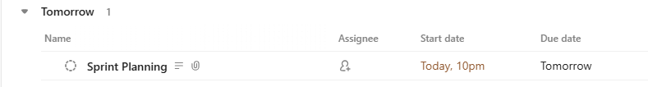
Activity:
Update Sprint Planning in Agile Ceremonies
- Add in “Sprint Planning Meeting” Description for Sprint 2 and 3.
- Write Sprint Goal, Sprint Dates, Team Capacity, Selected Tasks, Total Story Points.
Step 8 — Track Progress on the Kanban Board
The Kanban Board gives you a visual view of all tasks across 4 status columns: Open | In Progress | In Review | Closed.
- Click on “Sprint 1 — Mar 1–14, 2025” in the left sidebar.
- From the top menu, open the View options and select Board (Kanban View).
- You will now see the Kanban board with the following columns:
  - OPEN — tasks not started yet
  - IN PROGRESS — tasks currently being worked on
  - IN REVIEW — tasks completed but waiting for verification
  - CLOSED — completed tasks
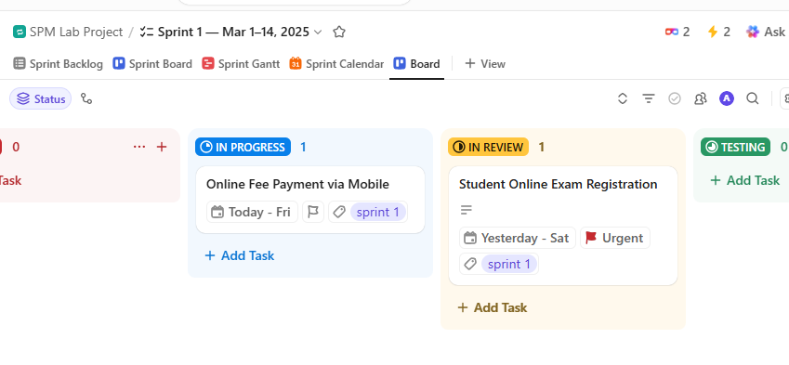
Activity:
UEMS task was moved from Open to In Progress when work started, then shifted to In Review after completion for testing, and finally moved to Closed after successful verification.
Ethical Case Study: The "Result Leak" Pressure
Scenario:
Your team is currently in Sprint 4, developing the "Online Result Publishing" feature for UEMS. The University administration is putting heavy pressure on TechBridge Solutions to ensure results are announced within 15 days (down from the previous 60-day manual process).
On the final day of the Sprint, the QA (Quality Assurance) lead discovers a major security bug: If a student manually changes the Roll Number ID in the browser URL, they can view and download the private results of any other student.

The Project Manager (PM) is worried that fixing this now will cause the Sprint to fail and lead to financial penalties for missing the University's deadline. The PM suggests: "Mark the task as 'Closed' and publish the results now. We will fix it in the next Sprint as a 'Security Patch.' For now, it's unlikely anyone will notice."
Lab Task (Critical Thinking):
- As an Agile Team Member, analyze this situation and respond to the following questions in a new ClickUp task titled "Ethical Review - Sprint 4":
- Speed vs. Privacy: Is meeting the 15-day deadline more important than the data privacy of 40,000 students? How does the Agile principle of "Working Software" apply if the software is functional but insecure?
- Integrity of Status: If you mark a task as "Closed" knowing it contains a major security flaw, which professional ethical standards (e.g., ACM or IEEE) are being violated?
- The Agile Solution: What alternative would you propose to the PM?
Examples: Moving the task back to 'In Progress', extending the Sprint, or informing the client of a 'Blocked' status due to critical risk.

