STRUCTURAL TESTING AND
COVERAGE ANALYSIS
OF PX4 AUTOPILOT
Software Quality Engineering - Assignment 02
System Under Test | PX4-Autopilot v1.17.0
Baseline Commit | d6f12ad1c4f70ad3230afd7d86e971421e02fef4
Course | Software Quality Engineering (SE3002)
Students | Hamza Ahmad(24I-3104), Irtaza Abid(24i-3085),Fizza Fatima Niaz Tour (24I-3076)

Executive Summary
This report presents a white-box structural testing study of two substantive production components in PX4-Autopilot v1.17.0: TakeoffHandling and the Failsafe policy logic in Failsafe::checkStateAndMode(). The work was performed against a fixed, recursively cloned baseline and used PX4's native GTest infrastructure under Ubuntu 24.04.5 LTS on WSL2. Existing upstream tests were used only as baseline and infrastructure references; all assignment test claims are based on student-authored tests.
Eighteen student-authored tests were implemented: five unit tests for TakeoffHandling and thirteen functional tests for Failsafe. The Takeoff suite achieved 95.2% executable-line coverage (40/42), 96.7% branch coverage (29/30), and 100% function coverage (3/3), compared with an authentic upstream baseline of 85.7% lines (36/42), 76.7% branches (23/30), and 100% functions (3/3). For the selected Failsafe scope, lines 445-642 of checkStateAndMode(), the authentic upstream baseline was 0/116 executable lines and 0/218 branches. The student suite achieved 116/116 lines (100%) and 193/218 branches (88.5%). A five-case MC/DC suite demonstrated independent effect for four atomic conditions in a mission-control-loss decision. The complete PX4 test suite subsequently passed 149/149 tests with zero failures. No production source code was modified.

1. Introduction
The objective of this assignment is to derive defensible structural tests from real production code rather than treat coverage percentage as an end in itself. The workflow therefore began with repository and decision analysis, followed by test-level selection, test design, implementation, isolated coverage measurement, gap investigation, and final regression execution.
The selected scope deliberately combines two different classes of production behavior. TakeoffHandling provides deterministic state-machine, timing, ramp, and boundary logic suitable for unit testing. Failsafe provides safety-relevant policy decisions involving flight mode, parameters, communication-loss conditions, mission state, battery state, navigation failures, and failure-detector inputs. Conclusions in this report are limited to these tested areas and do not constitute a general quality claim about PX4 as a whole.

2. Fixed Baseline and Test Environment
Item | Recorded value
PX4 tag | v1.17.0
Exact commit | d6f12ad1c4f70ad3230afd7d86e971421e02fef4
Operating environment | Ubuntu 24.04.5 LTS under WSL2
Architecture | x86_64
Kernel | 6.18.40.1-microsoft-standard-WSL2
Compiler | GCC/G++ 13.3.0
CMake | 3.28.3
Python | 3.12.3
Repository | /home/hamzaahmad/PX4-Autopilot

The repository was cloned recursively and verified at the exact v1.17.0 commit before student modifications. This fixed baseline was retained throughout the study so that source-line decisions, tests, and coverage evidence refer to a reproducible revision.
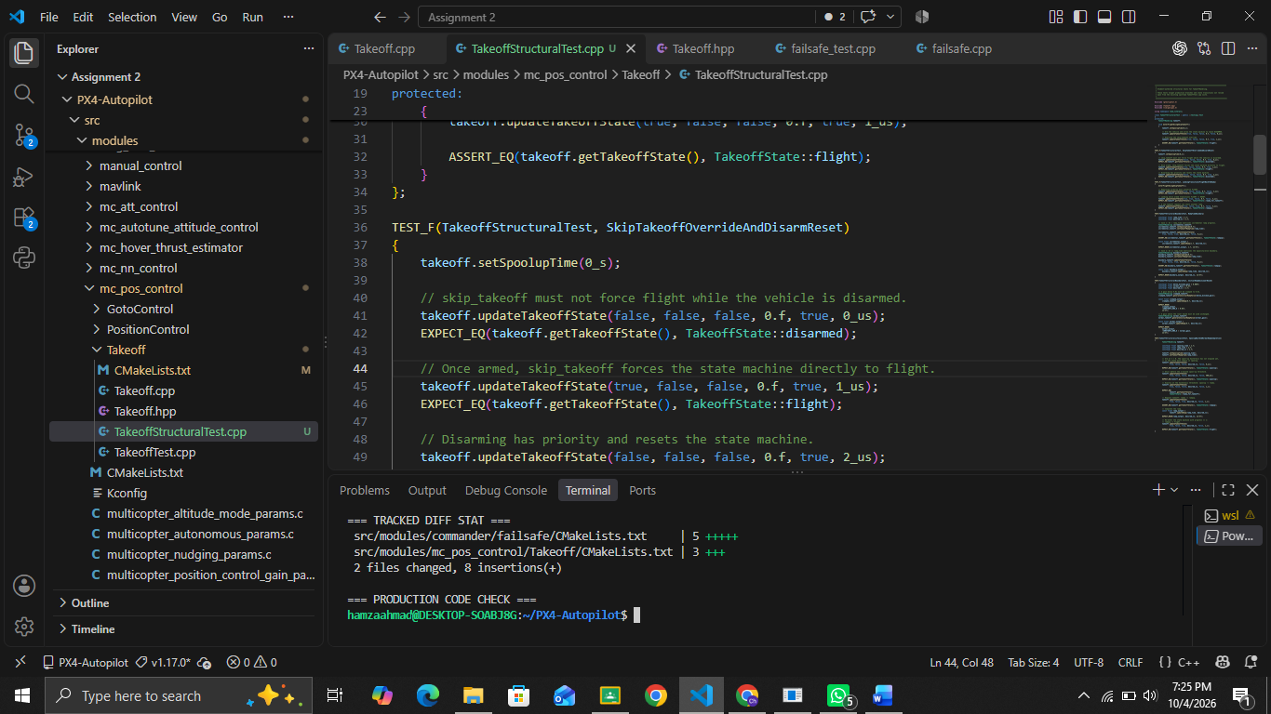

2.1 Baseline Build and Test Execution
The unmodified baseline was built successfully with `make px4_sitl`. The baseline test suite was then executed with `make tests`; all 147 discovered tests passed with zero failures. The reported baseline test time was 81.20 seconds. These upstream tests establish a clean starting point but are not counted as student-authored tests. Authentic coverage baselines were subsequently collected in a separate clean worktree at the exact commit, using only the relevant upstream targets unit-Takeoff and functional-failsafe_test. Both passed. Initial zero coverage was merged with runtime coverage to retain compiled-but-unexecuted production code. The upstream Failsafe tests use a test-specific FailsafeBase implementation and therefore do not execute the real checkStateAndMode() scope.

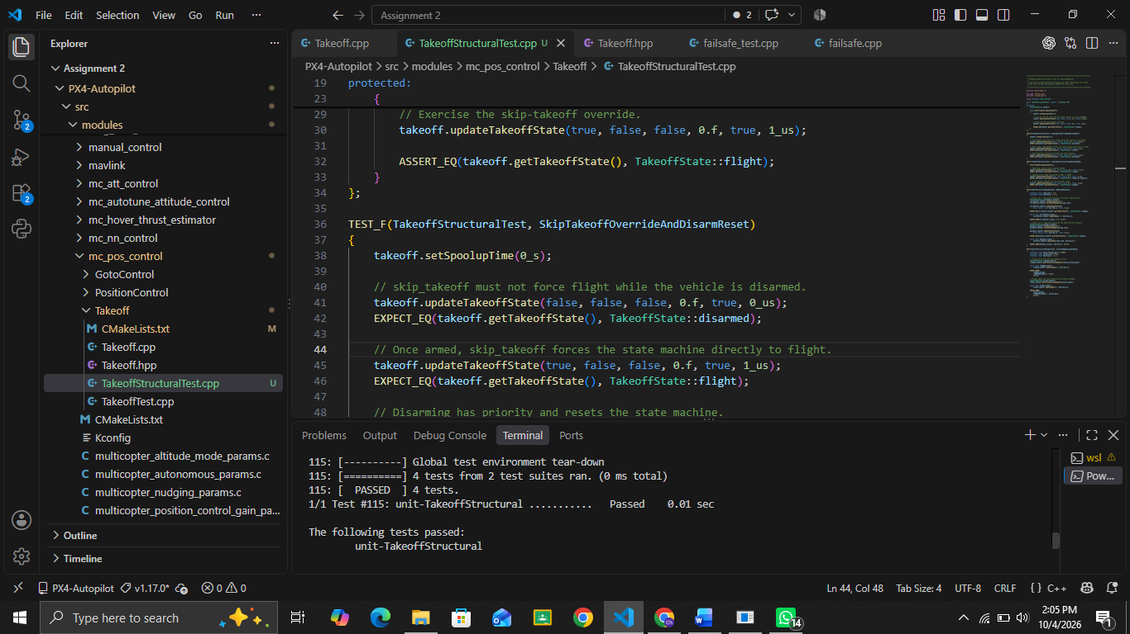

3. Repository Analysis and Scope Selection
Candidate areas were screened for production relevance, structural complexity, dependency burden, observability, and suitability for statement, branch, boundary/state, and MC/DC testing. The final scope contains two cohesive production components rather than many shallow targets.

3.1 Component 1 - TakeoffHandling
Production files: `src/modules/mc_pos_control/Takeoff/Takeoff.cpp` and `Takeoff.hpp`. The selected methods were `generateInitialRampValue()` (approximately lines 42-46), `updateTakeoffState()` (48-110), and `updateRamp()` (112-134). The component governs the sequence DISARMED -> SPOOLUP -> READY_FOR_TAKEOFF -> RAMPUP -> FLIGHT, including landing, disarming, skip-takeoff behavior, spool-up hysteresis, ramp progression, and gain/ramp boundaries.
Structural characteristic | Testing implication
State machine | Exercise legitimate transitions, landing, re-entry and disarm reset.
Temporal behavior | Control spool-up and ramp progression deterministically.
Boundary behavior | Exercise ramp-time threshold, progress threshold and minimum velocity-P gain.
Compound decision | Exercise the `armed && skip_takeoff` override.
Selected test level | GTest unit: dependencies are small and behavior is directly observable.

3.2 Component 2 - Failsafe Policy Logic
Production file: `src/modules/commander/failsafe/failsafe.cpp`. The cohesive selected scope is `Failsafe::checkStateAndMode()` lines 445-642. This safety-relevant policy logic evaluates navigation mode, manual-control and GCS connection state, configured exceptions/actions, mission status, battery warning state, navigation failures, VTOL failure state, and failure-detector conditions. Depending on the conditions, it can request responses including RTL, Land, Disarm, Terminate, Hold, or Warn.
A functional GTest level was selected because the real Failsafe implementation depends on PX4 parameters, vehicle state/status flags, and framework behavior. Existing `failsafe_test.cpp` tests a derived FailsafeBase tester with a test-specific `checkStateAndMode()` implementation; it is useful infrastructure guidance but does not establish structural coverage of the production decision selected here.

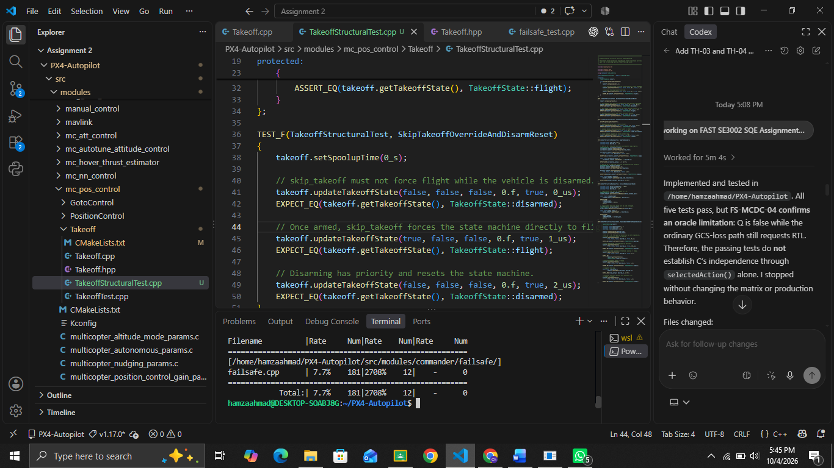

3.3 MC/DC Target and Boolean Decomposition
The MC/DC target is the mission-control-loss decision around lines 534-536. Its simplified Boolean form is:
Q = (A OR B) AND C AND M
A = manual control disabled; B = RC loss ignored for the current mission; C = GCS-loss failsafe action disabled; M = mission finished. When Q is true, the mission-control-loss path invokes failsafe handling with RTL.
Test | A | B | C | M | Q | Independence contribution
FS-MCDC-01 | T | F | T | T | T | A
FS-MCDC-02 | F | F | T | T | F | A, B
FS-MCDC-03 | F | T | T | T | T | B, C, M
FS-MCDC-04 | F | T | F | T | F | C
FS-MCDC-05 | F | T | T | F | F | M

The independence pairs are 01/02 for A, 02/03 for B, 03/04 for C, and 03/05 for M. This demonstrates independent effect without exhaustively enumerating all sixteen Boolean combinations. FS-MCDC-03 and FS-MCDC-04 differ only in C: row 03 uses NAV_DLL_ACT=0 and settles to RTL; row 04 uses NAV_DLL_ACT=1 and settles to Hold through the ordinary GCS-loss policy. RTL versus Hold gives an observable settled-action distinction for C. The ordinary GCS-loss path remains active in row 04 and is included in the interpretation.

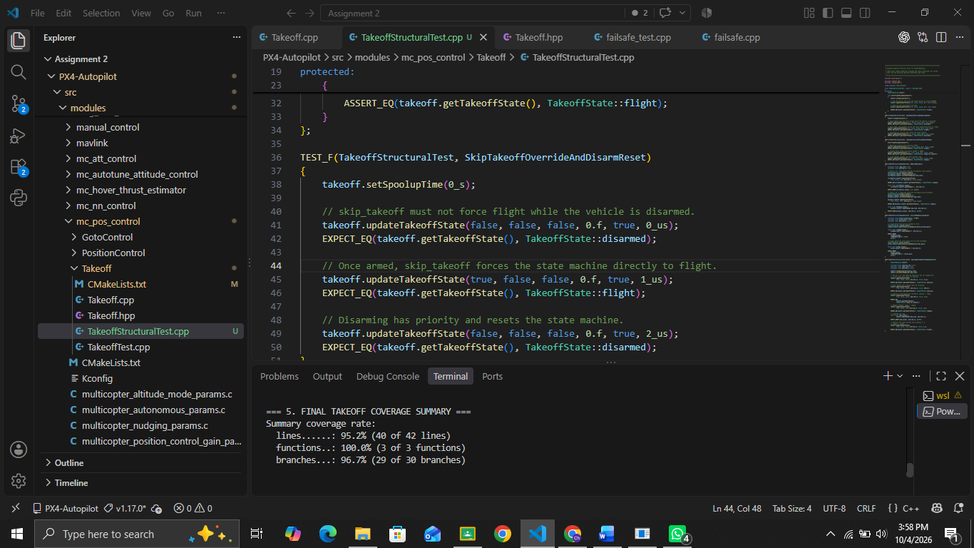

4. Structural Test Design
The suite was designed to retain tests that contribute a distinct branch outcome, state transition, boundary, failure scenario, or MC/DC independence requirement. The complete detailed inventory is supplied in the required two-sheet Excel workbook; the report summarizes the structural intent.

4.1 Takeoff Test Design
ID | Scenario | Primary structural contribution
TH-01 | Skip-takeoff override and disarm reset | Compound override and disarm branch/state reset.
TH-02 | Landing transition and re-takeoff | FLIGHT-to-READY landing path and valid re-entry.
TH-03 | Ramp-time boundary behavior | `ramp_time > dt` and ramp-progress threshold outcomes.
TH-04 | Initial-ramp gain lower-bound protection | Minimum-gain boundary and pre-ramp output.
TH-05 | Spool-up wait and normal ramp completion | Normal SPOOLUP/READY/RAMPUP/FLIGHT path.

4.2 Failsafe Test Design
Thirteen functional tests were used. Five implement the MC/DC matrix above. Eight additional scenario tests exercise manual-control and ordinary GCS-loss policies, quadchute and mode-dependent navigation, battery escalation and arming baselines, critical-failure timing and the termination breaker, spoolup health and optional manual control, independent flight-safety policies, link-loss exceptions and VTOL transitions, and EXTERNAL1 through EXTERNAL8 with the external RC-loss exception enabled and disabled. The tests use controlled PX4 parameters, vehicle state/status flags, and simulated time to keep execution deterministic.
Actual GoogleTest(s) | Purpose | Result
FailsafeStructuralTest.FS_MCDC_01..05 | Five actual MC/DC cases for Q = (A OR B) AND C AND M. Row 04 uses EnabledDatalinkHold. | 5/5 PASS
FailsafeSafetyScenarioTest.ManualAndGcsLossPolicies | Manual-control Land and independent ordinary GCS-loss RTL policies. | PASS
FailsafeSafetyScenarioTest.QuadchuteAndModeDependentNavigation | Quadchute RTL, position-accuracy Hold, navigator Land/Hold by mode. | PASS
FailsafeSafetyScenarioTest.BatteryEscalationAndArmingBaseline | LOW/CRITICAL/EMERGENCY escalation and low battery at arming. | PASS
FailsafeSafetyScenarioTest.CriticalFailureTimingAndCircuitBreaker | Early Disarm, late latched Terminate, breaker-enabled Warn. | PASS
FailsafeSafetyScenarioTest.SpoolupHealthAndOptionalManualControl | Armed lifecycle, spoolup health failures, optional RC regain/loss. | PASS
FailsafeSafetyScenarioTest.IndependentFlightSafetyPolicies | Isolated wind, time, geofence, remaining-time, motor, propeller and mission failures. | PASS
FailsafeSafetyScenarioTest.LinkLossExceptionsAndVtolTransition | Enabled/disabled link-loss exceptions and forward-flight VTOL suppression. | PASS
FailsafeSafetyScenarioTest.ExternalModesManualControlException | EXTERNAL1-EXTERNAL8: exception enabled -> None; disabled -> RTL. | PASS

5. Student-Authored Test Implementation and Execution
The Takeoff tests were added in `src/modules/mc_pos_control/Takeoff/TakeoffStructuralTest.cpp` and registered with `px4_add_unit_gtest(... LINKLIBS Takeoff)`. The Failsafe tests were added in `src/modules/commander/failsafe/FailsafeStructuralTest.cpp` and registered with `px4_add_functional_gtest(... LINKLIBS failsafe mode_util)`. No production source files were changed.
The final student-authored suite contains 18 GTests across two PX4 test executables: five Takeoff tests and thirteen Failsafe tests. Both targets passed in isolated execution before the final full regression. Each workbook inventory row corresponds to one actual TEST or TEST_F definition; the authoritative mapping is Coverage/final-test-traceability.txt.

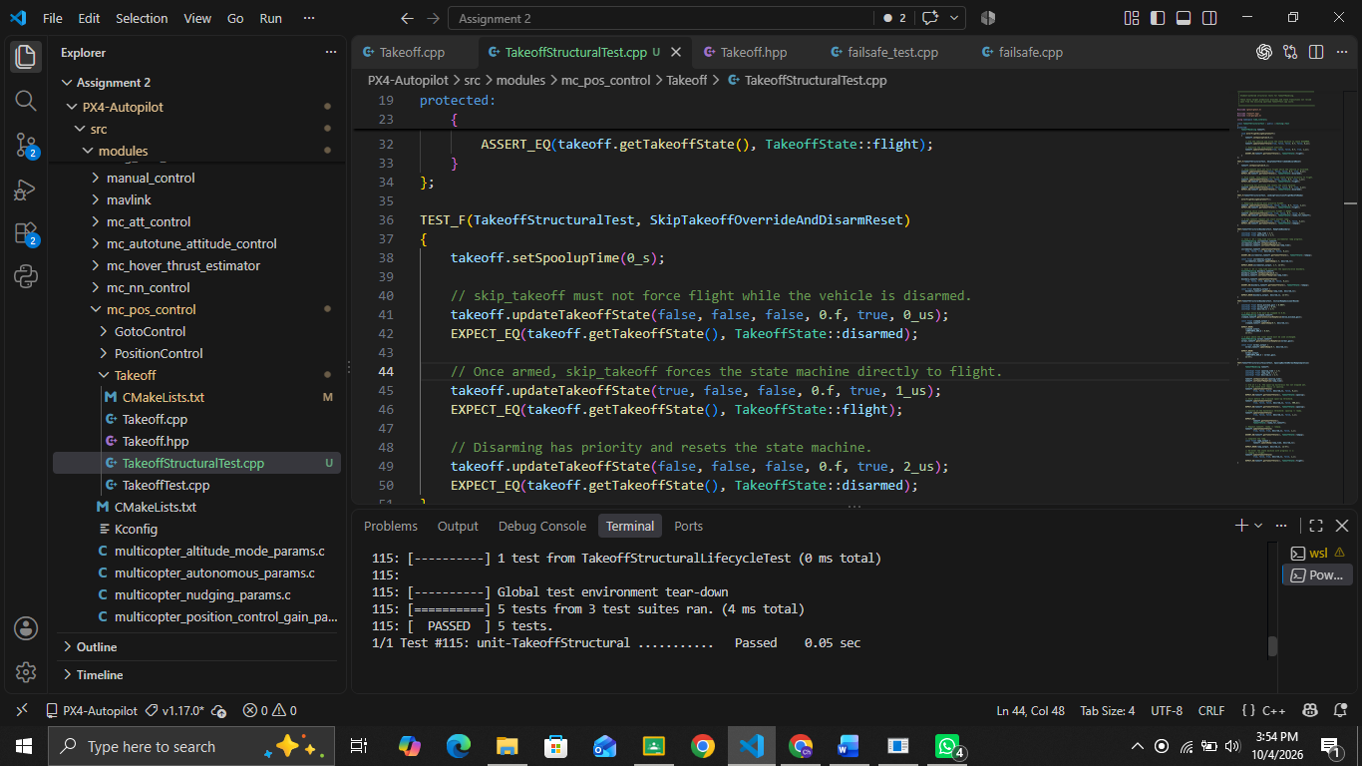

5.1 Final Regression
After integrating both structural targets, the complete PX4 test suite was executed again with `make tests`. The suite contained 149 tests: the original 147 plus the two newly registered student test executables. All 149 tests passed with zero failures. The latest verified final test time was 636.67 seconds. Coverage/full-make-tests-final.log and Coverage/full-make-tests-final.json retain the authoritative final result. This provides regression evidence that the added test targets integrate with the existing test configuration without breaking the baseline suite.

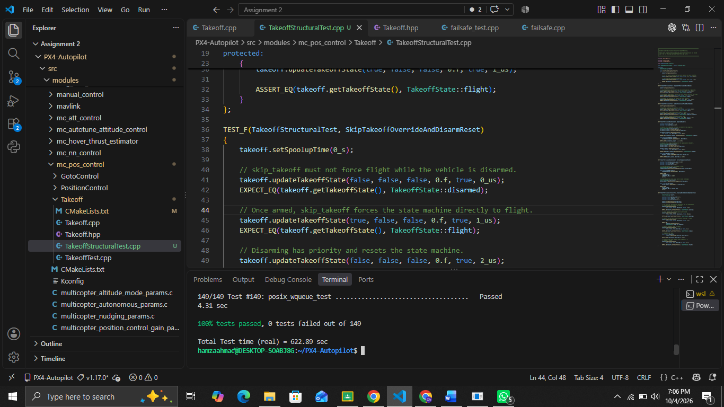

6. Structural Coverage Results and Gap Analysis
Authentic upstream baseline coverage was collected in a separate clean worktree at the exact commit, without student test sources or registrations. Final coverage was collected from isolated student-test execution after separate counter resets for each target, so the reported results are attributable to the student-authored suites. The Failsafe selected-scope metric uses lines 445-642 inclusive. For branch coverage, all LCOV BRDA records in the range are included in the denominator: the upstream baseline has 218 '-' records; the final capture has 218 numeric records, of which 193 have positive counts. The earlier 95/116-line and 107/218-branch measurements described an intermediate student suite, not an upstream baseline, and are not used for the final baseline comparison.

6.1 Takeoff Coverage
Metric | Authentic upstream baseline | Student final
Executable lines | 36/42 = 85.7% | 40/42 = 95.2%
Functions | 3/3 = 100.0% | 3/3 = 100.0%
Branches | 23/30 = 76.7% | 29/30 = 96.7%

The only uncovered executable statements are the `default` arm of the Takeoff-state switch (lines 98-99), corresponding to the sole uncovered branch. All defined operational states are reached through legitimate public state transitions. Reaching the default case would require forcing an invalid internal enum value rather than exercising a realistic production behavior. No production-access modification or private-state corruption was introduced merely to obtain a nominal 100% value.

6.2 Failsafe Coverage
Metric | Authentic upstream baseline | Student final | Change
Whole failsafe.cpp lines | 0/431 (0%) | 259/431 (60.1%) | +60.1 pp
Whole-file functions | 0/14 (0%) | 13/14 (92.9%) | +92.9 pp
Whole-file branches | 0/325 (0%) | 231/325 (71.1%) | +71.1 pp
Selected scope lines 445-642 | 0/116 (0%) | 116/116 (100%) | +100 pp
Selected scope branches | 0/218 (0%) | 193/218 (88.5%) | +88.5 pp

The final selected scope has no uncovered executable lines. EXTERNAL1 through EXTERNAL8 are now covered with the relevant exception enabled and disabled. The only remaining 25 branch records are e0 compiler exception/throw instrumentation edges; gcov inspection confirms their (throw) branch kind. No ordinary substantive selected-scope decision branch remains uncovered. Exact records and classification are retained in Coverage/failsafe-selected-scope-gaps-verified-final.json and Coverage/failsafe-throw-branch-audit.txt.

6.3 Change Integrity and Reproducibility
Final Git inspection confirmed an empty diff for the six selected production implementation files. The source patch contains only the two student-authored test sources and their two CMake registrations, and git apply --check passed against the clean exact-commit baseline worktree. The full regression regenerated two tracked EKF reference CSVs; their known-clean pre-run contents were restored. Coverage artifacts, documentation, workbook files, logs, and unrelated files are excluded from the source patch.

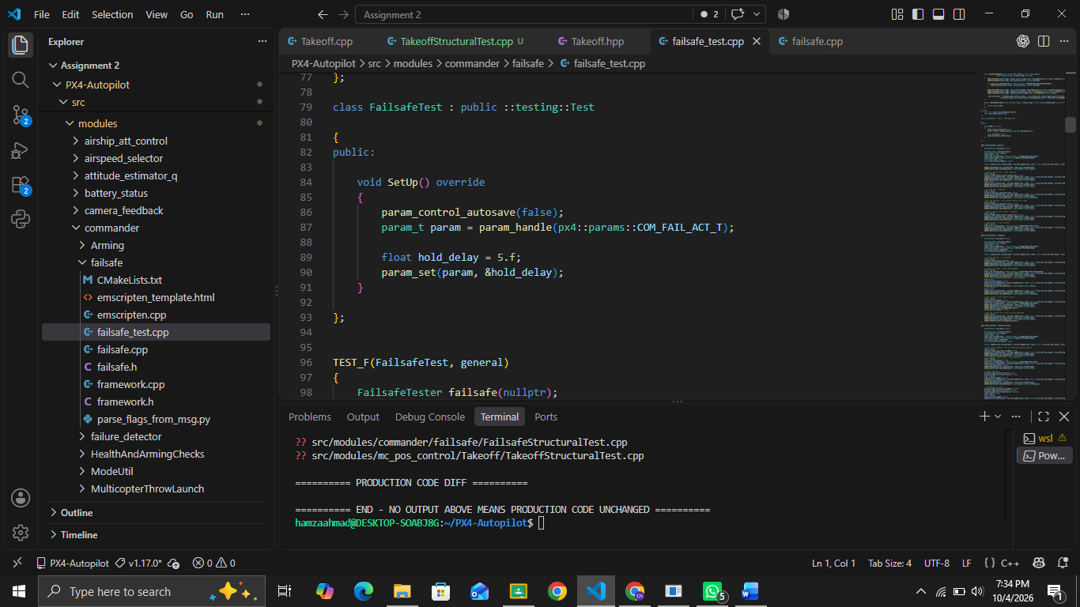

7. Findings and Final Quality Judgment
The evidence supports a strong but deliberately scoped conclusion about the two production areas examined. TakeoffHandling proved highly amenable to isolated unit-level structural testing because its public interface allows legitimate state transitions, timing configuration, and ramp outputs to be controlled without modifying production code. Five focused tests exercised the normal takeoff lifecycle, landing/re-entry behavior, the skip-takeoff override, disarm reset, ramp thresholds, and minimum-gain behavior. The resulting 95.2% executable-line and 96.7% branch coverage is considered practically complete for the public production behavior. The residual default switch arm represents an invalid internal enum state and was not forced solely to increase the percentage.
The Failsafe study provides broader safety-policy evidence. The final thirteen-test functional suite exercised the real Failsafe implementation through its framework path and raised coverage of the selected checkStateAndMode() scope from an authentic upstream baseline of 0/116 lines and 0/218 branches to 116/116 lines (100%) and 193/218 branches (88.5%). The five-case MC/DC design demonstrated independent effect for all four atomic conditions in the selected mission-control-loss decision. For condition C, FS-MCDC-03 and FS-MCDC-04 differ only in C and settle to RTL and Hold respectively. NAV_DLL_ACT=1 in row 04 preserves ordinary GCS-loss handling while making C observably independent.
The remaining Failsafe branch gaps were investigated individually. All eight external-mode predicates are covered. Only 25 compiler exception/throw instrumentation records remain unhit; no ordinary substantive selected-scope decision branch remains uncovered. The final 149/149 regression result further shows that the student test integration did not introduce observed regressions in the existing PX4 test suite. These results increase confidence in the tested Takeoff and Failsafe behaviors, but they do not justify a claim that PX4 as a whole is defect-free or comprehensively verified. Untested modules, hardware-dependent behavior, SITL/HIL interactions, concurrency, and environment-specific failures remain outside the scope of this assignment.

8. Reproduction Commands
Purpose | Command
Build SITL baseline | make px4_sitl
Run complete test suite | make tests
Run Takeoff student target | make tests TESTFILTER='unit-TakeoffStructural'
Run Failsafe student target | make tests TESTFILTER='functional-FailsafeStructural'
Reproduce isolated baseline/student coverage | bash coverage/reproduce-upstream-and-student-coverage.sh (after preparing the recorded clean baseline build)
Recompute Failsafe selected-scope metrics | python3 coverage/failsafe_scope_metrics.py --input coverage/failsafe-production-student-verified-final.info --output /tmp/failsafe-metrics.json

The retained evidence includes authentic upstream baseline LCOV files, verified isolated student-final LCOV files, selected-scope JSON metrics and gap records, test/regression logs, provenance, and reproduction scripts. HTML reports generated from the verified final .info files are available under Coverage/html/takeoff-final/ and Coverage/html/failsafe-final/. The Failsafe HTML reports whole-file coverage; the selected lines 445-642 metrics are reported separately in JSON. No tests were rerun to generate HTML.

Appendix A - Evidence Register
ID | Evidence | Report location
E01 / Fig. 1 | Tag, commit, OS/WSL2 and toolchain verification | Section 2
E02 / Fig. 2 | Successful `make px4_sitl` baseline build | Section 2.1
E03 / Fig. 3 | Baseline `make tests`: 147/147 passed | Section 2.1
E04 / Fig. 4 | Takeoff source structural basis | Section 3.1
E05 / Fig. 5 | Failsafe selected-scope source | Section 3.2
E06 / Fig. 6 | MC/DC production decision source | Section 3.3
E07 / Fig. 7 | Takeoff student execution: 5/5 passed | Section 5
E08 / Fig. 8 | Historical 12-case screenshot; final 13/13 execution in Coverage/failsafe-student-verified-tests.log | Section 5
E09 / Fig. 9 | Final regression: 149/149 passed | Section 5.1
E10 / Fig. 10 | Takeoff final isolated coverage | Section 6.1
E11 / Fig. 11 | Authentic upstream baseline and verified final coverage; earlier screenshot retained as historical evidence | Section 6.2
E12 / Fig. 12 | Clean assignment Git status + empty production diff | Section 6.3

Appendix B - AI Assistance Record
Generative AI assistance was used as a supporting engineering tool during the assignment. It assisted with repository navigation, identifying candidate structural decisions, proposing test scenarios and MC/DC matrices, drafting test scaffolding/commands, interpreting gcov/lcov output, organizing evidence, and formatting the report and workbook. AI output was not treated as authoritative test evidence.
The group remained responsible for fixing the PX4 baseline, selecting the final production targets, checking the source decisions, controlling test inputs and expected results, executing tests locally, validating the MC/DC independence argument, collecting coverage, investigating uncovered branches, distinguishing upstream from student-authored tests, and accepting the final conclusions. Where AI-generated suggestions conflicted with observed production behavior, the source code and actual execution/coverage evidence were treated as authoritative.

Appendix C - Submission Artifact Checklist
- Final formal report (this document).
- Two-sheet Excel workbook: Test Inventory and MC-DC Evidence.
- TakeoffStructuralTest.cpp and FailsafeStructuralTest.cpp.
- CMakeLists.txt changes registering both student test targets.
- Clean Git diff/patch containing only assignment changes.
- Baseline and final execution evidence.
- Baseline/final coverage HTML or equivalent LCOV evidence and selected-scope metrics.
- AI-assistance record.

