NETWORK PORT SCANNER

Cyber Security Internship

Week 2 Project Report
Submitted By: Muhammad Hamza
Submitted To: Optimus Automate

Abstract
The Network Port Scanner is a cybersecurity application developed to identify open ports on a target host. The system uses TCP socket connections to test individual ports and determine their accessibility. The scanner also maps commonly used ports to their associated network services.
The project provides practical experience in network communication, socket programming, multithreading, and cybersecurity assessment techniques.

Introduction
Network services communicate through ports. Attackers often identify vulnerable services by scanning available ports on a target system. Port scanning is therefore a fundamental cybersecurity technique used by both security professionals and malicious actors.
This project demonstrates the implementation of a safe and educational port scanner that helps users understand how network services are exposed on a system.

Objectives
- Develop a graphical port scanning application.
- Identify open ports on a target host.
- Display service names associated with ports.
- Support scanning of custom port ranges.
- Implement timeout handling.
- Export scan results.
- Improve understanding of network security concepts.

Technologies Used
Technology | Purpose
Python | Application Development
Tkinter | GUI Development
Socket Programming | Network Communication
Threading | Background Scanning
Datetime | Report Generation

System Requirements

Hardware Requirements
- Computer or Laptop
- Minimum 4 GB RAM
- Internet or Local Network Connection

Software Requirements
- Python 3.10+
- Tkinter
- Windows Operating System

System Features

Host Scanning
Allows scanning of a target hostname or IP address.

Port Range Scanning
Users can define custom start and end ports.

Open Port Detection
The application attempts TCP connections to identify accessible ports.

Service Identification
Displays common services associated with detected ports.

Export Functionality
Allows saving scan results into a text file.

Progress Tracking
Displays scan completion progress.

System Architecture
User Input
↓
Host Validation
↓
Port Range Selection
↓
Socket Connection Attempts
↓
Open Port Detection
↓
Service Identification
↓
Result Display
↓
Export Results

Working Methodology
The application receives a host address and port range from the user.
For each port within the selected range:
- A socket object is created.
- A TCP connection attempt is made.
- If successful, the port is marked as open.
- Associated service information is displayed.
- Results are added to the GUI table.
After all ports are scanned, the application displays completion status.

Important Code Explanation

Socket Creation
sock = socket.socket(
socket.AF_INET,
socket.SOCK_STREAM
)
This creates a TCP socket used for communication with the target host.

Timeout Handling
sock.settimeout(0.5)
This prevents the scanner from waiting indefinitely for a response.

Port Verification
result = sock.connect_ex(
(host, port)
)
Attempts connection to a specific port.
A return value of 0 indicates that the port is open.

Multithreading
thread = threading.Thread(
target=self.scan_ports,
args=(host, start_port, end_port),
daemon=True
)
Allows scanning operations to run without freezing the GUI.

Screenshots

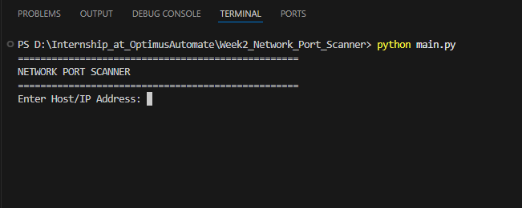
Main Application Window

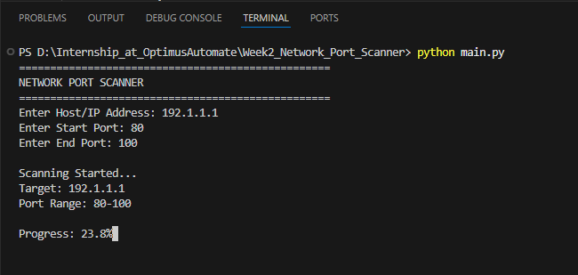
Scan In Progress

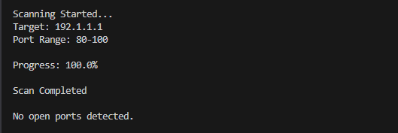
Open Ports Detected

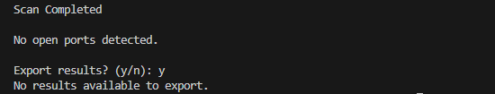
Export Results

Test Cases
Test Case | Input | Expected Output
Localhost Scan | 127.0.0.1 | Open Ports Displayed
Invalid Host | xyz123 | Error Handling
Large Port Range | 1-5000 | Successful Scan
Export Results | Save File | File Generated
Empty Input | Blank Fields | Validation Error

Results
The application successfully identified open ports across multiple test environments. Service identification and export functionality operated correctly. The graphical interface remained responsive throughout scanning due to the use of multithreading.

Advantages
- Easy to use GUI
- Fast scanning process
- Supports custom ranges
- Displays service names
- Export functionality
- Educational cybersecurity tool

Limitations
- Supports only TCP scanning
- No vulnerability detection
- No banner grabbing
- Limited service database

Future Enhancements
- UDP Scanning
- Banner Grabbing
- Service Version Detection
- Vulnerability Assessment
- PDF Report Generation
- Dark Theme Interface

Conclusion
The Network Port Scanner successfully demonstrates core networking and cybersecurity concepts through a practical implementation. The project enables users to identify open ports and understand exposed services on a networked system. It provides valuable experience in socket programming, multithreading, and network security analysis while maintaining a user-friendly graphical interface.

