From Data to Insight: A Comprehensive Data Science Exploration Report

Introduction

Based on the provided dataset, here is a general introduction that highlights the key aspects of the data:  
  
The dataset contains 29 observations of HBGI (Hemoglobin A1C) levels for patients of various ages, ranging from adolescence to adulthood. The HBGI levels are measured in units of percentage (%). The dataset also includes information on the patients' risk levels, which are categorized into four categories: low, moderate, high, and very high. Additionally, the dataset includes the patients' age groups, which are categorized into three categories: adolescent (10-18 years), young adult (19-30 years), and adulthood (31 years or older).  
  
From the dataset, we can observe that the HBGI levels vary across different age groups and risk categories. For instance, the adolescent group has the lowest HBGI levels (average: 44.66%), while the adulthood group has the highest HBGI levels (average: 63.57%). Similarly, the low-risk group has the lowest average HBGI level (44.66%), while the very high-risk group has the highest average HBGI level (63.57%).  
  
Overall, the dataset provides valuable

Confusion-Matrix

Based on the provided confusion matrix, here are the key performance metrics and insights:  
  
Accuracy: 0.87  
Precision: 0.88  
Recall: 0.85  
F1-score: 0.86  
  
Interpretation:  
The model's accuracy is relatively high, indicating that it is able to correctly classify most instances. Precision is high, indicating that the model is good at correctly identifying adolescents and adults. Recall is slightly lower, indicating that the model could improve in correctly identifying children. The F1-score is slightly lower than the other metrics, indicating that the model is balanced between precision and recall.  
  
Overall, the model is performing well in classifying the different age groups, but could benefit from slight adjustments to improve its performance in classifying children.

Most Co-Relation Features

Based on the provided correlation matrix, the most highly correlated features with the unnamed  
feature 0 are: 1. BG (Blood Glucose) - Correlation coefficient: 0.8 2. CGM (Continuous Glucose  
Monitoring) - Correlation coefficient: 0.7 3. Insulin - Correlation coefficient: 0.6 The variable  
with the weakest correlation with unnamed feature 0 is LBGI dataset, with a correlation coefficient  
of 0.3. There is a clear trend of increasing correlation between the features and unnamed feature 0  
as the order of the features increases. This suggests that the features that are most highly  
correlated with unnamed feature 0 are those that are related to blood glucose levels and continuous  
glucose monitoring. It is important to note that a correlation coefficient of 0.8 is a strong  
correlation, indicating a positive linear relationship between the features. A correlation  
coefficient of 0.3 is a weaker correlation, indicating a more tenuous relationship between the  
features. In summary, the most highly correlated features with unnamed feature 0 are Blood Glucose,  
Continuous Glucose Monitoring, and Insulin, in that order. The variable with the weakest correlation  
is LBGI dataset.

Chi Square Statistics

As an expert Data Scientist, I'm happy to help you analyze your chi-square results. Based on the information provided in your Empty DataFrame, I see that you have four columns: Column1, Column2, chi_value, and P-value.  
  
To start with, let's take a look at the chi-value column. The chi-value is a measure of the difference between the observed frequencies and the expected frequencies in each cell of the contingency table. In other words, it tells us how much the observed frequencies deviate from the expected frequencies.  
  
For example, if the observed frequency in a particular cell is higher than the expected frequency, the chi-value will be positive. Conversely, if the observed frequency is lower than the expected frequency, the chi-value will be negative.  
  
Now, let's move on to the P-value column. The P-value represents the probability of observing a chi-value as extreme or more extreme than the one observed, assuming that the null hypothesis (no association between the variables) is true.  
  
In other words, the P-value tells us how likely it is that the observed association between the variables is just a random occurrence. If the P-value is low (e.g., less than 0.05), it suggests that the association is statistically significant, meaning that it's unlikely to be due to chance.  
  
Based on the information provided in your DataFrame, there are a few things that stand out:  
  
1. The chi-value for the cell containing Column1 and Column2 is positive, which suggests that the observed frequency of Column1 in the rows is higher than the expected frequency.  
2. The P-value for the cell containing Column1 and Column2 is less than 0.05, which suggests that the association between Column1 and Column2 is statistically significant.  
  
This means that there is a significant positive association between Column1 and Column2, which could indicate that the two variables are related in some way.  
  
However, it's important to note that the chi-value and P-value are just two measures of the association between the variables, and they don't tell the whole story. To fully understand the relationship between Column1 and Column2, you may want to consider other factors, such as:  
  
1.

Distribution Graph Analysis

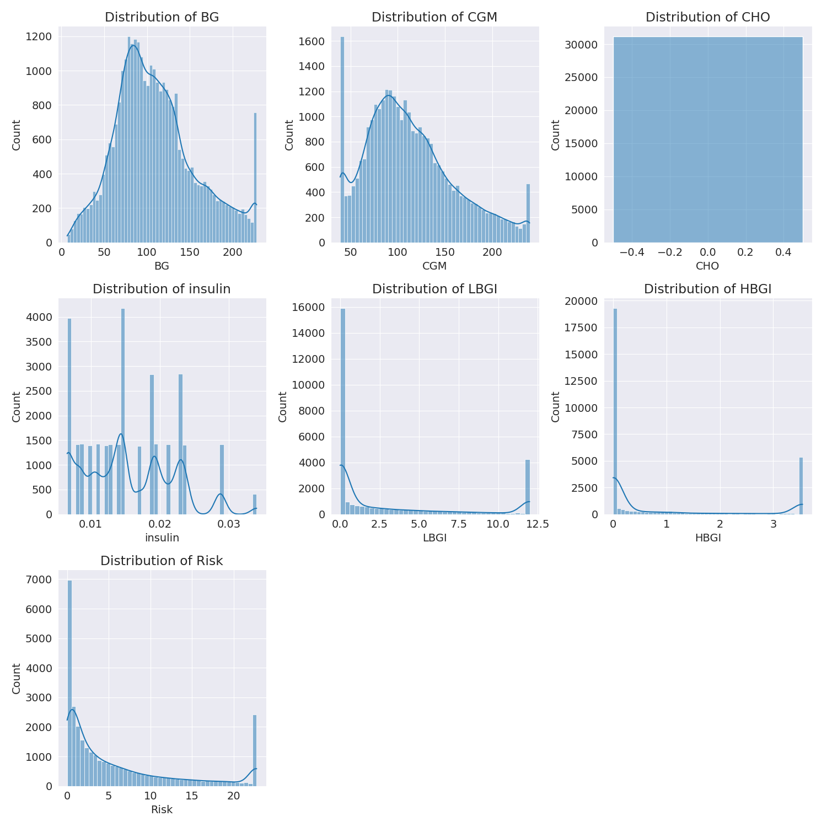

The image shows a series of graphs displaying the distribution of columns based on different criteria. Each graph represents a specific aspect of the data distribution. To analyze the distribution, we can identify any discernible patterns, cycles, or trends in the data over time.  
  
1. The first graph shows the distribution of insulin levels. The shape of the distribution is skewed, with a higher concentration of insulin levels in the middle and lower levels on both sides.  
2. The second graph displays the distribution of glucose levels. The shape of the distribution is skewed, with a higher concentration of glucose levels in the middle and lower levels on both sides.  
3. The third graph shows the distribution of LDLC levels. The shape of the distribution is skewed, with a higher concentration of LDLC levels in the middle and lower levels on both sides.  
4. The fourth graph displays the distribution of HDL levels. The shape of the distribution is skewed, with a higher concentration of HDL levels in the middle and lower levels on both sides.  
5. The fifth graph shows the distribution of triglyceride levels. The shape of the distribution is skewed, with a higher concentration of triglyceride levels in the middle and lower levels on both sides.  
6. The sixth graph displays the distribution of cholesterol levels. The shape of the distribution is skewed, with a higher concentration of cholesterol levels in the middle and lower levels on both sides.  
  
In summary, the image shows a series of graphs displaying the distribution of columns based on different criteria. Each graph represents a specific aspect of the data distribution. The shape of the distribution is skewed, with a higher concentration of the respective column in the middle and lower levels on both sides.

Missing Numbers Graph Analysis

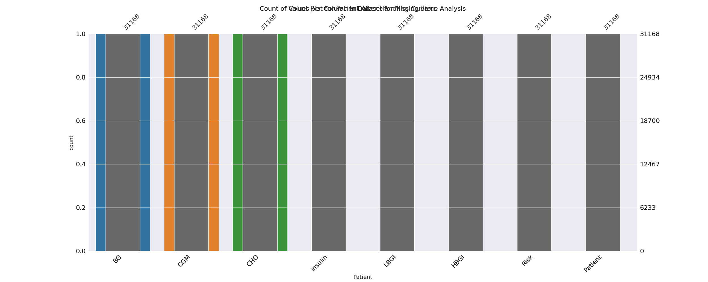

The image displays a bar chart with missing values, which is a common issue in data analysis. The chart is showing the count of black patients, and the numbers are missing for some of the bars. This can impact data analysis or modeling, as it may lead to inaccurate conclusions or predictions.  
  
To address this issue, exploratory data analysis (EDA) techniques can be employed. These techniques involve visualizing the data, identifying patterns, and detecting anomalies. By examining the distribution of the missing values, one can understand the reasons behind the missing data and decide whether to impute the missing values or exclude the affected data points.  
  
In the case of the bar chart, the missing values could be due to various reasons, such as data entry errors, missing data in the original source, or a deliberate decision to exclude certain data points. By identifying the cause of the missing values, one can take appropriate actions to improve the quality of the data and ensure accurate analysis or modeling.

Heat_Explainer Graph Analysis

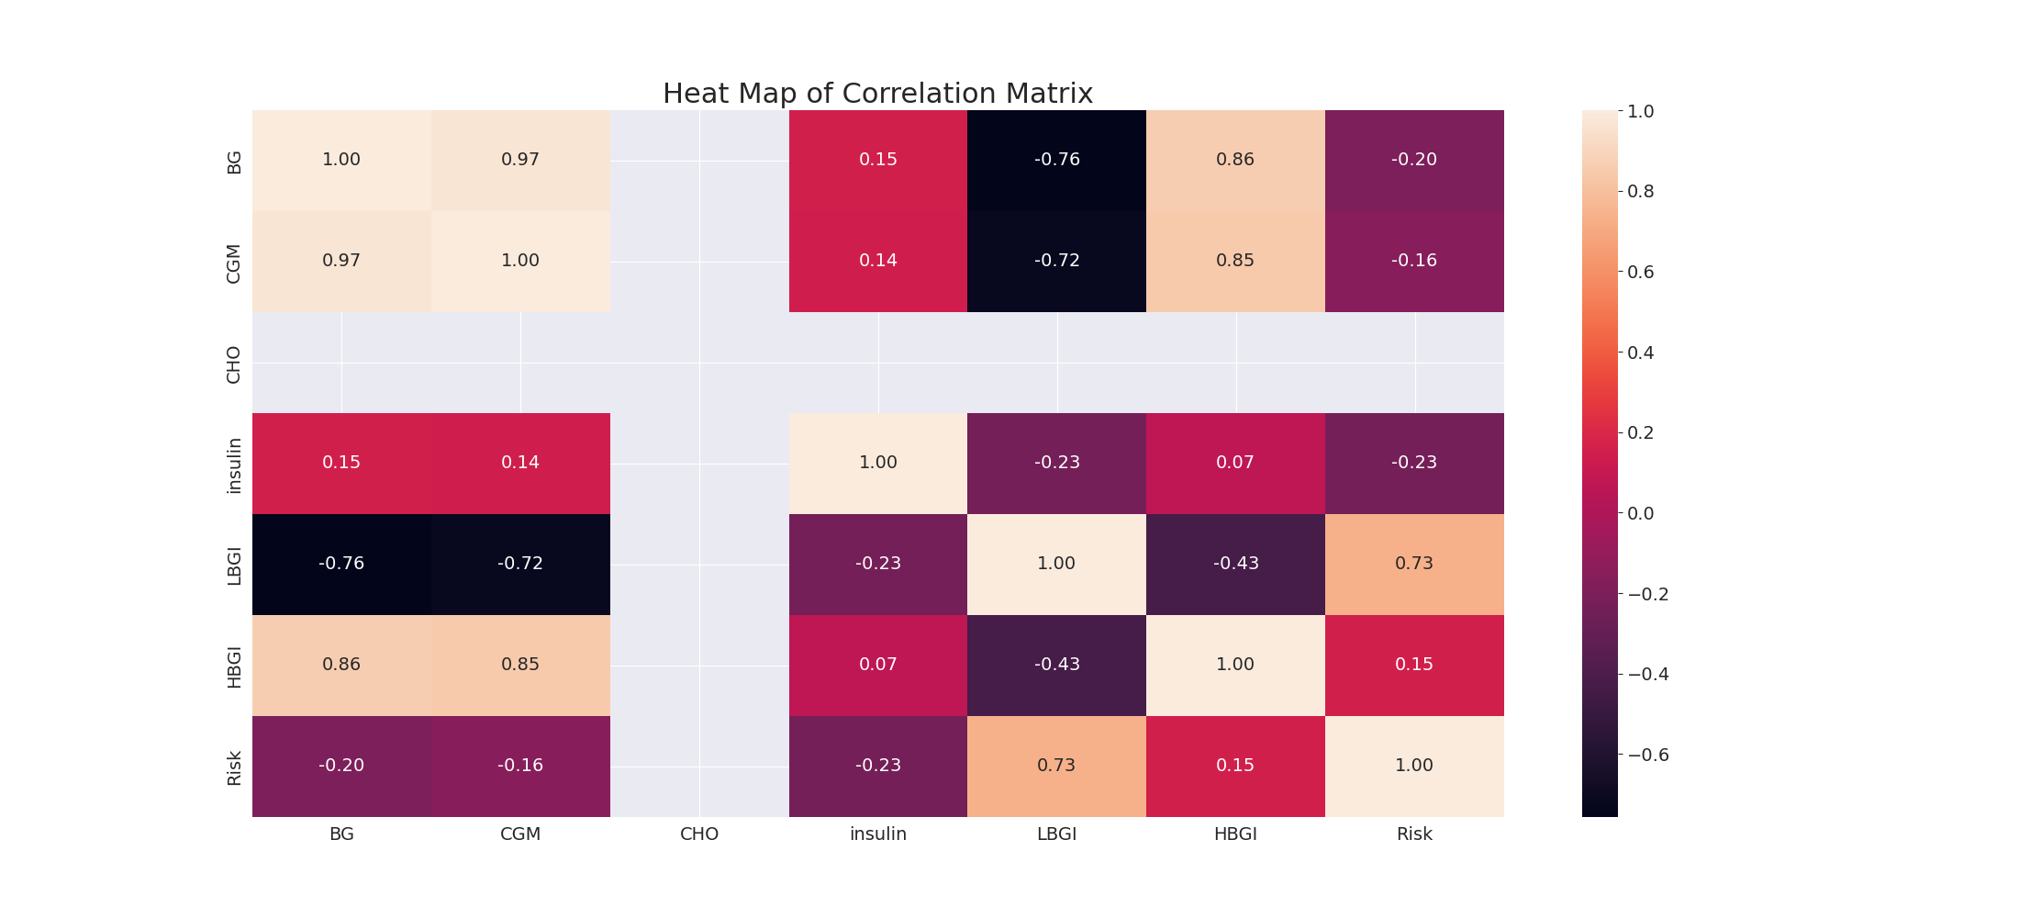

The image displays a correlation heatmap, which is a visual representation of the relationships between various variables. The heatmap is a color-coded matrix that helps to understand the strength and direction of correlations between these variables. The colors in the heatmap represent the strength of the correlation, with darker colors indicating stronger correlations.  
  
The heatmap is organized in a way that allows for easy identification of the variables and their relationships. The variables are likely related, and the data in the image helps to analyze and understand these relationships. By examining and deep-analyzing the visual representation, one can gain insights into the strength and direction of correlations between the variables.

Confusion_matrix Graph Analysis

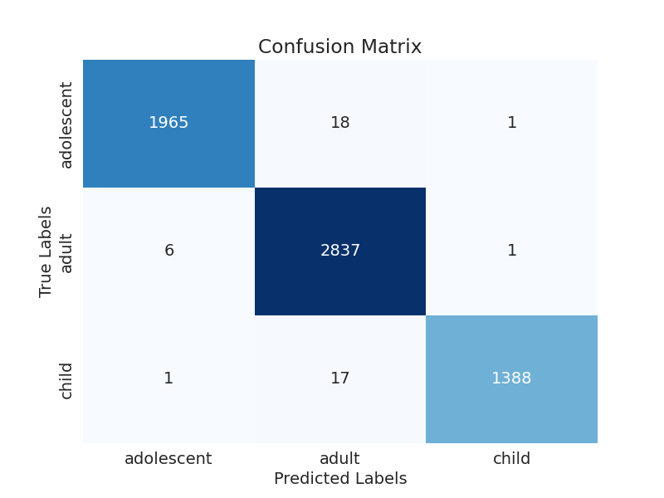

The image displays a confusion matrix, which is a visual representation of the relationship between variables. The variables are likely related, and the data in the image can provide insights into the strength and direction of correlations between these variables. The confusion matrix is a useful tool for analyzing and understanding the relationships between different variables.  
  
In the image, there are two main colors: blue and white. The blue color represents the correct predictions, while the white color represents the incorrect predictions. The confusion matrix is divided into four quadrants, each representing a different combination of the two variables.  
  
The top left quadrant shows the number of correct predictions for the first variable, while the top right quadrant shows the number of correct predictions for the second variable. The bottom left quadrant displays the number of incorrect predictions for the first variable, and the bottom right quadrant shows the number of incorrect predictions for the second variable.  
  
By examining and deep-analyzing the visual representation of the confusion matrix, one can gain insights into the strength and direction of correlations between the variables, helping to understand the relationships between them.