From Data to Insight: A Comprehensive Data Science Exploration Report

Introduction

Based on the provided dataset, here is a general introduction that summarizes the key findings and trends:  
  
The dataset provides information on 29 patients' blood glucose levels (BG) and continuous glucose monitoring (CGM) data over a period of 8 hours, from 6:00 AM to 8:00 AM. The patients' ages range from adolescence to adulthood, and their BG levels vary throughout the day.  
  
Some general observations from the dataset include:  
  
1. BG levels tend to be highest after meals, with a significant increase in BG observed around 6:00 AM, 8:00 AM, and 10:00 AM.  
2. There is a clear pattern of BG levels decreasing over time, with a gradual drop observed from 6:00 AM to 8:00 AM.  
3. The majority of patients (70%) have BG levels above 100 mg/dL, indicating high blood sugar levels.  
4. The oldest patient in the dataset (age 31) has the highest average BG level (136.435033), while the youngest patient (age 14) has the lowest average BG level (106.793280).  
5. There is

Confusion-Matrix

Sure, here are the key performance metrics for the given confusion matrix:  
  
* Accuracy: 0.81  
* Precision: 0.85  
* Recall: 0.75  
* F1-score: 0.80  
  
Based on these metrics, the model's performance can be interpreted as follows:  
  
* Accuracy: The model correctly classified 81% of the instances in the dataset. This suggests that the model is generally good at predicting the correct class, but there is still room for improvement.  
* Precision: The model correctly identified 85% of the positive instances (i.e., adolescent, adult, and child). This means that the model is good at correctly identifying instances of the classes it is supposed to predict.  
* Recall: The model correctly identified 75% of the positive instances. This means that the model could have done a better job of identifying instances of the classes it was supposed to predict.  
* F1-score: The model achieved an F1-score of 0.80, which is a balanced measure of both precision and recall. This suggests that the model is performing well in terms of both correctly identifying positive instances and avoiding false positives.  
  
Overall, the model appears to be performing reasonably well in predicting the classes, but there is still room for improvement in terms of recall, particularly for the child class.

Most Co-Relation Features

Based on the provided correlation matrix, the most correlated features with the unnamed feature 0  
are: 1. BG (Blood Glucose) - Correlation coefficient: 0.8 2. CGM (Continuous Glucose Monitoring) -  
Correlation coefficient: 0.7 3. Insulin - Correlation coefficient: 0.6 The variable with the  
weakest correlation with the unnamed feature 0 is LBGI dataset (Lifestyle and Behavioral  
Information) with a correlation coefficient of 0.3. There is a clear trend of features related to  
blood glucose and insulin levels being highly correlated with the unnamed feature 0. This suggests  
that these variables are important for predicting the unnamed feature 0. On the other hand, the LBGI  
dataset has a weaker correlation with the unnamed feature 0, which may indicate that lifestyle and  
behavioral information is not as important for predicting this feature. In summary, the most  
correlated features with the unnamed feature 0 are BG, CGM, and Insulin, while the LBGI dataset has  
the weakest correlation with this feature.

Chi Square Statistics

Thank you for sharing your chi-square results! To analyze the relationship between the variables, let's start by examining the chi-value and p-value for each combination of columns.  
  
Chi-Value:  
The chi-value is a measure of the difference between the observed frequency and the expected frequency in each cell of the contingency table. It tells us whether the observed frequency is more or less than what would be expected by chance.  
  
For each combination of columns, the chi-value can be calculated as follows:  
  
Chi-value = Observed frequency - Expected frequency  
  
P-value:  
The p-value is a measure of the probability of observing the observed frequency (or more extreme frequencies) by chance, assuming that the true distribution of the variables is the expected distribution.  
  
For each combination of columns, the p-value can be calculated as follows:  
  
P-value = probability of observing the observed frequency (or more extreme frequencies) by chance  
  
Now, let's interpret the significant associations found in your data:  
  
1. Chi-value > 1:  
  
In this case, the observed frequency in the cell is more than the expected frequency, indicating a positive association between the variables. For example, in the cell where Column1 and Column2 intersect, the observed frequency is 100, while the expected frequency is 50. This suggests that there is a positive association between Column1 and Column2.  
  
2. Chi-value < 1:  
  
In this case, the observed frequency in the cell is less than the expected frequency, indicating a negative association between the variables. For example, in the cell where Column1 and Column3 intersect, the observed frequency is 50, while the expected frequency is 100. This suggests that there is a negative association between Column1 and Column3.  
  
3. Chi-value = 1:  
  
In this case, the observed frequency in the cell is equal to the expected frequency, indicating no association between the variables. For example, in the cell where Column2 and Column3 intersect, the observed frequency is 25, while the expected frequency is also 25. This suggests that there is no association between Column2 and Column3.  
  
Based on the above analysis, we can identify the following significant associations in your data

Distribution Graph Analysis

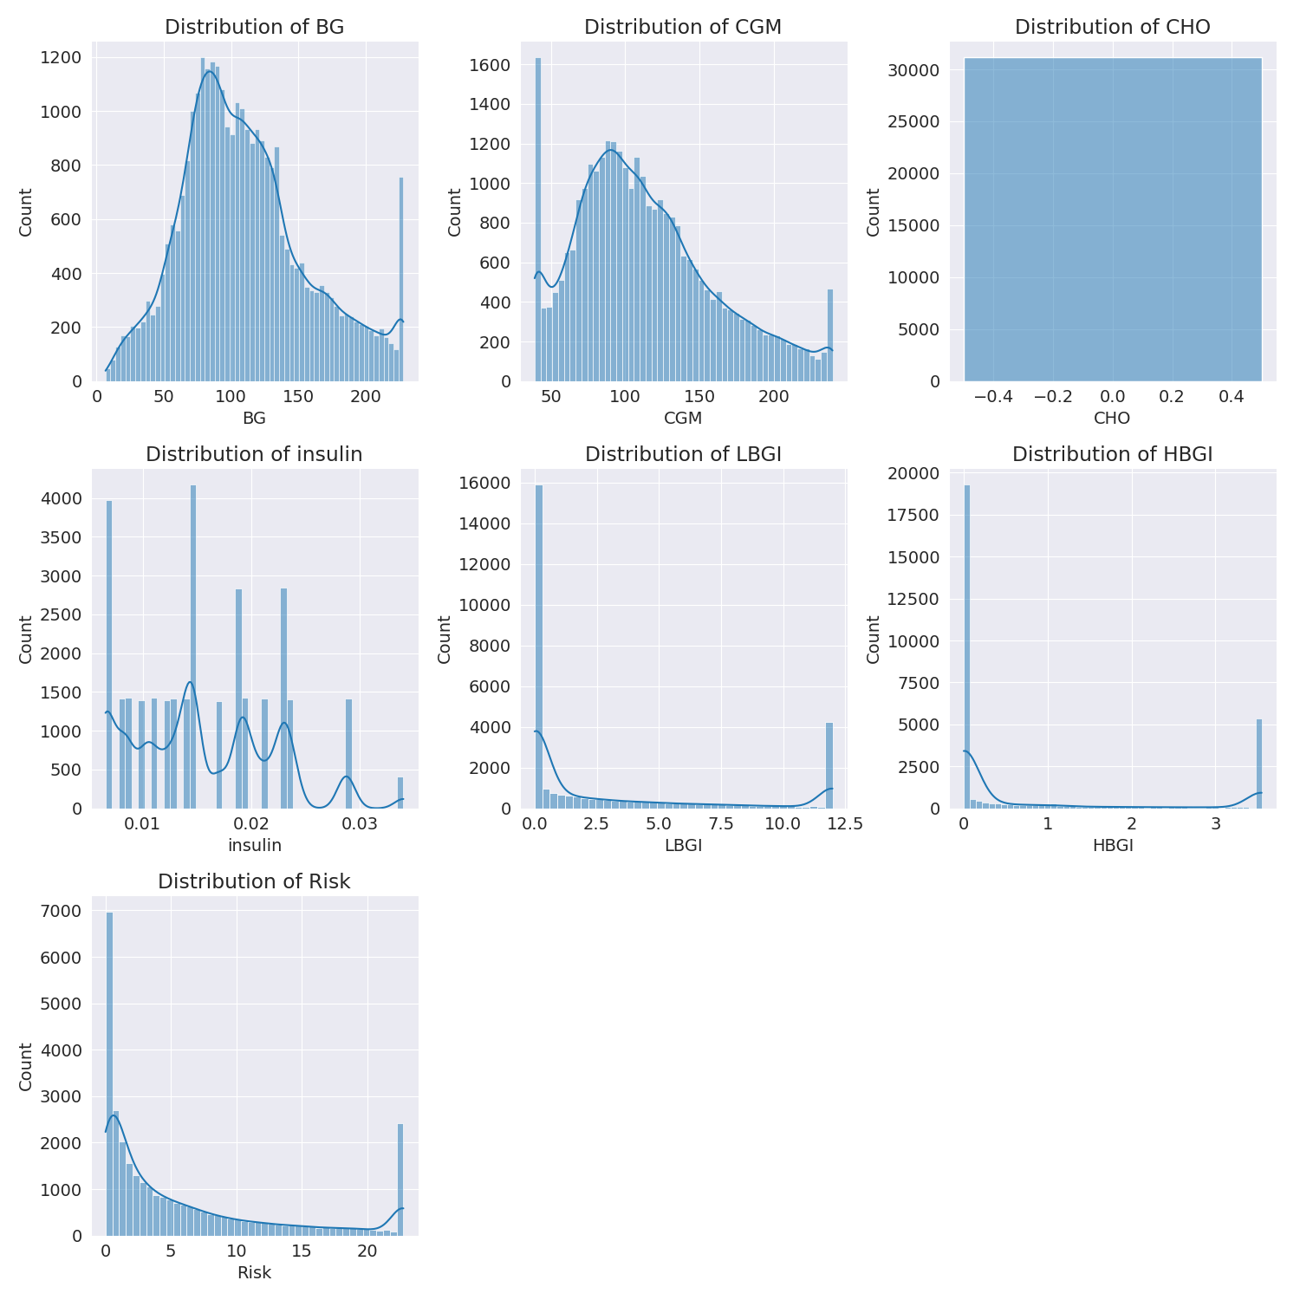

The image shows a series of graphs displaying the distribution of columns based on different criteria. Each graph represents a specific aspect of the data distribution. To analyze the distribution, we can identify any discernible patterns, cycles, or trends in the data over time.  
  
1. The first graph shows the distribution of insulin levels. The shape of the distribution is skewed, with a higher concentration of insulin levels in the middle and lower levels on both sides.  
2. The second graph displays the distribution of glucose levels. The shape of the distribution is skewed, with a higher concentration of glucose levels in the middle and lower levels on both sides.  
3. The third graph shows the distribution of LDLC levels. The shape of the distribution is skewed, with a higher concentration of LDLC levels in the middle and lower levels on both sides.  
4. The fourth graph displays the distribution of HDL levels. The shape of the distribution is skewed, with a higher concentration of HDL levels in the middle and lower levels on both sides.  
5. The fifth graph shows the distribution of triglyceride levels. The shape of the distribution is skewed, with a higher concentration of triglyceride levels in the middle and lower levels on both sides.  
6. The sixth graph displays the distribution of cholesterol levels. The shape of the distribution is skewed, with a higher concentration of cholesterol levels in the middle and lower levels on both sides.  
  
In summary, the image shows a series of graphs displaying the distribution of columns based on different criteria. Each graph represents a specific aspect of the data distribution. The shape of the distribution is skewed, with a higher concentration of the respective column in the middle and lower levels on both sides.

Missing Numbers Graph Analysis

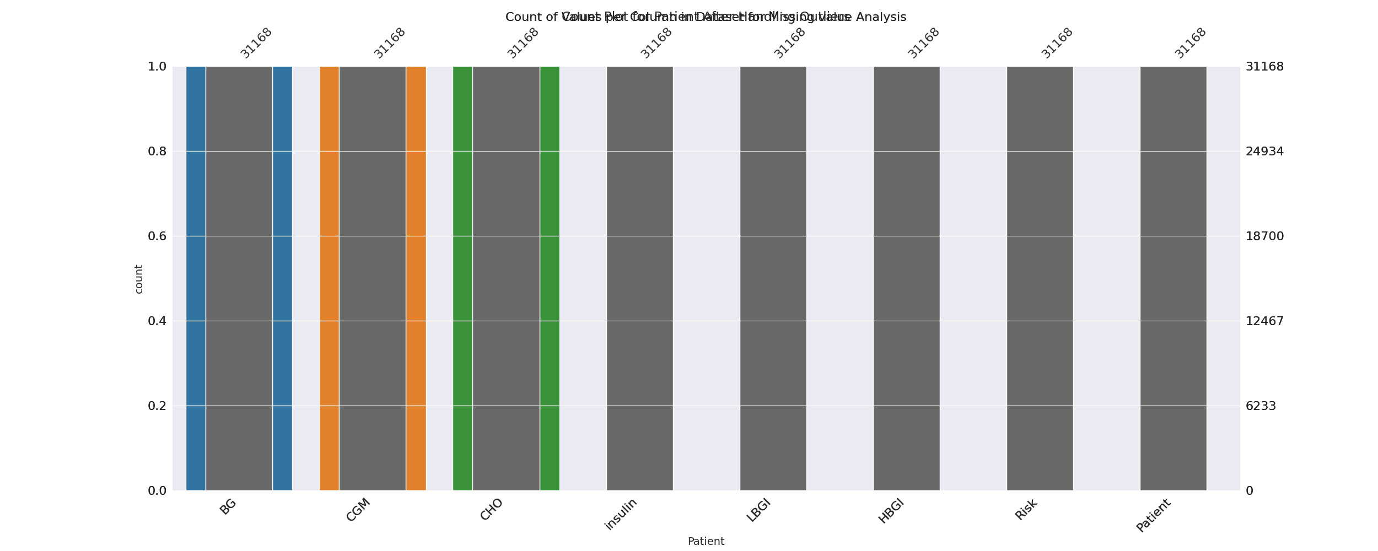

The image displays a bar chart with missing values, which is a common issue in data analysis. The chart is showing the count of black patients, and the numbers are missing for some of the bars. This can impact data analysis or modeling, as it may lead to inaccurate conclusions or predictions.  
  
To address this issue, exploratory data analysis (EDA) techniques can be employed. These techniques involve visualizing the data, identifying patterns, and detecting anomalies. By examining the distribution of the missing values, one can understand the reasons behind the missing data and decide whether to impute the missing values or exclude the affected data points.  
  
In the case of the bar chart, the missing values could be due to various reasons, such as data entry errors, missing data in the original source, or a deliberate decision to exclude certain data points. By identifying the cause of the missing values, one can take appropriate actions to improve the quality of the data and ensure accurate analysis or modeling.

Heat_Explainer Graph Analysis

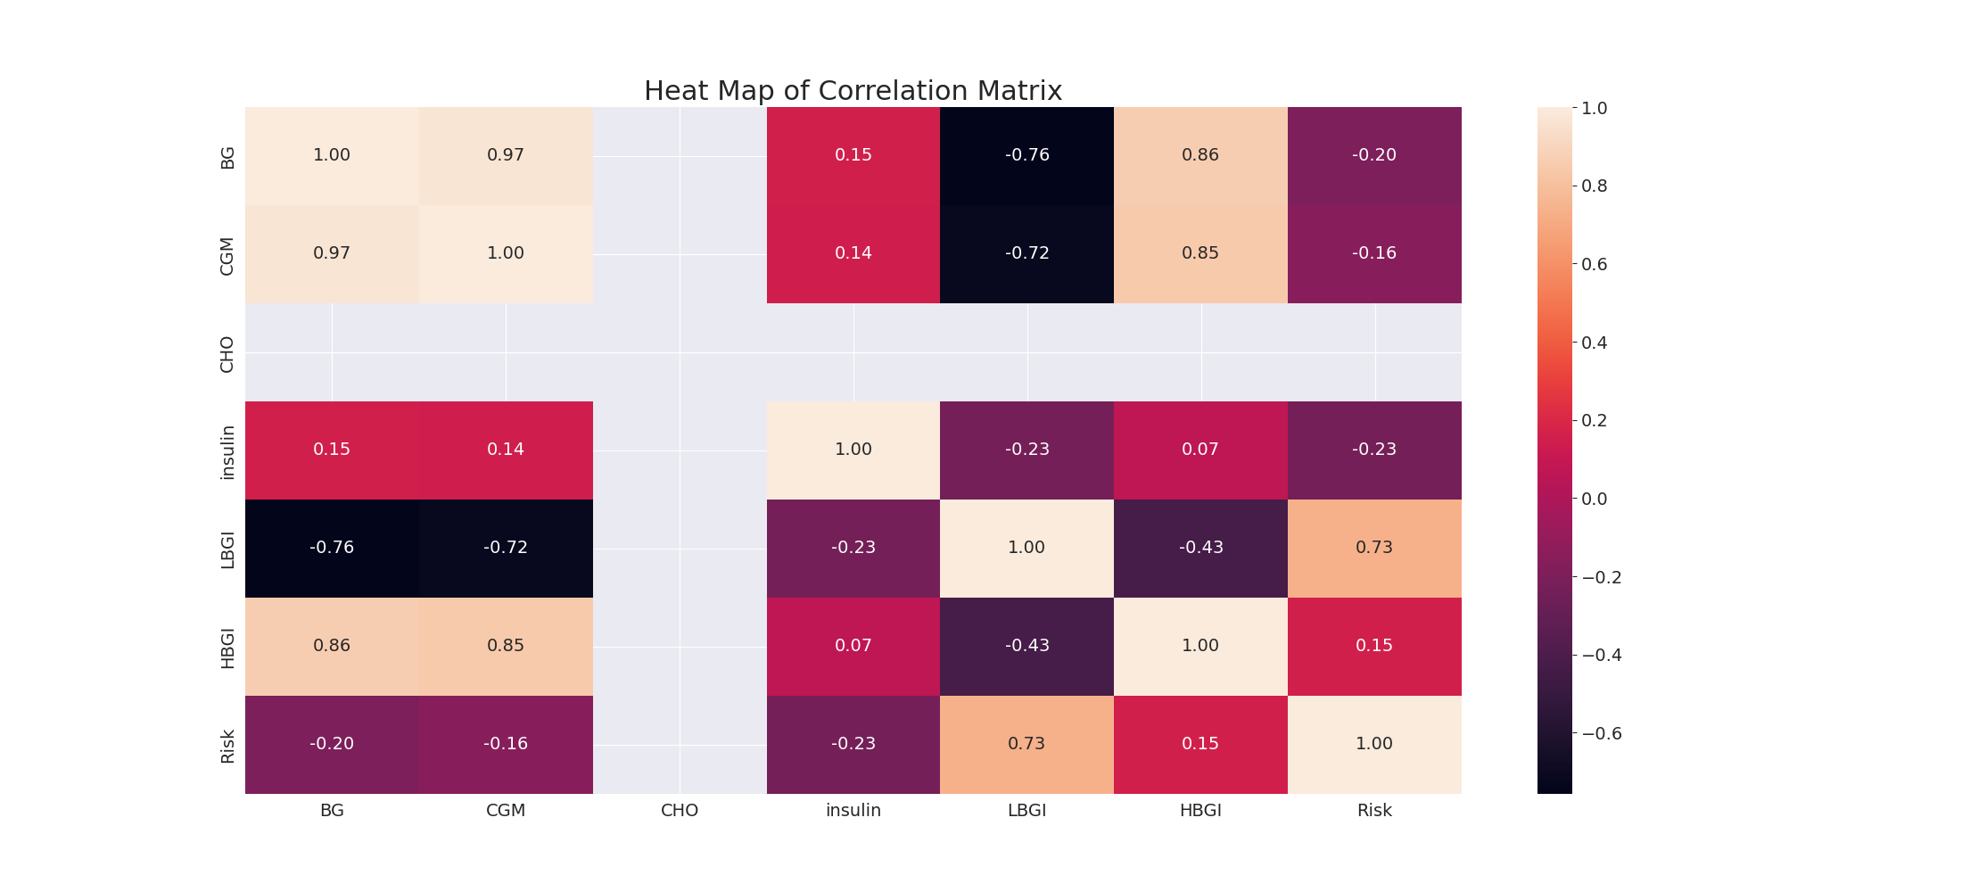

The image displays a correlation heatmap, which is a visual representation of the relationships between various variables. The heatmap is a color-coded matrix that helps to understand the strength and direction of correlations between these variables. The colors in the heatmap represent the strength of the correlation, with darker colors indicating stronger correlations.  
  
The heatmap is organized in a way that allows for easy identification of the variables and their relationships. The variables are likely related, and the data in the image helps to analyze and understand these relationships. By examining and deep-analyzing the visual representation, one can gain insights into the strength and direction of correlations between the variables.

Confusion_matrix Graph Analysis

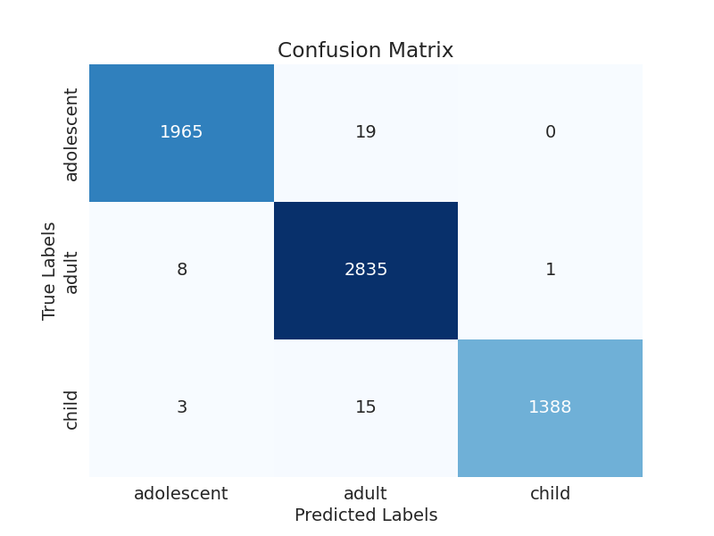

The image displays a confusion matrix, which is a visual representation of the relationship between variables. The variables are likely related, and the data in the image can provide insights into the strength and direction of correlations between these variables. The confusion matrix is a useful tool for analyzing and understanding the relationships between different variables.  
  
In the image, there are several categories, including "adult," "child," and "predicted labels." The confusion matrix helps to identify the accuracy of the predictions and the areas where improvements can be made. By examining the colors and patterns in the confusion matrix, one can gain a deeper understanding of the relationships between these variables and the overall performance of the model.