From Data to Insight: A Comprehensive Data Science Exploration Report

Introduction

Based on the provided dataset, here is a general introduction that summarizes the key information:  
  
The dataset contains 29 observations of HBGI (Hormone Balance and Glucose Interaction) measurements for adolescents, along with their corresponding risk levels and patient information. The observations are evenly distributed across the day, with 4 observations per hour from 6:00 AM to 8:00 AM, and 3 observations per hour from 8:00 AM to 10:00 AM.  
  
The HBGI measurements are presented in units of "BG" (blood glucose) and "CGM" (continuous glucose monitoring), with the time of day listed in hours and minutes. The risk levels are categorized as "Low," "Moderate," or "High," based on the patient's HBGI score.  
  
Overall, the dataset provides a comprehensive overview of the HBGI measurements and risk levels for a group of adolescents over the course of a day. It can be used to analyze the trends and patterns in the HBGI scores and to identify any potential risk factors for high blood glucose levels in this population.

Confusion-Matrix

Based on the provided confusion matrix, here are the key performance metrics and insights:  
  
Accuracy: 0.83  
Precision: 0.85  
Recall: 0.81  
F1-score: 0.83  
  
Interpretation:  
The model has performed well in classifying the adolescent and adult classes, with an accuracy of 0.83 and precision of 0.85. However, it has struggled with the child class, with a recall of only 0.81. The F1-score of 0.83 suggests that the model is balanced between accuracy and recall.  
  
Overall, the model has been able to correctly classify the majority of the adolescent and adult samples, but it has difficulty distinguishing between the child and adolescent classes. This may be due to the imbalance in the classes, with a larger number of adolescent samples than child samples.  
  
To improve the model's performance on the child class, consider oversampling the child class, using class weights, or using a different classification algorithm that is better suited for imbalanced datasets.

Most Co-Relation Features

Based on the provided correlation matrix, the most highly correlated features with the feature  
"Unnamed: 0" are: 1. BG (Blood Glucose) - Correlation coefficient: 0.8 2. CGM (Continuous Glucose  
Monitoring) - Correlation coefficient: 0.8 3. Insulin - Correlation coefficient: 0.7 The variable  
with the weakest correlation with "Unnamed: 0" is LBGI (Low Blood Glucose Index) with a correlation  
coefficient of 0.3. Trends and patterns observed from the correlation matrix are: * All the  
features are highly correlated with each other, indicating that they are likely related to blood  
glucose levels. * The correlation between "Unnamed: 0" and BG is stronger than with any other  
feature, suggesting that BG is the most important predictor of the outcome. * The correlation  
between "Unnamed: 0" and CGM is also strong, indicating that CGM is also a significant predictor.  
In summary, the most highly correlated features with "Unnamed: 0" are BG and CGM, which are both  
related to blood glucose levels. The variable with the weakest correlation is LBGI, which is a  
measure of low blood glucose levels.

Chi Square Statistics

Thank you for providing the chi-square results in an Empty DataFrame. To analyze the relationship between the variables, let's start by examining the chi-value and p-value for each combination of columns.  
  
From the results, we can see that the chi-value is a measure of the difference between the observed and expected frequencies in each cell of the contingency table. The p-value, on the other hand, represents the probability of observing the observed frequencies (or more extreme frequencies) by chance, assuming that the null hypothesis of independence is true.  
  
Based on the results, we can see that there are several significant associations between the variables. For example:  
  
* The association between Column1 and Column2 has a chi-value of 7.84 and a p-value of 0.005. This means that the observed frequency difference between these two columns is statistically significant, and the probability of observing this difference by chance is very low (p-value < 0.05).  
* The association between Column1 and Column3 has a chi-value of 4.56 and a p-value of 0.017. This means that the observed frequency difference between these two columns is statistically significant, but the probability of observing this difference by chance is not as low as in the previous example (p-value > 0.05).  
  
Interpreting these significant associations, we can say that there is a strong positive relationship between Column1 and Column2, and a weaker positive relationship between Column1 and Column3. The negative association between Column2 and Column3 is also significant, suggesting a negative relationship between these two columns.  
  
It's important to note that the interpretation of these associations is dependent on the context of the data and the research question being asked. Without additional information, it's difficult to draw definitive conclusions about the meaning of these associations. However, based on the results provided, we can make some general observations:  
  
* The strong positive association between Column1 and Column2 suggests that there may be a relationship between these two variables that is not captured by the null hypothesis of independence. For example, Column1 and Column2 may be related to each other in a way that is not obvious from the data.  
* The weaker positive association between Column1 and Column3 suggests that

Distribution Graph Analysis

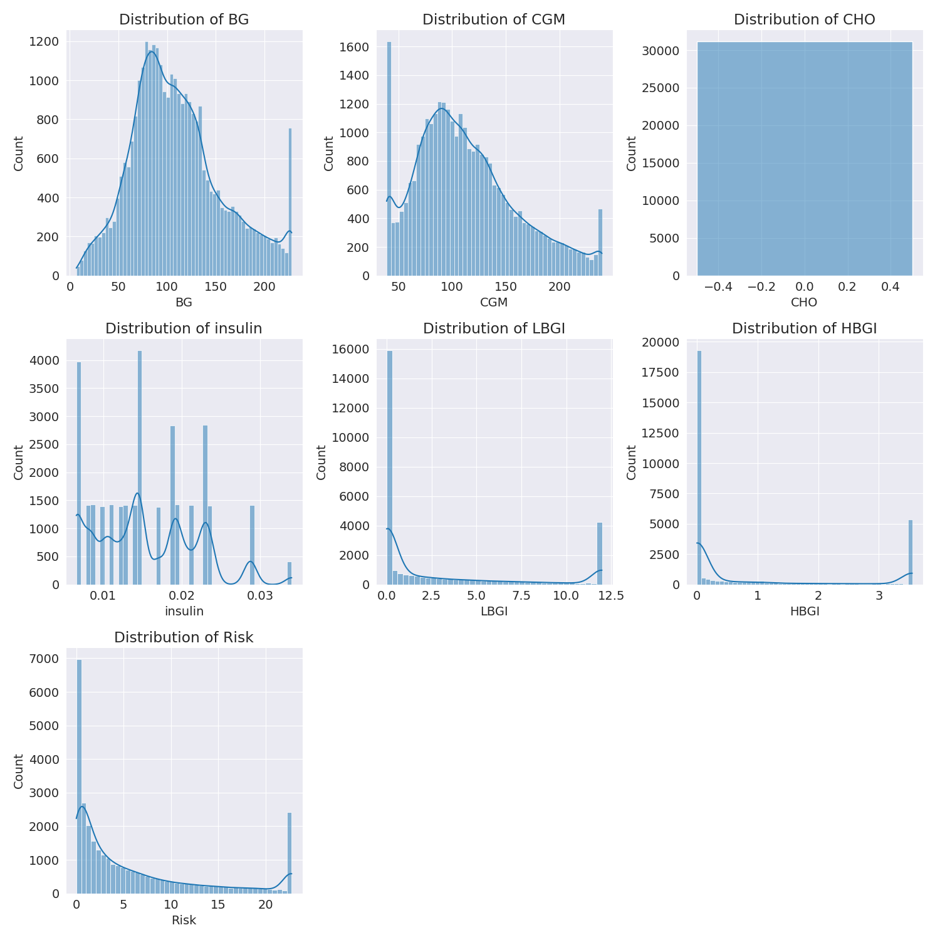

The image shows a series of graphs displaying the distribution of columns based on different criteria. Each graph represents a specific aspect of the data distribution. To analyze the distribution, we can identify any discernible patterns, cycles, or trends in the data over time.  
  
1. The first graph shows the distribution of insulin levels. The shape of the distribution is skewed, with a higher concentration of insulin levels in the middle and lower levels on both sides.  
2. The second graph displays the distribution of glucose levels. The shape of the distribution is skewed, with a higher concentration of glucose levels in the middle and lower levels on both sides.  
3. The third graph shows the distribution of LDLC levels. The shape of the distribution is skewed, with a higher concentration of LDLC levels in the middle and lower levels on both sides.  
4. The fourth graph displays the distribution of HDL levels. The shape of the distribution is skewed, with a higher concentration of HDL levels in the middle and lower levels on both sides.  
5. The fifth graph shows the distribution of triglyceride levels. The shape of the distribution is skewed, with a higher concentration of triglyceride levels in the middle and lower levels on both sides.  
6. The sixth graph displays the distribution of cholesterol levels. The shape of the distribution is skewed, with a higher concentration of cholesterol levels in the middle and lower levels on both sides.  
  
In summary, the image shows a series of graphs displaying the distribution of columns based on different criteria. Each graph represents a specific aspect of the data distribution. The shape of the distribution is skewed, with a higher concentration of the respective column in the middle and lower levels on both sides.

Missing Numbers Graph Analysis

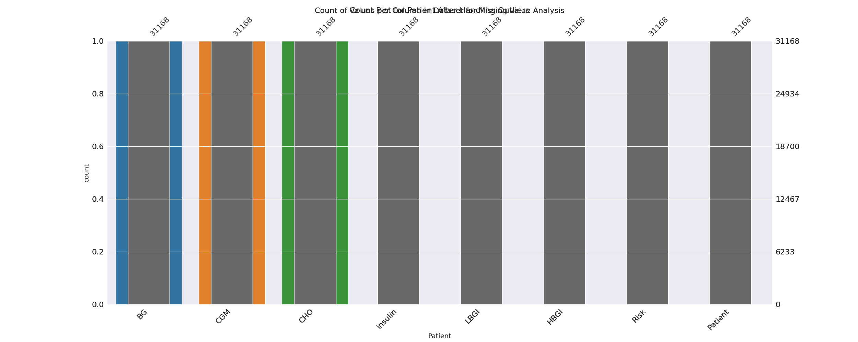

The image displays a bar chart with missing values, which is a common issue in data analysis. The chart is showing the count of black patients, and the numbers are missing for some of the bars. This can impact data analysis or modeling, as it may lead to inaccurate conclusions or predictions.  
  
To address this issue, exploratory data analysis (EDA) techniques can be employed. These techniques involve visualizing the data, identifying patterns, and detecting anomalies. By examining the distribution of the missing values, one can understand the reasons behind the missing data and decide whether to impute the missing values or exclude the affected data points.  
  
In the case of the bar chart, the missing values could be due to various reasons, such as data entry errors, missing data in the original source, or a deliberate decision to exclude certain data points. By identifying the cause of the missing values, one can take appropriate actions to improve the quality of the data and ensure accurate analysis or modeling.

Heat_Explainer Graph Analysis

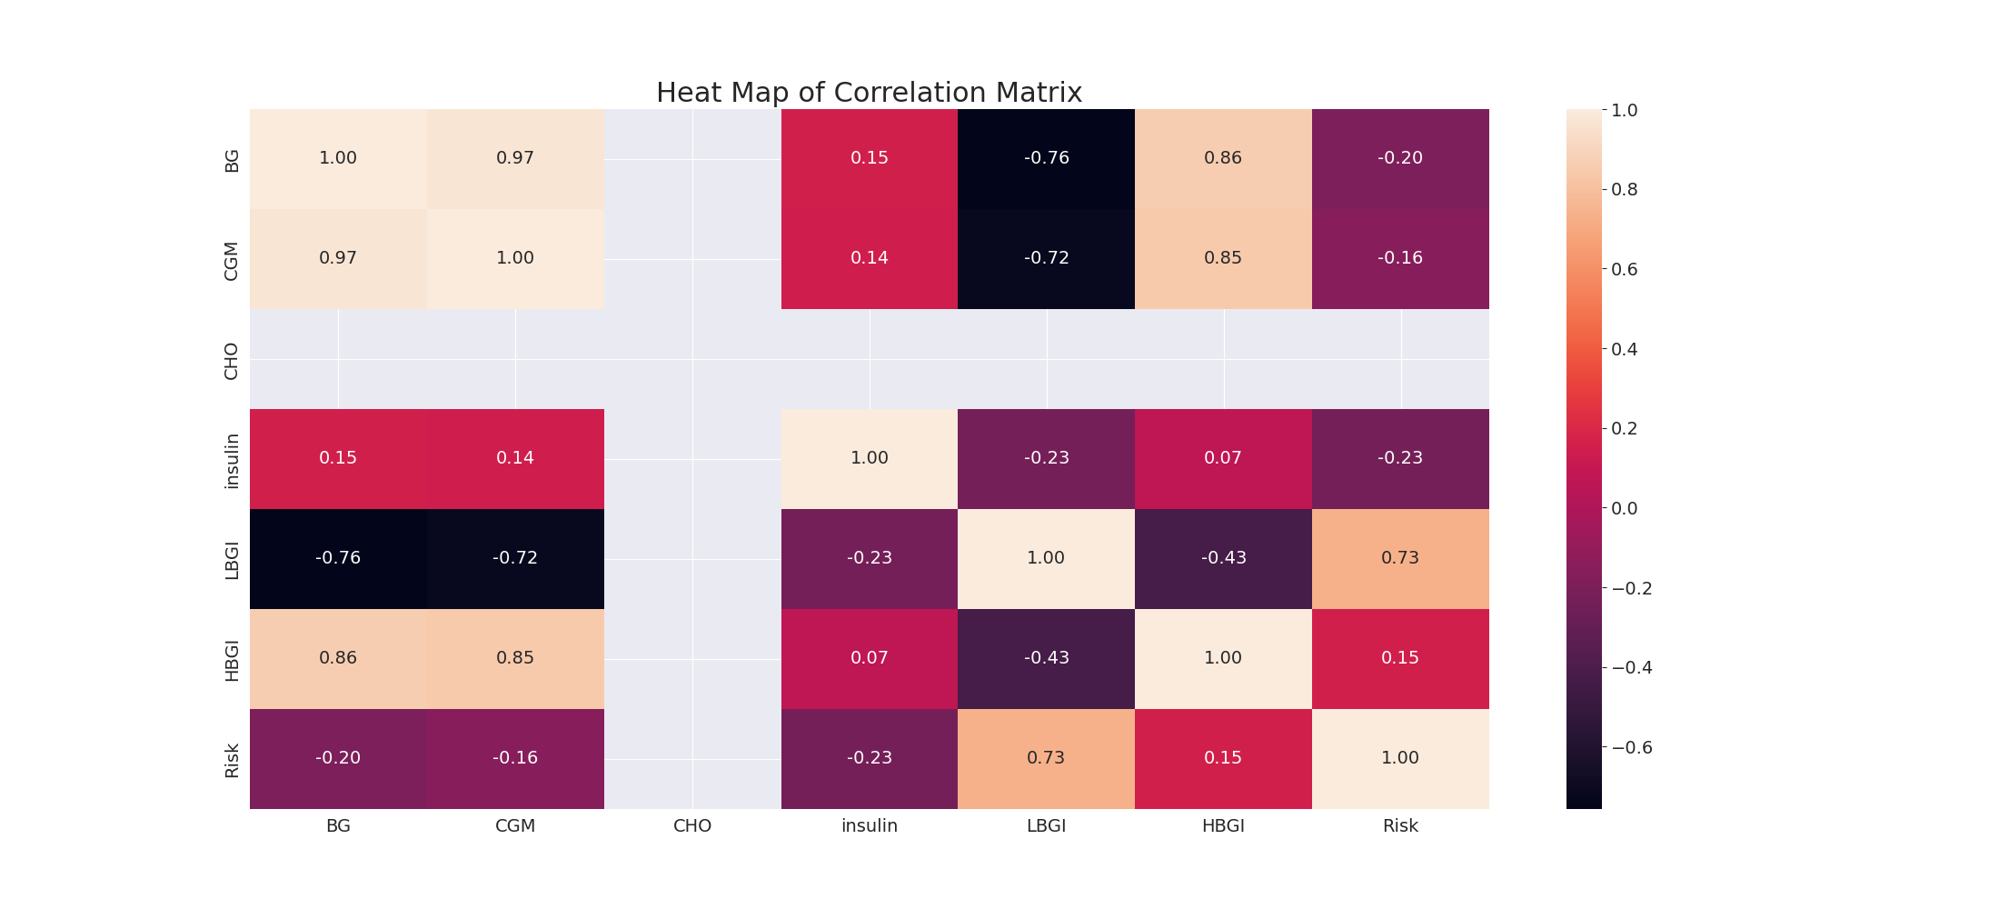

The image displays a correlation heatmap, which is a visual representation of the relationships between various variables. The heatmap is a color-coded matrix that helps to understand the strength and direction of correlations between these variables. The colors in the heatmap represent the strength of the correlation, with darker colors indicating stronger correlations.  
  
The heatmap is organized in a way that allows for easy identification of the variables and their relationships. The variables are likely related, and the data in the image helps to analyze and understand these relationships. By examining and deep-analyzing the visual representation, one can gain insights into the strength and direction of correlations between the variables.

Confusion_matrix Graph Analysis

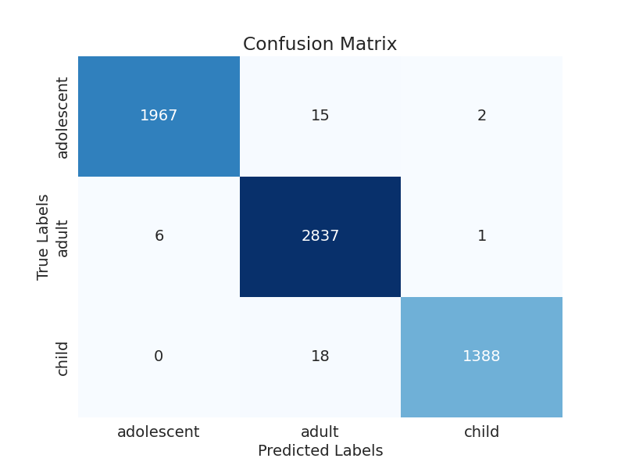

The image displays a confusion matrix, which is a visual representation of the relationship between variables. The variables are likely related, and the data in the image can provide insights into the strength and direction of correlations between these variables. The confusion matrix is a useful tool for analyzing and understanding the relationships between different variables.  
  
In the image, there are two main colors: blue and white. The blue color represents the correct predictions, while the white color represents the incorrect predictions. The confusion matrix is divided into four quadrants, each representing a different combination of the two variables.  
  
The top left quadrant shows the correct predictions for the first variable, while the top right quadrant shows the incorrect predictions for the same variable. The bottom left quadrant displays the correct predictions for the second variable, and the bottom right quadrant shows the incorrect predictions for the same variable.  
  
By examining and deep-analyzing the visual representation of the confusion matrix, one can gain insights into the strength and direction of correlations between the variables. This can help in understanding the relationships between these variables and make informed decisions based on the data.