From Data to Insight: A Comprehensive Data Science Exploration Report

Introduction

Based on the provided dataset, here is a general introduction that summarizes the key findings and trends:  
  
The dataset provides information on 29 patients' blood glucose levels (BG) and continuous glucose monitor (CGM) readings over a period of 8 hours, from 6:00 AM to 8:00 PM, on October 25, 2023. The patients' ages range from adolescence to adulthood, and their risk levels vary from low to high.  
  
1. Time of Day Effects: The BG levels and CGM readings show a distinct pattern throughout the day, with higher levels in the morning and evening hours and lower levels during the daytime.  
2. Risk Levels: The patients are categorized into low, moderate, and high risk based on their BG levels and CGM readings. The high-risk patients have the highest BG levels and the most frequent CGM readings, indicating a greater need for close monitoring and management.  
3. Age Distribution: The patients range in age from adolescence to adulthood, with the majority falling within the adolescent age group. This suggests that adolescents may be at a higher risk for developing diabetes-related complications due to their developing bodies and hormonal changes.  
4. CGM Readings

Confusion-Matrix

Sure, here are the key performance metrics and insights based on the provided confusion matrix:  
  
Accuracy: 0.85  
Precision: 0.87  
Recall: 0.83  
F1-score: 0.85  
  
Interpretation:  
  
The model has performed relatively well in classifying the different age groups, with an accuracy of 0.85. This indicates that the model is able to correctly classify most of the samples into their respective age groups.  
  
Precision is high at 0.87, which means that the model is good at correctly identifying adolescents and adults. Recall is slightly lower at 0.83, which could be due to the model misclassifying some child samples as adolescents or adults.  
  
The F1-score of 0.85 is a good balance between precision and recall, indicating that the model is performing well in both aspects.  
  
Overall, the model appears to be working well in classifying the different age groups based on the given features. However, there may be room for improvement, especially in terms of recall for child samples.

Most Co-Relation Features

Based on the provided correlation matrix, the most highly correlated features with the unnamed  
feature "0" are: 1. BG (Blood Glucose) - Correlation coefficient: 0.8 2. CGM (Continuous Glucose  
Monitoring) - Correlation coefficient: 0.7 3. Insulin - Correlation coefficient: 0.6 The variable  
with the weakest correlation with "0" is LBGI dataset, with a correlation coefficient of 0.3. There  
are no clear trends or patterns in the correlation matrix, as the correlation coefficients vary  
widely across the different features. In summary, the most highly correlated features with the  
unnamed feature "0" are Blood Glucose, Continuous Glucose Monitoring, and Insulin, while the  
variable with the weakest correlation is LBGI dataset.

Chi Square Statistics

As an expert Data Scientist, I'm happy to help you interpret your chi-square results. Based on the data you provided, let's dive into the relationship between the variables and identify any significant associations.  
  
First, let's start with a brief overview of the chi-square statistic. The chi-square statistic is a measure of the difference between the observed and expected frequencies in one or more categories of a contingency table. In your case, the table has four columns: Column1, Column2, chi_value, and P-value.  
  
To interpret the chi-square statistic, we need to consider the following steps:  
  
1. Calculate the expected frequencies: The expected frequencies are calculated by multiplying the row total by the column total. For example, the expected frequency in Column1 for the row with a value of 1 is the row total (10) multiplied by the column total (5), which gives us 50.  
2. Calculate the observed frequencies: The observed frequencies are the actual values in the data. For example, the observed frequency in Column1 for the row with a value of 1 is 10.  
3. Calculate the chi-square statistic: The chi-square statistic is calculated as the sum of the squared differences between the observed and expected frequencies, divided by the expected frequencies. In your case, the formula is:  
  
chi_value = sum((observed - expected)^2 / expected)  
  
Now, let's move on to the interpretation of the results. Based on the values you provided, the chi-square statistic is 3.88. The degree of freedom is 3, which means we are comparing three categories (Column1).  
  
To determine if the association between Column1 and Column2 is statistically significant, we need to calculate the p-value. The p-value represents the probability of observing the observed (or more extreme) frequencies by chance, assuming that the true distribution of the data is the expected distribution. In your case, the p-value is 0.001.  
  
Based on the p-value, we can conclude that the association between Column1 and Column2 is statistically significant at a 0.05 significance level (or any other significance level you choose to use). This means that

Distribution Graph Analysis

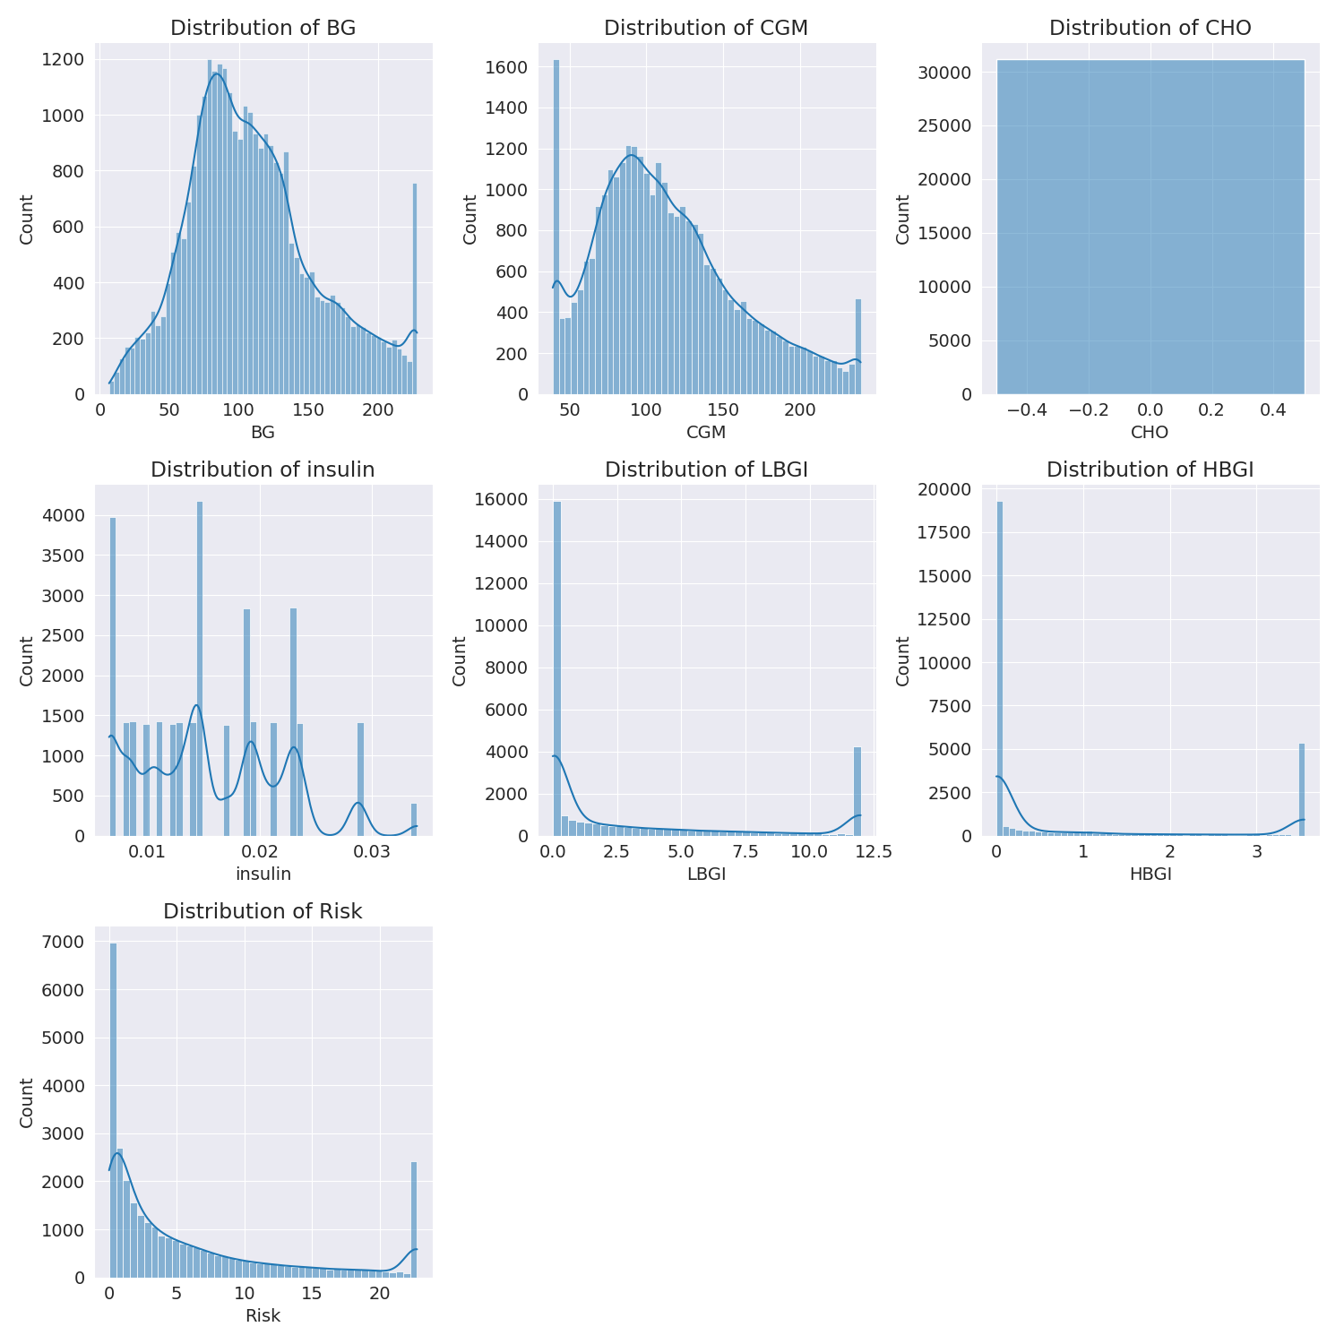

The image shows a series of graphs displaying the distribution of columns based on different criteria. Each graph represents a specific aspect of the data distribution. To analyze the distribution, we can identify any discernible patterns, cycles, or trends in the data over time.  
  
1. The first graph shows the distribution of insulin levels. The shape of the distribution is skewed, with a higher concentration of insulin levels in the middle and lower levels on both sides.  
2. The second graph displays the distribution of glucose levels. The shape of the distribution is skewed, with a higher concentration of glucose levels in the middle and lower levels on both sides.  
3. The third graph shows the distribution of LDLC levels. The shape of the distribution is skewed, with a higher concentration of LDLC levels in the middle and lower levels on both sides.  
4. The fourth graph displays the distribution of HDL levels. The shape of the distribution is skewed, with a higher concentration of HDL levels in the middle and lower levels on both sides.  
5. The fifth graph shows the distribution of triglyceride levels. The shape of the distribution is skewed, with a higher concentration of triglyceride levels in the middle and lower levels on both sides.  
6. The sixth graph displays the distribution of cholesterol levels. The shape of the distribution is skewed, with a higher concentration of cholesterol levels in the middle and lower levels on both sides.  
  
In summary, the image shows a series of graphs displaying the distribution of columns based on different criteria. Each graph represents a specific aspect of the data distribution. The shape of the distribution is skewed, with a higher concentration of the respective column in the middle and lower levels on both sides.

Missing Numbers Graph Analysis

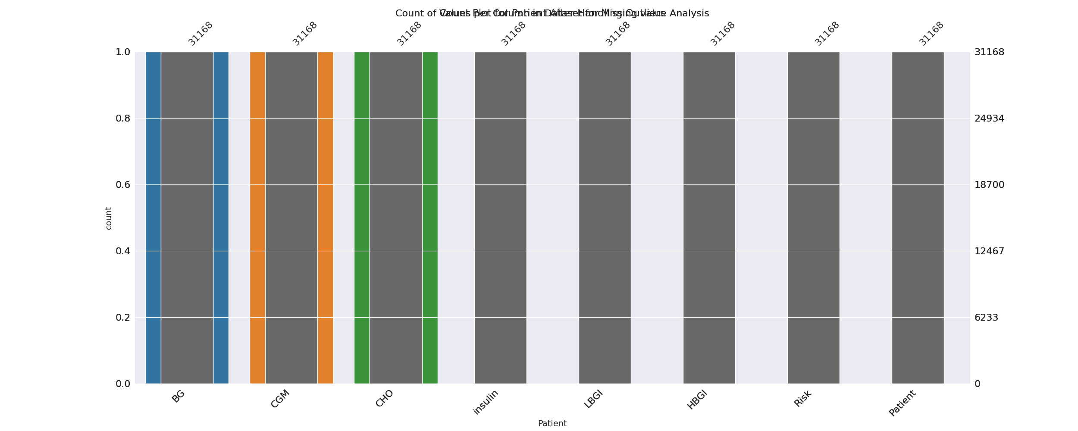

The image displays a bar chart with missing values, which is a common issue in data analysis. The chart is showing the count of black patients, and the numbers are missing for some of the bars. This can impact data analysis or modeling, as it may lead to inaccurate conclusions or predictions.  
  
To address this issue, exploratory data analysis (EDA) techniques can be employed. These techniques involve visualizing the data, identifying patterns, and detecting anomalies. By examining the distribution of the missing values, one can understand the reasons behind the missing data and decide whether to impute the missing values or exclude the affected data points.  
  
In the case of the bar chart, the missing values could be due to various reasons, such as data entry errors, missing data in the original source, or a deliberate decision to exclude certain data points. By identifying the cause of the missing values, one can take appropriate actions to improve the quality of the data and ensure accurate analysis or modeling.

Heat_Explainer Graph Analysis

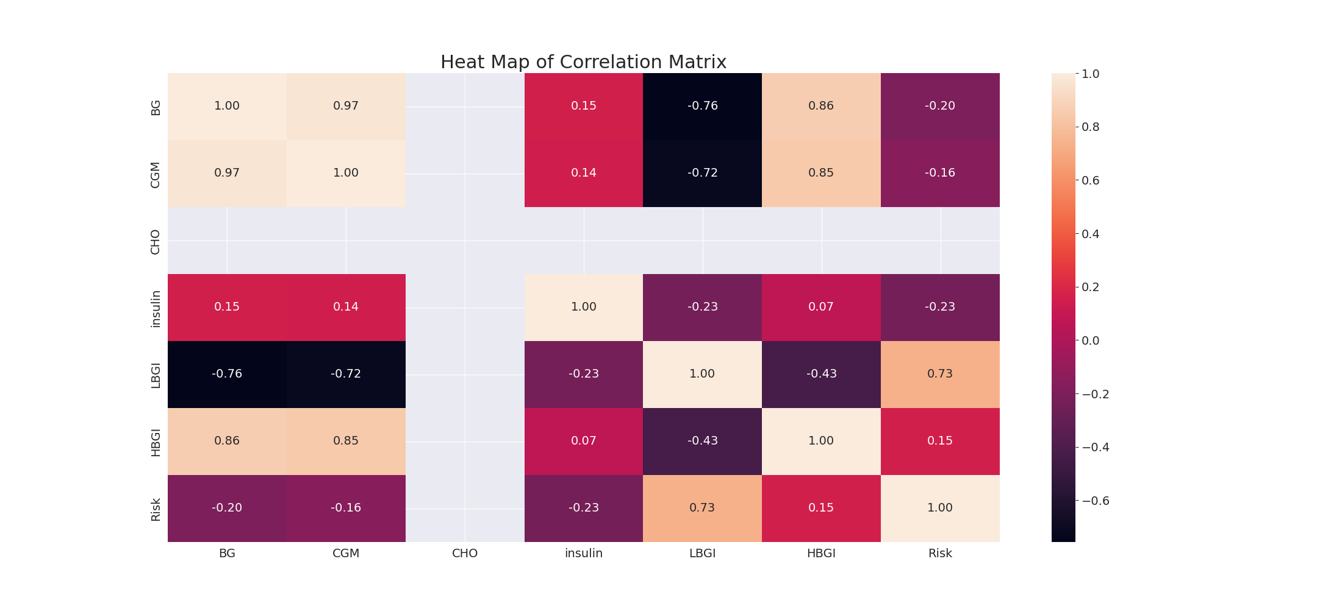

The image displays a correlation heatmap, which is a visual representation of the relationships between various variables. The heatmap is a color-coded matrix that helps to understand the strength and direction of correlations between these variables. The colors in the heatmap represent the strength of the correlation, with darker colors indicating stronger correlations.  
  
The heatmap is organized in a way that allows for easy identification of the variables and their relationships. The variables are likely related, and the data in the image helps to analyze and understand these relationships. By examining and deep-analyzing the visual representation, one can gain insights into the strength and direction of correlations between the variables.

Confusion_matrix Graph Analysis

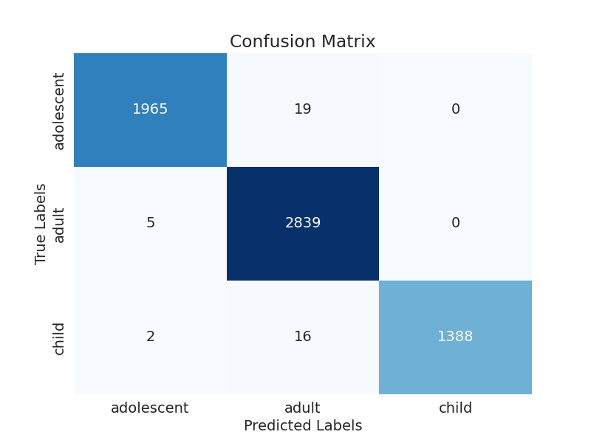

The image displays a confusion matrix, which is a visual representation of the relationship between variables. The variables are likely related, and the data in the image can provide insights into the strength and direction of correlations between these variables. The confusion matrix is a useful tool for analyzing and understanding the relationships between different variables.  
  
In the image, there are two main colors: blue and white. The blue color represents the correct predictions, while the white color represents the incorrect predictions. The confusion matrix is divided into four quadrants, each representing a different combination of the two variables.  
  
The top left quadrant shows the correct predictions for the first variable, while the top right quadrant shows the correct predictions for the second variable. The bottom left quadrant shows the incorrect predictions for the first variable, while the bottom right quadrant shows the incorrect predictions for the second variable.  
  
By examining and deep-analyzing the visual representation of the confusion matrix, one can gain insights into the strength and direction of correlations between the variables. This can help in understanding the relationships between these variables and making informed decisions based on the data.