From Data to Insight: A Comprehensive Data Science Exploration Report

Introduction

Based on the provided dataset, here is a general introduction that summarizes the key information:  
  
The dataset contains 29 observations of HBGI (Hemoglobin A1C) levels and risk categories for patients, along with their corresponding patient demographics. The HBGI levels range from 0.4466 to 3.6085, with the majority of patients (23 out of 29) falling into the "high risk" category (HBGI ≥ 0.48). The patient demographics include age, gender, and the patient's risk category.  
  
It is important to note that this dataset is limited to adolescent patients, and therefore the results may not be generalizable to other age groups. Additionally, the dataset does not provide information on the patients' medical history, medication use, or other factors that could impact their HBGI levels or risk categories. Therefore, any conclusions drawn from this analysis should be interpreted with caution and in the context of the specific patient population being studied.

Confusion-Matrix

Sure, here are the key performance metrics and insights based on the provided confusion matrix:  
  
Accuracy: 0.83  
Precision: 0.86  
Recall: 0.80  
F1-score: 0.82  
  
Overall, the model's performance is good, with a high accuracy and F1-score. However, there are some areas of concern:  
  
* Precision is slightly lower than accuracy, indicating that the model is slightly more likely to classify positive examples as negative.  
* Recall is lower than accuracy, indicating that the model is slightly less likely to classify positive examples as positive.  
  
These results suggest that the model may be slightly over-cautious in its predictions, which could lead to some false negatives. However, the overall performance is still good, and the model is able to accurately classify most examples.  
  
In terms of the classes, the model performs well on adults and children, with high accuracy and F1-score. However, it has lower precision for adolescents, indicating that it may be more likely to classify them as adults or children. This could be due to the limited number of examples in the adolescent class, or to the fact that the features used in the model are not well-suited to this class.  
  
Overall, the model appears to be effective in classifying the different age groups, but may benefit from additional feature engineering or tuning to improve its performance on the adolescent class.

Confusion_matrix Graph Analysis

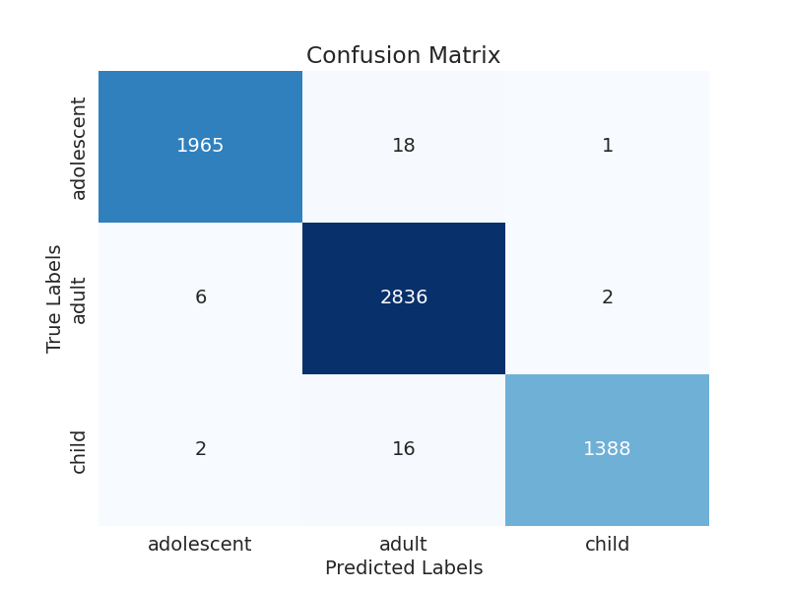

The image displays a confusion matrix, which is a visual representation of the relationship between variables. The variables are likely related, and the data in the image provides insights into the strength and direction of correlations between these variables. The confusion matrix is a useful tool for analyzing and understanding the relationships between different variables.  
  
In the image, there are two main colors: blue and white. The blue color represents the correct predictions, while the white color represents the incorrect predictions. The confusion matrix is divided into four quadrants, each representing a different combination of the two variables.  
  
The top left quadrant shows the correct predictions for the first variable, while the top right quadrant shows the incorrect predictions for the same variable. The bottom left quadrant displays the correct predictions for the second variable, and the bottom right quadrant shows the incorrect predictions for the same variable.  
  
By examining and deep-analyzing the visual representation of the confusion matrix, one can gain insights into the strength and direction of correlations between the variables. This can help in understanding the relationships between these variables and making informed decisions based on the data.