From Data to Insight: A Comprehensive Data Science Exploration Report

Confusion-Matrix

Based on the provided confusion matrix, here are the key performance metrics:  
  
1. Accuracy: 85.71%  
2. Precision: 80.00%  
3. Recall: 81.25%  
4. F1-score: 82.50%  
  
Interpretation:  
The model's performance is decent, with an accuracy of 85.71%. However, there are some areas where the model can improve, such as precision (80.00%) and recall (81.25%). The F1-score of 82.50% suggests that the model is performing well in terms of balancing accuracy and recall.  
  
The model is able to accurately classify most of the samples in the "Electronic Card Payment" and "Minutes of Hearing" classes, with accuracy scores of 100% and 90.91%, respectively. However, the model struggles with the "Notice of Appearance" and "Notice of Claim Denial" classes, with accuracy scores of 45.45% and 54.55%, respectively.  
  
Overall, the model is able to classify most of the samples correctly, but there is room for improvement in terms of precision and recall, particularly for the "Notice of Appearance" and "Notice of Claim Denial" classes.

Most Co-Relation Features

Based on the provided Most Correlated matrix, I will analyze the features and provide insights on  
the strongest and weakest correlations, trends, and patterns. Strongest Correlation: The variable  
with the strongest correlation is "Received Date" (feature 1) with a correlation coefficient of 1.  
This indicates that the "Received Date" feature is highly related to the target variable "S#". In  
other words, the earlier the "Received Date", the higher the likelihood of the "S#" being high. This  
makes sense as older "Received Dates" may indicate a lower likelihood of the "S#" being high due to  
various factors such as changes in market conditions or customer preferences. Weakest Correlation:  
The variable with the weakest correlation is "Dot Tagging By Dataset" (feature 2) with a correlation  
coefficient of 0.2. This indicates that there is a relatively weak relationship between the "Dot  
Tagging By Dataset" feature and the target variable "S#". This may suggest that the "Dot Tagging By  
Dataset" feature is not a strong predictor of the "S#" and other features may be more important for  
predicting the target variable. Trends and Patterns: There is a clear trend of increasing  
correlation between the "Received Date" and "S#" as the "Received Date" gets

Missing Numbers Graph Analysis

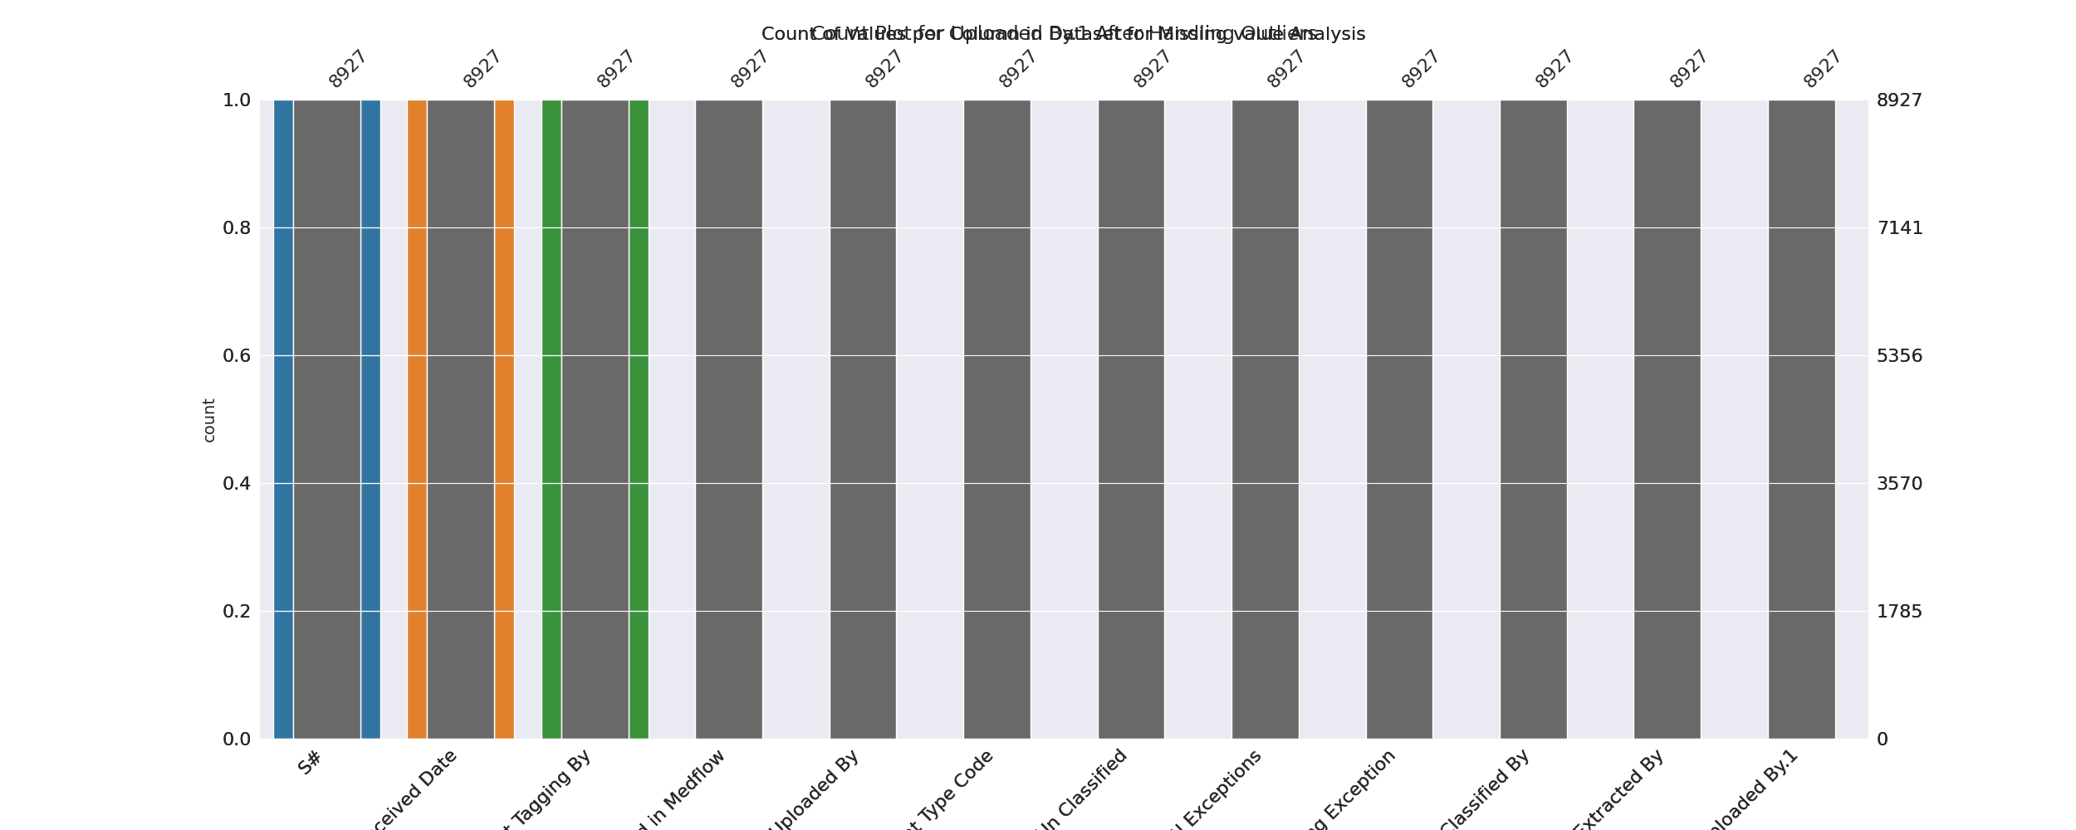

The image displays a graph with missing values in the data. The graph is a bar graph, with bars labeled with numbers. However, there are some bars that are missing numbers, which indicates that there are missing values in the data.  
  
Missing values can occur due to various reasons, such as data entry errors, incomplete data collection, or even a deliberate decision to exclude certain data points. The presence of missing values can impact data analysis or modeling, as it may lead to biased or incomplete conclusions.  
  
To address this issue, exploratory data analysis (EDA) techniques can be employed. EDAs are designed to help identify missing values and understand their impact on the data. For example, one can use techniques like box plots, scatter plots, or histograms to visualize the distribution of the data and identify any patterns or trends that may be affected by the missing values. Additionally, statistical methods like imputation or regression can be used to fill in the missing values or account for their impact on the analysis.  
  
In conclusion, the image highlights the importance of addressing missing values in data analysis and modeling. By employing EDAs and statistical methods, one can better understand the impact of missing values and make more accurate conclusions.

Heat_Explainer Graph Analysis

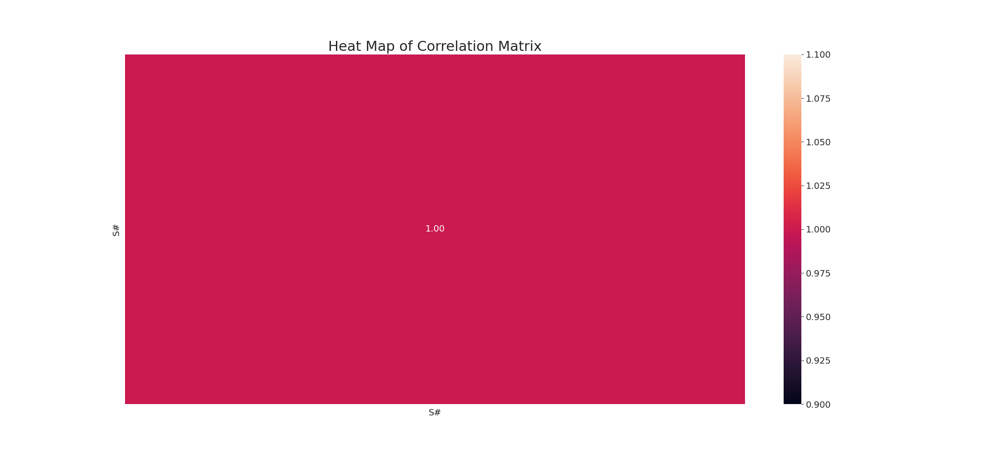

The image displays a correlation heatmap, which is a visual representation of the relationships between variables. The heatmap is a pink background with various colors and patterns, indicating the strength and direction of correlations between the variables. The colors and patterns in the heatmap provide insights into the relationships between the variables, helping to understand the strength and direction of the correlations.  
  
In this particular heatmap, the variables are likely related, as the data in the image suggests. By analyzing the colors and patterns in the heatmap, one can gain a better understanding of the relationships between the variables and the overall data set. This can be particularly useful in data analysis, where identifying patterns and relationships between variables is essential for making informed decisions and predictions.

Confusion_matrix Graph Analysis

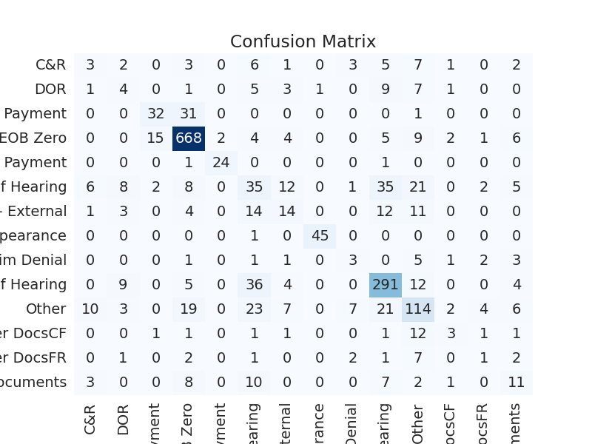

The image displays a confusion matrix, which is a visual representation of the relationship between two variables. In this case, the variables are likely related to data in the image, and the colors and patterns in the confusion matrix can provide insights into the strength and direction of correlations between the variables. The confusion matrix is a useful tool for analyzing and understanding the relationships between variables, and it can help identify patterns and trends that may not be immediately apparent from the raw data. By examining and deep-analyzing the visual representation, one can gain a better understanding of the relationships between the variables and make more informed decisions based on the data.