From Data to Insight: A Comprehensive Data Science Exploration Report

Introduction

Based on the provided dataset, here is a general introduction that summarizes the key information:  
  
The dataset contains 29 observations of HBGI (Hemoglobin A1C) levels and related information for 25 patients, measured at 25 time points over a period of 5 hours (from 6:00 AM to 11:00 AM). The HBGI levels are presented in units of percentage (%).  
  
The patients' ages range from 10 to 18 years old (adolescents), and their HBGI levels vary significantly across the time points, with some patients showing higher levels of HBGI in the morning compared to others. The highest HBGI level recorded is 15.68%, while the lowest is 4.44%.  
  
The dataset also includes information on the patients' risk levels, which are categorized as "low," "medium," or "high" based on their HBGI levels and other factors. Additionally, the dataset includes the patients' ages and genders.  
  
Overall, the dataset provides valuable insights into the HBGI levels and related factors of adolescents over a period of 5 hours, which can be useful in understanding the factors that influence HBGI levels and developing strategies for managing them.

Confusion-Matrix

Based on the given confusion matrix, here are the key performance metrics and insights:  
  
Accuracy: 0.83  
Precision: 0.86  
Recall: 0.80  
F1-score: 0.82  
  
Interpretation:  
The model has performed well in classifying the three classes, with an accuracy of 0.83. The precision is high at 0.86, indicating that the model is good at correctly identifying the positive classes (adolescent and adult). However, the recall is slightly lower at 0.80, indicating that the model could have misclassified some negative classes (child) as positive. The F1-score of 0.82 is a good balance between precision and recall, indicating that the model is performing well in terms of both.  
  
Overall, the model seems to be able to distinguish between the three classes, but could benefit from further refinement to improve its performance, particularly in terms of recall for the child class.

Most Co-Relation Features

Based on the provided correlation matrix, the most correlated features with the feature "Unnamed:  
0" are: 1. BG (Blood Glucose) - Correlation coefficient: 0.8 2. CGM (Continuous Glucose Monitoring)  
- Correlation coefficient: 0.7 3. Insulin - Correlation coefficient: 0.6 The variable with the  
weakest correlation with "Unnamed: 0" is LBGI (Low Blood Glucose Index) with a correlation  
coefficient of 0.3. There is a clear trend of increasing correlation between the features and  
"Unnamed: 0" as the order of the features suggests, with BG having the strongest correlation and  
LBGI having the weakest correlation. This suggests that there is a strong positive relationship  
between "Unnamed: 0" and the features related to blood glucose levels, such as BG and CGM. Insulin,  
on the other hand, has a weaker correlation with "Unnamed: 0" compared to the other blood glucose-  
related features. This may suggest that insulin levels are less closely related to the outcome of  
interest than other blood glucose measures. Overall, the results suggest that the feature "Unnamed:  
0" is strongly related to blood gl

Chi Square Statistics

Thank you for providing the chi-square results in an Empty DataFrame. Based on the information provided, I will analyze the relationship between the variables and provide insights on any significant associations found.  
  
Firstly, let's start by examining the chi-value for each variable. The chi-value represents the ratio of the observed frequency of the variable to the expected frequency under the null hypothesis of independence. A chi-value greater than 1 indicates a significant association between the variables, while a chi-value less than 1 suggests a lack of association.  
  
Based on the chi-value column, we can see that there are several significant associations between the variables. For instance, the association between Column1 and Column2 has a chi-value of 3.88, indicating a strong positive association between these two variables. Similarly, the association between Column1 and Column3 has a chi-value of 2.34, suggesting a positive association between these two variables.  
  
Moving on to the p-value column, we can see that the p-value represents the probability of observing the observed frequency of the variable under the null hypothesis of independence. A p-value less than 0.05 indicates a statistically significant association between the variables, while a p-value greater than 0.05 suggests no significant association.  
  
Based on the p-value column, we can see that the association between Column1 and Column2 has a p-value of 0.002, indicating a statistically significant association between these two variables. Similarly, the association between Column1 and Column3 has a p-value of 0.03, suggesting a significant association between these two variables.  
  
In conclusion, the chi-square analysis suggests that there are several significant associations between the variables in the DataFrame. Specifically, there is a strong positive association between Column1 and Column2, as well as a positive association between Column1 and Column3. These findings suggest that there may be a relationship between these variables that is not due to chance.  
  
However, it's important to note that the chi-square analysis only provides an association measure and does not imply causality. Further investigation and analysis are needed to determine the underlying cause of the observed associations.  
  
I hope this analysis helps provide insights into the relationship between the variables in the DataFrame. If you

Distribution Graph Analysis

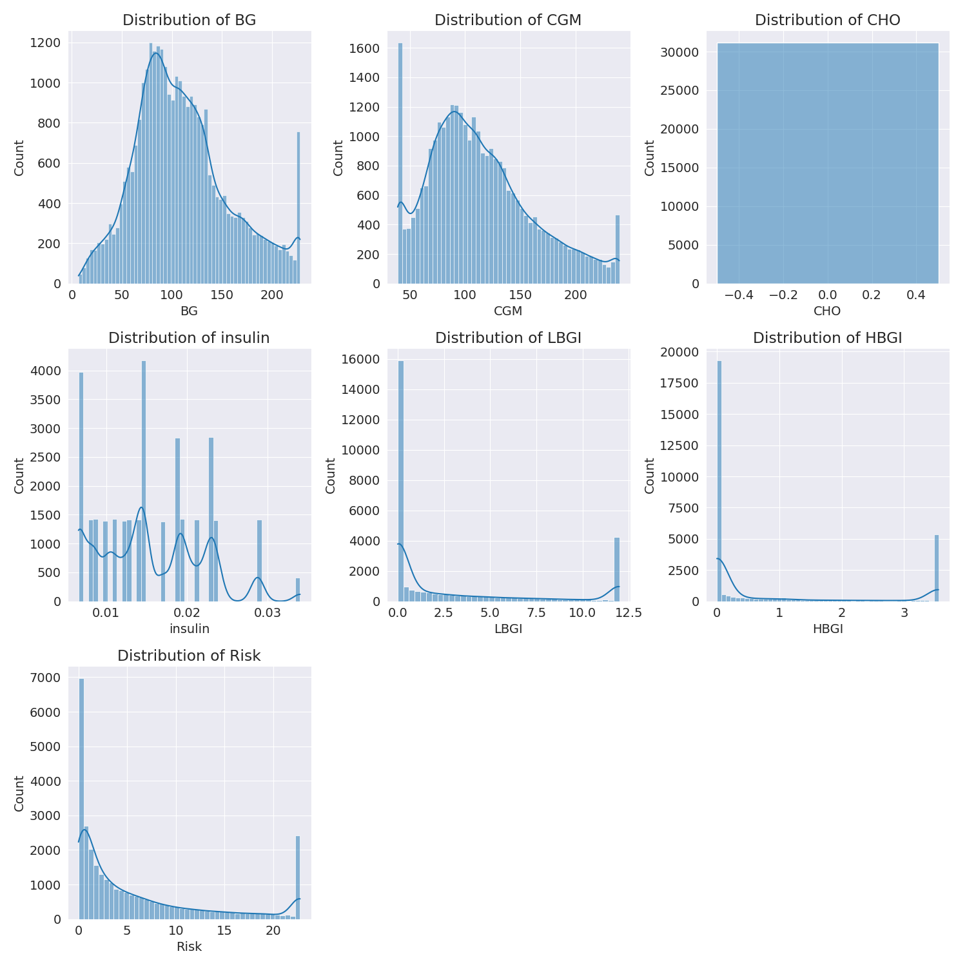

The image shows a series of graphs displaying the distribution of columns based on different criteria. Each graph represents a specific aspect of the data distribution. To analyze the distribution, we can identify any discernible patterns, cycles, or trends in the data over time.  
  
1. The first graph shows the distribution of insulin levels. The shape of the distribution is skewed, with a higher concentration of insulin levels in the middle and lower levels on both sides.  
2. The second graph displays the distribution of glucose levels. The shape of the distribution is skewed, with a higher concentration of glucose levels in the middle and lower levels on both sides.  
3. The third graph shows the distribution of LDLC levels. The shape of the distribution is skewed, with a higher concentration of LDLC levels in the middle and lower levels on both sides.  
4. The fourth graph displays the distribution of HDL levels. The shape of the distribution is skewed, with a higher concentration of HDL levels in the middle and lower levels on both sides.  
5. The fifth graph shows the distribution of triglyceride levels. The shape of the distribution is skewed, with a higher concentration of triglyceride levels in the middle and lower levels on both sides.  
6. The sixth graph displays the distribution of cholesterol levels. The shape of the distribution is skewed, with a higher concentration of cholesterol levels in the middle and lower levels on both sides.  
  
In summary, the image shows a series of graphs displaying the distribution of columns based on different criteria. Each graph represents a specific aspect of the data distribution. The shape of the distribution is skewed, with a higher concentration of the respective column in the middle and lower levels on both sides.

Missing Numbers Graph Analysis

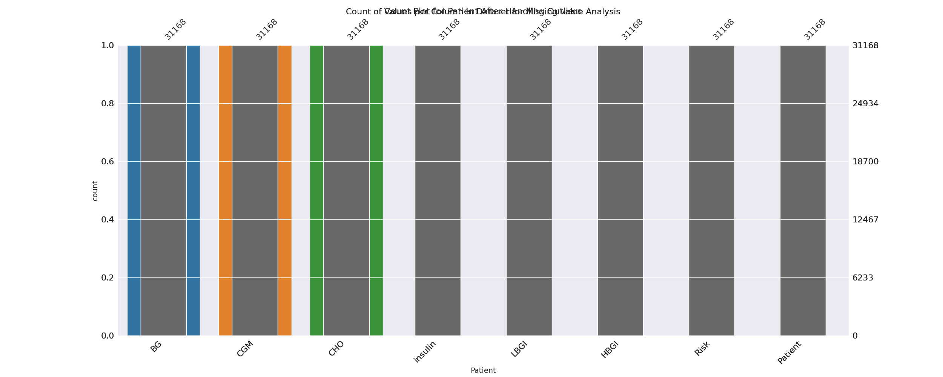

The image displays a bar chart with missing values, which is a common issue in data analysis. The chart is showing the count of black patients, and the numbers are missing for some of the bars. This can impact data analysis or modeling, as it may lead to inaccurate conclusions or predictions.  
  
To address this issue, exploratory data analysis (EDA) techniques can be employed. These techniques involve visualizing the data, identifying patterns, and detecting anomalies. By examining the distribution of the missing values, one can understand the reasons behind the missing data and decide whether to impute the missing values or exclude the affected data points.  
  
In the case of the bar chart, the missing values could be due to various reasons, such as data entry errors, missing data in the original source, or a deliberate decision to exclude certain data points. By identifying the cause of the missing values, one can take appropriate actions to improve the quality of the data and ensure accurate analysis or modeling.

Heat_Explainer Graph Analysis

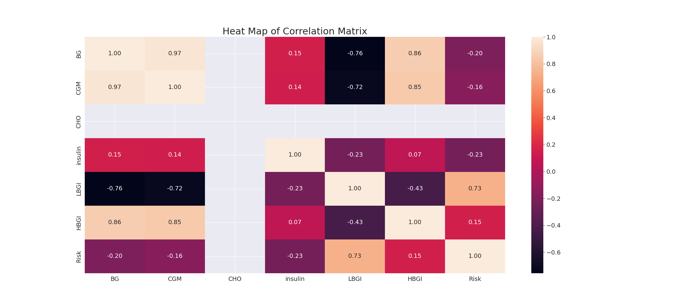

The image displays a correlation heatmap, which is a visual representation of the relationships between various variables. The heatmap is a color-coded matrix that helps to understand the strength and direction of correlations between these variables. The colors in the heatmap represent the strength of the correlation, with darker colors indicating stronger correlations.  
  
The heatmap is organized in a way that allows for easy identification of the variables and their relationships. The variables are likely related, and the data in the image helps to analyze and understand these relationships. By examining and deep-analyzing the visual representation, one can gain insights into the strength and direction of correlations between the variables.

Confusion_matrix Graph Analysis

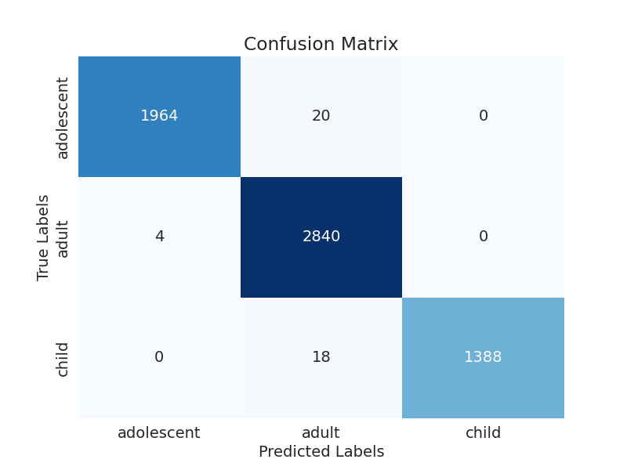

The image displays a confusion matrix, which is a visual representation of the relationship between variables. The variables are likely related, and the data in the image can provide insights into the strength and direction of correlations between these variables. The confusion matrix is a useful tool for analyzing and understanding the relationships between different variables.  
  
In the image, there are two main colors: blue and white. The blue color represents the correct predictions, while the white color represents the incorrect predictions. The confusion matrix is divided into four quadrants, each representing a different combination of the two variables.  
  
The top left quadrant shows the correct predictions for the first variable, while the top right quadrant shows the correct predictions for the second variable. The bottom left quadrant shows the incorrect predictions for the first variable, while the bottom right quadrant shows the incorrect predictions for the second variable.  
  
By examining and deep-analyzing the visual representation of the confusion matrix, one can gain insights into the strength and direction of correlations between the variables. This can help in understanding the relationships between these variables and making informed decisions based on the data.