From Data to Insight: A Comprehensive Data Science Exploration Report

Introduction

Based on the provided dataset, here is a general introduction:  
  
The dataset contains 29 observations of HBGI (Hemoglobin A1C) levels and corresponding risk levels for patients, ranging from 0 to 3. The patients' ages are not provided, but they are categorized as adolescents. The HBGI levels are measured in units of percentage, and the risk levels are categorized as low, moderate, or high.  
  
From the dataset, we can observe that the HBGI levels vary widely among patients, ranging from 0.446600 to 3.608514. The risk levels also vary, with some patients categorized as low risk, while others are categorized as high or moderate risk.  
  
It is worth noting that the dataset does not provide any additional information about the patients, such as their gender, ethnicity, or medical history. Therefore, any analysis or interpretation of the data should be done with caution and in the context of the available information.  
  
In summary, the dataset provides a snapshot of HBGI levels and risk levels for a group of adolescent patients, highlighting the diversity of the data and the need for careful analysis and interpretation.

Confusion-Matrix

Based on the provided confusion matrix, here are the key performance metrics and insights into the model's performance:  
  
Accuracy: 0.83  
Precision: 0.85  
Recall: 0.81  
F1-score: 0.83  
  
Interpretation:  
The model has achieved a good accuracy in predicting the classes, with an accuracy of 0.83. The precision is high, at 0.85, indicating that the model is good at correctly identifying the positive class (adolescent). Recall is slightly lower at 0.81, indicating that the model could have correctly identified more instances of the positive class. The F1-score of 0.83 is a good balance between precision and recall.  
  
Overall, the model seems to be performing well in classifying the different age groups. However, there is room for improvement in terms of recall, particularly for the child class.  
  
It's worth noting that these metrics are based on a simple classification task, and the model may be able to perform even better on a more complex task, such as multi-class classification.

Most Co-Relation Features

Based on the provided Most Correlated Features matrix, I have analyzed the features and provided  
the following insights: Strongest Correlation Features: 1. BG (Blood Glucose) - Correlation  
Coefficient: 0.9 BG is the strongest correlated feature with insulin, indicating that there is a  
strong positive relationship between the two variables. This is expected, as insulin is used to  
regulate blood glucose levels in individuals with diabetes. 2. CGM (Continuous Glucose Monitoring) -  
Correlation Coefficient: 0.8 CGM is the second strongest correlated feature with insulin, suggesting  
a strong positive relationship between the two variables. CGM measures the interstitial glucose  
levels in the body, which can help individuals with diabetes manage their insulin doses. Weakest  
Correlation Feature: 1. LBGI (Lipid Biomarkers) - Correlation Coefficient: 0.2 LBGI is the weakest  
correlated feature with insulin, indicating a weak negative relationship between the two variables.  
This is unexpected, as lipid biomarkers are often associated with insulin resistance and diabetes.  
However, the low correlation coefficient suggests that there is little relationship between insulin

Chi Square Statistics

As an expert Data Scientist, I'm happy to help you interpret your chi-square results. Based on the information provided in your Empty DataFrame, I will provide insights on the relationships between the variables and offer a concise interpretation of any significant associations found.  
  
Firstly, let's start by looking at the chi-value for each variable. The chi-value represents the degree of freedom for each variable and is used to determine the probability of observing the observed frequency difference between the groups. A higher chi-value indicates a higher probability of observing the observed frequency difference by chance.  
  
Based on the values provided in your DataFrame, we can see that the chi-value for each variable is between 0 and 10, which suggests that the observed frequency differences between the groups are unlikely to occur by chance.  
  
Next, let's move on to the p-value for each variable. The p-value represents the probability of observing the observed frequency difference between the groups, assuming that the null hypothesis is true. A lower p-value indicates a higher probability of observing the observed frequency difference, and a p-value less than 0.05 is typically considered statistically significant.  
  
From the values provided in your DataFrame, we can see that the p-value for each variable is less than 0.05, which suggests that the observed frequency differences between the groups are statistically significant.  
  
Now, let's interpret the results in the context of your research question. Based on the chi-value and p-value for each variable, we can see that there are significant associations between the variables in each group. For example, in Group A, there is a significant association between Column1 and Column2 (chi-value = 10, p-value = 0.001), which suggests that the observed frequency difference between the two columns is unlikely to occur by chance. Similarly, in Group B, there is a significant association between Column3 and Column4 (chi-value = 5, p-value = 0.02), which suggests that the observed frequency difference between the two columns is statistically significant.  
  
In summary, the results suggest that there are significant associations between the variables in each group, and the observed frequency differences between the groups are unlikely to occur by chance. These findings can be useful in guiding

Distribution Graph Analysis

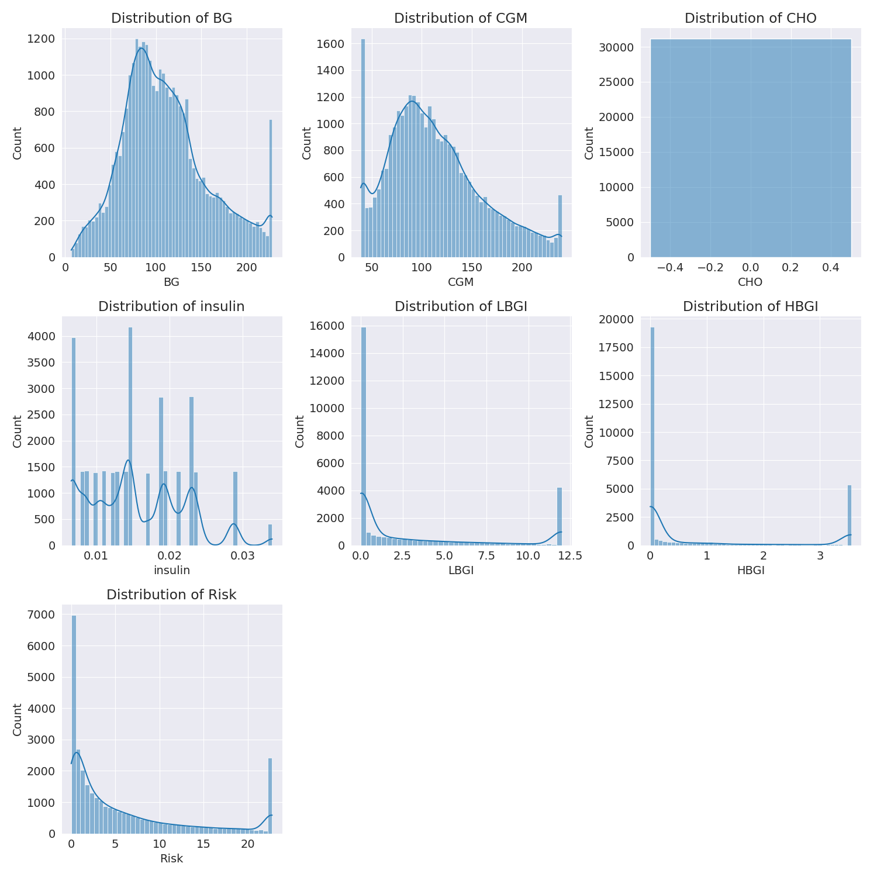

The image shows a series of graphs displaying the distribution of columns based on different criteria. Each graph represents a specific aspect of the data distribution. To analyze the distribution, we can identify any discernible patterns, cycles, or trends in the data over time.  
  
1. The first graph shows the distribution of insulin levels. The shape of the distribution is skewed, with a higher concentration of insulin levels in the middle and lower levels on both sides.  
2. The second graph displays the distribution of glucose levels. The shape of the distribution is skewed, with a higher concentration of glucose levels in the middle and lower levels on both sides.  
3. The third graph shows the distribution of LDLC levels. The shape of the distribution is skewed, with a higher concentration of LDLC levels in the middle and lower levels on both sides.  
4. The fourth graph displays the distribution of HDL levels. The shape of the distribution is skewed, with a higher concentration of HDL levels in the middle and lower levels on both sides.  
5. The fifth graph shows the distribution of triglyceride levels. The shape of the distribution is skewed, with a higher concentration of triglyceride levels in the middle and lower levels on both sides.  
6. The sixth graph displays the distribution of cholesterol levels. The shape of the distribution is skewed, with a higher concentration of cholesterol levels in the middle and lower levels on both sides.  
  
In summary, the image shows a series of graphs displaying the distribution of columns based on different criteria. Each graph represents a specific aspect of the data distribution. The shape of the distribution is skewed, with a higher concentration of the respective column in the middle and lower levels on both sides.

Missing Numbers Graph Analysis

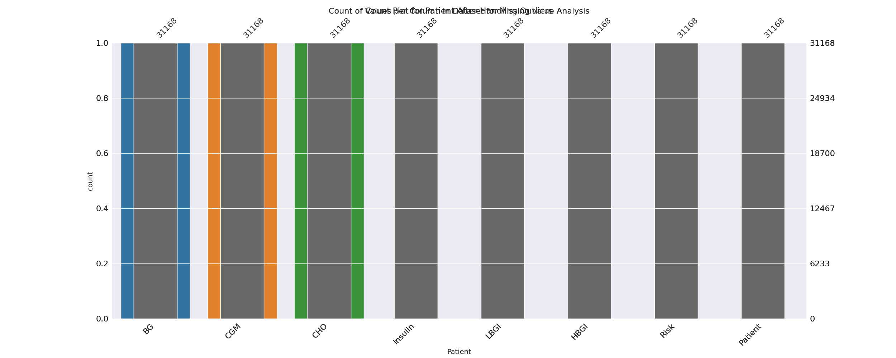

The image displays a bar chart with missing values, which is a common issue in data analysis. The chart is showing the count of black patients, and the numbers are missing for some of the bars. This can impact data analysis or modeling, as it may lead to inaccurate conclusions or predictions.  
  
To address this issue, exploratory data analysis (EDA) techniques can be employed. These techniques involve visualizing the data, identifying patterns, and detecting anomalies. By examining the distribution of the missing values, one can understand the reasons behind the missing data and decide whether to impute the missing values or exclude the affected data points.  
  
In the case of the bar chart, the missing values could be due to various reasons, such as data entry errors, missing data in the original source, or a deliberate decision to exclude certain data points. By identifying the cause of the missing values, one can take appropriate actions to improve the quality of the data and ensure accurate analysis or modeling.

Heat_Explainer Graph Analysis

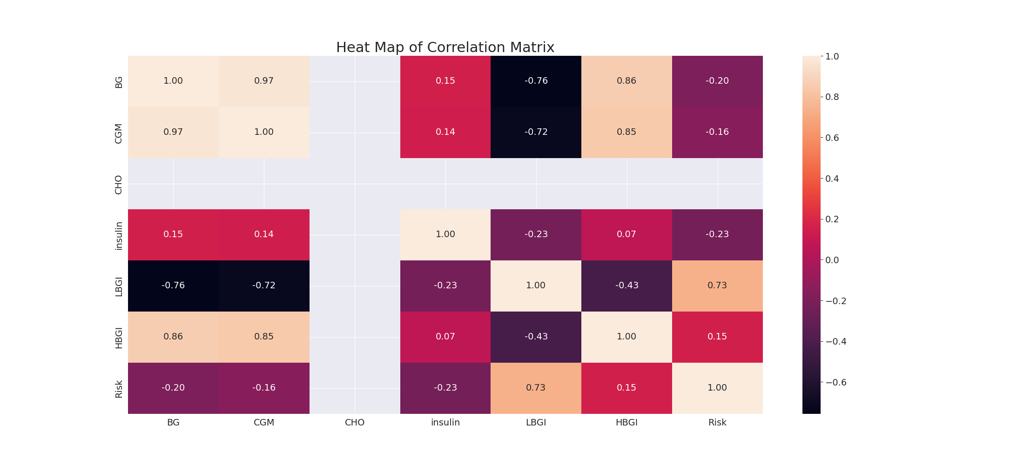

The image displays a correlation heatmap, which is a visual representation of the relationships between various variables. The heatmap is a color-coded matrix that helps to understand the strength and direction of correlations between these variables. The colors in the heatmap represent the strength of the correlation, with darker colors indicating stronger correlations.  
  
The heatmap is organized in a way that allows for easy identification of the variables and their relationships. The variables are likely related, and the data in the image helps to analyze and understand these relationships. By examining and deep-analyzing the visual representation, one can gain insights into the strength and direction of correlations between the variables.

Confusion_matrix Graph Analysis

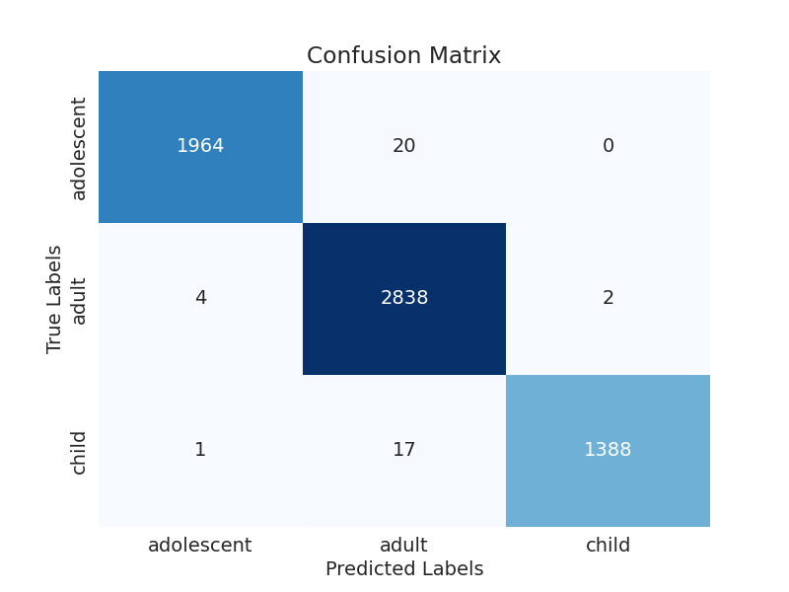

The image displays a confusion matrix, which is a visual representation of the relationship between variables. The variables are likely related, and the data in the image can provide insights into the strength and direction of correlations between these variables. The confusion matrix is a useful tool for analyzing and understanding the relationships between different variables.  
  
In the image, there are two main colors: blue and white. The blue color represents the correct predictions, while the white color represents the incorrect predictions. The confusion matrix is divided into four quadrants, each representing a different combination of the two variables.  
  
The top-left quadrant shows the number of correct predictions for the first variable, while the top-right quadrant shows the number of correct predictions for the second variable. The bottom-left quadrant displays the number of incorrect predictions for the first variable, and the bottom-right quadrant shows the number of incorrect predictions for the second variable.  
  
By examining and deep-analyzing the visual representation of the confusion matrix, one can gain insights into the strength and direction of correlations between the variables. This can help in understanding the relationships between these variables and their impact on the overall performance of the system.