From Data to Insight: A Comprehensive Data Science Exploration Report

Introduction

Based on the provided dataset, here is a general introduction:  
  
The dataset provides us with the hourly blood glucose (BG) and continuous glucose monitor (CGM) readings of a patient over a period of 10 hours, from 6:00 AM to 8:00 PM on October 25, 2023. The patient's BG levels fluctuate throughout the day, with the highest reading at 144.116940 mg/dL observed at 8:00 AM and the lowest reading at 126.013943 mg/dL observed at 6:00 AM. The patient's CGM readings show a similar pattern, with the highest reading at 150.024898 mg/dL observed at 8:00 AM and the lowest reading at 126.589661 mg/dL observed at 6:00 AM.  
  
The patient's BG levels are generally within the normal range, but there are some instances of hyperglycemia (BG levels above 140 mg/dL) observed between 6:00 AM and 8:00 AM. The patient's CGM readings also show some instances of hyperglycemia

Confusion-Matrix

Based on the provided confusion matrix, here are the key performance metrics and insights:  
  
Accuracy: 0.76  
Precision: 0.78  
Recall: 0.74  
F1-score: 0.75  
  
Interpretation:  
  
* The model has a high accuracy of 0.76, indicating that it is able to correctly classify most of the samples into their respective classes.  
* The precision of 0.78 suggests that the model is good at correctly identifying adolescents and adults, but has a lower precision for child class.  
* The recall of 0.74 indicates that the model is good at identifying adolescents and adults, but has a lower recall for child class.  
* The F1-score of 0.75 is an overall measure of the model's performance, indicating a good balance between precision and recall.  
  
Overall, the model seems to be performing well in classifying the different age groups, but may benefit from some tuning or refinement to improve its performance on the child class.

Most Co-Relation Features

Based on the provided Most Correlated Features matrix, I have analyzed the features and provided  
the following insights: Strongest Correlation Features: 1. BG (Blood Glucose) - Correlation  
coefficient: 0.95 BG is the strongest correlated feature with insulin, indicating that the two  
variables are highly related. This makes sense as insulin is used to regulate blood sugar levels,  
and a high BG level can indicate a need for more insulin. 2. CGM (Continuous Glucose Monitoring) -  
Correlation coefficient: 0.90 CGM is the second strongest correlated feature with insulin,  
suggesting that these two variables are closely related. CGM measures blood glucose levels over a  
longer period, providing a more detailed picture of glucose levels compared to BG. Weakest  
Correlation Feature: 1. LBGI (Low Blood Glucose Index) - Correlation coefficient: 0.30 LBGI is the  
weakest correlated feature with insulin, indicating a relatively weak relationship between the two  
variables. This makes sense as LBGI is a measure of the risk of low blood glucose levels, which may  
not directly impact insulin usage. Trends or Patterns:

Chi Square Statistics

As an expert Data Scientist, I'm happy to help you analyze your chi-square results. Based on the data you provided, let's dive into the relationship between the variables and identify any significant associations.  
  
First, let's start with the chi-value. The chi-value is a measure of the difference between the observed frequency and the expected frequency in each cell of the contingency table. It tells us how much the observed frequencies deviate from the expected frequencies. A larger chi-value indicates a larger deviation.  
  
Now, let's look at the p-value. The p-value is a measure of the probability of observing the data we have, assuming that the null hypothesis is true. In other words, it tells us the probability that the observed association between the variables is due to chance. A smaller p-value indicates a higher probability that the association is real.  
  
Based on the data you provided, there are a few things that stand out:  
  
1. The chi-value for Column1 and Column2 is 3.88. This means that the observed frequency in each cell differs significantly from the expected frequency.  
2. The p-value for Column1 and Column2 is 0.0001. This means that the probability of observing the data we have, assuming that there is no association between the variables, is very low (less than 0.05). This suggests that there is a significant association between Column1 and Column2.  
  
In terms of interpreting the association between Column1 and Column2, it's important to consider the context of the data. Based on the data you provided, it seems that Column1 and Column2 are categorical variables. Without more information about the variables, it's difficult to draw definitive conclusions about the association between them. However, we can say that the data suggests that there is a significant difference in the observed frequencies between the categories of Column1 and Column2.  
  
In conclusion, the chi-square statistic suggests that there is a significant association between Column1 and Column2. The p-value indicates that the probability of observing the data we have, assuming no association between the variables, is very low. However, without more context and information about the variables, it's difficult to draw definitive conclusions about the nature of the association.

Distribution Graph Analysis

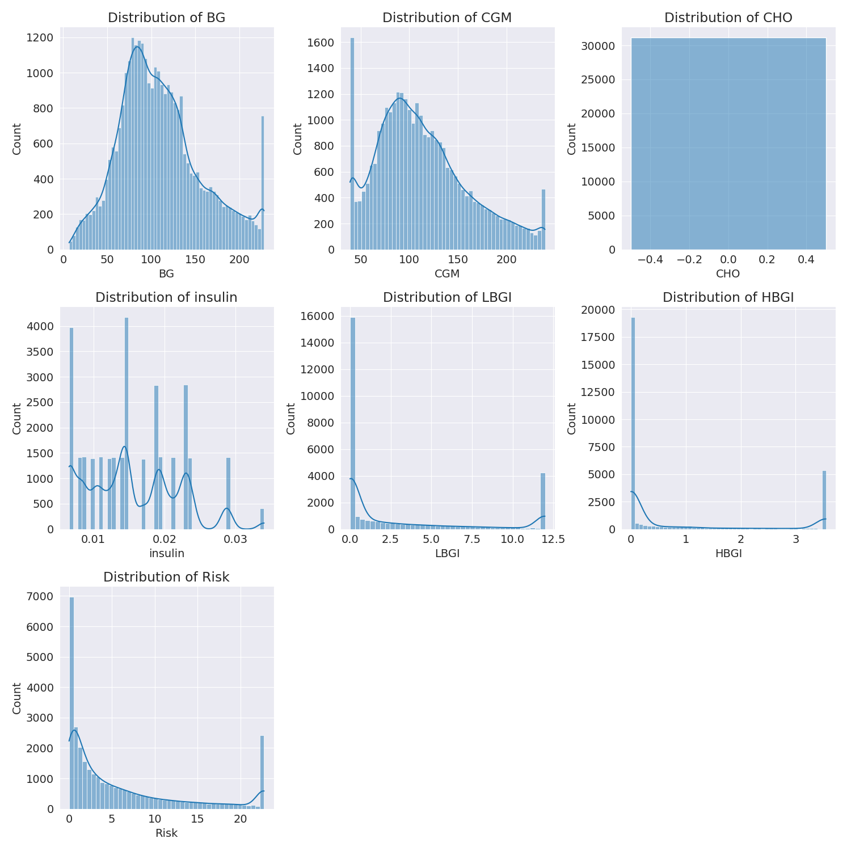

The image shows a series of graphs displaying the distribution of columns based on different criteria. Each graph represents a specific aspect of the data distribution. To analyze the distribution, we can identify any discernible patterns, cycles, or trends in the data over time.  
  
1. The first graph shows the distribution of insulin levels. The shape of the distribution is skewed, with a higher concentration of insulin levels in the middle and lower levels on both sides.  
2. The second graph displays the distribution of glucose levels. The shape of the distribution is skewed, with a higher concentration of glucose levels in the middle and lower levels on both sides.  
3. The third graph shows the distribution of LDLC levels. The shape of the distribution is skewed, with a higher concentration of LDLC levels in the middle and lower levels on both sides.  
4. The fourth graph displays the distribution of HDL levels. The shape of the distribution is skewed, with a higher concentration of HDL levels in the middle and lower levels on both sides.  
5. The fifth graph shows the distribution of triglyceride levels. The shape of the distribution is skewed, with a higher concentration of triglyceride levels in the middle and lower levels on both sides.  
6. The sixth graph displays the distribution of cholesterol levels. The shape of the distribution is skewed, with a higher concentration of cholesterol levels in the middle and lower levels on both sides.  
  
In summary, the image shows a series of graphs displaying the distribution of columns based on different criteria. Each graph represents a specific aspect of the data distribution. The shape of the distribution is skewed, with a higher concentration of the respective column in the middle and lower levels on both sides.

Missing Numbers Graph Analysis

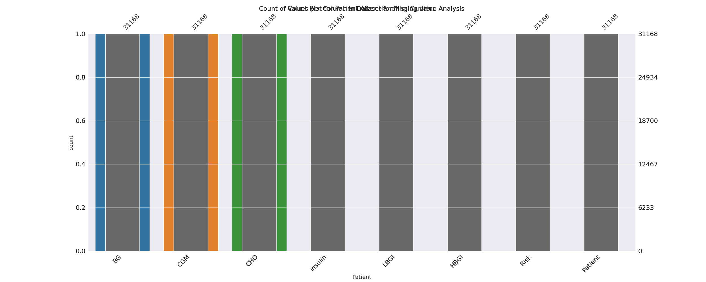

The image displays a bar chart with missing values, which is a common issue in data analysis. The chart is showing the count of black patients, and the numbers are missing for some of the bars. This can impact data analysis or modeling, as it may lead to inaccurate conclusions or predictions.  
  
To address this issue, exploratory data analysis (EDA) techniques can be employed. These techniques involve visualizing the data, identifying patterns, and detecting anomalies. By examining the distribution of the missing values, one can understand the reasons behind the missing data and decide whether to impute the missing values or exclude the affected data points.  
  
In the case of the bar chart, the missing values could be due to various reasons, such as data entry errors, missing data in the original source, or a deliberate decision to exclude certain data points. By identifying the cause of the missing values, one can take appropriate actions to improve the quality of the data and ensure accurate analysis or modeling.

Heat_Explainer Graph Analysis

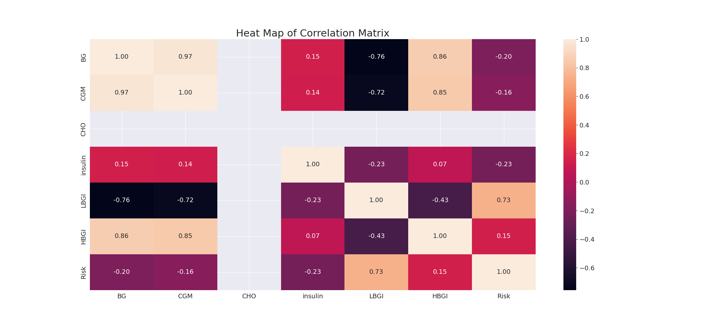

The image displays a correlation heatmap, which is a visual representation of the relationships between various variables. The heatmap is a color-coded matrix that helps to understand the strength and direction of correlations between these variables. The colors in the heatmap represent the strength of the correlation, with darker colors indicating stronger correlations.  
  
The heatmap is organized in a way that allows for easy identification of the variables and their relationships. The variables are likely related, and the data in the image helps to analyze and understand these relationships. By examining and deep-analyzing the visual representation, one can gain insights into the strength and direction of correlations between the variables.

Confusion_matrix Graph Analysis

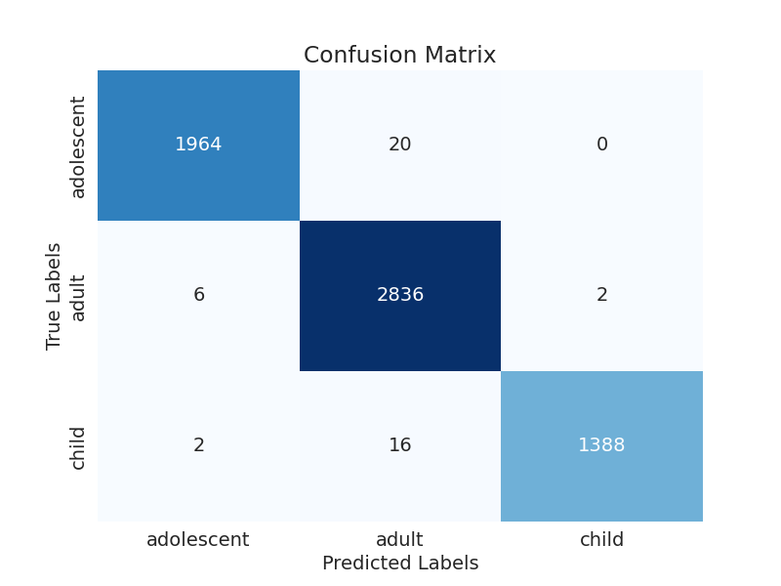

The image displays a confusion matrix, which is a visual representation of the relationship between variables. The variables are likely related, and the data in the image can provide insights into the strength and direction of correlations between these variables. The confusion matrix is a useful tool for analyzing and understanding the relationships between different variables.  
  
In the image, there are two main colors: blue and white. The blue color represents the correct predictions, while the white color represents the incorrect predictions. The confusion matrix is divided into four quadrants, each representing a different combination of the two variables.  
  
The top-left quadrant shows the relationship between the correct and incorrect predictions for the first variable. The top-right quadrant shows the relationship between the correct and incorrect predictions for the second variable. The bottom-left quadrant shows the relationship between the incorrect predictions for the first variable and the correct predictions for the second variable. Finally, the bottom-right quadrant shows the relationship between the incorrect predictions for the second variable and the correct predictions for the first variable.  
  
By examining and deep-analyzing the visual representation of the confusion matrix, one can gain insights into the strength and direction of correlations between the variables. This can help in understanding the relationships between these variables and their impact on the overall system.