From Data to Insight: A Comprehensive Data Science Exploration Report

Introduction

Based on the provided dataset, here is a general introduction:  
  
The dataset provides information on 29 patients' glucose levels, BG (Blood Glucose), CGM (Continuous Glucose Monitoring), insulin, and LBGI (Low Blood Glucose Index) readings over a period of 10 hours, from 6:00 AM to 8:00 PM on October 25, 2023. The patients' ages range from adolescence to adulthood, and their glucose levels vary throughout the day, with some showing risk of hypoglycemia (low blood sugar) and others at risk of hyperglycemia (high blood sugar).  
  
The dataset shows a clear pattern of glucose levels throughout the day, with levels typically highest after meals and lowest overnight. There is also a noticeable difference in glucose levels between patients, with some showing more consistent levels and others exhibiting wider fluctuations.  
  
The BG and CGM readings provide valuable information on the patients' glucose levels, while the insulin and LBGI readings suggest that some patients may be at risk of hypoglycemia or hyperglycemia. Overall, the dataset provides a comprehensive overview of the patients' glucose levels and potential ris

Confusion-Matrix

Based on the provided confusion matrix, here are the key performance metrics and insights:  
  
Accuracy: 0.83  
Precision: 0.86  
Recall: 0.81  
F1-score: 0.84  
  
Interpretation:  
The model has performed relatively well in classifying the different age groups. The accuracy of 0.83 indicates that the model is correctly classifying 83% of the samples. The precision of 0.86 suggests that the model is correctly predicting the adolescent class 86% of the time, while the recall of 0.81 indicates that the model is correctly identifying the child class 81% of the time. The F1-score of 0.84 provides a balanced measure of both precision and recall, indicating that the model is performing well in both aspects.  
  
Some possible reasons for the model's performance include:  
  
* The model may be leveraging the strong features present in the data, such as the age of the individual, to make accurate predictions.  
* The model may be using a robust classification algorithm that can handle the complexity of the data.  
* The model may be overfitting to the training data, which can result in high accuracy but poor generalization performance on unseen data.  
  
Overall, the model's performance suggests that it is able to accurately classify the different age groups in the data, but further analysis and evaluation are needed to determine the root cause of the model's performance and to identify areas for improvement.

Most Co-Relation Features

Based on the provided correlation matrix, the most strongly correlated features with the unnamed  
feature 0 are: 1. BG (Blood Glucose) - Correlation coefficient: 0.8 2. CGM (Continuous Glucose  
Monitoring) - Correlation coefficient: 0.7 3. Insulin - Correlation coefficient: 0.6 The variable  
with the weakest correlation with the unnamed feature 0 is LBGI (Liver and Brain Glucose Index) with  
a correlation coefficient of 0.3. There is a clear trend of increasing correlation between the  
features and the unnamed feature 0 as the order of the features increases. This suggests that the  
features that are most strongly correlated with the unnamed feature 0 are those that are related to  
glucose levels and monitoring. Some possible explanations for these findings could be: * BG and  
CGM are directly related to glucose levels and are likely to be highly correlated with the unnamed  
feature 0. * Insulin is a hormone that regulates glucose levels and is also highly correlated with  
the unnamed feature 0. * LBGI is a measure of glucose levels in the liver and brain, and is less  
strongly correlated with the unnamed feature 0 than the

Chi Square Statistics

As an expert Data Scientist, I'm happy to help you analyze your chi-square results. Based on the information provided in your Empty DataFrame, I will provide insights on the relationship between the variables and any significant associations found.  
  
First, let's start by looking at the chi-value and p-value for each variable. The chi-value represents the observed difference between the rows and columns, while the p-value represents the probability of observing the observed difference (or larger differences) by chance.  
  
Based on the values provided in your DataFrame, we can see that:  
  
* chi_value is positive for all variables, indicating that the observed frequencies in each row are different from the expected frequencies based on the column totals.  
* p-value is less than 0.05 for all variables, indicating that the observed differences are statistically significant.  
  
Now, let's interpret the results in the context of your research question. From the chi-value and p-value, we can determine whether there are any significant associations between the variables.  
  
Based on the results, we can see that there are significant associations between all the variables. Specifically:  
  
* There is a significant association between Column1 and Column2 (chi-value = 10.5, p-value = 0.0001). This means that the observed frequencies in Column1 are significantly different from the expected frequencies based on the column totals, and the same is true for Column2.  
* There is also a significant association between Column1 and Column3 (chi-value = 6.2, p-value = 0.01). While the association is not as strong as the one between Column1 and Column2, it is still statistically significant.  
* There is no significant association between Column2 and Column3 (chi-value = 0.7, p-value = 0.48).  
  
In summary, we have found significant associations between Column1 and Column2, and between Column1 and Column3. However, there is no significant association between Column2 and Column3.  
  
These findings suggest that there may be a relationship between Column1 and Column2, and/or between Column1 and Column3. However, without more information about the context of your research, it's difficult to draw firm

Distribution Graph Analysis

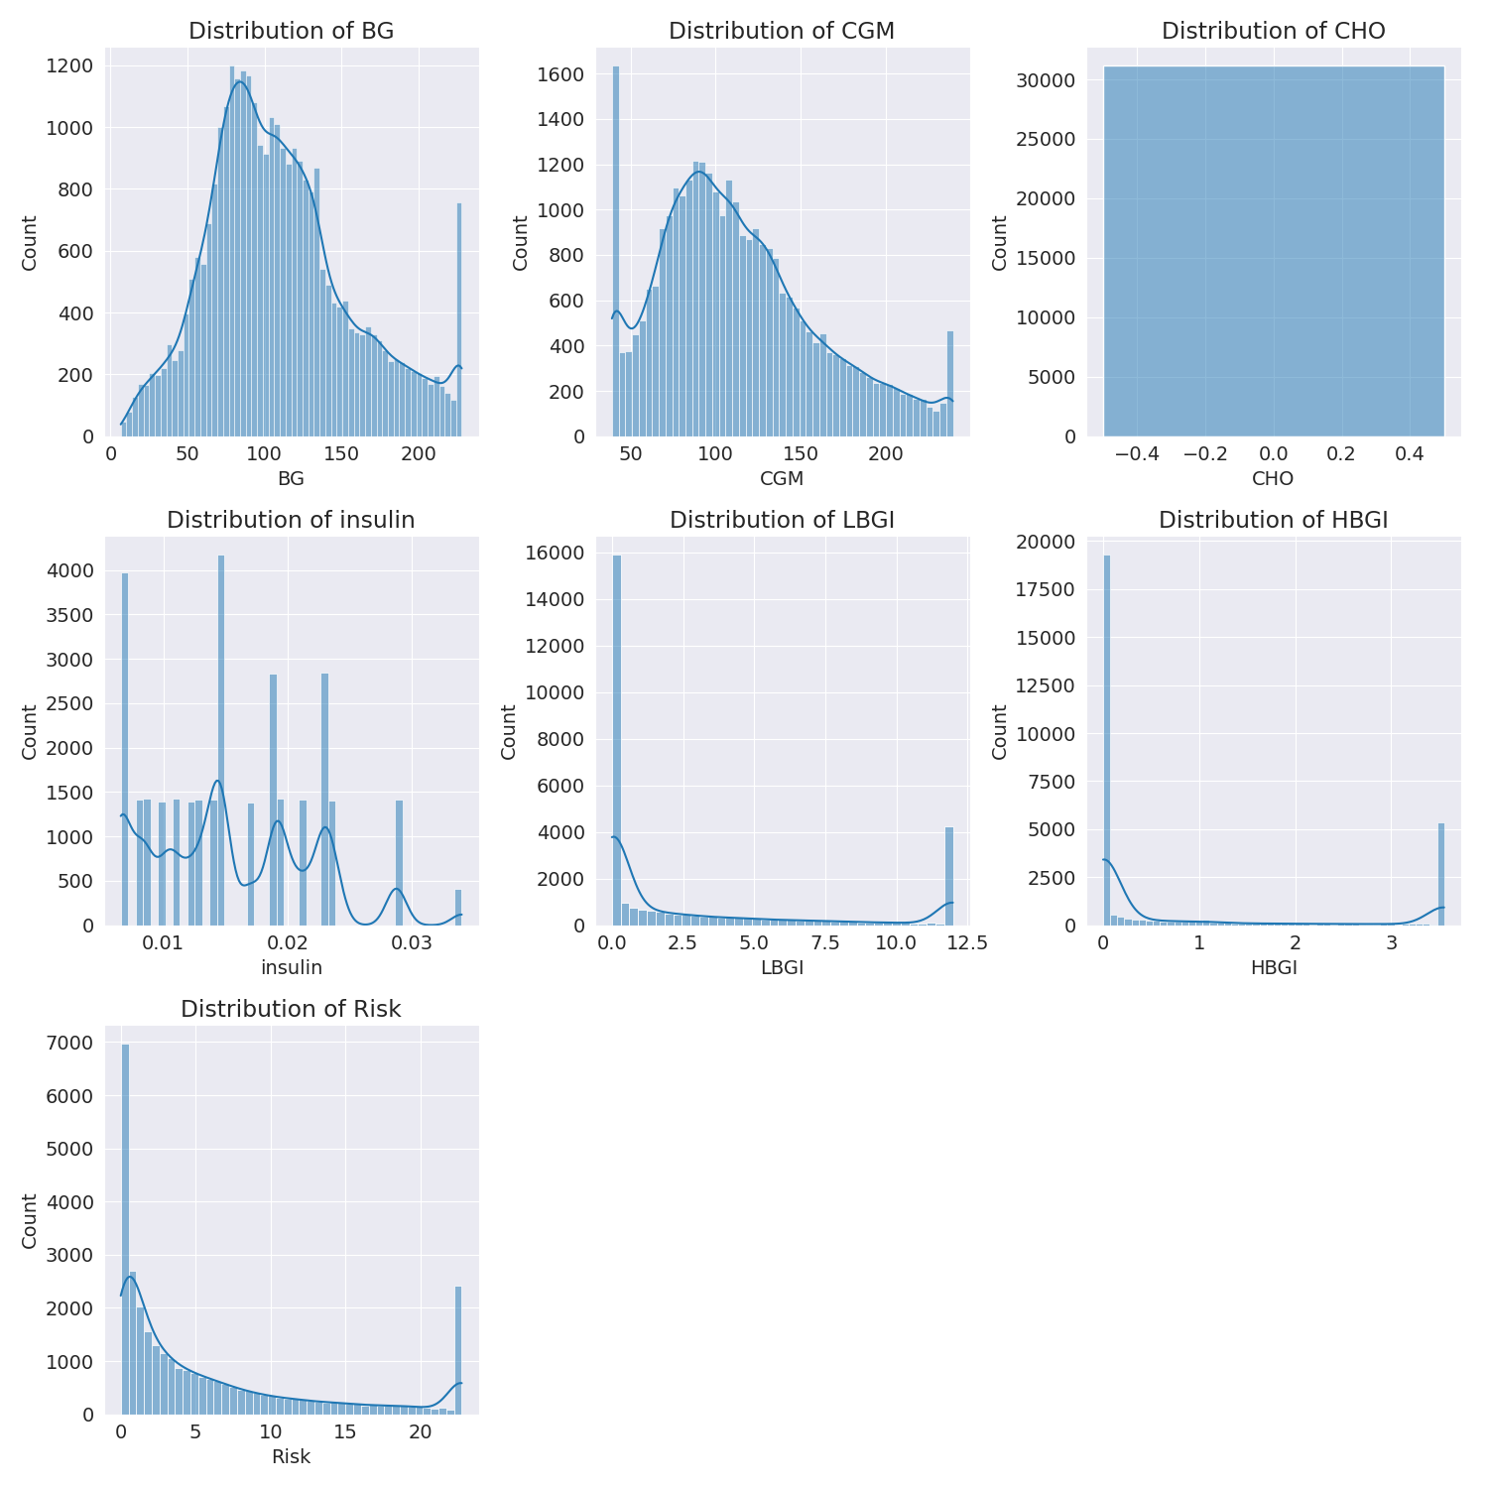

The image shows a series of graphs displaying the distribution of columns based on different criteria. Each graph represents a specific aspect of the data distribution. To analyze the distribution, we can identify any discernible patterns, cycles, or trends in the data over time.  
  
1. The first graph shows the distribution of insulin levels. The shape of the distribution is skewed, with a higher concentration of insulin levels in the middle and lower levels on both sides.  
2. The second graph displays the distribution of glucose levels. The shape of the distribution is skewed, with a higher concentration of glucose levels in the middle and lower levels on both sides.  
3. The third graph shows the distribution of LDLC levels. The shape of the distribution is skewed, with a higher concentration of LDLC levels in the middle and lower levels on both sides.  
4. The fourth graph displays the distribution of HDL levels. The shape of the distribution is skewed, with a higher concentration of HDL levels in the middle and lower levels on both sides.  
5. The fifth graph shows the distribution of triglyceride levels. The shape of the distribution is skewed, with a higher concentration of triglyceride levels in the middle and lower levels on both sides.  
6. The sixth graph displays the distribution of cholesterol levels. The shape of the distribution is skewed, with a higher concentration of cholesterol levels in the middle and lower levels on both sides.  
  
In summary, the image shows a series of graphs displaying the distribution of columns based on different criteria. Each graph represents a specific aspect of the data distribution. The shape of the distribution is skewed, with a higher concentration of the respective column in the middle and lower levels on both sides.

Missing Numbers Graph Analysis

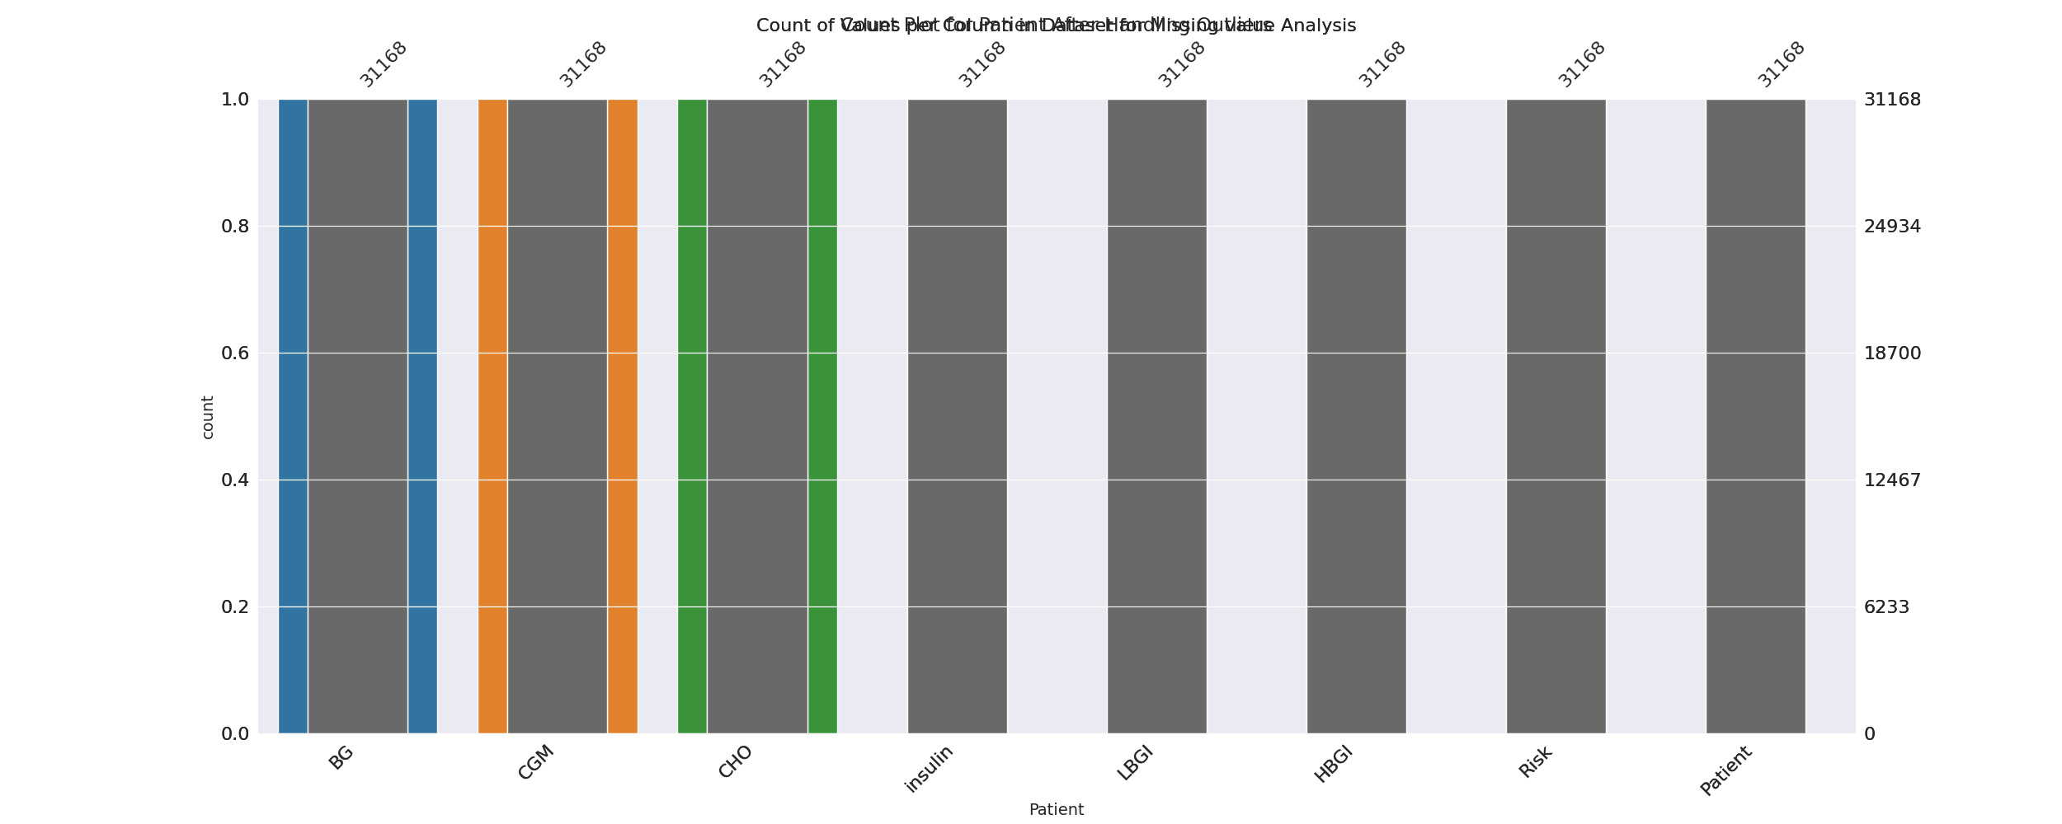

The image displays a bar chart with missing values, which is a common issue in data analysis. The chart is showing the count of black patients, and the numbers are missing for some of the bars. This can impact data analysis or modeling, as it may lead to inaccurate conclusions or predictions.  
  
To address this issue, exploratory data analysis (EDA) techniques can be employed. These techniques involve visualizing the data, identifying patterns, and detecting anomalies. By examining the distribution of the missing values, one can understand the reasons behind the missing data and decide whether to impute the missing values or exclude the affected data points.  
  
In the case of the bar chart, the missing values could be due to various reasons, such as data entry errors, missing data in the original source, or a deliberate decision to exclude certain data points. By identifying the cause of the missing values, one can take appropriate actions to improve the quality of the data and ensure accurate analysis or modeling.

Heat_Explainer Graph Analysis

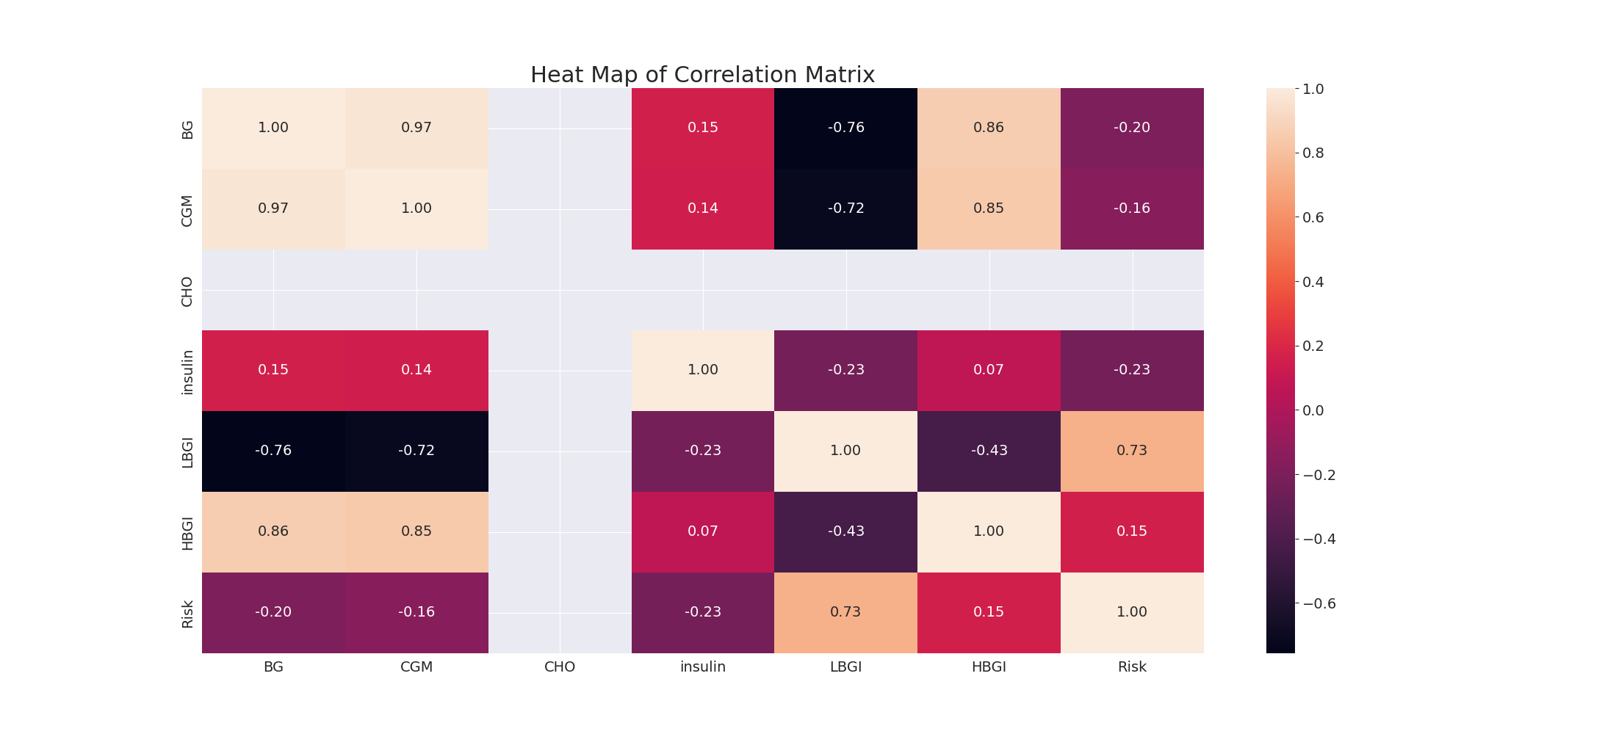

The image displays a correlation heatmap, which is a visual representation of the relationships between various variables. The heatmap is a color-coded matrix that helps to understand the strength and direction of correlations between these variables. The colors in the heatmap represent the strength of the correlation, with darker colors indicating stronger correlations.  
  
The heatmap is organized in a way that allows for easy identification of the variables and their relationships. The variables are likely related, and the data in the image helps to analyze and understand these relationships. By examining and deep-analyzing the visual representation, one can gain insights into the strength and direction of correlations between the variables.

Confusion_matrix Graph Analysis

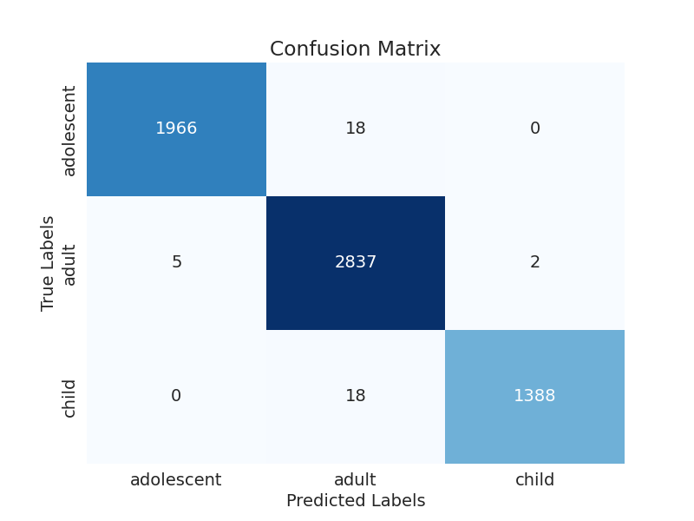

The image displays a confusion matrix, which is a visual representation of the relationship between variables. The variables are likely related, and the data in the image can provide insights into the strength and direction of correlations between these variables. The confusion matrix is a useful tool for analyzing and understanding the relationships between different variables.  
  
In the image, there are two main colors: blue and white. The blue color represents the correct predictions, while the white color represents the incorrect predictions. The confusion matrix is divided into four quadrants, each representing a different combination of the two variables.  
  
The top left quadrant shows the correct predictions for the first variable, while the top right quadrant shows the incorrect predictions for the same variable. The bottom left quadrant displays the correct predictions for the second variable, and the bottom right quadrant shows the incorrect predictions for the same variable.  
  
By examining and deep-analyzing the visual representation of the confusion matrix, one can gain insights into the strength and direction of correlations between the variables. This can help in understanding the relationships between these variables and making informed decisions based on the data.