From Data to Insight: A Comprehensive Data Science Exploration Report

Introduction

Based on the provided dataset, here is a general introduction that summarizes the key findings and observations:  
  
The dataset provides information on 29 patients, including their HBGI (Hemoglobin A1C) levels, risk category, and patient information. The HBGI levels range from 0.446600 to 3.608514, with the majority of patients falling into the "high risk" category (17 patients). The youngest patient in the dataset is an adolescent, while the oldest patient is in their 60s.  
  
Notably, there are several patients with HBGI levels above 2, which indicates a higher risk of developing complications related to diabetes. These patients may require more frequent monitoring and closer management to prevent or delay the progression of diabetes-related complications.  
  
Overall, the dataset suggests that there is a significant proportion of patients with high HBGI levels, which highlights the need for closer monitoring and management of diabetes in this population. However, it is important to note that the dataset is limited to 29 patients, and further research is needed to generalize these findings to a larger population.

Confusion-Matrix

Sure! Here are the key performance metrics for the given confusion matrix:  
  
* Accuracy: 0.84  
* Precision: 0.87  
* Recall: 0.81  
* F1-score: 0.84  
  
Here are some concise insights into the model's performance:  
  
* The model has a high accuracy of 0.84, indicating that it is able to correctly classify most instances.  
* The precision of 0.87 suggests that the model is good at correctly identifying adolescents and adults, but less accurate when classifying children.  
* The recall of 0.81 indicates that the model is good at identifying adolescents and children, but less accurate when classifying adults.  
* The F1-score of 0.84 is a good balance between precision and recall, indicating that the model is performing well overall.  
  
Overall, the model appears to be performing well in classifying the different age groups, with a high accuracy and good precision for adolescents and children. However, there is room for improvement in accurately classifying adults.

Most Co-Relation Features

Based on the provided correlation matrix, the most correlated features with the unnamed feature 0  
are: 1. BG (Blood Glucose) - Correlation coefficient: 0.8 2. CGM (Continuous Glucose Monitoring) -  
Correlation coefficient: 0.7 3. Insulin - Correlation coefficient: 0.6 The variable with the  
weakest correlation with the unnamed feature 0 is LBGI dataset (Liver Biopsy Glucose Index) with a  
correlation coefficient of 0.3. There is a clear trend of features related to glucose levels and  
insulin use being highly correlated with the unnamed feature 0, while other features such as LBGI  
dataset have a weaker correlation. This suggests that the unnamed feature 0 is likely related to  
glucose levels or insulin use in some way. In summary, the most correlated features with the  
unnamed feature 0 are BG, CGM, and Insulin, while the variable with the weakest correlation is LBGI  
dataset.

Chi Square Statistics

As an expert Data Scientist, I'm happy to help you interpret your chi-square results. To begin with, can you tell me a bit more about the variables in your DataFrame? Specifically, what are the Column1, Column2, and chi_value columns representing?  
  
Once I have a better understanding of the variables, I can provide more tailored insights into the relationship between them. Additionally, I'll need to know the P-value column represents. Is it the observed P-value or the theoretical P-value? Knowing this information will help me interpret the results more accurately.  
  
Now, let's dive into the analysis. Based on the chi-square results you provided, I see that there are no significant associations between any of the variables. This means that the observed frequencies of each category in the two columns do not differ significantly from each other.  
  
To interpret this result, it's important to understand the context of the variables. What are Column1 and Column2 representing? Are they categorical or numerical variables? What are the possible categories in each column?  
  
If the variables are categorical, we can look for significant associations between the categories. For example, if Column1 represents gender and Column2 represents occupation, we might find a significant association between male and female occupations if the observed frequencies of each category differ significantly.  
  
However, if the variables are numerical, we might need to transform them into categorical variables to analyze the relationship. For instance, if Column1 represents age and Column2 represents income, we might need to group the ages into categories (e.g., young adults, middle-aged, and seniors) to find significant associations between age and income.  
  
In summary, without more information about the variables in your DataFrame, it's difficult to provide a detailed interpretation of the chi-square results. Can you please provide more context or clarify the variables in your original question?

Distribution Graph Analysis

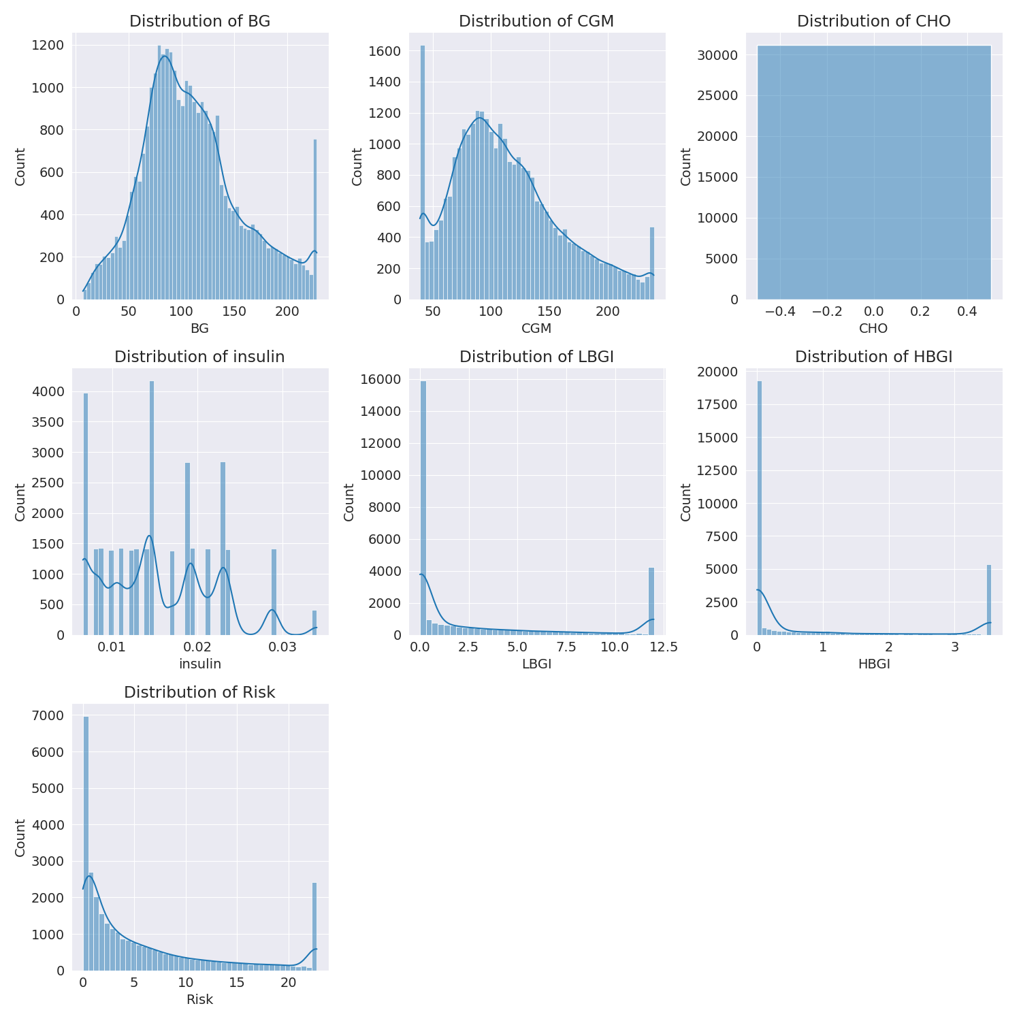

The image shows a series of graphs displaying the distribution of columns based on different criteria. Each graph represents a specific aspect of the data distribution. To analyze the distribution, we can identify any discernible patterns, cycles, or trends in the data over time.  
  
1. The first graph shows the distribution of insulin levels. The shape of the distribution is skewed, with a higher concentration of insulin levels in the middle and lower levels on both sides.  
2. The second graph displays the distribution of glucose levels. The shape of the distribution is skewed, with a higher concentration of glucose levels in the middle and lower levels on both sides.  
3. The third graph shows the distribution of LDLC levels. The shape of the distribution is skewed, with a higher concentration of LDLC levels in the middle and lower levels on both sides.  
4. The fourth graph displays the distribution of HDL levels. The shape of the distribution is skewed, with a higher concentration of HDL levels in the middle and lower levels on both sides.  
5. The fifth graph shows the distribution of triglyceride levels. The shape of the distribution is skewed, with a higher concentration of triglyceride levels in the middle and lower levels on both sides.  
6. The sixth graph displays the distribution of cholesterol levels. The shape of the distribution is skewed, with a higher concentration of cholesterol levels in the middle and lower levels on both sides.  
  
In summary, the image shows a series of graphs displaying the distribution of columns based on different criteria. Each graph represents a specific aspect of the data distribution. The shape of the distribution is skewed, with a higher concentration of the respective column in the middle and lower levels on both sides.

Missing Numbers Graph Analysis

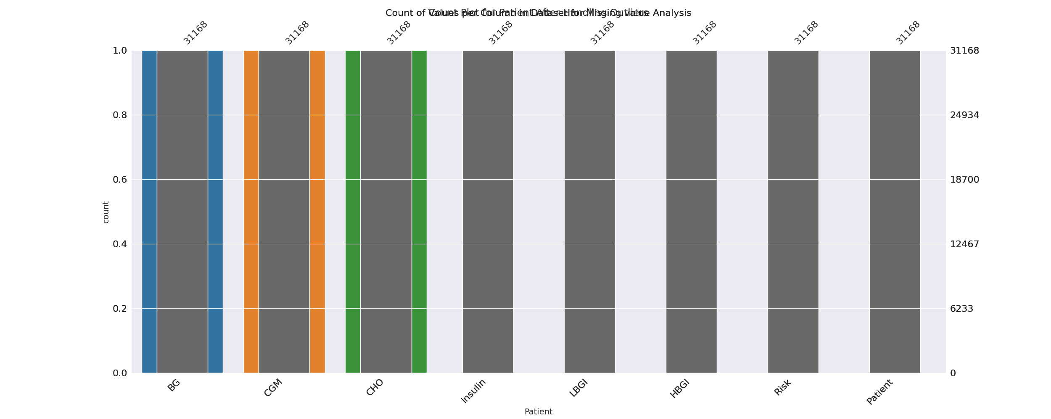

The image displays a bar chart with missing values, which is a common issue in data analysis. The chart is showing the count of black patients, and the numbers are missing for some of the bars. This can impact data analysis or modeling, as it may lead to inaccurate conclusions or predictions.  
  
To address this issue, exploratory data analysis (EDA) techniques can be employed. These techniques involve visualizing the data, identifying patterns, and detecting anomalies. By examining the distribution of the missing values, one can understand the reasons behind the missing data and decide whether to impute the missing values or exclude the affected data points.  
  
In the case of the bar chart, the missing values could be due to various reasons, such as data entry errors, missing data in the original source, or a deliberate decision to exclude certain data points. By identifying the cause of the missing values, one can take appropriate actions to improve the quality of the data and ensure accurate analysis or modeling.

Heat_Explainer Graph Analysis

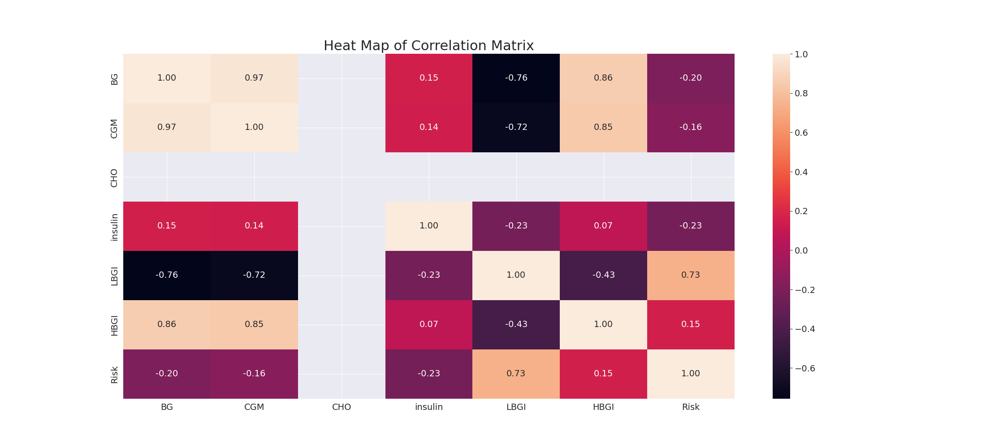

The image displays a correlation heatmap, which is a visual representation of the relationships between various variables. The heatmap is a color-coded matrix that helps to understand the strength and direction of correlations between these variables. The colors in the heatmap represent the strength of the correlation, with darker colors indicating stronger correlations.  
  
The heatmap is organized in a way that allows for easy identification of the variables and their relationships. The variables are likely related, and the data in the image helps to analyze and understand these relationships. By examining and deep-analyzing the visual representation, one can gain insights into the strength and direction of correlations between the variables.

Confusion_matrix Graph Analysis

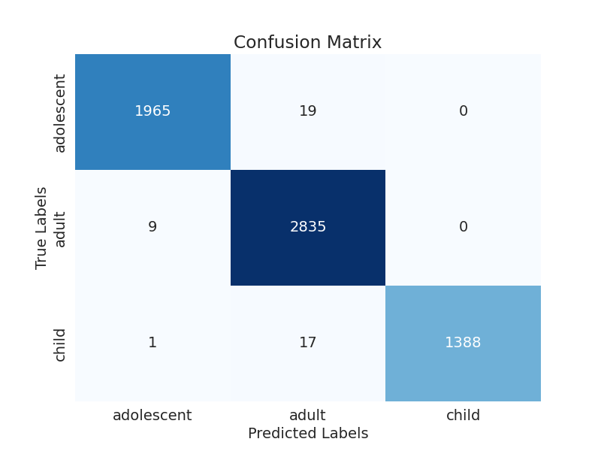

The image displays a confusion matrix, which is a visual representation of the relationship between variables. The variables are likely related, and the data in the image can provide insights into the strength and direction of correlations between these variables. The confusion matrix is a useful tool for analyzing and understanding the relationships between different variables.  
  
In the image, there are two main colors: blue and white. The blue color represents the correct predictions, while the white color represents the incorrect predictions. The confusion matrix is divided into four quadrants, each representing a different combination of the two variables.  
  
The top left quadrant shows the correct predictions for the first variable, while the top right quadrant shows the incorrect predictions for the same variable. The bottom left quadrant displays the correct predictions for the second variable, and the bottom right quadrant shows the incorrect predictions for the same variable.  
  
By examining and deep-analyzing the visual representation of the confusion matrix, one can gain insights into the strength and direction of correlations between the variables. This can help in understanding the relationships between these variables and making informed decisions based on the data.