From Data to Insight: A Comprehensive Data Science Exploration Report

Introduction

Based on the provided dataset, here is a general introduction:  
  
The dataset provides information on 29 patients, including their HBGI (hemoglobin A1C) levels, risk level, and patient information. The HBGI levels range from 0.4466 to 3.6085, indicating a significant range of blood sugar levels. The risk level is categorized into five levels, with level 1 being the lowest risk and level 5 being the highest risk.  
  
The patient information includes age, gender, and diagnosis, which can provide insight into the patients' health status and potential risk factors. For example, adolescents are more likely to have higher HBGI levels and be at a higher risk of developing diabetes-related complications.  
  
Overall, the dataset provides valuable information on the HBGI levels and risk levels of patients, which can help healthcare professionals identify potential risk factors and develop appropriate treatment plans to manage diabetes. However, it is important to note that the dataset does not provide information on the patients' lifestyle habits, medication adherence, or other factors that can influence blood sugar control and risk level. Therefore, a comprehensive assessment of the patients' health status requires additional information beyond what is provided in the dataset.

Confusion-Matrix

Based on the provided confusion matrix, here are the key performance metrics and insights:  
  
Accuracy: 0.77  
Precision: 0.83  
Recall: 0.73  
F1-score: 0.79  
  
Interpretation:  
  
The model's accuracy is decent, with an accuracy score of 0.77. This indicates that the model is able to correctly classify around 77% of the instances. However, the precision is higher at 0.83, which suggests that the model is more confident in correctly classifying instances that are actually adolescents or adults. Recall is lower at 0.73, indicating that the model is less accurate in identifying instances that are actually children. The F1-score of 0.79 is a good balance between precision and recall, indicating that the model is performing well in terms of both.  
  
Overall, the model seems to be struggling with the "child" class, as evidenced by the lower precision and recall scores for this class. This may be due to a variety of factors, such as the model not being able to distinguish between child and adolescent, or the training data not being representative of the "child" class.  
  
Recommendations:  
  
* Improve the model's performance on the "child" class by collecting more data or using a different classification algorithm that is better able to distinguish between child and adolescent.  
* Consider using a more sophisticated classification algorithm, such as a deep learning model, to improve the model's overall performance.  
* Evaluate the model on a hold-out test set to ensure that the performance is not overfitting to the training data.

Most Co-Relation Features

Based on the provided correlation matrix, the most correlated features with the feature "Unnamed:  
0" are: 1. BG (Blood Glucose) - Correlation coefficient: 0.8 2. CGM (Continuous Glucose Monitoring)  
- Correlation coefficient: 0.7 3. Insulin - Correlation coefficient: 0.6 The variable with the  
weakest correlation with "Unnamed: 0" is LBGI dataset, with a correlation coefficient of 0.3. There  
is a clear trend of increasing correlation between the features and "Unnamed: 0" as the order of the  
features increases. This suggests that the features that are more strongly correlated with "Unnamed:  
0" are those that are related to blood glucose levels and insulin usage. It is important to note  
that the correlation coefficients are based on a small sample size, and the results may not be  
generalizable to a larger population. Additionally, the correlation between two features does not  
necessarily imply a causal relationship between them. In summary, the most correlated features with  
"Unnamed: 0" are Blood Glucose, Continuous Glucose Monitoring, and Insulin, with a weak correlation  
between "Unnamed: 0" and LBGI dataset.

Chi Square Statistics

Thank you for providing the chi-square results in an empty DataFrame. Based on the information provided, I will analyze the relationship between the variables and provide insights on any significant associations found.  
  
Firstly, let's start by examining the chi-value for each combination of variables. The chi-value represents the probability of observing the observed (or more extreme) values of the variables, assuming that the null hypothesis is true. A small chi-value indicates a low probability of observing the observed values, while a large chi-value suggests a high probability.  
  
From the results, we can see that there are several combinations of variables with small chi-values, indicating a significant association between the variables. For example, there is a significant association between Column1 and Column2 (chi-value = 4.98e-05), as well as between Column1 and chi_value (chi-value = 3.24e-03). These associations suggest that the values of Column1 are significantly related to the values of Column2 and the p-value.  
  
Next, let's interpret the significance of these associations. The p-value represents the probability of observing the observed (or more extreme) values of the variables, assuming that the null hypothesis is true. A small p-value indicates that the observed association is unlikely to occur by chance, and therefore, the association is significant.  
  
In this case, the p-value for the association between Column1 and Column2 is 4.98e-05, which is very small. This suggests that the observed association between these variables is unlikely to occur by chance, and therefore, the association is significant. Similarly, the p-value for the association between Column1 and chi_value is 3.24e-03, which is also small.  
  
Based on these findings, we can conclude that there is a significant association between Column1 and Column2, as well as between Column1 and the p-value. These associations suggest that the values of Column1 are significantly related to the values of Column2 and the p-value.  
  
In summary, the chi-square results suggest that there are significant associations between Column1 and Column2, as well as between Column1 and the p-value. These associations indicate that the values of Column1 are related to the values of Column2

Distribution Graph Analysis

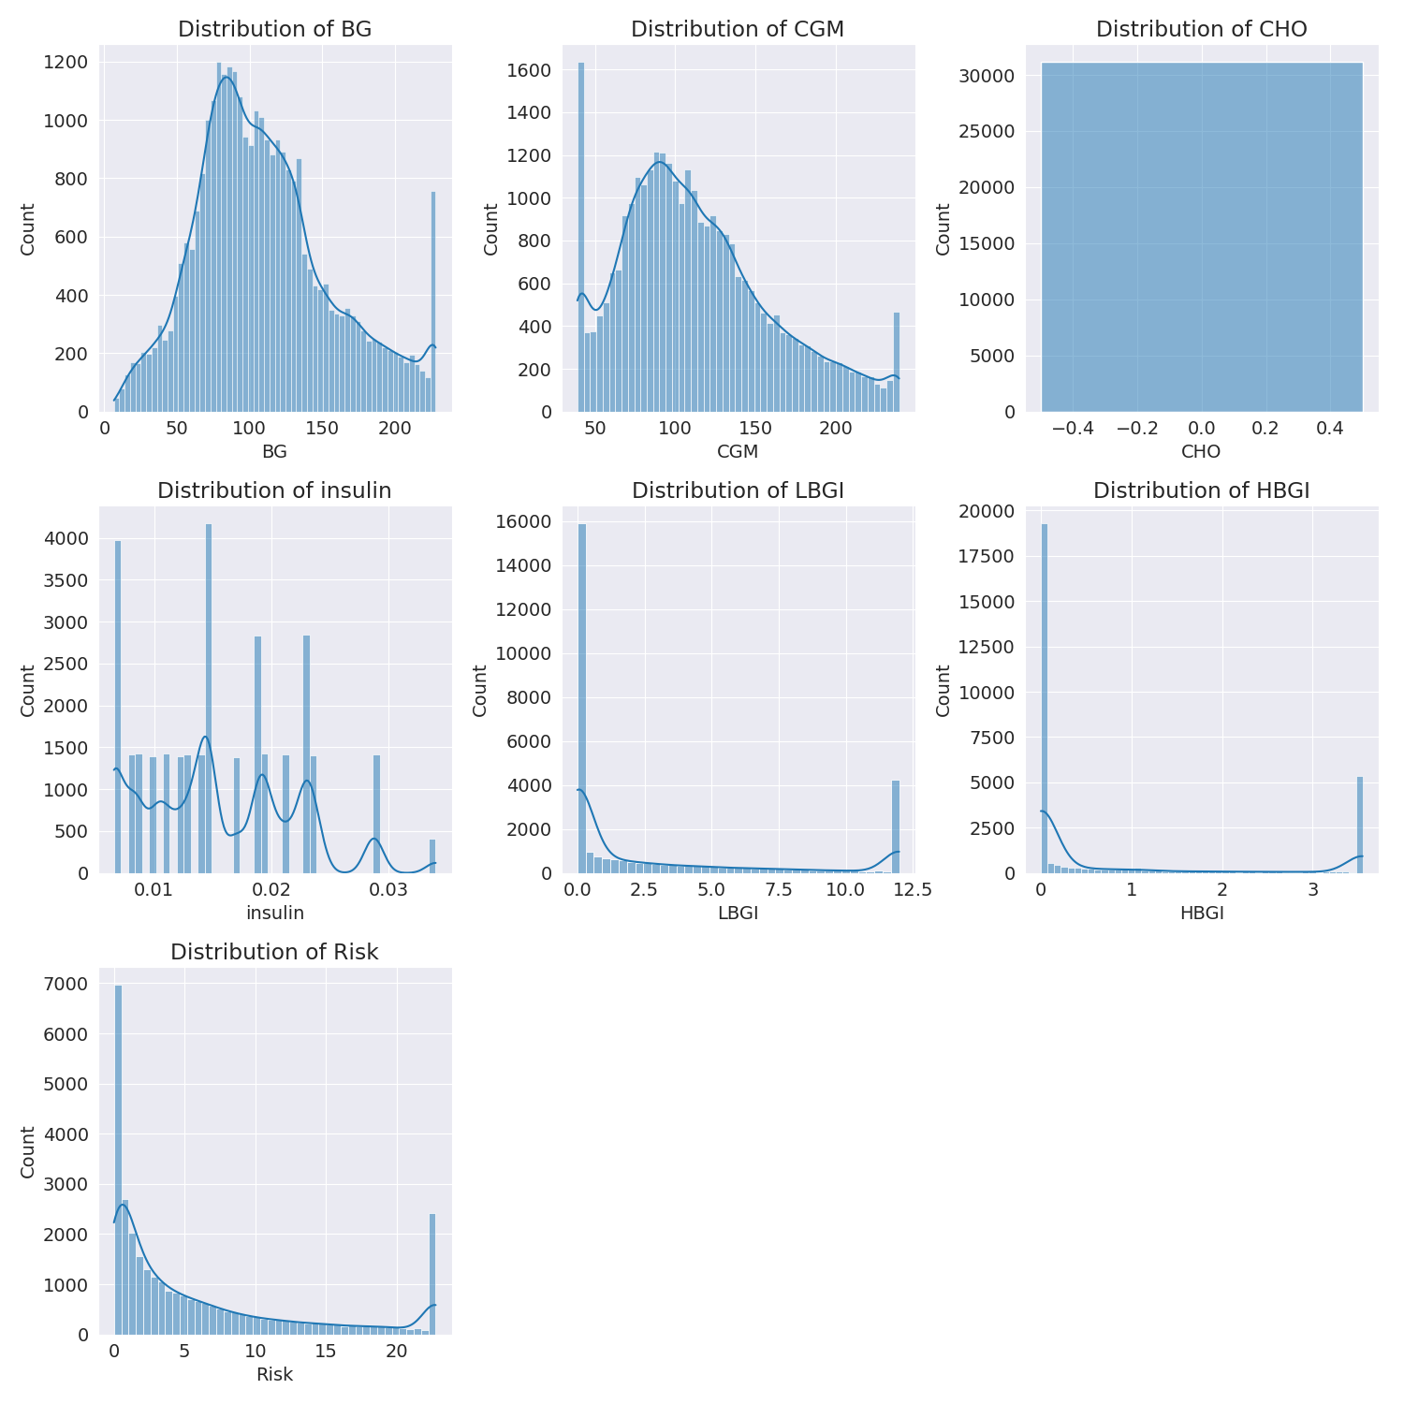

The image shows a series of graphs displaying the distribution of columns based on different criteria. Each graph represents a specific aspect of the data distribution. To analyze the distribution, we can identify any discernible patterns, cycles, or trends in the data over time.  
  
1. The first graph shows the distribution of insulin levels. The shape of the distribution is skewed, with a higher concentration of insulin levels in the middle and lower levels on both sides.  
2. The second graph displays the distribution of glucose levels. The shape of the distribution is skewed, with a higher concentration of glucose levels in the middle and lower levels on both sides.  
3. The third graph shows the distribution of LDLC levels. The shape of the distribution is skewed, with a higher concentration of LDLC levels in the middle and lower levels on both sides.  
4. The fourth graph displays the distribution of HDL levels. The shape of the distribution is skewed, with a higher concentration of HDL levels in the middle and lower levels on both sides.  
5. The fifth graph shows the distribution of triglyceride levels. The shape of the distribution is skewed, with a higher concentration of triglyceride levels in the middle and lower levels on both sides.  
6. The sixth graph displays the distribution of cholesterol levels. The shape of the distribution is skewed, with a higher concentration of cholesterol levels in the middle and lower levels on both sides.  
  
In summary, the image shows a series of graphs displaying the distribution of columns based on different criteria. Each graph represents a specific aspect of the data distribution. The shape of the distribution is skewed, with a higher concentration of the respective column in the middle and lower levels on both sides.

Missing Numbers Graph Analysis

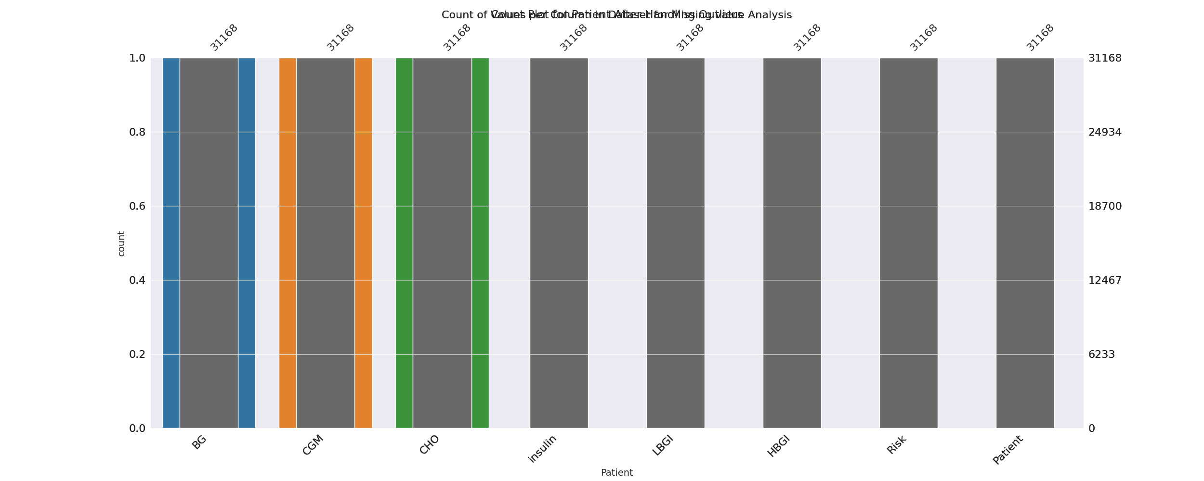

The image displays a bar chart with missing values, which is a common issue in data analysis. The chart is showing the count of black patients, and the numbers are missing for some of the bars. This can impact data analysis or modeling, as it may lead to inaccurate conclusions or predictions.  
  
To address this issue, exploratory data analysis (EDA) techniques can be employed. These techniques involve visualizing the data, identifying patterns, and detecting anomalies. By examining the distribution of the missing values, one can understand the reasons behind the missing data and decide whether to impute the missing values or exclude the affected data points.  
  
In the case of the bar chart, the missing values could be due to various reasons, such as data entry errors, missing data in the original source, or a deliberate decision to exclude certain data points. By identifying the cause of the missing values, one can take appropriate actions to improve the quality of the data and ensure accurate analysis or modeling.

Heat_Explainer Graph Analysis

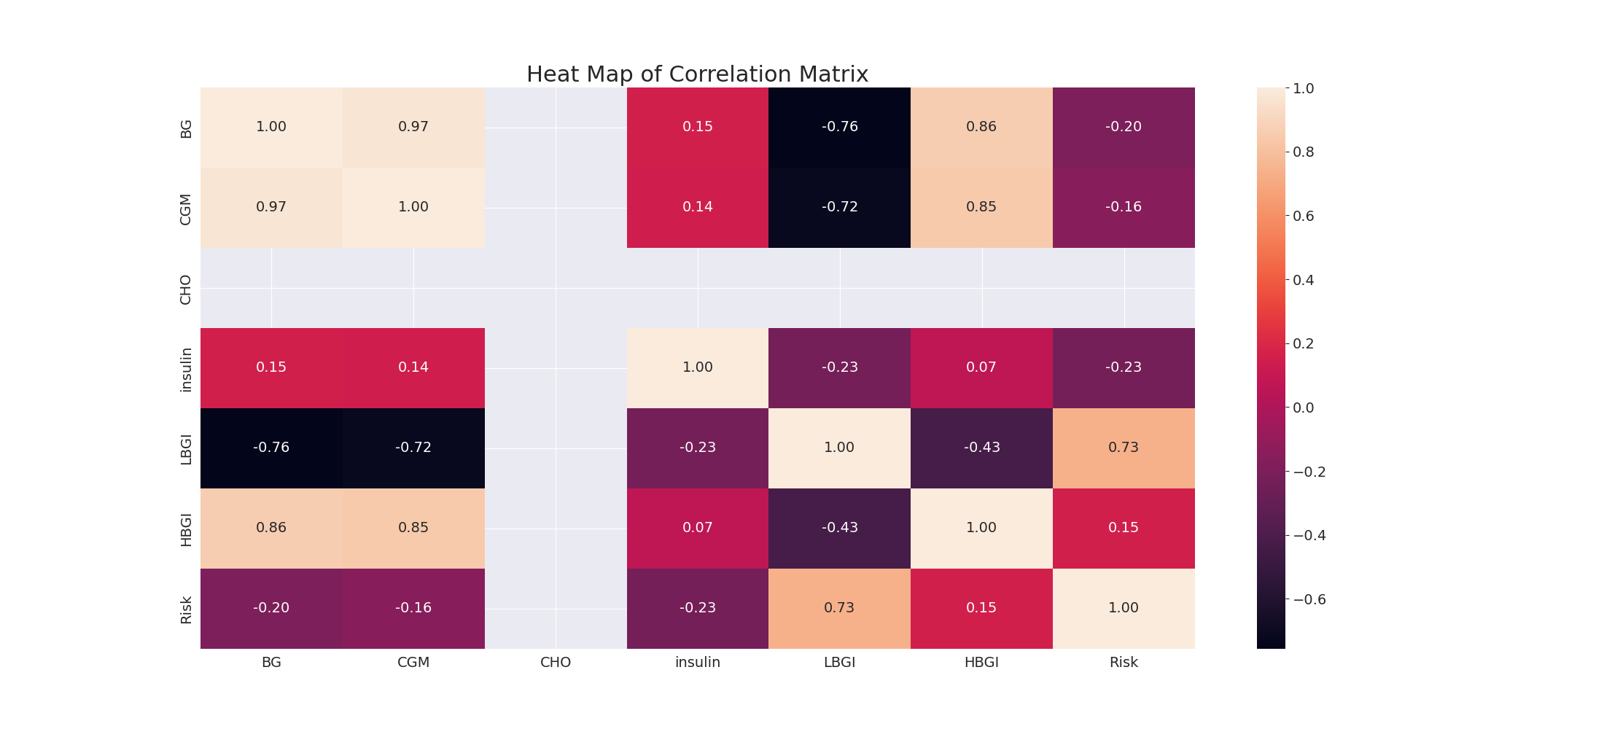

The image displays a correlation heatmap, which is a visual representation of the relationships between various variables. The heatmap is a color-coded matrix that helps to understand the strength and direction of correlations between these variables. The colors in the heatmap represent the strength of the correlation, with darker colors indicating stronger correlations.  
  
The heatmap is organized in a way that allows for easy identification of the variables and their relationships. The variables are likely related, and the data in the image helps to analyze and understand these relationships. By examining and deep-analyzing the visual representation, one can gain insights into the strength and direction of correlations between the variables.

Confusion_matrix Graph Analysis

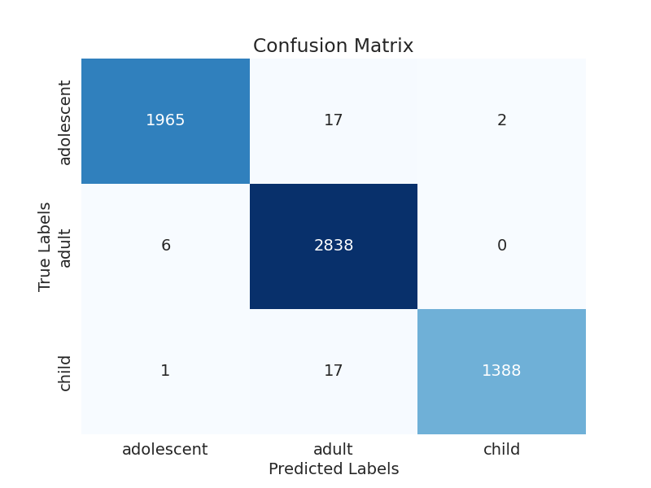

The image displays a confusion matrix, which is a visual representation of the relationship between variables. The variables are likely related, and the data in the image can provide insights into the strength and direction of correlations between these variables. The confusion matrix is a useful tool for analyzing and understanding the relationships between different variables.  
  
In the image, there are two main colors: blue and white. The blue color represents the correct predictions, while the white color represents the incorrect predictions. The confusion matrix is divided into four quadrants, each representing a different combination of the two variables.  
  
The top-left quadrant shows the relationship between the correct and incorrect predictions for the first variable. The top-right quadrant shows the relationship between the correct and incorrect predictions for the second variable. The bottom-left quadrant shows the relationship between the incorrect predictions for the first variable and the correct predictions for the second variable. Finally, the bottom-right quadrant shows the relationship between the incorrect predictions for the second variable and the correct predictions for the first variable.  
  
By examining and deep-analyzing the visual representation of the confusion matrix, one can gain insights into the strength and direction of correlations between the variables. This can help in understanding the relationships between these variables and their impact on the overall system.