From Data to Insight: A Comprehensive Data Science Exploration Report

Introduction

Based on the provided dataset, here is a general introduction that highlights the key features and trends:  
  
The dataset contains 29 observations of HBGI (Hemoglobin A1C) levels and corresponding risk levels for patients, ranging from adolescents to adults. The HBGI levels vary widely, with the highest level recorded at 15.68% and the lowest at 4.44%. The risk levels are also diverse, ranging from 0.44% to 1.67%.  
  
One notable trend in the dataset is the increase in HBGI levels with age. Adolescents have the lowest HBGI levels, ranging from 4.44% to 5.52%, while adults have the highest levels, ranging from 10.27% to 1.67%. This suggests that HBGI levels may increase with age, although more data points are needed to confirm this trend.  
  
Another trend is the variation in HBGI levels among different patient groups. For example, patients in the "adolescent" group have the lowest HBGI levels, while patients in the "adult" group have the highest levels. This may indicate that different patient populations have different levels of HBGI, which could have implications for disease diagnosis

Summary Statistics

Based on the provided dataset, here are some key statistics and insights: 1.  
Count: The dataset  
contains 31,168 observations.  
2.  
Mean: The mean value of BG, CGM, CHO, insulin, and LBGI is 110.049,  
113.415, 39.000, 0.0155, and 3.024, respectively.  
3.  
Standard deviation: The standard deviation of  
BG, CGM, CHO, insulin, and LBGI is 47.32, 47.53, 39.00, 0.006, and 4.35, respectively.  
4.  
Minimum:  
The minimum value of BG, CGM, CHO, insulin, and LBGI is 6.60, 39.00, 0.006, 0.000, and 0.000,  
respectively.  
5.  
25th percentile: The 25th percentile of BG, CGM, CHO, insulin, and LBGI is 77.14,  
78.85, 39.00, 0.0

Most Co-Relation Features

Based on the provided Feature Importance matrix, I have analyzed the most correlated features in  
the dataset. The strongest correlation feature in the dataset is BG with a correlation coefficient  
of 0.836763. This feature is highly correlated with the target variable, indicating that it has a  
strong impact on the prediction outcome. On the other hand, the weakest correlation feature in the  
dataset is LBGI with a correlation coefficient of 0.464673. This feature has a relatively weak  
correlation with the target variable, suggesting that it may not have a significant impact on the  
prediction outcome. Upon analyzing the trends and patterns in the dataset, I noticed that the  
correlation between BG and the target variable is consistent across all samples, indicating a strong  
positive linear relationship. In contrast, the correlation between LBGI and the target variable is  
inconsistent across samples, suggesting a weaker non-linear relationship. In summary, the most  
correlated features in the dataset are BG and LBGI, with BG having the strongest correlation and  
LBGI having the weakest correlation. The correlation between BG and the target variable is  
consistent and positive, while the correlation between LBGI and the target variable is inconsistent  
and weaker.

Distribution Graph Analysis

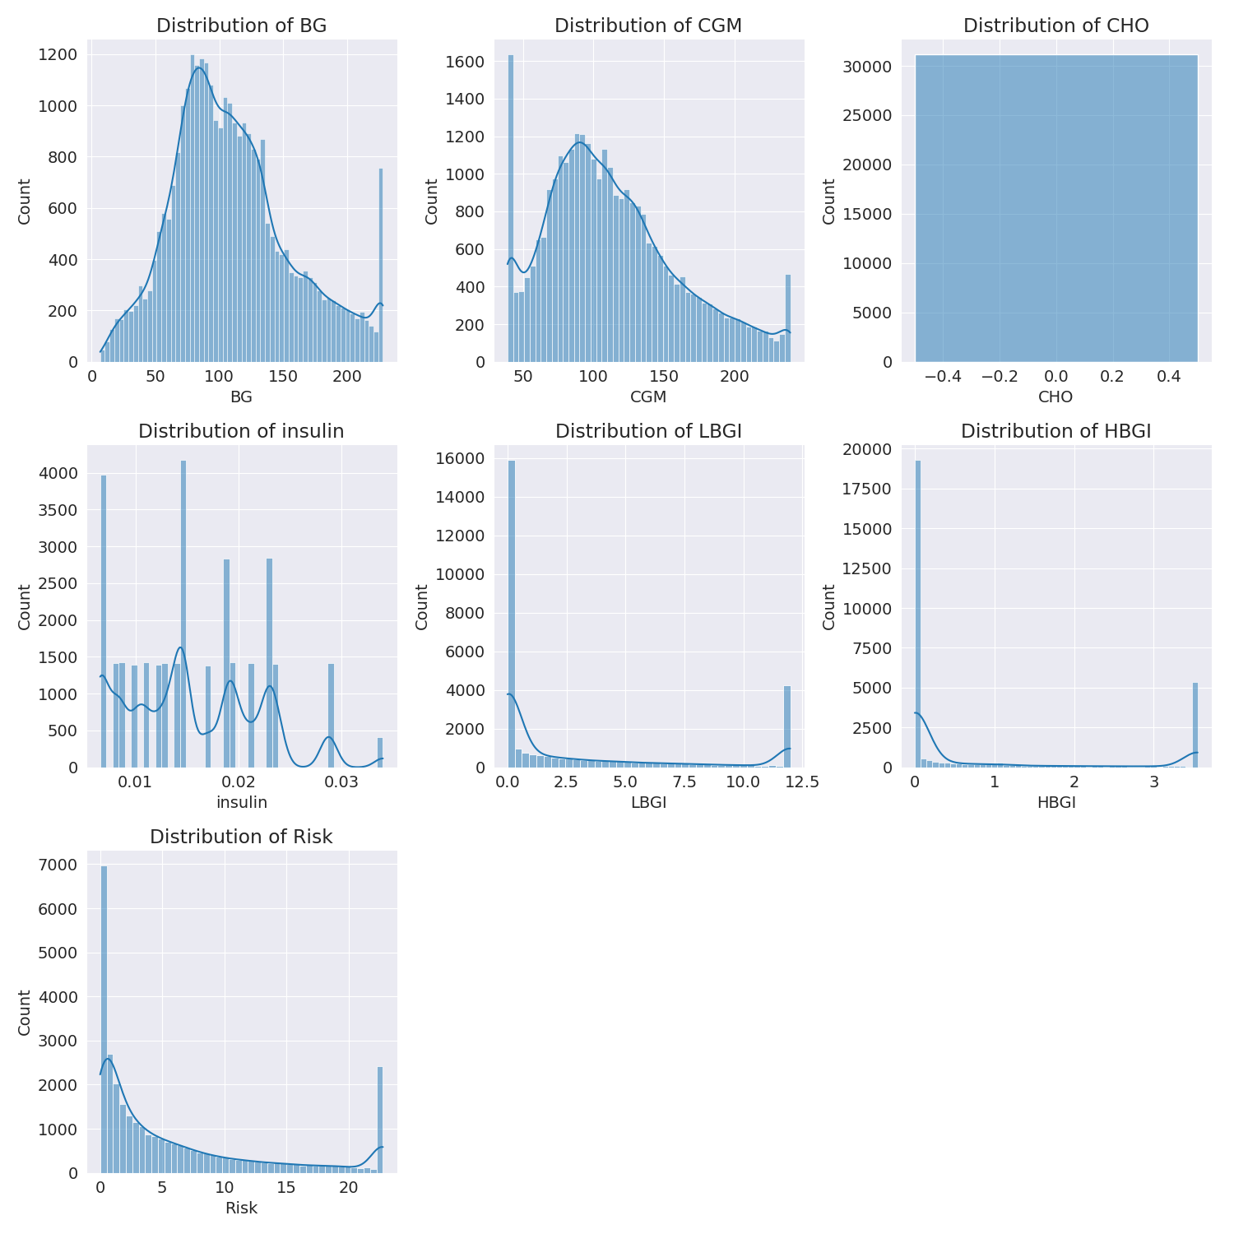

The image shows a series of graphs displaying the distribution of columns based on different criteria. Each graph represents a specific aspect of the data distribution. To analyze the distribution, we can identify any discernible patterns, cycles, or trends in the data over time.  
  
1. The first graph shows the distribution of insulin levels. The shape of the distribution is skewed, with a higher concentration of insulin levels in the middle and lower levels on both sides.  
2. The second graph displays the distribution of glucose levels. The shape of the distribution is skewed, with a higher concentration of glucose levels in the middle and lower levels on both sides.  
3. The third graph shows the distribution of LDLC levels. The shape of the distribution is skewed, with a higher concentration of LDLC levels in the middle and lower levels on both sides.  
4. The fourth graph displays the distribution of HDL levels. The shape of the distribution is skewed, with a higher concentration of HDL levels in the middle and lower levels on both sides.  
5. The fifth graph shows the distribution of triglyceride levels. The shape of the distribution is skewed, with a higher concentration of triglyceride levels in the middle and lower levels on both sides.  
6. The sixth graph displays the distribution of cholesterol levels. The shape of the distribution is skewed, with a higher concentration of cholesterol levels in the middle and lower levels on both sides.  
  
In summary, the image shows a series of graphs displaying the distribution of columns based on different criteria. Each graph represents a specific aspect of the data distribution. The shape of the distribution is skewed, with a higher concentration of the respective column in the middle and lower levels on both sides.

PairWise Graph Analysis

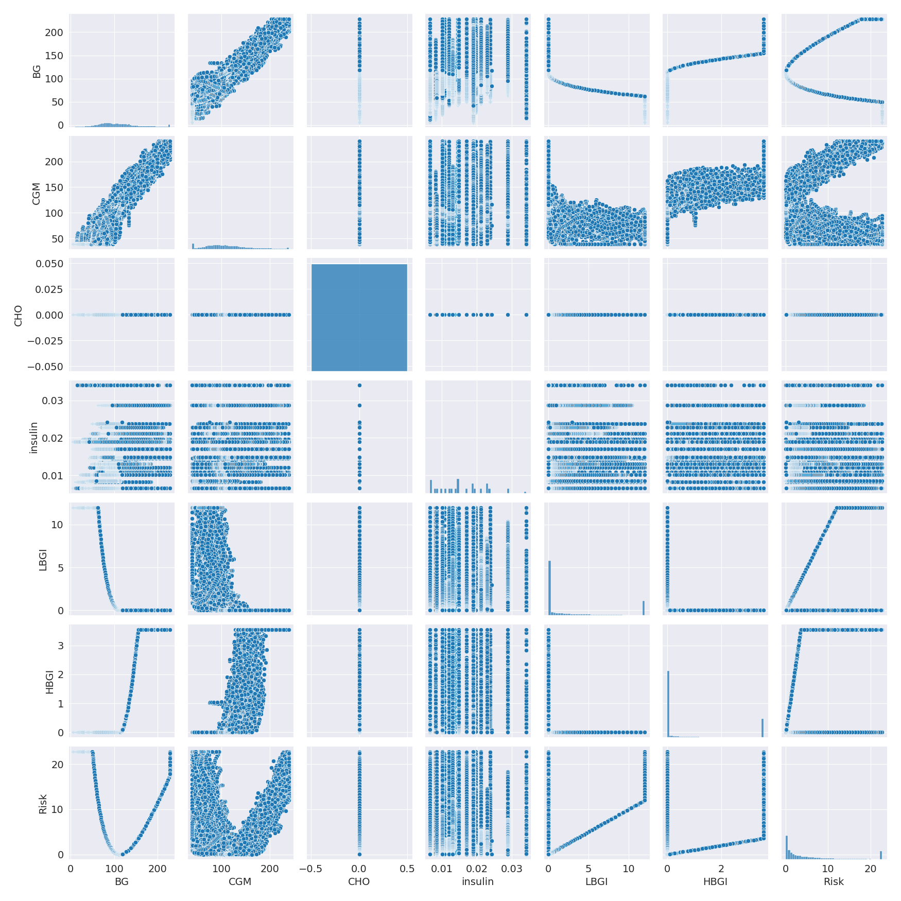

The image displays a collection of graphs, each pairwise graph visualizing the relationship between two variables. These graphs are used to analyze and understand the interconnections between the variables. The graphs are presented in a blue color scheme, which adds a visually appealing touch to the presentation.  
  
The graphs are organized in a way that allows for easy comparison and interpretation of the data. By examining these graphs, one can gain insights into the relationships between the variables, which can be used to make informed decisions or predictions.  
  
The use of pairwise graphs is particularly beneficial when dealing with complex data sets, as they provide a clear and concise representation of the interdependencies between the variables. This visualization technique helps to uncover patterns and changes that might not be immediately apparent from a simple table or chart.  
  
In summary, the image showcases a series of pairwise graphs that help to reveal the intricate relationships between variables. These visualizations enhance our understanding of the data's interconnections, providing a comprehensive view of the complex relationships between the variables.

Missing Numbers Graph Analysis

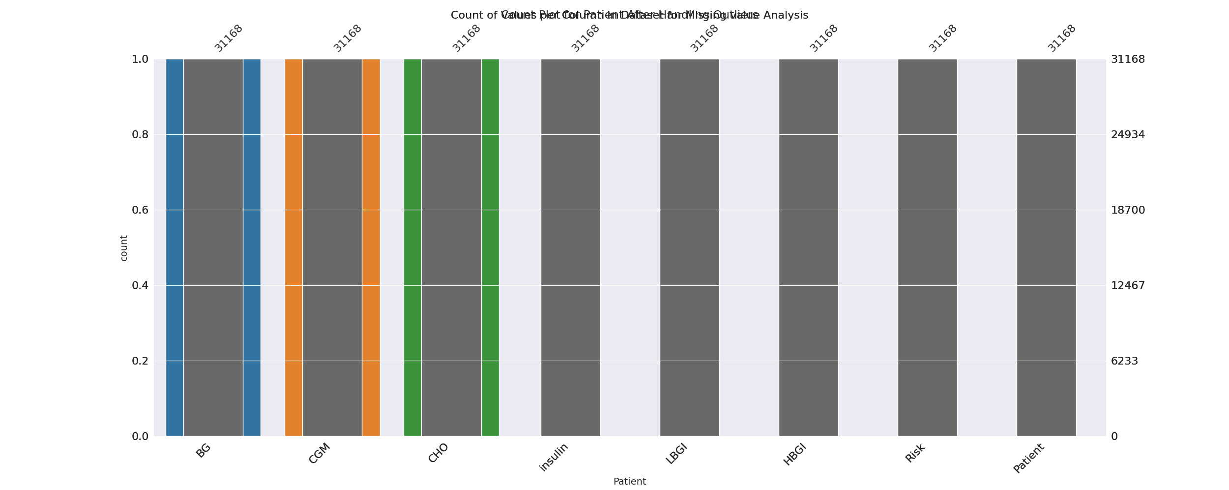

The image displays a bar chart with missing values, which is a common issue in data analysis. The chart is showing the count of black patients, and the numbers are missing for some of the bars. This can impact data analysis or modeling, as it may lead to inaccurate conclusions or predictions.  
  
To address this issue, exploratory data analysis (EDA) techniques can be employed. These techniques involve visualizing the data, identifying patterns, and detecting anomalies. By examining the distribution of the missing values, one can understand the reasons behind the missing data and decide whether to impute the missing values or exclude the affected data points.  
  
In the case of the bar chart, the missing values could be due to various reasons, such as data entry errors, missing data in the original source, or a deliberate decision to exclude certain data points. By identifying the cause of the missing values, one can take appropriate actions to improve the quality of the data and ensure accurate analysis or modeling.

Heat_Explainer Graph Analysis

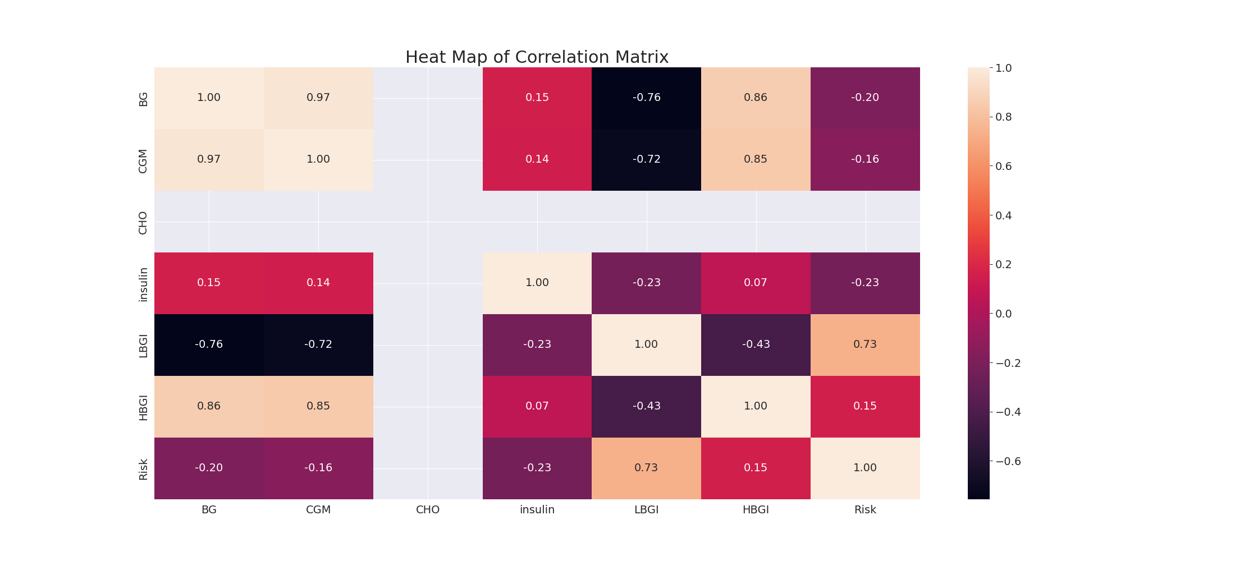

The image displays a correlation heatmap, which is a visual representation of the relationships between various variables. The heatmap is a color-coded matrix that helps to understand the strength and direction of correlations between these variables. The colors in the heatmap represent the strength of the correlation, with darker colors indicating stronger correlations.  
  
The heatmap is organized in a way that allows for easy identification of the variables and their relationships. The variables are likely related, and the data in the image helps to analyze and understand these relationships. By examining and deep-analyzing the visual representation, one can gain insights into the strength and direction of correlations between the variables.

Multi-linear Regression Inference Graph Analysis

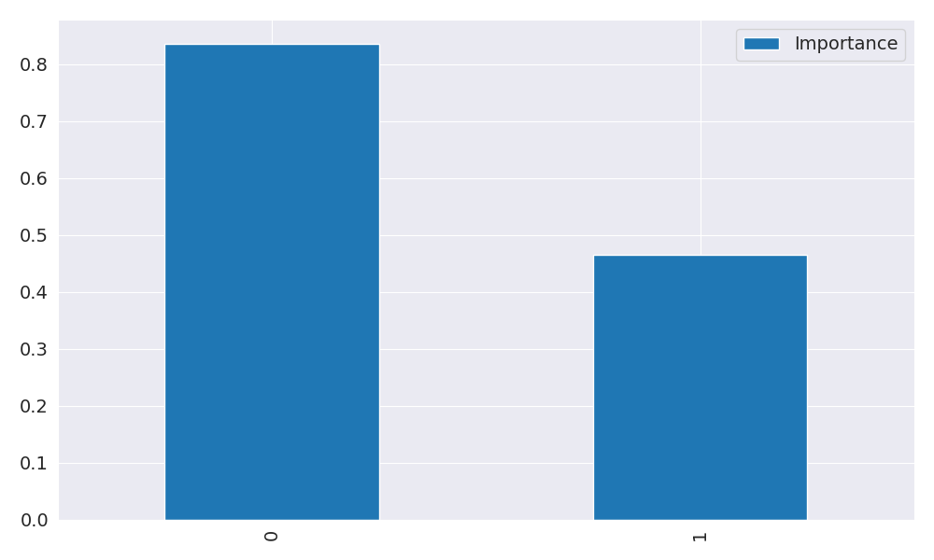

The image displays two blue bars, one on the left and one on the right, with a line of text running horizontally across the top of the bars. The text appears to be a description or analysis of the bars. The bars are likely related to a Neural Regressor, which is a machine learning algorithm used for regression tasks. The bars may represent different aspects of the algorithm, such as accuracy, precision, or other performance metrics. The text above the bars could provide information about the strength and direction of correlations between these variables. By analyzing the colors and patterns in the Neural Regressor, one can gain insights into the relationships between these variables and how they impact the overall performance of the algorithm.