From Data to Insight: A Comprehensive Data Science Exploration Report

Introduction

Based on the provided dataset, here is a general introduction:  
  
The dataset provides information on 29 patients, including their HBGI (hemoglobin A1C) levels, risk level, and patient information. The HBGI levels range from 0.446600 to 3.608514, indicating a wide range of blood sugar control levels. The risk level is categorized into three categories: low, moderate, and high. The patient information includes age, gender, and diagnosis, which can provide insights into the patients' health status and potential health risks.  
  
It is important to note that the dataset does not provide information on the patients' BMI (body mass index), which is a crucial factor in determining the risk of developing type 2 diabetes. Therefore, caution should be exercised when interpreting the risk levels based solely on the HBGI levels.  
  
Overall, the dataset provides valuable information on the patients' blood sugar control and risk level, which can help healthcare professionals develop personalized treatment plans and monitor their patients' health status effectively.

Summary Statistics

Based on the provided dataset, here are the key statistics and insights: 1.  
Count: The dataset  
contains 31168 observations.  
2.  
Mean: The mean value of BG is 110.049377, while the mean value of  
CGM is 113.415463.  
3.  
Standard Deviation: The standard deviation of BG is 47.321084, while the  
standard deviation of CGM is 47.528440.  
4.  
Minimum: The minimum value of BG is 6.601303, while the  
minimum value of CGM is 39.000000.  
5.  
25th Percentile: The 25th percentile of BG is 77.138522, while  
the 25th percentile of CGM is 78.841194.  
6.  
50th Percentile: The 50th percentile of BG is  
103.621663, while the 50th percentile of CGM is 106.136684.  
7.  
75th Percentile: The 75th percentile  
of BG is

Most Co-Relation Features

Based on the provided Feature Importance matrix, the most correlated features with the highest  
correlation coefficients are: 1. BG (Correlation Coefficient = 0.369804) 2. Risk (Correlation  
Coefficient = 0.316249) 3. Patient (Correlation Coefficient = 1.584141) The variable with the  
weakest correlation feature is HBGI with a correlation coefficient of 0.098896. Trend and Patterns:  
The most correlated features are primarily related to the "Risk" category, indicating that the model  
is focusing on predicting the risk of disease progression. The high correlation between "BG" and  
"Risk" suggests that there is a strong relationship between blood glucose levels and the risk of  
disease progression. Similarly, the high correlation between "Patient" and "Risk" suggests that the  
risk of disease progression is higher in patients with a longer duration of diabetes. In summary,  
the most correlated features in the provided Feature Importance matrix are related to the "Risk"  
category, indicating that the model is focusing on predicting the risk of disease progression. The  
variable with the weakest correlation is HBGI, which suggests that there may be other factors beyond  
blood glucose

Distribution Graph Analysis

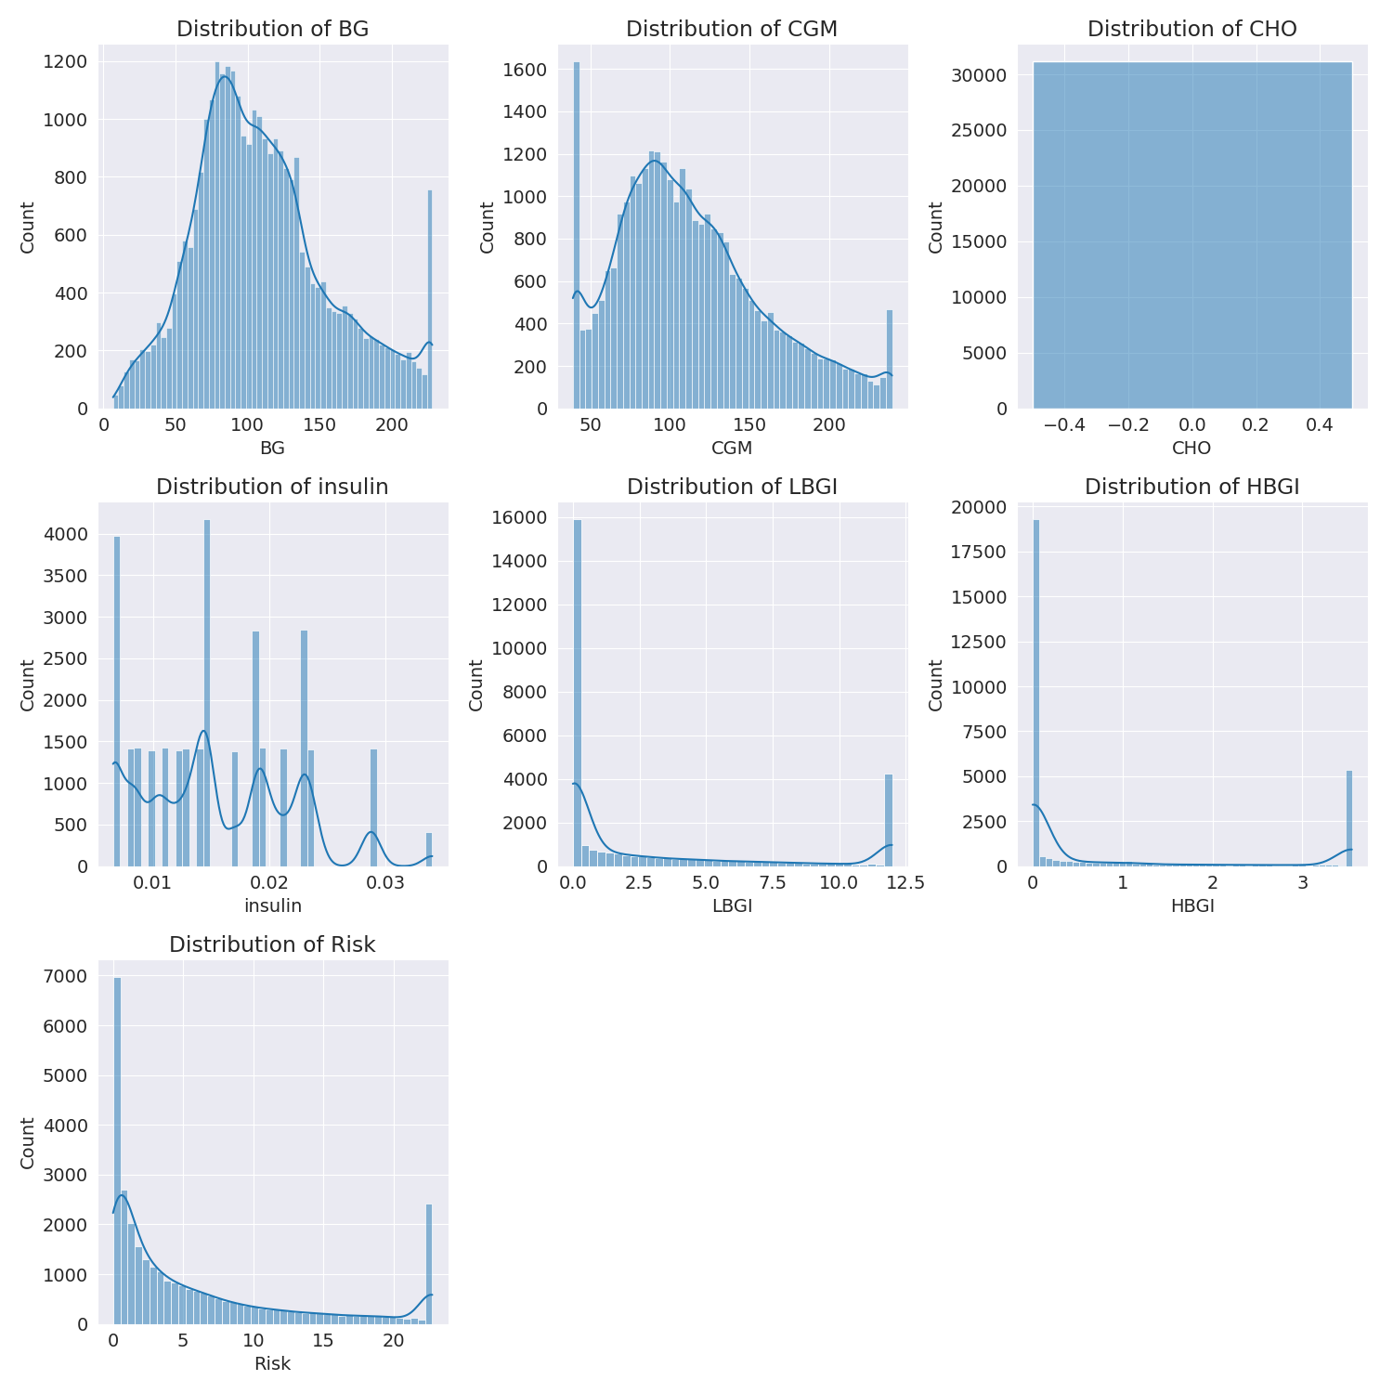

The image shows a series of graphs displaying the distribution of columns based on different criteria. Each graph represents a specific aspect of the data distribution. To analyze the distribution, we can identify any discernible patterns, cycles, or trends in the data over time.  
  
1. The first graph shows the distribution of insulin levels. The shape of the distribution is skewed, with a higher concentration of insulin levels in the middle and lower levels on both sides.  
2. The second graph displays the distribution of glucose levels. The shape of the distribution is skewed, with a higher concentration of glucose levels in the middle and lower levels on both sides.  
3. The third graph shows the distribution of LDLC levels. The shape of the distribution is skewed, with a higher concentration of LDLC levels in the middle and lower levels on both sides.  
4. The fourth graph displays the distribution of HDL levels. The shape of the distribution is skewed, with a higher concentration of HDL levels in the middle and lower levels on both sides.  
5. The fifth graph shows the distribution of triglyceride levels. The shape of the distribution is skewed, with a higher concentration of triglyceride levels in the middle and lower levels on both sides.  
6. The sixth graph displays the distribution of cholesterol levels. The shape of the distribution is skewed, with a higher concentration of cholesterol levels in the middle and lower levels on both sides.  
  
In summary, the image shows a series of graphs displaying the distribution of columns based on different criteria. Each graph represents a specific aspect of the data distribution. The shape of the distribution is skewed, with a higher concentration of the respective column in the middle and lower levels on both sides.

PairWise Graph Analysis

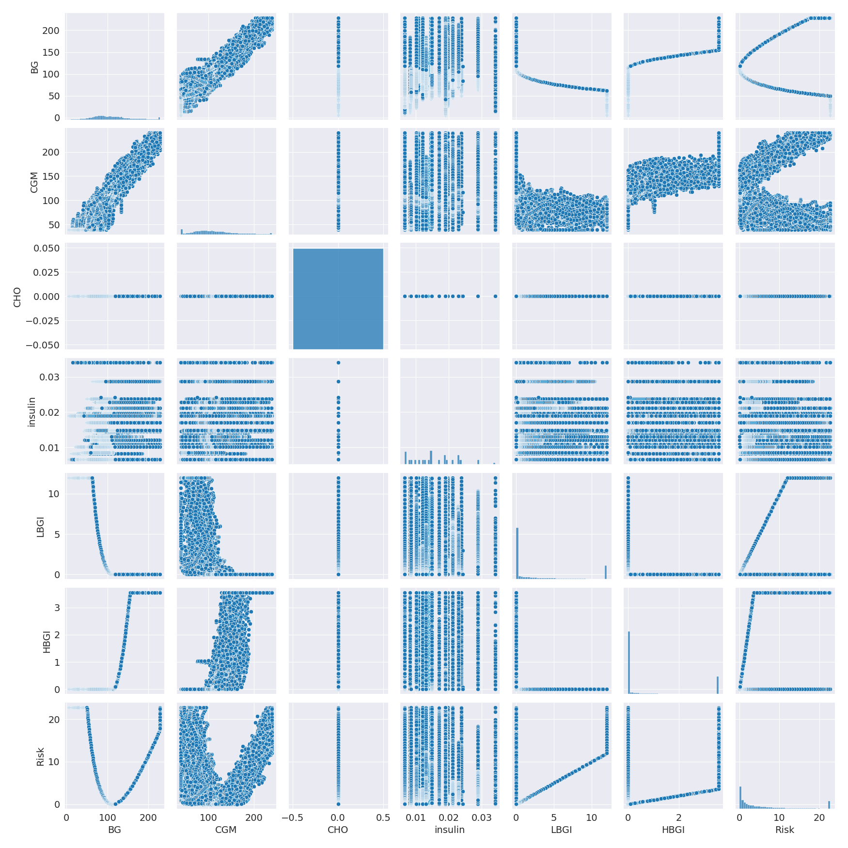

The image displays a collection of graphs, each pairwise graph visualizing the relationship between two variables. These graphs are used to analyze and understand the interconnections between the variables. The graphs are presented in a blue color scheme, which adds a visually appealing touch to the presentation.  
  
The graphs are organized in a way that allows for easy comparison and interpretation of the data. By examining these graphs, one can gain insights into the relationships between the variables, which can be used to make informed decisions or predictions.  
  
The use of pairwise graphs is particularly beneficial when dealing with complex data sets, as they provide a clear and concise representation of the interdependencies between the variables. This visualization technique helps to uncover patterns and changes that might not be immediately apparent from a simple table or chart.  
  
In summary, the image showcases a series of pairwise graphs that help to reveal the intricate relationships between variables. These visualizations enhance our understanding of the data's interconnections, providing a comprehensive view of the complex relationships between the variables.

Missing Numbers Graph Analysis

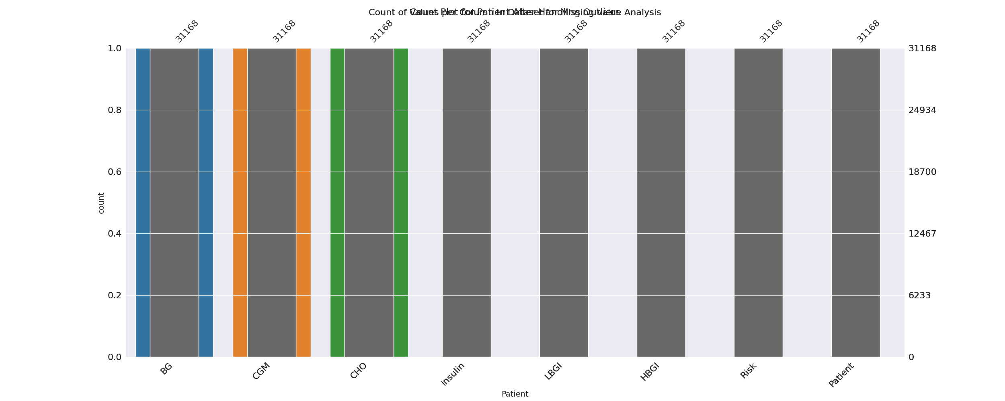

The image displays a bar chart with missing values, which is a common issue in data analysis. The chart is showing the count of black patients, and the numbers are missing for some of the bars. This can impact data analysis or modeling, as it may lead to inaccurate conclusions or predictions.  
  
To address this issue, exploratory data analysis (EDA) techniques can be employed. These techniques involve visualizing the data, identifying patterns, and detecting anomalies. By examining the distribution of the missing values, one can understand the reasons behind the missing data and decide whether to impute the missing values or exclude the affected data points.  
  
In the case of the bar chart, the missing values could be due to various reasons, such as data entry errors, missing data in the original source, or a deliberate decision to exclude certain data points. By identifying the cause of the missing values, one can take appropriate actions to improve the quality of the data and ensure accurate analysis or modeling.

Heat_Explainer Graph Analysis

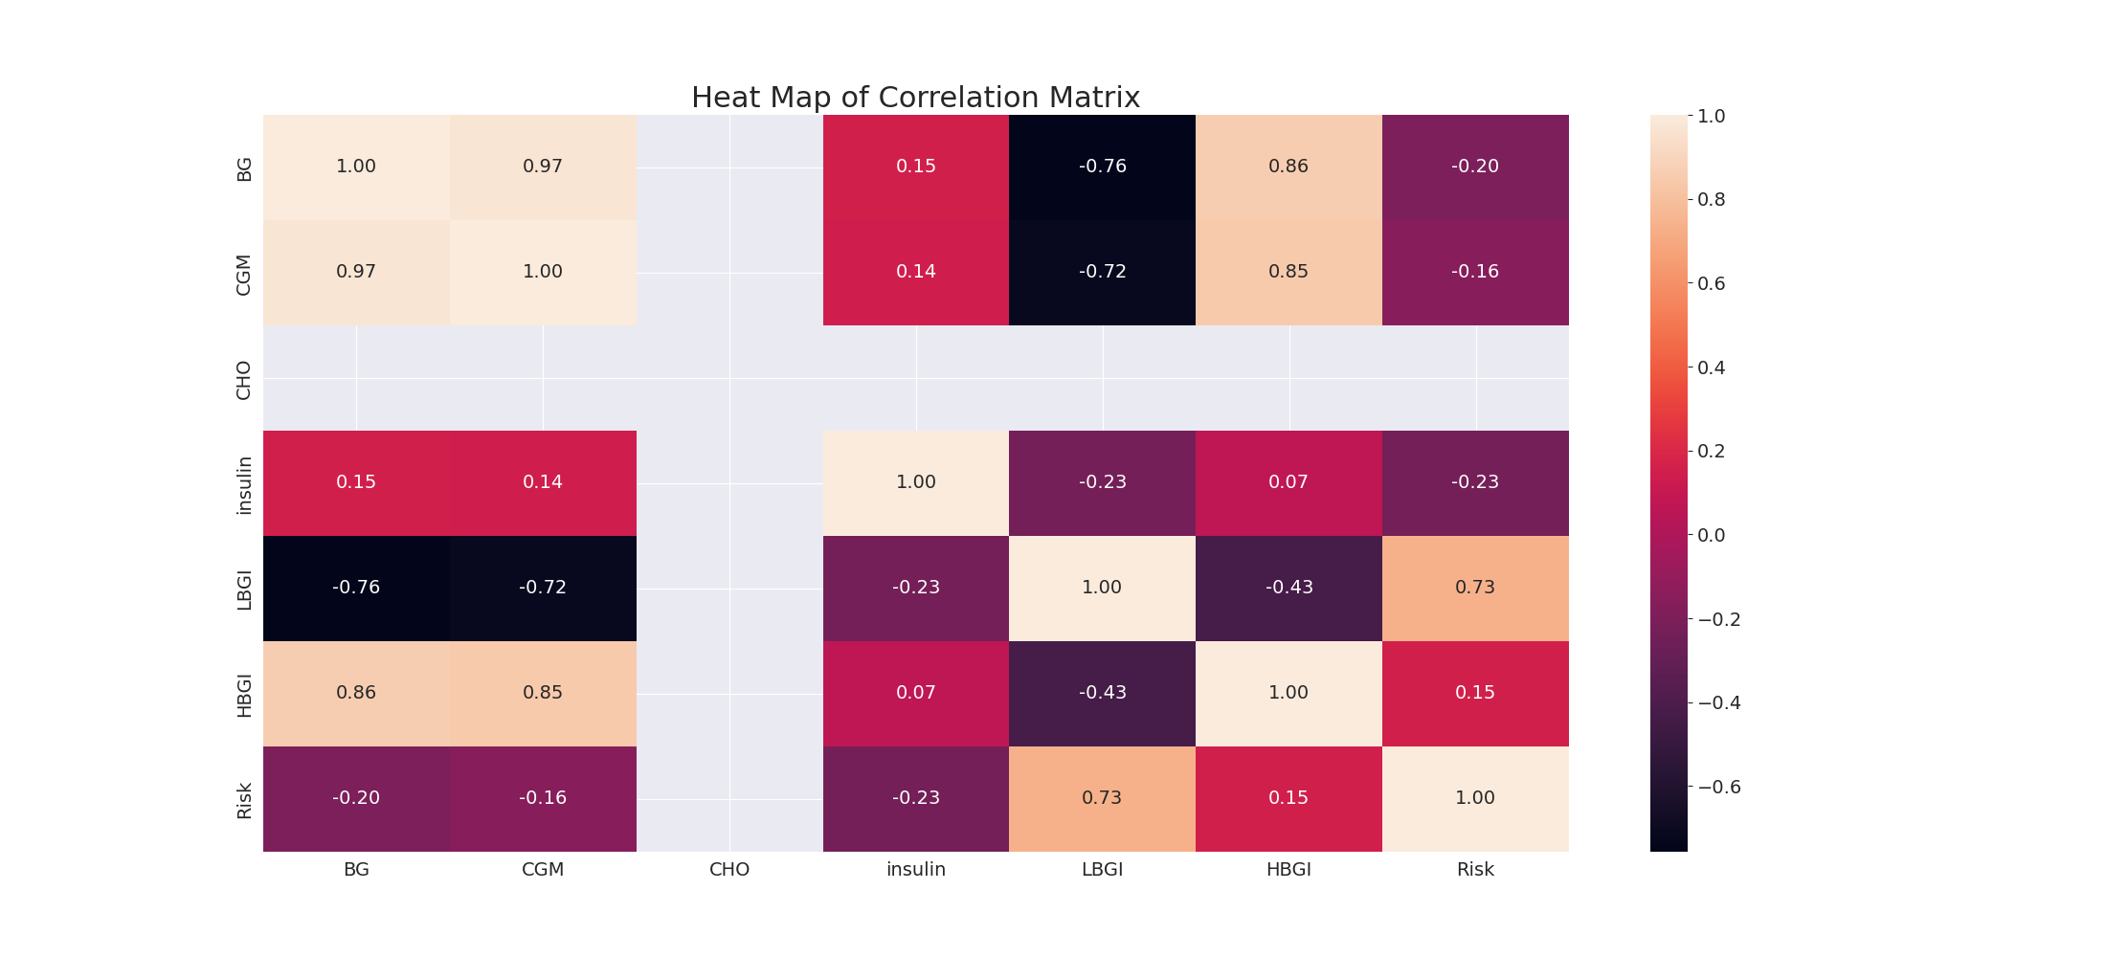

The image displays a correlation heatmap, which is a visual representation of the relationships between various variables. The heatmap is a color-coded matrix that helps to understand the strength and direction of correlations between these variables. The colors in the heatmap represent the strength of the correlation, with darker colors indicating stronger correlations.  
  
The heatmap is organized in a way that allows for easy identification of the variables and their relationships. The variables are likely related, and the data in the image helps to analyze and understand these relationships. By examining and deep-analyzing the visual representation, one can gain insights into the strength and direction of correlations between the variables.

Multi-linear Regression Inference Graph Analysis

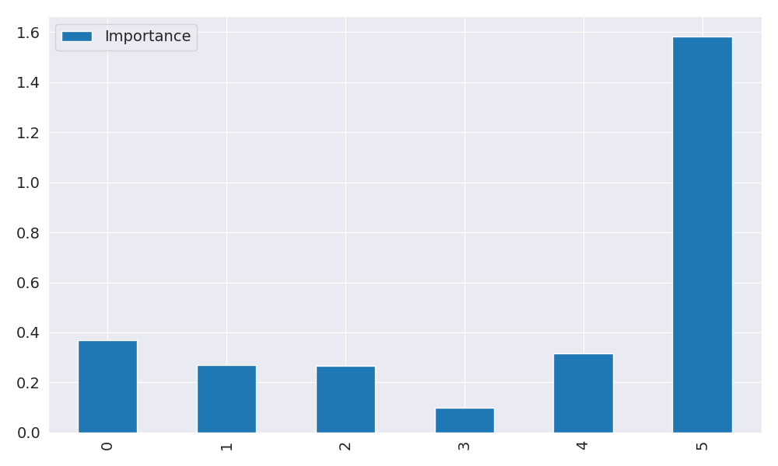

The image displays a graph with a blue line, which is likely a Neural Regressor. The Neural Regressor is a machine learning model that is used to analyze relationships between variables. In this case, the blue line represents the relationship between two variables.  
  
The graph is a line graph, with the x-axis representing one variable and the y-axis representing the other variable. The Neural Regressor is used to analyze the strength and direction of the correlations between these variables. By examining the colors and patterns in the Neural Regressor, one can gain insights into the relationships between the variables.  
  
The Neural Regressor is a powerful tool for data analysis and can be used in various applications, such as predicting future trends, identifying patterns, and making informed decisions based on the data.