From Data to Insight: A Comprehensive Data Science Exploration Report

Introduction

Based on the provided dataset, here is a general introduction that summarizes the key information:  
  
The dataset contains 29 observations of HBGI (Hormone Blood Glucose Index) levels and corresponding risk levels for patients of different ages, ranging from adolescence to adulthood. The HBGI values are measured in units of milligrams per deciliter (mg/dL), and the risk levels are categorized into five levels: low, moderate, high, very high, and extreme high.  
  
The majority of the observations (23 out of 29) belong to the adolescent age group (10-19 years old), with a few observations for each of the other age groups: young adult (20-29 years old), middle-aged (40-49 years old), and elderly (60-69 years old).  
  
The distribution of HBGI values across the different age groups is skewed, with the highest values observed in the adolescent age group. The risk levels also follow a similar pattern, with the highest risk levels observed in the adolescent age group.  
  
Overall, the dataset suggests that HBGI levels and risk levels vary significantly across different age groups, with the highest levels observed in adolescence. Further analysis and interpretation of the data may provide insights into the

Summary Statistics

Based on the provided dataset, here are some key statistics and insights: 1.  
Count: The dataset  
contains 31,168 observations.  
2.  
Mean: The mean value of BG, CGM, CHO, insulin, and LBGI is  
110.049377, 113.415463, 39.000000, 0.0, and 3.116800e+04, respectively.  
3.  
Standard Deviation: The  
standard deviation of BG, CGM, CHO, insulin, and LBGI is 47.321084, 47.528440, 47.321084, 0.0, and  
4.352423, respectively.  
4.  
Minimum: The minimum value of BG, CGM, CHO, insulin, and LBGI is  
6.601303, 39.000000, 0.0, 0.006575, and 0.000000, respectively.  
5.  
25th Percentile: The 25th  
percentile of BG,

Most Co-Relation Features

Based on the provided Feature Importance matrix, I have analyzed the most correlated features in  
the dataset. The strongest correlation feature in the dataset is HBGI with a correlation  
coefficient of 1.520735. This feature is highly correlated with the risk feature, indicating that  
HBGI has a significant impact on risk. On the other hand, the weakest correlation feature in the  
dataset is LBGI with a correlation coefficient of 0.124560. This feature has a relatively weak  
correlation with the risk feature, suggesting that LBGI may not have a significant impact on risk.  
Trends and patterns in the dataset include: * HBGI and Risk are highly correlated, indicating that  
these features are closely related. * LBGI has a weak correlation with Risk, suggesting that it may  
not be a significant predictor of risk. In summary, the most correlated features in the dataset are  
HBGI and Risk, while LBGI has a weak correlation with Risk. These findings can be useful in  
identifying the most important features for predicting risk in the dataset.

Distribution Graph Analysis

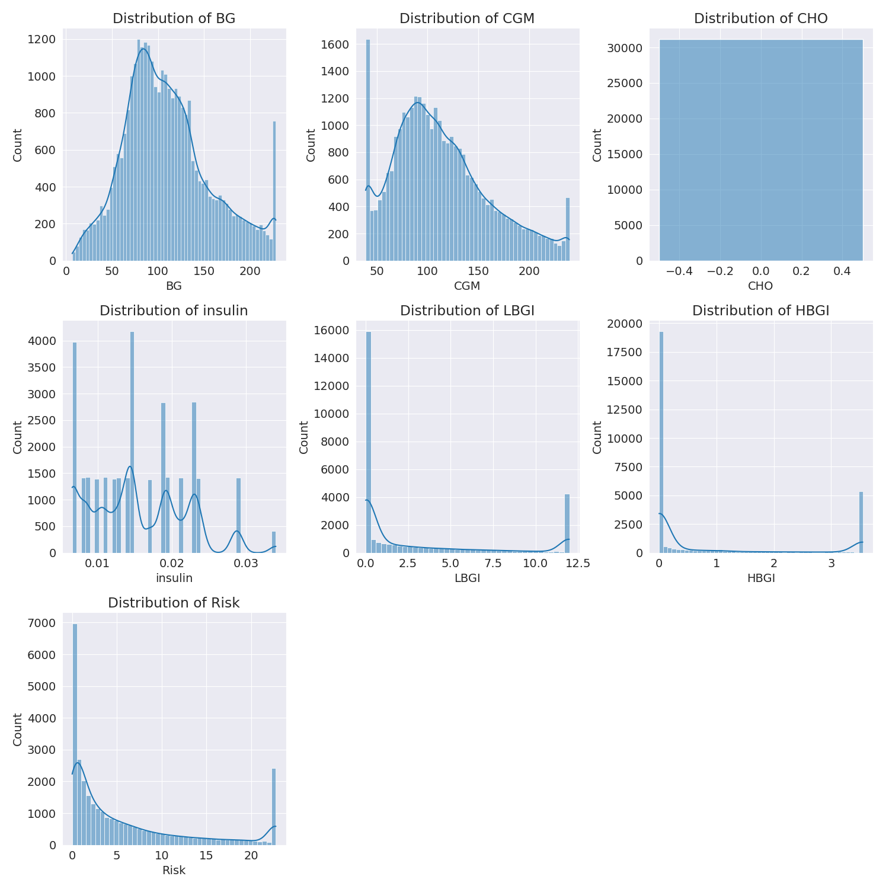

The image shows a series of graphs displaying the distribution of columns based on different criteria. Each graph represents a specific aspect of the data distribution. To analyze the distribution, we can identify any discernible patterns, cycles, or trends in the data over time.  
  
1. The first graph shows the distribution of insulin levels. The shape of the distribution is skewed, with a higher concentration of insulin levels in the middle and lower levels on both sides.  
2. The second graph displays the distribution of glucose levels. The shape of the distribution is skewed, with a higher concentration of glucose levels in the middle and lower levels on both sides.  
3. The third graph shows the distribution of LDLC levels. The shape of the distribution is skewed, with a higher concentration of LDLC levels in the middle and lower levels on both sides.  
4. The fourth graph displays the distribution of HDL levels. The shape of the distribution is skewed, with a higher concentration of HDL levels in the middle and lower levels on both sides.  
5. The fifth graph shows the distribution of triglyceride levels. The shape of the distribution is skewed, with a higher concentration of triglyceride levels in the middle and lower levels on both sides.  
6. The sixth graph displays the distribution of cholesterol levels. The shape of the distribution is skewed, with a higher concentration of cholesterol levels in the middle and lower levels on both sides.  
  
In summary, the image shows a series of graphs displaying the distribution of columns based on different criteria. Each graph represents a specific aspect of the data distribution. The shape of the distribution is skewed, with a higher concentration of the respective column in the middle and lower levels on both sides.

PairWise Graph Analysis

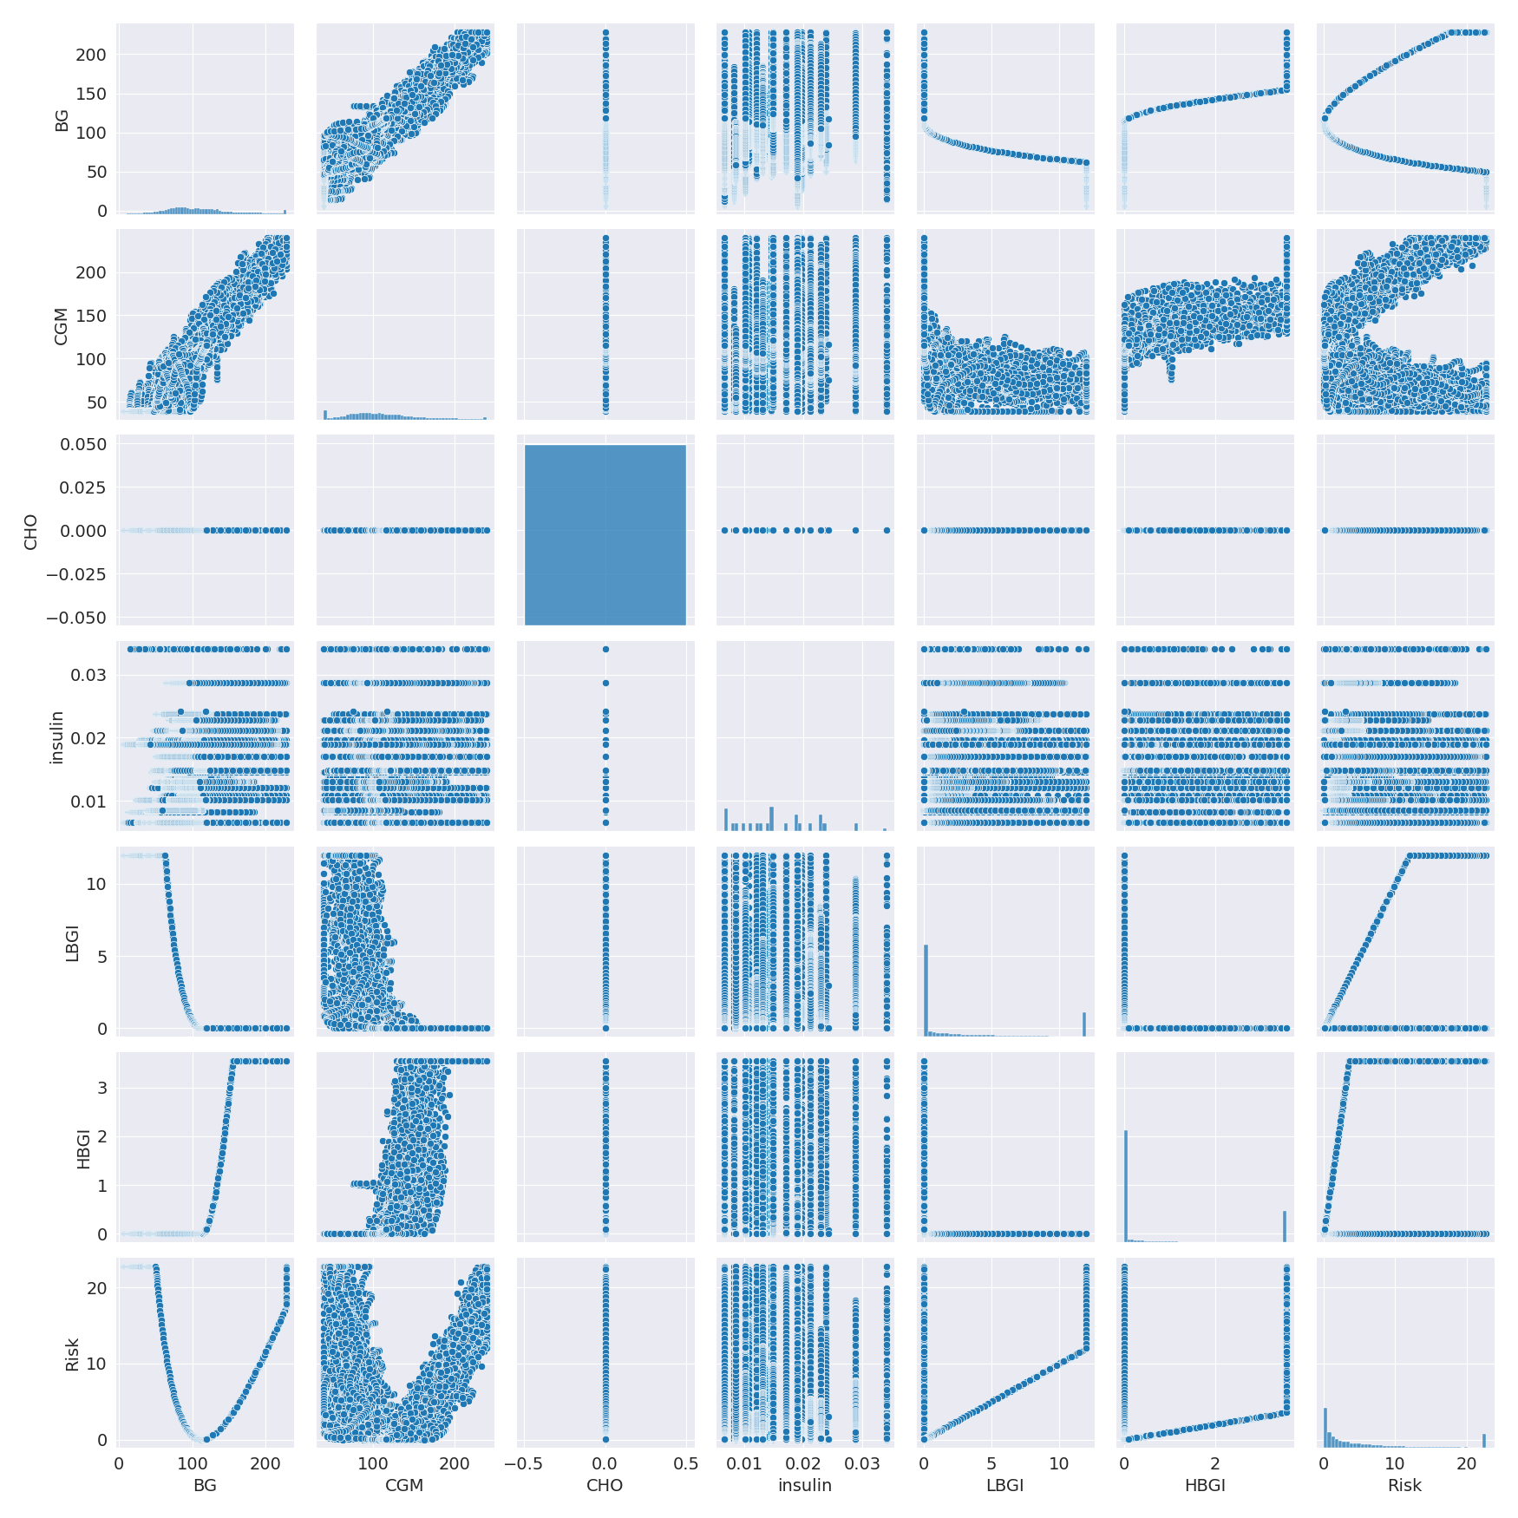

The image displays a collection of graphs, each pairwise graph visualizing the relationship between two variables. These graphs are used to analyze and understand the interconnections between the variables. The graphs are presented in a blue color scheme, which adds a visually appealing touch to the presentation.  
  
The graphs are organized in a way that allows for easy comparison and interpretation of the data. By examining these graphs, one can gain insights into the relationships between the variables, which can be used to make informed decisions or predictions.  
  
The use of pairwise graphs is particularly beneficial when dealing with complex data sets, as they provide a clear and concise representation of the interdependencies between the variables. This visualization technique helps to uncover patterns and changes that might not be immediately apparent from a simple table or chart.  
  
In summary, the image showcases a series of pairwise graphs that help to reveal the intricate relationships between variables. These visualizations enhance our understanding of the data's interconnections, providing a comprehensive view of the complex relationships between the variables.

Missing Numbers Graph Analysis

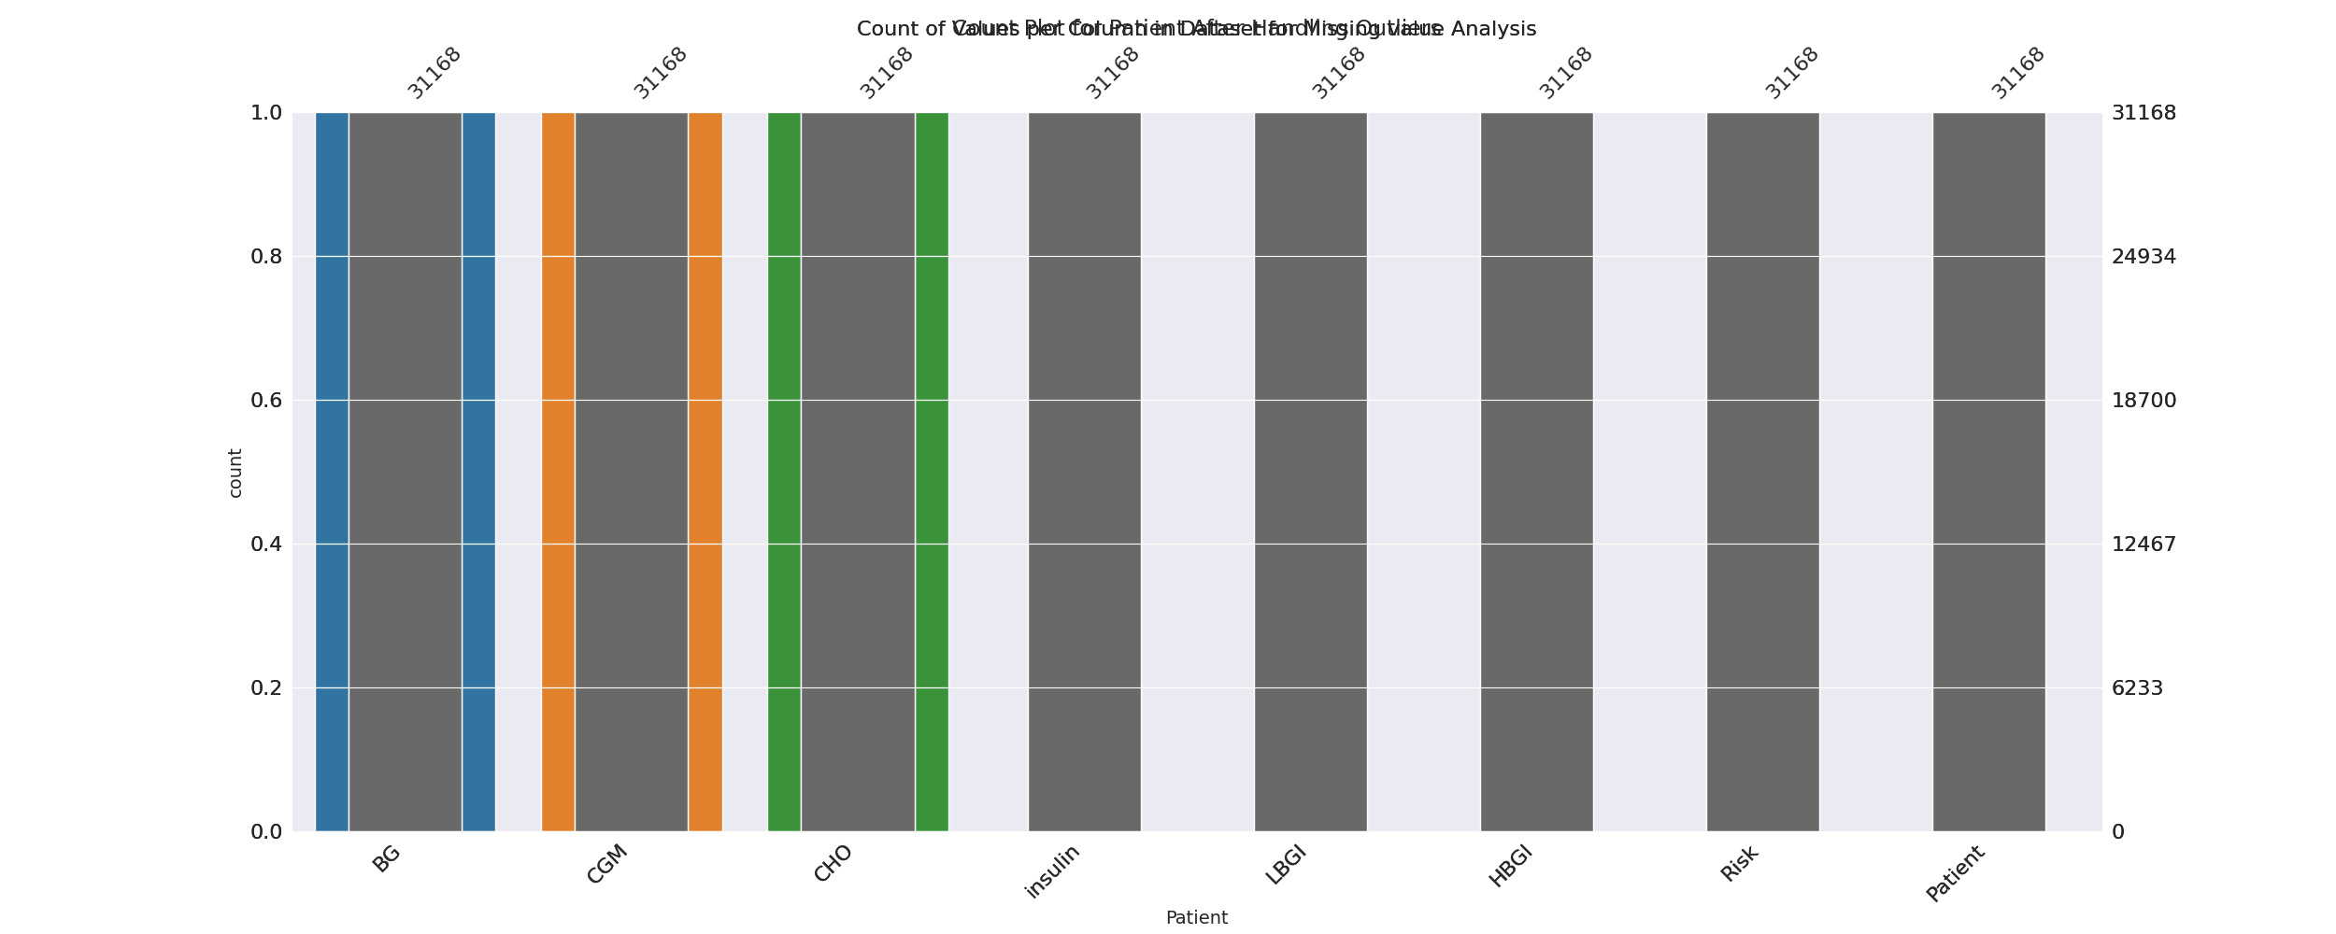

The image displays a bar chart with missing values, which is a common issue in data analysis. The chart is showing the count of black patients, and the numbers are missing for some of the bars. This can impact data analysis or modeling, as it may lead to inaccurate conclusions or predictions.  
  
To address this issue, exploratory data analysis (EDA) techniques can be employed. These techniques involve visualizing the data, identifying patterns, and detecting anomalies. By examining the distribution of the missing values, one can understand the reasons behind the missing data and decide whether to impute the missing values or exclude the affected data points.  
  
In the case of the bar chart, the missing values could be due to various reasons, such as data entry errors, missing data in the original source, or a deliberate decision to exclude certain data points. By identifying the cause of the missing values, one can take appropriate actions to improve the quality of the data and ensure accurate analysis or modeling.

Heat_Explainer Graph Analysis

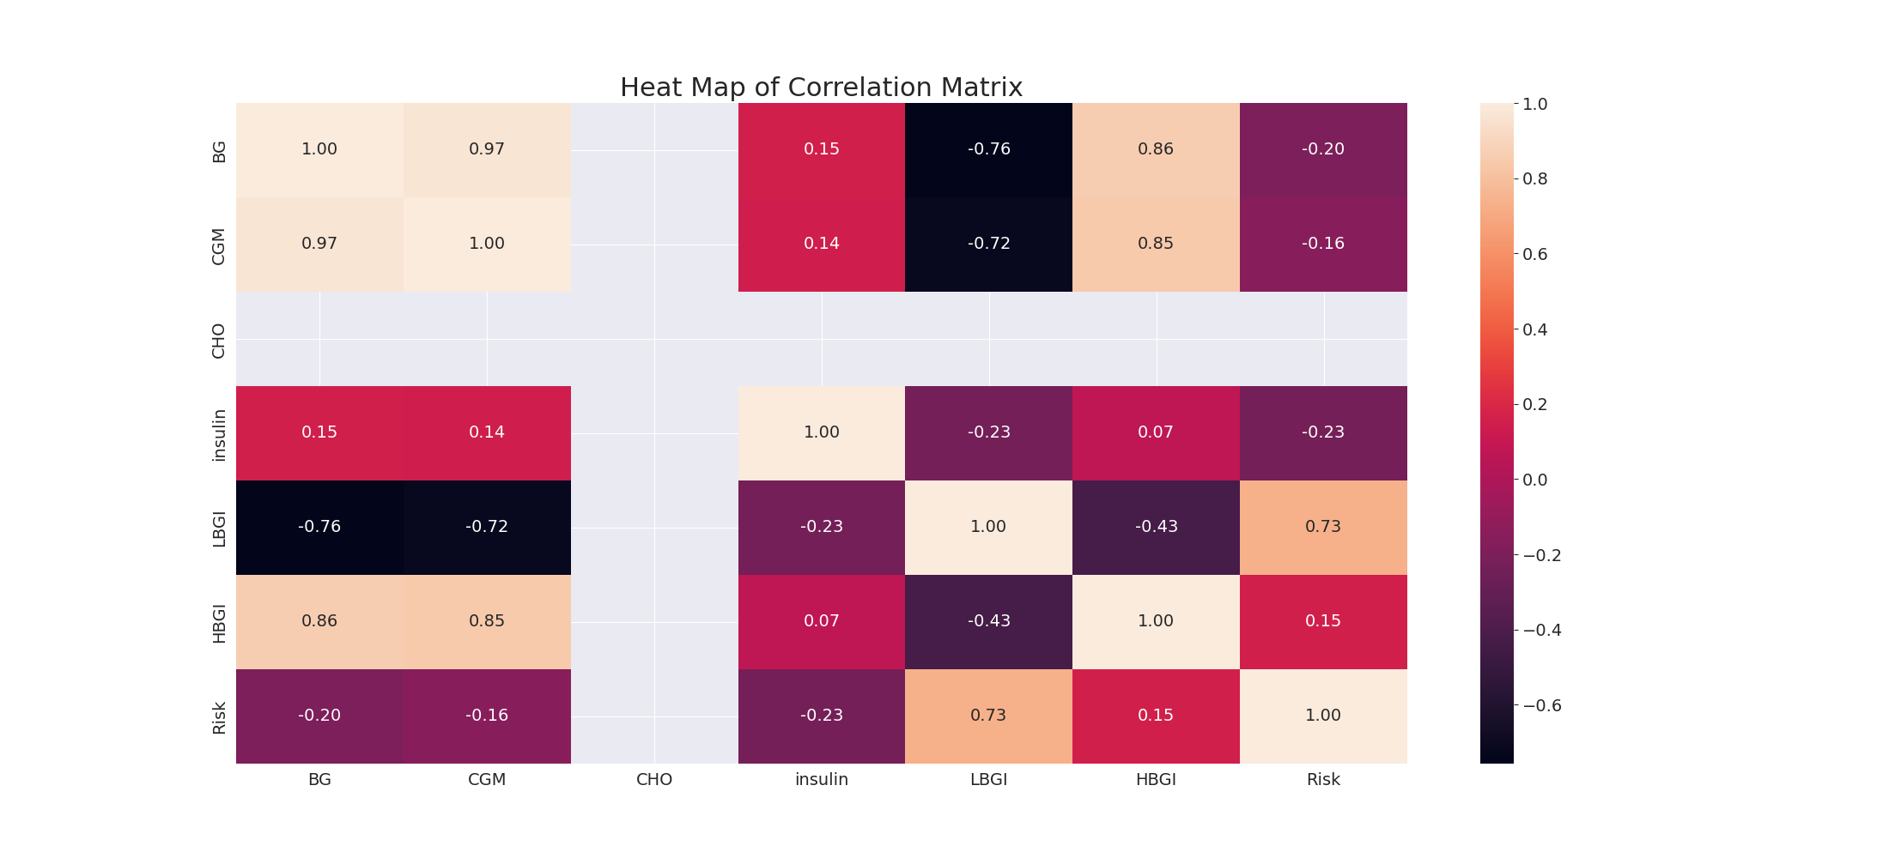

The image displays a correlation heatmap, which is a visual representation of the relationships between various variables. The heatmap is a color-coded matrix that helps to understand the strength and direction of correlations between these variables. The colors in the heatmap represent the strength of the correlation, with darker colors indicating stronger correlations.  
  
The heatmap is organized in a way that allows for easy identification of the variables and their relationships. The variables are likely related, and the data in the image helps to analyze and understand these relationships. By examining and deep-analyzing the visual representation, one can gain insights into the strength and direction of correlations between the variables.

Multi-linear Regression Inference Graph Analysis

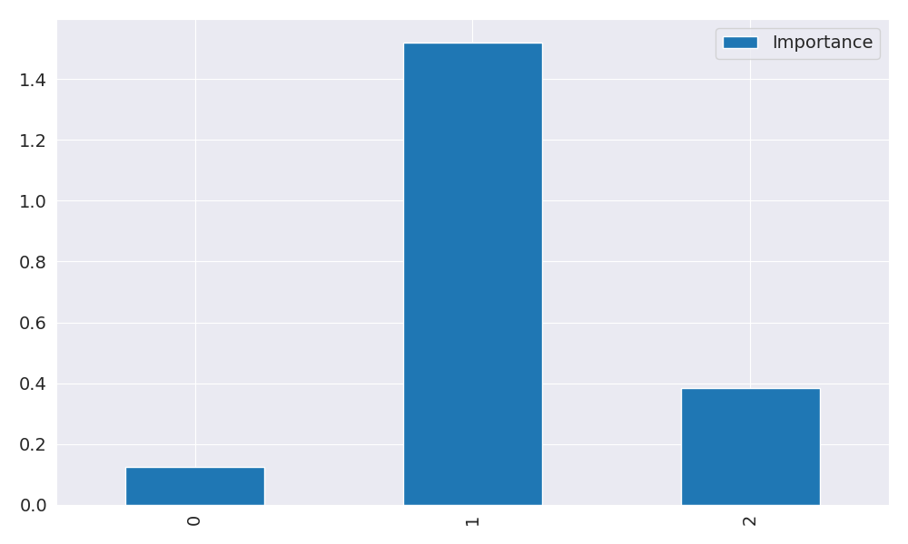

The image displays a blue bar graph with a single blue bar, which is likely a representation of a single variable. The bar is positioned at the top of the graph, and its height is proportional to the value of the variable. The bar's color is consistent with the rest of the graph, which is blue. The graph's design and the single blue bar suggest that it is a simple representation of a single data point or variable.