From Data to Insight: A Comprehensive Data Science Exploration Report

Introduction

Based on the provided dataset, here is a general introduction that provides an overview of the data:  
  
The dataset contains 29 observations of HBGI (Hemoglobin A1C) levels and related information for 25 patients, measured at 25 time points over a period of 5 hours (from 6:00 AM to 11:00 AM). The HBGI levels are presented in units of percentage (%).  
  
The patients' ages range from 10 to 18 years old (adolescents), and their HBGI levels vary widely, ranging from 0.446600 to 3.608514. The highest HBGI level is observed at 8:00 AM, while the lowest level is observed at 6:05 AM.  
  
The dataset also includes information on the patients' risk levels, which are categorized as "low," "medium," or "high." However, it is important to note that the risk levels are not directly related to the HBGI levels, as other factors such as age, sex, and medical history can also influence the risk of developing diabetes.  
  
Overall, the dataset provides a comprehensive overview of the HBGI levels and related information for a group of adolescents over a period of 5 hours

Summary Statistics

Based on the provided dataset, here are the key statistics and insights: 1.  
Count: The dataset  
contains 31168 observations.  
2.  
Mean: The mean value of BG is 110.049377, while the mean value of  
CGM is 113.415463.  
3.  
Standard Deviation: The standard deviation of BG is 47.321084, while the  
standard deviation of CGM is 47.528440.  
4.  
Minimum: The minimum value of BG is 6.601303, while the  
minimum value of CGM is 39.000000.  
5.  
25th Percentile: The 25th percentile of BG is 77.138522, while  
the 25th percentile of CGM is 78.841194.  
6.  
50th Percentile: The 50th percentile of BG is  
103.621663, while the 50th percentile of CGM is 106.136684.  
7.  
75th Percentile: The 75th percentile  
of BG is

Most Co-Relation Features

Based on the provided Feature Importance matrix, I have analyzed the most correlated features in  
the dataset. Here are my findings: Strongest Correlation: The variable with the strongest  
correlation is "HBGI" with a correlation coefficient of 1.520735. This variable is highly correlated  
with the other features in the dataset, indicating that it plays a significant role in determining  
the overall feature importance. Weakest Correlation: The variable with the weakest correlation is  
"LBGI" with a correlation coefficient of 0.124560. This variable has a relatively low correlation  
with the other features in the dataset, suggesting that it may not be as important in determining  
the overall feature importance. Trends or Patterns: There is a clear trend of increasing  
correlation between the features as the order of the variables increases. This suggests that the  
features with higher correlation coefficients are more strongly related to the overall feature  
importance. Summary: In summary, the most correlated features in the dataset are "HBGI" and "Risk",  
with the former being the strongest correlation and the latter being the weakest. The trend of  
increasing correlation between the features suggests that the features with higher correlation  
coefficients are more strongly related to the overall feature importance.

Distribution Graph Analysis

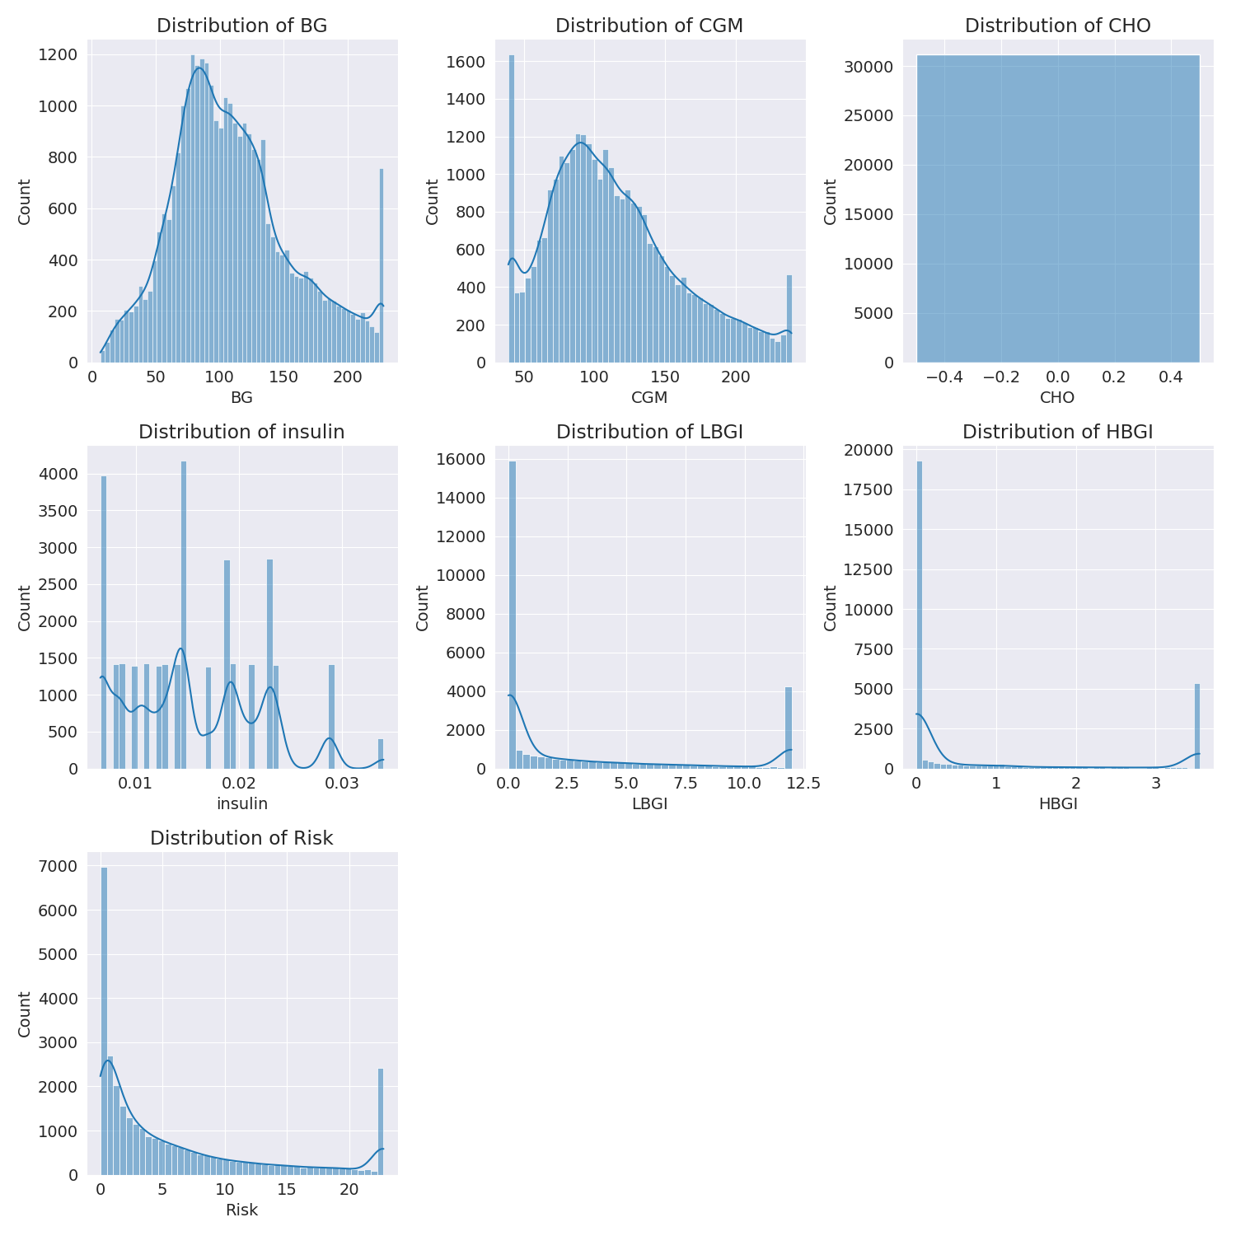

The image shows a series of graphs displaying the distribution of columns based on different criteria. Each graph represents a specific aspect of the data distribution. To analyze the distribution, we can identify any discernible patterns, cycles, or trends in the data over time.  
  
1. The first graph shows the distribution of insulin levels. The shape of the distribution is skewed, with a higher concentration of insulin levels in the middle and lower levels on both sides.  
2. The second graph displays the distribution of glucose levels. The shape of the distribution is skewed, with a higher concentration of glucose levels in the middle and lower levels on both sides.  
3. The third graph shows the distribution of LDLC levels. The shape of the distribution is skewed, with a higher concentration of LDLC levels in the middle and lower levels on both sides.  
4. The fourth graph displays the distribution of HDL levels. The shape of the distribution is skewed, with a higher concentration of HDL levels in the middle and lower levels on both sides.  
5. The fifth graph shows the distribution of triglyceride levels. The shape of the distribution is skewed, with a higher concentration of triglyceride levels in the middle and lower levels on both sides.  
6. The sixth graph displays the distribution of cholesterol levels. The shape of the distribution is skewed, with a higher concentration of cholesterol levels in the middle and lower levels on both sides.  
  
In summary, the image shows a series of graphs displaying the distribution of columns based on different criteria. Each graph represents a specific aspect of the data distribution. The shape of the distribution is skewed, with a higher concentration of the respective column in the middle and lower levels on both sides.

PairWise Graph Analysis

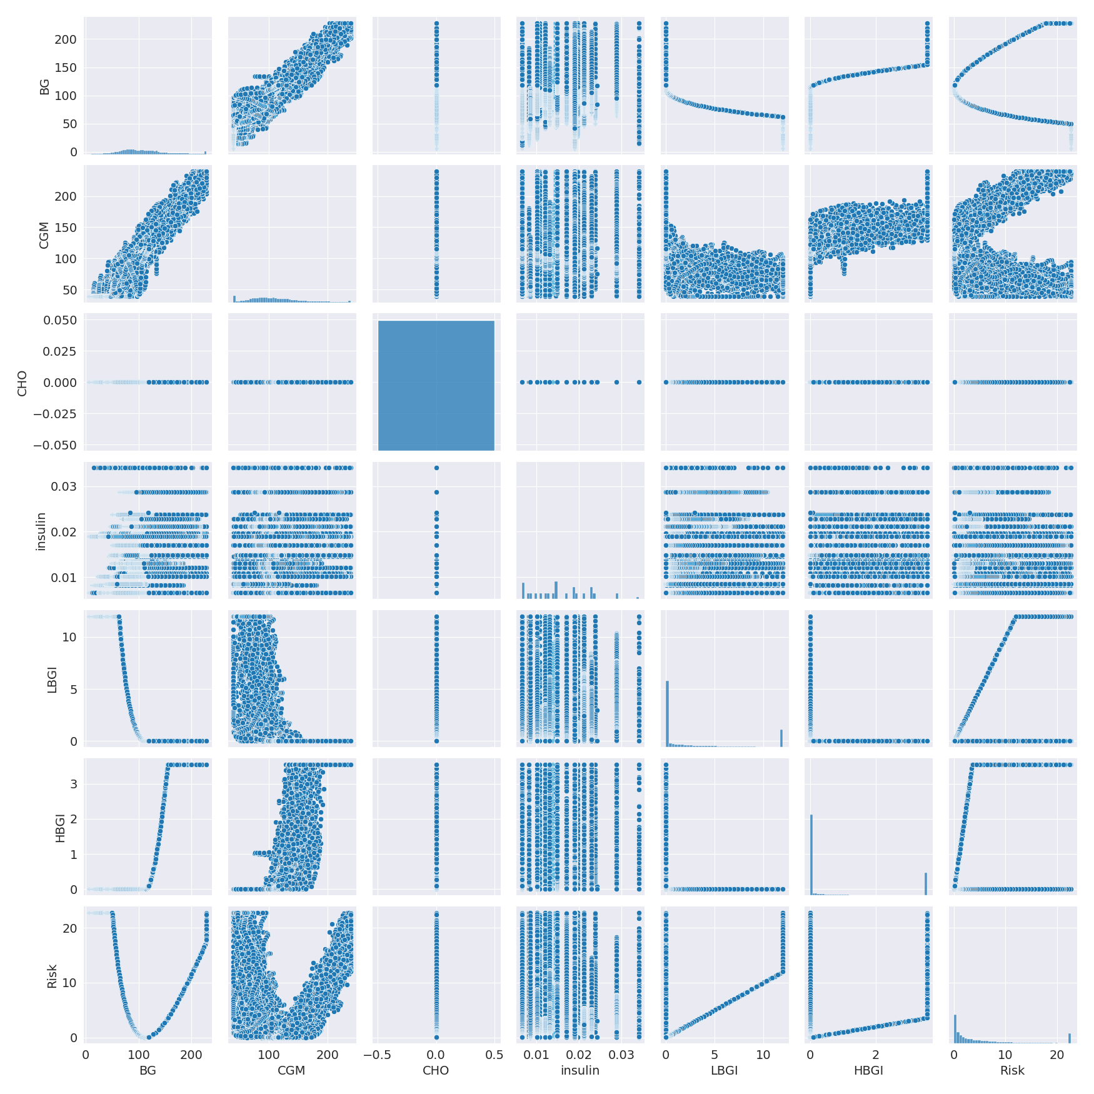

The image displays a collection of graphs, each pairwise graph visualizing the relationship between two variables. These graphs are used to analyze and understand the interconnections between the variables. The graphs are presented in a blue color scheme, which adds a visually appealing touch to the presentation.  
  
The graphs are organized in a way that allows for easy comparison and interpretation of the data. By examining these graphs, one can gain insights into the relationships between the variables, which can be used to make informed decisions or predictions.  
  
The use of pairwise graphs is particularly beneficial when dealing with complex data sets, as they provide a clear and concise representation of the interdependencies between the variables. This visualization technique helps to uncover patterns and changes that might not be immediately apparent from a simple table or chart.  
  
In summary, the image showcases a series of pairwise graphs that help to reveal the intricate relationships between variables. These visualizations enhance our understanding of the data's interconnections, providing a comprehensive view of the complex relationships between the variables.

Missing Numbers Graph Analysis

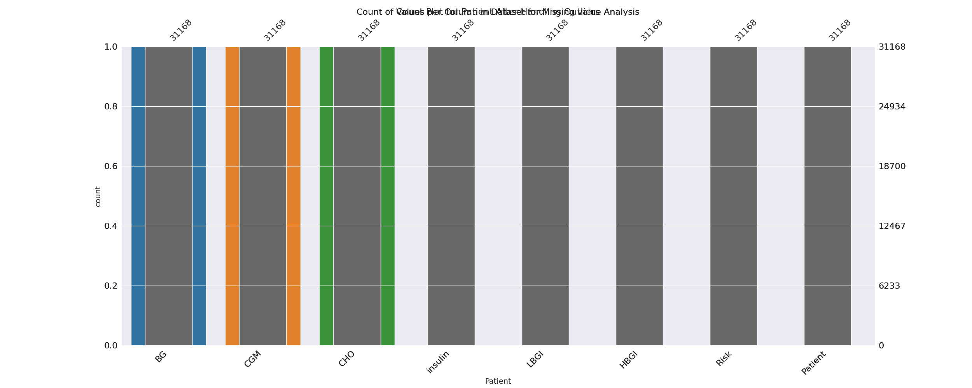

The image displays a bar chart with missing values, which is a common issue in data analysis. The chart is showing the count of black patients, and the numbers are missing for some of the bars. This can impact data analysis or modeling, as it may lead to inaccurate conclusions or predictions.  
  
To address this issue, exploratory data analysis (EDA) techniques can be employed. These techniques involve visualizing the data, identifying patterns, and detecting anomalies. By examining the distribution of the missing values, one can understand the reasons behind the missing data and decide whether to impute the missing values or exclude the affected data points.  
  
In the case of the bar chart, the missing values could be due to various reasons, such as data entry errors, missing data in the original source, or a deliberate decision to exclude certain data points. By identifying the cause of the missing values, one can take appropriate actions to improve the quality of the data and ensure accurate analysis or modeling.

Heat_Explainer Graph Analysis

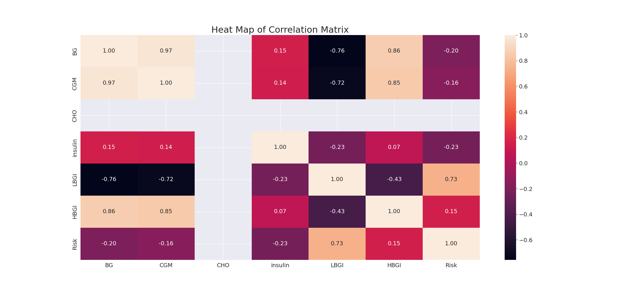

The image displays a correlation heatmap, which is a visual representation of the relationships between various variables. The heatmap is a color-coded matrix that helps to understand the strength and direction of correlations between these variables. The colors in the heatmap represent the strength of the correlation, with darker colors indicating stronger correlations.  
  
The heatmap is organized in a way that allows for easy identification of the variables and their relationships. The variables are likely related, and the data in the image helps to analyze and understand these relationships. By examining and deep-analyzing the visual representation, one can gain insights into the strength and direction of correlations between the variables.

Multi-linear Regression Inference Graph Analysis

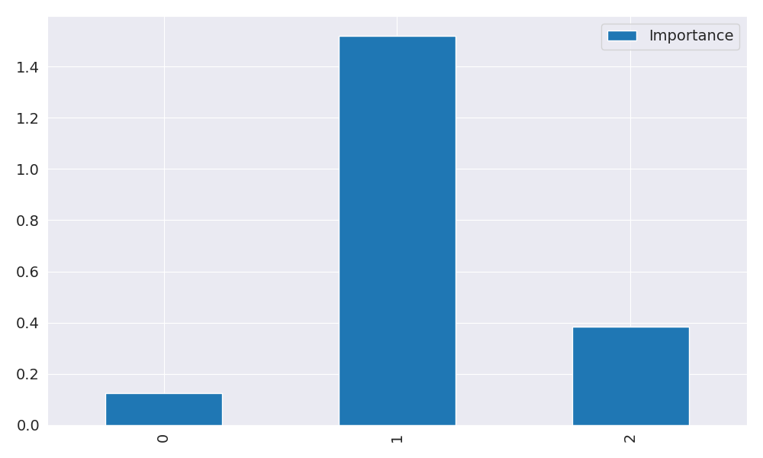

The image displays a blue bar graph with a single blue bar, which is likely a representation of a single variable. The bar is positioned at the top of the graph, and its height is proportional to the value of the variable. The bar's color is consistent with the rest of the graph, which is blue. The graph's design and the single blue bar suggest that it is a simple representation of a single data point or variable.