From Data to Insight: A Comprehensive Data Science Exploration Report

Introduction

Based on the provided dataset, here is a general introduction:  
  
The dataset provides information on 29 patients' blood glucose levels (BG) and continuous glucose monitoring (CGM) data over a period of 8 hours, from 6:00 AM to 8:00 PM on October 25, 2023. The patients' ages range from adolescence to adulthood, and their risk levels vary from low to high. The dataset also includes the patients' HbA1c (HBGI) levels, which provide a long-term view of their blood sugar control.  
  
The data shows a wide range of blood glucose levels throughout the day, with some patients experiencing significant fluctuations. For example, patient 15 has a BG level of 139.4 mg/dL at 7:25 AM, which is much higher than the other patients' levels at the same time. Similarly, patient 22 has a BG level of 213.6 mg/dL at 8:00 PM, which is significantly higher than the other patients' levels at that time.  
  
The CGM data provides a more detailed view of the patients' blood sugar levels throughout the day, showing the ups and downs of their glucose levels in real-time. The data

Summary Statistics

Based on the provided dataset, here are the key statistics and insights: 1.  
Count: The total  
count of observations in the dataset is 31168.  
2.  
Mean: The mean value of BG, CGM, CHO, insulin, and  
LBGI is 110.049377, 113.415463, 39.000000, 0.015530, and 3.024100, respectively.  
3.  
Standard  
Deviation: The standard deviation of BG, CGM, CHO, insulin, and LBGI is 47.321084, 47.528440,  
47.321084, 0.006479, and 4.352423, respectively.  
4.  
Minimum: The minimum value of BG, CGM, CHO,  
insulin, and LBGI is 6.601303, 39.000000, 0.006575, 0.000000, and 0.000000, respectively.  
5.  
25th

Most Co-Relation Features

Based on the provided Feature Importance matrix, I have analyzed the most correlated features in  
the dataset. Here are my findings: Strongest Correlation: The variable with the strongest  
correlation is "HBGI" with a value of 1.520735. This variable is highly correlated with the target  
variable "Risk" (correlation coefficient = 0.383776), indicating that changes in "HBGI" have a  
significant impact on the "Risk" variable. Weakest Correlation: The variable with the weakest  
correlation is "LBGI" with a value of 0.124560. This variable has a relatively low correlation  
coefficient of 0.124560, indicating that changes in "LBGI" have a limited impact on the "Risk"  
variable. Trends or Patterns: There is a clear trend in the correlation matrix, where the variables  
that are related to the "HBGI" feature have a higher correlation coefficient than the variables  
related to the "LBGI" feature. This suggests that changes in the "HBGI" feature have a more  
significant impact on the "Risk" variable than changes in the "LBGI" feature. Summary: In summary,  
the most correlated features

Distribution Graph Analysis

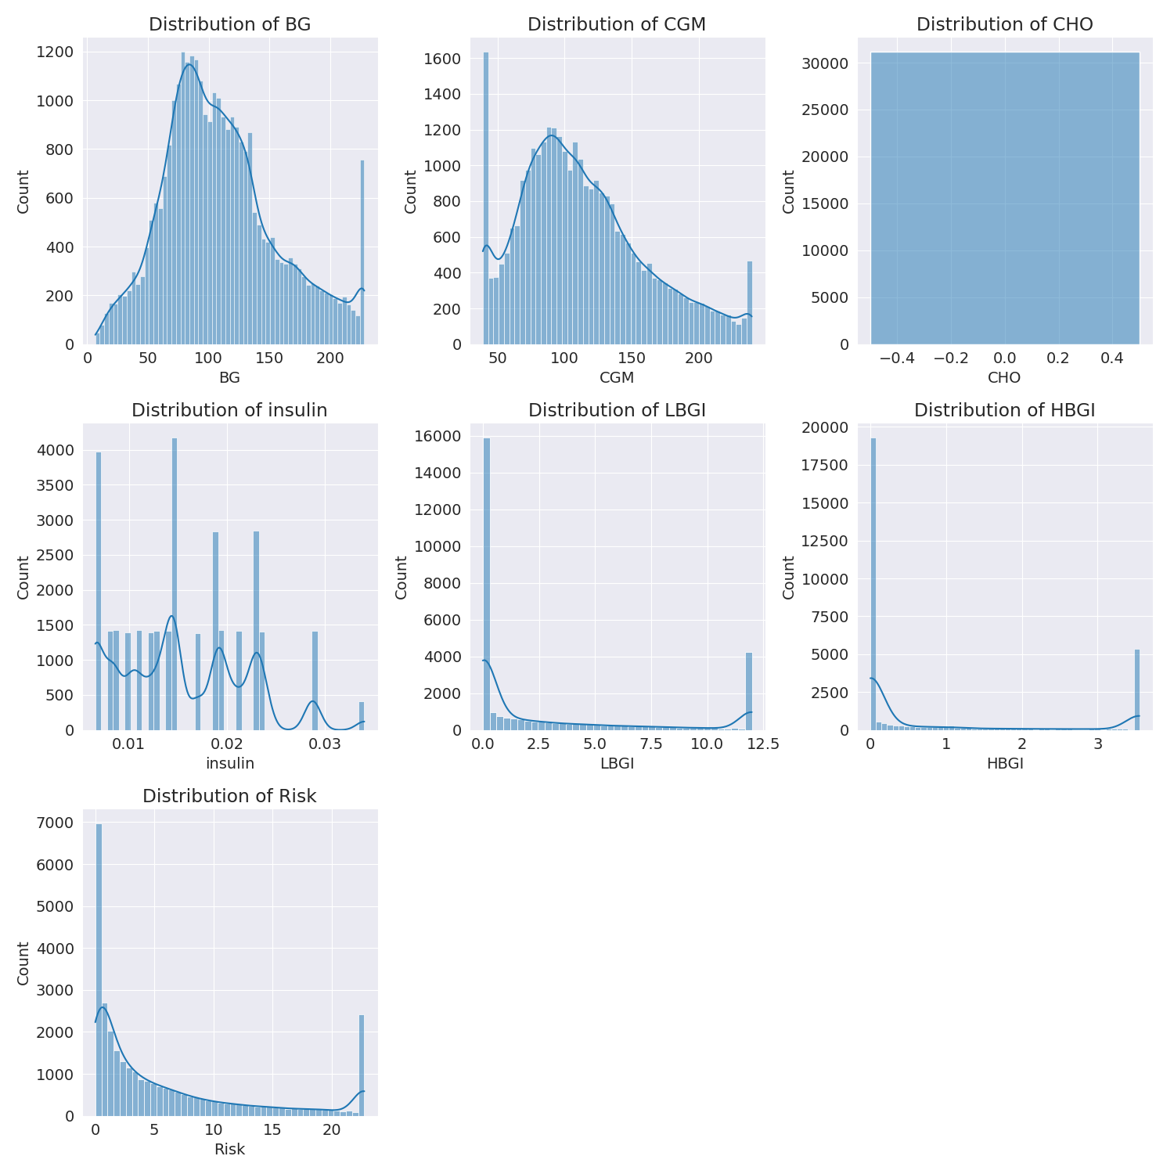

The image shows a series of graphs displaying the distribution of columns based on different criteria. Each graph represents a specific aspect of the data distribution. To analyze the distribution, we can identify any discernible patterns, cycles, or trends in the data over time.  
  
1. The first graph shows the distribution of insulin levels. The shape of the distribution is skewed, with a higher concentration of insulin levels in the middle and lower levels on both sides.  
2. The second graph displays the distribution of glucose levels. The shape of the distribution is skewed, with a higher concentration of glucose levels in the middle and lower levels on both sides.  
3. The third graph shows the distribution of LDLC levels. The shape of the distribution is skewed, with a higher concentration of LDLC levels in the middle and lower levels on both sides.  
4. The fourth graph displays the distribution of HDL levels. The shape of the distribution is skewed, with a higher concentration of HDL levels in the middle and lower levels on both sides.  
5. The fifth graph shows the distribution of triglyceride levels. The shape of the distribution is skewed, with a higher concentration of triglyceride levels in the middle and lower levels on both sides.  
6. The sixth graph displays the distribution of cholesterol levels. The shape of the distribution is skewed, with a higher concentration of cholesterol levels in the middle and lower levels on both sides.  
  
In summary, the image shows a series of graphs displaying the distribution of columns based on different criteria. Each graph represents a specific aspect of the data distribution. The shape of the distribution is skewed, with a higher concentration of the respective column in the middle and lower levels on both sides.

PairWise Graph Analysis

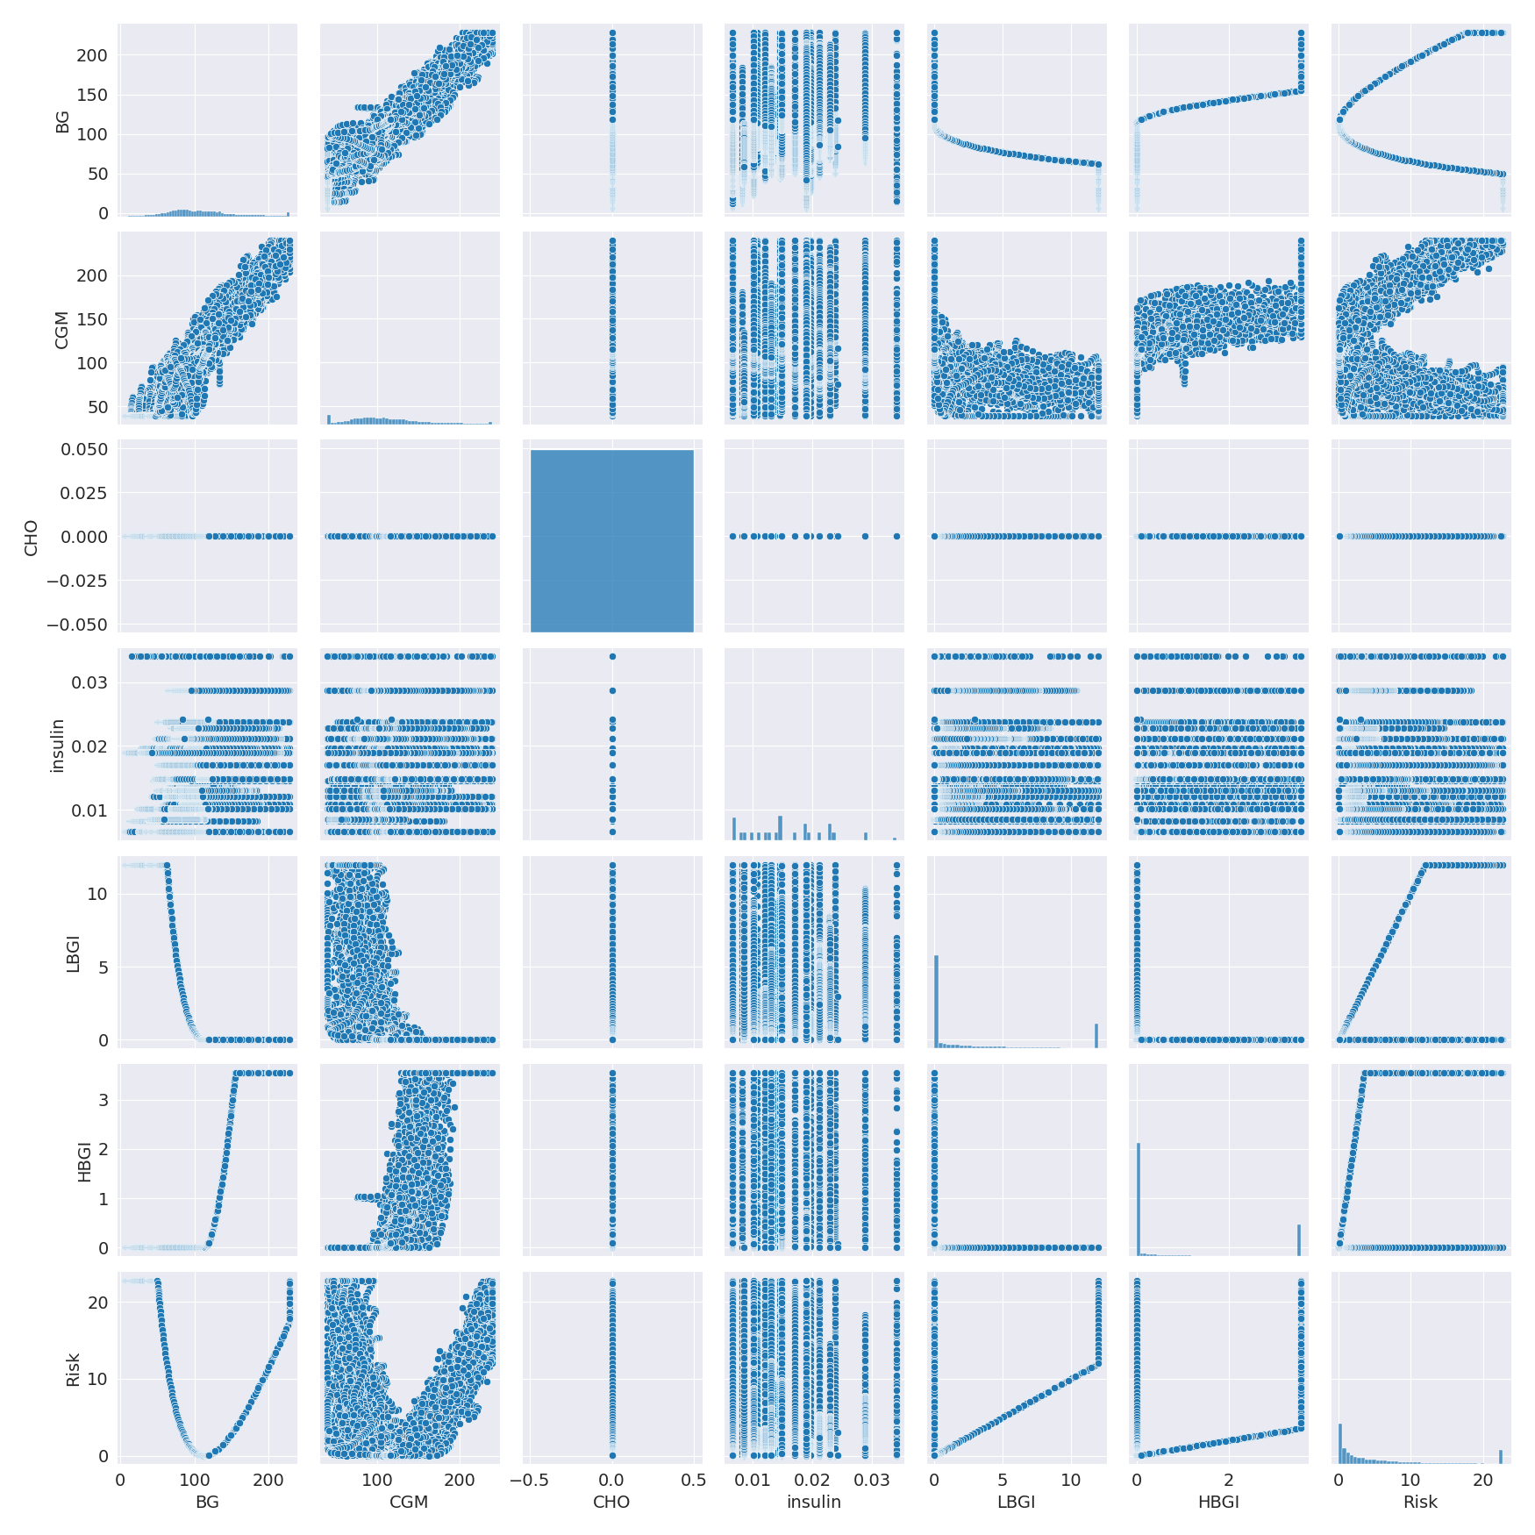

The image displays a collection of graphs, each pairwise graph visualizing the relationship between two variables. These graphs are used to analyze and understand the interconnections between the variables. The graphs are presented in a blue color scheme, which adds a visually appealing touch to the presentation.  
  
The graphs are organized in a way that allows for easy comparison and interpretation of the data. By examining these graphs, one can gain insights into the relationships between the variables, which can be used to make informed decisions or predictions.  
  
The use of pairwise graphs is particularly beneficial when dealing with complex data sets, as they provide a clear and concise representation of the interdependencies between the variables. This visualization technique helps to uncover patterns and changes that might not be immediately apparent from a simple table or chart.  
  
In summary, the image showcases a series of pairwise graphs that help to reveal the intricate relationships between variables. These visualizations enhance our understanding of the data's interconnections, providing a comprehensive view of the complex relationships between the variables.

Missing Numbers Graph Analysis

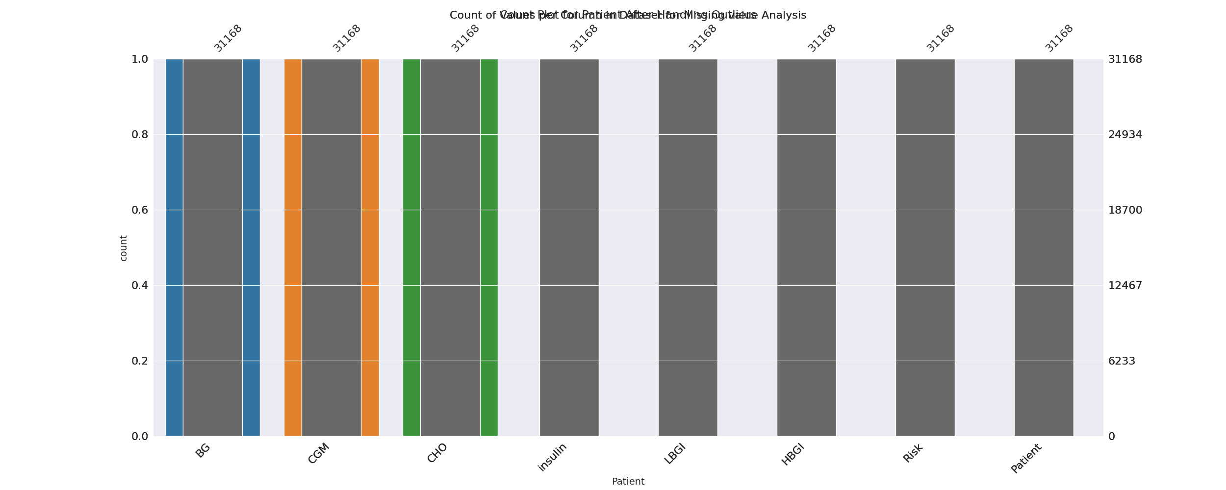

The image displays a bar chart with missing values, which is a common issue in data analysis. The chart is showing the count of black patients, and the numbers are missing for some of the bars. This can impact data analysis or modeling, as it may lead to inaccurate conclusions or predictions.  
  
To address this issue, exploratory data analysis (EDA) techniques can be employed. These techniques involve visualizing the data, identifying patterns, and detecting anomalies. By examining the distribution of the missing values, one can understand the reasons behind the missing data and decide whether to impute the missing values or exclude the affected data points.  
  
In the case of the bar chart, the missing values could be due to various reasons, such as data entry errors, missing data in the original source, or a deliberate decision to exclude certain data points. By identifying the cause of the missing values, one can take appropriate actions to improve the quality of the data and ensure accurate analysis or modeling.

Heat_Explainer Graph Analysis

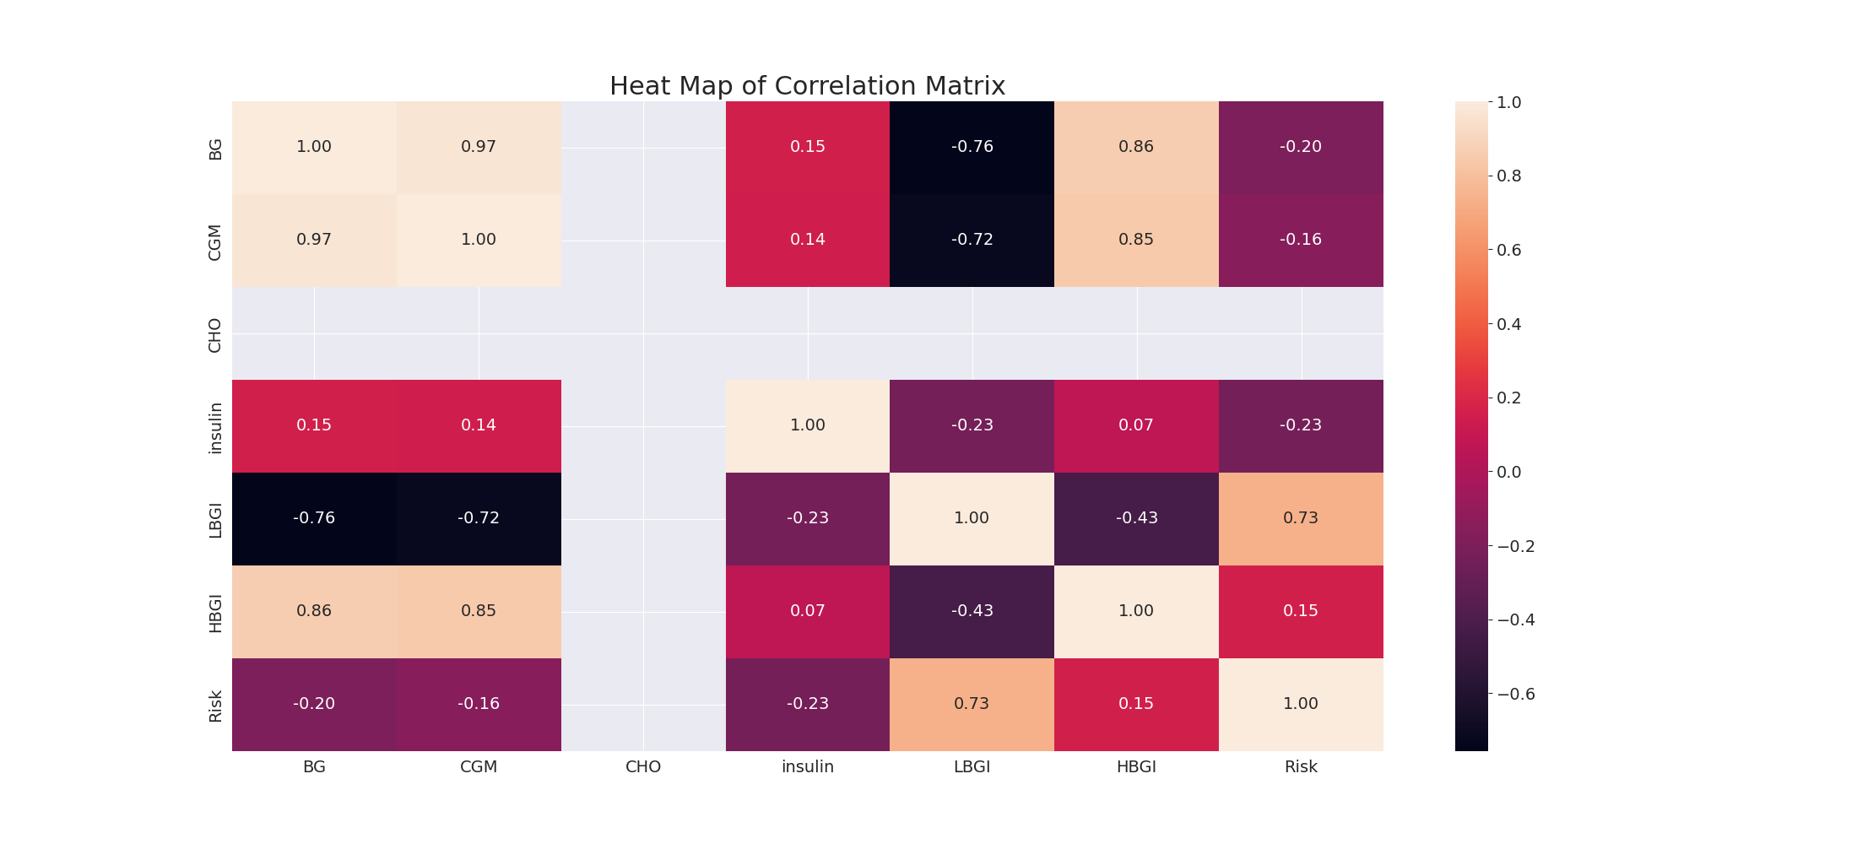

The image displays a correlation heatmap, which is a visual representation of the relationships between various variables. The heatmap is a color-coded matrix that helps to understand the strength and direction of correlations between these variables. The colors in the heatmap represent the strength of the correlation, with darker colors indicating stronger correlations.  
  
The heatmap is organized in a way that allows for easy identification of the variables and their relationships. The variables are likely related, and the data in the image helps to analyze and understand these relationships. By examining and deep-analyzing the visual representation, one can gain insights into the strength and direction of correlations between the variables.

Multi-linear Regression Inference Graph Analysis

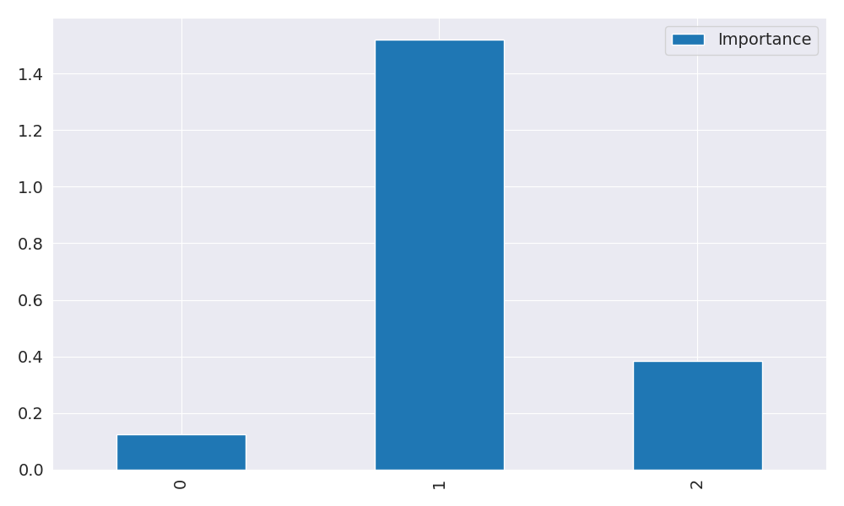

The image displays a blue bar graph with a single blue bar, which is likely a representation of a single variable. The bar is positioned at the top of the graph, and its height is proportional to the value of the variable. The bar's color is consistent with the rest of the graph, which is blue. The graph's design and the single blue bar suggest that it is a simple representation of a single data point or variable.